Game Desing Document

TP1 Third Person

Dev: Remi Allard-Mayer

Actions

The main character should be able to jump, run, and look around in a 3d environment.

States

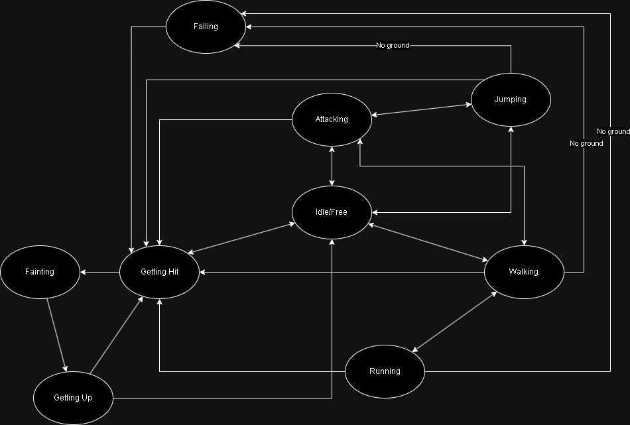

Mechanics

Jump height: Two times and a half the height of the character, currently 5 units. May change with the official asset.

Jump length: ~4 units without momentum, ~11 units with momentum.

Walking speed 19.35 ku/h in kilounits, 322 unit/minutes. To adjust with the new 3D asset.

Running: // TODO To adjust with the new 3D asset.

Running, Jumping and walking from and on a moving platform.