Case Study 156: Drone Mapping & Surveying Analysis

1. Introduction
MapTech Survey Solutions Pvt. Ltd. is a Pune-based company that provides land surveying and mapping services for construction companies, infrastructure developers, and government agencies. Traditional surveying methods are slow and expensive. The company is considering adopting AI‑enabled drone surveying systems to improve efficiency, accuracy, and reduce operational costs.

2. Problem Statement
The company currently spends approximately ₹40 lakhs annually on manual surveying operations. Survey projects take 2–4 weeks to complete and often face delays due to terrain difficulty and human error. Customer complaints have increased by 17%, and some clients have moved to competitors using digital solutions. To solve this problem, the company plans to invest ₹70 lakhs in AI‑enabled drone surveying systems.

3. Objectives
• Analyze financial feasibility of drone surveying
• Calculate operational savings
• Generate synthetic survey data using Python
• Analyze survey efficiency and client satisfaction
• Recommend whether the company should invest in drone technology

4. Financial Analysis
Current Operational Cost = ₹40,00,000
Cost Reduction using Drone Technology = 45%
Annual Savings = Current Cost × Cost Reduction = ₹18,00,000
Drone Investment = ₹70,00,000
Net Benefit (Year 1) = ₹18,00,000 − ₹70,00,000 = −₹52,00,000
Although the first year shows negative benefit due to high investment, long‑term savings and improved efficiency make drone surveying beneficial.

5. Python Data Analysis
Synthetic survey data was generated using Python in Google Colab to simulate survey area, manual survey time, drone survey time, mapping accuracy, and client satisfaction.
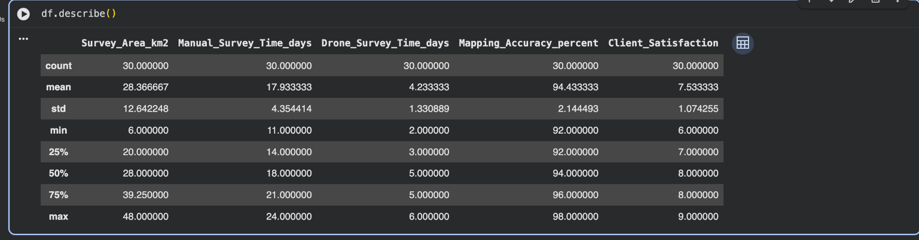
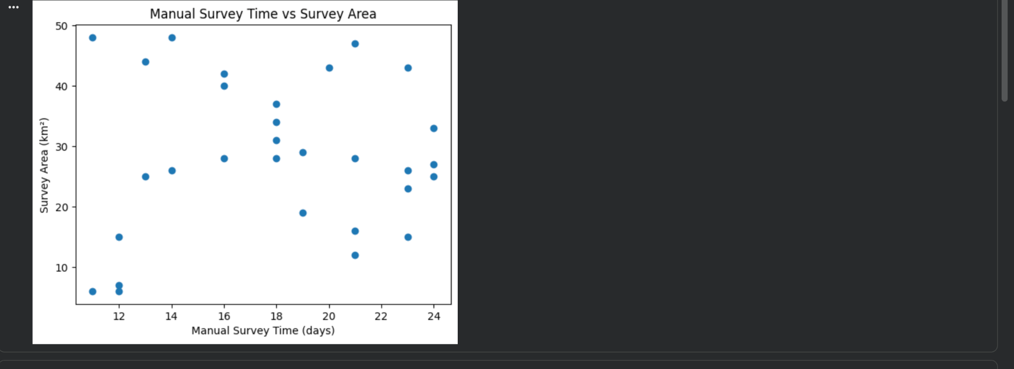



6. Key Variables
Altitude – Drone flight height affects image coverage and detail
Image Resolution – Higher resolution improves mapping accuracy
GPS Accuracy – Ensures precise land measurement
Survey Area Size – Large areas benefit from drone surveying
Terrain Complexity – Drones perform better in difficult terrain
Client Satisfaction – Faster surveys improve satisfaction and repeat business

7. Conclusion
Drone surveying significantly reduces survey time and improves mapping accuracy. Although the first‑year investment is high, long‑term operational savings and improved client satisfaction make the investment beneficial for MapTech Survey Solutions.

