PROJECT NAME : AI AUTOMATED FRUIT SORTER
PROJECT TEAM : BENARD MECER,TINASHE SAIDI,LOVELLE K
MUSADOGERA,KUDAKWASHE CHIGUVARE

PROBLEM OVERVIEW
It has been observed that orchards in Manicaland Province are experiencing significant losses during and after the harvesting of fruits.One of the major challenges is the improper sorting and storage of harvested fruits. Good-quality, damaged, defective and infected fruits are often stored together in the same repository without proper classification.
For instance, in Claremont orchards(located in Nyanga) ,Dombera orchards(located in Chimanimani) there was a significance decrease in produce due to the mixture of decaying/rotten fruits and healthy fruits.Fruits are being harvested in large amounts making it difficult for the orchard operators to oversee and manage the state of the fruits, hence the contagious nature of the rot.
This project therefore seeks to address this problem by developing an AI Automated Fruit Sorting that can identify and separate fruits based on their condition before they are stored. The proposed system aims to reduce fruit spoilage, improve the quality of stored fruits, minimize post-harvest losses, and potentially improve the income generated from fruit production.
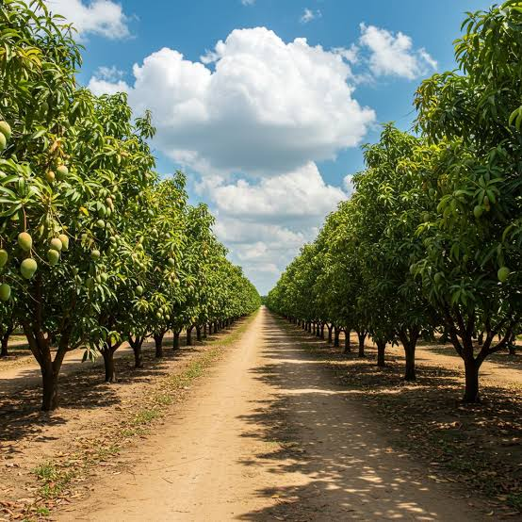

The quality and marketability of agricultural yield begin directly in the orchard, where natural variations in fruit maturity, size, and health present immediate post-harvest sorting challenges. Large-scale production environments require structured, automated sorting systems to efficiently categorize harvested fruit before distribution. By bridging raw agricultural output with downstream automated classification, the project establishes a scalable quality assurance pipeline that optimizes market grading, minimizes post-harvest loss, and improves supply chain efficiency.

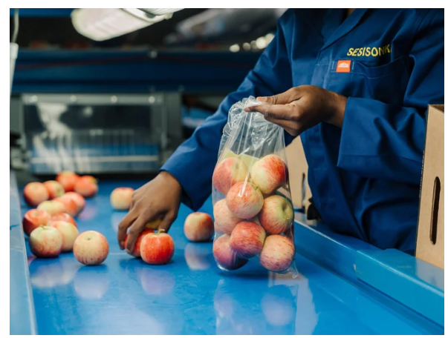
-Sorting produce like apples is critical for maintaining consistent quality control, optimizing supply chain management, and maximizing market value.
-By categorizing fruit based on size, color, and defect levels, operations ensure high-tier stock meets strict retail and export specifications.
-Methodical sorting minimizes post-harvest waste by routing lower-grade produce to secondary processing streams rather than letting it spoil bulk batches.
-Standardizing batch specifications improves packaging efficiency and protects brand reputation through reliable, uniform customer deliverables.
-Ultimately, an automated or structured sorting framework directly strengthens operational throughput and profitability across the distribution pipeline.

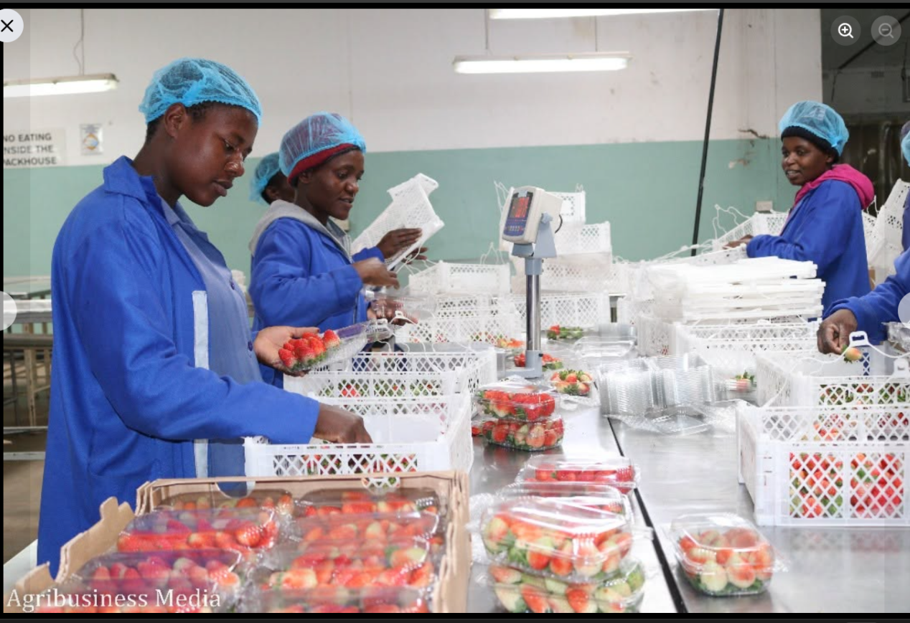
Challenges Faced in Manual Sorting includes

Human Errors & Inconsistency: Subjective judgment leads to inconsistent grading based on size, color, and minor defects, especially during long shifts.

Low Throughput & Bottlenecks: Manual handling slows down processing rates, creating severe packing bottlenecks during peak harvest periods.

Labor Costs & Fatigue: High reliance on manual labor increases operational costs and is prone to reduced accuracy over time due to worker fatigue.

Why an Automated System is Needed

An automated vision-based sorting system delivers objective, high-speed classification, ensuring standard quality, higher operational throughput, and significantly reduced post-harvest labor costs.

PROBLEM STATEMENT
Manual fruit sorting causes quality inconsistencies, severe packing bottlenecks, and high labor dependency that require an automated classification system.

Project Aim

To design and develop an Al driven fruit sorting system that automates the inspection process drastically improving grading accuracy, reducing labor costs through real-time defect detection

Project Objectives

- Edge Computer Vision Classification
There is going to be deployment of a lightweight convolutional neural network (MobileNetV3 ) optimized via TensorFlow Lite to classify fruits by ripeness, size, and surface defects with a target accuracy of on the Pi 4.

2.Low-Latency Image Pipeline Execution
Optimizing the OpenCV camera capture pipeline to process frames maintaining an end-to-end processing latency per frame without exceeding Pi 4 thermal limits.

- Deterministic GPIO Actuator Synchronization
Implementing an inline timing module using the RPi.GPIO library to trigger hardware actuators (e.g., servo gates or pneumatic valves via relay/FET drivers) within a precise window based on conveyor belt speed and camera offset.

4.Edge Time-Series Data Ingestion
Construction of a lightweight local data logging system using SQLite to synchronously capture fruit IDs, timestamped quality grades, belt speed metrics, and sorting decision flags directly on the Pi's storage.

5.Automated Batch Analytics & Report Generation
Developing a background python subsystem (using ReportLab and Pandas) that automatically compiles local database logs into structured summary reports (PDF/CSV) detailing total fruit count, grade distribution percentages, defect ratios, and runtime throughput at the end of every sorting run.
DATA COLLECTION
We aquired our first dataset via Kaggle API (https://www.kaggle.com/datasets/leftin/fruit-ripeness-unripe-ripe-and-rotten) ,credits : lefin.
Accordingly, we accessed Kaggle API to capture our second dataset
https://www.kaggle.com/datasets/kritikseth/fruit-and-vegetable-image-recognition
SYSTEM ANALYSIS AND DESIGN
DATA SET DISCREPTION
About Datasets
The first dataset includes images of tropical fruits at different ripeness stages. You'll find pictures of:
Fresh : bananas, apples, and oranges
Rotten : bananas, apples, and oranges
Unripe : bananas, apples, and oranges
The second dataset includes images of tropical fruits at different ripeness stages. You'll find pictures of:
Fruits: Bananas, Apples, Pears, Grapes, Oranges, Kiwis, Watermelons, Pomegranates, Pineapples, Mangoes
Vegetables: Cucumbers, Carrots, Capsicums, Onions, Potatoes, Lemons, Tomatoes, Radish, Beetroot, Cabbage, Lettuce, Spinach, Soybean, Cauliflower, Bell Pepper, Chilli Pepper, Turnip, Corn, Sweetcorn, Sweet Potato, Paprika, Jalapeño, Ginger, Garlic, Peas, Eggplant
The goal is to help with training machine learning models that can identify whether a fruit is unripe, ripe, or rotten. It's useful for projects in fruit quality detection, food sorting systems, and smart agriculture. All images are organized by category and can be used directly for classification tasks like training a CNN or MobileNet model. Perfect for anyone working on fruit freshness detection or related computer vision projects.
Usability(7.50)
License(CC BY-SA 4.0)

SYSTEM ARCHITECTURE
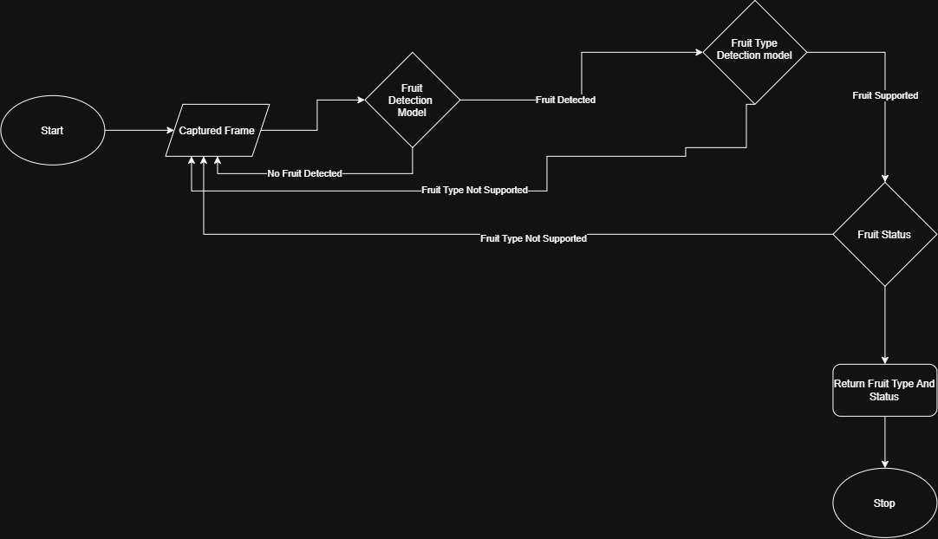 Initialization & Frame Capture·
Start -> Captured Frame: The system initializes and continuously fetches an image frame from the camera stream.

· Stage 1: Presence Detection (Fruit Detection Model)
The frame is passed into a preliminary detection model to check if an object/fruit is present.
No Fruit Detected: If nothing is in view, the loop immediately routes back to Captured Frame to await the next incoming image.
Fruit Detected: If a fruit is present, the pipeline proceeds to the next stage.
Stage 2: Variety Identification (Fruit Type Detection model)
The fruit is evaluated to determine its specific class/variety (e.g., apple, orange, banana).
Fruit Type Not Supported: If the detected object doesn't match a target class supported by the model, the execution loops back to Captured Frame.
Fruit Supported: If it is a recognized variety, execution proceeds to quality assessment.
Stage 3: Quality & Condition Assessment (Fruit Status)
The system evaluates the condition/ripeness/defect status of the identified fruit.
Fruit Type Not Supported / Unusable Status: If the fruit fails validation or has an unrecognized status, the system resets back to Captured Frame.
Valid Classification: Once status determination is successful, the output is passed to the next process.
Output & Termination
Return Fruit Type And Status: The final decision payload (combining fruit identity and condition grade) is emitted. This payload is what triggers downstream sorting mechanisms, actuators, or database reporting.
Stop: The processing cycle for the current frame completes.

Fruit Grading Use Case
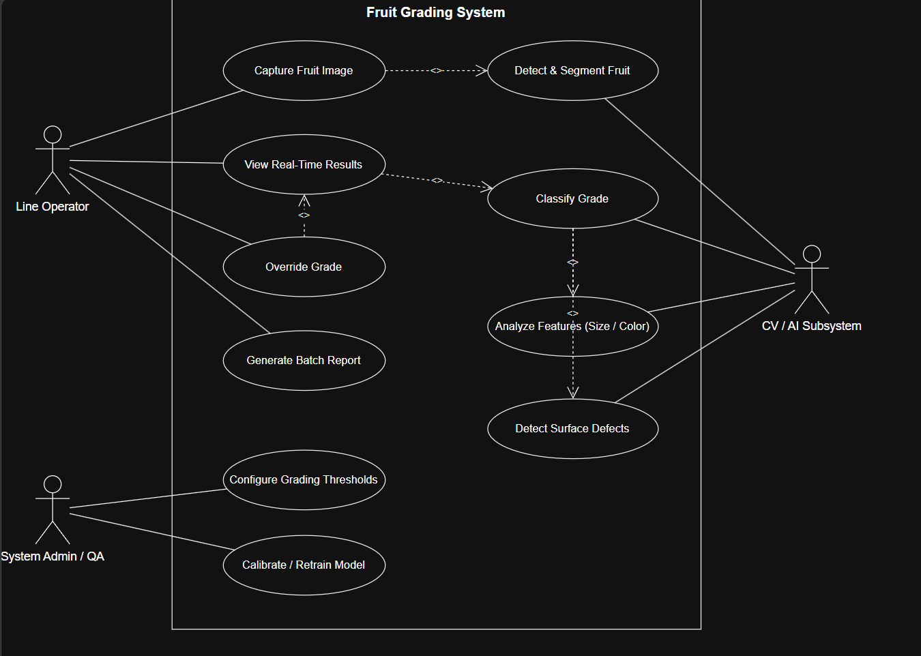

This UML Use Case Diagram illustrates the functional boundary and interactions of your Fruit Grading System. It organizes the system's capabilities into interactions between external actors (users or automated secondary systems) and the internal use cases (ovals).

1. System Actors

Line Operator (Human Actor): The frontline worker is monitoring the physical conveyor operations.
System Admin / QA (Human Actor): The technical or quality assurance supervisor manages the system settings and model performance.

CV / AI Subsystem (Secondary / Machine Actor): The automated vision pipeline (running on your Raspberry Pi 4) executing image analysis algorithms.

2. Breakdown of Use Cases

Line Operator Capabilities
Capture Fruit Image: Triggers or monitors image acquisition from the camera.
View Real-Time Results: Displays live video feeds, predicted fruit grades, defect overlays, and throughput metrics.
Override Grade: Allows manual intervention to reclassify a fruit if the AI misclassifies it.
Generate Batch Report: Compiles the summary data for a completed run into exportable reports (PDF/CSV).

System Admin Capabilities
Configure Grading Thresholds: Adjusts physical and quality boundaries (e.g., minimum diameter, color ranges, defect percentage limits).

Calibrate / Retrain Model: Updates camera calibration profiles or loads updated AI weights into the system.

AI Subsystem Capabilities
Detect & Segment Fruit: Isolates the fruit from the conveyor background in raw frames.
Analyze Features (Size / Color): Extracts physical features such as pixel area, bounding dimensions, and color histograms.
Detect Surface Defects: Scans the segmented fruit surface for blemishes, rot, or bruising.
Classify Grade: Merges extracted features and defect metrics to determine final grade assignment.

3. Key Relationships (<<include>> / <<extend>>)
Capture Fruit Image -> Detect & Segment Fruit: Capturing an image automatically invokes the vision subsystem to segment the fruit from the background.
Classify Grade -> Analyze Features & Detect Surface Defects: Final grade classification depends directly on executing feature extraction and surface defect detection.
Override Grade -> View Real-Time Results: Overriding a grade is an optional extension triggered by the operator while inspecting live results.

FRUIT FRESHNESS MODEL CREATION VERSION 1
Key steps covered:
1. Dataset Download & Verification: Used kagglehub to download the 'fruit ripeness' dataset and verified its structure.
2. Library Imports & Transformations: Imported necessary PyTorch and Torchvision libraries, and defined image transformations (resize, to tensor, normalize) for data preprocessing.
3. DataLoader Setup: Created ImageFolder datasets and DataLoader instances for both training and testing, enabling efficient batch processing.
4. Model Definition & Fine-tuning: Loaded a pre-trained MobileNetV3-Smal1 model (transfer learning) and adapted its final classification layer for our specific 9 fruit ripeness classes.
5. Training Setup: Defined the CrossEntropyLoss criterion and the Adam optimizer.
6. Training Phase: Executed a basic training loop (though a full multi-epoch training was not explicitly shown in detail, the setup was completed).
7. Testing Phase: Evaluated the trained model on a test set, achieving a Test Loss of 0.1410 and a Test Accuracy of 95.59%.
8. Custom Image Prediction: Implemented functionality to upload a custom image and get a real-time prediction from the model.
9. Model Saving & Downloading: Provided code to save the trained model's state dictionary (fruit_ripeness_model pth) and to download it to the local machine for future use.
Implementations
Component | Current implementation
Web service | FastAPI application with health, readiness, status, event, report, camera, and sorter control endpoints.
Inference | FruitClassifier loads FruitClassifier.keras and FruitClassifier.json; inference runs in a background thread.
Camera | OpenCV reads the configured network stream from FRUIT_SORTER_CAMERA_URL.
Storage | SQLite records event labels, fruit, quality, source, timestamp, and optional saved frame path.
Dashboard | HTML, CSS, and JavaScript console with live camera feed, classification card, metrics, events, and start/stop controls.
Deployment | Docker and compose configuration are included for repeatable local or edge deployment.

System workflow

- Start: an operator starts the station from the dashboard.
- Capture: the runtime opens the configured camera stream and continually reads frames.
- Classify: approximately every 0.7 seconds, an available classifier predicts a label.
- Record: the result and optional JPEG frame are written to the local database and frame directory.
- Present: the API returns current state and recent events; the dashboard refreshes automatically.
- Stop or failure: the camera is released, the runtime stops, and the dashboard reports the condition to the operator.

Dashboard overview

The dashboard is designed for a line operator or supervisor. It shows whether the station is running, whether the camera and classifier are ready, the current detected item and quality, total counts by quality, session uptime, and a real time sorting report with saved frames. Start and Stop controls prevent conflicting requests and communicate service or camera errors clearly.
Data sources and model work
The project uses public fruit image datasets for model development, including the Fruit Ripeness Unripe Ripe and Rotten data set and the Fruit and Vegetable Image Recognition data set. The repository contains trained model artifacts and notebooks documenting experimentation. Reported notebook results include a test accuracy of 95.59% for the described MobileNetV3-based ripeness experiment; production performance should still be measured against the target camera, lighting, fruit varieties, and deployment hardware.

Result Analysis
The test accuracy of the model is 95.59%

Limitations and next steps

- The current runtime classifies frames and logs decisions but does not yet drive physical sorting actuators.
- Accuracy and latency need validation on representative orchard and conveyor images.
- Camera configuration, lighting, calibration, and model confidence thresholds should be made operator-configurable.
- Add authenticated access and role-based controls before exposing the dashboard beyond a trusted local network.
- Add exportable batch reports and monitoring for storage limits, camera failures, and model drift.
- Integrate GPIO or another hardware interface for deterministic gate or relay control after classification validation.

Conclusion

The Automated Fruit Sorter provides a working foundation for edge-based fruit quality inspection. Its current architecture connects camera capture, model inference, local event storage, and a live operator console in one deployable service. The next development priority is to validate the classifier in real operating conditions and then connect reliable classification decisions to physical sorting hardware.

Results analysis
Contribution to the body of knowledge

References (list)

IEEE referencing

