**Issue #1:**

**Issue:** Close button NOT clickable (i.e. Modal doesn’t close when clicked)

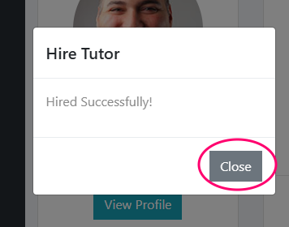

**Fix:** Remove (comment out) double imports of JQuery.min.js and Bootstrap.min.js

