iptraf, iftop, nload(network usage) for monitoring network

2. ifconfig | tee -a Test.txt //Print output of the command in file

3. List contents of an archive:

pax < archive.tar

Extract contents of an archive into the current directory:

pax -r < archive.tar

For extracting a gziped archive:

pax -rzf archive.tar.gz

4. fuser -k EMMG // For Killing the process

fuser -v -n tcp 8080

5. du -sh * //For obtaining file size in current directory



6. dd //Primary purpose is to convert and copy files.

Check the File system which you want to backup by df command.

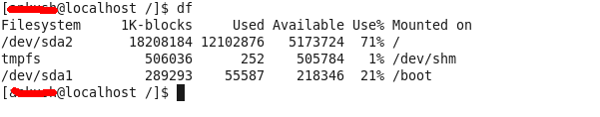

 Backup Entire Harddisk by the following command;

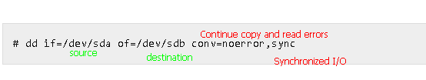

Backup as image;

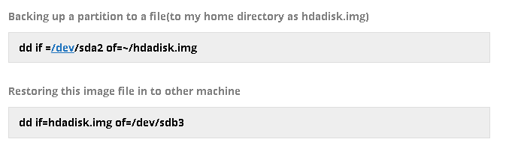

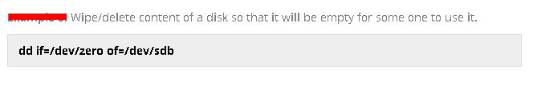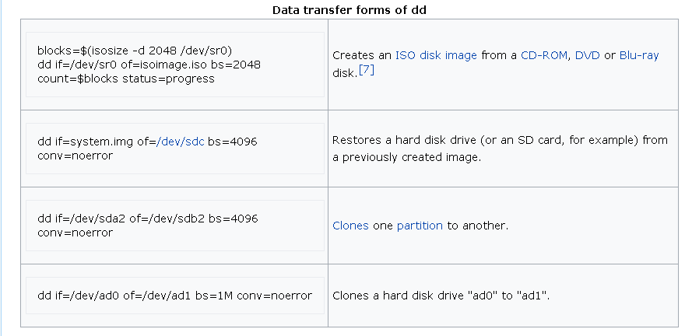

7. cksum test.txt //Output a [cyclic redundancy check](https://www.computerhope.com/jargon/c/crc.htm)

Result: 4038471504 75 test.txt

8.

┌───────────── minute (0 - 59)

│ ┌───────────── hour (0 - 23)

│ │ ┌───────────── day of month (1 - 31)

│ │ │ ┌───────────── month (1 - 12)

│ │ │ │ ┌───────────── day of week (0 - 6) (Sunday to Saturday;

│ │ │ │ │ 7 is also Sunday)

│ │ │ │ │

│ │ │ │ │

* * * * * command to execute



9. $ talk <username>@<hostname> <tty> //For fun

Enable this service if required: systemctl start xinetd.service

10. 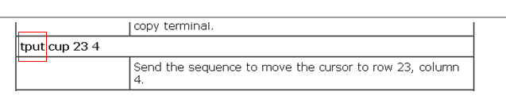

11. dirname //Retrieve the directory-path name from a pathname ignoring any trailing slashes.

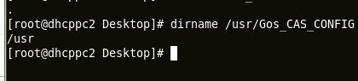

12. nl //Numbers the line in a file.

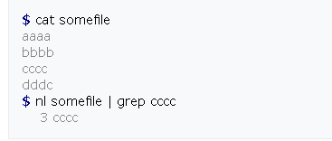

13. paste

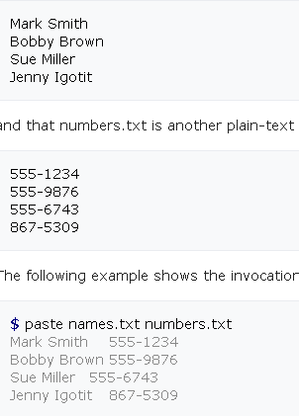

14.wc

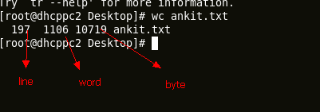

15. sleep

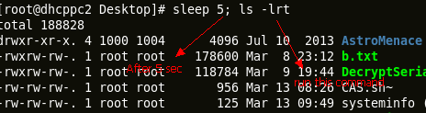

14. Check on what partition folder is mounted and disk info, to check all list(mount+unmount) use **sfdisk -l**

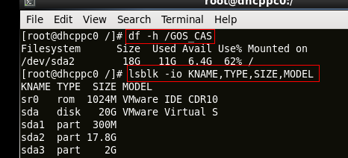

15. Check model

smartctl -i /dev/sda

results:

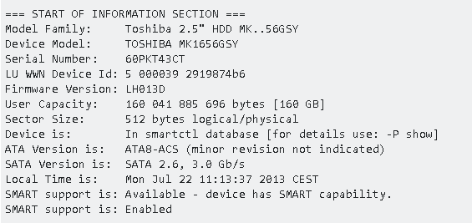

16. SS Command

ss -4 state listening

1 Show connected sockets from specific address;

ss dst 192.168.1.139

2 Print process name and pid

$ ss -ltp

3 Filtering connections by tcp state

ss -t4 state established

4 Sockets with destination port 443 or 80

$ ss -nt '( dst :443 or dst :80 )'

State Recv-Q Send-Q Local Address:Port Peer Address:Port

ESTAB 0 0 192.168.1.2:58844 199.59.148.82:443

ESTAB 0 0 192.168.1.2:55320 165.193.246.23:443

ESTAB 0 0 192.168.1.2:56198 108.160.162.37:80

ESTAB 0 0 192.168.1.2:54889 192.241.177.148:443

ESTAB 0 0 192.168.1.2:39893 173.255.230.5:80

ESTAB 0 0 192.168.1.2:33440 38.127.167.38:443

5 # Filter by address

$ ss -nt dst 74.125.236.178

6 Particular Port

$ ss -nt dport = :80

State Recv-Q Send-Q Local Address:Port Peer Address:Port

ESTAB 0 0 192.168.1.2:56198 108.160.162.37:80

ESTAB 0 0 192.168.1.2:39893 173.255.230.5:80

ESTAB 0 0 192.168.1.2:55043 74.125.236.178:80

7 Display All TCP Sockets

# ss -t -a

17. iftop (tool)

The iftop command listens to network traffic on a given network interface such as eth0, and displays a table of current bandwidth usage by pairs of hosts:  
# iftop -i eth1  
It can display or analyses packet flowing in and out of the 192.168.1.0/24 network:  
# iftop -F 192.168.1.0/24

18. Set Bandwidth;

tc Command

show a rule;

tc qdisc show dev eth0

delete a rule;

tc qdisc del dev eth0 root

delay;

tc qdisc add dev eth0 root netem delay 200ms

19. Find the local port number and use netstat to find which process the connection belongs to.

netstat -tpn | grep 12345

20. For Collecting logs;

tcpdump -wi eth0 and port 8080 packet.log

tcpdump -w /var/tmp/tcpdata.pcap -i any -c 10 -vvv -XX

21. iotop

Check by process ID;

sudo iotop -o -p 15883

TID: PID of process

PRIO: the I/O priority at which the process is running. This can be modified using the ionice command.

USER: The user id which owns the process

DISK READ: data read per second

DISK WRITE: data written per second

SWAPIN: Time spent swapping, i.e., copying of memory pages back and forth between memory and swap.

IO: Time spent by the process waiting for I/O during the sampling interval. While debugging I/O performance issues, take note that a high value of IO column will result in a performance bottleneck.

COMMAND: The command being executed by the process.

To set priorities of a process;

# ionice -c3 -p89   
Sets process with PID 89 as an idle io process.

# ionice -c2 -n0 bash   
Runs ’bash’ as a best-effort program with highest priority.

# ionice -p89   
Returns the class and priority of the process with PID 89.

