**Created a index.html**

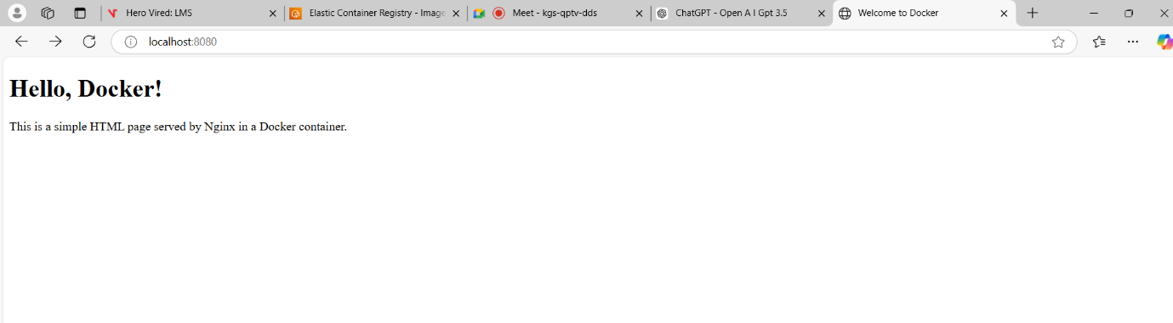

**Docker build**

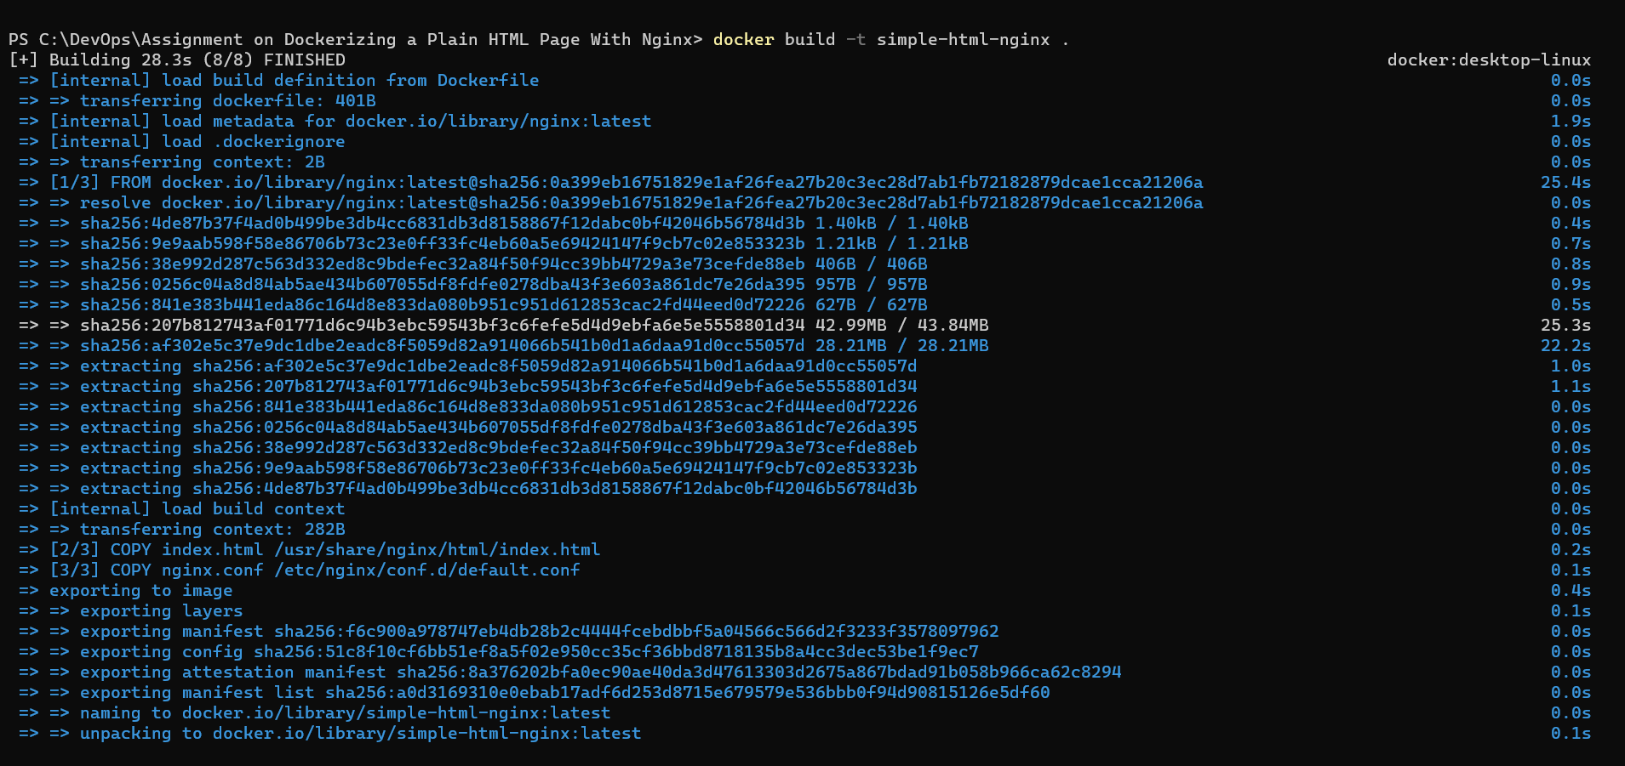

**Docker run**



**Created an ECR**

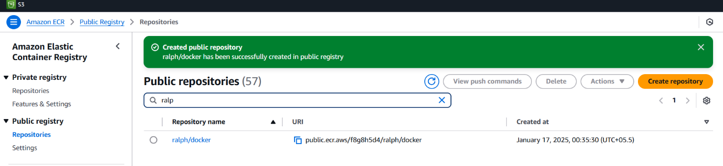

**Docker connection to ECR**

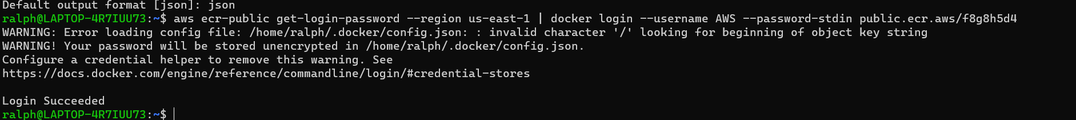

**Docker Tag & Docker Push**

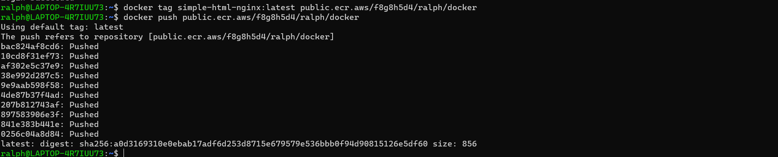

**Docker Container**

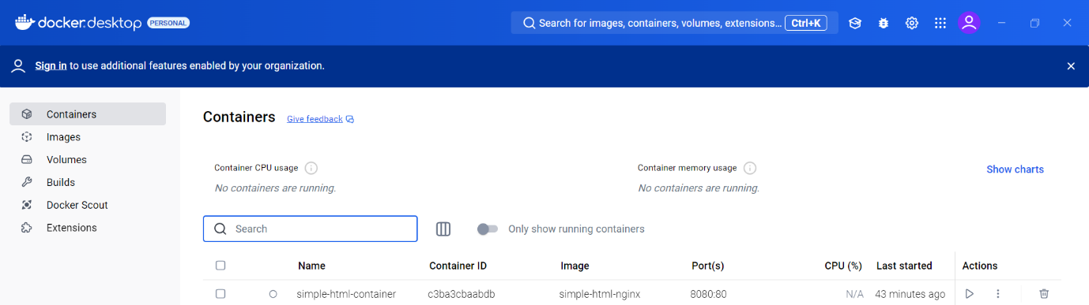

**Docker Images**

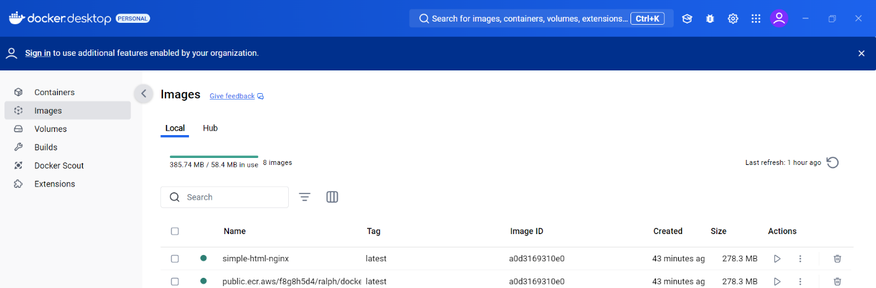

**AWS ECR**

