Computer Vision-Driven Two-Stage Instance Segmentation of Post-Harvest Surface Defects in Apple and Tomato Using YOLO26

Ralph Kevin G. Morales
School of Information Technology
Mapúa University
Makati, Philippines
rkgmorales@mymail.mapua.edu.ph
Niel Francis M. Arligue
School of Information Technology
Mapúa University
Makati, Philippines
nfmarligue@mymail.mapua.edu.ph
Alexander Jann P. Espia
School of Information Technology
Mapúa University
Makati, Philippines
ajpespia@mymail.mapua.edu.ph
Lysa V. Comia
School of Information Technology
Mapúa University
Makati, Philippines
lvcomia@mapua.edu.ph
Deangelo James P. Largueza
School of Information Technology
Mapúa University
Makati, Philippines
djlargueza@mymail.mapua.edu.ph

Abstract—Visible surface defects such as bruises, rot and cuts lower the market value of fresh produce, yet manual post-harvest inspection is slow and inconsistent. Public grading datasets label whole images by quality grade and do not show where a defect is or how much of the fruit it covers. This study presents a two-stage instance segmentation framework based on YOLO26l-seg that first segments the whole fruit and then segments three visible defect classes: bruise or discoloration, rot mold or decay, and surface damage. Pixel masks were drawn and reviewed by the team in Roboflow on 2,110 apple and 1,313 tomato training images, with validation and test splits separated by capture group. On the held-out test set the apple model achieved a mask mAP50 of 0.613, a precision of 0.718 and a recall of 0.597. The tomato model achieved a mask mAP50 of 0.393 with a precision of 0.732. A single model trained on both fruits reached 0.586 on apple and 0.352 on tomato. Predicted defect coverage agreed with the team labels with a correlation of 0.91 for apple and 0.82 for tomato. The models are deployed in a Streamlit web application that marks each defect and reports its share of the fruit, supporting automated post-harvest quality inspection.
Keywords—computer vision, deep learning, instance segmentation, YOLO26, post-harvest defects, smart agriculture

Introduction
Visible surface defects are an important part of post-harvest fruit quality assessment. A grade assigned to a whole image does not show where a defect is or how much of the surface it covers. AFruitDB provides 3,167 images of six fruit types sorted into three quality grades [1]. These image-level labels support grading research but do not give the pixel-level information needed to outline damaged regions.
Computer vision tasks differ in what they output. Image classification gives one label per image. Object detection draws a bounding box around each object. Instance segmentation outputs a mask for each object, which is the exact set of pixels it covers. Mask R-CNN established this approach by predicting a mask together with each class and box [2]. A box around a small or irregular bruise also contains healthy skin so a mask is a better fit for fruit inspection.
Earlier studies show that pixel-level analysis helps produce inspection. Agarla et al. segmented apple defects using color and multispectral images [3]. Knott et al. combined banana foreground segmentation with individual defect masks for defect-based grading [4]. Leiva et al. trained YOLO11 in two phases on apples with scab, first on the fruit and then on the disease, and reported that the first phase helped the second [5]. Their results cannot be assumed to transfer to a new mixed-source dataset with different defect categories.
This study segments visible post-harvest surface defects on apple and tomato in RGB photos. It adapts the two-phase idea of [5] to YOLO26. Stage 1 segments the whole fruit. Stage 2 starts from the Stage 1 weights and segments three defect classes. The classes describe visible appearance only. They do not confirm a disease or internal damage.
The contributions are: (1) a reviewed set of polygon masks for three visible defect classes built on top of image-level grading photos, (2) a frozen leakage-controlled split by capture group, (3) a record of 24 training runs from the first pilot to the final model, (4) a two-stage YOLO26l model evaluated on an untouched test split, (5) a comparison of separate and combined models for apple and tomato, and (6) an upload-and-predict web application.

Review of Related Literature

Fruit Grading Data and Pixel-Level Annotations
Mojumdar et al. introduced AFruitDB for grading six common Asian fruits [1]. Images are organized by fruit and grade. A grade does not mark the boundary of a bruise or scar and a lower grade does not name a defect type. In this study defect labels were therefore assigned by inspecting each image and not inferred from grade folders.
Whole-fruit masks also change the role of healthy-looking images. Each image still needs a fruit mask and simply has no defect mask when careful inspection finds none. This keeps fruit identity separate from visible damage and allows several defect regions on one fruit.

Segmentation for Fruit Defect Assessment
Agarla et al. built a U-shaped network for quasi real-time apple defect segmentation and studied the value of near-infrared input [3]. Their work labels defective pixels rather than a whole-fruit grade. It used a different imaging setup and did not separate several visually similar defect types.
Tan et al. measured internal bruising in cut blueberries by segmenting the cross-section and the bruised tissue separately [6]. This is a useful precedent for pairing an object mask with a damage mask. It studied internal tissue so its scores do not apply to external defects on whole fruit.
Knott et al. used weakly supervised panoptic segmentation for banana grading with defect instances such as bruises and scars [4]. Box prompts and human checks supported mask preparation. Leiva et al. used YOLO11 segmentation for apple scab with a fruit phase before a disease phase [5]. The present study follows this staged design but uses three appearance classes and two fruits.

Instance Segmentation and Human-Reviewed Masks
Mask R-CNN shows that recognition and mask prediction can be learned in one framework [2]. A strong architecture still depends on consistent labels. Annotation quality is therefore treated as part of the research design.

Robustness and Evaluation
Nesteruk et al. combined image collection with augmentation for apple rot segmentation under changing conditions [7]. Their work shows how hard it is to transfer a model beyond its training conditions. Augmentation adds variety but does not replace evaluation on genuinely new images. This study keeps a frozen test split that was never used for training or model selection.

Synthesis
The reviewed work supports three design choices: masks for irregular damage, a fruit mask kept separate from defect masks, and human review of every label. It also shows that results on one fruit or setup do not prove performance on another. The question here is how well a two-stage YOLO26 model segments visible defects once grading photos are extended with reviewed masks.

Dataset and Annotation

Image Sources
Apple images come from three sources. AFruitDB grading photos [1] supply 986 training files. The Lab2Wild apple rot set by Nesteruk [8] supplies 843. Photos taken by the team supply 281. The original AFruitDB grade folders are image-level labels and were not used as training targets. All pixel masks were drawn by the team. Tomato images also come from the AFruitDB grading photos [1]. The tomato set has 1,313 training files from 459 capture groups, 132 validation images, 95 test images and a 39-image reserve.

Classes and Annotation Protocol
Polygons were drawn by the team in Roboflow [9]. Every mask was reviewed and corrected by a team member. Pilots began with five defect classes. Cut or crack and spot or scar were rare and often confused so they were combined as surface damage. Visible mold was combined with rot. The final classes are listed in Table I. Shadows, glare, stems, natural speckling and normal ripening color are excluded.
- Defect classes and apple training counts
Class | Visible appearance | Train images | Train masks
bruise_discoloration | Smooth dark or discolored patch | 607 | 709
rot_mold_decay | Soft collapsed or moldy tissue | 620 | 697
surface_damage | Cut crack scar or dry spot | 547 | 873

Fig. 1 shows labeled examples of each class on both fruits. Fig. 2 shows how many masks each class has and how large they are. Apple rot masks often cover most of the fruit, with a median of 48% of the fruit area. Tomato rot masks are much smaller, with a median of 3.5%. Surface damage masks are tiny on both fruits, with a median below 0.5% of the fruit. Small masks are harder to segment, which helps explain the weaker tomato and surface damage scores in Section V.
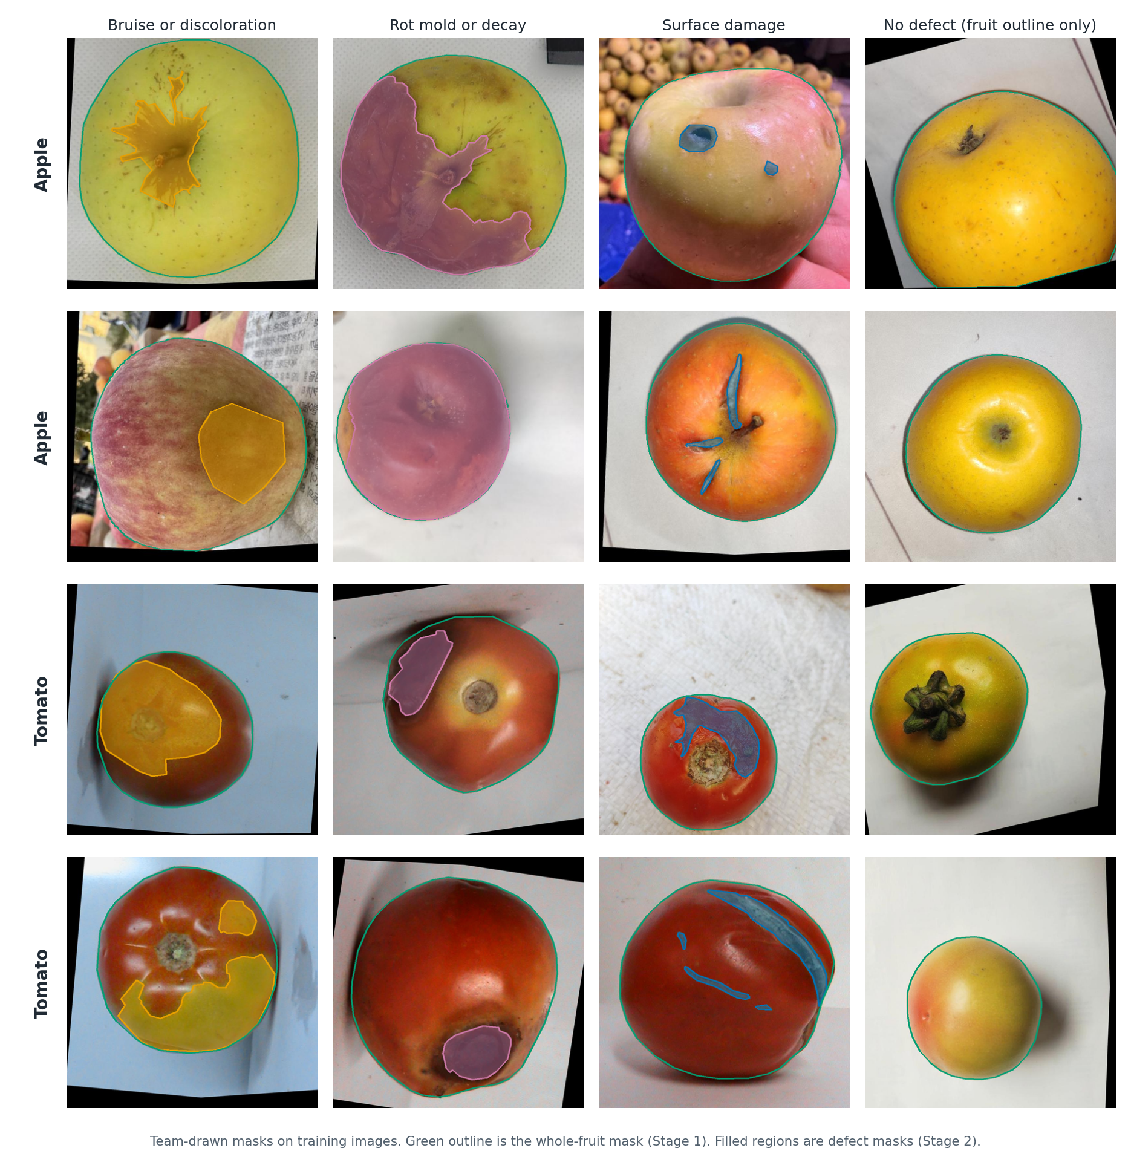
- Team-drawn masks on training images. Green outline is the whole fruit (Stage 1). Filled regions are defects (Stage 2): orange bruise, pink rot, blue surface damage.

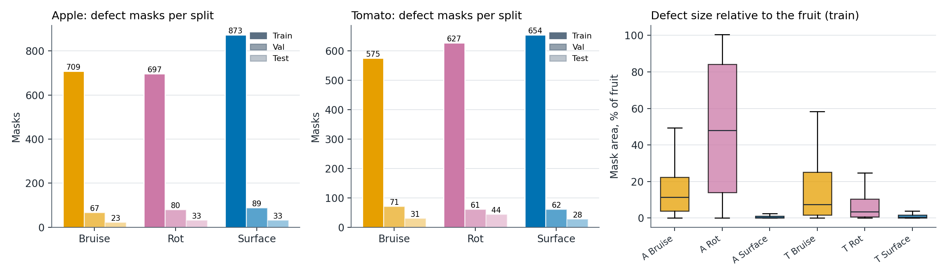
- Defect masks per split for each fruit (left, middle) and defect size as a share of the fruit on the training split (right).

Splits and Leakage Control
The Roboflow training export contains up to three augmented variants of many photos. The 2,110 training files therefore come from 726 capture groups and not 2,110 distinct photos. Each group stays in one split. Validation has 215 images from 210 groups and test has 79 images from 75 groups. A further 63 images form a protected reserve that was not used at all. Exact pixel hashes and capture groups were checked for overlap across splits and none was found. 545 training images have no defect mask and act as negatives.

Methodology

Two-Stage Training

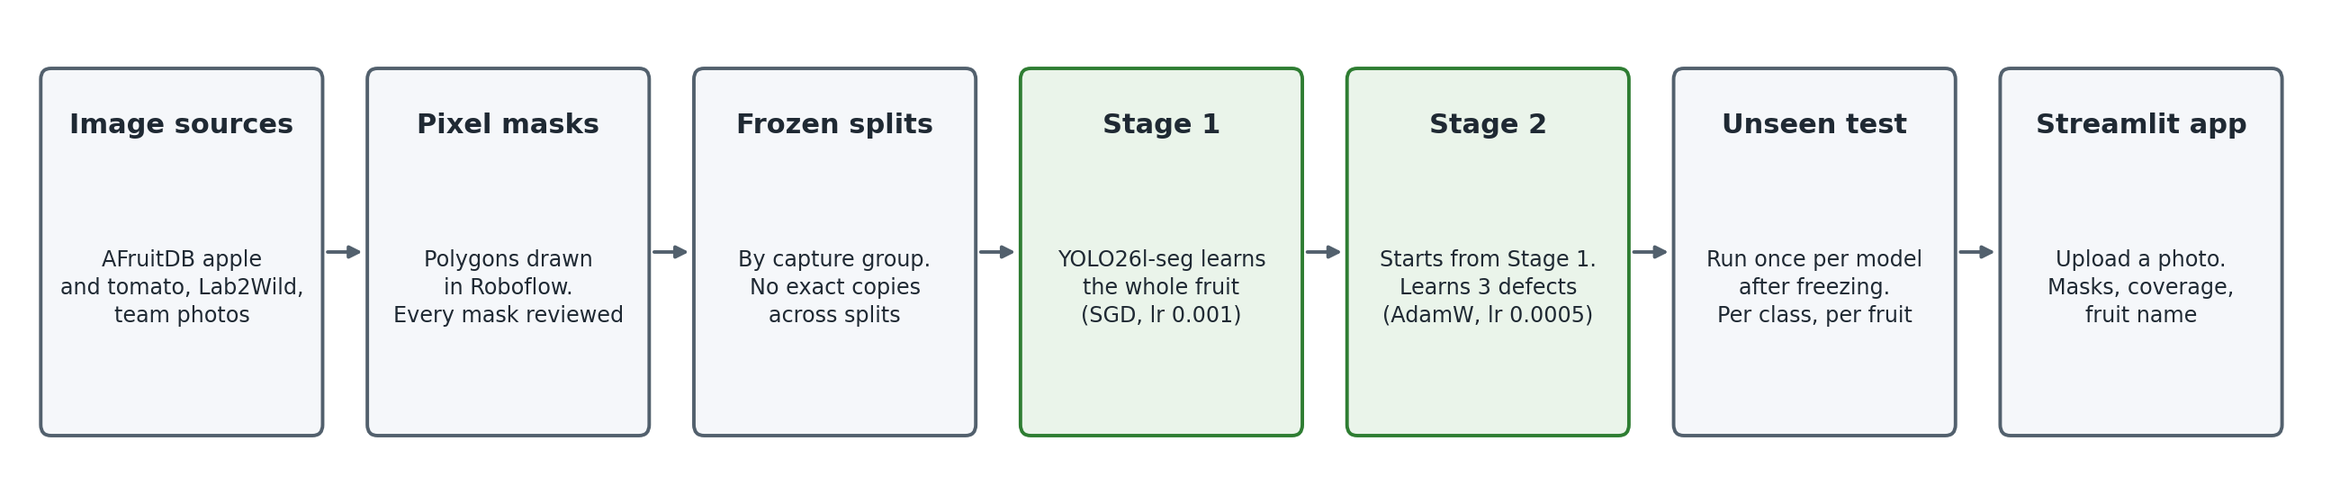
- Project pipeline from image collection to the web application.

YOLO26 is the 2026 release of the Ultralytics YOLO family [10]. The large segmentation variant YOLO26l-seg was used. In Stage 1 the model learns a single fruit class on every training image including damaged fruit. In Stage 2 the Stage 1 best checkpoint initializes a new run with three defect outputs, a fresh AdamW optimizer and a new learning-rate schedule. Shared backbone and neck weights carry over and the output layers are rebuilt. Table II lists the settings.
- Training settings (apple)
Setting | Stage 1 (Run 21) | Stage 2 (Run 22)
Initial weights | yolo26l-seg.pt | Run 21 best.pt
Classes | apple | 3 defects
Optimizer / lr0 | SGD / 0.001 | AdamW / 0.0005
Max epochs / patience | 100 / 10 | 300 / 30
Image size / batch | 864 / 56 | 864 / 56
LR schedule | cosine lrf 0.01 | cosine lrf 0.01
Weight decay / warmup | 0.0005 / 3 | 0.0005 / 3

Tomato uses the same recipe: Run 23 for Stage 1 and Run 24 for Stage 2. The combined model uses the apple and tomato splits merged without reshuffling, so no image changes split. Its Stage 1 (Run 25) learns two classes, apple and tomato, with patience 5. Its Stage 2 (Run 26) starts from the Run 25 best checkpoint, keeps the same three shared defect names and was capped at 100 epochs because of compute. Fruit identity therefore comes from Stage 1 and defect type from Stage 2. Shared names were chosen over fruit-specific names such as apple_bruise because the classes describe appearance and splitting them would leave tomato with fewer examples per class.
Fig. 4 shows the two stages at inference. Stage 1 outlines the fruit and Stage 2 outlines each defect. The app divides the defect area by the Stage 1 fruit area to report how much of the fruit is damaged.

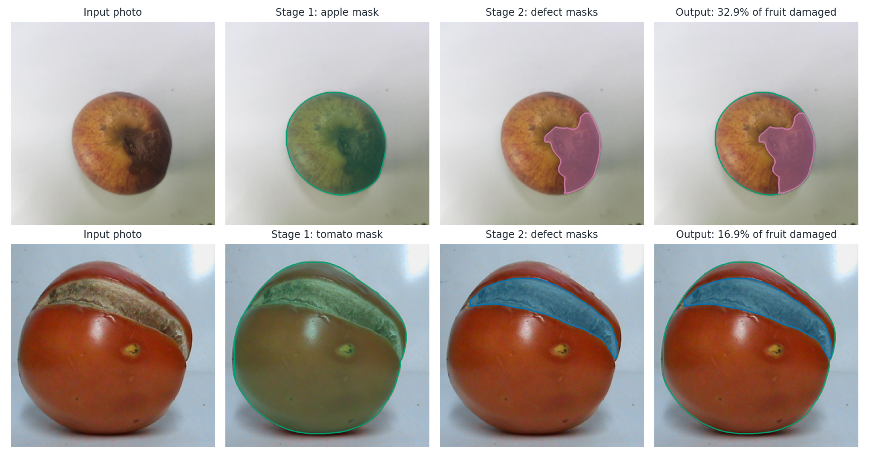
- Two-stage inference on an apple and a tomato test image: input, Stage 1 fruit mask, Stage 2 defect masks and the combined output with damaged share of the fruit.

Online augmentation was applied to training images only: horizontal and vertical flips (p = 0.5), rotation up to 10 degrees, translation 0.05, scale 0.1 and small hue saturation and value shifts (0.01, 0.2, 0.2). Mosaic, MixUp and Copy-Paste were off so that defect color and texture stay realistic. Training ran on one NVIDIA A100 80 GB GPU in Google Colab with Ultralytics 8.4.126, mixed precision and seed 0.

Evaluation Metrics
All scores are mask metrics. Precision is the share of predicted masks that match a labeled mask. Recall is the share of labeled masks that are found. A match needs an intersection over union (IoU) above a threshold, where IoU is the overlap area divided by the combined area. mAP50 is the mean average precision at IoU 0.50 and mAP50-95 averages it over IoU 0.50 to 0.95. The best checkpoint was chosen on validation only. The test split was evaluated once after every choice was frozen.

Results and Discussion

Run History
Twenty-four runs were recorded from 13 September to 1 October 2026 (Table III). Early YOLO26n pilots on five classes stayed below 0.50 mask mAP50. Merging rare classes and adding more reviewed images raised scores. Joint apple and tomato models reached about 0.75 overall mAP50 but most of that came from the easy whole-fruit classes. Runs on different datasets are historical and not controlled comparisons.
- Selected runs (validation mask metrics)
Run | Data | Model | mAP50 | mAP50-95
P1 pilot | Apple 5 cls | 26n | 0.474 | 0.310
P6 pilot | Apple+tomato | 26s | 0.687 | 0.506
Run 11 | Apple+tomato | 26m | 0.715 | 0.598
Run 14 | Apple 4 cls | 26m | 0.714 | 0.558
Run 20 S2 | Apple defects | 26m | 0.671 | 0.450
Run 21 S1 | Apple fruit | 26l | 0.985 | 0.985
Run 22 S2 | Apple defects | 26l | 0.688 | 0.457
Run 24 S2 | Tomato defects | 26l | 0.494 | 0.295
Run 26 S2 | Both, defects | 26l | 0.600 | 0.374

Runs 14, 20 and 22 share the same images and splits. The single-stage Run 14 averaged 0.624 mask mAP50 over its three defect classes. The two-stage YOLO26m Run 20 reached 0.671 and the two-stage YOLO26l Run 22 reached 0.688. These runs also differ in image size, optimizer and model size so the gain cannot be credited to the two-stage design alone.

Final Apple Model
Stage 1 segments the whole apple almost perfectly on validation with 98.5% mask mAP50 and 98.6% recall. Stage 2 reached 80.9% precision, 68.0% recall, 68.8% mAP50 and 45.7% mAP50-95 on validation at its best epoch. Table IV gives per-class results.
- Apple stage 2 per-class mask results
Class | Val P | Val R | Val mAP50 | Test mAP50
Bruise | 0.847 | 0.744 | 0.777 | 0.594
Rot | 0.931 | 0.713 | 0.761 | 0.732
Surface | 0.648 | 0.584 | 0.527 | 0.511
All | 0.809 | 0.680 | 0.688 | 0.613

Fig. 5 shows the training curves of the apple and combined Stage 2 runs. Training loss falls smoothly and validation mAP rises quickly in the first 30 epochs and then levels off, so early stopping ended both runs without a long decline. The tomato run (Run 24) shows a clearer sign of overfitting: its validation segmentation loss was lowest near epoch 26 and rose afterwards while its training loss kept falling. Its validation mAP still crept up slowly, and the saved checkpoint was chosen on validation fitness, but the tomato model would likely gain more from extra data than from longer training.

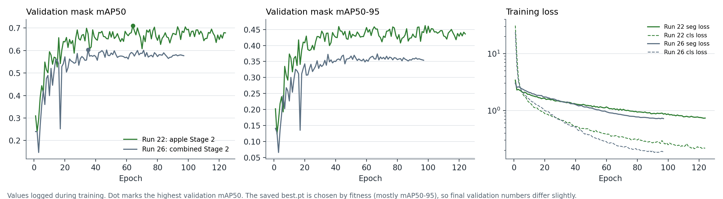
- Validation mask mAP50 and mAP50-95 per epoch and training loss for the apple (Run 22) and combined (Run 26) Stage 2 runs.

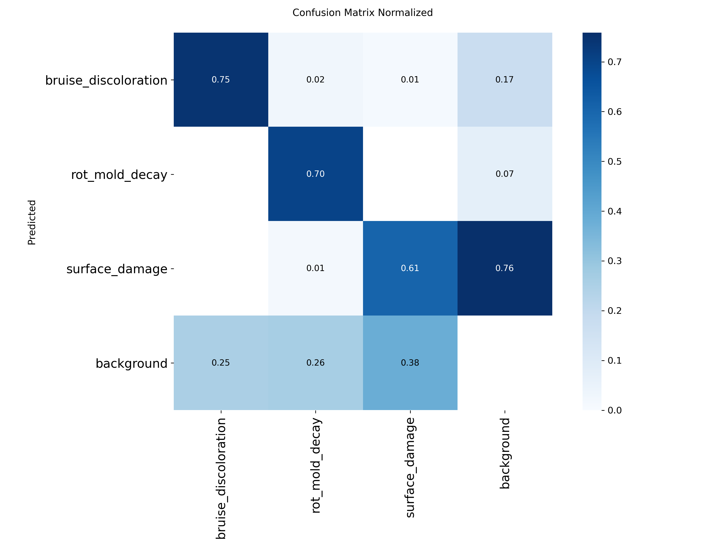
- Normalized validation confusion matrix of the apple Stage 2 model.

Unseen Test
The frozen test split (79 images, 75 capture groups) was evaluated once with the final Stage 2 checkpoint. Test mask precision was 71.8%, recall 59.7%, mAP50 61.3% and mAP50-95 41.1%. Test mAP50 is 7.5 points below validation. This is expected because the best checkpoint was chosen on validation. Almost the whole drop comes from bruise (0.777 to 0.594) while rot (0.761 to 0.732) and surface damage (0.527 to 0.511) stay close. The test split has only about 23 bruise instances so one missed bruise moves bruise recall by about four points. The test bruises may also differ in source or lighting from the training bruises. The test confusion matrix shows the same pattern as validation: most errors are missed defects while bruise and rot are rarely confused. Fig. 7 compares validation and test per class.

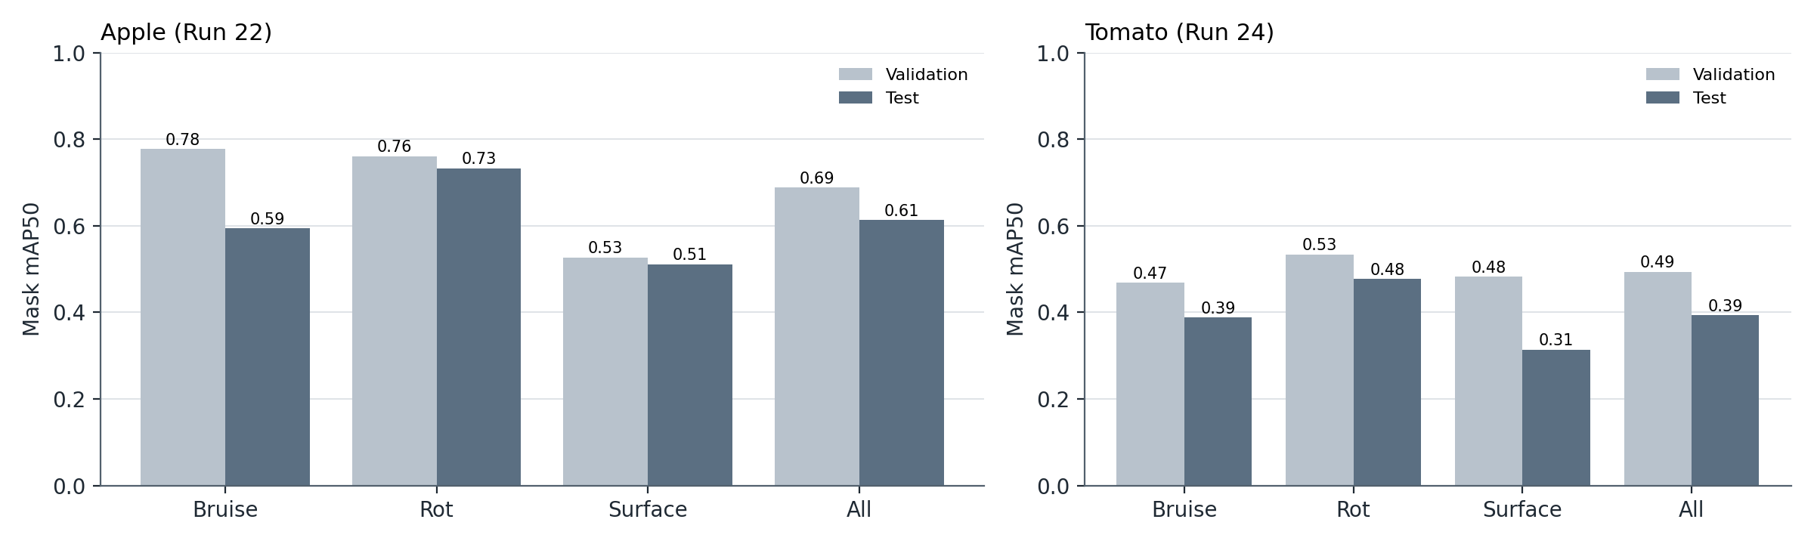
- Mask mAP50 per class on validation and test for apple (left) and tomato (right).

Across the 62 apple test images with a labeled defect, the mean per-image pixel IoU between predicted and labeled defect masks at confidence 0.25 was 0.58. For tomato it was 0.41 over 51 images. The app reports the damaged share of the fruit, so Fig. 8 checks that number directly. Predicted and labeled coverage agree with a correlation of 0.91 and a mean absolute error of 5.2 percentage points on apple, and 0.82 and 3.7 points on tomato. Most large errors are images where a defect was missed entirely and coverage is predicted as zero.

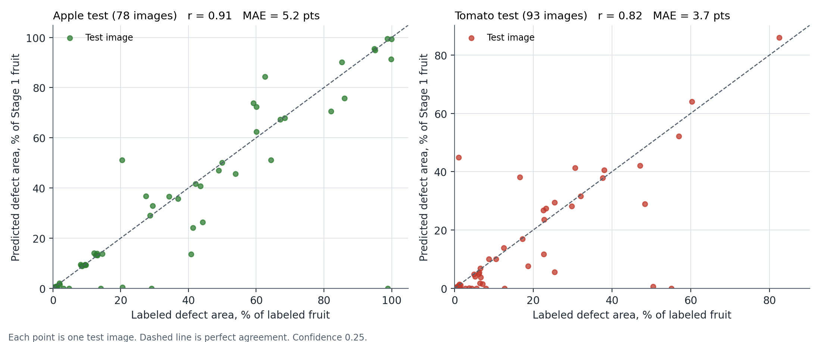
- Predicted against labeled defect coverage for every test image.

Tomato
Stage 1 segments the whole tomato with 96.6% validation mask mAP50. Stage 2 reached 49.4% validation mask mAP50 and 39.3% on the 95 test images. Test precision was 73.2% but recall only 37.5%. When the model marks a tomato defect it is usually right but it misses most of them. Table V gives per-class results. Tomato has fewer training files than apple (1,313 against 2,110) from fewer capture groups (459 against 726). An earlier joint model (Run 11) also found tomato defects the weakest part of the project.
- Tomato stage 2 per-class mask results
Class | Val mAP50 | Test P | Test R | Test mAP50
Bruise | 0.468 | 0.794 | 0.387 | 0.388
Rot | 0.533 | 0.848 | 0.382 | 0.477
Surface | 0.482 | 0.555 | 0.357 | 0.314
All | 0.494 | 0.732 | 0.375 | 0.393

Fig. 9 shows the three best and three worst tomato test images. The model handles large rot regions well. The worst cases are faint bruises that look like a slight color change on glossy skin, which the model does not mark at all.

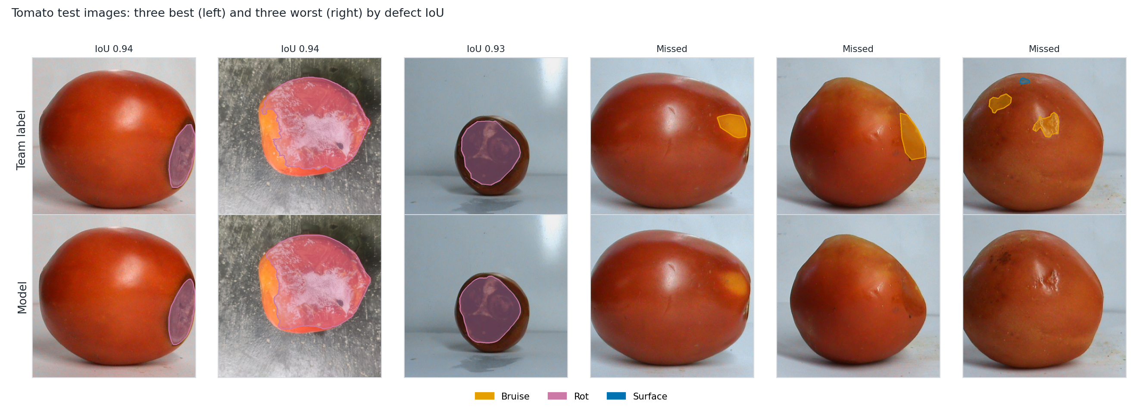
- Tomato test images. Top row is the team label and bottom row is the model. Left three have the highest defect IoU and right three the lowest.

One Model for Both Fruits
The combined Stage 1 model separates the two fruits well, with 98.5% mask mAP50 for apple and 94.9% for tomato on validation. On validation the combined Stage 2 model was level with the separate models. On the test split it was slightly lower for both fruits (Table VI): 58.6% against 61.3% for apple and 35.2% against 39.3% for tomato. Some classes moved in opposite directions. Apple rot rose from 0.732 to 0.849 while apple bruise fell from 0.594 to 0.411. Each class has only 18 to 28 test images, so gaps of three to four points are within the noise of a single split. The result does not show that combining fruits helps. It does show that one model can serve both fruits at a small cost.
- TEST MASK mAP50: SEPARATE (SEP) VS COMBINED (COMB) MODELS
Class | Apple sep | Apple comb | Tomato sep | Tomato comb
Bruise | 0.594 | 0.411 | 0.388 | 0.360
Rot | 0.732 | 0.849 | 0.477 | 0.442
Surface | 0.511 | 0.497 | 0.314 | 0.253
All | 0.613 | 0.586 | 0.393 | 0.352

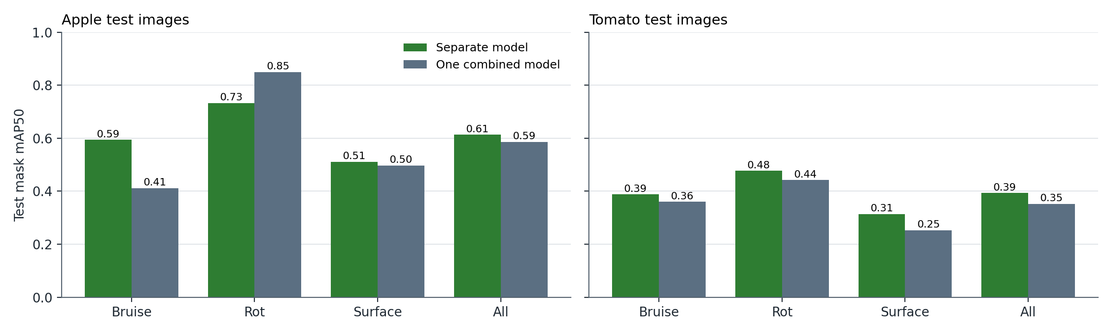
- Test mask mAP50 per class for the separate models and the combined model.

Errors and Limits
Surface damage is the hardest class because it covers small scars, cuts and dry spots with weak contrast. The confusion matrices show that most errors are missed defects predicted as background. Bruise and rot are rarely confused with each other. On validation most false positives are surface damage predicted on marks the team did not label. The images come from a few sources with mostly plain backgrounds. Performance on new lighting, cultivars or conveyor images is unknown. Classes describe appearance only and the model does not diagnose disease or internal damage. Fig. 11 shows typical apple failures.

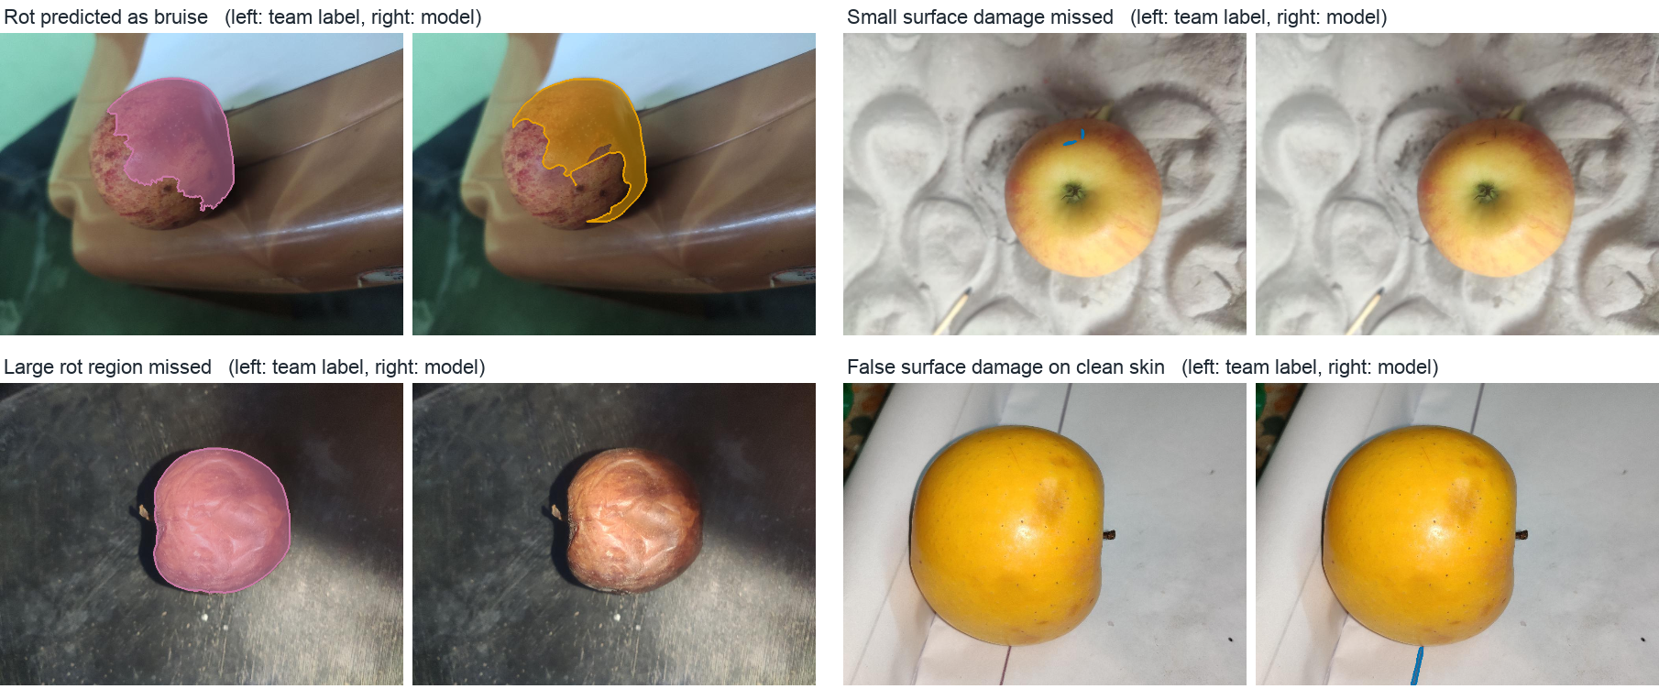
- Apple test failures. Team label (left of each pair) and model output (right).

Web Application
A Streamlit application loads the Stage 1 and Stage 2 checkpoints for the selected model: apple, tomato or the combined model. Users upload a photo or pick a sample. The app overlays colored defect masks with a legend and reports each defect class with its share of the image and of the Stage 1 fruit mask. A confidence slider, class toggles, inference time and a PNG download are included. Unreadable files and images with no defect produce clear messages. Fig. 12 shows the interface.
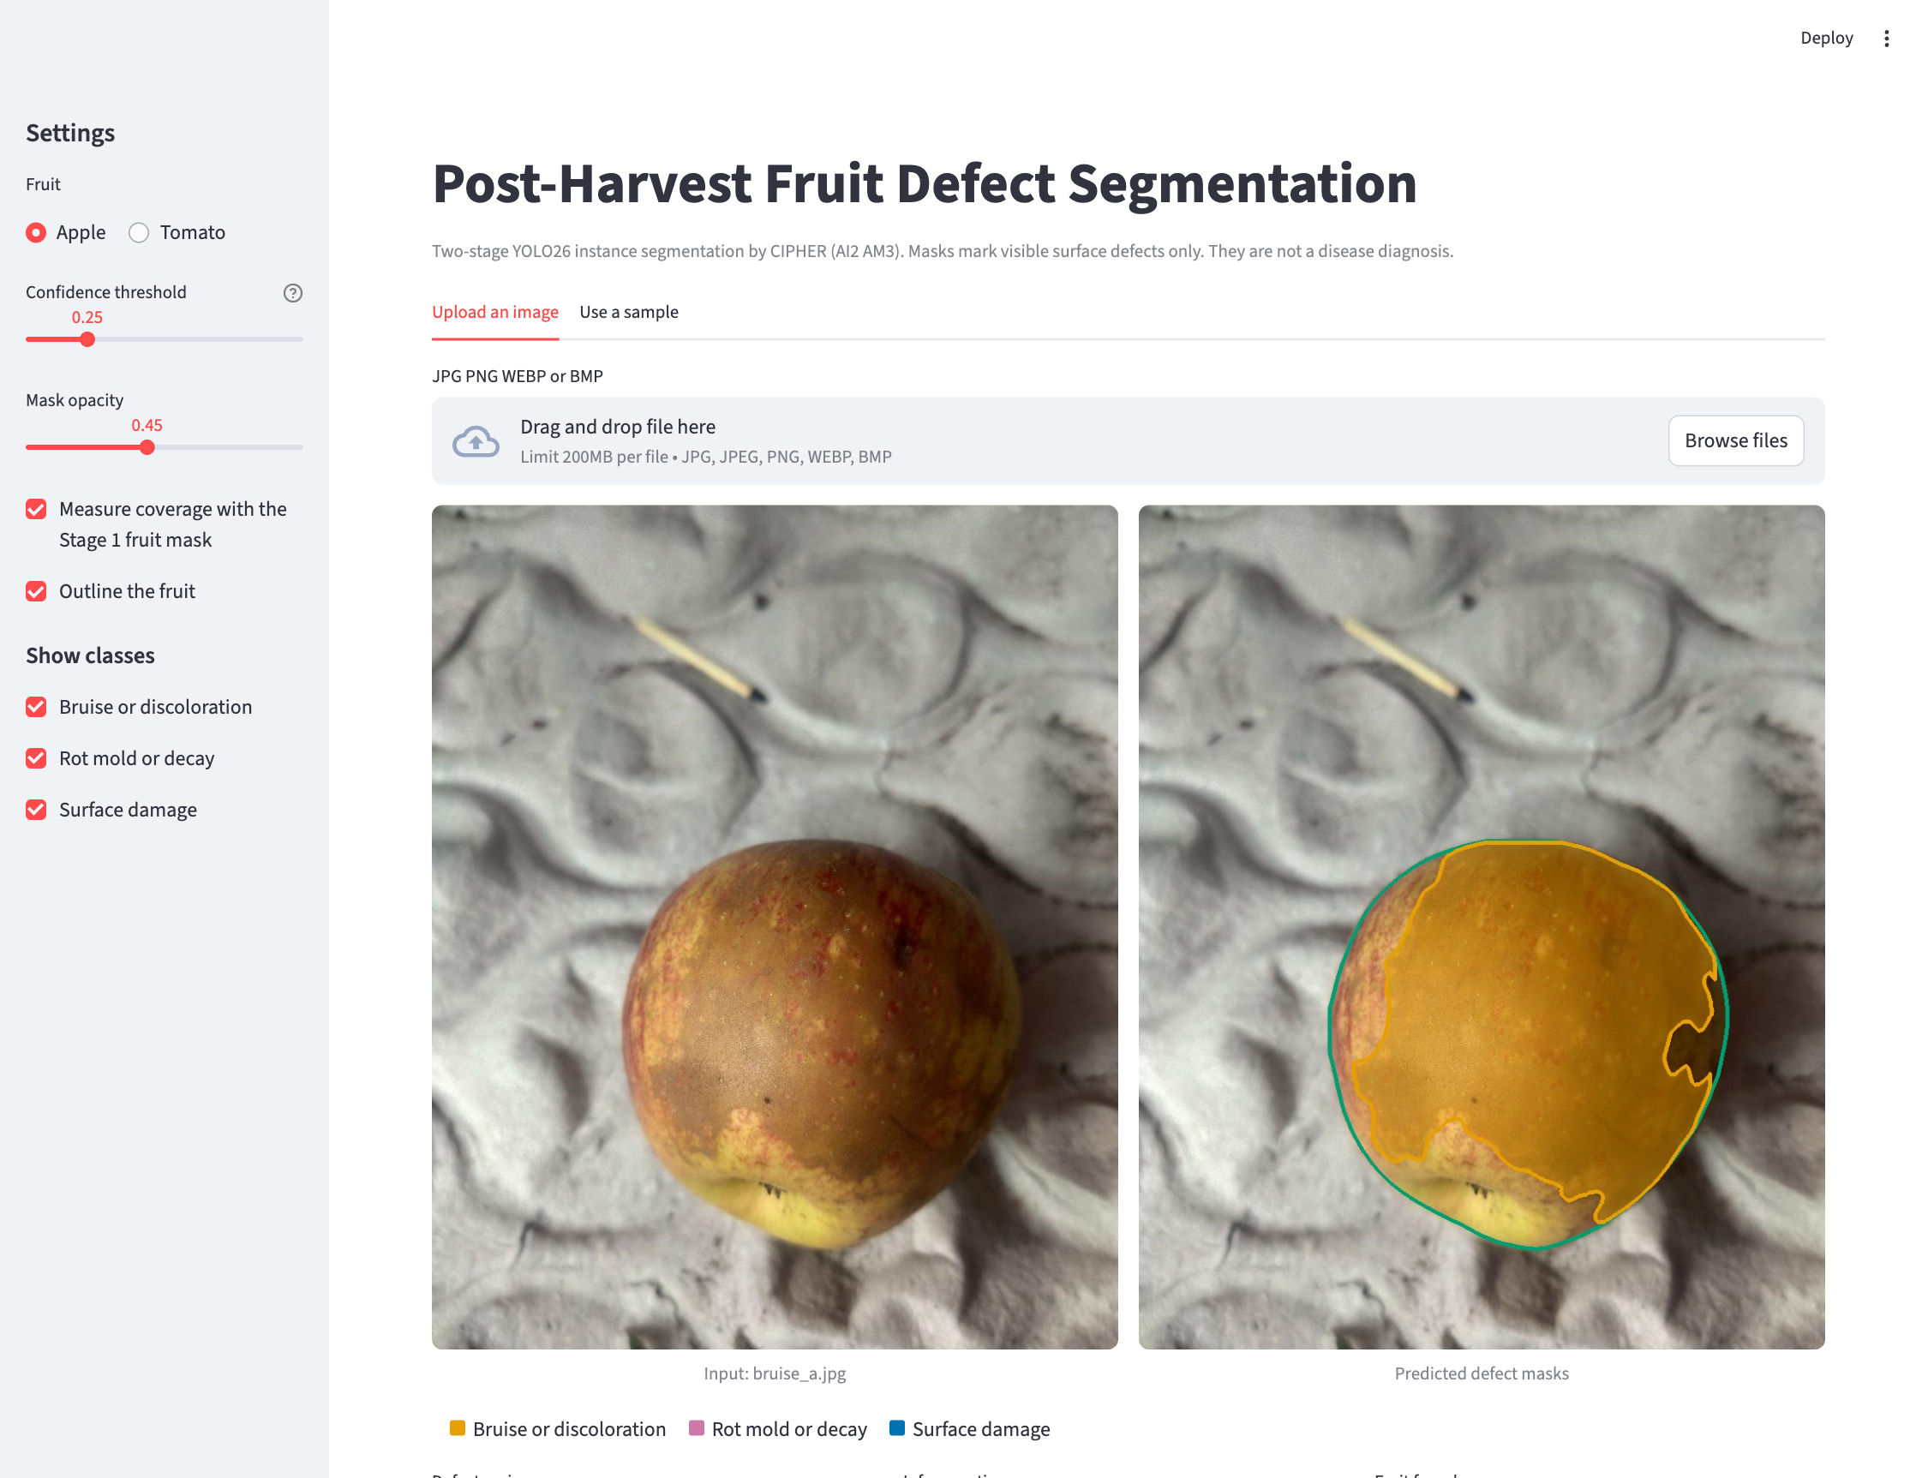
- The Streamlit application showing a rot prediction.

Conclusion and Future Work
A two-stage YOLO26l model trained on team-reviewed masks segments the whole apple almost perfectly and segments three visible defect classes with 68.8% validation mask mAP50 and 61.3% mask mAP50 on the test split. Rot was the most stable class and surface damage the hardest. The tomato model reached 39.3% test mask mAP50 and misses most tomato defects. One combined model for both fruits scored slightly below the separate models on test. Future work will add more reviewed small-defect examples, run a controlled single-stage baseline with identical settings, test on images from new sources and measure agreement between annotators.

References
- M. U. Mojumdar et al., “AFruitDB: A comprehensive dataset of six commonly used Asian fruits for advanced grading and biodiversity insights,” Data in Brief, vol. 59, Art. no. 111380, 2025, doi: 10.1016/j.dib.2025.111380.
- K. He, G. Gkioxari, P. Dollár, and R. Girshick, “Mask R-CNN,” in Proc. IEEE Int. Conf. Computer Vision (ICCV), 2017, pp. 2961–2969.
- M. Agarla, P. Napoletano, and R. Schettini, “Quasi real-time apple defect segmentation using deep learning,” Sensors, vol. 23, no. 18, Art. no. 7893, 2023, doi: 10.3390/s23187893.
- M. Knott, D. Odion, S. Sontakke, A. Karwa, and T. Defraeye, “Weakly supervised panoptic segmentation for defect-based grading of fresh produce,” in Proc. IEEE/CVF Conf. Computer Vision and Pattern Recognition Workshops (CVPRW), 2025.
- F. Leiva, S. G. Rebeaud, and D. Christen, “Real-time identification and quantification of apple scab on fruit in preharvest and postharvest conditions using YOLO11: a deep learning approach,” Plant Methods, vol. 22, Art. no. 29, 2026, doi: 10.1186/s13007-026-01508-7.
- C. Tan, C. Li, P. Perkins-Veazie, H. Oh, R. Xu, and M. Iorizzo, “High throughput assessment of blueberry fruit internal bruising using deep learning models,” Front. Plant Sci., vol. 16, Art. no. 1575038, 2025, doi: 10.3389/fpls.2025.1575038.
- S. Nesteruk et al., “XtremeAugment: Getting more from your data through combination of image collection and image augmentation,” IEEE Access, vol. 10, pp. 24010–24028, 2022, doi: 10.1109/ACCESS.2022.3154709.
- S. Nesteruk, “Apple rotting segmentation problem in the wild,” Kaggle dataset, CC BY-NC-SA 4.0. [Online]. Available: https://www.kaggle.com/datasets/sergeynesteruk/apple-rotting-segmentation-problem-in-the-wild
- Roboflow, “Roboflow Annotate.” [Online]. Available: https://roboflow.com
- Ultralytics, “YOLO26,” Ultralytics documentation, 2026. [Online]. Available: https://docs.ultralytics.com/models/yolo26/

