Day Ahead Forecasting of Modeled Solar and Wind Generation and Battery Planning in Three Philippine Locations

Ralph Kevin G. Morales
Mapúa University
Philippines
Niccolo Ticzon
Mapúa University
Philippines
Jermaine Van Danganan
Mapúa University
Philippines
David Solano
Mapúa University
Philippines
David Ferrer
Mapúa University
Philippines
Richard N. Monreal
Mapúa University
Philippines

Abstract: This study compares identical 1 MWdc photovoltaic and 1 MW wind systems in Laoag, Mactan and General Santos using NASA POWER weather estimates and physical generation equations. A retrospective expanding evaluation tests 2024, 2025 and January-June 2026 using only preceding years for fitting and candidate selection. A recent-window experiment fits 2021-2024, selects settings on 2025 and refits through 2025 before testing 2026. The 2026 test ends in June because required irradiance for later months is unavailable. Separate XGBoost regressors predict 24 hourly outputs from previous-day generation and calendar features; previous-day and fitting-period climatology provide baselines. XGBoost has the lowest combined-output error at all three sites in each chronological test. Recent-window 2026 combined mean absolute errors are 0.0944, 0.0844, 0.0521 MW, respectively. Matched-calendar comparisons, paired daily block intervals and a common 2 MWh battery replay assess stability. Generation is modeled and demand is synthetic; the results do not establish measured plant accuracy, savings or full-year 2027 forecasting skill.
Keywords: Solar photovoltaic, wind power, day ahead forecasting, XGBoost, battery storage, Philippines.

Introduction
Solar and wind generation vary by hour. Annual energy alone cannot reveal whether output coincides with demand or whether a battery can cover a shortage. Philippine hybrid system studies have examined resource complementarity and microgrid planning [1]–[3], but an hourly comparison is needed to connect resource estimates, demand, storage, and forecast based plans under one common set of assumptions.
This work asks: (1) how identical solar and wind equipment would perform in three Philippine locations; (2) how much of the same synthetic demand it would cover with different battery capacities; (3) whether a learned day ahead forecast improves on simple baselines; and (4) whether better forecasts reduce a defined grid planning error. Laoag, Mactan, and General Santos are case locations for Luzon, the Visayas, and Mindanao. One point cannot represent an entire island group.
The contribution is a reproducible comparison of standardized site scenarios, an expanding chronological evaluation across two complete years and one partial year, and a paired planning replay with common physical and demand rules. A predefined recent-window sensitivity case tests the effect of retaining 2020 in the 2026 training archive. All generation comes from weather estimates and physical equations. The work evaluates modeled hourly energy adequacy rather than electrical stability, construction suitability or financial viability.

Review of Related Literature

Philippine Solar, Wind, and Hybrid Systems
Pilario et al. assessed solar and wind complementarity in Kalinga and Apayao [1]. Their analysis motivates checking temporal overlap rather than assuming that wind always fills low solar periods. Supapo et al. used resource estimates and hourly utility load records to study renewable transition scenarios for off grid Philippine islands [2]. Lacea et al. considered solar, battery, and diesel supply for households in Cebu [3]. These studies show why energy and load must be evaluated together, but none provides measured output for the three equipment and location cases used here.
Abantao et al. distinguish grid connected and islanded microgrid planning [4]. Rivadulla et al. studied electrical behavior in a Philippine photovoltaic and fuel cell microgrid [5]. Their network and control questions are different from this paper’s hourly energy balance. Salvador and Manalo also investigated planned renewable use during power outage using a Philippine simulation [6]. Their electrical simulation motivates outage analysis, but its voltage and current results cannot be inferred from the present hourly energy model.

Resource Modeling and Forecasting
NASA POWER supplies gridded solar and meteorological estimates, with source and uncertainty details in its documentation [7]. A gridded value is not a site measurement. The PVWatts manual provides established photovoltaic conversion and loss concepts [8]. The EWT DW61 brochure and archived theoretical power curve provide the turbine rating and curve used here [9], [10].
Kavaz and Karazor used the preceding 24 hours to predict the next 24 hours at a colocated wind and photovoltaic plant [11]. Their horizon structure informed this study. They reported strong RMSE and MSE performance for boosting methods including XGBoost, while other models led on MAE. This supports XGBoost as a candidate. Their measured plant target cannot supply Philippine error estimates. Zhang et al. jointly forecast renewable power and load [12]; we lack measured local load to evaluate such a joint forecast. Freeman and Agar analyzed wind-solar supply and storage in New England [13]. Zarate-Perez et al. simulated residential PV/wind/battery supply with hourly demand and weather [14]. These energy-balance studies motivate our demand and storage replay.
Chen and Guestrin describe the regularized tree boosting method underlying XGBoost [15]. Its ability to fit nonlinear relationships in lagged and calendar variables, modest tuning budget, and direct tabular inputs make it practical here. Hu et al. compared data cleaning and input duration in a more complex CNN-BiLSTM-Attention forecast [16]. Zhang et al. studied regional joint wind and solar forecasting with an attention network [17]. Earlier systems combined numerical weather prediction with statistical models for next-day and four-hour farm forecasts in China [18], trained feed-forward networks for one-hour-ahead load, wind and solar forecasts in France [19], specialized neural networks with a genetic algorithm for 168-hour forecasts in Uruguay [20], and used LSTM irradiance predictions to size street-lamp photovoltaic systems in Jakarta [21]. The regional attention model can use spatial relationships that the three independent point cases in this study do not provide. This study checks continuity and uses preceding-year model selection in chronological test folds, but does not benchmark deep networks. XGBoost is assessed against the same simple baselines in every fold rather than selected using transferred performance claims.

Synthesis
Philippine planning studies emphasize sizing and electrical behavior. A University of the Philippines tool simulates 8,760 hourly balances, interruptions and expected energy not supplied [22], and a genetic algorithm sizes isolated microgrids under cost or reliability targets [23]. HOMER studies optimized hybrid designs for Basco [24] and Sibuyan Island [25]. Simulink studies examined battery support during faults [26] and photovoltaic output across Philippine climates [27]. Table I contrasts these studies with the present design. Evaluation designs differ: Vallejo et al. used an earlier fitting interval and a later test interval [20]. The Philippine planning studies address scenarios rather than forecast-error comparisons. This study evaluates whole held-out years in order and links each forecast to the same storage plan, at the cost of using modeled rather than measured output.
- Positioning against related studies
Study | Data | Horizon | Evaluation
[16] | Measured, China | Ultra-short | 7:3 split
[11] | Measured, Denmark | 24 h | 70/20/10 split
[17] | NWP + measured, China | Short-term | 54 test days
[18] | NWP, China | 4 h, next day | Monthly accuracy
[19] | Measured, France | 1 h | Test-period MAPE
[20] | Met. forecasts, Uruguay | 168 h | Chronological 70/30
[21] | Daily weather, Jakarta | Daily | 85:15 split
[22]–[27] | Philippine scenarios | Hourly / dynamics | No forecast test
This work | NASA POWER, modeled | 24 h at 00:00 | Year folds + replay
The reviewed work motivates temporal resource analysis and demand/storage balancing. This study uses identical equipment, chronological forecast tests, and common demand and battery rules to connect these questions in one workflow. It does not transfer foreign plant accuracy or infer operating reliability from annual energy. The question is whether lag-based XGBoost improves modeled generation error and grid planning disagreement over simple baselines.

Dataset and Preparation

Weather Sources and Case Locations
Hourly weather estimates were downloaded as CSV from the NASA POWER Hourly Point API for Laoag (18.182931° N, 120.534394° E), Mactan (10.322444° N, 123.980131° E), and General Santos (6.057181° N, 125.103108° E) [28]. The coordinates and site elevations came from PAGASA climatological extremes tables, with station metadata as of 2014 [29]–[31]; the returned weather values represent NASA grid cells, not station observations or surveyed plant sites. Requests specified the renewable energy community, each coordinate and elevation, UTC, and the historical date range. They included all sky global irradiance, 2 m air temperature, 50 m wind speed, and pressure; direct normal and diffuse horizontal irradiance were requested separately and joined one to one by UTC hour.
An extra UTC boundary day supplies the first local day. UTC timestamps are converted to Philippine Standard Time (UTC+8). The original 2020-2024 physical comparison contains 43,848 consecutive hours per site; 2025 supplies another 8,760. On 3 October 2026, requests through 30 September returned complete irradiance only through 30 June UTC. Eight local hours of 1 July are available, but incomplete forecast days are excluded. The common 2026 test therefore ends 30 June 23:00 PHT and contains 4,344 hours per site. No missing irradiance is interpolated or replaced. Raw responses, timestamps, parameter coverage and SHA-256 hashes are retained.

Data Quality and Scenario Labels
The physical dataset contains 131,544 site-hours for 2020-2024. Required fields include global, direct normal and diffuse horizontal irradiance, air temperature, 10 m and 50 m wind speed, and elevation-corrected surface pressure. Hourly irradiance in Wh/m² is numerically converted to average W/m² over the one-hour interval. The target solar and wind outputs are generated by the physical equations, not acquired plant measurements. Raw downloads, acquisition metadata and SHA-256 hashes are retained with the processed files.
Checks found no duplicate site and timestamp keys, missing required modeled values, or solar and wind bound violations. The demand and storage extension contains 526,176 hourly case rows with no missing values, state-of-charge violations, or simultaneous charging and discharging. Load and generation balance errors were zero at stored precision. These checks establish internal consistency, not agreement with observed generation. Demand and outage labels are explicitly synthetic.

Chronological Splits and Leakage Control
Each forecast is issued at 00:00 Philippine time for that date’s 24 target hours. Input histories contain only the previous day’s modeled output. Calendar variables are known in advance; future observed weather, output, demand and battery state are excluded. Year-based assignment avoids random mixing, following time-series evaluation principles [32]. Table II separates candidate fitting, preceding-year selection and final refitting from testing. Full-year 2024 and 2025 contain 8,784 and 8,760 hours per site; 2026 is a January-June test.
- Chronological evaluation periods
Test | Candidate fit | Select | Final refit
2024 | 2020-2022 | 2023 | 2020-2023
2025 | 2020-2023 | 2024 | 2020-2024
2026 Jan-Jun | 2020-2024 | 2025 | 2020-2025
Recent 2026 | 2021-2024 | 2025 | 2021-2025

The 2026 tests contain 4,344 target hours per site and source. In the recent-window experiment, candidate fitting uses 35,064 hours, selection 8,760 hours and final refitting 43,824 hours. Historical December 2020 values supply January 2021 lag inputs but are not fitting targets. The expanding 2026 refit uses 52,584 targets. The first archive day is omitted because its previous-day history is unavailable. Every lag precedes issue time, including lags across year boundaries.
This is a retrospective protocol amendment after earlier 2024 and 2025 results were inspected. Each fold preserves chronological data separation, but the expanded design is not a prospective preregistered study. The 2026 period does not select candidate settings. The recent and expanding 2026 windows are compared as predefined sensitivity cases; neither is selected on 2026 scores for a claimed future accuracy.

Methodology
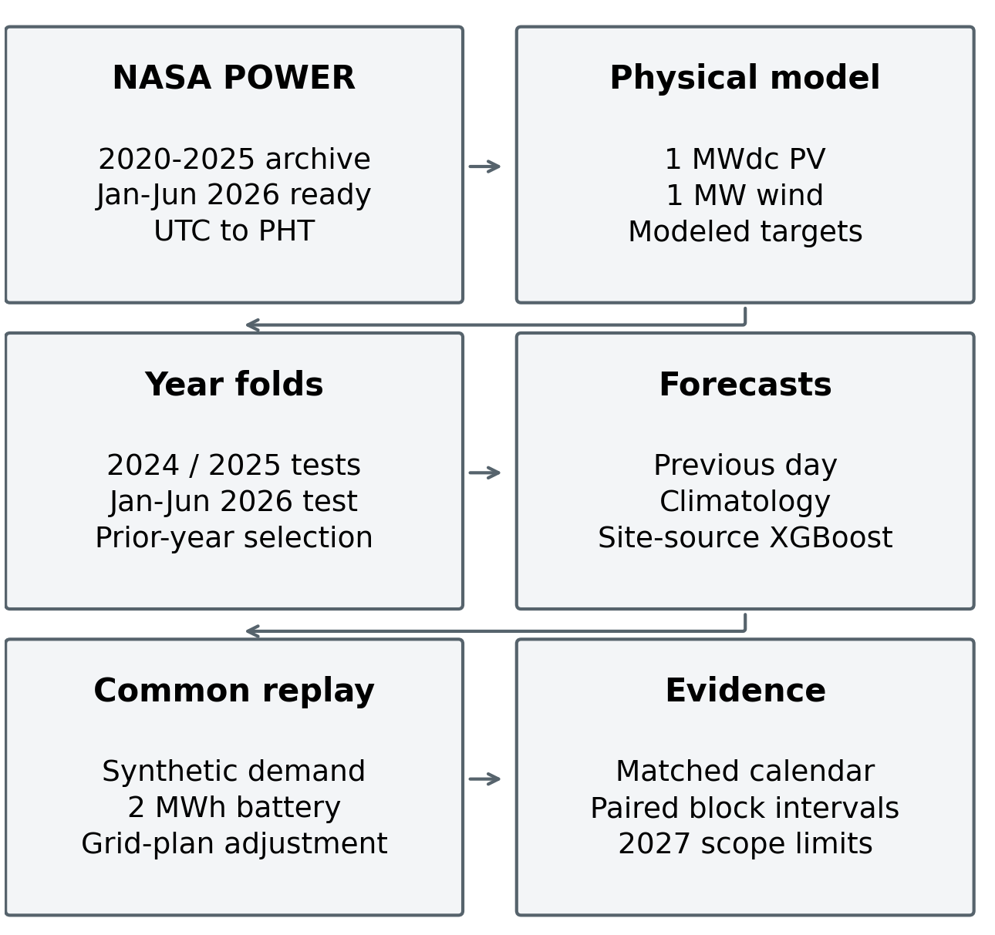
- Study pipeline from archived weather through chronological forecasts and paired planning evidence.

Physical Generation Model
The same equipment was modeled everywhere: 1 MWdc fixed tilt photovoltaic panels at 10° facing south and one 1 MW EWT DW61 wind turbine at a 69 m hub height. The photovoltaic calculation uses irradiance on the tilted plane, temperature adjustment, system losses, and inverter limits. The wind calculation extrapolates the 50 m wind estimate to hub height with a baseline power law exponent of 0.14, applies air density adjustment, interpolates the archived electrical power curve, and enforces a 1 MW limit. Because the curve is already electrical, no separate rotor power coefficient or drivetrain efficiency is multiplied into it [8]–[10].
Solar position follows NOAA equations at each hourly midpoint [33]. Plane-of-array irradiance sums direct incidence, isotropic diffuse sky and ground reflection [34]. Ground albedo is assumed to be 0.20. The Faiman model uses U₀ = 25 and U₁ = 6.84 [35]. Its wind input assumes a 2 m module height and extrapolates the 10 m estimate with exponent 0.14. These height and extrapolation choices are study assumptions. Temperature and AC output follow:
$Tcell = Tair + GPOA / (25 + 6.84 V₂)$ (1)
Let g = GPOA/1000 and fT = max[0, 1 - 0.0047(Tcell - 25)]. For the 1 MWdc array:
$PPV = clip(0.8256 g fT, 0, 1)$ (2)
Here PPV is in MW, GPOA is average irradiance in W/m², temperatures are in °C, and V₂ is in m/s. The 0.86 factor represents 14% system losses and 0.96 the fixed inverter efficiency. PV capacity is 1 MWdc; the AC upper limit is 1 MW. These are shared scenario assumptions, not locally calibrated equipment characteristics. The temperature coefficient and nominal losses draw on PVWatts v5 [8], but the Faiman model and fixed inverter factor make this a study variant, not the complete PVWatts algorithm.
For wind, V₆₉ = V₅₀(69/50)^0.14. Air density is ρ = p/[287.05(Tair + 273.15)], using pressure in Pa. The curve input is V₆₉(ρ/1.225)^(1/3), following the density-corrected speed approach documented in PLUSWIND [36]. Linear interpolation on the archived DW61 electrical power curve is followed by a 0.90 net-output factor and a 0-1 MW bound. Values beyond the curve’s highest speed give zero output. Because the curve already represents electrical power, no additional rotor power coefficient or drivetrain efficiency is applied [9], [10].

Synthetic Demand and Battery Dispatch
The same daily demand profile is repeated at each site: 0.25 MW at 00:00-05:00, 0.40 MW at 06:00-08:00, 0.50 MW at 09:00-16:00, 0.65 MW at 17:00-21:00, and 0.35 MW at 22:00-23:00. It is a transparent comparison load, not NGCP demand or measured household consumption. Outages are fixed hypothetical scenarios.
In each one hour interval, solar plus wind generation first serves demand. Excess charges the battery; any remaining excess is curtailed. When generation is insufficient, the battery discharges before grid import. During a simulated outage, residual need is unmet demand. Battery capacities of 0, 1, 2, and 4 MWh were tested with a 1 MW power limit, 95% charge and discharge efficiency, 10%–90% allowed state of charge, and renewable only charging. The demand scale was varied to 0.5, 1.0, and 1.5 times the common profile. Battery energy was carried from hour to hour rather than reset.
$E(t+1) = E(t) + 0.95 C(t) - D(t)/0.95$ (3)
E is battery energy in MWh; C is renewable charging input and D is discharge delivered to the load over the one-hour interval, also in MWh. Charging and discharging are each limited to 1 MWh per hour and remaining state-of-charge headroom. Historical scenarios start at 10% of battery capacity and preserve the resulting state between hours; outage initialization is stated separately below.
Demand coverage is renewable origin energy served divided by demand energy. Combined capacity factor is combined energy divided by 2 MW times the hours in the period. Low output means combined power below 10% of the 2 MW rating. The five year study has 36 demand and battery cases and 96 fixed hypothetical outage cases. In an outage the model reports energy served, unmet energy, hours with shortage, and time to first shortage. The full synthetic demand is counted because a separate critical load was not specified. No claim about real critical load protection follows.
One factor at a time sensitivity cases use solar losses of 10%, 14%, and 20%; wind shear exponents of 0.10, 0.14, and 0.20; wind net output factors of 85%, 90%, and 95%; and two solar temperature coefficients. These values are discrete stress tests, not probability distributions. No P10/P50/P90 or Monte Carlo reliability estimate is reported.

Day-Ahead Forecast Model and Selection
Each site and source has one XGBoost scalar-output regressor, giving six final models [15]. The regressor predicts one target hour per row; 24 rows form a day-ahead forecast. It is not a 24-output neural network. The 29 features are 24 preceding-hour outputs, horizon 1-24, sine and cosine of day-of-year, and sine and cosine of target hour. Models use squared-error loss, histogram tree construction and random seed 142. Table III lists the two predefined candidates.
- XGBoost candidate settings
Setting | Compact | Shallow
Trees | 350 | 500
Maximum depth | 5 | 3
Learning rate | 0.05 | 0.04
Row subsample | 0.85 | 0.90
Column subsample | 0.85 | 0.90
Minimum child weight | 3 | 2
L2 regularization | 1.0 | 2.0

For each fold, the two existing candidates fit the candidate period in Table II and predict the immediately preceding selection year. The lower all-hour MAE setting is frozen for that site and source, then weights are refitted through the year before testing. Solar and wind forecasts are bounded at 0-1 MW. No test-year target or future observed weather enters fitting or settings selection. Six saved models are retained for each fold. Versions are Python 3.9.6, XGBoost 2.1.4, scikit-learn 1.6.1 and joblib 1.5.3.

Baselines and Evaluation Metrics
Previous-day persistence repeats the preceding day’s same-hour output. Climatology is the fitting-period mean for each month and hour: candidate-fit years for validation and refit years for testing, excluding test targets. Combined output sums the two source forecasts. MAE = mean(|prediction - reference|) and RMSE = sqrt(mean((prediction - reference)²)) are reported in MW. Daylight solar uses reference irradiance above 20 Wh/m². MAPE is omitted because outputs can be zero. Full-year and January-September historical scores are retained separately. The matched-calendar comparison uses January-June in every year and removes 29 February 2024, giving 4,344 hours per site in each fold; it does not annualize partial results.
For hourly average power P in MW, energy is ΣPΔt in MWh with Δt = 1 h. Renewable demand coverage counts only renewable-origin energy served, including battery discharge after losses. A common physical model, demand profile and storage rule are used for every forecast method. The comparison changes the forecasts rather than the reference dispatch or equipment.

Battery Estimates and Grid Planning Replay
The reference and each forecast use the same synthetic demand and 2 MWh battery. In the rolling replay, each model receives the same known reference state of charge at midnight; the initial reference state is 1 MWh, and reference charge is carried continuously thereafter. A forecast fixes the next 24 hourly grid imports before target outcomes are revealed. This isolates forecast-induced planning differences. Separate original 2025 battery-estimation and fixed-outage outputs remain supporting scenario diagnostics, not new 2026 outage evidence.
For hour t, extra balancing energy is max(Gref,t - Gplan,t, 0) and unused planned energy is max(Gplan,t - Gref,t, 0). Their sum across the evaluated hours is total grid-plan adjustment in MWh. Reported mean hourly adjustment divides that total by the actual number of hours, allowing full-year and partial-year replays to be distinguished. The reference dispatch is common to every model: this metric is planning disagreement, not cost, reliability or an optimized controller’s performance.
Uncertainty is summarized using a paired circular moving-block bootstrap on daily combined-output MAE differences (XGBoost minus each baseline): 2,000 resamples, seven consecutive days per block, seed 142 and percentile 95% intervals. Pairing preserves the same target days and weekly blocks retain some serial dependence. The intervals condition on the fitted models and chosen block length; they do not include physical-model uncertainty, refitting variability or multiple-comparison adjustment.

Results and Discussion

Physical Generation and Demand Coverage
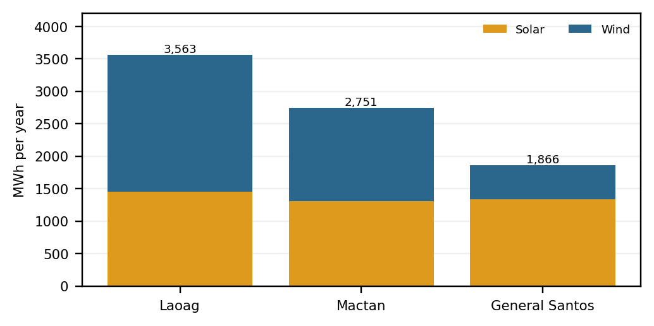
- Mean annual modeled energy, 2020-2024, from identical equipment. Annual output does not guarantee hourly supply.
Fig. 2 compares mean annual modeled energy. Laoag had the highest mean combined output at 3,563 MWh per year, followed by Mactan at 2,751 MWh and General Santos at 1,866 MWh. Wind explains most of Laoag’s advantage. Its hourly solar and wind correlation was −0.139, compared with −0.043 for Mactan and +0.097 for General Santos. This suggests more compensation at Laoag in this modeled series, but correlation alone does not establish supply adequacy. June had the lowest mean combined output at all sites.
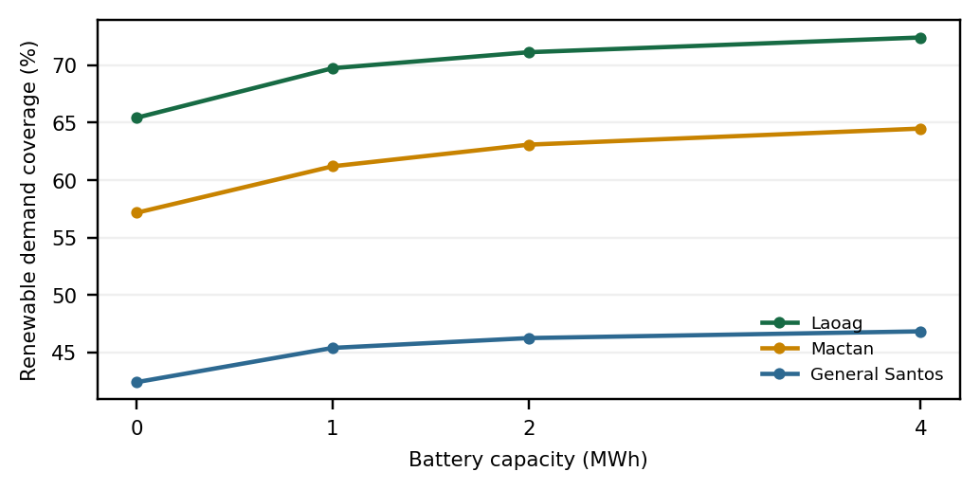
- Renewable coverage of the common synthetic demand by battery capacity. Stored energy is carried between hours.
Fig. 3 shows storage-dependent coverage. At the base demand scale, storage improved renewable demand coverage at every site. Laoag increased from 65.4% without storage to 72.4% with 4 MWh. Mactan increased from 57.2% to 64.5%, and General Santos from 42.4% to 46.8%. The battery shifts energy between hours; it cannot create energy or remove all deficits. These percentages refer to the repeated synthetic load, not measured local households.
Fig. 4 contrasts the morning and evening outages. Fixed outages illustrate why nominal battery size does not establish backup duration. In the Laoag 12 hour evening case beginning 15 March 2022, modeled unmet demand was 2.069 MWh with 0, 1, 2, and 4 MWh batteries. Each installed battery was at its minimum allowed charge at the start, so increasing its capacity alone supplied no extra stored energy in that event. By contrast, in the 12 hour morning case on the same date, a battery reduced unmet energy from 1.828 to 1.281 MWh. These are scenario examples, not observed outages or probabilities.
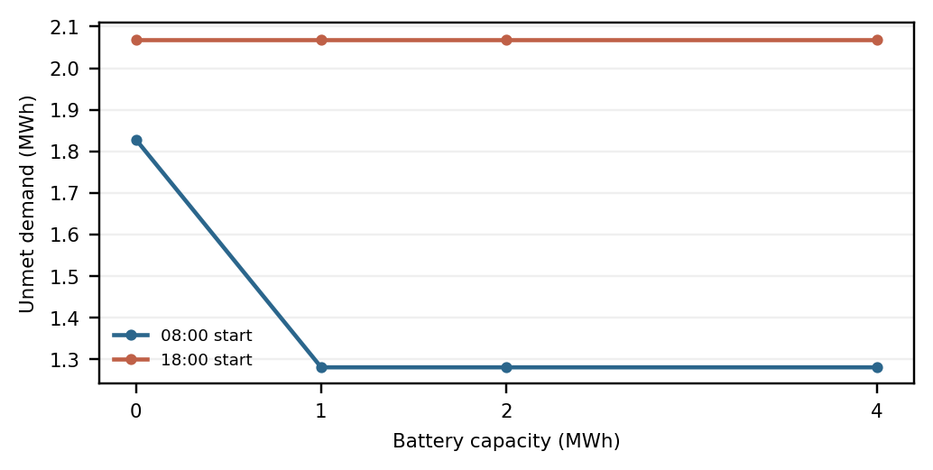
- Laoag 12-hour hypothetical outages on 15 March 2022. The flat evening result reflects minimum initial charge.

Expanding Chronological Year Tests
- Combined output MAE by chronological test (MW)
Test / site | Previous day | Climatology | XGBoost
2024: Laoag | 0.1428 | 0.1681 | 0.1088
2024: Mactan | 0.1002 | 0.1257 | 0.0826
2024: General Santos | 0.0833 | 0.0826 | 0.0637
2025: Laoag | 0.1668 | 0.1952 | 0.1220
2025: Mactan | 0.1151 | 0.1182 | 0.0855
2025: General Santos | 0.0783 | 0.0725 | 0.0600
2026: Laoag | 0.1346 | 0.1608 | 0.0953
2026: Mactan | 0.1140 | 0.1232 | 0.0837
2026: General Santos | 0.0647 | 0.0668 | 0.0533

Table IV reports full-year 2024 and 2025 and January-June 2026. XGBoost has lower combined-output MAE than both baselines at all three sites in each test. Its MAE is 0.1088, 0.0826 and 0.0637 MW in 2024; 0.1220, 0.0855 and 0.0600 MW in 2025; and 0.0953, 0.0837 and 0.0533 MW in the expanding 2026 fold, in Laoag, Mactan and General Santos order. This repeated ranking supports stability within the modeled cases, while the absolute errors still depend on the evaluated weather period.
The 2024 fold selects settings on 2023 and refits on 2020-2023. It is a different evaluation from the earlier 2024 selection score; those selection results are not reused as test evidence. The 2025 fold reproduces the original candidate selection on 2024 and refit on 2020-2024. Test-year targets remain outside each fold’s fitting and selection. Full-year versus partial-year values should not be interpreted as like-for-like weather comparisons.

Matched January-June Comparison
- Matched January-June combined MAE (MW)
Test / site | Previous day | Climatology | XGBoost
2024: Laoag | 0.1289 | 0.1561 | 0.1032
2024: Mactan | 0.1023 | 0.1154 | 0.0863
2024: General Santos | 0.0965 | 0.0956 | 0.0695
2025: Laoag | 0.1515 | 0.1757 | 0.1070
2025: Mactan | 0.1052 | 0.1116 | 0.0812
2025: General Santos | 0.0812 | 0.0760 | 0.0624
2026: Laoag | 0.1346 | 0.1608 | 0.0953
2026: Mactan | 0.1140 | 0.1232 | 0.0837
2026: General Santos | 0.0647 | 0.0668 | 0.0533

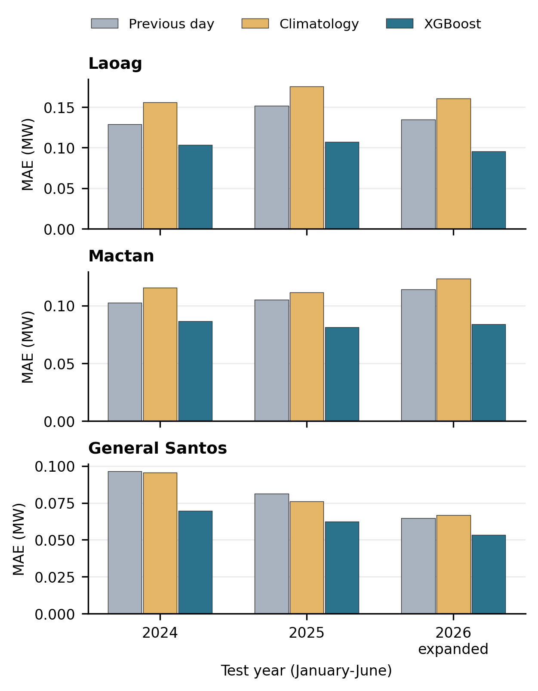
- Combined output MAE for the same January-June calendar window; leap day is excluded in 2024. Each method uses 4,344 target hours per site and year.
In the matched calendar window, XGBoost again leads both baselines in all nine site-year cases. Laoag combined MAE is 0.1032, 0.1070 and 0.0953 MW for 2024, 2025 and 2026; Mactan is 0.0863, 0.0812 and 0.0837 MW; General Santos is 0.0695, 0.0624 and 0.0533 MW. Thus the XGBoost advantage over the baselines repeats across calendar years, while lower 2026 error cannot be attributed solely to adding training data. Year-specific weather and refitted weights both differ. Fig. 6 compares the 2026 forecasts with output computed from 2026 weather.
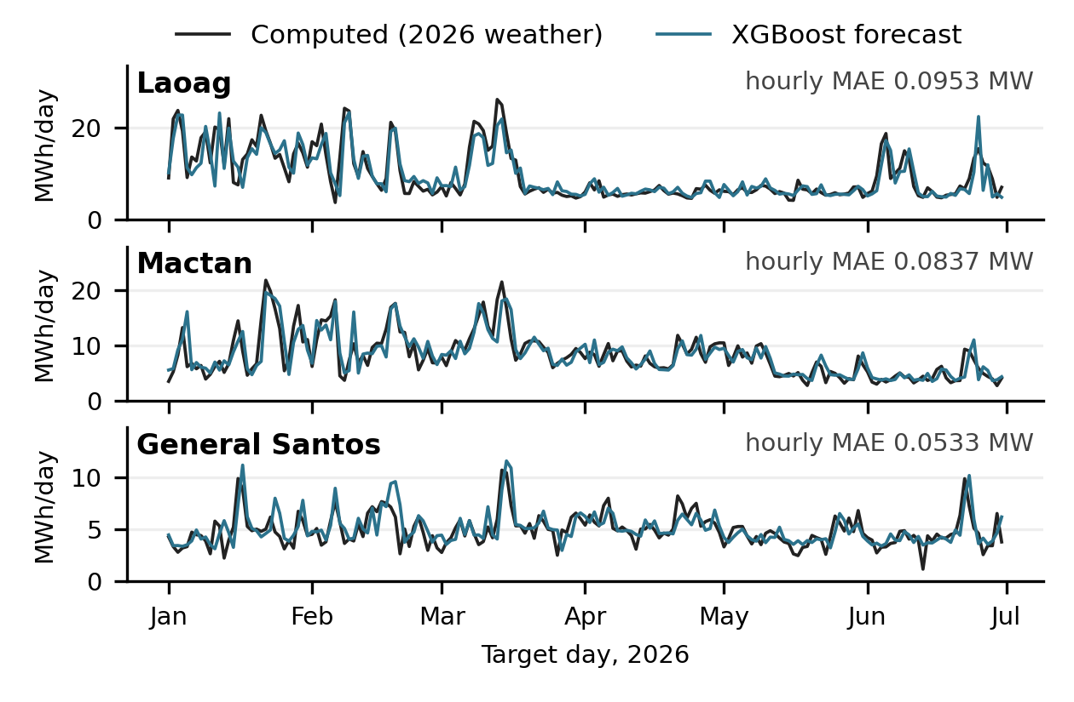
- January-June 2026 daily energy computed from 2026 weather versus XGBoost forecasts issued at 00:00 by models trained only on 2020-2025 data (last target 31 December 2025, 23:00).

Recent Training Window and 2026 Test
- 2026 combined MAE and training-window sensitivity (MW)
Site | Previous day | Recent climat. | Recent XGB | All-year XGB
Laoag | 0.1346 | 0.1607 | 0.0944 | 0.0953
Mactan | 0.1140 | 0.1225 | 0.0844 | 0.0837
General Santos | 0.0647 | 0.0644 | 0.0521 | 0.0533

In Table VI, recent climatology and XGBoost use 2021-2025 refit targets; expanded XGBoost uses 2020-2025. Both choose XGBoost settings on 2025 after candidate fitting through 2024, and predict exactly the same January-June 2026 targets. Dropping 2020 lowers combined MAE slightly at Laoag (0.0953 to 0.0944 MW) and General Santos (0.0533 to 0.0521 MW), but raises it at Mactan (0.0837 to 0.0844 MW). This sensitivity comparison cannot establish that a shorter training history is generally preferable.
Recent-window combined RMSE is 0.1404, 0.1221 and 0.0808 MW, respectively. Solar daylight-only MAE is 0.0416, 0.0678 and 0.0657 MW; these exceed all-hour solar MAE because night zeros reduce the average. Horizon remains tied to clock hour in this midnight-only issue design, so horizon error is not a pure lead-time effect.
- Recent-window 2026 paired MAE difference, 95% interval (MW)
Site / baseline | XGB minus base | Lower | Upper
Laoag / day | -0.0401 | -0.0586 | -0.0245
Laoag / climate | -0.0662 | -0.0887 | -0.0451
Mactan / day | -0.0296 | -0.0407 | -0.0195
Mactan / climate | -0.0381 | -0.0530 | -0.0246
General Santos / day | -0.0125 | -0.0174 | -0.0078
General Santos / climate | -0.0123 | -0.0171 | -0.0077

All six recent-window intervals are below zero: within the January-June 2026 modeled series, the resampled combined-output error differences favor XGBoost against both baselines at each site. Negative values favor XGBoost. These are descriptive paired intervals conditional on this archive and the selected seven-day block; they are not adjusted for the six comparisons or physical-model error.

Forecast Effects on Grid Plans
- Recent-window Jan-Jun 2026 grid-plan adjustment (MWh)
Site | Previous day | Climatology | XGBoost
Laoag | 217.23 | 323.01 | 180.59
Mactan | 293.60 | 326.80 | 222.52
General Santos | 240.29 | 246.80 | 193.72

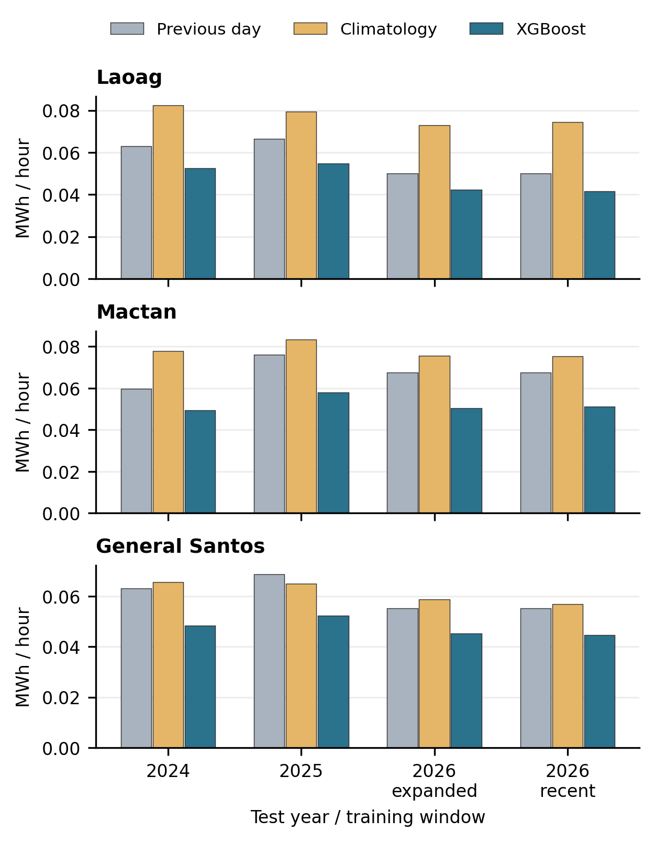
- Grid-plan adjustment per evaluated hour under the common 2 MWh battery replay. Normalization distinguishes full-year tests from partial 2026; units are MWh per hour.
XGBoost has the lowest total grid-plan adjustment in every site for all four evaluated folds. In the recent January-June 2026 replay, totals are 180.59 MWh for Laoag, 222.52 MWh for Mactan and 193.72 MWh for General Santos. They are lower than previous-day totals of 217.23, 293.60 and 240.30 MWh, respectively. The January-June totals contain 4,344 hours and are not annual costs, savings or predictions for July-December. The same reference battery state is used for all methods, so physical load service is not attributed to the forecast choice.

Sensitivity and Interpretation
- Combined energy change in one-factor tests
Site | Minimum | Maximum
Laoag | -3.3% | +3.3%
Mactan | -3.3% | +2.9%
General Santos | -5.0% | +3.3%

Across the stated one factor tests, combined modeled energy changed from −3.3% to +3.3% in Laoag, −3.3% to +2.9% in Mactan, and −5.0% to +3.3% in General Santos. The rank of these three baseline locations did not change in these tests. That observation is limited to the chosen parameter values; it is not a confidence interval and cannot cover unknown local wind shear or equipment performance.
The standardized equipment comparison indicates that modeled wind availability drives much of the site ranking. Because all three sites share the equipment and synthetic demand assumptions, location weather is the main difference. Even the highest annual output did not remove hourly shortages. Battery capacity improved coverage but remained constrained by available surplus, charge limits, efficiency, and long low output periods.

Errors and Limitations
The forecast target is generated by the study’s physical model from archived NASA POWER weather. The reported scores measure the predictability of that modeled series, not live plant forecasting accuracy. NASA POWER may have publication delay and later revisions, which make the experiment retrospective. The turbine curve is theoretical, hub height wind is extrapolated, and demand and outages are invented test scenarios. Independent local weather, plant output, load, and outage records are required before operational claims. Electrical power flow, frequency, voltage, protection, equipment failure, typhoon damage, and cost are outside the model.
Two full-year tests and one matched partial-year test strengthen the chronological comparison, but three calendar cases do not establish robustness across climates, equipment or plants. The retrospective protocol extension also cannot remove earlier knowledge of historical outcomes. Only two candidate XGBoost settings are assessed; neural networks, numerical weather prediction and calibrated probabilistic forecasts remain untested. Bootstrap intervals summarize paired error differences within each period and do not supply future-year prediction intervals.
The controlled replay measures planning disagreement, not measured savings, reliability or performance of an optimized controller. July-September 2026 remains untested because required solar inputs are unavailable. A complete 2026 test, additional forecasting families, block-length sensitivity and independent observations remain necessary. Annual averages should be interpreted alongside daylight, monthly and horizon diagnostics.

Climate Variability and the 2027 Planning Scope
NOAA historical ONI values show cold conditions in 2021-2022 and a transition to warm conditions in 2023 and early 2024 [37]. Therefore, a short recent archive samples different ENSO conditions and should not be treated as a stable climate normal. This study does not estimate an ENSO effect at these sites or demonstrate that ENSO variability exceeds a climate trend. Retaining older years in the expanding folds tests sensitivity to training history; it does not identify a causal climate mechanism.
An expected-2027 resource outlook is a separate planning task from these midnight 24-hour forecasts. A defensible extension would use a longer complete weather archive, report monthly expected energy and interannual spread, and check site-specific relevance before choosing a recent window. Neither January-June 2026 output nor day-ahead skill validates a full-year 2027 forecast. No October-December values or 2027 annual energy are extrapolated here.

Web Application
A Streamlit application, SolWind, presents the study as an interactive tool. A map of the three sites replays any modeled day hour by hour with generation, demand, battery state and grid import. Other views change equipment, battery and demand assumptions and rerun the physical model, compare sites and outage cases, show the 2025 forecast test, and replay the grid plan. A rolling-test view presents every forecast day of 2024, 2025 and January-June 2026 as a calendar; selecting a day shows its 24-hour forecasts, error and grid-plan adjustment beside the paired intervals and training-window comparison. The app reads saved predictions and does not retrain XGBoost.
Source code, packaged data and automated checks are public at github.com/RalphKGM/habagat-streamlit. The checks reproduce the published site energy totals and demand coverage at stored precision and render every page. The interface is a teaching and research demonstration using archived inputs, not a live forecasting service.

Conclusion and Future Work
Identical equipment produces different modeled hourly outcomes at the three sites; Laoag leads the original five-year resource and synthetic-demand comparison. The expanded evaluation tests 2024, 2025 and the available January-June 2026 period with preceding-year selection and a separate recent-window experiment. XGBoost leads both simple baselines for combined MAE and defined grid-plan disagreement at all sites in every evaluated fold, while the recent-window comparison shows that dropping the oldest year has mixed effects across locations. The paper reports window sensitivity and conditional paired uncertainty without claiming July-September or whole-year 2027 accuracy. A longer archive can support a separate resource planning outlook, while measured site, plant and demand records are required for practical validation.
Future work will compare modeled output against measured weather and generation, replace synthetic demand with a documented local load, complete the remaining 2026 months when available, extend the archive for a separate 2027 planning outlook, and evaluate additional forecasting architectures under the same inputs. Operational use would also require inputs available at issue time, a defined controller and explicit economic or reliability measures. These checks are necessary before translating the present modeled comparison into an equipment or deployment decision.

References
- K. E. S. Pilario, J. A. Ibañez, X. N. Penisa, J. B. Obra, C. M. F. Odulio, and J. D. Ocon, “Spatio-temporal solar–wind complementarity assessment in the province of Kalinga-Apayao, Philippines using canonical correlation analysis,” Sustainability, vol. 14, no. 6, art. 3253, 2022, doi: 10.3390/su14063253.
- K. R. M. Supapo, L. Lozano, I. D. F. Tabañag, and E. M. Querikiol, “A backcasting analysis toward a 100% renewable energy transition by 2040 for off-grid islands,” Energies, vol. 15, no. 13, art. 4794, 2022, doi: 10.3390/en15134794.
- J. Lacea, E. Querikiol, and E. Taboada, “Balancing energy trilemma using hybrid distributed rooftop solar PV (DRSP)/battery/diesel microgrid: A case study in Gilutongan Island, Cordova, Cebu, Philippines,” Energies, vol. 14, no. 21, art. 7358, 2021, doi: 10.3390/en14217358.
- G. A. Abantao et al., “Utility-scale grid-connected microgrid planning framework for sustainable renewable energy integration,” Energies, vol. 17, no. 20, art. 5206, 2024, doi: 10.3390/en17205206.
- G. A. T. Rivadulla, G. F. D. G. Apolinario, and M. C. Pacis, “Optimizing hybrid microgrid power systems for local power distribution: A study on combined photovoltaic and fuel cell systems in the Philippines,” Energies, vol. 16, no. 16, art. 5906, 2023, doi: 10.3390/en16165906.
- C. S. Salvador and A. A. L. Manalo, “Planned renewable energy usage during power outage,” in Proc. 25th Int. Conf. Systems Engineering, 2017, pp. 377–385, doi: 10.1109/ICSEng.2017.79.
- NASA POWER, “POWER data methodology,” NASA Langley Research Center. [Online]. Available: https://power.larc.nasa.gov/docs/methodology/. Accessed: Oct. 5, 2026.
- A. P. Dobos, “PVWatts version 5 manual,” National Renewable Energy Laboratory, Rep. NREL/TP-6A20-62641, Sep. 2014. [Online]. Available: https://docs.nlr.gov/docs/fy14osti/62641.pdf. Accessed: Oct. 5, 2026.
- EWT, “EWT DW61,” manufacturer brochure, n.d. [Online]. Available: https://ewtdirectwind.com/wp-content/uploads/2023/11/EWT_DW61.pdf. Accessed: Oct. 5, 2026.
- National Laboratory of the Rockies, “EWT DW61 1 MW turbine model,” archived theoretical power curve. [Online]. Available: https://github.com/NatLabRockies/turbine-models/blob/e9e4ccc6a87f50c0c65d236154a2897e752c47c9/turbine_models/data/Distributed/EWT_DW61_1MW_60.9.csv. Accessed: Oct. 5, 2026.
- A. G. Kavaz and A. Karazor, “Solar power forecasting by machine learning methods in a co-located wind and photovoltaic plant,” in Proc. 12th Int. Conf. Power Science and Engineering, 2023, pp. 55-59, doi: 10.1109/ICPSE59506.2023.10329287.
- J. Zhang, L. Zheng, S. Wang, L. Li, and Y. Ye, “Joint forecasting method for wind and solar power generation and electricity load,” in Proc. 2nd Int. Conf. Telecommunications and Power Electronics, 2025, pp. 681-685, doi: 10.1109/TELEPE66277.2025.00130.
- S. Freeman and E. Agar, “The impact of energy storage on the reliability of wind and solar power in New England,” Heliyon, vol. 10, no. 6, art. e27652, 2024, doi: 10.1016/j.heliyon.2024.e27652.
- E. Zarate-Perez, C. Santos-Mejía, and R. Sebastián, “Reliability of autonomous solar-wind microgrids with battery energy storage system applied in the residential sector,” Energy Reports, vol. 9, suppl. 9, pp. 172–183, 2023, doi: 10.1016/j.egyr.2023.05.239.
- T. Chen and C. Guestrin, “XGBoost: A scalable tree boosting system,” in Proc. 22nd ACM SIGKDD Int. Conf. Knowledge Discovery and Data Mining, 2016, pp. 785–794, doi: 10.1145/2939672.2939785.
- S. Hu et al., “CNN-BiLSTM-Attention model for wind and solar power forecasting and analysis of factors affecting forecast accuracy,” in Proc. 6th Int. Conf. Electrical, Electronic Information and Communication Engineering, 2025, pp. 347-350, doi: 10.1109/EEICE65049.2025.11033699.
- Y. Zhang, J. Yan, S. Han, Y. Liu, and Z. Song, “Joint forecasting of regional wind and solar power based on attention neural network,” in Proc. 2022 IEEE 5th Int. Electrical and Energy Conf. (CIEEC), 2022, pp. 4165-4169, doi: 10.1109/CIEEC54735.2022.9845969.
- Z. Yan et al., “Integrated wind and solar power forecasting in China,” in Proc. 2013 IEEE Int. Conf. Service Operations and Logistics, and Informatics (SOLI), 2013, pp. 500-505, doi: 10.1109/SOLI.2013.6611466.
- A. Laouafi, M. Mordjaoui, and D. Dib, “One-hour ahead electric load and wind-solar power generation forecasting using artificial neural network,” in Proc. 6th Int. Renewable Energy Congress (IREC), 2015, pp. 1-6, doi: 10.1109/IREC.2015.7110894.
- D. Vallejo, E. Cornalino, and R. Chaer, “Genetic algorithm applied to the specialization of neural networks for the forecast of wind and solar generation,” in Proc. 2018 IEEE 9th Power, Instrumentation and Measurement Meeting (EPIM), 2018, pp. 1-4, doi: 10.1109/epim.2018.8756397.
- M. S. Tambing, S. H. Supangkat, and D. W. Anggara, “Prediction of solar panel requirements based on solar irradiance and energy consumption data in Jakarta,” in Proc. 2025 Int. Conf. ICT for Smart Society (ICISS), 2025, pp. 1-6, doi: 10.1109/ICISS66954.2025.11389696.
- L. E. R. Luya, P. C. Gan, and M. A. A. Pedrasa, “Simulation platform for supply deficient microgrids,” in Proc. 2016 IEEE Innovative Smart Grid Technologies - Asia (ISGT-Asia), 2016, pp. 1171-1176, doi: 10.1109/ISGT-Asia.2016.7796551.
- D. C. Fronda, K. T. U. Rosendo, and M. A. A. Pedrasa, “Optimization of isolated microgrids with cost and reliability targets,” in Proc. 2017 IEEE Innovative Smart Grid Technologies - Asia (ISGT-Asia), 2017, pp. 1-6, doi: 10.1109/ISGT-Asia.2017.8378420.
- C. E. Lin, B. C. Phan, and Y.-C. Lai, “Optimal design of hybrid renewable energy system using HOMER: A case study in the Philippines,” in Proc. 2019 SoutheastCon, 2019, pp. 1-6, doi: 10.1109/southeastcon42311.2019.9020552.
- J. Garcia and J. Gacu, “Optimizing hybrid energy systems for rural electrification: A case study of Sibuyan Island,” in Proc. 2025 IEEE 17th Int. Conf. Computational Intelligence and Communication Networks (CICN), 2025, pp. 1652-1657, doi: 10.1109/CICN67655.2025.11368002.
- R. R. M. Fajardo, E. V. Mallari, P. J. H. Vivo, M. C. Pacis, and J. Martinez Jr., “Impact study of a microgrid with battery energy storage system (BESS) and hybrid distributed energy resources using MATLAB Simulink and t-test analysis,” in Proc. 2020 IEEE 12th Int. Conf. Humanoid, Nanotechnology, Information Technology, Communication and Control, Environment, and Management (HNICEM), 2020, pp. 1-6, doi: 10.1109/HNICEM51456.2020.9400061.
- J. Pao et al., “Power maximization through thermodynamic optimization of PV systems under Philippine climate conditions,” in Proc. 2025 IEEE 17th Int. Conf. Humanoid, Nanotechnology, Information Technology, Communication and Control, Environment, and Management (HNICEM), 2025, pp. 1-6, doi: 10.1109/HNICEM69498.2025.11569260.
- NASA POWER, “Hourly API,” NASA Langley Research Center. [Online]. Available: https://power.larc.nasa.gov/docs/services/api/temporal/hourly/. Accessed: Oct. 5, 2026.
- PAGASA, “Climatological extremes: Laoag City, Ilocos Norte, as of 2014.” [Online]. Available: https://pubfiles.pagasa.dost.gov.ph/cds/Laoag.pdf. Accessed: Oct. 5, 2026.
- PAGASA, “Climatological extremes: Mactan International Airport, Cebu, as of 2014.” [Online]. Available: https://pubfiles.pagasa.dost.gov.ph/cds/Mactan.pdf. Accessed: Oct. 5, 2026.
- PAGASA, “Climatological extremes: General Santos City, as of 2014.” [Online]. Available: https://pubfiles.pagasa.dost.gov.ph/cds/General_Santos.pdf. Accessed: Oct. 5, 2026.
- scikit-learn developers, “Cross validation of time series data.” [Online]. Available: https://scikit-learn.org/stable/modules/cross_validation.html#cross-validation-of-time-series-data. Accessed: Oct. 5, 2026.
- NOAA Global Monitoring Division, “General solar position calculations.” [Online]. Available: https://gml.noaa.gov/grad/solcalc/solareqns.PDF. Accessed: Oct. 5, 2026.
- pvlib python, “pvlib.irradiance.get_total_irradiance,” version 0.13.0 documentation. [Online]. Available: https://pvlib-python.readthedocs.io/en/v0.13.0/reference/generated/pvlib.irradiance.get_total_irradiance.html. Accessed: Oct. 5, 2026.
- pvlib python, “pvlib.temperature.faiman,” version 0.9.0 documentation. [Online]. Available: https://pvlib-python.readthedocs.io/en/v0.9.0/generated/pvlib.temperature.faiman.html. Accessed: Oct. 5, 2026.
- “The Plant-Level US multi-model WIND and generation (PLUSWIND) database: Metadata description,” hosted by U.S. Department of Energy Wind Data Hub, n.d. [Online]. Available: https://wdh.energy.gov/api/content/pluswind/documents/PLUSWIND-Documentation-20221213.pdf. Accessed: Oct. 5, 2026.
- NOAA Climate Prediction Center, “Cold and warm episodes by season (ERSSTv6): Oceanic Niño Index.” [Online]. Available: https://www.cpc.ncep.noaa.gov/products/analysis_monitoring/enso/oni/v6/. Accessed: Oct. 5, 2026.

