SolWind
Walkthrough Script
Every part of the app, a screenshot, and what to say about it.
https://habagat.streamlit.app

Contents
1. Map 4
1.1 The whole Map page 4
1.2 Map area, key and wind 5
1.3 Side panel, This day tab 6
1.4 Timeline and day picker 7
1.5 Side panel, 2025 forecast test tab 8
2. Live plant 10
2.1 The animated plant 10
2.2 Day totals and ledger chart 11
2.3 The day picker 12
3. System designer 13
3.1 Design controls and results 13
3.2 Surplus by month and hour 14
3.3 Outage test 15
3.4 Engineering assumptions 16
3.5 Hourly results table and download 17
4. Compare sites 18
4.1 Energy per year and by month 18
4.2 Wind roses 18
4.3 Solar–wind complementarity 19
5. Forecast accuracy 20
5.1 Leaderboard 20
5.2 Error by hour ahead and by month 20
5.3 Single-day playback 21
6. Grid planning 22
6.1 Total grid-plan adjustment 22
6.2 Day replay 23
7. Rolling test 24
7.1 The fold grid 24
7.2 Error across the three test years 24
7.3 Every day, at midnight 25
7.4 One day, opened from the calendar 25
7.5 Is the gap real? 26
7.6 Shorter history? 26
7.7 Other models 27
8. 2026 forecast 28
8.1 The five steps 28
8.2 Computed vs forecast, daily 28
8.3 Computed vs forecast, each hour 29
8.4 Monthly table 29
8.5 Recompute it 30
8.6 Download 30
9. Methodology 31
9.1 Solar PV equations 31
9.2 Wind turbine equations 31
9.3 Battery and demand 32
9.4 Forecasting method and scores 32
9.5 Fixed parameters 33
9.6 How this compares (international studies) 33
9.7 How this compares (Philippine studies) 34
9.8 Sources 34
9.9 Limitations 35

1. Map

1.1 The whole Map page
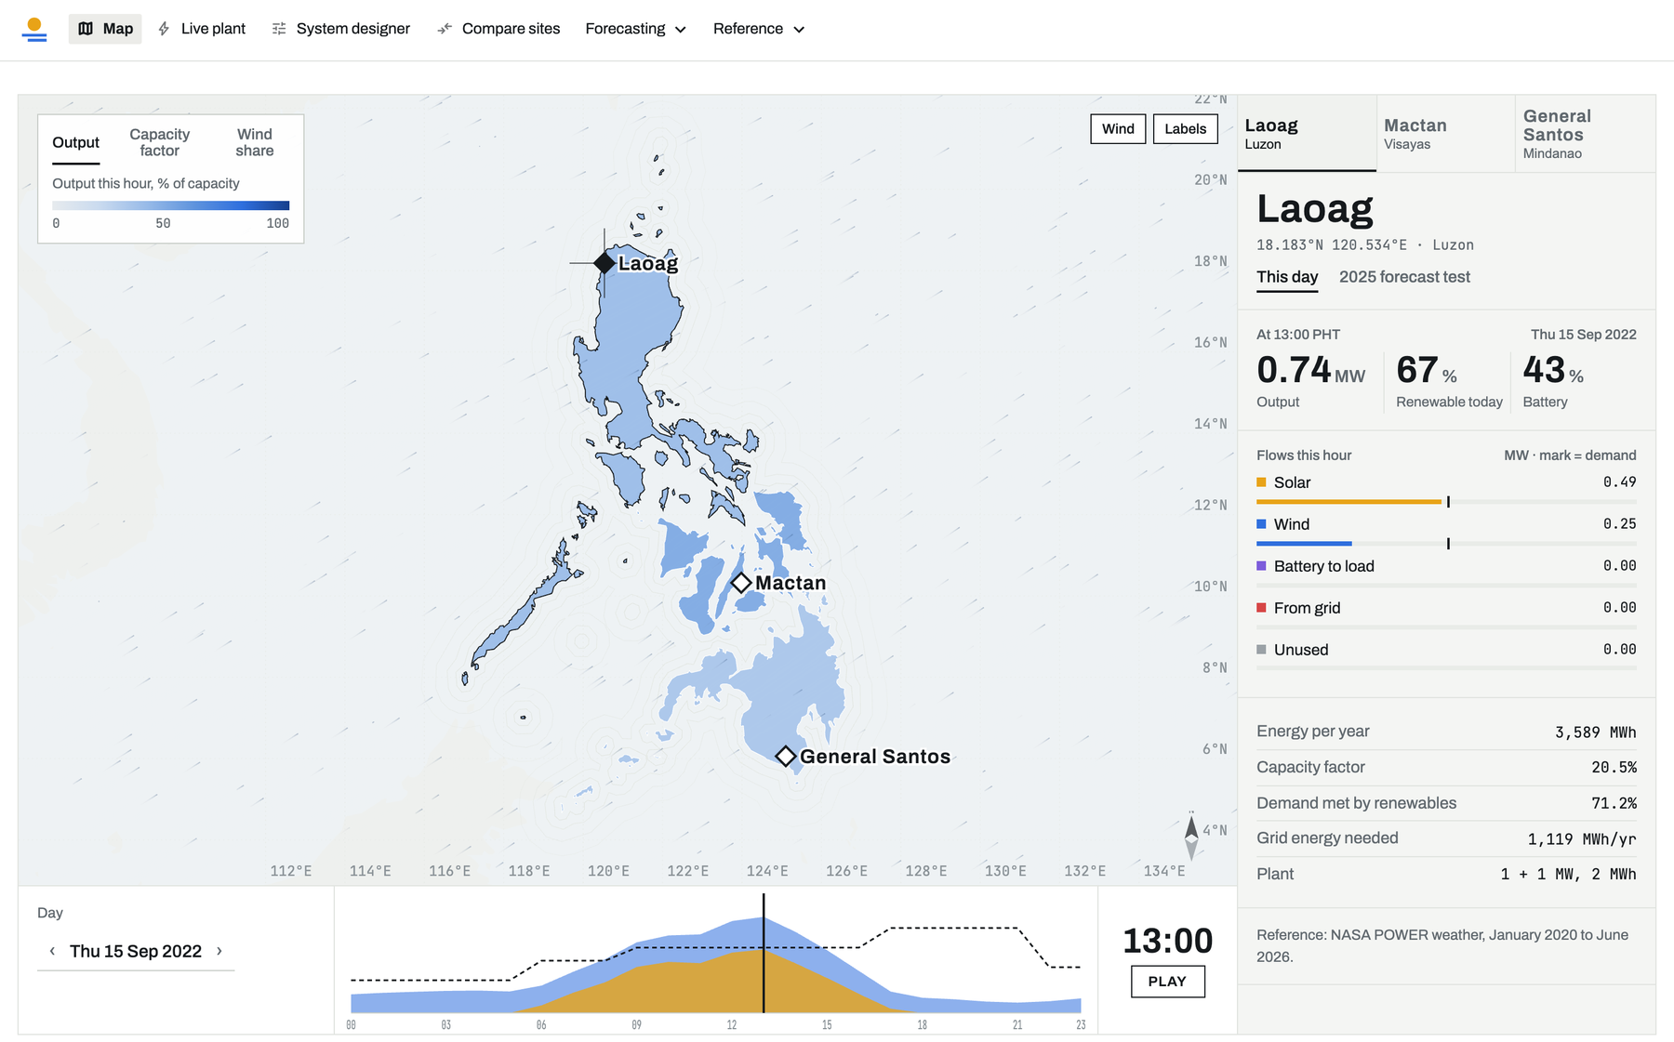
Basically, this is the first thing you see when you open SolWind. It's a map of the Philippines with our three sites on it: Laoag up north in Luzon, Mactan in the Visayas, and General Santos down in Mindanao. Every site has the exact same equipment, a 1 MW solar plant, a 1 MW wind turbine and a 2 MWh battery, so any difference you see between them comes from the weather and nothing else.
The page is split into three areas. The map itself is in the middle, the panel on the right gives the numbers for whichever site you click, and the bar along the bottom is the clock for the day you're looking at. Everything here is hourly, from 1 January 2020 all the way to 30 June 2026.

1.2 Map area, key and wind
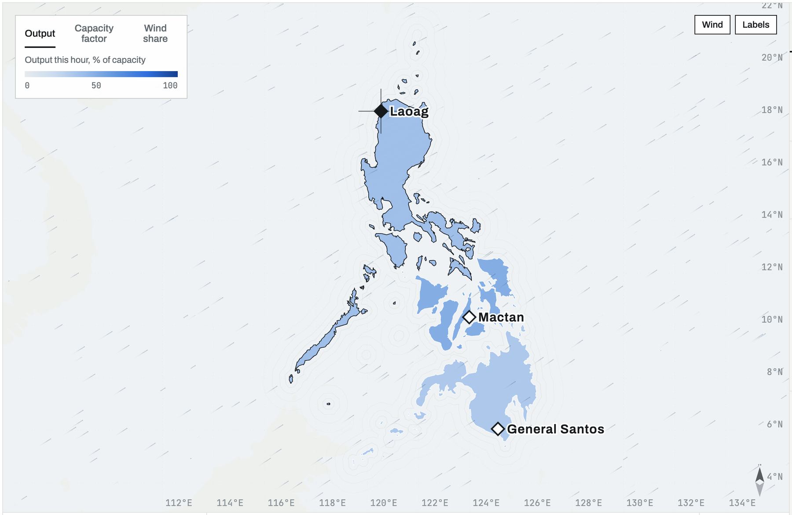
Basically, the map colors each region by how hard its plant is working at that hour. The key in the top left lets you switch between three views: Output, which is the raw megawatts; Capacity factor, which is output divided by what the plant could do at full power; and Wind share, which tells you how much of the energy is coming from the turbine instead of the panels.
The Wind and Labels buttons in the top right turn the moving particles and the site names on or off. Those particles aren't decoration. They follow each site's simulated wind at the turbine's 69 m hub height, so when Laoag lights up with fast particles, that's the turbine actually spinning harder in the model.

1.3 Side panel, This day tab
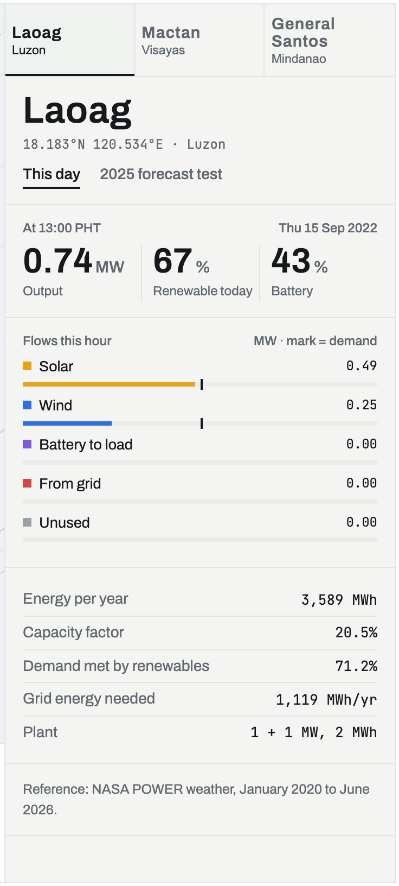
Basically, this panel is the scoreboard for the site you selected. At the top you get the output this hour, how much of today's demand renewables covered, and how full the battery is. Below that are the flows for this hour: how much is coming from solar, from wind, from the battery, from the grid, and how much is going unused, each drawn against the demand mark.
The bottom block zooms out to the long-term picture for the same site: energy per year, capacity factor, the share of demand met by renewables and the grid energy still needed. Those are averages over January 2020 to June 2026, so you can compare one day against what's normal for that place.

1.4 Timeline and day picker

Basically, this strip is how you move through time. On the left you pick the day, in the middle is a 24-hour chart of that day with solar in yellow, wind in blue and demand as the dashed line, and the black needle marks the hour the whole page is showing. You can drag the needle, or just hit PLAY and watch the day run by itself.
When you move the needle, the map colors, the wind particles and the side panel all update together, so it's the easiest way to see things like solar fading out in the evening while wind picks up the slack.

1.5 Side panel, 2025 forecast test tab
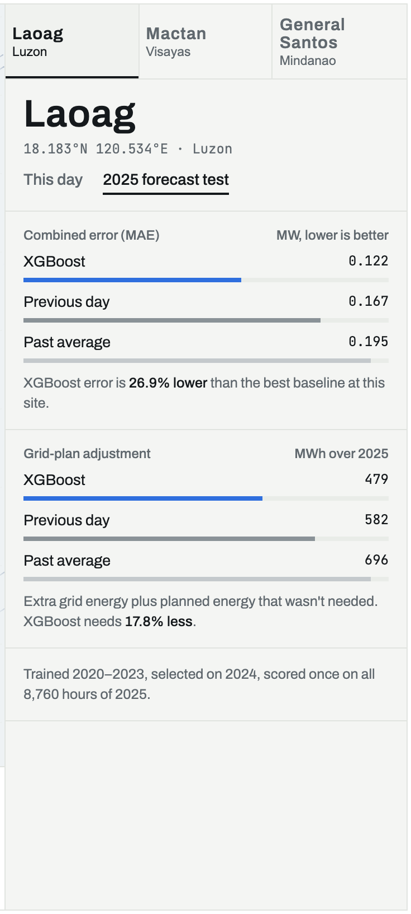
Basically, the second tab of the panel switches from what happened to how well we predicted it. It shows the combined error, the MAE, of our three forecasting methods for 2025 at this site: XGBoost, Previous day, which just repeats yesterday, and Past average, which uses the typical value for that month and hour. Lower is better, and XGBoost comes out on top.
Below that it shows what those errors mean for the grid. The grid-plan adjustment is the extra energy you had to buy plus the energy you planned for but didn't need. For Laoag, XGBoost needs about 18 percent less adjustment than the best simple method, which is the real-world payoff of a better forecast.

2. Live plant

2.1 The animated plant
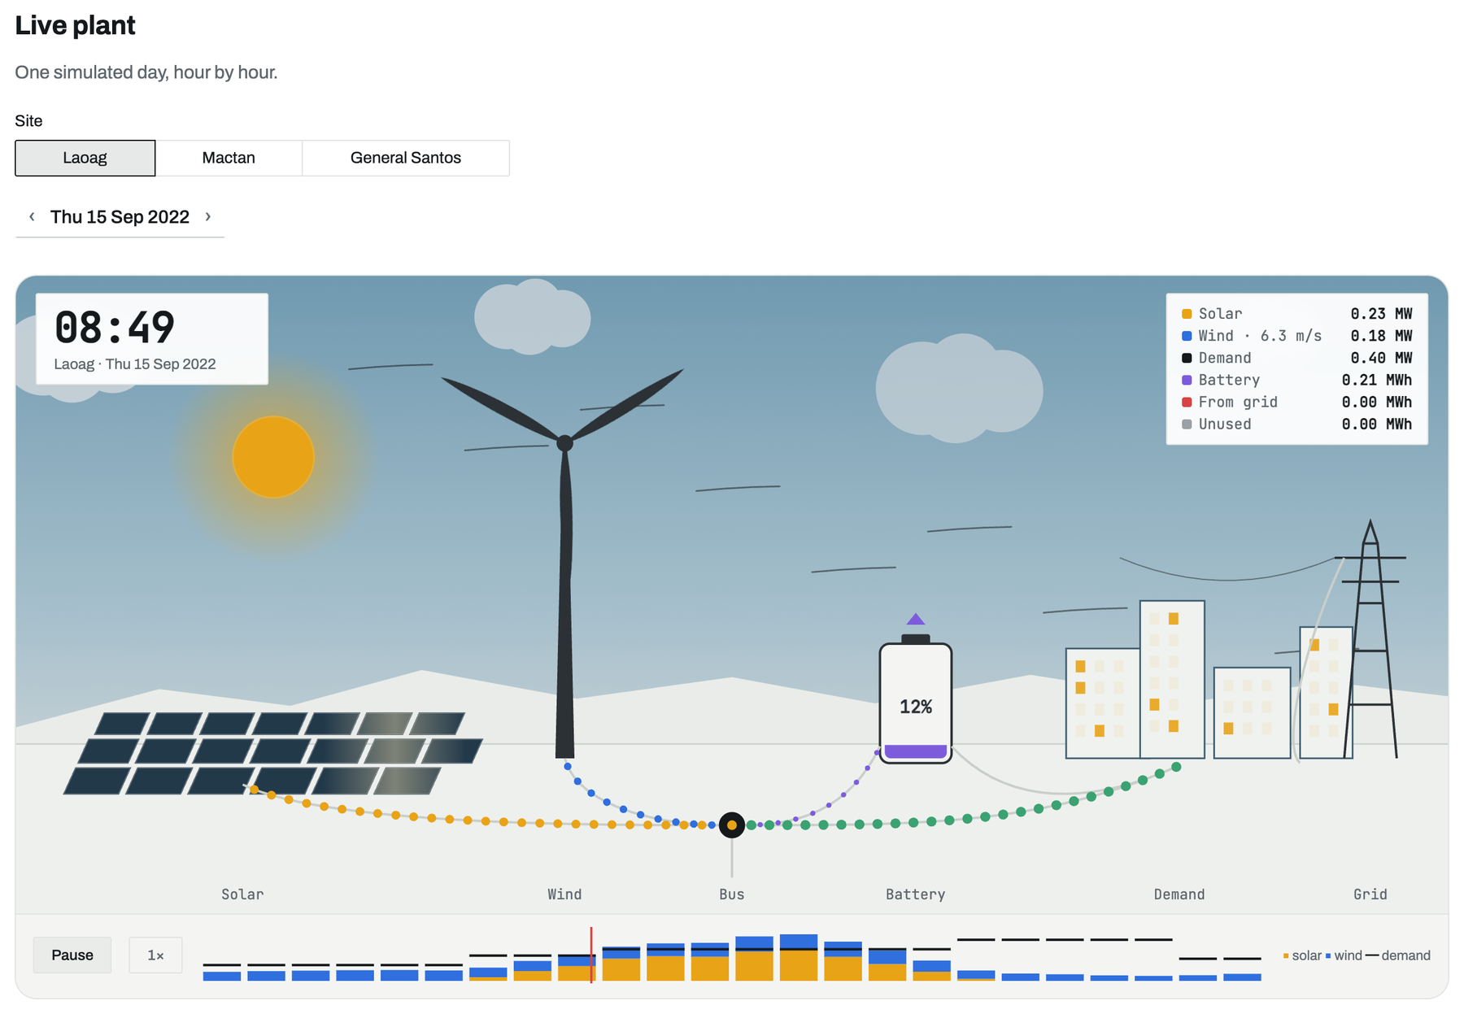
Basically, this page takes one site and one day and turns the numbers into a little animated plant. The sky follows the hour, the clouds follow the actual cloud cover, the rotor spins with the wind output, and the dotted lines show energy moving between the panels, the turbine, the battery, the town and the grid, scaled to megawatts.
The legend in the corner gives the exact values for the current hour, and the bar strip underneath is the whole day at a glance. You pick the site and the day at the top. It's the page we use when someone just wants to see what a hybrid plant actually does over a day.

2.2 Day totals and ledger chart
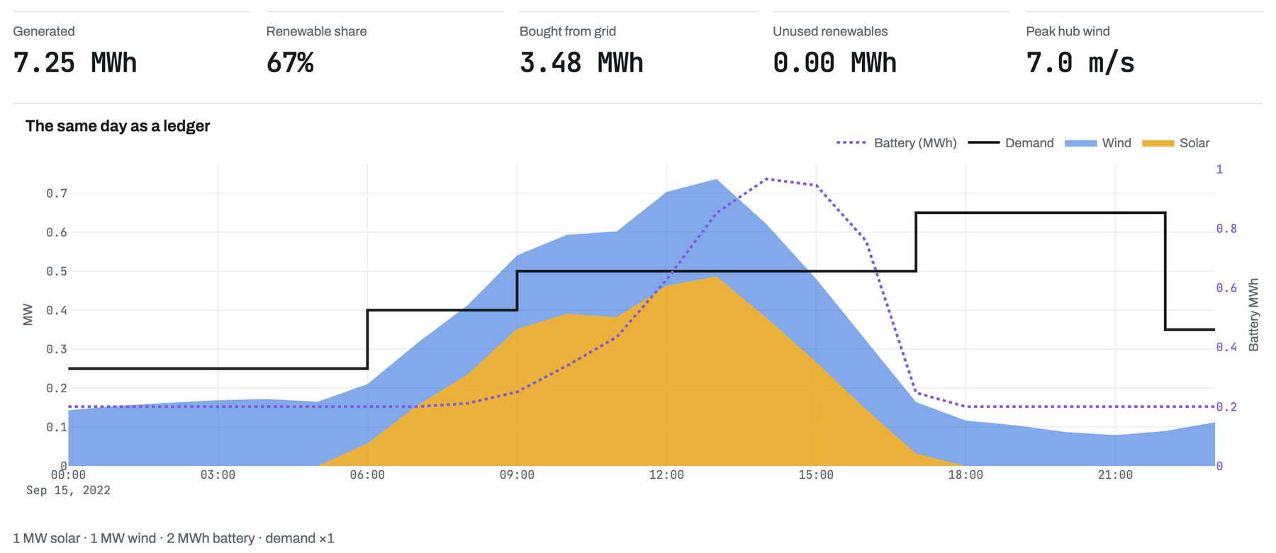
Basically, this is the same day written down as numbers. The five figures at the top are the day's totals: how much was generated, what share of demand renewables covered, how much we bought from the grid, how much went unused, and the peak wind at hub height.
The chart below is the ledger. Solar and wind are stacked as filled areas, demand is the black step line, and the dotted purple line is the battery charge. You can literally see the battery filling up around midday when solar is strong, then draining in the evening when demand jumps and the sun is gone.

2.3 The day picker
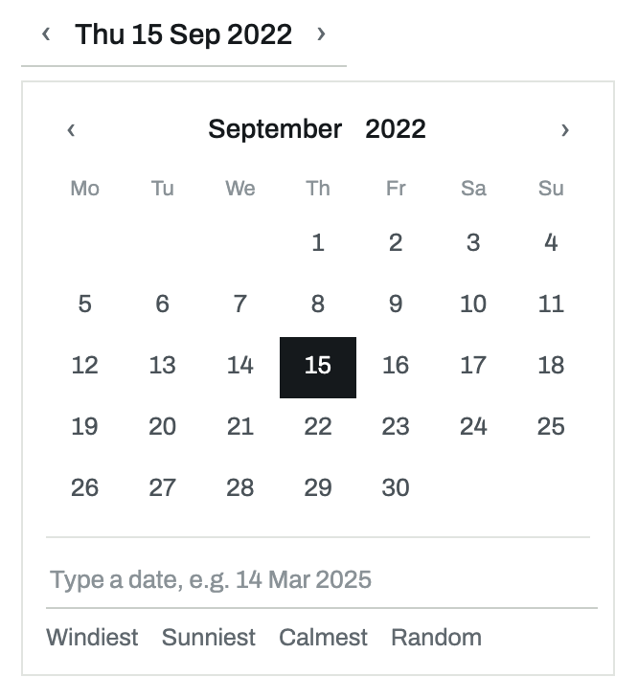
Basically, this is the date control we use on every page that shows a single day. Click the date and a calendar opens. You can jump by month and year, step with the arrows, or type a date straight in, like 14 Mar 2025, and press Enter.
The four shortcuts at the bottom are handy for demos: Windiest, Sunniest, Calmest and Random. They pick the matching day for the site you have selected, so you don't have to hunt for an interesting day by hand.

3. System designer

3.1 Design controls and results
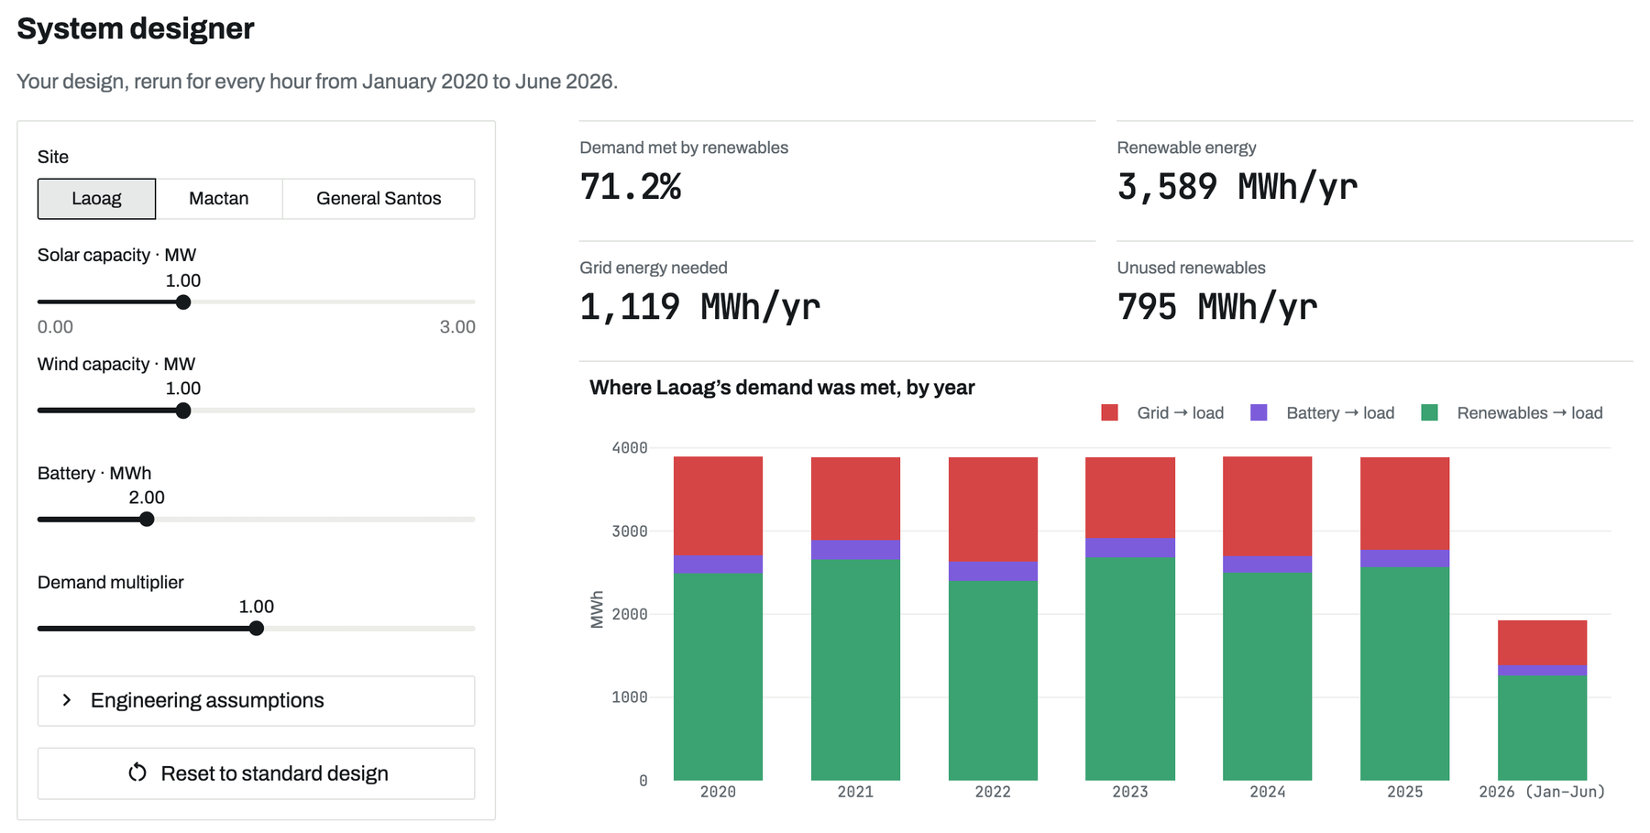
Basically, this is where you change the plant and see what happens. The sliders on the left set the solar size, the wind size, the battery size and a demand multiplier. Every time you move one, the app reruns every single hour from January 2020 to June 2026 for that site, which is about 57,000 hours, in a second or two.
The four numbers on the right are the headline results: demand met by renewables, renewable energy per year, grid energy still needed and unused renewables. Each one is compared against the standard 1 + 1 MW design. The chart below breaks each year down into what came from renewables, the battery and the grid. 2026 looks short only because it's half a year.

3.2 Surplus by month and hour
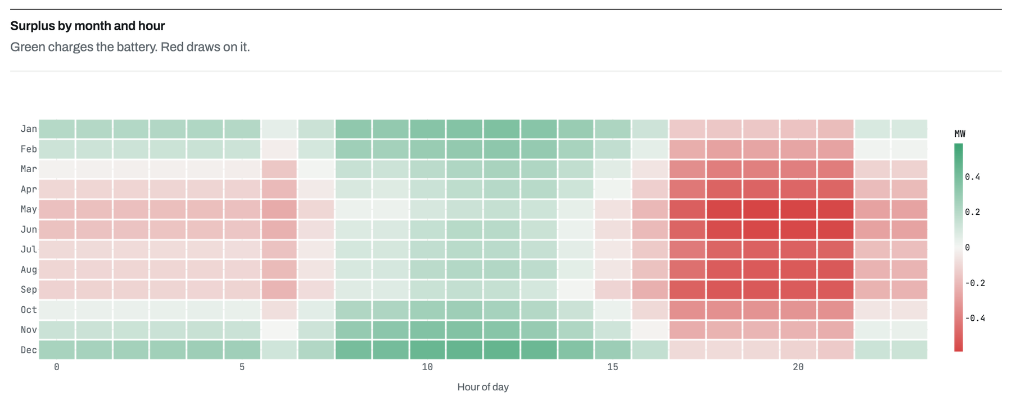
Basically, this heatmap answers the question of when the plant has too much energy and when it has too little. Each row is a month, each column is an hour of the day, and the color shows the average surplus. Green means generation is above demand and the battery is charging. Red means demand is higher and the plant is leaning on the battery or the grid.
For Laoag, you can see the strong red band in the evening hours, especially from March to September. That's the classic problem with solar: demand peaks after sunset. It's also exactly why the wind turbine and the battery matter.

3.3 Outage test
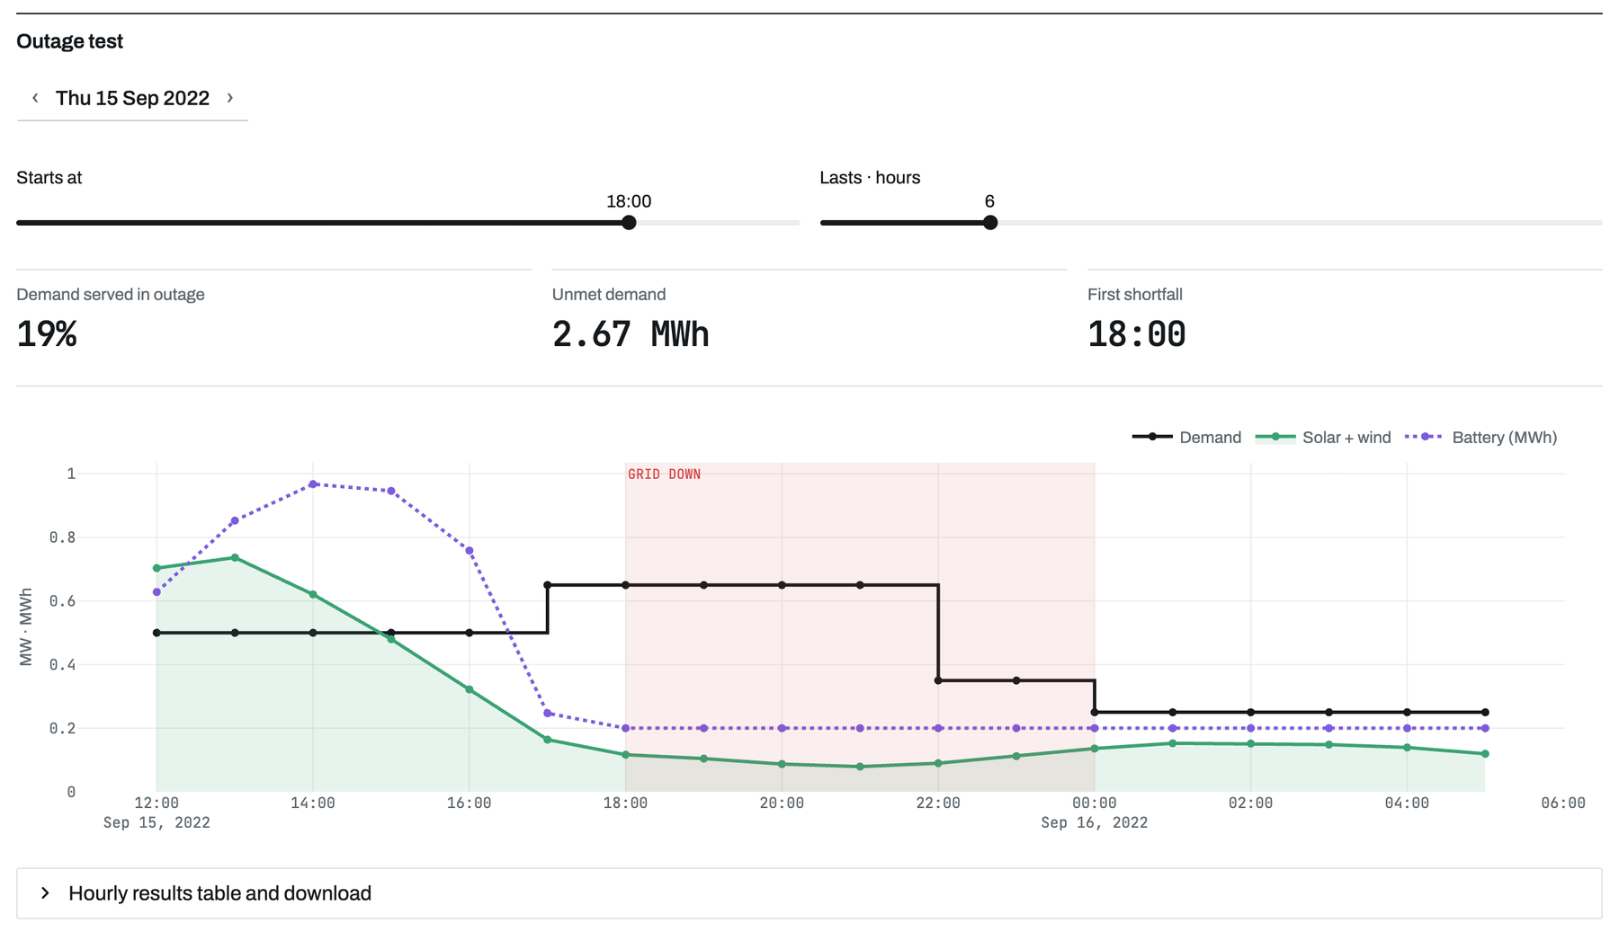
Basically, this is a stress test. You pick a day, a start hour and how long the grid goes down, and the app replays that window with no grid at all. Anything the plant and battery can't cover becomes unmet demand.
The three numbers tell you how much of the demand was still served, how much energy was missing and the first hour the lights would go out. In the chart, the shaded red area is the outage, so you can see the battery drop, and the exact moment demand rises above what solar, wind and storage can give.

3.4 Engineering assumptions
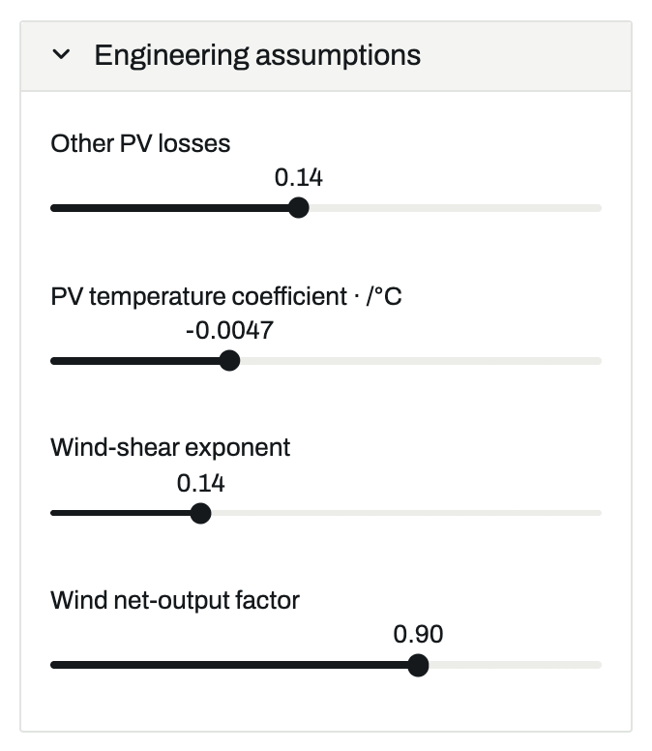
Basically, these are the technical knobs behind the equations, tucked away so they don't confuse first-time users. Other PV losses covers things like dirt and wiring losses. The temperature coefficient is how much the panels lose as they heat up. The wind-shear exponent is how we scale the wind from NASA's 50 m data up to the 69 m hub, and the net-output factor covers turbine availability and losses.
The defaults come from the turbine datasheet and standard PV modelling references. Changing them is mainly for sensitivity checks, like asking how much the results move if the panels run hotter than we assumed.

3.5 Hourly results table and download
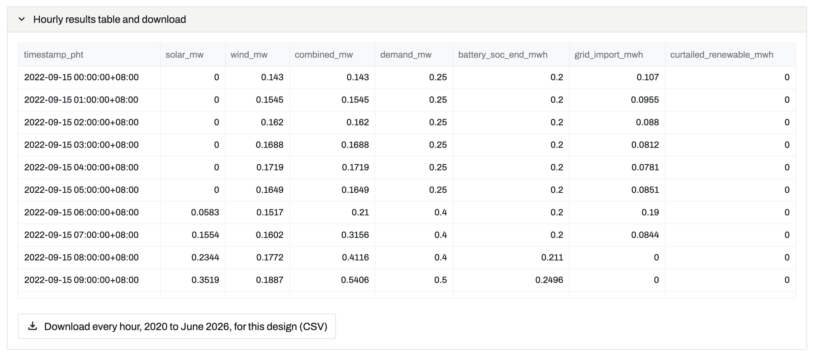
Basically, this is the raw data behind everything on the page. The table shows each hour of the selected day: solar, wind, combined output, demand, battery charge at the end of the hour, energy bought from the grid, and energy that went unused.
The download button gives you the same columns for every hour from 2020 to June 2026, for whatever design you have set. So if anyone wants to check our numbers in Excel, or build their own chart, it's all there in one CSV.

4. Compare sites

4.1 Energy per year and by month
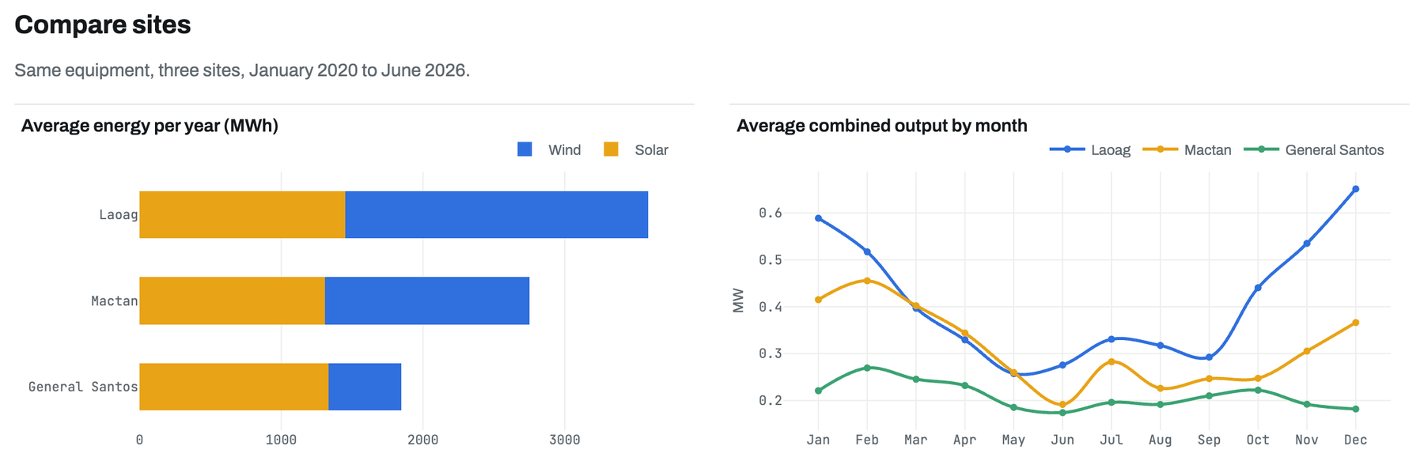
Basically, this page puts the three sites side by side with identical equipment. The bar chart on the left is average energy per year, split into wind and solar. Solar is fairly similar everywhere, but wind is a completely different story: Laoag gets a lot of it, Mactan a fair amount, and General Santos very little.
The line chart on the right shows the average combined output for each month. Laoag swings hard, with strong output from November to February when the northeast monsoon blows and a dip mid-year. That seasonality is something a planner really has to know before choosing a site.

4.2 Wind roses
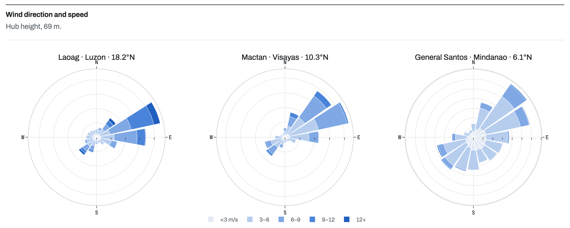
Basically, these are wind roses. Each one shows which direction the wind comes from at each site and how strong it is, measured at the 69 m hub height. The longer the petal, the more often the wind blows from that direction, and the darker the color, the faster it is.
Laoag and Mactan both have a clear dominant direction, which is what you want for a turbine. General Santos has wind spread out in all directions and mostly at low speeds, which explains why its wind output is so small.

4.3 Solar–wind complementarity
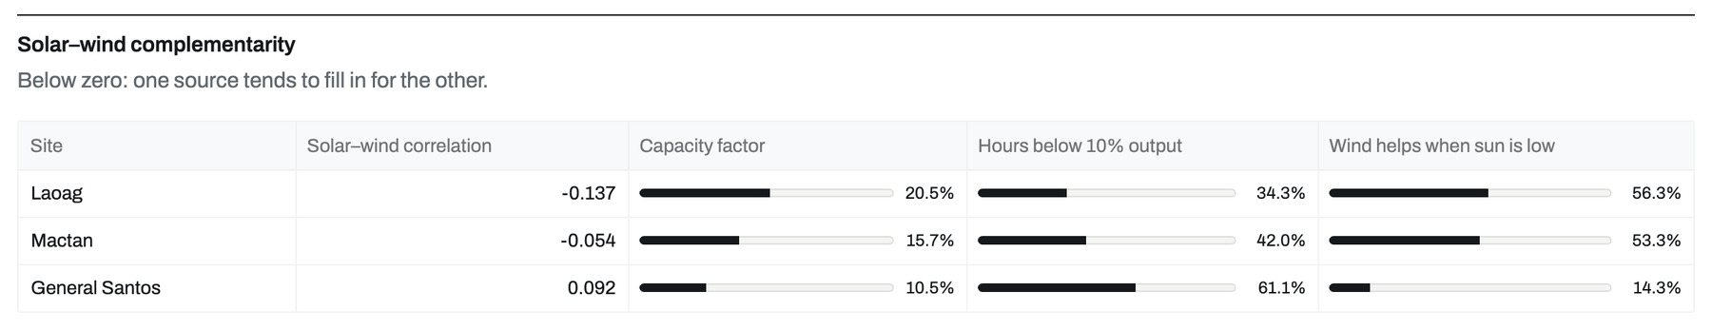
Basically, this table checks whether solar and wind cover for each other. The first column is the correlation between the two. A negative number means when one is low the other tends to be up, which is the ideal case for a hybrid plant. Laoag and Mactan are slightly negative, and General Santos is slightly positive.
The other columns make it concrete: the capacity factor, how many hours the plant sits under 10 percent output, and how often wind helps when the sun is low. At Laoag, wind helps in more than half of those low-sun hours. At General Santos it's under one in five.

5. Forecast accuracy

5.1 Leaderboard
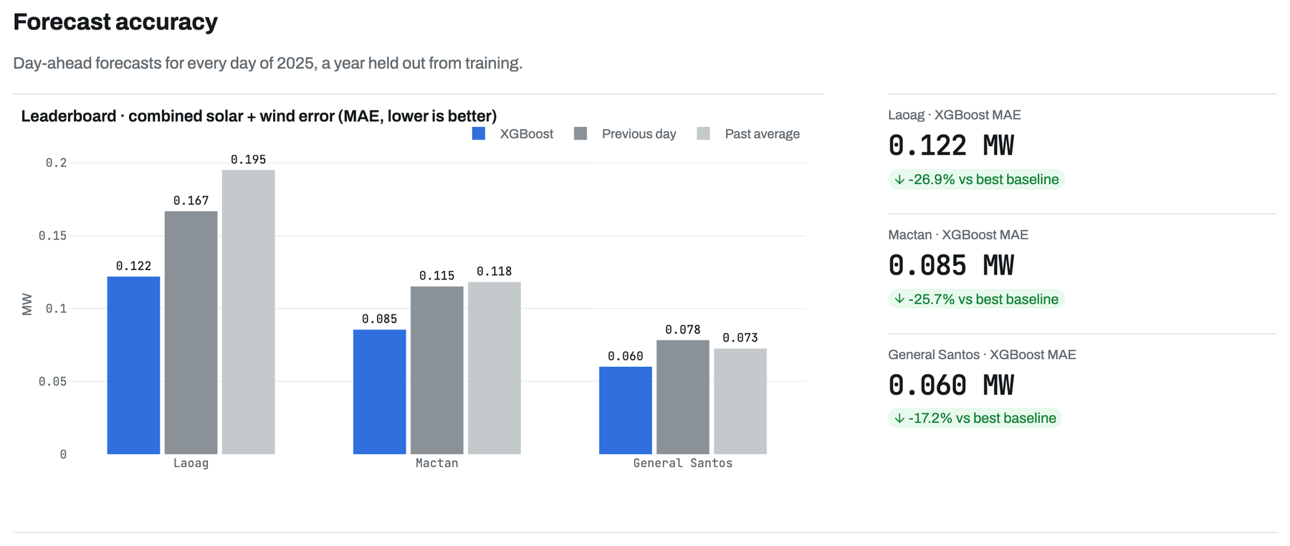
Basically, this is the main result of the forecasting part. For every day of 2025, each method made a 24-hour forecast at midnight, and we compared it with what actually happened. The bars are the average error in megawatts, so shorter is better. XGBoost is the blue bar, Previous day is dark grey, and Past average is light grey.
XGBoost wins at all three sites. On the right you can see how much: about 27 percent less error than the best simple method at Laoag, 26 percent at Mactan and 17 percent at General Santos. 2025 was held out completely, so the model never saw that year while it was learning.

5.2 Error by hour ahead and by month
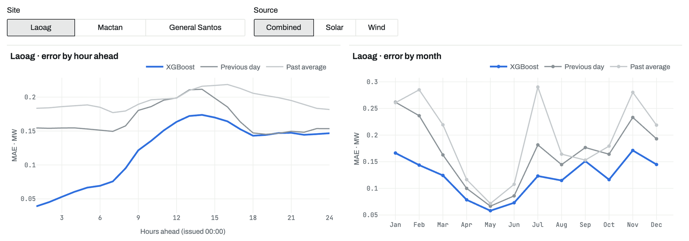
Basically, these two charts show where the errors come from. You can pick the site and switch between combined, solar only, or wind only. On the left, error is plotted against how many hours ahead the forecast is. The early hours are easier because they're close to the last known value, and the error climbs as you look further ahead.
On the right is the error by month. All the methods struggle more in the windy months because wind is harder to predict than sunshine, but XGBoost stays below the other two almost all year.

5.3 Single-day playback
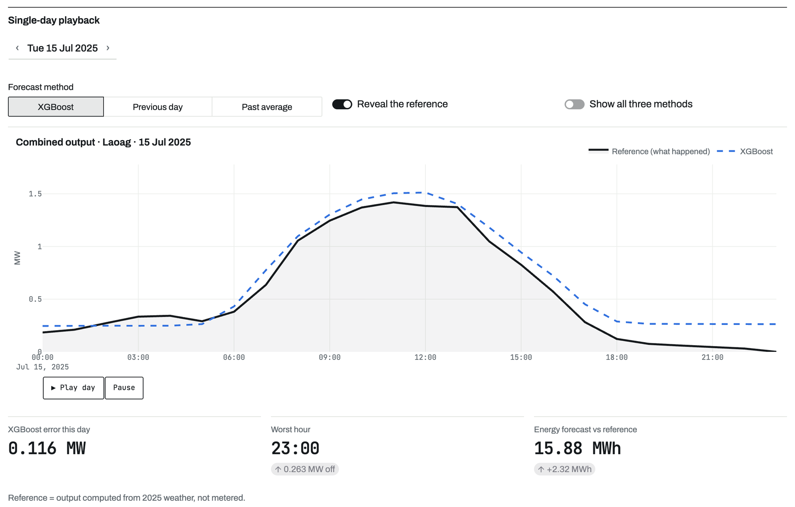
Basically, this lets you replay one 2025 day and watch a forecast against reality. You pick the day and the method, then press play. The black line is what actually happened and the dashed blue line is the forecast made at midnight. You can turn off Reveal the reference to see the forecast on its own first, or turn on Show all three methods to compare them.
Underneath it gives the error for that day, the worst hour, and the total energy forecast against the reference. It's the best way to show that a good average doesn't mean every day is perfect, since some days the forecast still misses by a lot.

6. Grid planning

6.1 Total grid-plan adjustment
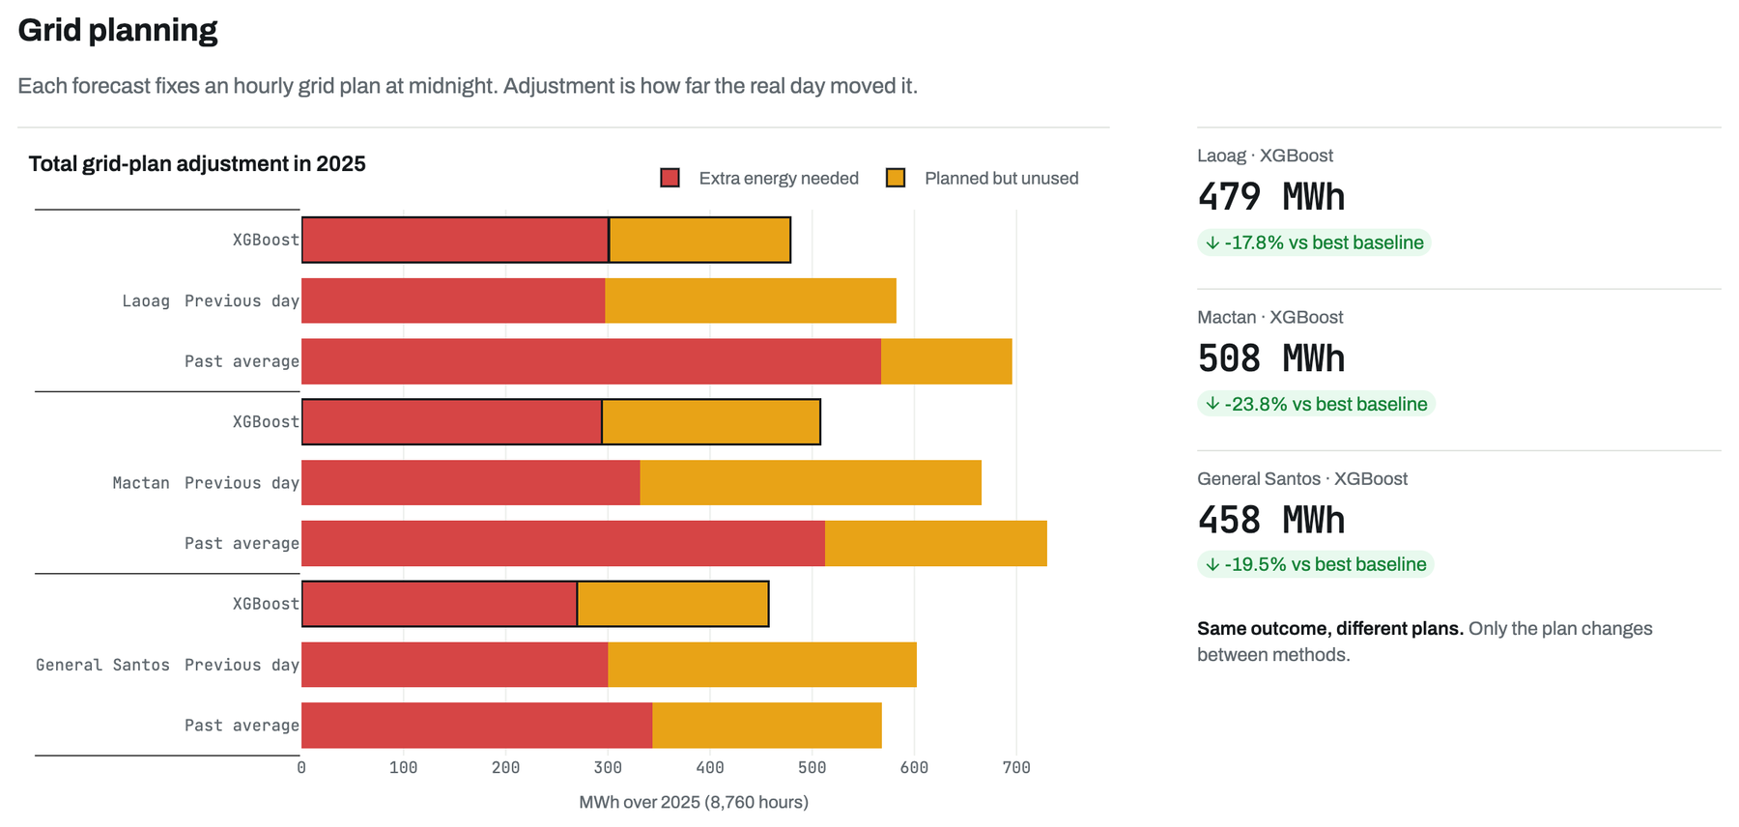
Basically, this page turns forecast error into something a grid operator actually cares about. At midnight, each forecast is used to plan how much energy to buy from the grid for every hour of the next day. Then the real day plays out, and we measure the adjustment: the extra energy we had to buy on short notice, in red, plus the energy we planned for but didn't need, in yellow.
The bars total that up for all of 2025. XGBoost needs the least adjustment at every site: 479 MWh at Laoag against 582 for Previous day. Same weather, same plant, only the plan changes, so the difference comes purely from the quality of the forecast.

6.2 Day replay
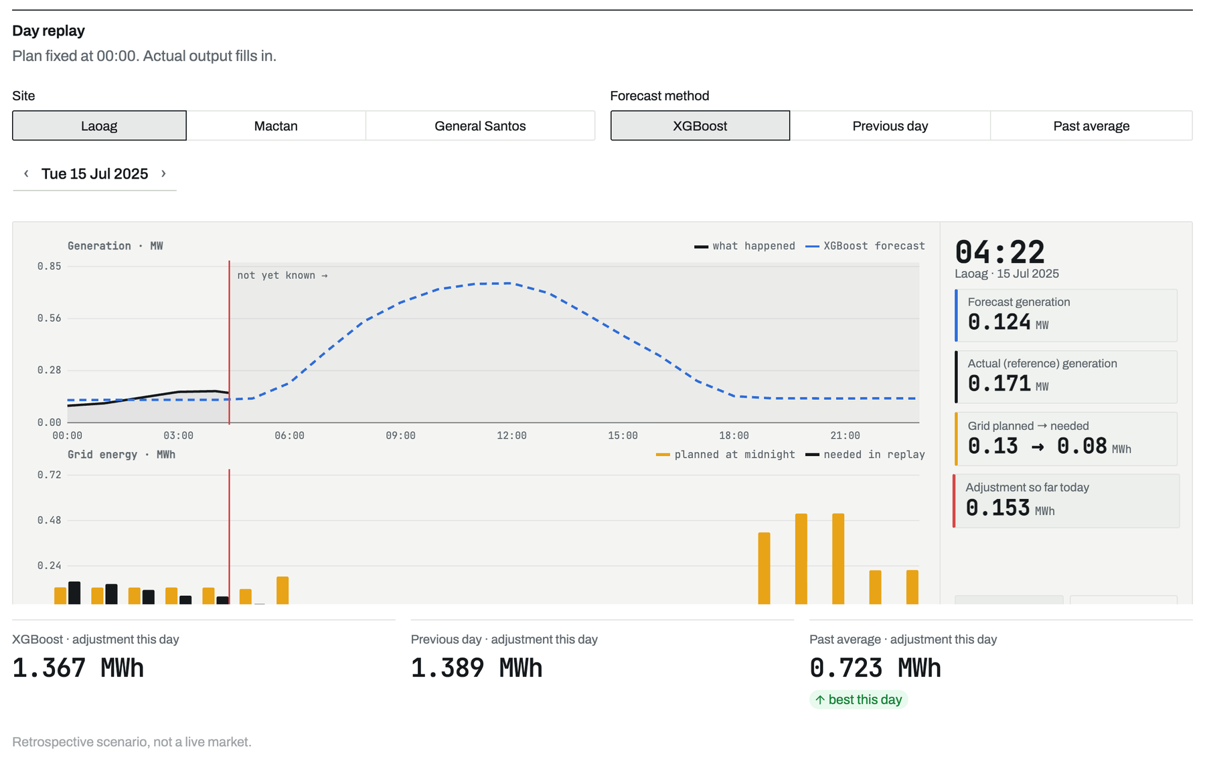
Basically, this is the planning idea shown one day at a time. The top chart is generation, with the forecast as the dashed line and what actually happened filling in as the clock moves. The bottom chart is grid energy, where yellow bars are what we planned to buy at midnight and the black bars are what we really needed once the day happened.
The panel on the right keeps a running tally for the current hour. The three numbers under the chart compare the day's total adjustment for each method, so you can find days where a simple method got lucky and days where XGBoost clearly saved energy.

7. Rolling test

7.1 The fold grid
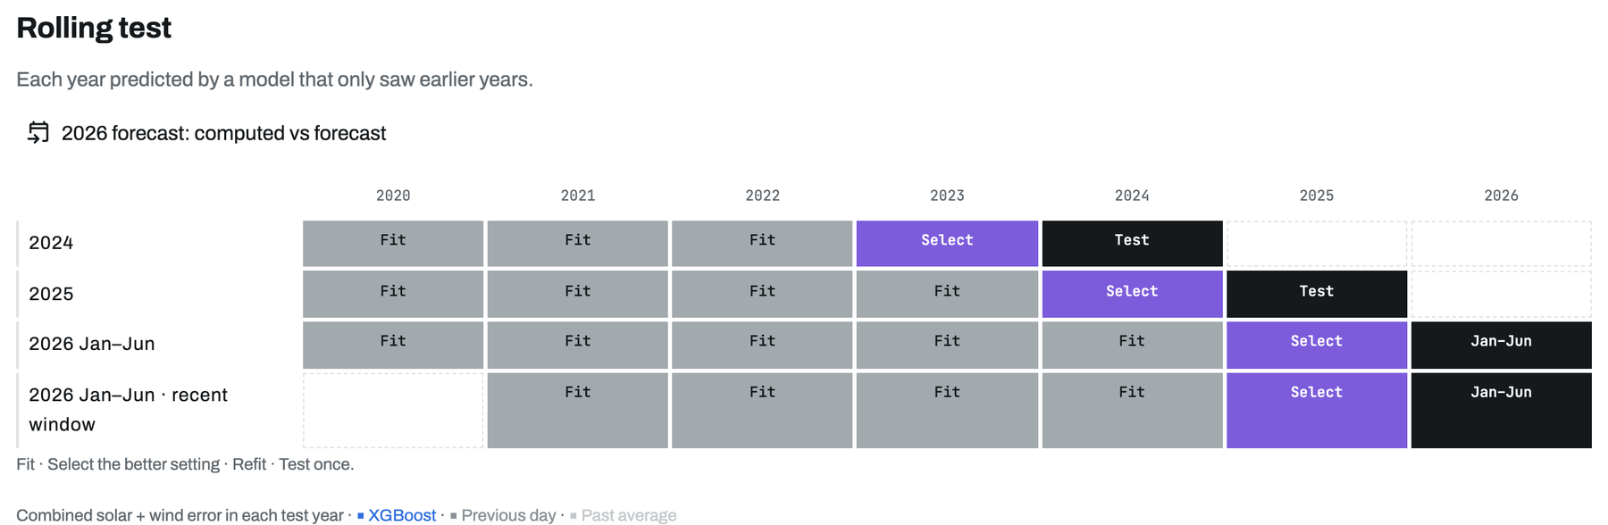
Basically, this grid explains how we tested fairly. Each row is one test. For 2024, the model learned from 2020 to 2022, picked its best setting using 2023, and then was scored once on 2024. For 2025 we shifted everything forward one year, and the same for January to June 2026. Grey is fit, purple is select, black is test.
The point is that the model never sees the year it's tested on. This is called a rolling or walk-forward test, and it's stricter than the usual random 70/30 split, because in real life you can only ever learn from the past.

7.2 Error across the three test years
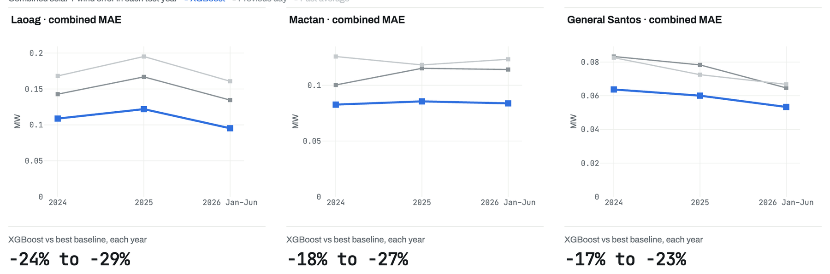
Basically, these three charts show the combined error for each test year at each site, with XGBoost in blue and the two simple methods in grey. The blue line stays at the bottom in every year and at every site.
The numbers underneath sum it up. XGBoost cuts the error by 24 to 29 percent at Laoag, 18 to 27 percent at Mactan, and 17 to 23 percent at General Santos, compared with whichever simple method did best that year. The fact that it holds across three separate years is what makes us confident it isn't a fluke.

7.3 Every day, at midnight
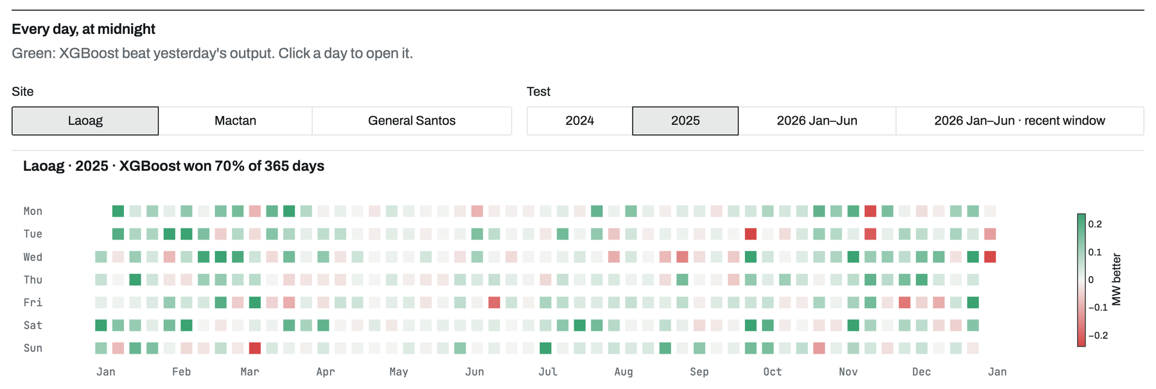
Basically, this calendar shows every single day of the chosen test year. Each square is a day, and it's green when XGBoost beat the previous-day forecast and red when it lost. The darker the color, the bigger the difference.
For Laoag in 2025, XGBoost won 70 percent of the 365 days. You can pick the site and the test year at the top, and clicking any square opens that day's forecast just below.

7.4 One day, opened from the calendar
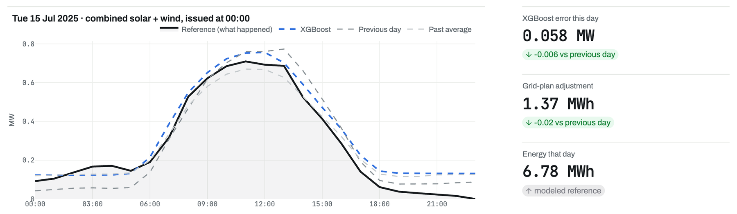
Basically, this is the day you clicked in the calendar. It shows the real output in black against all three forecasts made at midnight, so you can see exactly where each one went wrong.
On the right are that day's numbers: the XGBoost error, the grid-plan adjustment and the total energy, each compared against the previous-day method. It's a quick way to check any claim we make about a specific day.

7.5 Is the gap real?
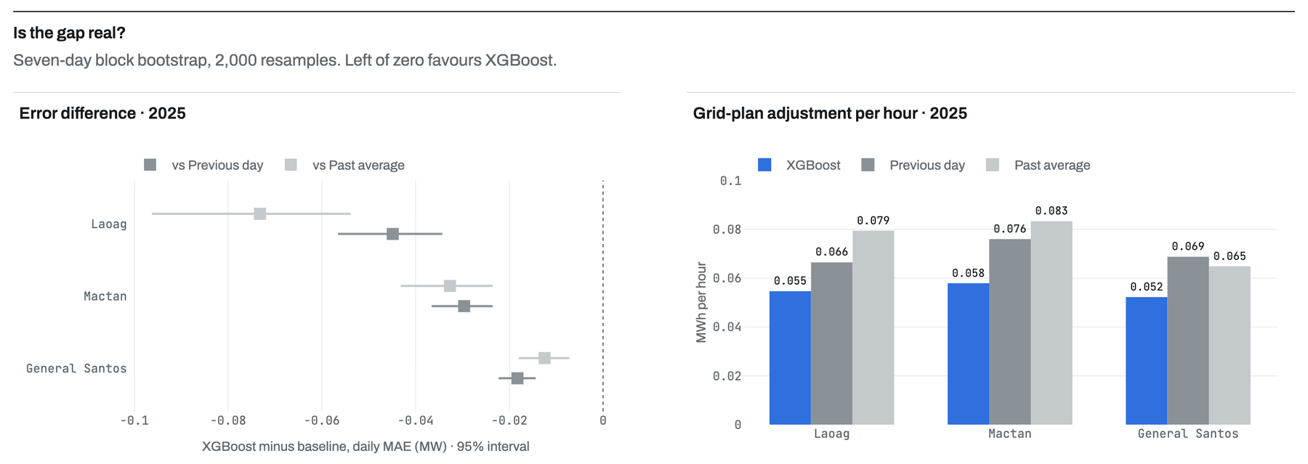
Basically, this answers the question every reviewer asks: is XGBoost really better, or did it just get lucky? We used a block bootstrap, which means resampling the year in seven-day chunks 2,000 times and recomputing the difference each time. Each dot is the average difference and the line is the 95 percent range. Everything to the left of zero favors XGBoost.
All the ranges sit left of zero, so the advantage is real and not noise. The chart on the right shows the same story in grid terms: the average adjustment per hour is lowest for XGBoost at all three sites.

7.6 Shorter history?
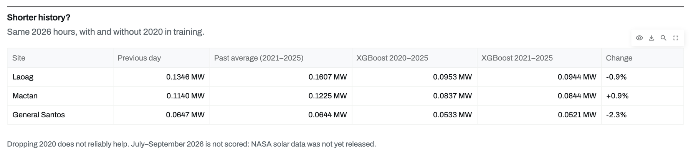
Basically, this is a sensitivity check. We asked whether the model does better if we drop 2020 from training, since 2020 was an unusual year and older data might be less useful. So we trained a second version on 2021 to 2025 only and scored both on the same 2026 hours.
The change is tiny, around 1 to 2 percent either way, so dropping 2020 doesn't reliably help. That tells us the results don't depend on one lucky choice of training years.

7.7 Other models
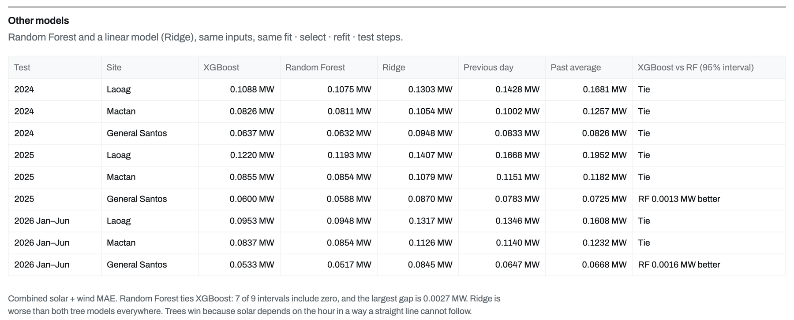
Basically, we wanted to know if XGBoost was the right choice, so we added two more methods: a Random Forest, which is another tree-based model, and Ridge, which is a straight-line regression. They got the same inputs and went through exactly the same fit, select, refit and test steps, on the exact same hours.
Random Forest turned out to be just as good as XGBoost. In seven of the nine site and year combinations the difference isn't statistically real, and in the other two Random Forest is ahead by about a thousandth of a megawatt. Ridge is clearly worse than both, because solar output depends on the hour in a curved way a straight line can't follow. So the honest takeaway is that tree-based machine learning beats the simple methods, and XGBoost and Random Forest are basically tied.

8. 2026 forecast

8.1 The five steps
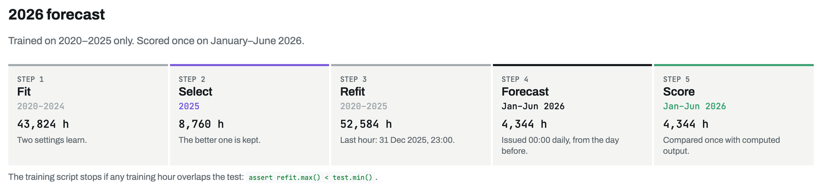
Basically, this page proves we didn't cheat with 2026. The five cards are the exact steps, with real hour counts. We fit on 2020 to 2024, which is 43,824 hours per site and source. We picked the better setting using 2025, then retrained on 2020 to 2025, with the last training hour being 11 PM on 31 December 2025.
Then the model forecast January to June 2026, 4,344 hours, issued at midnight each day using only the day before. It was scored once against the output computed from 2026 weather. The note at the bottom points to the line in the code that stops the run if any training hour overlaps the test.

8.2 Computed vs forecast, daily
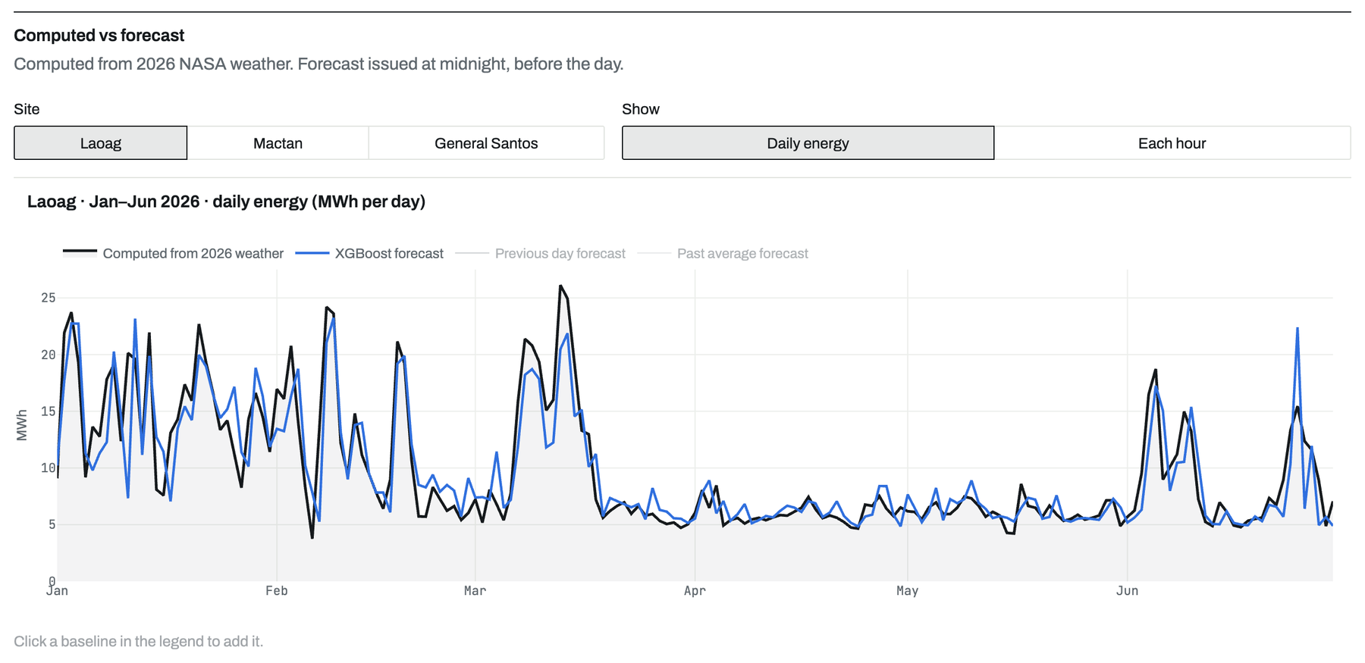
Basically, this is 2026 computed against 2026 forecast. The black line is the daily energy we computed from the real 2026 NASA weather, and the blue line is what XGBoost forecast at midnight, a day before. You can switch sites at the top, and click the other methods in the legend to add them.
The two lines track each other closely through all six months, including the windy spikes in January and February. That's the visual answer to the question of whether the 2025-trained model still works on a year it has never seen.

8.3 Computed vs forecast, each hour
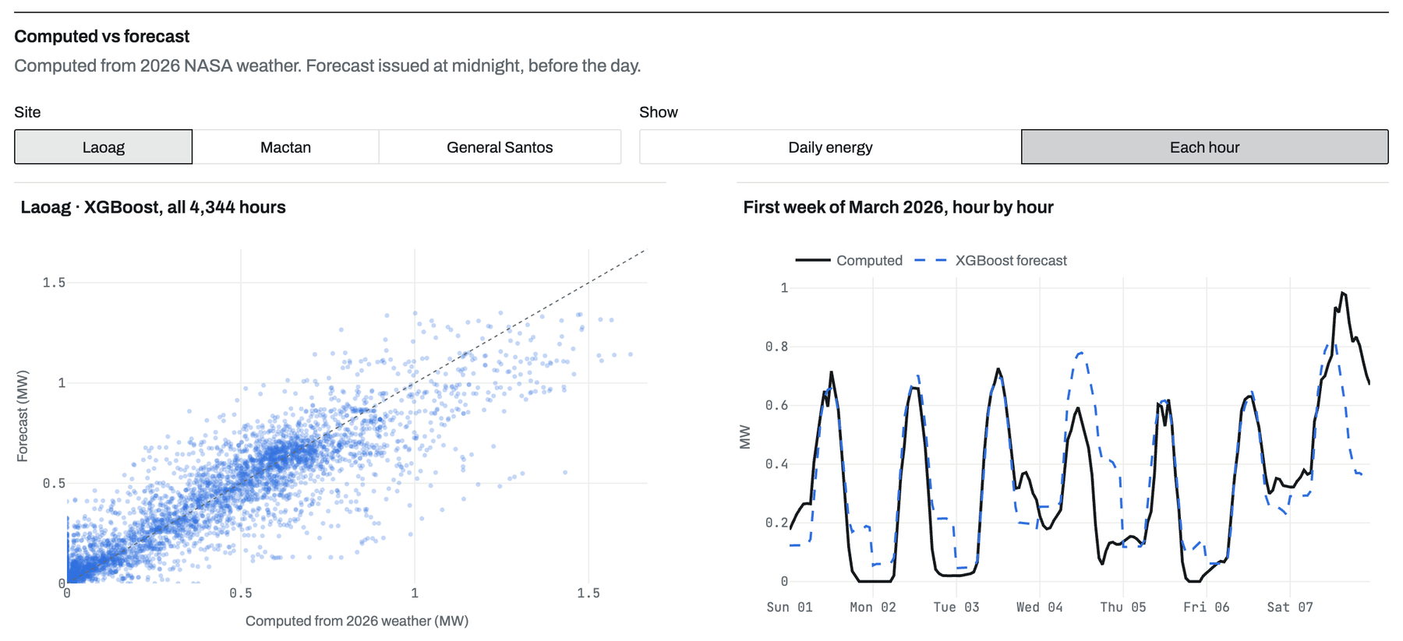
Basically, this is the same comparison without averaging anything away. On the left, every one of the 4,344 hours is a dot, with the computed value across the bottom and the forecast up the side. If the forecast were perfect, every dot would sit on the diagonal line. Most of them cluster close to it.
On the right is one week in March, hour by hour, so you can see the daily solar humps and how closely the dashed forecast follows them. It shows we're not hiding bad hours inside a good average.

8.4 Monthly table
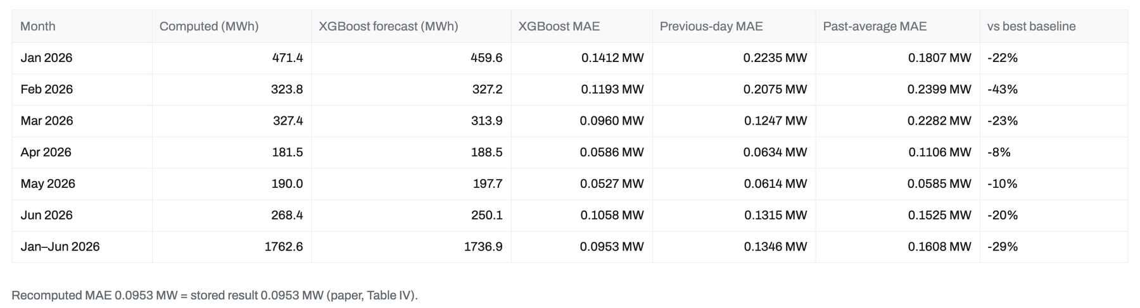
Basically, this table breaks 2026 down by month: the computed energy, the XGBoost forecast, and the error for all three methods. The last column is how much XGBoost beat the best simple method that month.
XGBoost wins every month, by anywhere from 8 to 43 percent, and 29 percent over the whole half year at Laoag. The line underneath shows that recomputing the error here gives exactly the number reported in the paper, 0.0953 MW.

8.5 Recompute it
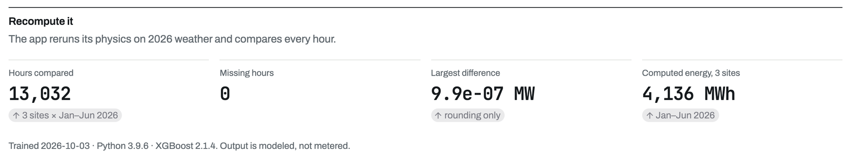
Basically, this is a live double-check. When the page loads, the app reruns its own physics equations on the 2026 weather and compares every hour with the values the forecasts were scored against. It checks 13,032 hours across all three sites and finds zero missing.
The largest difference is 0.00000099 MW, which is just rounding. So the computed side of the comparison isn't something we typed in. Anyone can watch the app regenerate it from the raw weather.

8.6 Download
Basically, this button gives you the whole 2026 evidence as one CSV. Every hour at all three sites has the time the forecast was issued, the computed output, and the forecast from each of the three methods.
If a professor or reviewer wants to verify our numbers independently, this is the file to hand them. They can recompute every error themselves in a spreadsheet.

9. Methodology

9.1 Solar PV equations
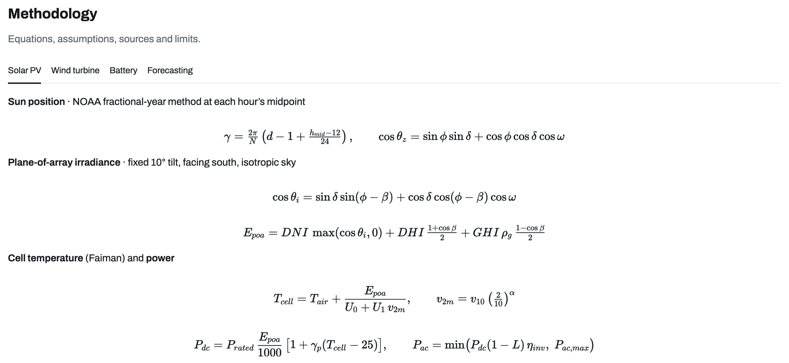
Basically, this page is the engine room. The first tab shows how we turn weather into solar power. We find the sun's position for every hour, work out how much light actually hits a panel tilted at 10 degrees, estimate how hot the panel gets using the Faiman model, and then apply the temperature loss, the system losses and the inverter limit.
These are standard equations from NOAA and the PVWatts and pvlib references, so nothing here is invented. Every number the app shows ultimately comes from these few lines.

9.2 Wind turbine equations
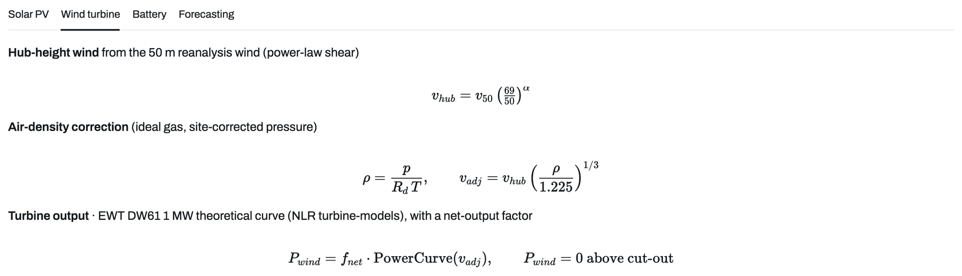
Basically, this tab does the same for wind. NASA gives us wind at 50 m, so first we scale it up to the 69 m hub using the power law. Then we correct for air density, because warm, humid air carries less power than the standard air the turbine was rated in.
Finally, we read the output off the real power curve of an EWT DW61 1 MW turbine and apply a net-output factor for losses. Above the cut-out speed the turbine shuts down to protect itself, so output drops to zero.

9.3 Battery and demand
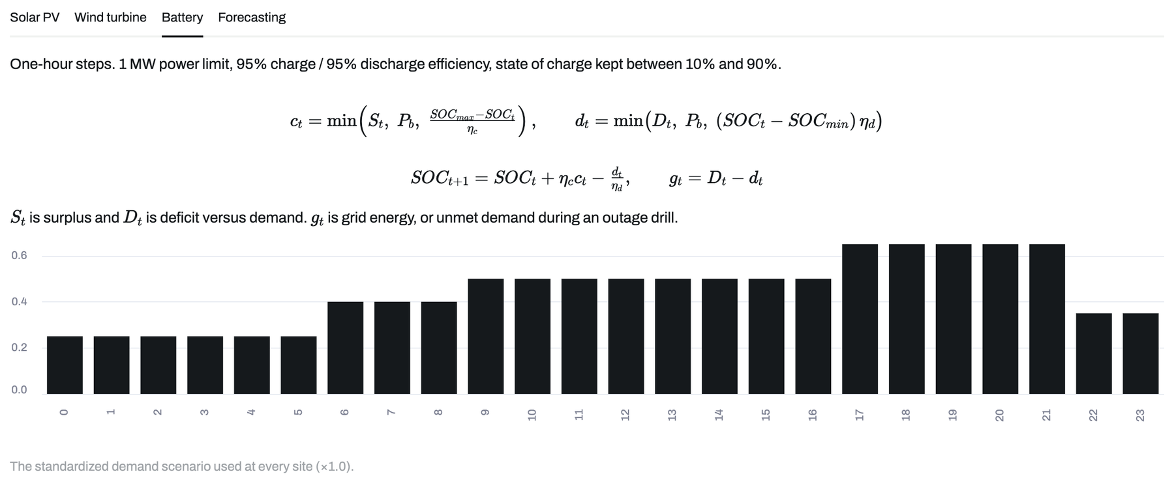
Basically, this is how the battery works in the model. Every hour, surplus energy charges it and any shortfall draws from it, with 95 percent efficiency each way and the charge kept between 10 and 90 percent so it isn't abused. Whatever the battery can't cover comes from the grid.
The bar chart is the demand profile we use at every site: low overnight, rising through the day and peaking in the evening. It's a standard scenario, not real city data, which keeps the three sites comparable.

9.4 Forecasting method and scores
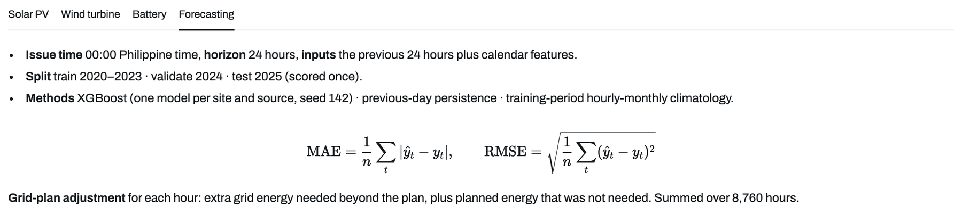
Basically, this tab explains the forecasting setup in a few lines. Forecasts are issued at midnight Philippine time for the next 24 hours, using the previous 24 hours of output plus calendar features like the hour and the day of the year. There's one model per site and source.
It also shows the two error formulas, MAE and RMSE, and how the grid-plan adjustment is defined. MAE is the main one: the average size of the miss in megawatts, where lower is better.

9.5 Fixed parameters
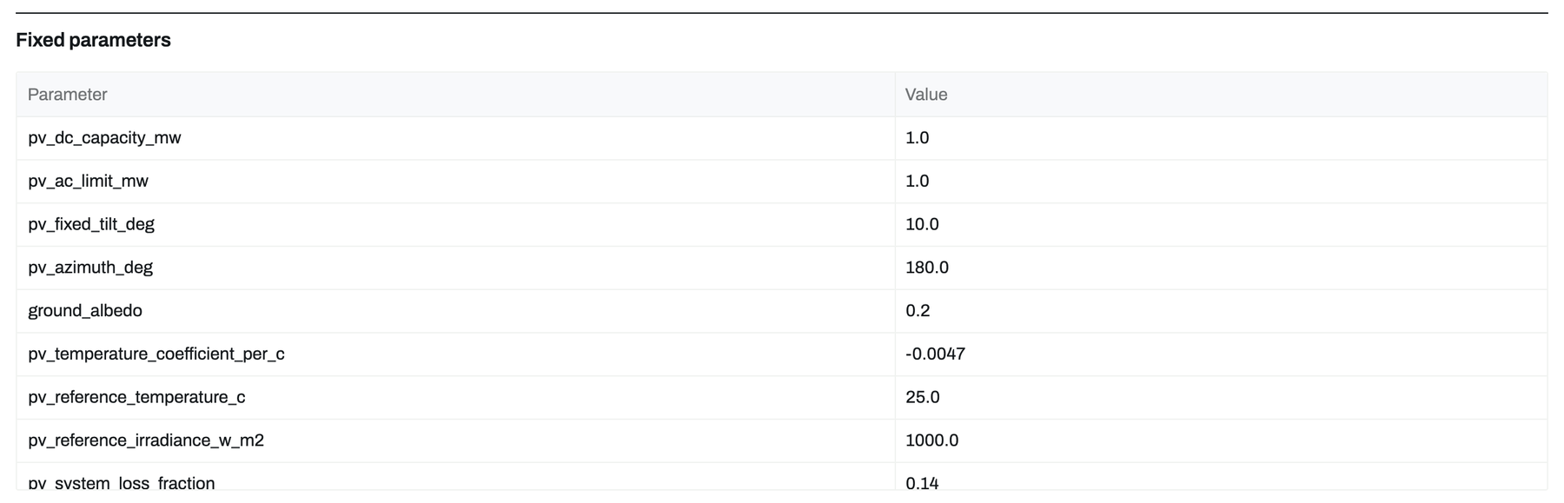
Basically, this is the full list of fixed numbers the model runs on: panel tilt and direction, ground reflectance, temperature coefficients, losses, inverter efficiency, turbine model, hub height and so on.
Having them all in one table means anyone can check our assumptions or rerun the model with different values. Nothing is hidden in the code.

9.6 How this compares (international studies)
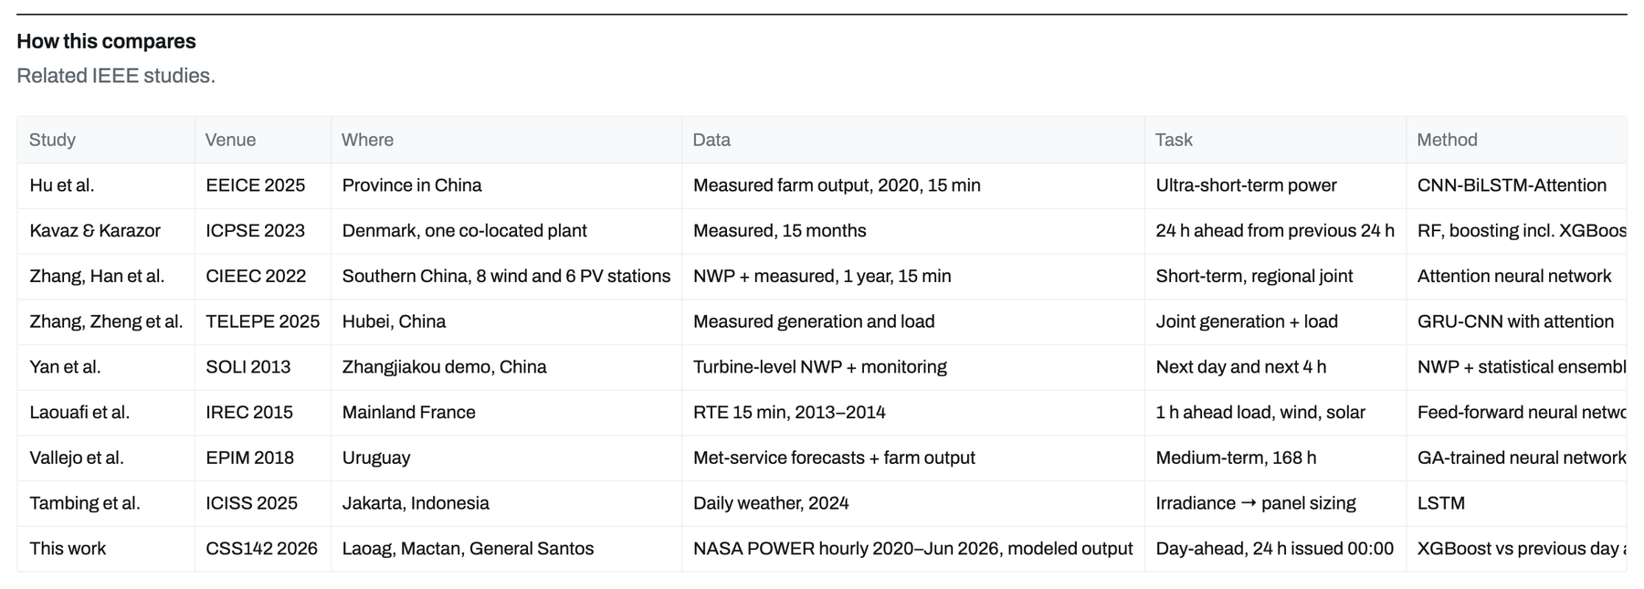
Basically, this table places our work next to recent IEEE studies on solar and wind forecasting: who did it, where, what data they used, how far ahead they forecast, and which method they used.
The main difference is the testing. Most of those papers split one period of data by ratio, while we test whole years in order. We also link the forecast directly to a grid-purchase plan, which most of them don't.

9.7 How this compares (Philippine studies)
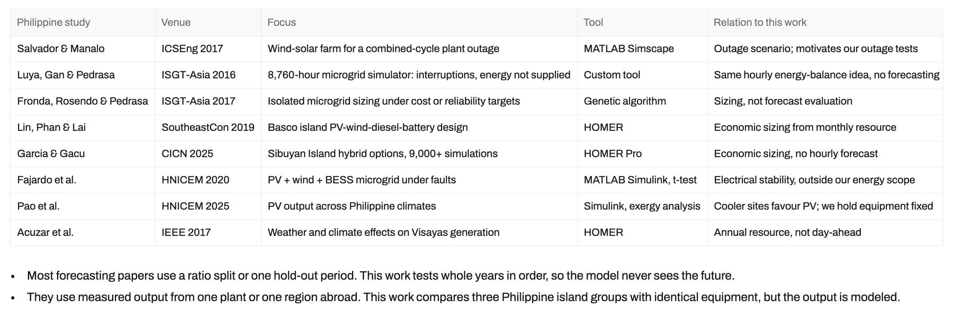
Basically, this is the same comparison for studies done in the Philippines. Most of them use tools like HOMER or MATLAB to size a system or study an outage, but they don't do hourly day-ahead forecasting.
The notes underneath sum up where SolWind fits. We test whole years in order so the model never sees the future, and we compare three Philippine island groups with identical equipment. The honest catch is that our output is modeled from weather, not measured at a real plant.

9.8 Sources
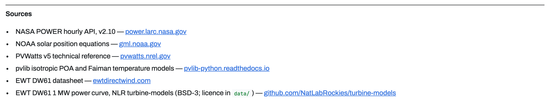
Basically, this lists where everything comes from: the NASA POWER weather data, the NOAA sun-position equations, the PVWatts and pvlib references for the solar model, and the EWT datasheet and the published power curve for the turbine.
Each one is linked, so a reviewer can go straight to the original source.

9.9 Limitations
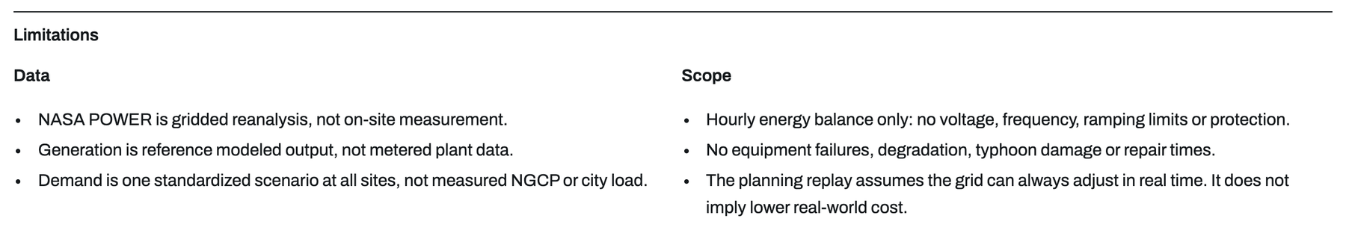
Basically, this is where we're upfront about what the model doesn't do. The weather is satellite-based reanalysis, not a weather station on site. The generation is modeled, not metered, and the demand is a standard profile, not a real city's load.
It's also an hourly energy balance only, so it doesn't model voltage, frequency, equipment failures, typhoon damage or cost. Saying this clearly makes the rest of the results easier to trust.

