





Republic of the Philippines

PALAWAN STATE UNIVERSITY

College of Sciences

Puerto Princesa City

“**S.A.S.A: SAFETY ALARM SECURITY APPLICATION** **IN PUERTO PRINCESA CITY”**

**A Capstone Project**

**Presented to the Faculty of**

**Computer Studies Department,**

**Palawan State University**

**In Partial Fulfillment of the Requirements**

**for the Degree of Bachelor of Science in Information Technology**

By:

**Macahipay, Ralph Kevin**

**Martinez, Francis**

**Rodriguez, Jhenzel**

**Rodriguez, Diana**

February 2022

**TABLE OF CONTENTS**

**1.CHAPTER I**

1.1. Introduction…………………………………………………………………………………3

1.2. Project Context…………………………………………………………………………………......3

1.3. Purpose and Description.. *……………………………………………………………………...................4*

1.4. Objectives………………………………………………………………..………………….4

1.5. Scope and Limitation……………………………………………………………………………………4-5

**2. CHAPTER II**

2.1 Review of Related Literature/Systems*……………………………………………………………………*………6-9

**3.CHAPTER III**

3.1 Technical Background………………………………………………………………………….…

**4.CHAPTER IV**

* 1. Methodology…………………………………………………………………………
  2. Design of the Software and Process……………………………………………………………….

**5.CHAPTER V**

* 1. Results and Discussions…………………………………………………………………..…….…
  2. References………………………………………………………………………………….…………
  3. Appendices…………………………………………………………………………….…………
  4. Curriculum Vitae………………………………………………………………………………..

**Chapter I**

**Introduction**

The increasing use of apps over the past few decades has seen the rise of information technology to a pervasive position in human jobs. According to Oza (2017), "All this information is stored on our phone, which helps us plan our lives and facilitates proper time management. Alarms, reminders, to-do lists, everything. Life is more comfortable, easier and more productive, thanks to a number of apps that can be programmed to suit your individual needs and requirements, such as the type of notification app. Individual-specific difficulties arose from a variety of scenarios. Therefore, the cause may be the difficulty of living, such as poverty, or the amount of work that needs to be accomplished over a period of time. As a result, they tend to go home late or at night shifts. We are aware of the dangers of the night because we are aware of the news that one accident or people are committing atrocities against others. This certainty concludes that notifying someone's condition is a step towards increasing the chances of success, whether you are safe or not. This is how S.A.S.A., the safety alarm security app was born. It's the perfect application to show some degree of human safety, even when you're near your home, or to sound an alarm when you're tired while driving.

**Project Context**

This application implies the individual problem when coming home. This people had night shift or overtime during the need of money or it was demand of their superior. They tend to get depressed and a higher rate of anxiety because of their danger awareness. After all, people distrust other people. Another case is that because of overwork, fatigue and tiredness is taking effect on a person’s mind, and because others were taking a ride or had a vehicle, they were too sleepy and might fall asleep.

With this, the benefit of S.A.S.A is its repetitive notification and alarm, signaling a person of its near destination to their home or other places.

In our modern era, people are more receptive to technology with their lives. We are becoming highly dependent and cannot live without it. So, entrusting their safety to a certain application is preferably approvable and appealing, it is because humans become distrustful to others as they are aware that humans have a will on its own and can make other choices if they want to.

**Purposes**

Here are the lists of the purpose of creating this specific application.

1. The purpose of this app is to help the people who're working on a night shift, getting off to work late. S.A.S.A is an app for safety.
2. To protect the users from harm while driving late, or to make home safely.
3. This app is a locator to make sure that the individuals are getting home safe.
4. This app will warn the user if he/she’s near to the location of his/her home.
5. It warns the users if they’re at home or not.

**Description**

Safety Alarm Security Application (S.A.S.A), is an app that will help people when it comes to their own safety, the use of this app is to notify the individual who is often going home late and will notify the user when he/she’s at home or nearly at home. In addition, the app will make the user more aware of driving, or being around their house’s radar for them to know if they’re near or out of radar. This is for the safety of the one who has night shifts at work or people who work late.

**Objectives**

This project aims to help the night shift workers in terms of security and awareness about their destination, when they are going home after work. Falling asleep while driving or commuting is not a new case, especially if the actor is from the intense activities during work hours. In fact, a survey from New Zealand stated that one out of three nurses fell asleep while driving home from work (Hello Care, 2019). This is the reason why we want to develop this project; we want to create an application that will alarm if the night shift workers were already in their destination and it will also alarm if the route changed, for their safety because it is very dangerous if their companions take advantage while they are sleeping, especially for the women.

**Scope and Limitations**

This project is designed for those who are working mostly during night time, or late shift work, such as Call center Agents, Teachers or Government Employees who tend to work overnight, that’s the common reason they tend to fall asleep on public transportation that may lead them to accidents or other cases. This is applicable as well to the students who are working as well, this application will be useful any time of a day.

The application requires for the users to register some information such as their home location, as this will help the application to monitor whether the users are near or not, and as well accept the terms and conditions of the application. The application requires internet connection or mobile data, as it keeps track of the user location in real time.

**Operational Definition of Terms**

A study observes how the technology evolve around us by describing the apps in a “pervasive position” on human jobs.

**Pervasive** (pronounced pərˈveɪsɪv) is an adjective that describes something that is noticeable or present in every part of a thing or place. For example, the pervasive odor of garlic that fills a room when someone is cooking with it could smell delicious to come while disgusting others.

**Atrocities**, acts of outrageous cruelty, are often committed during wars and armed conflicts.

**Degree** describes the level, intensity or seriousness of something. As defined on the introduction “..show some degree of human safety.

**Receptive** in fact, it comes from the Latin word meaning to receive. Therefore, receptive people are willing to accept things, especially disputes, constructive criticisms, and useful tips. How receptive you are is a testament to your willingness to make an impression. As defined on the project context “..people are more receptive to technology with their lives.”

**Shift** the time period during which you are at work, defined on the Scope and Limitations “…or late shift work,”

**Conceptual Framework**

Output

• A mobile application that will help the night shift workers and solve the issue in terms of fallen asleep while driving or commuting.

Process

• Collection and analysis of data through questionnaire and focus group discussion

• Mobile Application development base on the gathered data.

INPUT

I. Profile of respondents:

• Sex

• Work

• Age

II. Fallen asleep while driving or commuting

Figure 1. Conceptual Framework

This conceptual framework shows the input, process, and output. The researchers include the profile of respondents such as sex, work, and age as an input, because these factors might have an effect why the night shift workers fall asleep while on the road. For the process, the researchers will gather the data from the said workers through questionnaire, and will analysis the gathered data to provide a concrete information for the development of mobile application, and it will serve as an output. A mobile application that will alarm when the user was already near to the arrival location, which is based on the user’s set up.

**Chapter II**

**Review of Related Systems**

Nowadays, as we encounter in our daily lives, there are phases that we need to take care of our own privacy, and also our safety. Like in privacy, and also the safety needs of an individual’s there are multiple ways how to prevent the harm around. People need to be safer also nowadays, people are going home late because of their work night shift or over time. There are people who are being harmed because of their tiredness of daily routine. The safety measures that are used in this generation are more on technological prospects. These are the studies that are being used and also the types of safety applications/systems that can be used to be more careful in every type of safety needs.

**LOCAL**

The AT&T created a software app named Drivemode that allows the user to access the most frequently used services of your phone, such as calls, messages, navigation, apps, and music, while staying safe by adopting a "No-Look" user interface that eliminates the need for you to take your eyes off the road. The unusual UI helps you control your phone without actually focusing your eyes on the screen by combining voice narration, large color changes and animations, and a large touch area to input basic movements. AT&T Drivemode was lunch in the Philippines as of 2020, AT&T Drivemode was

Drivemode is an app that allows you to run programs like Google Maps or Waze while controlling other features like music or calls through a translucent overlay on top, so you don't have to move between apps to skip a song, for example. It will enable the user to communicate or send messages without having to leave his or her vehicle. This app is giving the help of voice command in order to drive properly without looking at the mobile phone or other type of hardware.

**SYNTHESIS**

AT&T Drivemode is a safety app that will help the users to be safer while driving and also for the safety and emergency needs. This launching method of making an app for safety is to help people and other companies to provide the needs of the people when it comes to basic safety and also the information on how to be more knowledgeable of the needs of one society. Compromising the needs when it comes to safety, people should be knowledgeable about what are the safety measures that are in need. The Health department of Manila conducted and created an app that will help Filipino people and companies to give safety measures and provide the safety needs of the people. For the safety of the people, especially on the road, the safety app is an app that will allow the users to scan or to provide the information that a company is demanding for the safety of a company or a place that a user’s visiting. In this kind of safety measures, it will give the people easier ways of having safety through being a responsible person. This app is a help on easier work using mobile phones and less hassle in other ways. In the app that the researchers will create, it will help the users to be more careful on driving, commuting, or even a place where to go.

**SYNTHESIS**

In order to provide the needs of one community when it comes to safety, it will be able to allow the users safer and more careful in going in some places that might be crowded like mall, park, public market etc., the purpose of this safety app is to provide the ways that the safety measures of one place is to know the personal information of someone, that the app is demanding to be filled out by the user. It gives advantage to the people who’s using the app to make their job easier and more productive in a way that the app will be used properly to socialize and to make others learn what Safety app can be able to provide.  According to the Capstone research project named “*(SASA) Security Alarm System App”* it will allow the users to be notified if the radar or the mobile phone activates the alarm nearby their home, it will snooze the user’s phone until his/her phone wake’s up. It will help the person to be alert all the time, so that the user will arrive at the location to arrive. It will give alerts to the families also to the mobile phone of the user if the radar was tracked and linked to the nearest location of the user.

**SYNTHESIS**

In this synthesis, the difference of the project is that, it will be able to allow the user not to be disturbed while driving and use voice commands instead of touching phones or any gadgets that will interfere with the driver to lessen accidents. meanwhile  the project that creates is a navigator similarly on the process where the user needs to be safe on road. To be more

**FOREIGN**

1 in 3 Nurses Have Fallen Asleep While Driving Home From Work Survey findings from an ongoing research project in New Zealand have revealed a number of startling statistics regarding the effects of sleep deprivation on nurses. [Safer Nursing 24/7](https://www.safernursing24-7.co.nz/) is a 3-year project that combines new science along with nursing knowledge and experience to better understand and improve the fatigue management processes in New Zealand (Hello Care, 2019). An integral part of this project has been the surveying of close to 2000 nurses that have been utilized to create a better understanding of the cause of sleep deprivation and the consequences involved with being sleep deprived in a hospital-based setting.

While the full survey findings are yet to be released, there are a number of research findings housed within the project'sdraft code of practice that identifies the dangerous impact that a lack of sleep can have on both the nurses and those in their care. According to the survey, 32 percent of nurses reported that they had actually fallen asleep driving home since becoming a nurse and 65 percent reported feeling close to falling asleep in the 12 months before undertaking the survey. The vast majority of nurses reported getting less than 7 hours of sleep per night and more than 70 percent reported never or rarely waking up feeling refreshed. The Side Effects of Shift Work, it is universally understood that human beings are physiologically wired to sleep during the night-time hours, but unfortunately, due to the 24-7 nature of hospital-based nursing environments like aged care settings, someone is always required to be rostered on. Shift workers and those that work outside of the natural day/night cycle, do so at the detriment of their own physical and mental health due to the framework of their internal body clock. It will allow the nurses more sleepiness during or after duties.

**SYNTHESIS**

*1 in 3 Nurses Have Fallen Asleep While Driving Home From Work* say that in this survey, there are some nurses in a night shift who’s falling asleep while driving or going home, because of their night shift. Mostly because of this incident, there are night shift workers that get into a worst situation like, left on the bus station, or going to an accident. This survey says that one among 3 or more nurses falls asleep going home. In this study, this will allow the users to be notified if they are around their home or the Radar will tell the user if he/she’s near in his/her house. The measures of this kind of app are to make sure that users will be able to go home safely, being alert and also being responsible in his/herself. The side effect of this study is that it will help users be more protective or safer in order to prevent having accidents, falling asleep on public transportation and also lacking on self-manage of safety measures.

**SYNTHESIS**

Making a way to learn on the safety purposes, is a knowledge where a person can be able to conduct a process where the users can be safe everywhere they go. Safety applications are the applications that are in demand during this pandemic even for a simple user who works at the night shift, and also for those people who easily fall asleep on the public transport. What will happen is that some situations are putting a life in danger, like having an accident, being left in a public transport and waking up alone. This is a lesson to those who easily fall asleep. The standards of using a safety app is to take care of the users and also the needs of users for safety.

**Chapter III**

**Technical Background**

In this chapter, the Researchers are going to discuss about the technology that is about to use and the explanation for all those technical development for the proposed system.

**Physical Architecture Diagram**

**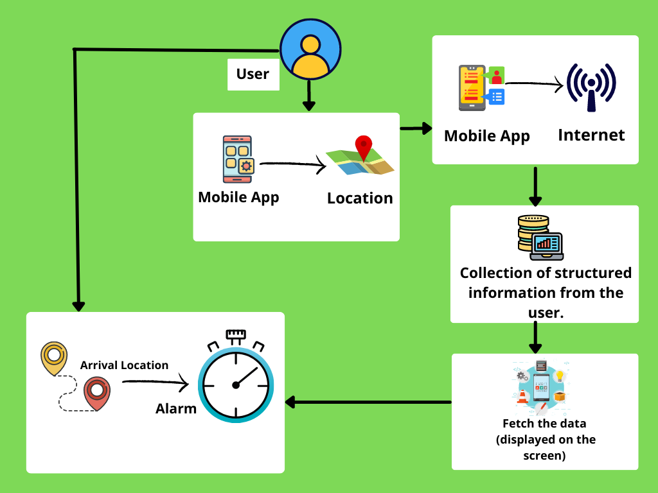**

Figure 1: Physical Architecture Diagram

The Physical Architecture Diagram above shows, how the user will interact with the proposed system, the user will first need to open the location of the mobile phone, after that the user needs to set up the arrival location, and set an alarm on the mobile application, it will notify the user if the arrival location is already nearby.

**System Flowchart**

START

Turn on the Location

Sign in/ Sign up

Sign up

END

Fill up registration form

Set an alarm

Sign in

Figure 2: System Flowchart

**List of Hardware and Software**

**For Development**

**Table 1. Hardware During Development (Developer Side)**

|  |  |
| --- | --- |
| **Hardware** | **Specifications** |
| Laptop | * CPU: AMD Ryzen 3 * Processor: AMD Ryzen 3 3200U with Radeon Vega Mobile Gfx 2.60 GHz * Storage type: HDD * RAM: 4GB * HDD: 1 TB * Memory: 256 GB SSD 4GB * Display size: 15.6" diagonal HD * System type: 64-bit OS * Resolution: 1366x768 |
| Cellphone | * RAM: 4GB * ROM 128GB * Processor: 2.0 GHz Octa-core * Android Version: 11 |

**Table 1.1 Hardware During Development (Client-Side)**

|  |  |
| --- | --- |
| **Hardware** | **Specifications** |
| Cellphone | * At least 3GB RAM * Android Version: at least 6 |

**List of Hardware and Software**

**For implementation**

**Table 2 Software During Implementation (Developer Side)**

|  |  |
| --- | --- |
| **Software** | **Uses** |
| **Android Studio** | - use for the development of the application and implement the algorithm. |
| **Windows 10** | - the compatible operating system for the version of required software, to be installed. |
| **WPS Office and Microsoft Word 2019** | * To compile the information and process for development. |

**Table 2.1 Software During Implementation (Client-Side)**

|  |  |
| --- | --- |
| **Software** | **Uses** |
| * Android Version: at least 6 | - compatible android version to run the application. |

**Chapter IV**

**METHODOLOGY, RESULTS AND DISCUSSION**

The Safety Alarm Security Application has methods that explains various methodologies that were used in gathering data and analysis which are relevant to the research. The methodologies will include areas such as the scope of the study, system design, diagrams, types of data collection method and its process.

**Requirements Analysis**

The Safety Alarm Security Application requires internet connection and gadgets that can access the application.

**Chapter V**

**Results and Discussion**

**References**

*1 in 3 Nurses Have Fallen Asleep While Driving Home From Work Survey*

<https://hellocare.com.au/1-3-nurses-fallen-asleep-driving-home-work/>

<https://stylecaster.com/personal-safety-app/#slide-4>

AT&T Drivemode app : https://www.att.com/support/article/wireless/KM1000730/

**Appendices**

**Curriculum Vitae**

**CURRICULUM VITAE**

**DIANA B. RODRIGUEZ**

#37 Naval Road, Barangay San Miguel

Puerto Princesa City

09456823786

Rodriguezdiana2821@gmail.com

**OBJECTIVES**

IMG_257

● To hone my knowledge and skills and find a company that I can grow with as I achieve their goals.

● To be the best in different fields of work with initiative, perseverance, honesty, patience and hard work.

**PERSONAL BACKGROUND**

IMG_258

Age : 21 years old

Civil status : Single

Date of birth : December 28, 1999

Place of birth : Davao City

Citizenship : Filipino

Height : 5’2

Weight : 60 kilos

Religion : Roman Catholic

Mother : Maria Theresa V. Rodriguez

Occupation : Government Employee

Father : Armando S. Rodriguez

Occupation : Teacher (Palawan State University, Holy Trinity University)

**EDUCATIONAL BACKGROUND**

IMG_259

**Elementary**

Year Graduated : March 2011

School : Tiniguiban Elementary School

Address : Puerto Princesa City, Palawan

**Junior High School**

Year Graduated   : April 2016

School : Sta. Monica High School

Address : Barangay Sta. Monica, Puerto Princesa City

**Senior High School**

Year Graduated : April 3, 2018

School : Palawan State University

Address : Tiniguiban Heights, Puerto Princesa City

**College**

School   : Palawan State University

Address : Tiniguiban Heights, Puerto Princesa City

Level : 3rd Year

**Additional Education Attainment:**

School : Georgia Institute of Technology

: Write Professional Emails in English

: Speak English Professionally: In Person, Online & On the Phone

: Build Your Professional ePortfolio in English

School : Northeastern University

Course : Value Creation: The Carlson-Polizotto Method

School : University of California, Irvine

Course : Effective Problem-Solving and Decision-Making

School : University of Michigan

Course : Programming for Everybody

School : University of Virginia

Course : Customer-Centric IT Strategy

**SKILLS**

IMG_260

● Data Entry

● Computer Literate (word, powerpoint etc.)

● Communication skills

● Photo and Video editing (Intermediate)

● Wordpress Web developer (novice)

● Programming (html,java,c++,python) (novice)

**ORGANIZATION**

\_\_\_\_\_\_\_\_\_\_\_\_\_\_\_\_\_\_\_\_\_\_\_\_\_\_\_\_\_\_\_\_\_\_\_\_\_\_\_\_\_\_\_\_\_\_\_\_\_\_\_\_\_\_\_\_\_\_\_\_\_\_

• Editor-in-Chief in English Journalism, Sta. Monica High School (2015-2016)

• Supreme Student Council (SSG) President, Senior High School at Palawan State University

(2016-2017).

• University Student Council (USG), Judicial Secretary at Palawan State University (2019-2020)

**SPECIAL TRAINING**

\_\_\_\_\_\_\_\_\_\_\_\_\_\_\_\_\_\_\_\_\_\_\_\_\_\_\_\_\_\_\_\_\_\_\_\_\_\_\_\_\_\_\_\_\_\_\_\_\_\_\_\_\_\_\_\_\_\_\_\_\_\_

• Google Apps End User Training Course (November 11, 2014).

• Workshop on Thesis & Dissertation Writing (May 26, 2017)

**WORK EXPERIENCE**

\_\_\_\_\_\_\_\_\_\_\_\_\_\_\_\_\_\_\_\_\_\_\_\_\_\_\_\_\_\_\_\_\_\_\_\_\_\_\_\_\_\_\_\_\_\_\_\_\_\_\_\_\_\_\_\_\_\_\_\_\_\_\_\_\_\_\_\_

• Young radio broadcaster in Family Program at DYPR (2008-2009).

• Work Immersion at Water District (Feb. 5-15, 2018)

• Working at cashier position at Jollibee Rizal. (April 5-July 15 2019)

**ACHIEVEMENTS**

\_\_\_\_\_\_\_\_\_\_\_\_\_\_\_\_\_\_\_\_\_\_\_\_\_\_\_\_\_\_\_\_\_\_\_\_\_\_\_\_\_\_\_\_\_\_\_\_\_\_\_\_\_\_\_\_\_\_\_\_\_\_\_\_\_\_\_\_\_

**•** Received Galing Award for “Most Improved Crew-COUNTER STATION” at Jollibee Rizal.

**CHARACTER REFERENCES**

IMG_261

**Mrs. Angelica Taladtad**

Teacher, Sta. Monica High School

Puerto Princesa City, Palawan

**General Alex Flores**

Brotherhood of Christian Businessmen and Professional

BCBP North, Cell Phone no. 09178007605

**DIANA RODRIGUEZ**

Applicant