# Survival Analysis--Cox model

## Survival curve

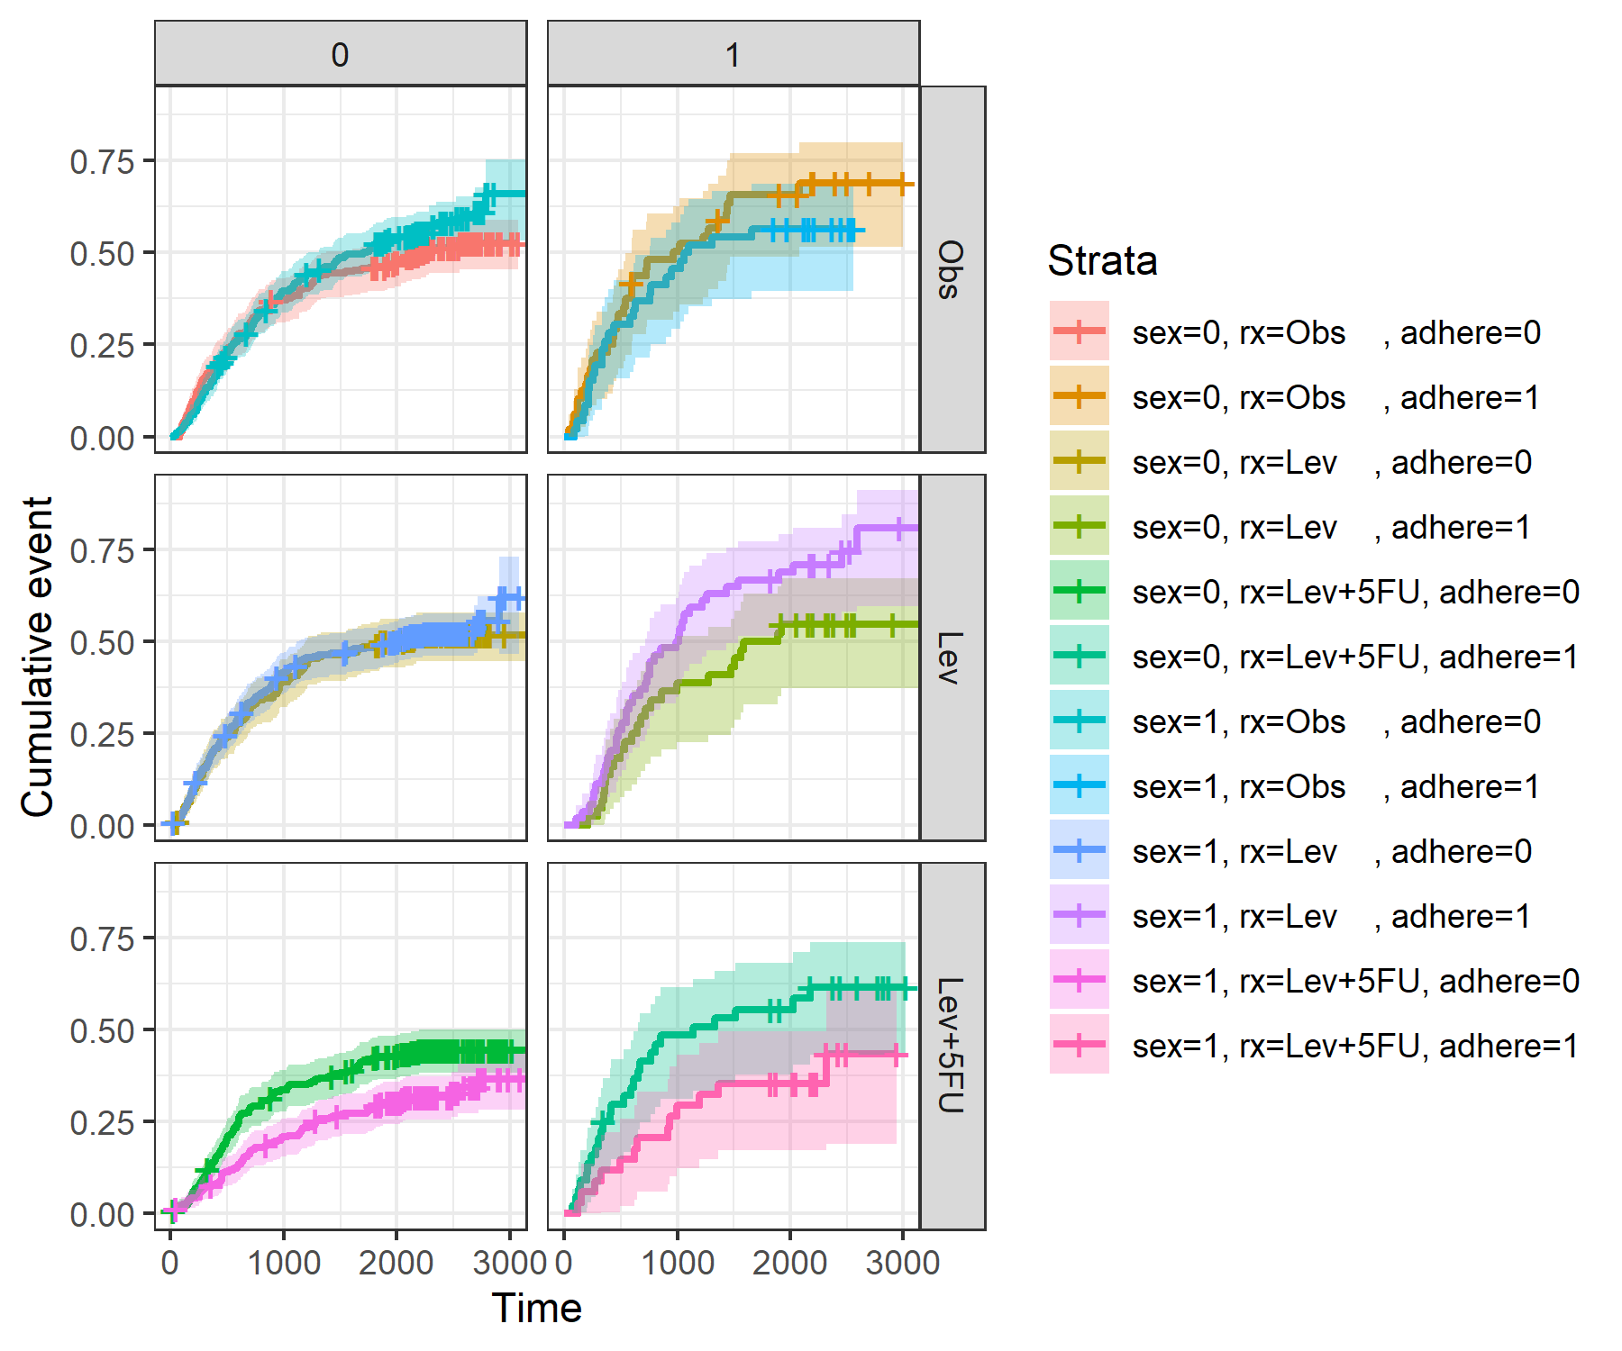

# Coefficients estimate

| coef | exp(coef) | se(coef) | z | Pr(>|z|) |
| --- | --- | --- | --- | --- |
| -0.04614856 | 0.9549001 | 0.06608775 | -0.6982922 | 4.849945e-01 |
| -0.02723627 | 0.9731313 | 0.07690162 | -0.3541703 | 7.232112e-01 |
| -0.43723064 | 0.6458225 | 0.08395129 | -5.2081470 | 1.907358e-07 |
| 0.29354836 | 1.3411780 | 0.08696089 | 3.3756366 | 7.364513e-04 |