Acquiring Repositories Locally
Git enables users to clone hosted repositories in a local directory to be able to work on it locally.
As Git enables creation and saving changes without network connection, one can choose to synchronize repositories at a later time. (Done through the ‘Push’ and ‘Pull’ commands) This is very powerful as developers don’t need to be always connected to be able to work and one can sync work changes, additions and the likes at a later time while still preserving all the timestamps and comments in the local commits.
There are three ways of doing this namely:
- Clone from web
- Clone via personal repo list in GitHub Desktop
- Clone via SSH or HTTPS URL

Clone from web

Clone via personal repo list in GitHub Desktop
To use GitHub Desktop, you first need to get GitHub account.
If you don’t have one yet you can create a free account at:
https://GitHub.com/join
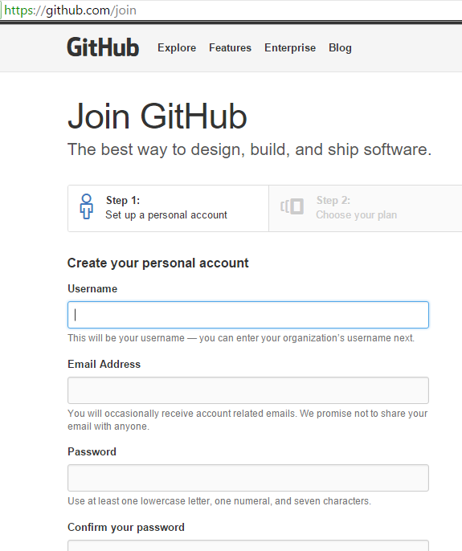
Now you need to install the GitHub desktop software to your computer.
Again, this is free and can be downloaded at:
https://desktop.GitHub.com/.

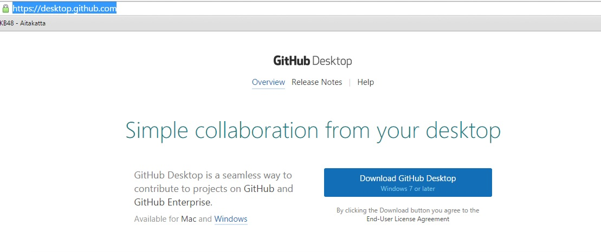

After GitHub Desktop finishes installing, you will be prompted to login.
Just enter you GitHub account details.
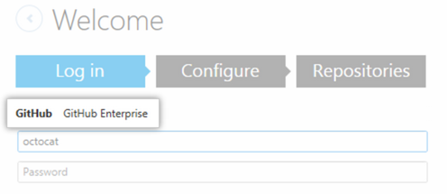

You can also use the Option Menu to login and configure your GitHub Desktop.
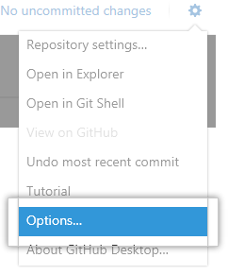

In the top left corner click, + (GitHub Desktop Help, 2015)


Then at the top of the menu click, Clone

In the left sidebar, do one of the following:
- To work with a personal repository, select your username.
- To work with a repository that belongs to an organization you're a member of, select the name of the organization.
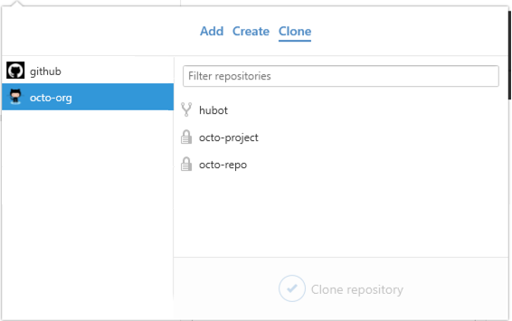
· In the list of repositories for the selected account, click the repository you'd like to clone.
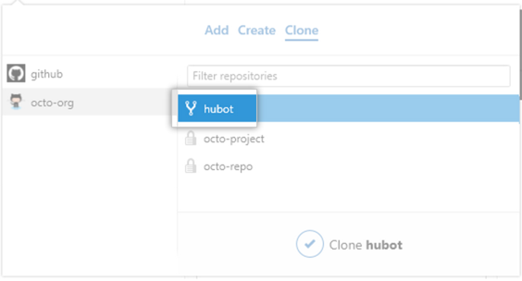

• At the bottom of the menu, click Clone REPOSITORY. (GitHub Desktop Help, 2015)
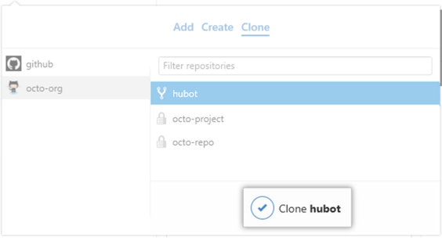
GitHub Desktop Help (2015). Retrieved from https://help.GitHub.com/desktop/guides/getting-started/authenticating-to-GitHub/.
² GitHub Desktop Help (2015). Retrieved from https://help.GitHub.com/

Clone via HTTPS URL
To clone via an HTTPS URL, the first thing you need to do is to look for the repository you want to clone. You can do this through GitHub.
Once you decided on the repository you want to clone you need to copy the HTTPS clone URL.
This is where you will find the link you need to copy:
