

OJT TIMESHEET MONITORING SYSTEM

In Partial Fulfillment of the Requirements in

**INFORMATION TECHNOLOGY**

SS7 – Special Project

*Under the supervision of*

***Jerick Carlo Almeda***

*Submitted by:*

***Ralph Vin Joe J. Oliveros***

***Ivanne Karl M. Sombol***

***Yisha J. Villarin***

***March 2023***

Introduction

This project's goal is to assist the OJT coordinator, Supervisors, and grade 12 ICI intern students in monitoring their development, accumulated working hours, and other important information. This project will help grade 12 ICI intern students make it easy for them to track, compute and record their on-the-job training hours, complete the necessary number of hours for their course, and give their school a clear record of their progress. The importance of an OJT timesheet monitoring system can be seen in its capacity to enhance the process of monitoring and controlling grade 12 ICI trainees' work hours, activities, and progress, it also offers a more effective, time-saving, real-time tracking, and accurate progress updates to monitor grade 12 ICI trainees' work hours and development during their on-the-job training. This project also provides supervisors with real-time visibility into the progress of each trainee. The system may be used by the supervisor and OJT coordinator to check if a trainee has completed the required number of safety training hours. Supervisors can more effectively assess trainees' performance by keeping track of the number of hours they work. OJT Coordinator manages all of this data, including files and information contained within the system, as well as registering user accounts for Supervisors. In general, an OJT timesheet tracking system may assist supervisors and the OJT coordinator in better manage their trainees and enhance training outcomes.

Background of the Study

A thorough analysis of the quality of on-the-job practices in ICI, including the present techniques for monitoring and controlling the activities and hours that grade 12 ICI trainees engage in during their OJT will also be examined as part of this study, along with their drawbacks such as manually recording their time and development during the on-the-job training, also OJT coordinator and supervisors will not be provided a copy of the recorded hours and progress of the ICI OJT trainees, thus they have no clue whether or not a trainee is about to finish or has finished the required hours in his/her on-the-job training. The background of the study would offer a thorough overview of the condition of OJT practices in ICI at present and the potential contribution of technology to their improvement. It would also examine the growing relevance of using technology to advance OJT processes, including how online timekeeping and management tools are used, as well as their advantages and disadvantages. Additionally, it would serve as a preamble to the research, underlining the need for a better response to the concerns that OJT coordinator, supervisors, and grade 12 ICI intern students who are participating in on-the-job training face, as well as the possible advantages of this project an OJT online timesheet monitoring system.

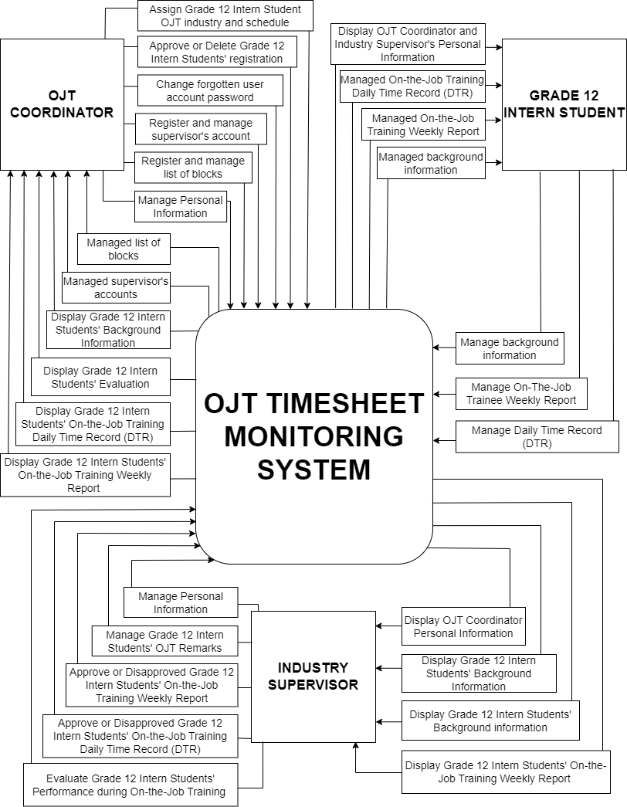Context Diagram

Users Description

There are three users in this system, the Grade 12 ICI Intern Students, OJT Coordinator, and Supervisors.

**Grade 12 ICI Intern Students** – Provides background information that the system requires to identify them and communicate with them about their timesheets, Grade 12 ICI Intern Students can log in to the system and requires to update detailed information about their on-the-job trainee weekly report and daily time record report (DTR).

**OJT Coordinator** - The OJT Coordinator, who also serves as the system administrator for the entire system, is in charge of managing all the data, files, and information stored within the system. Is also able to register accounts for Supervisors and change user accounts' forgotten passwords. The OJT Coordinator is in charge of adding and removing users from the system and controlling their access to it. The program provides the OJT Coordinator access to Grade 12 ICI Intern Students’ background Information, daily time record (DTR), and on-the-job trainee weekly report. The system also allows OJT Coordinator to have the capability to approve or decline the Grade 12 ICI Intern Students’ overall records.

**Industry Supervisors** – Industry Supervisors can also log in to the system and has access to Grade 12 ICI Intern Students’ background Information, daily-time-record (DTR), and on-the-job trainee weekly report. The system also enables Industry Supervisors to approve or decline the Grade 12 ICI Intern Students updated daily time record and on-the-job trainee weekly reports, and also evaluate the Intern student performance.

Systems Description

The OJT Timesheet Monitoring System is a system that may be very useful for Grade 12 ICI Intern Students, the OJT Coordinator, and Industry Supervisors since it makes it simple to access and manage trainee records such as background information, daily time records, and weekly reports. The procedure of updating all the records that the intern students needed to is made simpler by this system. Features of the system might include logging in and keeping daily work records, showing the total hours worked, creating reports, and updating information. The system assures users of effective and reliable functions in the program.

Scope and Limitation

The OJT Timesheet Monitoring System will cover the information of the ICI Grade 12 Intern students, OJT coordinator, and Industry supervisors. A database is provided to hold data and files such as:

**OJT COORDINATORS** - manages the entire system including users' access to the program and is in charge of all the data, files, and information it contains. Responsible to troubleshoot any issues that arise with the system, also in charge of choosing the company that the Grade 12 Interns will work for. Having the authority to approve or decline the overall records of Grade 12 ICI Intern Students.

**INDUSTRY** - Depending on where the intern students were assigned, this contains information on the supervisors and the company. Have access to evaluate the performance of Grade 12 Intern Students during On-the-Job Training.

**DAILY TIME RECORD** - information on the intern student’s daily time record, including their ID number, learner reference number (LRN), the date that their on-the-job training starts, time in and out, the number of hours worked, and remarks.

**EVALUATION** - shows the Grade 12 Intern student’s evaluation records, considering the job knowledge, quality of work, quantity of work, dependability, initiative, conduct, decision making, interpersonal skills, attendance, personal appearance, recommendation, supervisor’s name, designation, and the overall rating.

**GRADE 12 ICI INTERN STUDENTS** - holds the personal information of the Grade 12 Intern Students, such as the full name, learner reference number, email address, mobile number, password, current school, industry, course, required training hours, home address, birth date, place of birth, gender, nationality, marital status, religion, height, skills, qualifications, and picture of the Grade 12 Intern Students.

**WEEKLY REPORT** - information such as learner reference number (LRN), number of weeks, date started, number of working hours, description of task, and progress.

This system was created specifically for the adoption of the online OJT Timesheet Monitoring System, and exclusive only ICI Grade 12 Intern students, OJT coordinators, and industry supervisors have access to it.

The ICI Grade 12 Intern Students must provide their personal information and records during their on-the-job training.

The OJT Coordinator will also serve as a system administrator that has the power to manage all system transactions.

Purposes and Objectives

The purpose of such a system is to provide a reliable record of the ICI Grade 12 Intern Students during their on-the-job training, the objective of this project is to help OJT coordinators, industry supervisors, and grade 12 ICI intern students keep track of their progress, acquired working hours, and other important information. The System Administrator who serves as the OJT Coordinator will play a big role to make the system run successfully, they ensure that the right users have access to the right features. The main goal of this project is to provide an interactive online OJT timesheet tracking system for the system's users.

Use Case Diagram

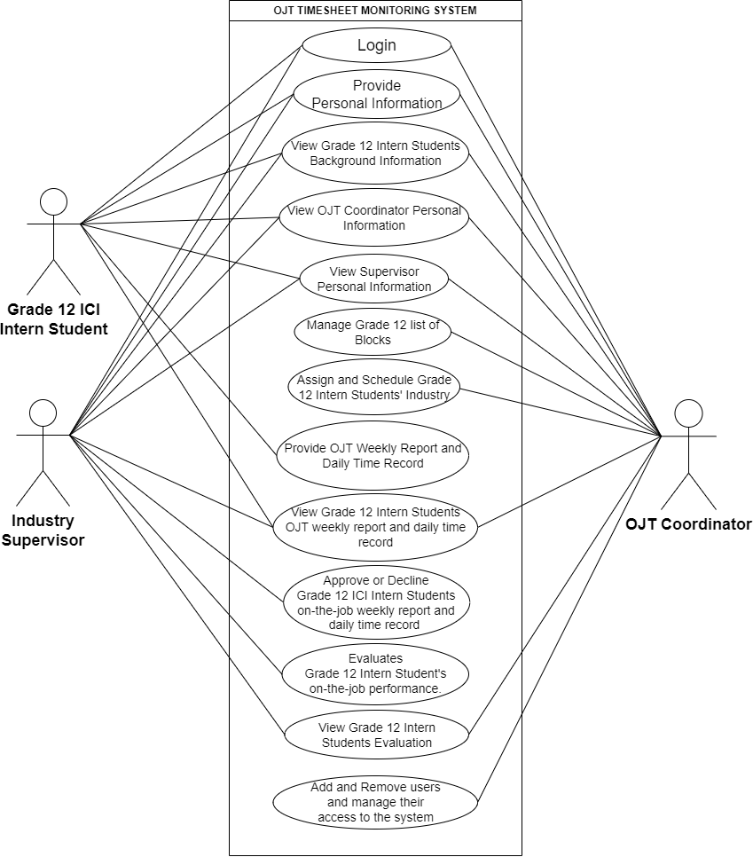

Use Case Specification: *Login*

**Brief Description**

This use case allows the Grade 12 Intern Student, OJT Coordinator, and Supervisor to register and log in to the system.

1. **Flow of Events**
   1. ***Basic Flow -*** (The use case starts when the Grade 12 Intern Student, Supervisor, or OJT Coordinator wants to log in to the system.)
      1. The system displays the login form containing the LRN or username and password and the login button.
      2. The system asks the Grade 12 Intern Student, Supervisor, or OJT Coordinator to input his/her learner reference number (LRN) and password.
      3. The Grade 12 Intern Student, Supervisor, or OJT Coordinator fills up their learner reference number or username and password.
      4. The system validates the learner reference number (LRN) or username and password in the database and then logs in the user to the system.
   2. ***Alternative Flow(s)***

(Empty required fields.)

* + 1. The system will display an error message “Please fill out this field.”

(Invalid LRN/username and/or password.)

* + 1. The system will display an error message “Invalid LRN/Username or Password!”

(Account is waiting for approval.)

* + 1. The system will display an error message “Please wait, your account is being processed!”

1. **Precondition**

To access the login system, the Grade 12 intern student must first complete the registration process and obtain approval from the OJT Coordinator.

Before supervisors can log in, their accounts must be registered by the OJT coordinator. The OJT coordinator will handle the process of registering the supervisors' accounts, ensuring that they have the necessary credentials to access the system.

1. **Post-conditions**

If the Login is successful, a message will be displayed: “Logged in Successfully!”

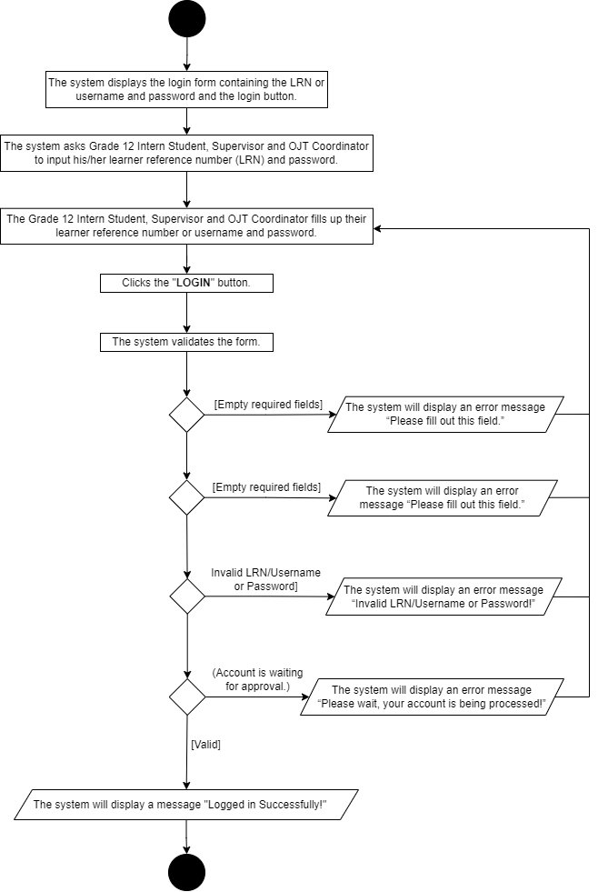Activity Diagram: Login

Use Case Specification: *Register*

**Brief Description**

This use case allows Grade 12 Intern Students to create accounts and register in the system.

1. **Flow of Events**
   1. ***Basic Flow -*** (The use case starts when the Grade 12 Intern wants to register to the system.)
      1. The Grade 12 Intern Student opens the registration form.
      2. The system displays the registration form to the Grade 12 Intern students, requiring them to provide their personal information, including their learner reference number and password.
      3. The Grade 12 Intern Student fills up the registration form.
      4. The system validates the entries and registers the Grade 12 Intern Student to the system.
   2. ***Alternative Flow(s)***

(Empty Required Fields)

* + 1. The system will display a message “Please fill out this field!”

(Learner Reference Number (LRN) must not exceed or less than 12 digits)

* + 1. The system will display an error message “LRN must be 12 digits!”.

(Learner Reference Number (LRN) already exists)

* + 1. The system will display an error message “LRN already exists!

(Password does not match)

* + 1. The system will display an error message “Password does not match!”

(Password contains 8 characters, 1 uppercase, 1 lowercase, and a number)

* + 1. The system will display an error message “Your password must be at least 8 characters long and contain at least one uppercase letter, one lowercase letter, and one number.”

1. **Precondition**

To register in the system, the user must be a Grade 12 intern student who is currently enrolled at Iligan Computer Institute.

1. **Post-conditions**

If the registration is successful, a message will be displayed: “Your account has been registered! Please wait for approval.”

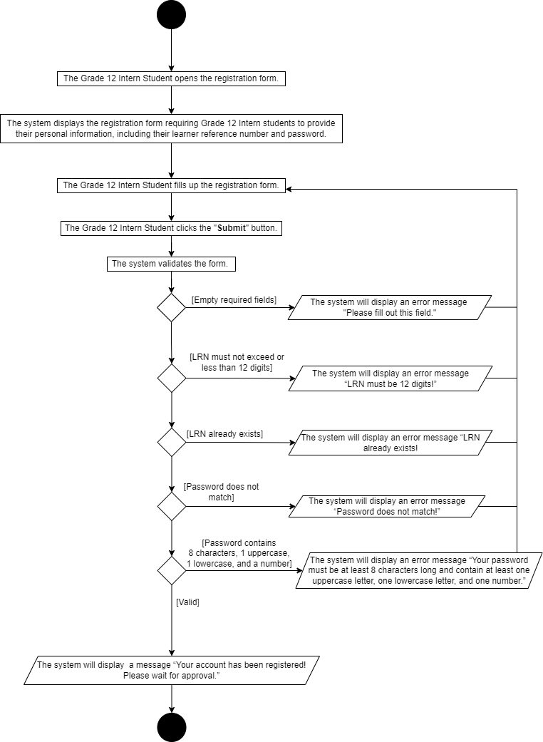 Activity Diagram: Register

Use Case Specification: *Weekly Report*

**Brief Description**

This use case allows Grade 12 Intern Students to record and keep track of their weekly reports during on-the-job training.

1. **Flow of Events**
   1. ***Basic Flow -*** (The use case starts when the Grade 12 Intern Students have logged on to the system and clicked the weekly report tab at the top of the screen.)
      1. **Add**
         1. The system displays the weekly report form containing the week, date, hours, description of tasks, progress, date of completion, remarks, and operation during the on-the-job training of the Grade 12 Intern Students.
         2. The Grade 12 Intern Student clicks the “Add” button.
         3. The system displays a blank form.
         4. The Grade 12 Intern Student inputs their weekly task progress in the form.
         5. The Grade 12 Intern Student clicks the “Submit” button.
         6. The system displays a message “Successfully added!”
      2. **Edit**
         1. The Grade 12 Intern Student clicks the “Edit” button.
         2. The system displays a form containing the updated weekly task progress report ready for editing.
         3. The Grade 12 Intern Student edits the weekly report if needed.
         4. The Grade 12 Intern Student clicks the “Update” then the system updates the weekly task progress report.
      3. **Delete**
         1. The Grade 12 Intern Student clicks the “Delete” button.
         2. The system will display a message to confirm the deletion: “Are you sure you want to delete this data?”
         3. The Grade 12 Intern Student has two options; delete the entire data or cancel the deletion.
   2. ***Alternative Flow(s)***

(Empty required fields)

* + - 1. If the Grade 12 Intern Student saves the form with blank fields that need to be filled in.
      2. The system will display an error message “Please fill out this field.”

(Cancel)

* + - 1. The Grade 12 Intern Student clicks the “Cancel” button.
      2. The form will close and the system will return to the blank weekly report form.

1. **Precondition**

The Grade 12 Intern Student must first log in to the system before he/she can make changes in the files.

Before a Grade 12 Intern student can make changes to the files, they must first be assigned to an industry by the OJT Coordinator.

1. **Post-conditions**

If the Grade 12 Intern Student successfully submit and updated their weekly task progress report, this use case is successful but if not, the system remains unchanged.

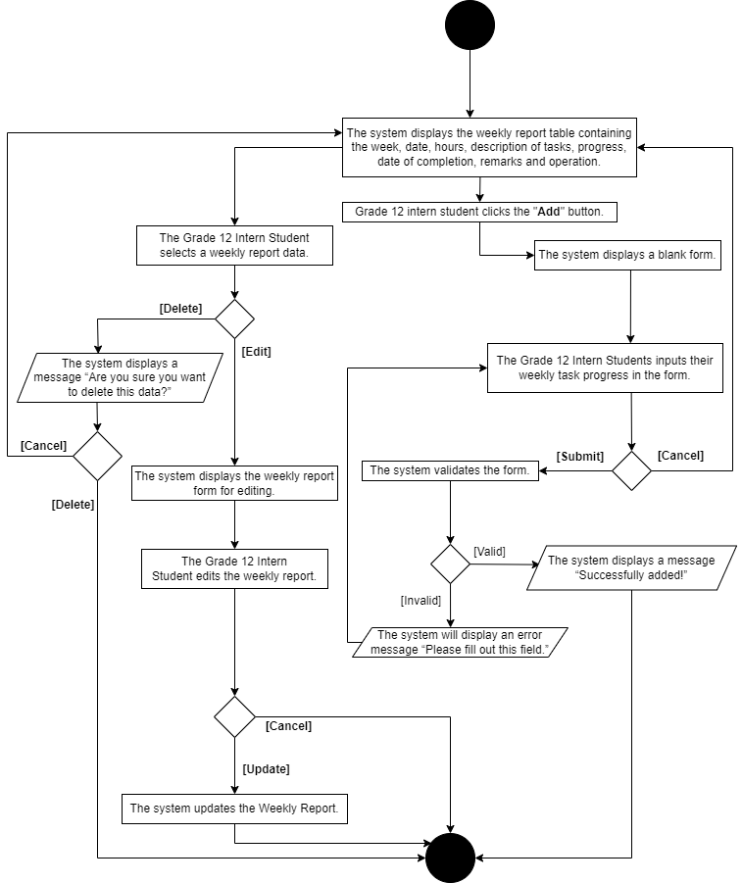Activity Diagram: *Weekly Report*

Use Case Specification: *Daily Time Record*

**Brief Description**

This use case allows Grade 12 Intern Students to record and monitor their daily time record during on-the-job training

1. **Flow of Events**
   1. ***Basic Flow -*** (The use case starts when the Grade 12 Intern Student has logged on to the system and clicked the daily time record at the top of the screen.)
      1. **Punch In**
         1. The system displays the daily time record form containing the date, time in, time out, total hours, and remarks.
         2. The Grade 12 Intern Student clicks the “Punch In” button.
         3. The system displays a message stating two options: “Do you want to manually **Input** your time or do you want to **Punch In** directly?”
         4. The Grade 12 Intern Student can either “Input” to their daily time record manually or “Punch In” directly, depending on their liking.
         5. The Grade 12 Intern Student clicks the “Input” button.
         6. The system displays a blank form for daily time record inputs.
         7. The Grade 12 Intern Student inputs daily time records in the form.
         8. The Grade 12 Intern Student clicks the “Submit” button.
         9. The system displays a message “Successfully added!”
      2. **Punch Out**
         1. The Grade 12 Intern Student clicks the “Punch Out” button.
         2. The system displays a message stating two options: “Do you want to manually Input your time or do you want to Punch Out directly?”
         3. The Grade 12 Intern Student can either “Input” to their daily time record manually or “Punch Out” directly, depending to their liking.
         4. The Grade 12 Intern Student clicks the “Input” button.
         5. The system shows a non-editable date and time in the field, along with a blank time-out form, for daily time record inputs.
         6. The Grade 12 Intern student inputs the time out for their daily time record in the provided form.
         7. The Grade 12 Intern Student clicks “Submit” button.
         8. The system displays a message “Successfully Updated!”
      3. **Delete**
         1. The Grade 12 Intern Student clicks the “Delete” button.
         2. The system will display a message to confirm the deletion: “Are you sure you want to delete this data?”
         3. The Grade 12 Intern Student has two options; delete the entire data or cancel the deletion.
   2. ***Alternative Flow(s)***

(Require Input fields)

* + 1. The system will display an error message “Please fill out this field.”

(Required hour for time in and time out)

* + 1. The system will display a message “Your working hours must be longer than one hour.”

(Input date is before the assigned date)

* + 1. The system will display an error message “Error: Date cannot be before (Assigned Date).”

(Cancel)

* + 1. The Grade 12 Intern Student clicks the “Cancel” button.
    2. The form will close and the system remains unchanged.

1. **Precondition**

The Grade 12 Intern Student must first log in to the system before he/she can make changes in the files.

Before a Grade 12 Intern student can make changes to the files, they must first be assigned to an industry by the OJT Coordinator.

1. **Post-conditions**

If the Grade 12 Intern Student successfully submit and updated their daily time record, this use case is successful. But if not, the system remains unchanged.

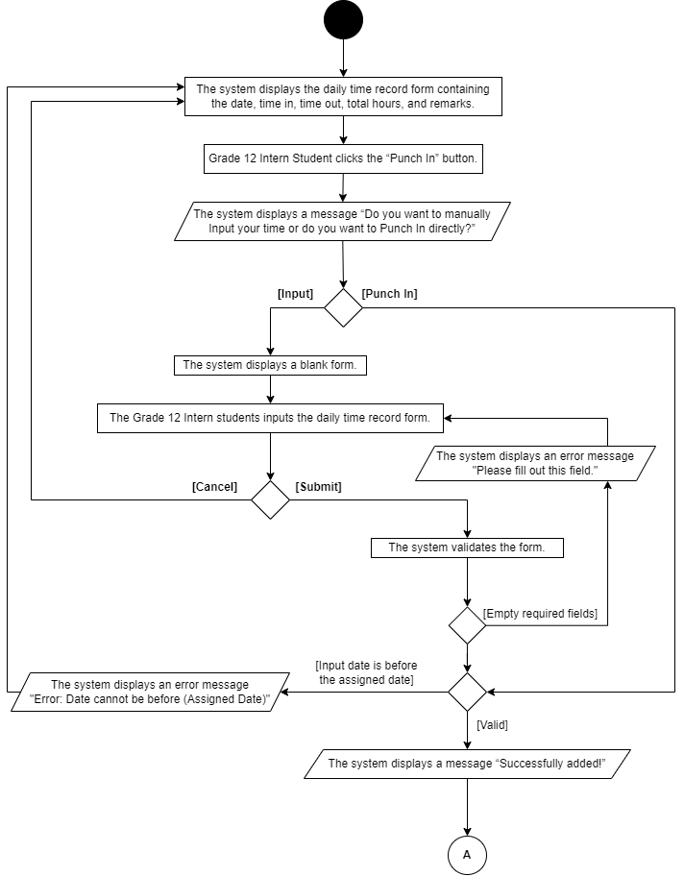Activity Diagram: *Daily Time Record*

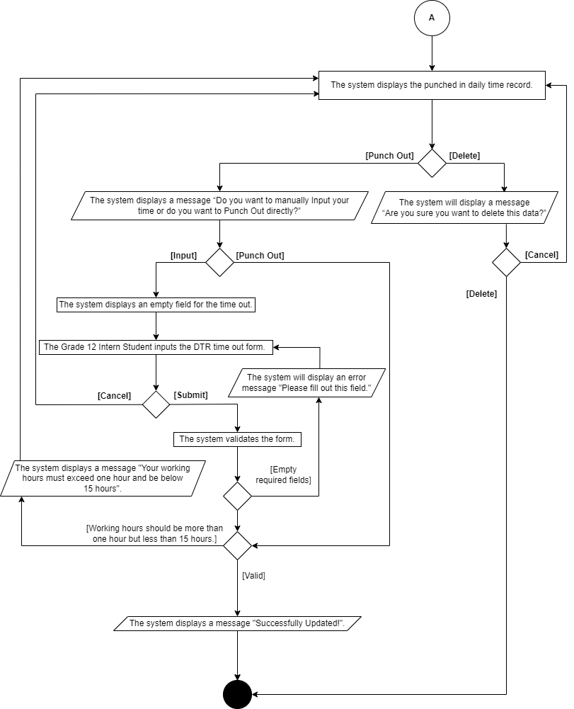

Use Case Specification: *Profile Settings*

**Brief Description**

This use case allows Grade 12 Intern Students, OJT Coordinator and Supervisor to provide and change their personal information, picture, and password.

1. **Flow of Events**
   1. ***Basic Flow -*** (The use case starts when the Grade 12 Intern Students, OJT Coordinator, and Industry Supervisor successfully log into the system. Once logged in, they navigate to the right part of the navigation bar, click on their respective names, and then select "Profile Settings.")
      1. The system displays a form that presents the personal information, picture, and password fields for the Grade 12 Intern Student, OJT Coordinator, and Supervisors.
      2. The Grade 12 Intern Student, OJT Coordinator, and Industry Supervisor provide and can edit their personal information including their password in the system.
      3. The Grade 12 Intern Student, OJT Coordinator, and Supervisor input or change their personal information, picture, or password in the system"
      4. The Grade 12 Intern Students, OJT Coordinator, and Supervisors click the “Save Changes” button, and the system state change.
      5. The system will display a message “Successfully Updated!”
   2. ***Alternative Flow(s)***

(Incorrect Current Password)

* + 1. The system allows the Grade 12 Intern Student, OJT Coordinator, and Supervisor to input their new password and the confirmation of their new password.
    2. If the current password is incorrect the system will display a message “Current password is incorrect!”

(Empty Required Fields)

* + 1. When the Grade 12 Intern student inputs the current password but leaves the new password and confirm password fields empty, the system displays an error message "Please fill up the new password and confirm password field!"

(New password must not be the same as the current password)

* + 1. If the new password is the same as the current password the system will display a message “New password is the same as the current password!”

(New password and confirm password do not match)

* + 1. If the confirmation of the new password does not match the system will display a message “New password and confirm password does not match!”

(Password contains 8 characters, 1 uppercase, 1 lowercase, and a number)

* + 1. The Grade 12 Intern Student, OJT Coordinator and Supervisor must provide a minimum of eight-character password is required, and it must include at least one uppercase, one lowercase, and one number.
    2. If not, the system will display a message “Your password must be at least 8 characters long and contain at least one uppercase letter, one lowercase letter, and one number.”

(Image must be in jpg, jpeg, and png format)

* + 1. The system will display an error message “Only JPG, JPEG, and PNG files are allowed.”

1. **Precondition**

The Grade 12 Intern Student, OJT Coordinator, and Supervisors must first log in to system, before he/she can make changes in the files.

1. **Post-conditions**

If the Grade 12 Intern Student successfully edits and updated personal information, this use case is successful but if not, the system remains unchanged.

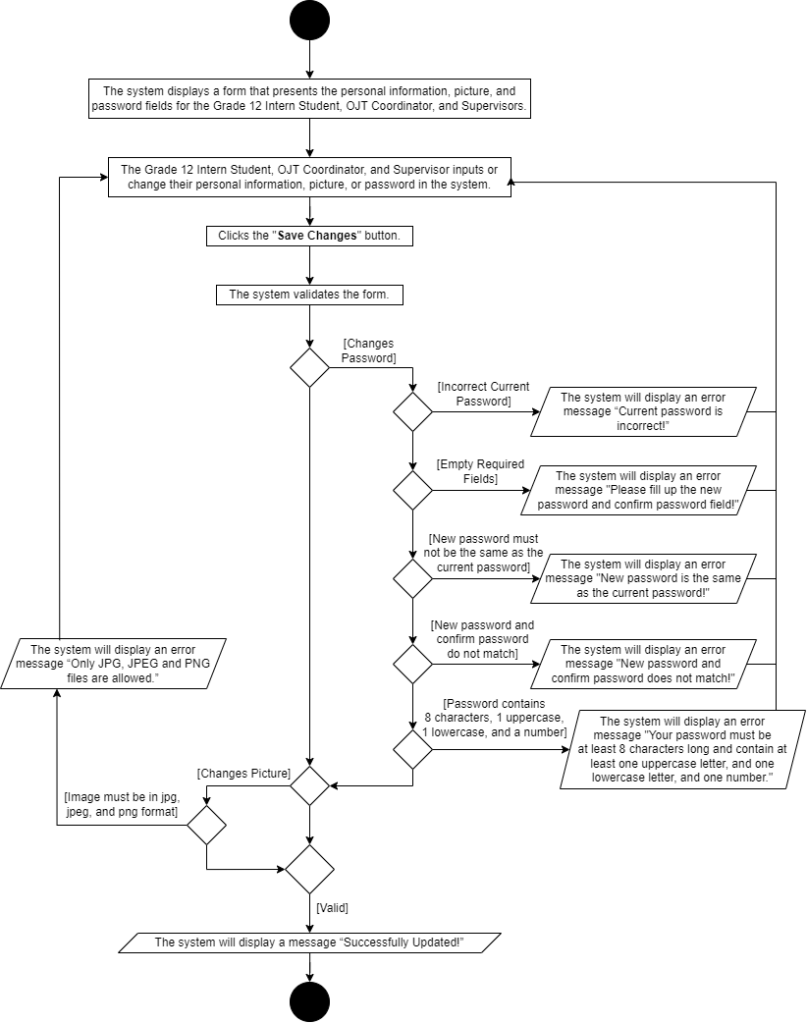Activity Diagram: *Profile Settings*

Use Case Specification: *Manage Grade 12 Intern Students’ Weekly Reports, Daily Time Records, and Evaluation*

**Brief Description**

This use case allows the Industry Supervisor to view and edit the Grade 12 Intern Students’ information, reports, and evaluation.

1. **Flow of Events**
   1. ***Basic Flow -*** (The use case starts when the Industry Supervisor logs in, they are presented with a list of Grade 12 Intern Students' names, allowing them to edit the reports and remarks associated with each student.)
      1. **Edit**
         1. The Industry Supervisor clicks the “edit” button.
         2. The system displays a form containing the Grade 12 Intern Students’ remarks ready for editing.
         3. The Industry Supervisor edits the Grade 12 Intern Student’s remarks.
         4. The Industry Supervisor clicks the “Update” button.
         5. The system displays a message “Successfully Evaluated!”
      2. **View**
         1. **Profile Info**
            1. The Industry Supervisor clicks the “Profile Info” tab.
            2. This tab provides the Grade 12 Intern Students’ personal information.
         2. **DTR Report**
            1. The Industry Supervisor clicks the “DTR Report” tab.
            2. This tab provides the Grade 12 Intern Students’ daily time record reports.

**1.1.2.2.3. Edit**

After the Industry Supervisor chooses a DTR report from the list.

The Industry Supervisor clicks the “Edit” button.

The system displays a form containing the Grade 12 Intern Student’s chosen DTR report and remarks.

The Industry Supervisor edits the Grade 12 Intern Student remarks regardless of whether the associated records are to be approved or disapproved.

The Industry Supervisor clicks the “Update” button.

The system displays a message “Remarks Updated!”.

* + - 1. **Weekly Report**
         1. The Industry Supervisor clicks the “Weekly Report” tab.
         2. This tab provides the Grade 12 Intern Students weekly progress reports during OJT.

1. **Edit**
2. After the Industry Supervisor chooses a Weekly Report from the list.
3. The Industry Supervisor clicks the “Edit” button.
4. The system displays a form containing the Grade 12 Intern Student’s weekly progress report and remarks.
5. The Industry Supervisor edits the Grade 12 Intern Student remarks regardless of whether the associated records are to be approved or disapproved.
6. The Industry Supervisor clicks the “Update” button.
7. The system displays a message “Remarks Updated!”.
   * + 1. **Evaluation**
          1. The Industry Supervisor clicks the “Evaluation” tab.
          2. The system displays a blank form containing the Grade 12 intern student's Evaluation.
          3. The Industry Supervisor evaluates the Grade 12 Intern Students’ performance during on-the-job training by rating them.
          4. The Industry Supervisor clicks the “Update” button.
          5. The system displays a message “Remarks Updated!”
   1. ***Alternative Flow(s)***

(Cancel)

* + 1. The Industry Supervisor clicks the “Cancel” button.
    2. The form will close and the system will remain unchanged.

1. **Precondition**

The Industry Supervisor can only make file modifications if they log in to the system and the OJT Coordinator has already assigned Grade 12 Intern students to their industries.

1. **Post-conditions**

If the Industry Supervisor successfully updated the Grade 12 Intern Students’ remarks, this use case is successful but if not, the system remains unchanged.

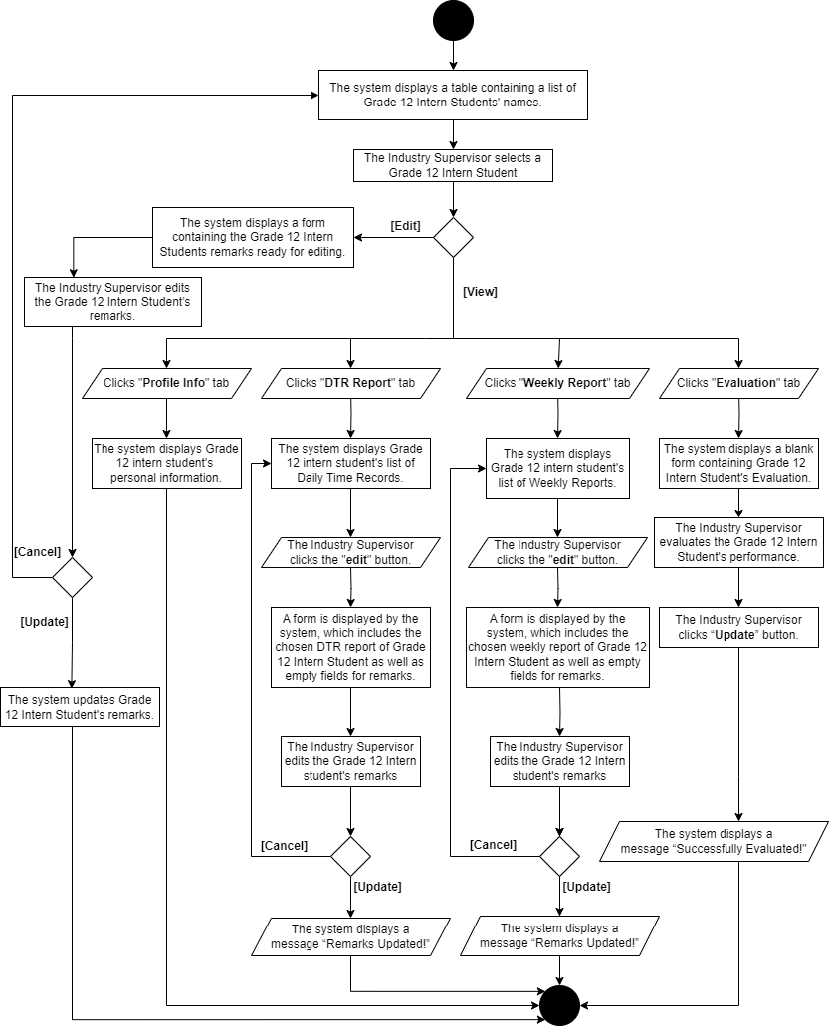Activity Diagram: *Manage Grade 12 Intern Students’ Weekly Reports, Daily Time Records, and Evaluation*

Use Case Specification: *Manage Grade 12 Intern Students OJT Industries and Schedules*

**Brief Description**

This use case allows the OJT Coordinator to assign and schedule Grade 12 Intern Students in their industries, with access to their profiles, daily time records, weekly reports, and evaluations.

1. **Flow of Events**
   1. ***Basic Flow -*** (The use case starts when the OJT Coordinator logs into the system. The OJT Coordinator is presented with a list of student names, enabling efficient management of the allocation of industries and schedules for Grade 12 Intern Students.)
      1. **View**
         1. After the OJT coordinator choose a Grade 12 Intern Student’s name from the list of students.
         2. The OJT coordinator clicks the “View” button.
         3. The system displays the profiles, daily time records, weekly reports, and evaluation of Grade 12 Intern Students remarked by the industry supervisor.
      2. **Assign**
         1. The OJT coordinator clicks the “Assign” button.
         2. The system displays a form that allows the OJT coordinator to input the assigned industry, start date, schedule, and required number of hours for the chosen Grade 12 Intern Student.
         3. The Industry Supervisor inputs the required fields.
         4. The Industry Supervisor clicks the “Submit” button
         5. The system will display a message “Successfully Assigned!”
   2. ***Alternative Flow(s)***.

(Cancel)

* + - 1. The OJT coordinator clicks the “Cancel” button.
      2. The form will close and the system will remain unchanged.

(Empty Industry Selection)

* + - 1. The system displays an error message “Please select an item in the list.”

(Empty Start Date)

* + - 1. The system displays an error message “Please fill out this field.”

(The minimum required number of hours must be greater than or equal to 80)

* + - 1. The system displays an error message “Value must be greater than or equal to 80.”

1. **Precondition**

The OJT Coordinator must first log in to the system before he/she can make changes in the files.

The OJT Coordinator is only authorized to make changes in the files once the registration of the Grade 12 Intern Student has been formally approved.

1. **Post-conditions**

If the OJT Coordinator successfully edit and submit the Grade 12 Intern Students assign form, this use case is successful but if not, the system remains unchanged.

Activity Diagram: *Manage Grade 12 Intern Students OJT Industries and*

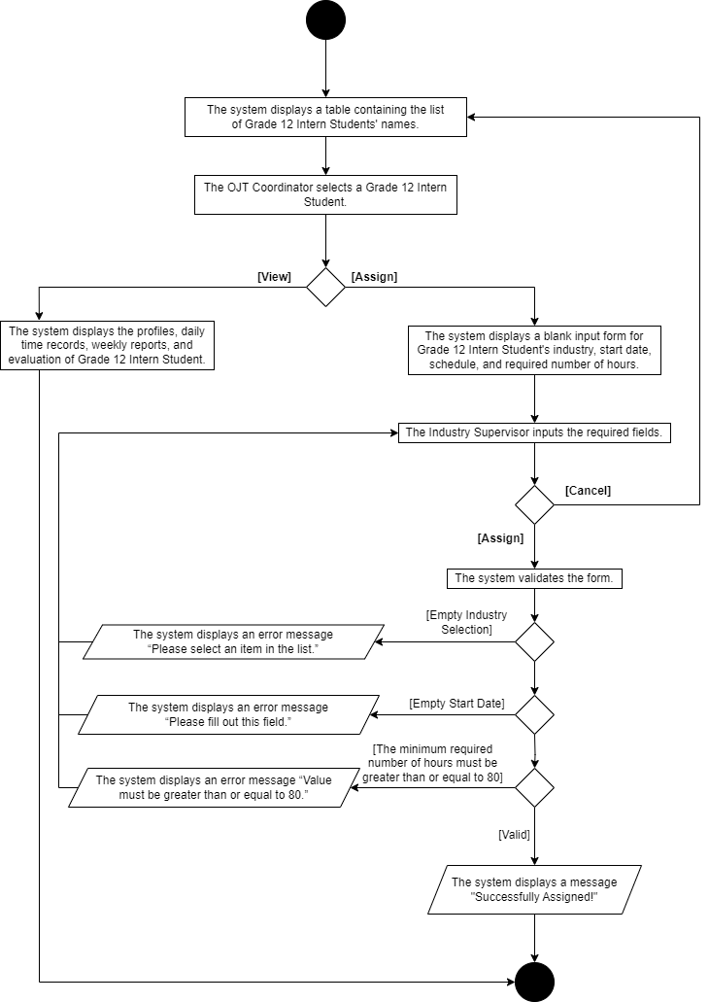*Schedules*

Use Case Specification: *Manage Grade 12 Intern Student’s Registration*

**Brief Description**

This use case allows the OJT Coordinator to approve or delete Grade 12 Intern Students who register in the system. It also enables the OJT Coordinator to reset or change the Grade 12 Intern Students' current password to a predefined default password.

1. **Flow of Events**
   1. ***Basic Flow -*** (The use case starts when the OJT Coordinator logs into the system. The OJT Coordinator is presented with a list of student names who have registered, enabling efficient management of the Grade 12 Intern Students.)
      1. **View**
         1. After the OJT coordinator choose a Grade 12 Intern Student’s name form the list of students.
         2. The OJT coordinator clicks “View” button.
         3. The system displays the Personal Information of Grade 12 Intern Students, which is essential for the registration approval process.
      2. **Approve**
         1. The OJT coordinator clicks the “Approve” button.
         2. The system displays a message “Are you sure you want to approve this student?”
         3. The OJT coordinator clicks the “Approve” button.
         4. The system displays a message “Successfully Approved!”
      3. **Delete**
         1. The OJT Coordinator clicks the “Delete” button.
         2. The system displays a message “Are you sure you want to delete this student?”
         3. The system displays a message “Successfully Deleted!”
      4. **Change Password**
         1. The OJT Coordinator clicks the “Change” button.
         2. The system displays a message “Are you sure you want to change (Grade 12 Intern Student) password?”
         3. The OJT Coordinator clicks the “Change” button.
         4. The system displays a message “Password Successfully Changed!”
   2. ***Alternative Flow(s)***.

(Cancel)

* + - 1. The OJT coordinator clicks the “Cancel” button.
      2. The form will close and the system will remain unchanged.

1. **Precondition**

The OJT Coordinator must first log in to the system before he/she can make changes in the files.

The OJT Coordinator can only manage the Grade 12 Intern Student's account after they have registered in the system.

1. **Post-conditions**

The OJT Coordinator successfully approved or delete the Grade 12 Intern Students registration.

Activity Diagram: *Manage Grade 12 Intern Student’s Registration*

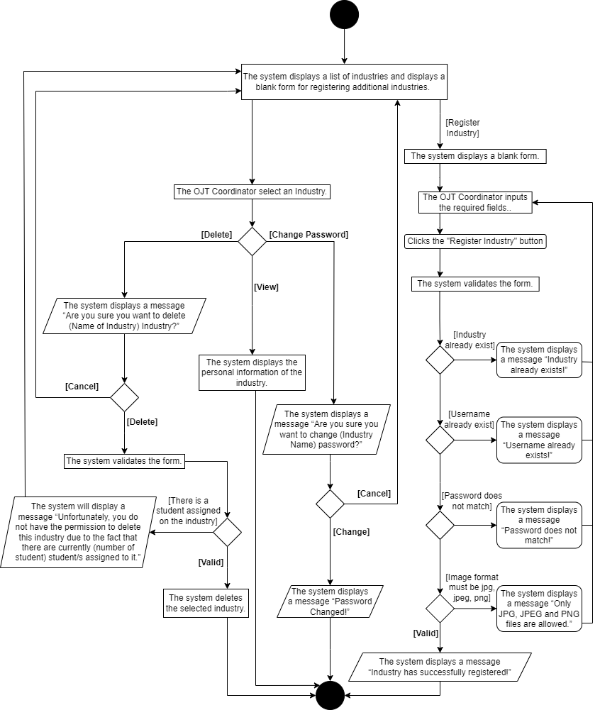

Use Case Specification: *Manage Grade 12 Intern Students List of Blocks*

**Brief Description**

This use case allows the OJT Coordinator the ability to modify the Grade 12 Intern Students List of Blocks by adding or deleting sections as needed.

* + - 1. **Flow of Events**
  1. ***Basic Flow -*** (The use case starts when the OJT Coordinator logs into the system and has chosen “List of Blocks” on the navigation bar. The OJT Coordinator is presented with a list of blocks that are currently registered in the system and an input form to register new blocks.)
     1. **Delete**
        1. After the OJT Coordinator selects a block from the list.
        2. The OJT Coordinator clicks the “Delete” button.
        3. The system displays a message “Are you sure you want to delete Block (Name of Block)?”
        4. The OJT Coordinator clicks the “Delete” button.
     2. **Register Block**
        1. The system displays a blank input form for registering new blocks.
        2. The OJT Coordinator inputs a block.
        3. The OJT Coordinator clicks the “Register Block” button.
        4. The system displays a message “Grade Level and Block successfully registered.”
  2. ***Alternative Flow(s)***.

(Cancel)

* + - 1. The OJT coordinator clicks the “Cancel” button.
      2. The form will close and the system will remain unchanged.

(There is a student associated on the block)

* + - 1. The system will display a message “You are not eligible to delete this block because there are currently (number of students) student(s) associated with it.”

(Block already exists)

* + - 1. The system displays a message “Grade Level and Block already exists in the system, please try another one.”

1. **Precondition**

The OJT Coordinator must first log in to the system before he/she can make changes in the files.

1. **Post-conditions**

If the OJT Coordinator successfully registered a new block onto the system, this use case is successful. But if not, the system remains unchanged.

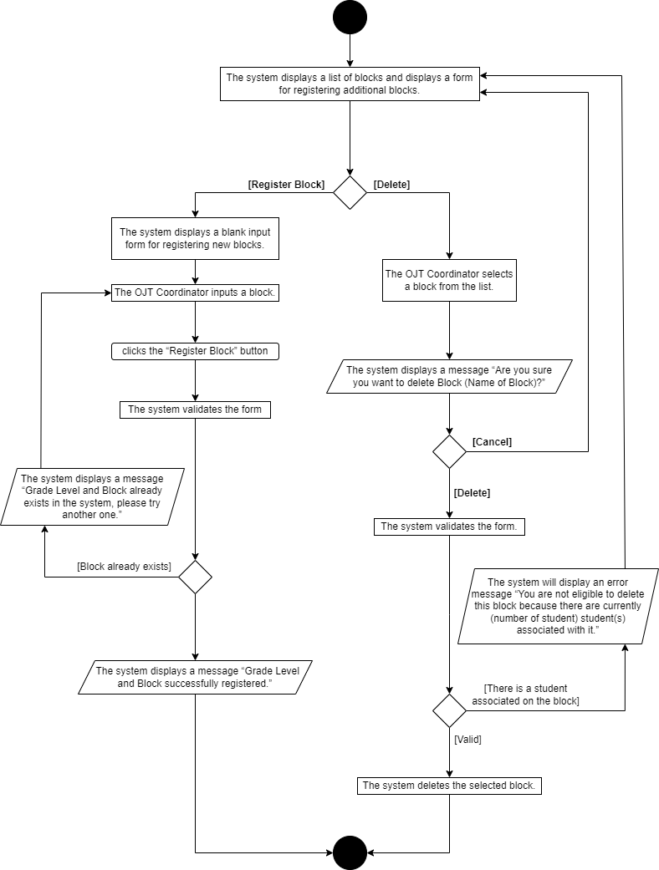Activity Diagram: *Manage Grade 12 Intern Students List of Blocks*

Use Case Specification: *Manage List of Industries*

**Brief Description**

This use case allows the OJT Coordinator to both register and manages the industries that are currently registered within the system.

1. **Flow of Events**
   1. ***Basic Flow -*** (The use case starts when the OJT Coordinator logs into the system and has chosen “List of Industries” on the navigation bar. The OJT Coordinator is presented with the list of industries that are currently registered in the system and an input form to register new industries.)
      1. **Delete**
         1. After the OJT Coordinator selects an industry from the list.
         2. The OJT Coordinator clicks the “Delete” button.
         3. The system displays a message “Are you sure you want to delete (Name of Industry) Industry?”
         4. The OJT Coordinator clicks the “Delete” button.
      2. **Register Industry**
         1. The system displays a blank form for registering new Industries.
         2. The OJT Coordinator inputs the blank form.
         3. The OJT Coordinator clicks the “Register Industry” button.
         4. The system displays a message “Industry has successfully registered!”
      3. **View**
         1. The OJT Coordinator clicks the “View” button.
         2. The system displays the personal information of the industry including email, address, Contact Number, and Facebook Name.
      4. **Change Password**
         1. The OJT Coordinator clicks the “Change” button.
         2. The system displays a message “Are you sure you want to change (Industry Name) password?”
         3. The OJT Coordinator clicks the “Change” button.
         4. The system displays a message “Password Changed!”
   2. ***Alternative Flow(s)***.

(Cancel)

* + - 1. The OJT coordinator clicks the “Cancel” button.
      2. The form will close and the system will remain unchanged.

(Empty Required fields)

* + - 1. The system will display the message “Please fill out this field!”

(There is a student assigned to the industry)

* + - 1. The system will display a message “Unfortunately, you do not have permission to delete this industry because there are currently (number of student) student/s assigned to it.”

(Industry already exists)

* + - 1. The system displays a message “Industry already exists!”

(Username already exists)

* + - 1. The system displays a message “Username already exists!”

(Password does not match)

* + - 1. The system displays a message “Password does not match!”

(Image format must be jpg, jpeg, png)

* + - 1. The system displays a message “Only JPG, JPEG, and PNG files are allowed.”

1. **Precondition**

The OJT Coordinator must first log in to the system before he/she can make changes in the files.

1. **Post-conditions**

If the OJT Coordinator successfully registered a new block onto the system, this use case is successful. But if not, the system remains unchanged.

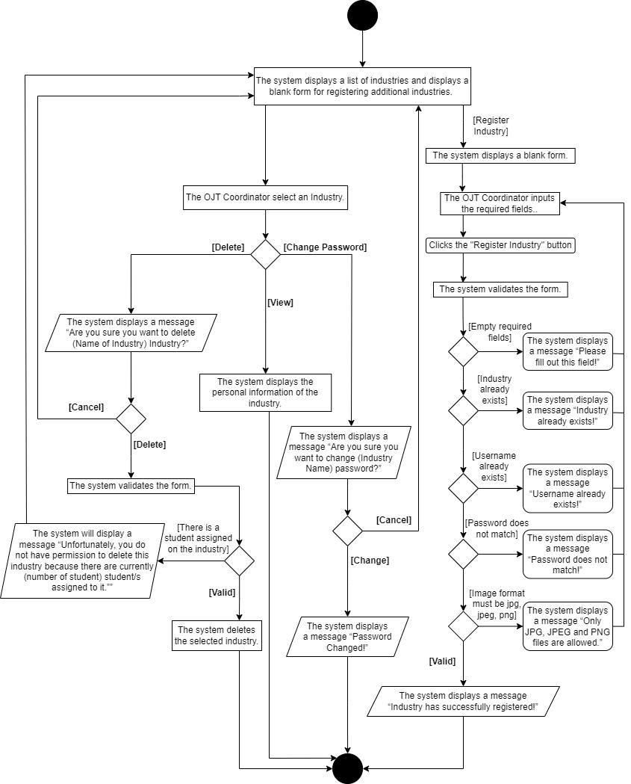Activity Diagram: *Manage List of Industries*