Ralph Donato

Computer Organization Project I

Net id rd716418

# System Documentation

Dataflows

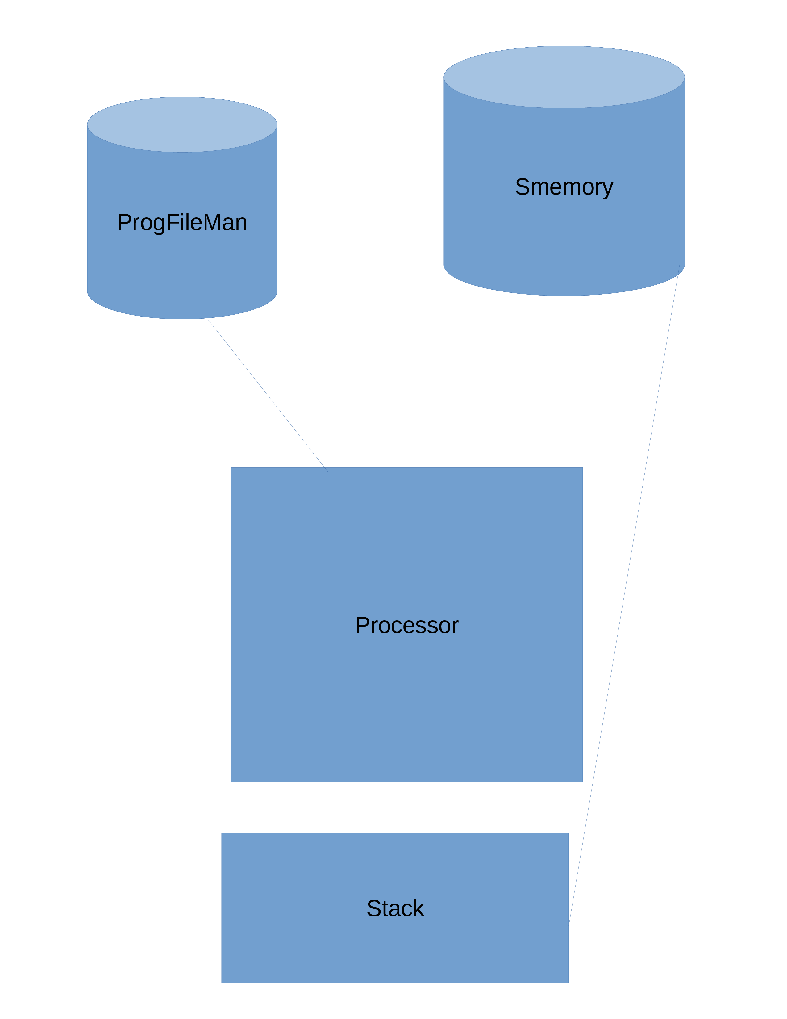

Routines

### CLASS Smemory

### class that handles memory.

ROUTINES

public bool isMainMem() Check if the instance is the main memory as opposed to routine memory

public Smemory addChild Factory method to create memory for a subroutine

DumpMemory tool function to display contents of the memory very helpful for debgging

GetValue returns value from memory

Add Value puts value into memory

### CLASS ProgFileMan

A class for maintaining the program this keeps track of where the application is a program pointer.

ROUTINES

LoadProgram loads a program file and stores it in the list of strings program.

NextCmdNum gets the next command number

NExtCommand actually gets the next command

Jump Moves to a label

Go moves to a label based on a condition

Call calls a subroutine

ReturnFromCall handles return from subroutine

CLASS PROCESSOR  
 handles running process and calling other objects

Process is the main function.

Handles setting up stack and ProgFileMan.

It pools the ProgFileMan to get the next command then process it. Most process are handled by the stack.

CLASS SStack

Handles stack

Stack functions are encapsulated here.

Also most functions are implemented here.

Implementation Details

Processor is the main class. Memory is a singleton. Children of Memory are created when subroutines care called. Memory has a child memory object that are genrated when a subroutine is called.

The ProgFileMan

# Test documentation.

Testing Methods

I have run all the test files provided. It has successfully processed these.

## Know Bugs

No actual known bugs. Unfortunately, I didn't get to test more than the provided data files.

## Executable version of your solution

Dotnet run

Difficulties and solutions involved in creating the program recursive factorial was fun.

# Algorithms and data structures

Algorithms

Data structures

Stacks are used extensively.

A dictionary is used for the memory.

User Documentation

## What Operating System was used.

Ubuntu

How to compile your program.

From the root of your project run

dotnet build

What other applications (tools) does your system require

.net core can be installed using the following link

https://docs.microsoft.com/en-us/dotnet/core/install/linux-ubuntu#2010-

How to run your program

ralph@ralph-Inspiron-5521:~/development/dotnet/ProjectOne$ dotnet run ./test.abm

## Describe parameters (if any). Filename

## Other requirements needed to run your executable.

This requires .net core 5.0. .net core is now an open source api that runs on Ubuntu linux or any other version of linux