Project Sprint #1

The Solitaire game is described in CS449HomeworkOverview. You should read the description very carefully.

In this assignment, you aim to specify the requirements (i.e., user stories and acceptance criteria) of the target software that allows a human player to play a Solitaire game. These requirements will be fully implemented by the end of sprint 3. The minimum features include choosing the board size and type, starting a new game, making a move, determining if a game is over. The following is a sample GUI layout.

Board size
7
Board Type  - English  - Hexagon  - Diamond | 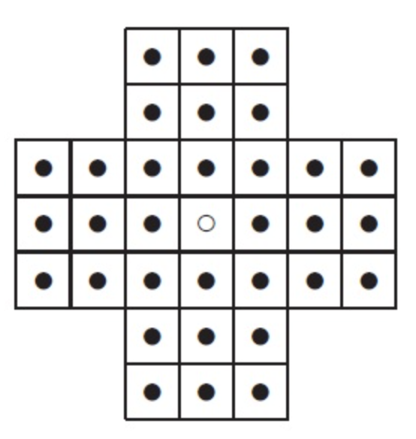 | New Game
Figure 1. Sample GUI layout of the first working program by the end of Sprint 3

Use the following tables to document your user stories and acceptance criteria.

You are required to use the free ChatGPT or another LLM to complete two user stories and two of their respective acceptance criteria. You must ensure that the generated user stories are correct and fix them if not. At the end of the submission, provide screenshots of your LLM prompts and answers, along with the description of errors the LLM made that you had to correct. Points will be deducted if no screenshots/description are provided.

For the other user stories and acceptance criteria, you are not required to use LLM.

- User Stories (3 points)

- User Story Template: As a <role>, I want <goal> [so that <benefit>]
- I did not identify any errors from the LLM I used

ID | User Story Name | User Story Description | Priority | Estimated effort (hours)
1 | Choose a board size | 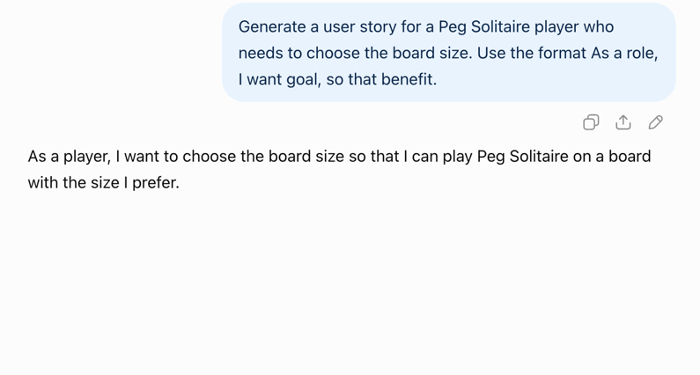I used ChatGPT for this one and this is the user story it provided which I believe works for this ID. | Medium | 1-2 hours
2 | Choose the board type | 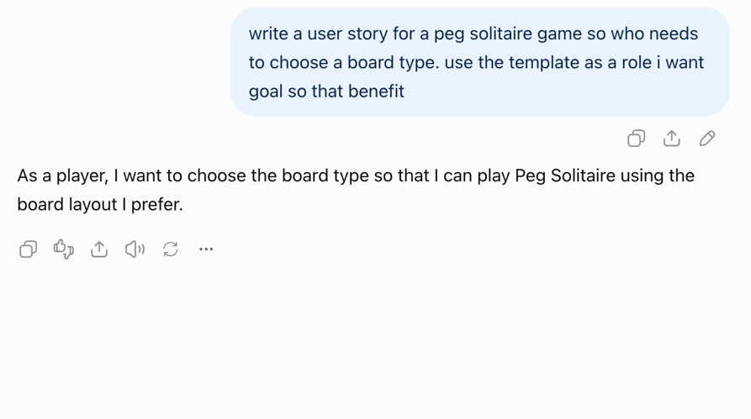I used ChatGPT for this one too and this is the user story which is also correct. | Medium | 2 hours
3 | Start a new game of the chosen board size and type | As a player I want to be able to start a new game with my chosen board size and type so that I can play repeatedly with different options. | High | 3 hours
4 | Make a move in a game | As a player I want to be able to make my move so that I can remove pegs and progress in the game. | High | 4-5 hours
5 | A game is over | As a player I want to know when there are no more possible moves so that I can restart my game. | High | 3-4 hours

- Acceptance Criteria (AC) (12 points): Add/delete rows as needed.

User Story ID and Name | AC  ID | Description of Acceptance Criterion | Status (completed, toDo, inPprogress)
1. Choose a board size | 1.1 | AC 1.1 Select a board size  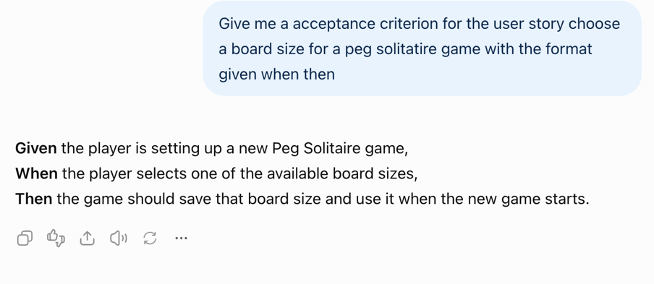  This was one I used ChatGPT for. | Todo
1. Choose a board size | 1.2 | AC 1.2 Change Selected Board Size  Given The player has already selected a board size  When a player wants to select a new board size for the next game  Then the newly selected board size should replace the previous one | todo
2. Choose the board type | 2.1 | AC 2.1 Choose Board Type- ChatGPT response  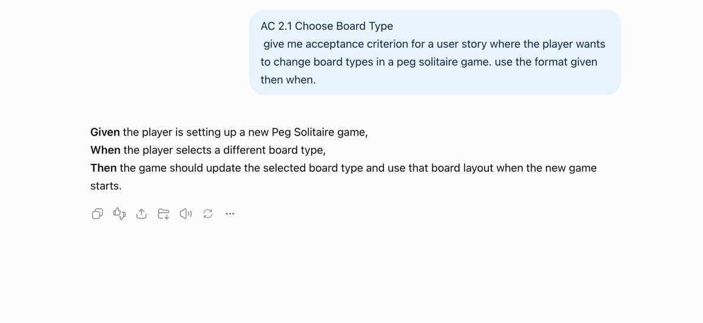
2. Choose the board type | 2.2 | AC 2.2 Change Board Type  Given a player has chosen a board type  When the player selects a different board type before starting a new game  Then the new board type should replace the original board type | todo
3. Start a new game with chosen board size and type | 3.1 | AC 3.1- Start Game  Given: the player has selected board type and size  When: the user wants to start a game  Then: the game should start using the selected board size and board type | todo
 | 3.2 | AC 3.2 Restarting A Game  Given: The player’s current game is over  When: The player wants to play again  Then: the board should reset to its original state while keeping size and type the same | todo
4. Make a move in a game | 4.1 | AC 4.1 Make a valid move  Given: The player has selected a peg that has an adjacent peg and an empty space two positions away  When: They attempt to move their chosen peg into the empty space  Then: Their peg should jump over exactly one other nearby peg at a time and the peg that got jumped over should be removed. | todo
 | 4.2 | AC 4.2 Make an invalid move  Given: The player has selected a peg to jump over more than one other nearby pegs  When: They attempt to jump over more than one peg  Then: They won’t be allowed to make that move and will have to choose a different move | todo
5. Game is over | 5.1 | AC 5.1 The board has no more valid moves  Given: The board has no more valid moves  When: The game checks the board state and determines no more moves are possible  Then: The player will be prompted to start a new game. | todo
 | 5.2 | AC 5.2 Only one peg is left  Given: Only one peg remains on the board  When: The game checks the state of the board and determines only one peg is left  Then: The game should let the user know they completed the game and ask if they want to play again. | todo

