GitHub Repository: github.com/username/repo

Sprint #0 Report

Instructions

Objectives
- Make decisions on the Solitaire software development project.
- Learn unit testing and GUI programming in the language of your choice.

Deliverables and Grading Policy
Read the “CS 449 Homework Overview” document carefully and make the key decisions for the software development. Use the following template to complete your report.

- Key Decisions of the Solitaire Project (2 points)

Topic | Decision
Object-oriented programming language (if not using OOP, then justify the use of the language) | Python
GUI library (strongly encouraged) | Tkinter
IDE (Integrated Development Environment) | Visual Studio Code
xUnit framework (e.g., JUnit for Java) | unittest
Programming style guide (must read it carefully) | Google Python Style Guide
Project hosting site | Github.com
Other decisions if applicable

Sample programming style guides:
- Google Java Style Guide: https://google.github.io/styleguide/javaguide.html
- Google C++ Style Guide: https://google.github.io/styleguide/cppguide.html
- Google Python Style Guide: https://google.github.io/styleguide/pyguide.html

- Unit testing (4 points)

Find a tutorial on the unit test framework you have chosen and write at least two xUnit tests of a program you have written or found elsewhere. Attach here (1) the screenshot of your program execution and (2) the source code of your program.

For example, Junit5 user guide: https://docs.junit.org/5.10.3/user-guide/index.html
I used a calculator program I found on github to write the unit tests for.
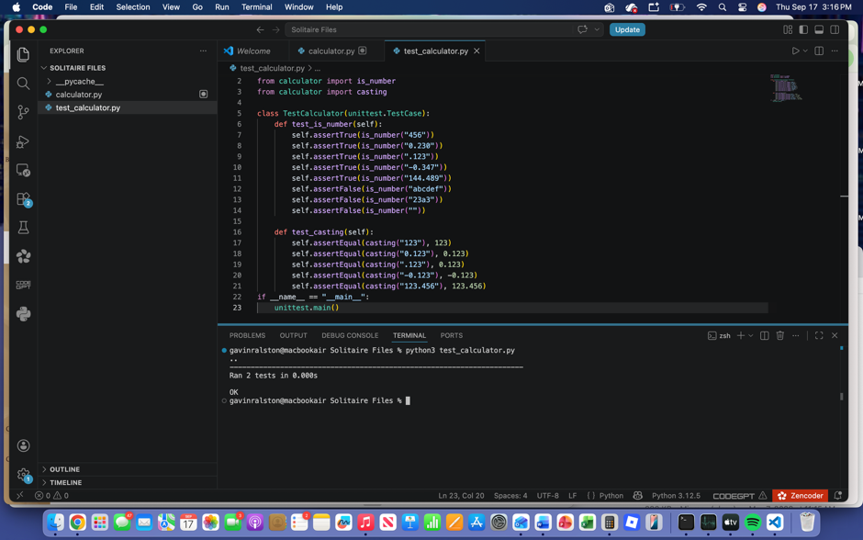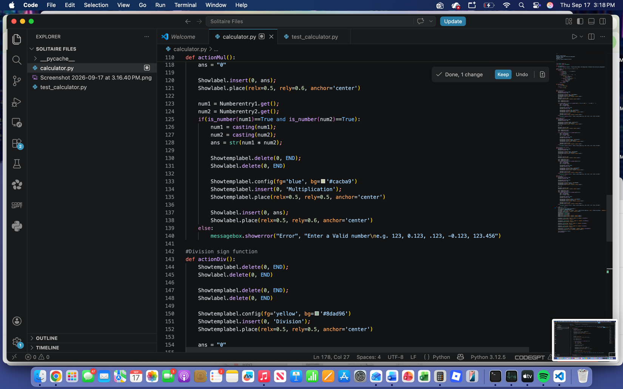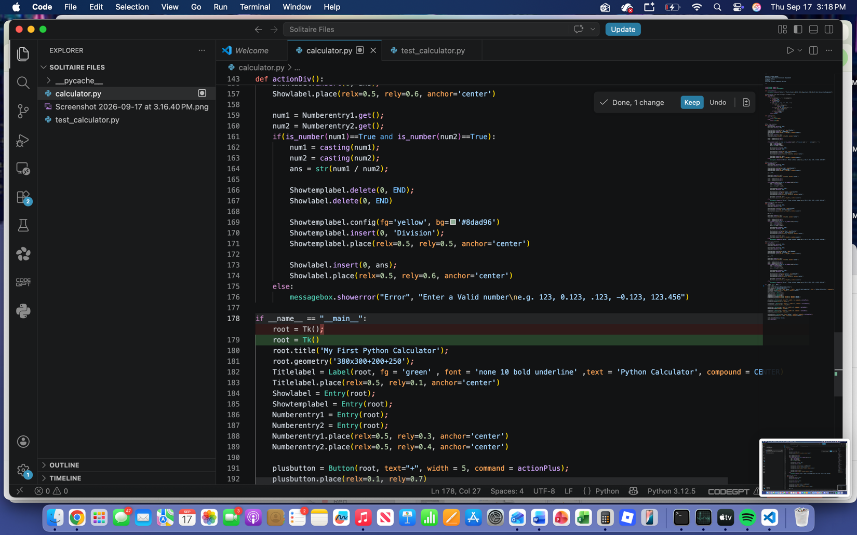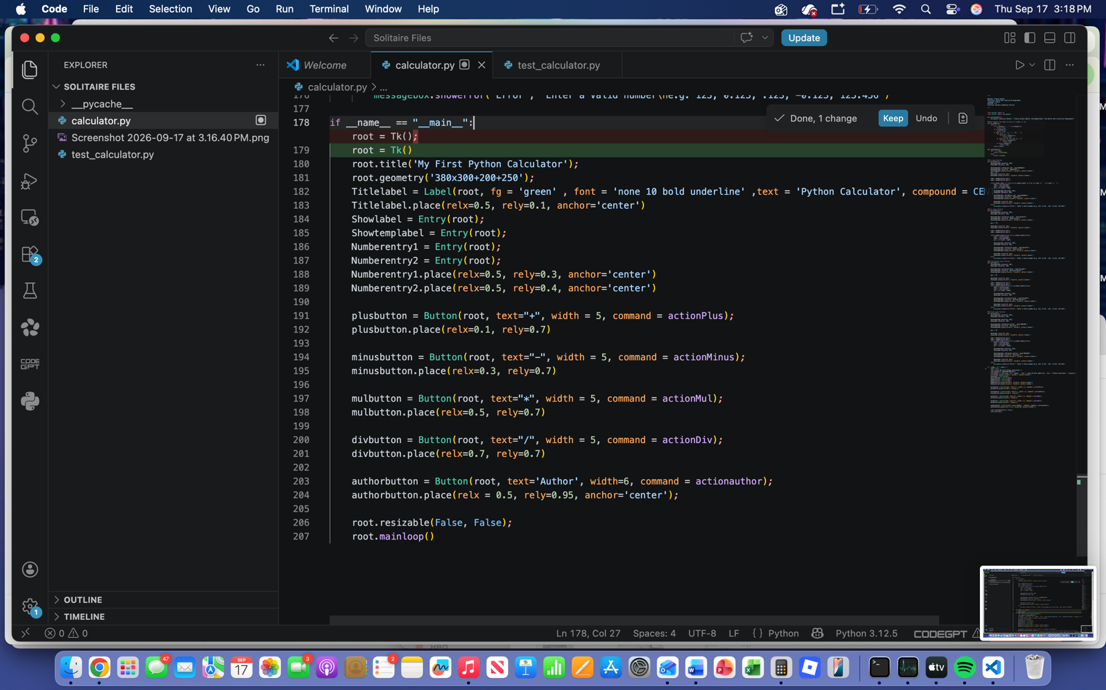
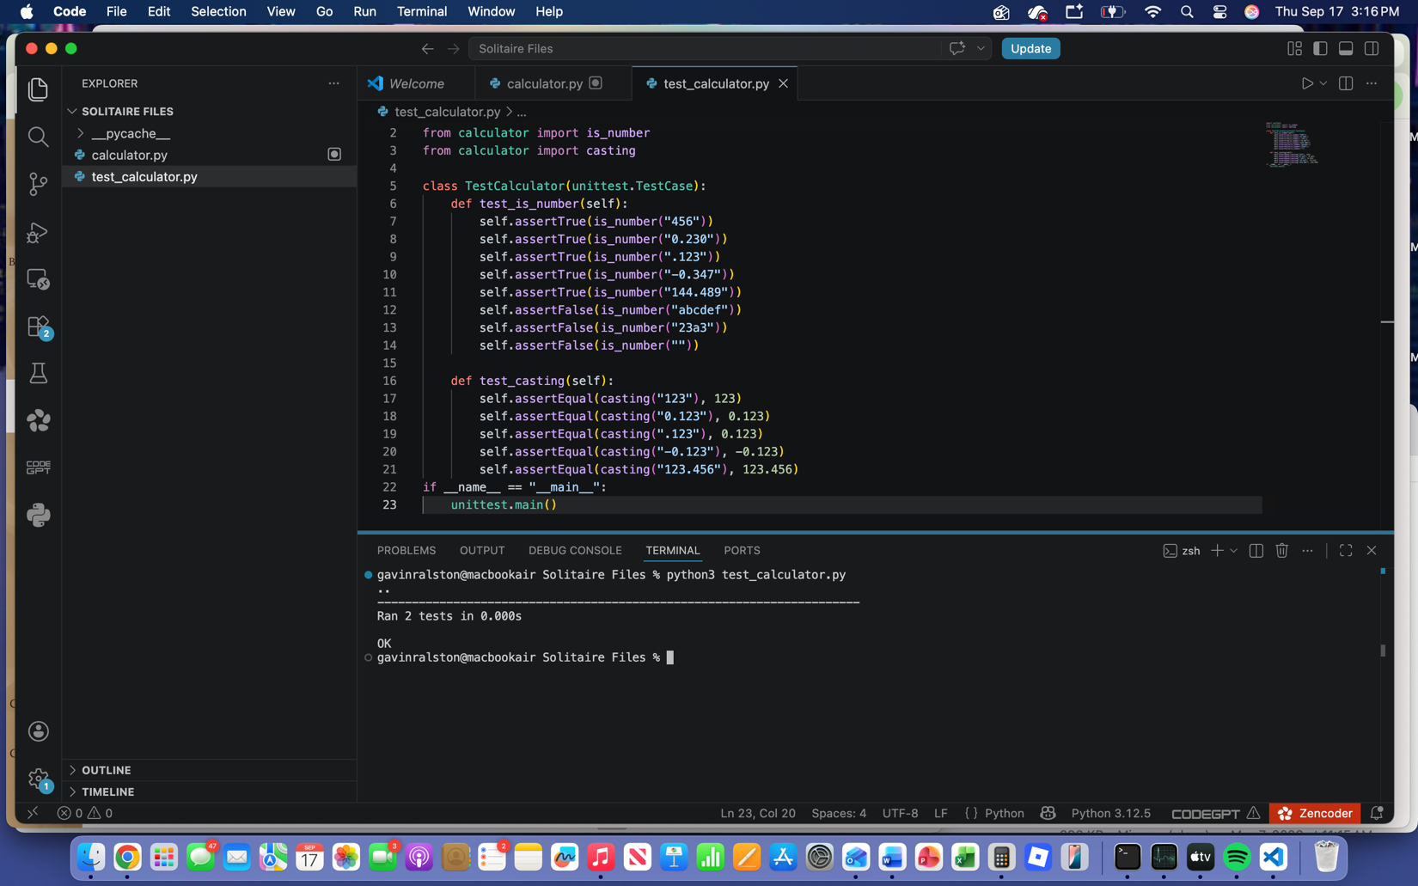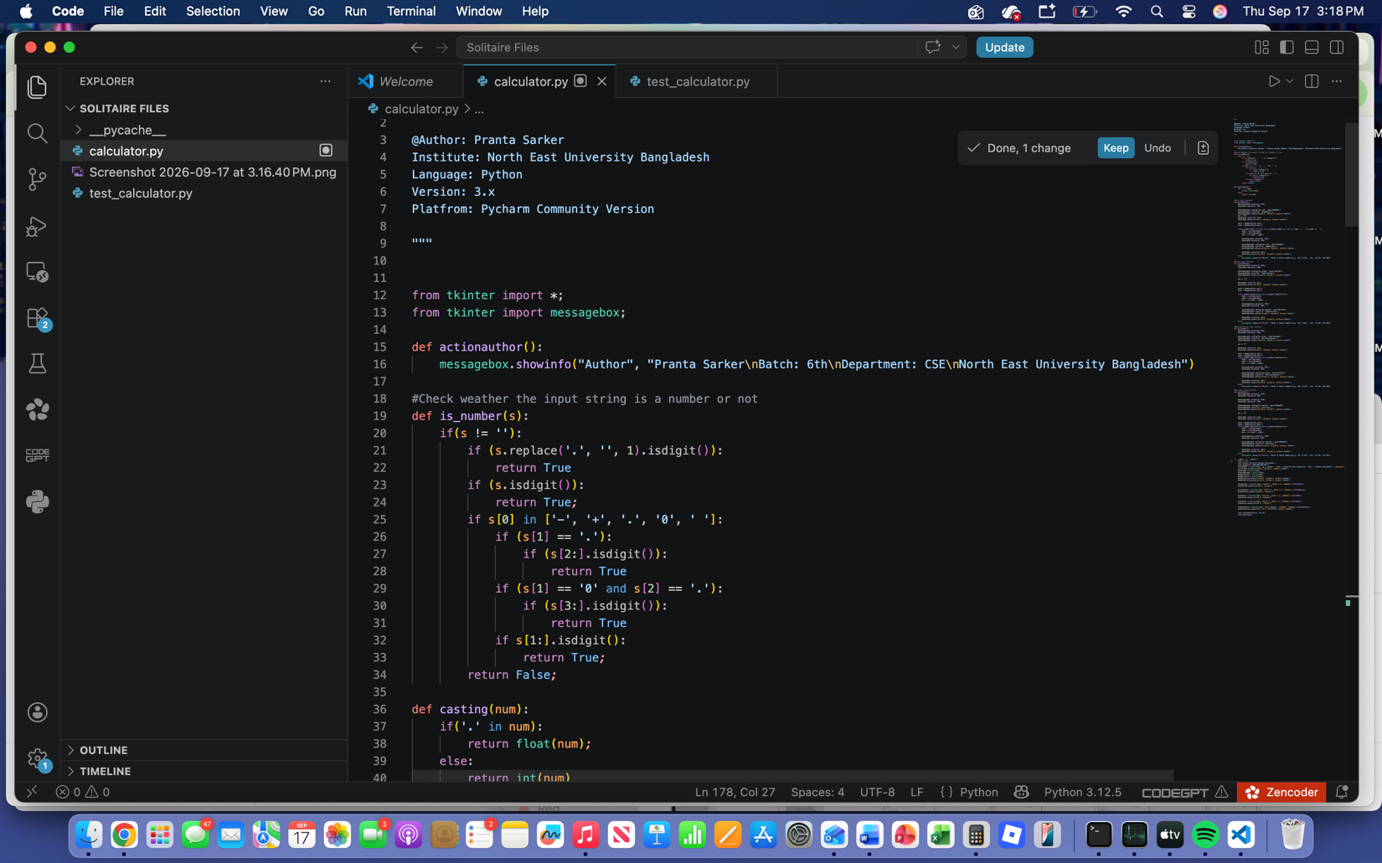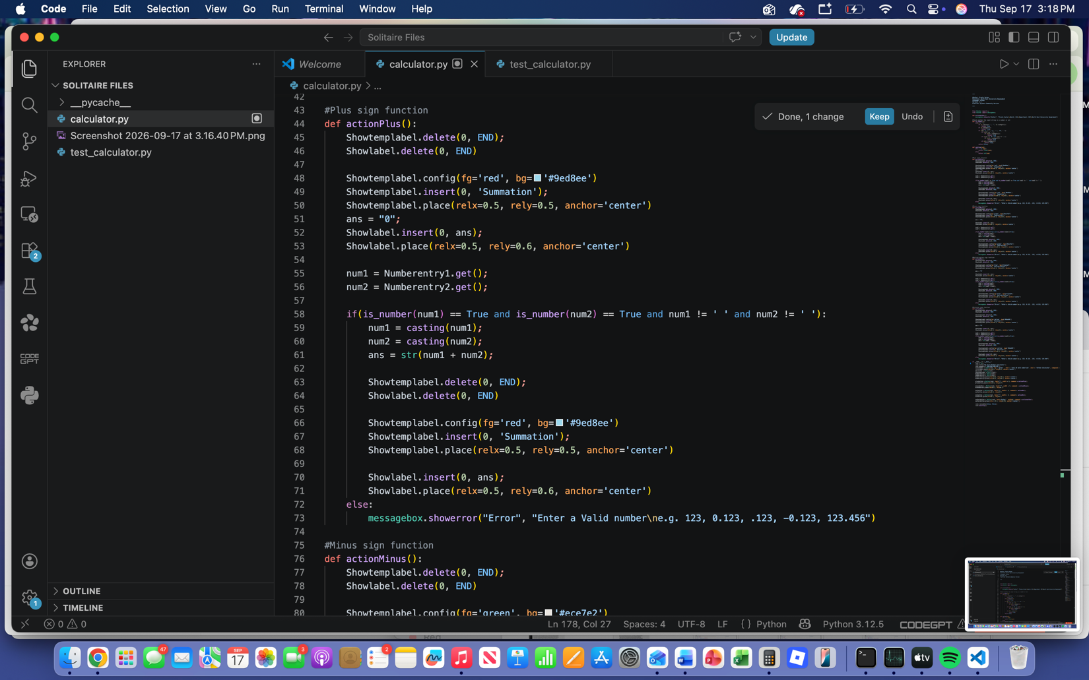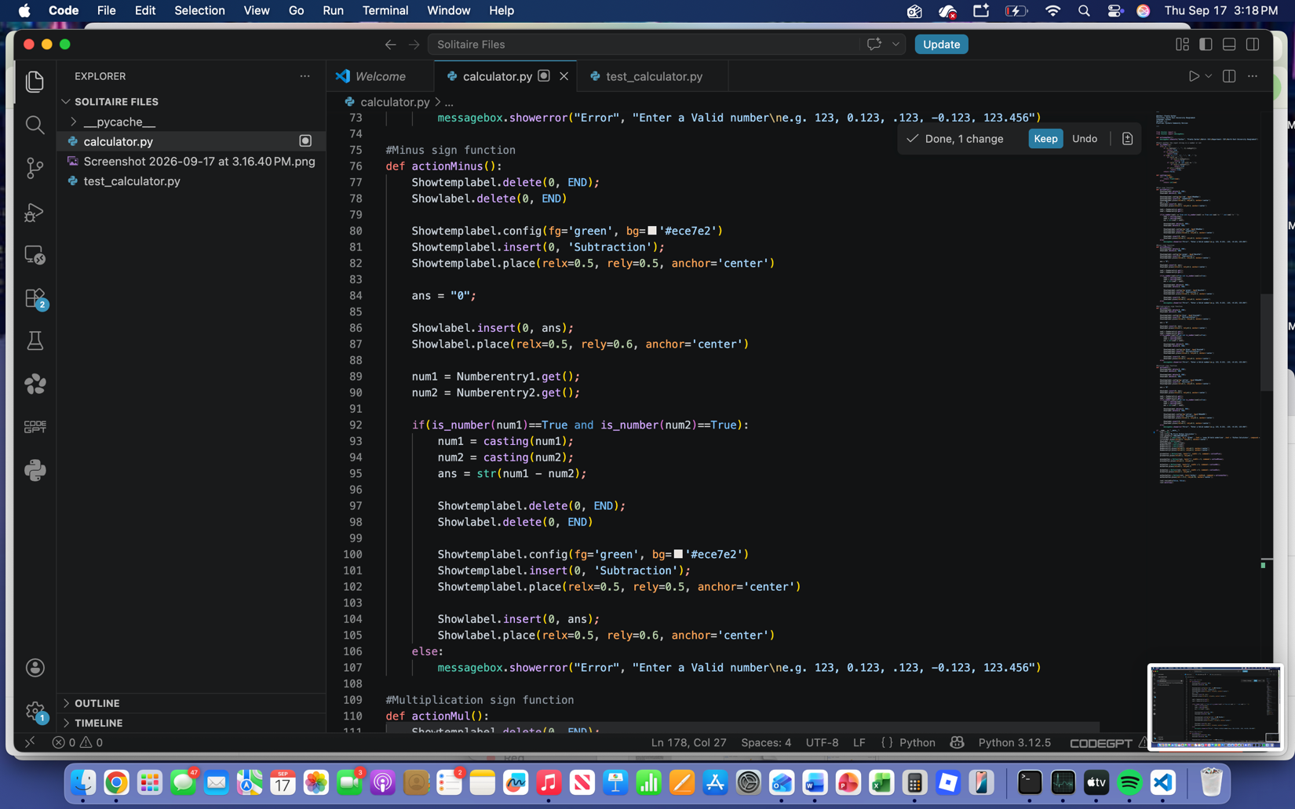
- GUI programming (4 points)

Write a GUI program in the language you have chosen for your Solitaire project. The GUI of your program must include text, lines, a check box, and radio buttons. In this assignment, any GUI program of your own work is acceptable.

Attach here (1) the screenshot of your program execution and (2) the source code of your program.
