Ralu Offodile
ITFN 1401
Help me Help You Responsive
Desktop View
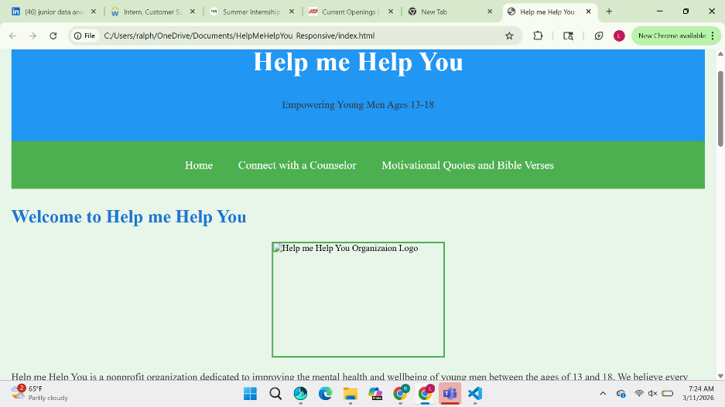

IPad Mini View


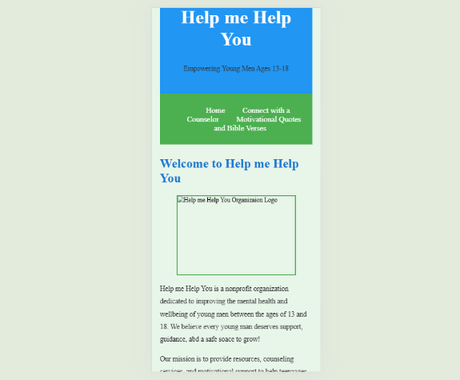
IPhone 14 ProMax View

