 | UNIVERSITATEA DIN CRAIOVA  FACULTATEA DE AUTOMATICĂ, CALCULATOARE ȘI ELECTRONICĂ  DEPARTAMENTUL DE CALCULATOARE ȘI TEHNOLOGIA INFORMAȚIEI | 

LUCRARE DE DISERTATIE
Andreea-Raluca Brătan

COORDONATOR ȘTIINȚIFIC
Prof. dr. ing. Constantin Renato Ivănescu

Iulie 2026
CRAIOVA

 | UNIVERSITATEA DIN CRAIOVA  FACULTATEA DE AUTOMATICĂ, CALCULATOARE ȘI ELECTRONICĂ  DEPARTAMENTUL DE CALCULATOARE ȘI TEHNOLOGIA INFORMAȚIEI | 

WEB-BASED MACHINE LEARNING SYSTEM
FOR AIRFARE PRICE EVALUATION AND PREDICTION
Andreea-Raluca Brătan

COORDONATOR ȘTIINȚIFIC
Prof. dr. ing. Constantin Renato Ivănescu

Iulie 2026
CRAIOVA

„Take what you learn and make a difference with it.”
Tony Robbins

DECLARAȚIE DE ORIGINALITATE

Subsemnatul ANDREEA-RALUCA BRĂTAN, student la specializarea Information Systems for e-Business din cadrul Facultății de Automatică, Calculatoare și Electronică a Universității din Craiova, certific prin prezenta că am luat la cunoştinţă de cele prezentate mai jos şi că îmi asum, în acest context, originalitatea proiectului meu de licenţă:
- cu titlul Web-based machine learning system for airfare price evaluation and prediction ,
- coordonată de Prof. dr. ing. Constantin Renato Ivănescu,
- prezentată în sesiunea iulie 2026.
La elaborarea lucrării de disertație, se consideră plagiat una dintre următoarele acţiuni:
- reproducerea exactă a cuvintelor unui alt autor, dintr-o altă lucrare, în limba română sau prin traducere dintr-o altă limbă, dacă se omit ghilimele şi referinţa precisă,
- redarea cu alte cuvinte, reformularea prin cuvinte proprii sau rezumarea ideilor din alte lucrări, dacă nu se indică sursa bibliografică,
- prezentarea unor date experimentale obţinute sau a unor aplicaţii realizate de alţi autori fără menţionarea corectă a acestor surse,
- însuşirea totală sau parţială a unei lucrări în care regulile de mai sus sunt respectate, dar care are alt autor.
Pentru evitarea acestor situaţii neplăcute se recomandă:
- plasarea între ghilimele a citatelor directe şi indicarea referinţei într-o listă corespunzătoare la sfărşitul lucrării,
- indicarea în text a reformulării unei idei, opinii sau teorii şi corespunzător în lista de referinţe a sursei originale de la care s-a făcut preluarea,
- precizarea sursei de la care s-au preluat date experimentale, descrieri tehnice, figuri, imagini, statistici, tabele et caetera,
- precizarea referinţelor poate fi omisă dacă se folosesc informaţii sau teorii arhicunoscute, a căror paternitate este unanim cunoscută și acceptată.
Data, Semnătura candidatului,

 | UNIVERSITATEA DIN CRAIOVA  Facultatea de Automatică, Calculatoare şi Electronică  Departamentul de Calculatoare și Tehnologia Informației | Aprobat la data de  …………………  Şef de departament,  S.l. dr. ing.  Nicolae Enescu
PROIECTUL DE DIPLOMĂ

Numele și prenumele studentului/-ei: | Brătan Andreea-Raluca
Enunțul temei: | Dezvoltarea unui sistem web de suport decizional pentru achiziția biletelor de avion utilizând tehnici de machine learning.
Datele de pornire: | Aplicația va fi proiectată sa poată fi accesată de pe orice dispozitiv, cum ar fi laptop, desktop, tabletă, telefon mobil, care să aibă acces la internet , prin intermediul unui browser web.  Tehnologiile utilizate în cadrul sistemului sunt ASP.NET Core pentru implementarea logicii server-side și expunerea serviciilor API, Angular pentru realizarea interfeței web responsive, precum și Flask pentru dezvoltarea și expunerea unui serviciu de machine learning responsabil de generarea recomandărilor decizionale.
Conținutul proiectului: | Primul capitol va fi introducerea, oferind o prezentare generală a subiectului aplicației și motivația acesteia.  Al doilea capitol va explica problemele pe care le rezolvă aplicația și va compara aplicația cu alte sisteme existente, evidențiind în același timp tehnologiile și framework-urile utilizate.  Al treilea capitol se va concentra pe cerințe, proiectarea sistemului, arhitectura sistemului și structura bazei de date. În plus, va prezenta funcționalitățile și câteva detalii relevante de implementare.  Al patrulea capitol va reprezenta manualul de utilizare, prezentând funcționalitățile  Al cincilea capitol va fi concluzia, care va prezinta realizările, limitările sistemului și direcțiile viitoare de dezvoltare.
Material grafic obligatoriu: | Diagrame, schițe, capturi de ecran
Consultații: | Periodice
Conducătorul științific  (titlul, nume și prenume, semnătura): | Prof. dr. ing. Constantin Renato Ivănescu
Data eliberării temei: | 16.10.2025
Termenul estimat de predare a proiectului: | 22.06.2026
Data predării proiectului de către student și semnătura acestuia:

 | UNIVERSITATEA DIN CRAIOVA  Facultatea de Automatică, Calculatoare şi Electronică  Departamentul de Calculatoare și Tehnologia Informației

REFERATUL CONDUCĂTORULUI ȘTIINȚIFIC

Numele și prenumele candidatului/-ei: | Brătan Andreea-Raluca
Specializarea: | Calculatoare în limba engleză
Titlul proiectului: | Web Platform for Cinema Bookings and Recommendations
Locația în care s-a realizat practica de documentare (se bifează una sau mai multe din opțiunile din dreapta): | În facultate □
 | În producție □
 | În cercetare □
 | Altă locație: [se detaliază]

În urma analizei lucrării candidatului au fost constatate următoarele:
Nivelul documentării |  | Insuficient  □ | Satisfăcător □ | Bine  □ | Foarte bine  □
Tipul proiectului |  | Cercetare  □ | Proiectare  □ | Realizare practică □ | Altul  [se detaliază]
Aparatul matematic utilizat |  | Simplu  □ | Mediu  □ | Complex □ | Absent  □
Utilitate |  | Contract de cercetare □ | Cercetare internă □ | Utilare  □ | Altul  [se detaliază]
Redactarea lucrării |  | Insuficient  □ | Satisfăcător □ | Bine  □ | Foarte bine  □
Partea grafică, desene |  | Insuficientă  □ | Satisfăcătoare □ | Bună  □ | Foarte bună  □
Realizarea practică | Contribuția autorului | Insuficientă  □ | Satisfăcătoare □ | Mare  □ | Foarte mare  □
 | Complexitatea  temei | Simplă  □ | Medie  □ | Mare  □ | Complexă  □
 | Analiza cerințelor | Insuficient  □ | Satisfăcător □ | Bine  □ | Foarte bine  □
 | Arhitectura | Simplă  □ | Medie  □ | Mare  □ | Complexă  □
 | Întocmirea specificațiilor funcționale | Insuficientă  □ | Satisfăcătoare □ | Bună  □ | Foarte bună  □
 | Implementarea | Insuficientă  □ | Satisfăcătoare □ | Bună  □ | Foarte bună  □
 | Testarea | Insuficientă  □ | Satisfăcătoare □ | Bună  □ | Foarte bună  □
 | Funcționarea | Da  □ | Parțială  □ | Nu  □
Rezultate experimentale |  | Experiment propriu  □ |  | Preluare din bibliografie  □
Bibliografie |  | Cărți | Reviste | Articole | Referințe web
Comentarii
și
observații

În concluzie, se propune:

ADMITEREA PROIECTULUI  □ | RESPINGEREA PROIECTULUI  □

Data, Semnătura conducătorului științific,

REZUMATUL PROIECTULUI

În zilele noastre, tehnologia joacă un rol esențial în simplificarea proceselor de luare a deciziilor și în automatizarea analizelor complexe. Ideea acestei aplicații a pornit din dorința de a ajuta utilizatorii să ia decizii mai informate în ceea ce privește achiziția biletelor de avion, prin utilizarea tehnicilor de machine learning și a analizelor bazate pe date istorice.
Aplicația propusă reprezintă un sistem web de suport decizional pentru achiziția biletelor de avion, care analizează informații precum aeroportul de plecare, aeroportul de destinație, data călătoriei, durata zborului, numărul de escale și prețul biletului. Pe baza acestor date, sistemul utilizează modele de machine learning pentru a evalua oportunitatea achiziției și pentru a genera recomandări de tip semnal puternic de cumpărare, semnal de cumpărare, suprapreț față de medie și recomandare de așteptare, ajutând utilizatorul să decidă momentul optim de cumpărare.
Arhitectura aplicației este una de tip full-stack, fiind compusă dintr-o interfață web dezvoltată în Angular, un backend implementat în ASP.NET Core și un serviciu de machine learning dezvoltat în Flask, care expune un API responsabil de procesarea datelor și generarea recomandărilor.
Pe parcursul dezvoltării acestei aplicații, am învățat importanța integrării mai multor tehnologii într-un sistem unitar și modul în care modelele de machine learning pot fi utilizate în scenarii reale pentru a sprijini luarea deciziilor.
Cuvinte cheie: aplicație web, machine learning, sistem de suport decizional, ASP.NET Core, Angular, Flask, API, analiză date, predicție, zboruri, programare full-stack, C#, TypeScript.

PROJECT SUMMARY

In today’s world, technology plays a crucial role in simplifying decision-making processes and automating complex analyses. The idea behind this application originated from the desire to help users make more informed decisions regarding airline ticket purchases by leveraging machine learning techniques and historical data analysis.
The proposed application is a web-based decision support system for airline ticket purchasing, which analyzes information such as departure airport, destination airport, travel date, flight duration, number of layovers, and ticket price. Based on this data, the system uses machine learning models to assess the suitability of purchasing a ticket and to generate recommendations in the form of Strong Buy signal, Buy signal, Overpriced compared to average, and Wait recommendation, helping users determine the optimal time to buy.
The application architecture follows a full-stack approach, consisting of a web interface developed in Angular, a backend implemented in ASP.NET Core, and a machine learning service developed in Flask, which exposes an API responsible for data processing and recommendation generation.
During the development of this application, I learned the importance of integrating multiple technologies into a unified system and how machine learning models can be applied in real-world scenarios to support decision-making processes.
Keywords: web application, machine learning, decision support system, ASP.NET Core, Angular, Flask, API, data analysis, prediction, flights, full-stack development, C#, TypeScript.

CONTENT
1 IntroDUCTION 1
1.1 THE TOPIC OF THE APPLICATION 1
1.2 MotivaTION 1
1.3 Overview of the proposed solution, technologies employed, key functionalities 2
1.4 Document Structure 3
2 Theoretical and Technical Fundamentals 5
2.1 Identifying the challenge 5
2.2 Surveying existing systems 6
2.3 Key technologies and frameworks 8
3 The sYSTEM OF CINEMA BOOKINGS AND RECOMMENDATIONS 13
3.1 Defining Requirements and System Design 13
3.2 System Architecture 15
3.3 Database Structure 22
3.4 Functionalities 26
3.5 Implementation Details 29
4 User Manual 34
4.1 Client user functionalities 34
4.2 Administrator functionalities 41
5 cONCLUSIONS 46
5.1 Achievements 46
5.2 System limitations 47
5.3 Future development directions 48
6 REFERENCES 51
A. source code 52
B. PROJECT WEBSITE 53
C. CD / DVD 54
Index 55

LIST OF FIGURES
Figure 2-1 How api works 11
Figure 3-1 Use case diagram 15
Figure 3-2 Layered architecture 17
Figure 3-3 Layered architecture within my project 17
Figure 3-4 Before and after the repository pattern 20
Figure 3-5 Repository wrapper 21
Figure 3-6 Angular architecture 22
Figure 3-7 Database diagram 23
Figure 3-8 GetRecommendations method 30
Figure 3-9 The continuation of GetRecommendations method 30
Figure 3-10 BuildUserItemMatrix method 31
Figure 3-11 CalculateCosineSimilarity method 31
Figure 3-12 Autosuggest search HTML 32
Figure 3-13 Autosuggest search TypeScript 32
Figure 3-14 Charts definition Typescript 33
Figure 3-15 Charts definition html 33
Figure 4-1 Home page 34
Figure 4-2 Home page quotes 35
Figure 4-3 Register 35
Figure 4-4 Login 35
Figure 4-5 User’s profile 36
Figure 4-6 Movies page 37
Figure 4-7Movie details page part I 37
Figure 4-8 Movie details page part II 38
Figure 4-9 Reviews section 39
Figure 4-10 Booking functionality 40
Figure 4-11 Ticket types selection 41
Figure 4-12 Administrator menu 41
Figure 4-13 Insert tool part I 42
Figure 4-14 Insert tool part II 43
Figure 4-15 Edit movie pop-up 44
Figure 4-16 Bar chart movie ratings 44
Figure 4-17 Pie chart movie categories 45

Introduction

The topic of the application
The web application with the title „Web Platform for Cinema Bookings and Recommendations” is meant to be a platform having as main purpose making seat reservations at cinema movies running in the cinema at the moment. Users can do this from anywhere as long as they have internet connection and a device such as a smartphone, tablet or laptop. The word „recommendations” refers to the personalized experience the user can have by taking into account their preferences and similar users’ preferences. In addition to these, the platform offers a wide range of functionalities.
The platform serves as a tool for the administrators, providing an intuitive interface that allows them to manage the movie database effectively. Administrators can easily add new movies, actors, and categories, as well as edit the data of existing movies. Additionally, the interface offers a statistical presentation of user preferences and movie-related data, enabling administrators to make informed decisions based on user behavior and trends.
The most interesting objective of the application in my opinion is creating a community of cinema lovers. The users can choose to share their preferences, their contact data and a little bit of their personality with the others. They are encouraged to express their opinions regarding the movies and to rate them from one to five in order to improve their experience and other users experience as well.

Motivation
One of the reasons I chose this topic for my diploma project is my passion for watching movies at the cinema. Developing this project was a pleasure for me, as it aligns with one of my personal interests. In fact, I didn't view it as work but rather as a hobby—an engaging activity I could enjoy in my free time. This project not only allowed me to dive deeper into the world of movies but also helped me expand my knowledge of web development.
I chose web development because I found myself increasingly interested in this field over the last two years. My education, hands-on experience, and current job have made me even more dedicated to web development, which feels like the perfect fit for my career.
My goal in developing this project was to connect with the community of cinema enthusiasts, addressing their needs and providing conveniences. I believe fostering connections among individuals with shared interests is crucial, as humans are inherently social beings. Moreover, active engagement within the platform, including providing reviews and ratings for movies, enhances the overall user experience. The recommended movies section, in particular, aids users in discovering new films they are likely to enjoy, enriching their cinematic journey.
My coordinator professor encouraged me to incorporate a few more complex features that have the most impact on user experience on the web application like the recommendations algorithm and creating a community among users by giving them the option to leave ratings and reviews and to share their personal information. This guidance challenged me to push beyond my boundaries and acquire new skills.
I started creating this application having the following quote in mind "A web page is more than a simple document. It is an experience that must be designed to be intuitive, effortless, and enjoyable." [1] - Steve Krug. A web application serves a need indeed, but how good is it if the users cannot use it easily and smoothly. The success of a web application consists in the numbers of users accessing it.

Overview of the proposed solution, technologies employed, key functionalities
The proposed solution is designed to encourage user interaction through an intuitive and efficient platform. The application addresses the main needs identified for the cinema lovers target group by providing a smooth, user-friendly interface that facilitates easy navigation and quick access to essential features.
Among the technologies I used are ASP.NET Core, Angular, Microsoft SQL Server and JSON Web Tokens.
I chose ASP.NET Core for the backend part because it supports APIs, microservices and web applications and it can integrate frontend frameworks like Angular. It allows highly maintainable and extensible code structure. Another important fact for making this choice was the built-in support for dependency injection which makes the code loosely coupled and testable.
As frontend framework I chose Angular because it gives access to built-in functionalities and tools without needing to rely heavily on third-party libraries. It benefits of a dependency injection system that the same as ASP.NET Core promotes modularity, testability and maintainability. I find the structure of Angular very facile to understand and to follow by incorporating modules, components, and services. Furthermore, I was drawn to the idea of experiencing TypeScript, HTML, and CSS concurrently.
For storing and retrieving the data I used Microsoft SQL Server. It is an advantage that it can be integrated with ASP.NET Core through Entity Framework Object-Relational Mapping. Using Entity Framework simplifies data interaction, reduces the amount of written code and it allows the developer to focus more on the application logic than on database management tasks. It allows the developer to write flexible queries through Language Integrated Query (LINQ).
I used JSON Web Tokens (JWT) for managing the authentication and authorization in the application. It provides a secure and efficient for the users to authenticate and to authorize access to restricted sections of the application.
As key functionalities there are user registration and login, displaying movies by status and search filters, adding rating and reviews to movies, booking seats at a movie screening, displaying recommended movies, viewing and editing profile page. For admin there are extra features like displaying reports related to the movie activity, insert end edit tools for movie data.

Document structure
The document is structured of six chapters. All the information together aims to describe the purpose of the project, the process of developing it, the tools, the functionalities, the conclusions and the resources utilized. It is recommended to read the chapters in order to follow the logical progression of the project's evolution.
The first chapter serves as the introduction, offering the readers a concise overview of the application's scope, explaining the motivation behind choosing this topic and outlining proposed solutions to the identified problems. Additionally, it provides a brief summary of each subsequent chapter, ensuring a clear path for the reader to navigate through the document.
The second chapter offers information regarding the problem addressed by the diploma project. It presents strategies of existing similar systems and includes a brief description of the main technologies and frameworks used.
The third chapter exposes defining requirements and the system design. There it is presented the architecture of the application and the database structure. The functionalities are explained in detail, including some code samples for the most interesting parts of code. To enhance clarity and facilitate understanding, this chapter incorporates diagrams that visually depict the system's architecture and database structure.
The forth chapter is the user’s manual. Here, the readers are guided through detailed instructions on how to navigate the application's interface and effectively utilize its functionalities for each type of role. To provide a tangible visualization of the user experience, the manual includes selected screenshots from the application, offering users a preview of its interface and features.
The fifth chapter summarizes the achievements and the system limitations discovered during the process of developing the project. There are presented, as well, future directions that the project may follow in the future.
The final chapter includes a detailed list of references from various websites, providing valuable sources of information and supporting the content presented in the document.

Theoretical and Technical Fundamentals

Identifying the challenge
In this section, we will explore the current challenges tackled by the platform “Web Platform for Cinema Booking and Recommendations”.
The users often face difficulties when attempting to make seat reservations for movie screenings. This may be due to navigating through not intuitive and user friendly websites. They can experience challenges in finding and comparing available movies. These issues can result in frustration and may discourage users from completing their bookings efficiently.
I believe that my website solves this problem as the interface contains a menu easy recognizable through a specific icon. When clicked the menu icon, it displays several options clearly presented and explained. The movies are initially categorized based on their status, with additional search filters available to further facilitate users in filtering them according to their preferences. After the user decides on a specific movie the booking process flows smoothly, guiding the user to the next step until they successfully complete it.
Another nowadays issue is the fact that the market is over saturated of movies. Therefore, the users struggle to discover movies that align with their preferences. With an overwhelming number of options available, users often find it challenging to decide what to watch.
My platform addresses this problem by providing personalized recommendations customized to each user's tastes and interests. By utilizing advanced algorithms and user data analysis, I aim to offer relevant and engaging suggestions that enrich the overall movie-watching experience.
If the administrators of the cinema were required to manage the data directly from the database, it would present significant challenges. They would either need to acquire expertise in database management or hire specialized employee to handle data insertion and modification whenever updates occur. This approach could potentially lead to inefficiencies in both time and money. Therefore, the optimal solution lies in enabling administrators to perform all tasks through the interface.
Within my platform, I've integrated three distinct modules for administrators. The first module facilitates data insertion, while the second module focuses on data modification. Additionally, the third module serves the purpose of data visualization, allowing administrators to analyze reports and gain insights into user preferences.

Surveying existing systems
There are multiple examples of existing cinema booking platforms across the world and in Romania. I will use two of the websites in Romania that I have access to.
The first example is the InspireCinema website. The interface is visually appealing and responsive, making navigation intuitive for users. However, a downside is the limited filtering options for movies, which are only categorized by status. Despite this limitation, given the number of movies available, it remains acceptable. Additionally, the platform lacks a movie recommendation system, meaning users cannot rate or review attended movies and do not receive personalized recommendations. On a positive note, the website offers other interesting features such as loyalty points that accumulate with bookings. Logged-in users can access their booking and order history, and there's also the option to purchase products through the platform. The platform facilitates payment processing through a payment gateway offering the only option to pay by card.
Another example is the EventBook website, which offers information on various types of events such as music, cinema, sports, and theater. In this discussion, however, we will focus only on the cinema section.
The interface is a little bit crowded with various types of information, not all of which are relevant to the section you are currently navigating. In the cinema section the user is first asked to choose a cinema to attend. In the lower part of the page there are displayed upcoming movies and popular movies. The popular movies feature is particularly interesting, it is likely based on the number of bookings each movie has received. Additionally, there is a section for recommended movies; however, it is accessible even when the user is not logged in, so the recommendations may not be personalized. These recommended movies only appear when a specific movie is selected, showcasing similar recommendations. Each time a movie is selected, even if I select the same movie twice, the recommendations change accordingly. While this feature is beneficial, users may not always notice it as they have to scroll down to reach that section.
When examining movie recommendation systems, it's essential to explore specialized platforms dedicated to movie recommendation systems, utilizing advanced algorithms to provide personalized suggestions. Leading streaming services such as Netflix, [4] Amazon Prime Video [5], and others are recognized as major players in the industry, renowned for their sophisticated recommendation algorithms.
Netflix, for example, utilizes a recommendation system that relies on machine learning algorithms and collaborative filtering techniques. These algorithms analyze vast amounts of user data, including viewing history, ratings, interactions with the platform and preferences of similar members to generate personalized suggestions. The system takes into account contextual factors like the time of day, preferred languages, and viewing devices. Additionally, Netflix employs content-based filtering, which considers the attributes of movies and TV shows to recommend similar content based on users' preferences. [2]
Similarly, Amazon Prime Video utilizes machine learning algorithms to analyze user behavior and preferences. The platform tracks users' viewing habits, ratings, and reviews to recommend content that aligns with their interests. [3]
IMDb stands as another example of a platform integrating movie-related data with user ratings, reviews, and community interaction. The platform’s rating system influences user decisions about which movies or TV shows to watch and can help users discover new content based on community feedback. IMDb offers personalized recommendations based on users' viewing history and ratings. These recommendations help users discover new movies and TV shows matching their interests. Recommendations on IMDb are often based on collaborative filtering algorithms that analyze user behavior and preferences to suggest similar content. They used to have discussion boards available for users but concluded that it is not a positive feature anymore and eliminated it. „We considered many options to preserve the current message boards during our extensive review, but in the end concluded that they no longer provide a positive, useful experience for the vast majority of our more than 250 million monthly users worldwide. The message board software is based on outdated technology that is being phased out across all of IMDb, clearing the way for more innovation for IMDb customers.” [4]
An interesting thing that IMDb does it is the way that they compute the rating for a movie even if they do not disclose the exact formula, they state „We take all the individual ratings cast by IMDb registered users and use them to calculate a single rating. We don't use the arithmetic mean (i.e. the sum of all votes divided by the number of votes), although we do display the mean and average votes on the votes breakdown page; instead the rating displayed on a title's page is a weighted average.” „The IMDb weighted average does not change upon receipt of each new vote, but instead is updated numerous times per day.” „IMDb publishes weighted vote averages rather than raw data averages. The simplest way to explain it is that although we accept and consider all votes received by users, not all votes have the same impact (or 'weight') on the final rating. When unusual voting activity is detected, an different weighting calculation may be applied in order to preserve the reliability of our system. ” [5]
IMDb offers a diverse range of menu options to accommodate users' preferences and interests. One notable feature is the 'Top 250 Movies,' showcasing the highest-rated films of all time, which users can sort according to various criteria. Additionally, IMDb provides a list of the 'Most Popular Movies' of the moment, offering insight into trending titles. For users seeking specific genres, IMDb offers access to search filters, allowing for easy navigation and discovery of movies. These menu options enable personalized exploration of IMDb's extensive database of movies and TV shows.
Although, as an extension to the main IMDb website there is a forum dedicated website where users can initiate discussions with other users starting from a question, an idea, a problem or a praise. Administrators also utilize this platform to share announcements. Furthermore, users have the ability to follow each other, like, share, or comment on other users' posts, and navigate to their profile pages.
Each of these similar systems has served as inspiration for my web application.

Key technologies and frameworks
To develop a web application, you first need a database management system for data storage. Next, you need a backend component that contains the application logic and handles database queries to retrieve the required data. The backend then transmits this data to the frontend part of the application, which is the interface the user interacts with, also known as the client side.
Relational databases are the oldest among database types, known for their structured organization where every piece of information has a relationship with every other piece. Each data value in the database has a unique key in the form of a record, and all data is stored in tables. This model, popularized by SQL, simplifies data organization and retrieval, making it widely integrated into web interfaces and easy to utilize. The introduction of tables to organize data has made increasing in volume and traversing through data much more efficient compared to hierarchical databases.
SQL databases offer strong data consistency and integrity through ACID principles, making them well-suited for applications where data integrity is essential, such as banking systems or e-commerce platforms. They provide a structured data model with well-defined relationships between tables, making complex queries and data analysis relatively straightforward. However, SQL databases may struggle with horizontal scalability and handling unstructured or semi-structured data efficiently. Unstructured data can include text documents, images, videos, or sensor data, while semi-structured data might be in formats like JSON or XML. Some examples of SQL databases are MySQL, PostgreSQL, Oracle Database, Microsoft SQL Server, SQLite, IBM Db2, MariaDB, Amazon Aurora, Google Cloud SQL.
On the other hand, NoSQL databases excel in scalability and flexibility, allowing for easy horizontal scaling and accommodating large volumes of unstructured data. They are particularly useful for applications requiring fast development cycles, like agile software development projects. Some of the disadvantages of NoSQL databases, such as MongoDB include the fact that they are open-source, which, while fostering innovation, may result in limited formal support options and potential challenges with reliability or security compared to commercial databases. Additionally, many NoSQL databases lack built-in graphical user interfaces (GUIs), making tasks like data querying, management, and monitoring more complex and requiring more technical expertise. Moreover, while some NoSQL databases offer mechanisms for data backup and recovery, others, like MongoDB, may not provide as complete backup solutions as some SQL databases, presenting difficulties in ensuring data security and reliability, particularly in large-scale or mission-critical applications. Furthermore, the flexibility of NoSQL databases in storing unstructured or semi-structured data can lead to larger document sizes compared to structured data in SQL databases, impacting storage requirements and query performance, particularly for applications dealing with large volumes of data. [6][7]
As data management system I chose Microsoft SQL Server. “Microsoft SQL Server (Structured Query Language) is a relational database management system developed by Microsoft. As a database server, it is a software product with the primary function of storing and retrieving data as requested by other software applications - which may run either on the same computer or on another computer across a network (including the Internet). Microsoft markets at least a dozen different editions of Microsoft Microsoft SQL Server, aimed at different audiences and for workloads ranging from small single-machine applications to large Internet-facing applications with many concurrent users.” [8]
“Microsoft SQL Server is primarily built around a row-based table structure that connects related data elements in different tables to one another, avoiding the need to redundantly store data in multiple places within a database.” [9] The relational model in databases ensures data accuracy by enforcing rules that keep relationships between tables correct, such as making sure linked data exists. It also uses other rules to ensure data standards, like requiring certain fields to be filled or making sure values are unique. These rules support the ACID principles—Atomicity, Consistency, Isolation, and Durability—which ensure reliable transactions. Atomicity means a transaction is all-or-nothing; Consistency means transactions move the database from one correct state to another; Isolation means transactions do not interfere with each other; and Durability means once a transaction is saved, it remains saved even if the system crashes. [10]
In the backend project, I utilized Entity Framework alongside Microsoft SQL Server for efficient database management. Entity Framework simplified the implementation of CRUD operations by providing an object-relational mapping (ORM) framework, allowing me to interact with the database using familiar C# classes and LINQ queries. By defining entity models that represent database tables and their relationships, I integrated Entity Framework with SQL Server, enabling me to perform Create, Read, Update, and Delete operations. This approach ensured data integrity and reliability by using Entity Framework's built-in features such as change tracking, transactions, and automatic migrations. Additionally, Entity Framework's support for asynchronous operations improved the application's performance by allowing non-blocking database interactions, resulting in a responsive and scalable web application.
CRUD operations, standing for Create, Read, Update, and Delete, are fundamental actions performed on data within a database. The Create operation involves adding new records or entries to the database, such as when a user registers on a website. The Read operation retrieves existing data from the database, such as when a user logs in. Updating involves modifying or updating existing data, such as when a user changes their email address. Finally, the Delete operation removes data from the database, such as when a user closes their account.
Language-Integrated Query (LINQ) is a powerful feature in .NET that allows developers to query and manipulate data using C# or Visual Basic directly within their code. With LINQ, developers can write queries that resemble natural language queries, making it easier to express complex logic and retrieve data from various data sources such as databases, collections. LINQ provides a syntax for querying different data types. Additionally, LINQ offers strong type checking and IntelliSense support, helping to catch errors at compile time and improve developer productivity. Overall, LINQ simplifies data manipulation and querying tasks, leading to cleaner, more maintainable code in .NET applications.
For the backend part of the application I used ASP.NET Core which is a cross-platform, open-source framework for building modern web applications and services with .NET. It is a modular and lightweight successor to the ASP.NET framework, designed to be fast, flexible, and scalable. ASP.NET Core supports the development of web applications using MVC (Model-View-Controller) architecture, Web API for building RESTful services, and Razor Pages for creating dynamic web pages. One of the key features of ASP.NET Core is its support for cross-platform development, allowing developers to build and deploy applications on Windows, macOS, and Linux environments. It also offers built-in support for dependency injection, middleware pipeline, and authentication and authorization, making it easy to implement common web application patterns and security features. With its performance optimizations and modern development tools, ASP.NET Core is well-suited for building high-performance, cloud-ready web applications that can run on any platform. [11]
The backend is responsible for implementing the logic of the application, which includes performing CRUD operations on the database. Additionally, it has the role to communicate with the frontend through APIs, which is crucial for enabling data exchange and interaction between different parts of the application.
APIs, or Application Programming Interfaces, are sets of rules, protocols, and tools that allow different software applications to communicate with each other. They define the methods and data formats that applications can use to request and exchange information. APIs enable developers to access the functionality of another software component or service without needing to understand its implementation details.
In developing this web application I used Web APIs and RESTful APIs. Web APIs allow communication over the internet using standard web protocols such as HTTP. They are commonly used for building web services and enabling interaction between web applications. Representational State Transfer (REST) APIs follow REST principles, which use standard HTTP methods (GET, POST, PUT, DELETE) to perform operations on resources. They typically return data in formats like JSON or XML and are widely used for building web APIs. [12]
source: https://www.altexsoft.com/blog/what-is-api-definition-types-specifications-documentation/
Figure 2-1: How an API works

I opted for the Integrated Development Environment (IDE) Visual Studio 2022 as my development environment for the backend part. This powerful tool provided a suite of features and tools customized specifically for .NET development. With Visual Studio 2022, I could efficiently write, debug, and test backend code. The IDE's intuitive interface and advanced features, such as code refactoring, version control integration, and built-in debugging tools, contributed to a smooth development experience, allowing me to focus on building backend functionalities for the application.
Angular was a suitable choice for hosting the interface in my web application as it is a popular open-source web application framework maintained by Google and a community of developers. It is used for building dynamic single-page web applications (SPAs) and offers a complete toolkit for frontend development. Angular provides features such as data binding, dependency injection, routing, and modularization, making it efficient for developing large-scale and complex web applications. It follows the Model-View-Controller (MVC) architectural pattern, where the application logic is divided into three interconnected components: the Model (data), the View (UI), and the Controller (business logic). Angular uses TypeScript, a superset of JavaScript, which adds optional static typing and other features to JavaScript, enhancing code quality and maintainability. With its robust features and strong community support, Angular is widely adopted for building modern web applications. [13]
I used Visual Studio 2022 for the frontend part as well. It provides extensive support for Angular development, including project templates, IntelliSense, debugging tools, and smooth integration with source control systems like Git. I found it more convenient to use than Visual Studio Code as I prefer using the graphic interface rather than command line.
To ensure the safety of my code and prevent accidental deletions while ensuring accessibility from any location at any time, I utilized the integrated Git feature in Visual Studio. This feature facilitated access to all versions of my code, enabling me to utilize different branches for individual features. I maintained a test branch where all code was merged together, while the main branch hosted the final results. I find a good practice using Git even when working on a project by yourself.
Git is a powerful and widely-used distributed version control system designed for tracking changes in source code during software development. It offers a decentralized architecture, allowing developers to work independently on their local copies of a repository and then merge their changes. With Git, developers can track updates, collaborate with team members, and manage project history effectively. Its branching and merging capabilities enable parallel development, facilitating experimentation and feature development without affecting the main codebase. Additionally, Git provides support for handling conflicts and reverting changes, making it an indispensable tool for modern software development workflows. [14]

The system of cinema bookings and recommendations

Defining Requirements and System Design
“Functional requirements define how the system must work and non-functional requirements detail how it should perform. Without functional requirements the system will not work. Without at least some non-functional requirements being met to a certain level, users will become frustrated.” [15]
Functional requirements specify the behaviors, capabilities, and functions that a system or software application must perform to meet the needs of its users. These requirements describe what the system should do, including its features, functionalities, and interactions with users and other systems. Functional requirements are typically expressed in terms of specific actions or tasks that the system must be able to perform.
Describing the functional requirements I can start with the fact that there are 2 types of users: regular user (customer) and administrator. Both roles have some common functionalities, but the administrator has access to some more. When a new account is created that user will automatically receive the role of customer. The administrator role can be associated to a user in the database.
In the development of the system, I utilized ASP.NET Core Identity to handle user authentication and authorization processes. This included creating user accounts and assigning specific roles to users to control access and permissions within the application.
In the following paragraphs, I will present the functional requirements from the perspectives of different types of users.
The register functionality does not depend on any role because in that point it is assumed that you do not have an account at all or you want to create a new one. For this the registration the user of the platform has to introduce some information like name, surname, email and password.
The login functionality is as well common. Both types of users need to login. For this they have to complete the email and password of an existing account. If the email or password is wrong there will appear the following message “Authentication failed. Wrong username or password.”
There is also a “forgot password” functionality in case the user wants to login but does not remember the password. If the email provided is correct, a link for setting a new password will be available in the confirmation email.
The common requirements or customer requirements are to be presented below.
- To have access to view and edit their profile page, which includes personal details, a profile picture, and preferences, the users need to be logged in and to access the avatar icon in the header.
- To be able to view different types of movies available in the platform’s database they have to access the “Movies” option in the menu.
- In order to access a movie detail page where the user can leave a rating and a review to the movie and is able to make a booking, the user must click on one of the movies in the “Movies” page.
- In order to rate and review a movie the user must be logged in and needs to access the movie detail page.
- To be able to make a booking, the user must be logged in and needs to choose a day from the calendar in which the movie is available. Then, a time must be chosen. After the time has been chosen, a matrix of seats will appear. The user needs to select minimum one seat, maximum three seats and then needs to select for the exact number the seats selected their ticket types ( for students, for children, for adults, for seniors).
The administrator requirements will be presented next.
- To be able to add new data like movies, actors, genres, the logged in administrator needs to navigate to the menu item insert tool. In order to add the entities in the database the required fields must be filled in and the input must respect the field type. The movie, actor and genre has to be unique in the database, otherwise it cannot be added and will generate an error message for the administrator.
- To be able to edit movie data the logged in administrator has to navigate to a movie detail page and to press the edit button. A popup will appear with all the fields already completed and the administrator can change something considering the field types and the required fields and then can press the button “Save” in order to save the changes.
- To be able to view statistics, the logged in administrator has to navigate to the “Reports” page. There a tab must be chosen in order to see the chart for the specific section.

Non-functional requirements are essential aspects of a system that focus on how it operates rather than what it does. Non-functional requirements define the qualities and characteristics that the system must possess. These requirements often relate to attributes such as performance, security, usability, reliability, scalability, and maintainability.

The non-functional requirements that the web application integrates are the following:

- Security: User passwords are stored securely in the database using cryptographic hashing techniques.
- Availability: The platform is available every day of the year and overnight, as well.
- Speed: The pages load fast enough, as the server queries the database through asynchronous operations.
- Compatibility: The application is be compatible with a wide range of devices (desktop, laptop, tablet, smartphone), browsers, and operating systems to ensure accessibility for all users.
- Data Integrity: The application ensures the integrity and accuracy of data, with appropriate validation on input fields and with error-handling mechanisms to prevent data corruption or loss, both on frontend and backend.
- Interoperability: The application is be able to exchange data and communicate effectively with other systems or services, using standardized protocols and formats such as HTTP for backend and frontend communication, and incorporating authorization or role-based access control from identity services.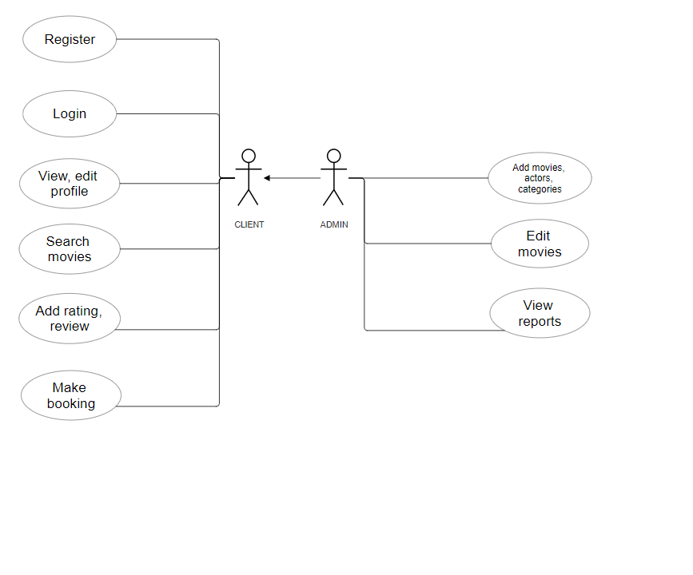
Figure 3-1: Use case diagram

System Architecture
The architecture of a web application is crucial to its performance, scalability, maintainability, and overall success. This subchapter provides an in-depth overview of the system architecture for a web application built using ASP.NET Core APIs, SQL Server, and Angular. By utilizing a layered architecture, the application ensures a clear separation of responsibilities, promoting modularity and ease of maintenance.
The backend, powered by ASP.NET Core, handles business logic, data processing, and interactions with the database. The architecture is organized into distinct layers: Domain, Infrastructure, and Application. Each layer has a specific role and interacts with others to provide a unified and efficient system.
The domain layer is the core of the application, encapsulating the business logic and rules. It is responsible for representing the business concepts, information, and the rules that dictate how that information can be manipulated and processed. This layer is independent of the infrastructure and application layers, focusing only on the business logic. The domain layer does not depend on any other layer, but all the other layers depend on it. The entities retrieved from the database are faithfully represented within the domain layer, ensuring precise alignment between the database schema and the application's domain model. Additionally, the domain layer includes interfaces of repositories, facilitating interaction between the business logic and data storage mechanisms.
The infrastructure layer serves as the foundation of the application. It is responsible for handling external concerns such as data access, communication with external systems, and infrastructure-related operations. This layer shields the domain and application layers from the complexities of the infrastructure and ensures smooth interaction with external resources. This layer defines the operations to be executed on the database, sets up the database structure, and manages the relationships between entities. Utilizing Entity Framework, portions of code can be automatically generated to model the database based on existing code.
The application layer serves as the intermediary between the presentation layer (frontend) and the domain layer (backend). It encapsulates the application's business logic, models the execution of use cases, and coordinates interactions between different parts of the system. This layer is responsible for processing user inputs, executing business rules, and producing the appropriate outputs for presentation to the user. In the application layer, you will discover services hosting the core business logic and the controllers serving as the gateways for API communication, facilitating smooth interaction between the frontend and the backend. The DTOs (Data Transfer Objects) are also located within this layer, serving the purpose of transferring data between the application layer and the client, ensuring smooth communication and facilitating the exchange of information.
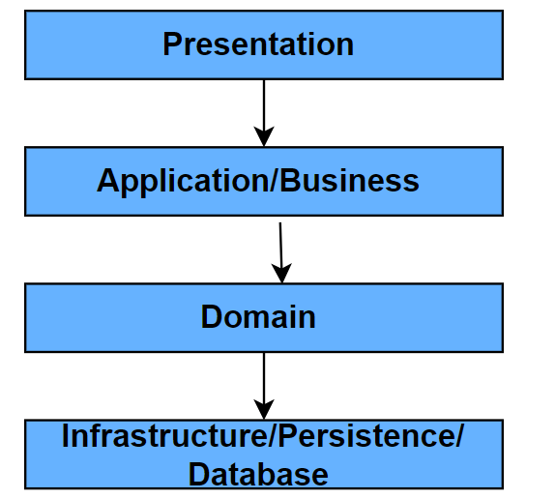
source: https://www.baeldung.com/cs/layered-architecture
Figure 3-2: Layered architecture
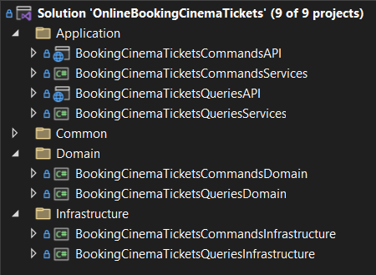
Figure 3-3: Applied layered architecture within my project

Some of the advantages of using layered architecture are the fact that it is easy to learn and implement, there is reduced dependency among layers, because each layer has its own functionality. Therefore, the testing is easier, having separate components. Additionally, the costs for implementing this are low.
However, on the other hand, the disadvantages are that it is difficult for the implementation to extend, as the structure of the framework does not allow growth, it can be challenging to maintain as a change in a layer can affect the whole system because it operates as a single unit. Moreover, the layers depend on each other, the layer above depends on the layer below and receives data from the layer above. Moreover, parallel processing is not possible, limiting opportunities for performance optimization within the system. [16]
As you can see in the Figure 3-4, I used an architectural pattern called CQRS. The Command Query Responsibility Segregation (CQRS) pattern is an architectural pattern that supports a clear separation between operations that modify data (commands) and operations that retrieve data (queries). It promotes the idea of having distinct models and components for reading and writing data, allowing for optimization and scalability strategies for each type of operation.
Commands represent operations that modify the state of the system. These operations typically involve creating, updating, or deleting data. Command objects encapsulate the intent to perform a specific action and may include parameters or payload data necessary for executing the command. Command handlers are responsible for processing and executing commands. They contain the business logic for validating, processing, and applying changes to the system's state.
Queries represent operations that retrieve data from the system without modifying its state. These operations typically involve fetching data for display or analysis purposes. Query objects encapsulate the criteria or parameters for retrieving specific data. Query handlers are responsible for processing queries and fetching data from the appropriate data sources. They may involve complex data joins, aggregations, or filtering operations to fulfill specific requirements.
CQRS offers several advantages that contribute to the efficiency and flexibility of software systems. By making a clear distinction between commands and queries, CQRS encourages a structured approach to system design, making it easier for developers to understand and maintain the behavior of the application. CQRS provides a scalable architecture by allowing read and write operations to be scaled independently. This flexibility ensures that systems can adapt to changing demands and handle increased workloads without sacrificing performance. Another significant advantage of CQRS is its flexibility in accommodating changes over time. By decoupling the read and write models, CQRS enables developers to evolve the system independently, making it easier to introduce new features or modify existing functionality without disrupting the entire architecture.
Despite its benefits, CQRS also presents challenges and considerations that developers must address when implementing this architecture. CQRS introduces additional complexity compared to simpler architectures, which may require developers to invest more time and effort in understanding and implementing the system. This increased complexity can also impact the learning progress for new team members and add indirect expenses to the development process. Maintaining consistency between the read and write models can be challenging, especially in distributed systems where data updates may occur concurrently. Developers must carefully synchronize changes between the two models to ensure data integrity and consistency across the system.
Another pattern I used in backend development is the repository pattern. It is a design pattern commonly used in software development to abstract the data access layer from the rest of the application. It provides a way to encapsulate the logic required to access data stored in a database or other data source.
In the repository pattern, each entity in the domain layer typically has a corresponding repository interface. These interfaces define the contract for accessing and manipulating the data associated with the entity. Implementations of these repository interfaces are responsible for interacting with the data storage mechanism, whether it is a relational database, NoSQL database, or any other type of data source.
The repository pattern offers several benefits. Firstly, it abstracts the details of data access, allowing the rest of the application to work with a consistent interface regardless of the data storage technology. Secondly, repositories encapsulate the logic required to access and manipulate data, promoting a separation of concerns within the application. Additionally, by abstracting data access behind repository interfaces, it becomes easier to mock data access operations in unit tests, facilitating testing of other application components. Repositories can also provide additional functionality beyond simple CRUD operations, such as querying, filtering which are designed to the specific needs of the application. Finally, the use of repositories decouples the domain model from the data access layer, allowing changes to one without affecting the other, which promotes maintainability and flexibility in the application architecture.
However, the repository pattern also has some drawbacks. Implementing repositories can introduce additional complexity to the application, particularly in cases where there are many entities and complex data access requirements. In some cases, the abstraction provided by repositories may introduce a performance excess compared to directly accessing the data source. There is also a risk of over-abstraction when implementing repositories, leading to unnecessary complexity and decreased clarity in the code implementation. Therefore, it's important to maintain balance between abstraction and simplicity when applying the repository pattern in software development.
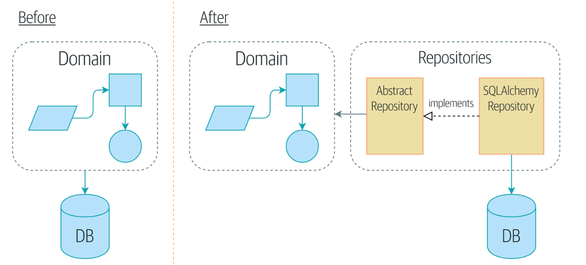
source: https://www.cosmicpython.com/book/chapter_02_repository.html
Figure 3-4: Before and after the repository pattern
Along the repository pattern, I used The Repository Wrapper. It is a design pattern that serves as a centralized entry point for data access operations within a software application. It encapsulates the creation and management of repository instances, which are responsible for querying and manipulating data from the data source.
By abstracting away the details of data access, the Repository Wrapper promotes a clean separation of responsibilities. It acts as a facade that shields the rest of the application from the complexities of the data access mechanisms, such as database connections, query execution, and result mapping.
One of the key benefits of the Repository Wrapper is its ability to simplify dependency management and promote code reusability. Instead of spreading data access logic throughout the application codebase, developers can centralize it within repository classes managed by the Repository Wrapper. This makes it easier to maintain and evolve the data access layer over time, as changes only need to be made in one place.

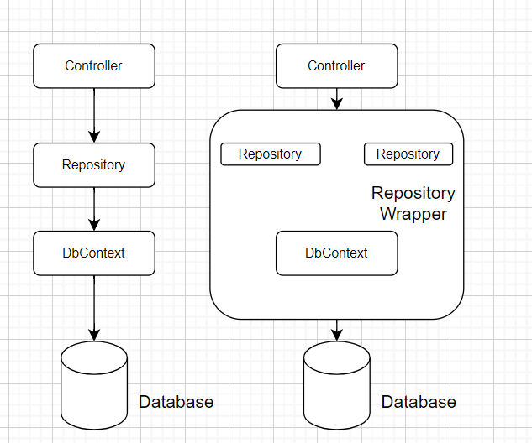
Figure 3-5: Repository wrapper
Angular, the front-end framework that I used has an architecture designed to facilitate the development of well-structured and maintainable code. It is based on several key concepts and components that work together to create an efficient development environment.
At the core of Angular's architecture are the modules, which serve as the main building blocks of Angular applications. Each Angular application has at least one module, the root module, which bootstraps the application. Modules group related components, directives, pipes, and services together, making it easier to manage and organize the code. They encapsulate functionality, making it reusable and easier to maintain.
Components are another fundamental way to organize code in Angular applications, as they control parts of the user interface (UI). A component consists of an HTML template for the view, a TypeScript class that defines the behavior, and CSS styles for presentation. Components interact with each other through property and event binding, forming a tree structure that defines the application's UI and logic. Templates define the HTML view of a component, using Angular's template syntax to bind data, handle user events, and manage the rendering of dynamic content.
Services and Dependency Injection (DI) play a crucial role in Angular architecture by encapsulating business logic, data retrieval, and other operations that are not directly related to the UI. This promotes code reusability and separation of responsibilities. Angular uses dependency injection to provide components with the services they need. Services are typically registered with an Angular injector, which makes them available for injection into components and other services, ensuring a clean and efficient way to manage dependencies.
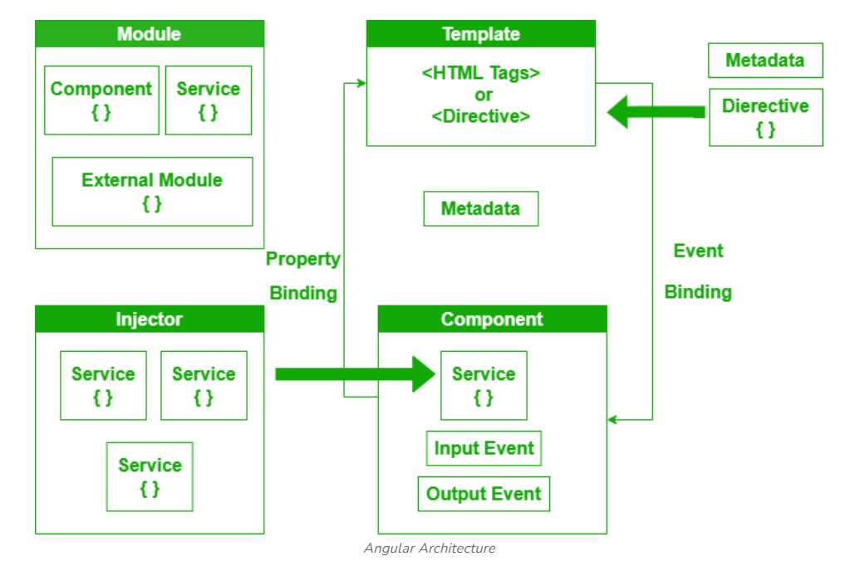
source: https://www.geeksforgeeks.org/explain-the-architecture-overview-of-angular/
Figure 3-6: Angular architecture

Database structure
The database structure is a crucial aspect of any web application, serving as the foundation for data storage, retrieval, and management. In this subchapter, we will explore the organization and design of the database used in the web application. Understanding the database structure involves examining the schema, the relationships between entities, and the methods used to ensure data integrity and performance.
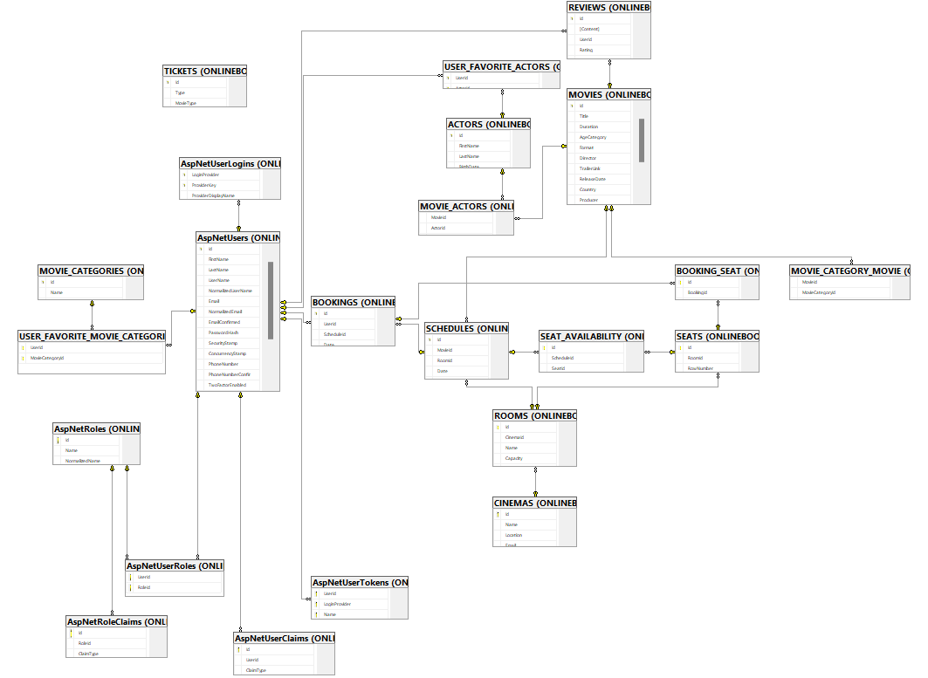
Figure 3-7: Database diagram
The database diagram contains all the tables that I used in the development for storing the data and their corresponding entity relationships. The lines in the figure represent connections. The end with a key symbol indicates that the entity is involved in the relationship once, which we interpret as "one." If the other end also has a key, the relationship is "one-to-one." If the other end has an infinity symbol, the relationship is "one-to-many." For the "many-to-many" relationship, a junction table is used. Each of the tables involved in the many-to-many relationship has a "one-to-many" relationship with the junction table.
A one-to-one relationship exists when a single row in a table is associated with a single row in another table. This type of relationship is often used to split data into different tables for normalization or security reasons. For example, you might have a “User” table and a “UserProfile” table, where each user has exactly one profile, and each profile is associated with exactly one user. The primary key of one table is also used as a foreign key in the related table, ensuring that each entry corresponds uniquely. In the figure there is no one-to-one relationship, as the user profile information is stored in the user table.
One-to-many relationship occurs when a single row in one table is associated with multiple rows in another table. This type of relationship is common and is used to link entities that can have multiple related entities. For example, in the figure 3-7 there is a table “MOVIES” and a table “REVIEWS”. Each movie can have multiple reviews, but each review is associated with only one movie. This is implemented by adding a foreign key in the “REVIEW” table that references the primary key of the “MOVIES” table.
A many-to-many relationship is when multiple rows in one table are associated with multiple rows in another table. This relationship is used when entities on both sides can have multiple associations with each other. For instance, look at the “MOVIES” and “ACTORS” tables. A movie can have multiple actors playing in it, and an actor can play in multiple students. To implement this, a junction table (also known as a bridge table or associative table) is used. The junction table includes foreign keys referencing the primary keys of both related tables, such as “MOVIE_ACTORS” with foreign keys MovieId and ActorId.
Now I will describe each table a little bit and I will present its relationships with other tables. The tables I started from are the ones with “AspNet” in their names. These tables are identity-generated and are used to manage user authentication, authorization, and user-related data within an ASP.NET application.
The “AspNetUsers” table contains the registration and the login information about the user. The password is stored hashed. Additionally, it contains information about user preferences that can be added or modified by the user from the profile page. The “AspNetRoles” contains all the existing roles in the application. There is a “many-to-many” relationship between users and roles, as a user can have theoretically more roles, but within the web application a user has only one role, and a role can be assigned to multiple users, so it results the junction table “AspNetUserRoles”.
The “AspNetLogins” table stores external login information for users who have associated external authentication providers (e.g., Google, Facebook). It typically contains columns for the provider's name, the user's external identifier, and any additional data provided by the external provider. A user can have multiple logins.
The table “AspNetClaims” stores user claims, which are key-value pairs containing additional information about the user. Claims are used to store information such as user roles, permissions, or custom user attributes. Each claim typically has an identity-generated primary key. A user can have multiple claims and a claim can be assigned to multiple users, so it results a junction table called “AspNetClaims”.
“AspNetUserTokens” table stores security tokens associated with users for purposes such as two-factor authentication or password reset functionality. It typically contains columns for the token's purpose, its value, and the user it belongs to. A user can have multiple tokens.
User’s table has a “many-to-many” relationship with the table “MOVIE_CATEGORIES”, resulting a junction table. The second mentioned table stores all the types of movie categories or genres added by the administrator. The idea is that users can set preferences of the genres that interests them and we need to have evidence of that.
As well, a user set in the preferences section, favorite actors and we will keep evidence of it in the junction table “USER_FAVORITE_ACTORS”. The “ACTORS” table contains information about the actors
A user can have multiple bookings and a booking can belong to a single user so it results a “one-to-many” relationship. The table “BOOKINGS” contains information about the price, date when the booking was made, a schedule of the movie foreign key reference and a foreign key reference to the user that completed the booking.
There is a “many-to-many” relationship between “ACTORS” and “MOVIES”, as I explained previously. It’s the same for “MOVIE_CATEGORIES” and “MOVIES”.
There is a “one-to-many” relationship between movies and reviews.
I created a table named “SCHEDULES” that keeps record of the screening times for different movies, a movie having multiple screenings. In addition, at a certain schedule, multiple bookings can occur, so I defined a “one-to-many” relationship between “SCHEDULES” and “BOOKINGS”.
Through a booking can be reserved more seats, and a specific seat may be reserved through multiple bookings, therefore I built a “many-to-many” relationship between “BOOKINGS” and “SEATS” tables.
“SCHEDULES” and “SEATS” tables are connected through a “many-to-many” relationship because we need to track the seat availability in the junction table.
The “CINEMAS” and “ROOMS” tables present a “one-to-many relationship”. The “ROOM”
entity is connected as well with “SCHEDULES” and “SEATS”. We need to know in which room is the specific seat and to know where the screening for a movie will take place, so these last to relationships are “one-to-many” starting from the room entity.
There is also a table that has no connections at all names “TICKETS” that stores just the information about the ticket types like price, type of movie (3D, 2D), type of customer.
For the integrity of data I used indexes and constraints on some columns of the tables.
Indexes are database structures that improve the speed and efficiency of data retrieval operations. They are used to quickly locate and access the data without having to search every row in a database table every time a database table is accessed. Constraints, on the other hand, ensure that the data in the database respects certain conditions and business rules, preventing invalid or inconsistent data from being inserted, updated, or deleted.
For example, in the table “AspNetRoles” there is a unique non-clustered index on the column “Name”. That is because there cannot be two roles with the same name, so if we try to insert a role with the same name as one already in the table, we will get an error.
On the "MOVIES" table, a constraint is defined on the "Status" column to set its default value to "Incoming". This allows the administrator to change the status to "In cinema" whenever considers appropriate.
For facilitating the interaction between the application and the database I used Entity Framework (EF). It is an Object-Relational Mapper (ORM). EF enables developers to work with database objects using .NET objects, abstracting the complexities of SQL queries and database schema management.
In order to create the tables in the database with the corresponding indexes and constraints, I used a development approach called code-first. In this approach, the database schema is generated from the code models. Developers define the database structure using classes and EF generates the corresponding database schema. This approach allows for a more agile and iterative development process, where the code defines the database.
After building and configuring the classes corresponding to the database tables, I added a migration using the built-in terminal in Visual Studio. I then scripted the code and applied it to the database. Whenever I changed the classes or configurations, I added a new migration and applied the new generated script.

Functionalities
In order to keep records of the users making bookings on the web application and to provide administrators with extra features, I decided to implement the register, login, and logout functionalities using ASP.NET Core Identity and JWT tokens.
The register functionality implies the user to introduce a valid and unique email that does not already exist in the database, a password that has to be introduced identically twice respecting the security requirements, a username, and first name and last name. The conditions for a secure password are
- password must be at least 6 characters
- password must have at least one non alphanumeric character
- password must have at least one digit ('0'-'9')
- password must have at least one uppercase ('A'-'Z').
If something went wrong, the fields are provided with error messages for required data and validating data. There are also validation techniques on the backend part for preserving data integrity.
After registering with valid data, the user will be created and will be able to log into the application. The login functionality requires the user to complete the email and password fields with valid credentials corresponding to an existing user. If the credentials are invalid, an appropriate error message will be displayed.
Upon successful login, the backend generates a JWT (JSON Web Token) for the user. The JWT includes claims about the user's identity and role, encoded in a secure manner. This token is then sent to the client and is used for authenticating following requests. The user is then directed to the home page, where specific menu items and functionalities are made available based on the user's role.
JWT tokens are used to securely transmit information between the client and the server. The token is signed with a secret key known only to the server, ensuring its integrity and authenticity. Upon successful authentication, a JWT is generated containing user information and claims, such as user ID and roles. For each request requiring authentication, the server validates the token's signature and extracts the user information from it. Claims are used to store additional metadata about the user, such as their roles, which determine their access to various parts of the application.
There is also a “Forgot Password” functionality. If a user forgets their password but remembers their email address, they can enter it to receive an email with a unique URL. By accessing this URL, the user can set a new password.
The logout functionality is accessible through a button, which, when clicked, invalidates the JWT token, effectively ending the user's session and ensuring secure logout.
For the logged in users it is available their profile page, where they can add or modify information like profile picture, description. They can add, as well, their preferences in actors and movie categories, which will improve their experience on the platform overall. For the changes to be applied, users must press the button “Update Account” and will be informed if the profile has been updated successfully or if it was an error.
In the menu section labeled “Movies” users can explore a variety of movies organized in four different categories: recommended, past movies, in cinema movies and incoming movies. If a user has previously rated movies, the platform utilizes a user-based collaborative filtering algorithm to suggest recommended films matching their preferences. Within each category, movies are further sorted based on their current status. For instance, the “Past Movies” tab displays movies that are no longer available in cinemas, while the “In Cinema” tab displays currently screening movies, and the “Incoming Movies” tab previews upcoming releases. For these three tabs based on movie status there are available many filtering options for the users. Users can search based on the movie title, they can choose which actors or movie categories to contain. And then the results can be ordered either by release date or by rating, ascending or descending.
When deciding upon an upcoming movie, the user can read all the related data about that movie and can watch a trailer. If the movie is not available anymore in the cinema, the user can read its details, can even leave a rating and a review to the movie and can read others’ reviews. According and viewing ratings and reviews is also possible when a movie is available in cinema at the moment. Moreover, in this case, a logged in user can go through the next steps to make a booking. The first step is choosing an available date from the calendar. Then the user needs to select a screening time from the ones displayed. After that, a matrix representing the seats in the cinema room will appear. Next to it is a legend explaining that green squares are available seats, yellow squares are the selected seats by the user and red squares are unavailable seats. The user will have to choose from one to three seats among the red ones, and then needs to select the ticket types. When a booking is successfully made, the user will receive the booking details through an email.
When a user browses through reviews of a particular movie left by other users, they have the option to navigate to the profile pages of those users. However, on these profile pages, the user is restricted from making any modifications; instead, they can only view the information displayed.
Leaving a review feature implies the user rating the movie from one to five, selecting how many stars the movie deserves and writing an opinion about the movie then pressing the “Submit” button in order to record it.
These are the functionalities available to a regular user. Administrators have additional features, such as like inserting movie related data. There is an “Insert Tool” menu option that is available for administrators. Here they can insert movie categories that have not been inserted already just by introducing the name of the movie genre. They can add new actors to the database by specifying actor’s first name, last name, birthdate, and biography. Only first name and last name are required and an actor can be stored just once in the database. An administrator can also add new movies that have multiple fields to complete having their requirements. To insert a movie, you need to complete specific fields, including uploading a picture and selecting a format from a dropdown menu that lists existing formats. The same applies to the fields for 'actors' and 'movie categories,' where you can choose from existing options in dropdown menus. Some fields have autocomplete activated, displaying suggestions from previous completions. A movie is unique in the database.
When an administrator inserts a new movie, users who have added some of the movie categories or actors from the newly inserted movie to their preferences will receive an email informing them about the movie specifying its release date and inviting them to the cinema.
Furthermore, the administrator can edit existing movies from a movie details’ page. There is a button “Edit” on the right side, available only for administrators. It opens up a pop-up with a pre-completed form with the movie’s details that the administrator can modify and then apply the changes.
Another functionality available for administrators lies in the “Reports” menu option. There are four tabs that display charts containing analytics information regarding user preferences. The first tab displays a pie chart containing the names of the most preferred ten actors. The second tab reveals the most preferred ten movie categories in a pie chart. In the next tab, the administrators have information about the most booked movies. Finally, in the last tab, we can find movies with the highest or lowest ratings of all time in a bar chart.

Implementation details
The most interesting part of the code implementation I would say it is the recommendation algorithm. The algorithm computes the cosine similarity between the target user and all other users in the dataset. It then identifies the most similar users and aggregates their ratings for movies that the target user has not rated. The aggregated ratings are weighted by the similarity scores, and the top recommended movies are selected based on these weighted ratings.
“GetRecommendations” method takes a user id as input and returns a list of recommended movies for that user. It first checks if the user id is valid and then builds a user-item matrix using the ratings provided by users for various movies.

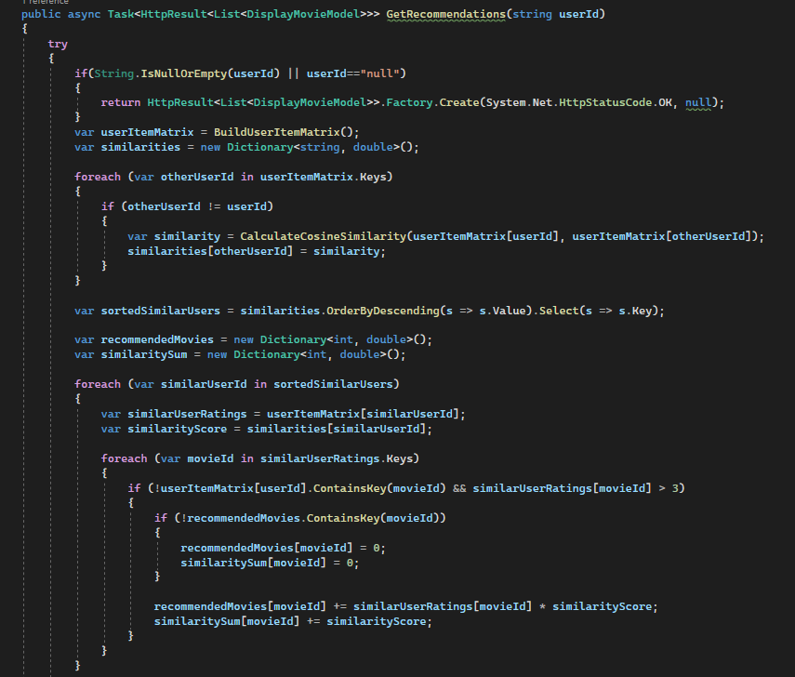
Figure 3-8: GetRecommendations method
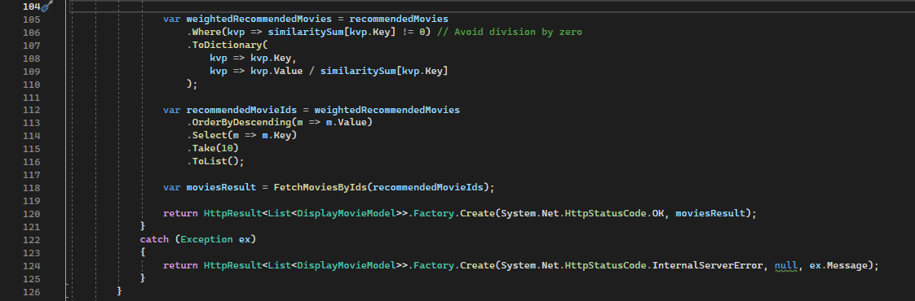
Figure 3-9: The continuation of GetRecommendations method
The “BuildUserItemMatrix” method constructs a user-item matrix, where each row represents a user and each column represents a movie, with the corresponding cell value being the user's rating for that movie.
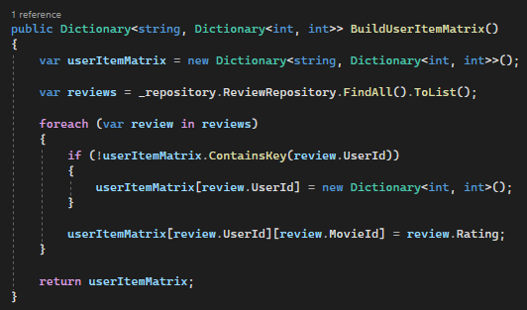
Figure 3-10: BuildUserItemMatrix method
“CalculateCosineSimilarity” method calculates the cosine similarity between two users based on their ratings for common movies. It computes the dot product and lengths of the rating vectors and then returns the cosine similarity score. This result is a value between -1 and 1, where 1 indicates perfect similarity, -1 indicates perfect dissimilarity, and 0 indicates no similarity.
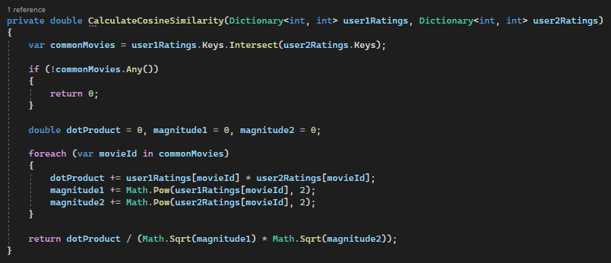
Figure 3-11: CalculateCosineSimilarity method
Another functionality that I find interesting is the user interface feature for managing favorite actors and movie categories within the user’s profile page. This feature allows users to add and remove their preferred actors and movie categories smoothly.
The UI layout consists of two sections: one for managing favorite actors and another for managing favorite movie categories. Each section includes an input field for adding new items and a list of chips displaying the selected items.
For the favorite actors section, users can type the name of an actor into the input field, and autocomplete suggestions based on existing actor names are provided. Selected actors are displayed as chips, and users can remove them by clicking on the close icon associated with each chip.
Similarly, for the favorite movie categories section, users can add new categories by typing their names into the input field, which also offers autocomplete suggestions. Selected categories are displayed as chips, and users can remove them as needed.
The functionality is implemented using Angular Material components, providing a intuitive user interface. TypeScript logic handles user interactions, including adding, removing, and filtering actors and movie categories, ensuring a good user experience.
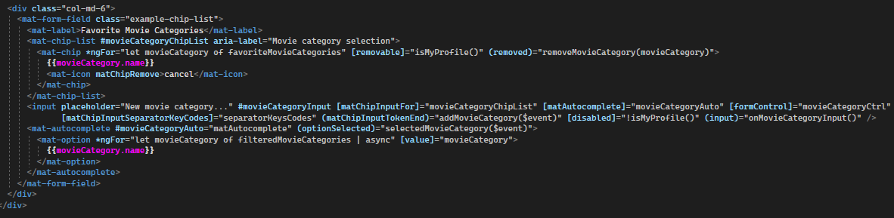
Figure 3-12: Autosuggest search HTML
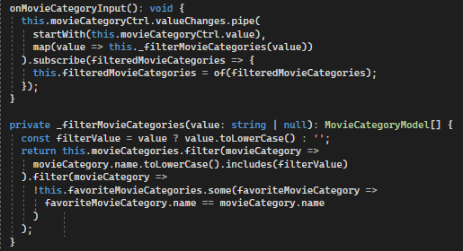
Figure 3-13: Autosuggest search TypeScript
The charts implementation was engaging as I retrieved the necessary data through an API and I displayed it in a visually appealing manner for the user using canvas-based charts.
The AdminReports component is responsible for managing the reports displayed in the admin dashboard. It initializes variables for configuring pie and bar charts using the Chart.js library. It retrieves data from the backend through the MovieService, including users' favorite actors, favorite movie categories, movies with the most bookings, and movies by rating. Selecting a tab dynamically updates the corresponding chart data. The HTML template renders pie charts for displaying the top ten actors and top ten movie categories and bar charts for displaying top the most booked ten movies and ten movies with the highest or lowest ratings.
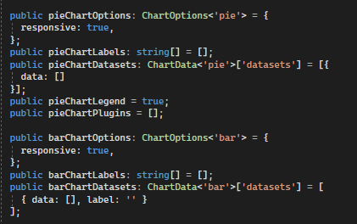
Figure 3-14: Charts definition Typescript
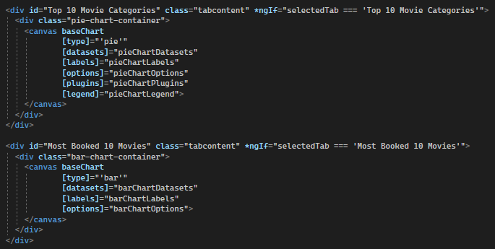
Figure 3-15: Charts definition HTML

User manual

Client user functionalities
A regular user is a client who navigates to this website to search for movies, read about them, make bookings, configure their profile to receive notifications about upcoming movies they might like, and rate and review movies.
An administrator has access to all the features a regular user has.
No matter the type of user reaches this website, everyone will be welcomed by the home page which is suggestive for a cinema bookings and recommendations platform.
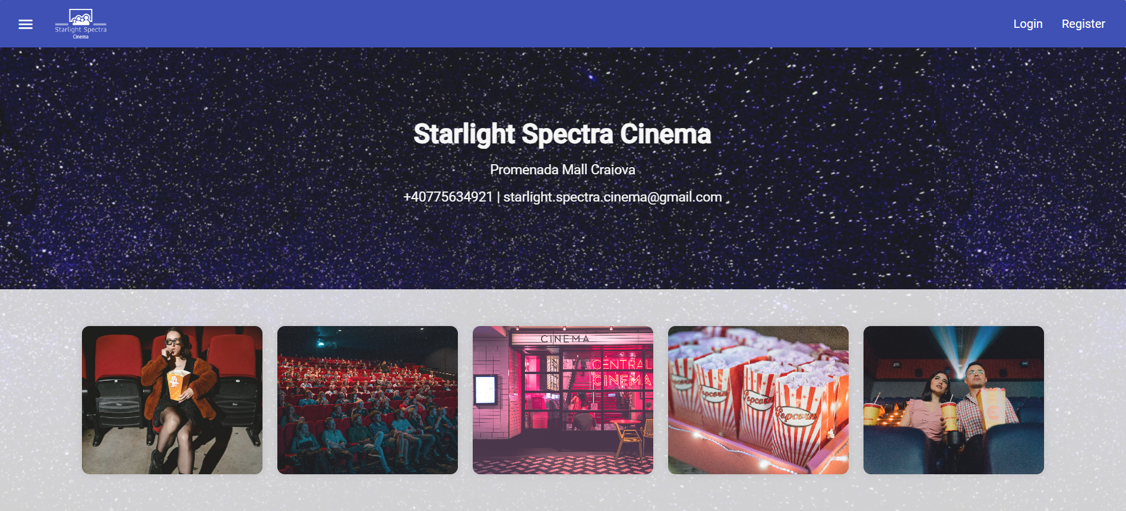
Figure 4-1: Home page
Scrolling down on the home page, users will encounter inspiring and suggestive quotes about cinema and movies, creating an inviting atmosphere for their browsing experience.

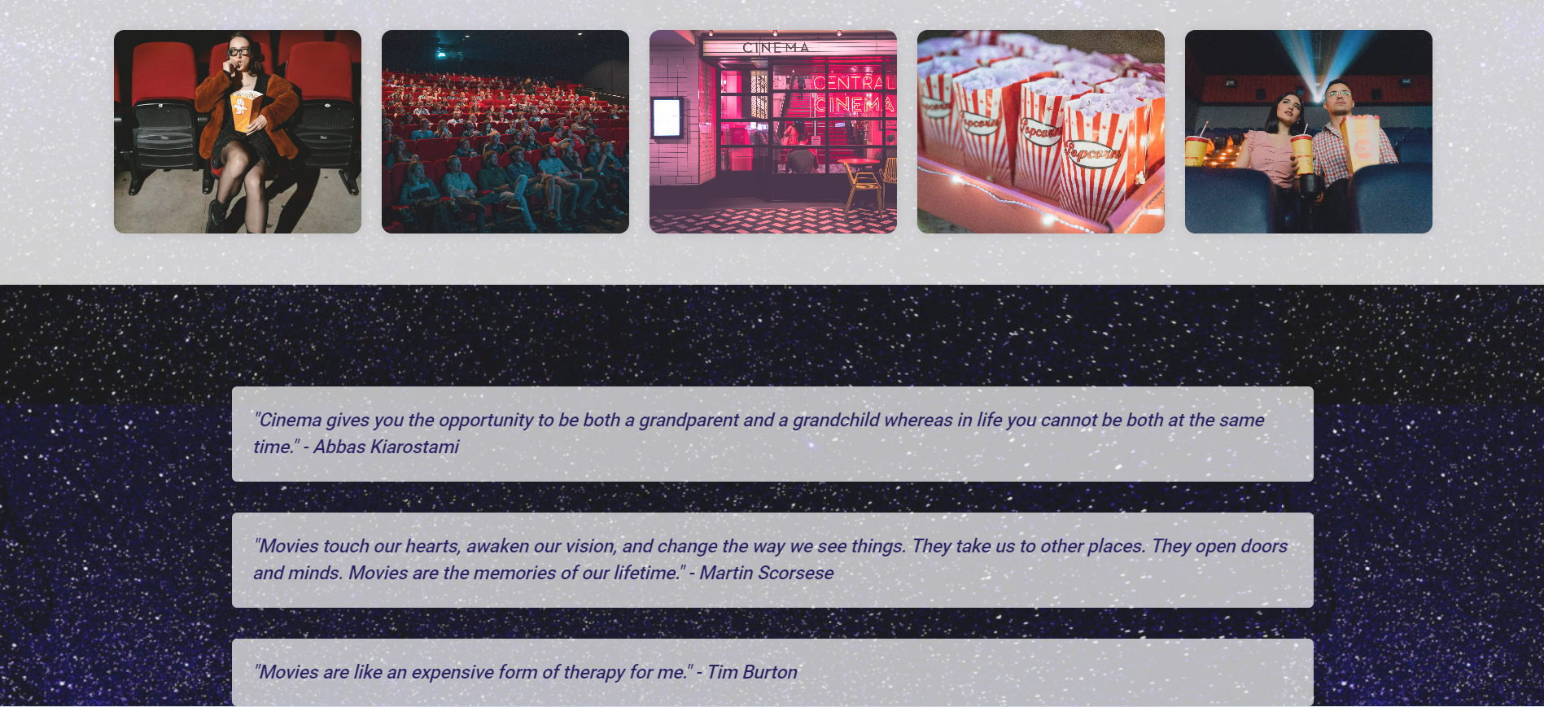
Figure 4-2: Home page quotes
There are available register, login, forgot password, and logout functionalities for all kind of users.
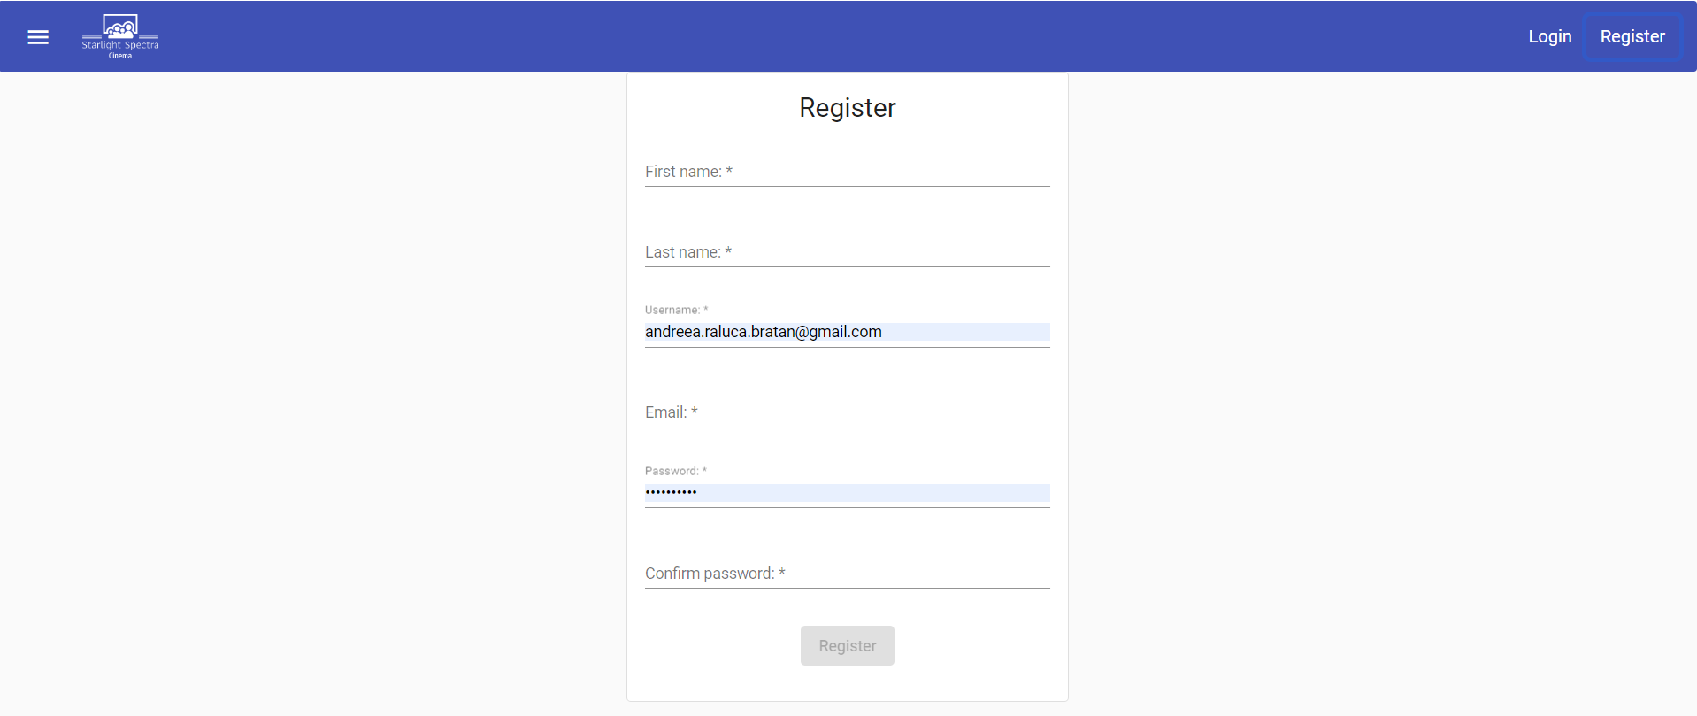
Figure 4-3: Register

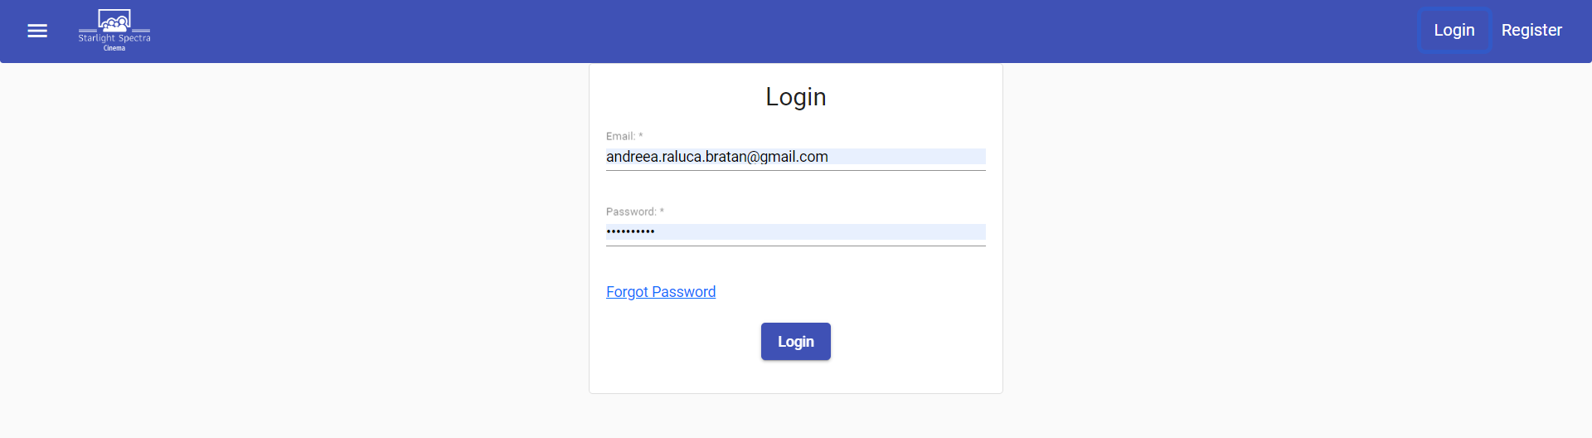
Figure 4-4: Login
Once logged in successfully, the user can navigate to the profile page where it is possible to add new personal information or to modify the existing one. If the user chooses to delete their profile picture, their avatar on the website will revert to the default avatar picture. Adding new favorite movie categories or actors is straightforward: users simply need to type into the corresponding field. As they type more characters, the suggestions will gradually become closer to what the user is looking for.

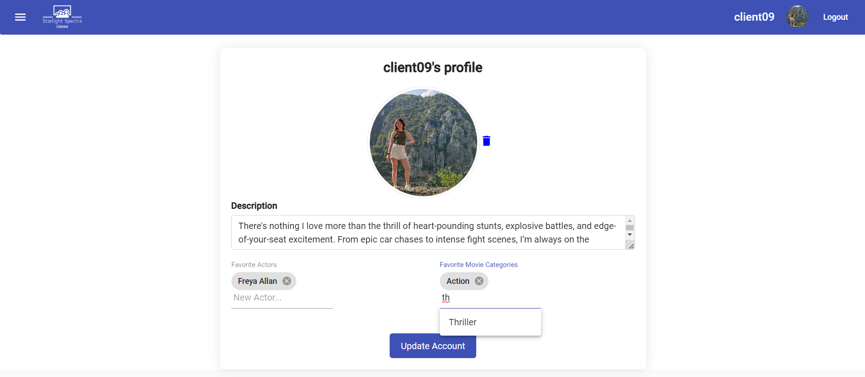
Figure 4-5: User’s profile

Users can navigate to the "Movies" section in the menu, accessible to all users, whether they have an account or not. On this page, movies from the database are displayed, filtered based on several criteria, and ordered by different attributes. I used pagination in order to display smoothly large amounts of movies. The purpose of this page is to facilitate users in finding a specific movie or one that closely aligns with their desires and preferences.
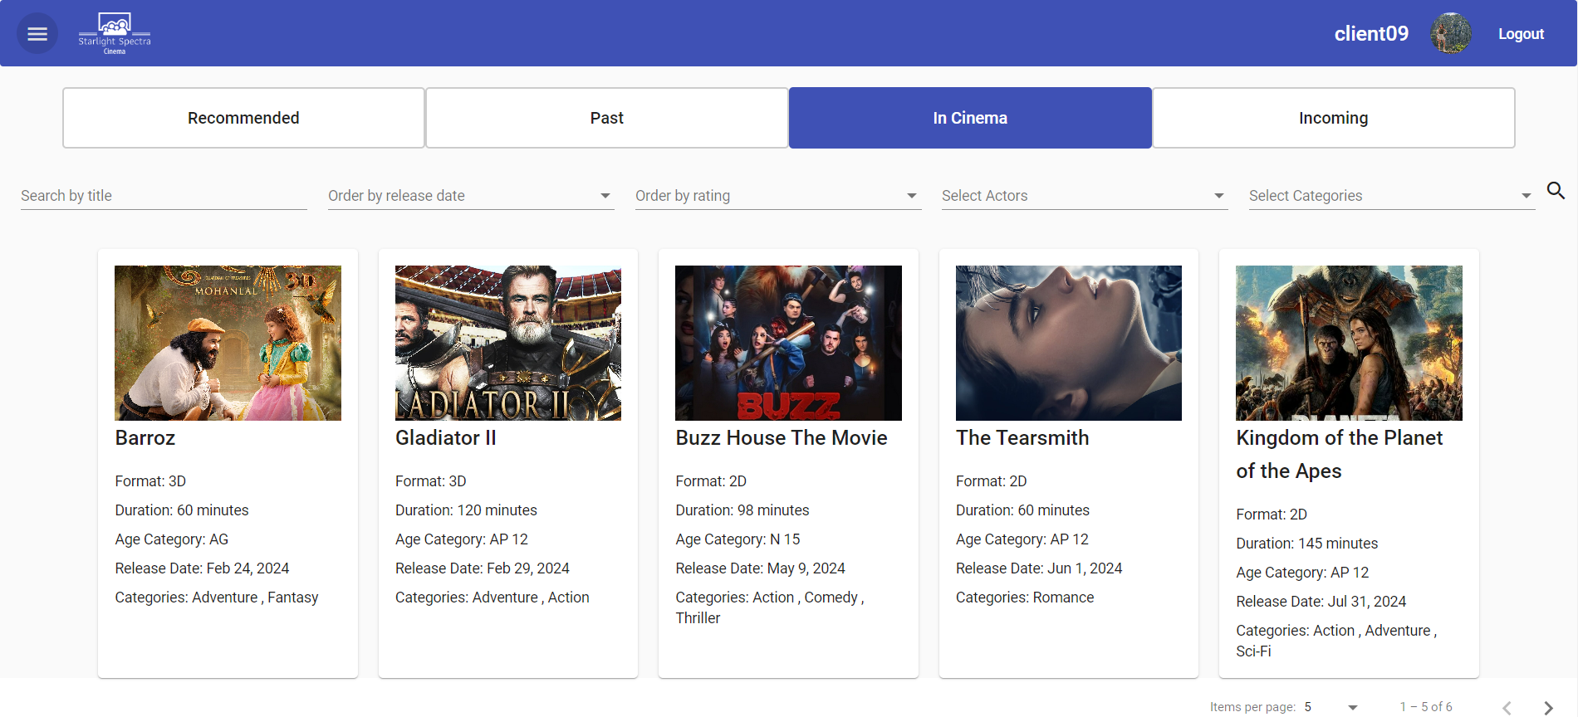
Figure 4-6: Movies page
Once the user has selected a particular movie, they can click on the movie card, which will redirect them to the movie details page. Here, they will find more information about the movie, as well as facilities for rating and reviewing both current and past movies. Additionally, for movies currently running in cinema, users have the option to make seat reservations.
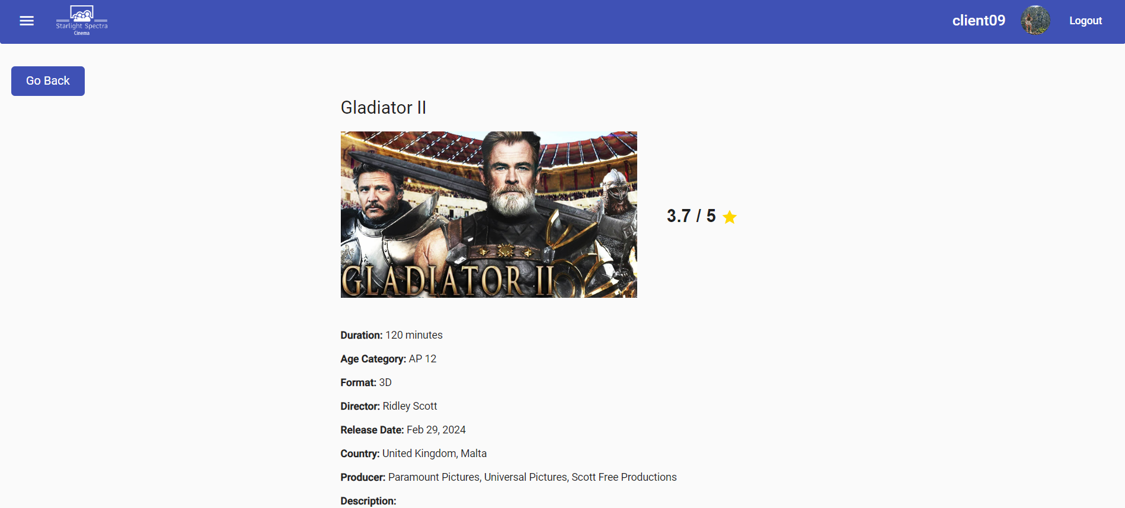
Figure 4-7: Movie details page part I
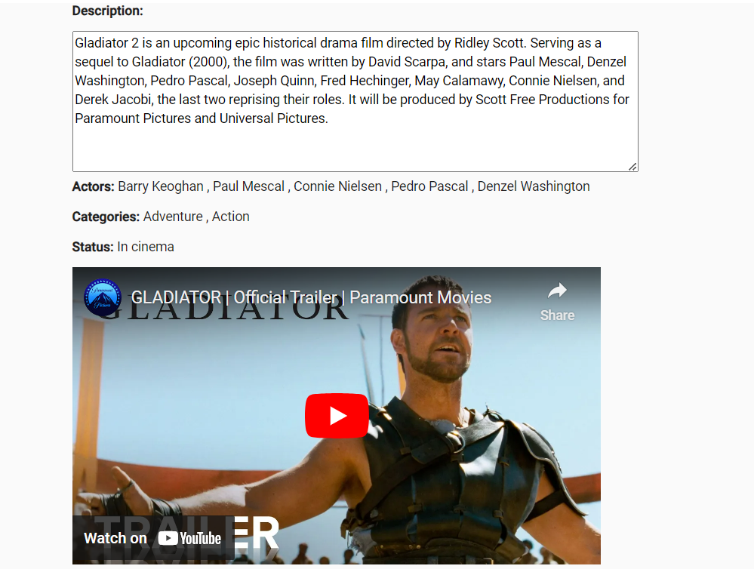
Figure 4-8: Movie details page part II
As you can see in Figure 4-6 and Figure 4-7 the movie details page includes information about the movie, as well as the current average rating. There is also a trailer from YouTube integrated into the web page’s content.

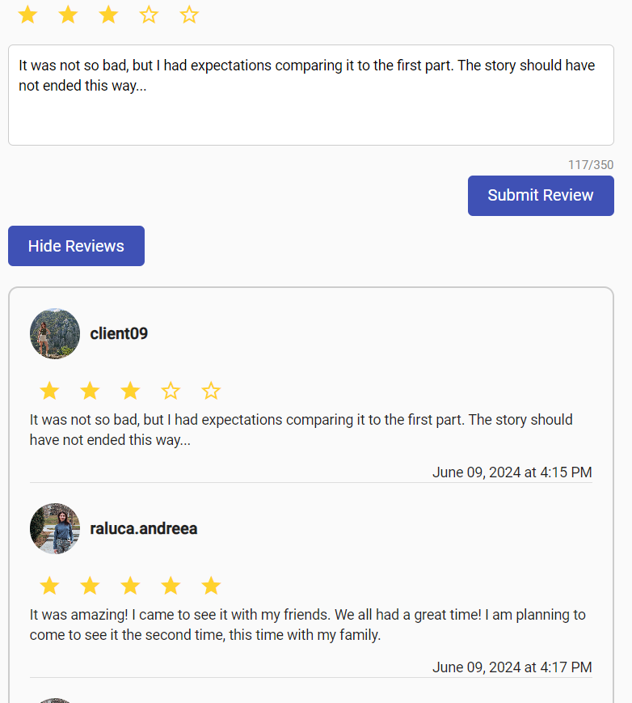
Figure 4-9 Reviews section
Figure 4-8 showcases the review and the rating accorded by the current logged-in user. The user can update it by pressing “Submit Review” button. Additionally, there's a toggle button enabling showing and hiding all the existing reviews for the current movie. Pagination is utilized to manage the display of all reviews. By clicking a user’s profile picture from the reviews, the user will be redirected to the corresponding profile page of the user being able to visualize the available information.
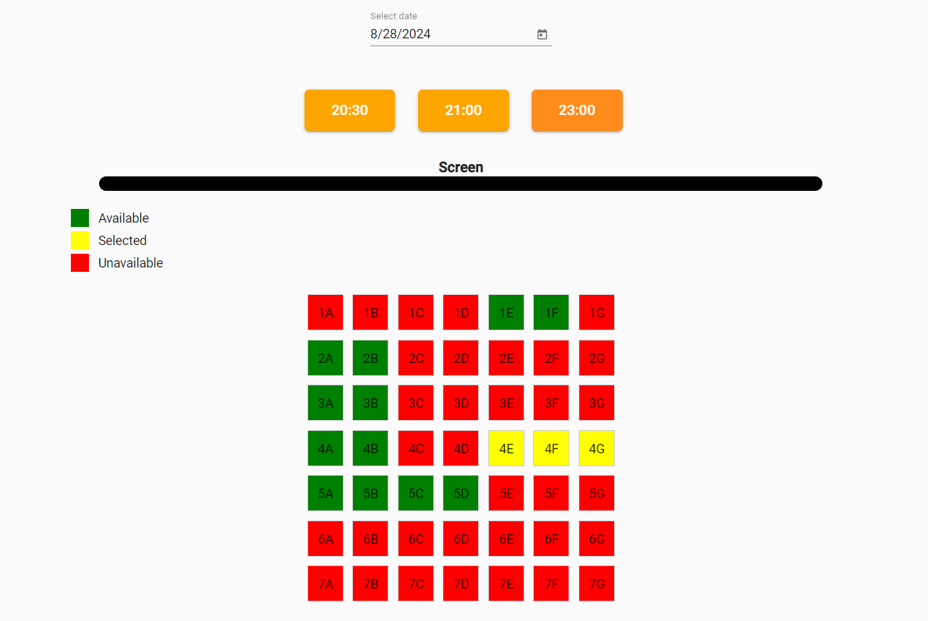
Figure 4-10: Booking functionality
To access this section, users need to scroll down past the review section. From there, they can select a date from the available options on the calendar. After selecting a date, the available showtimes will be displayed, and users can choose one of them. Once a showtime is selected, the seat layout will be shown along with a legend to guide users through the seating options.
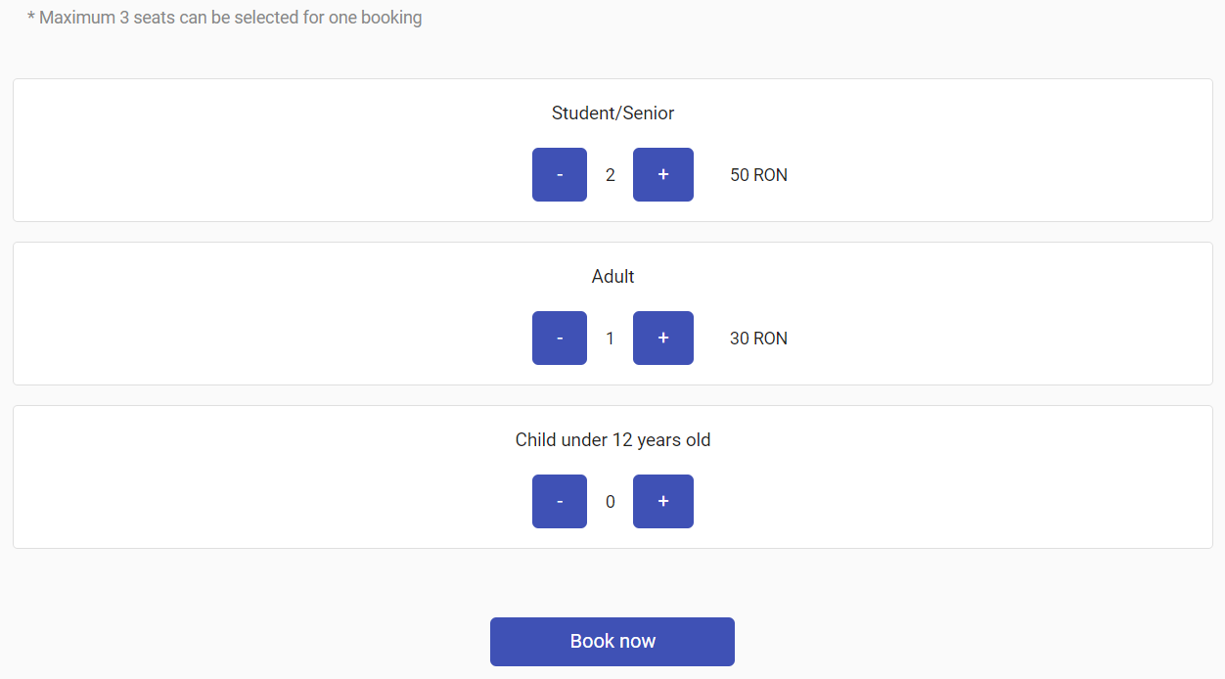
Figure 4-11: Ticket types selection
Figure 4-10 illustrates the final step of the booking process. Here, users are required to select the types of tickets corresponding to the number of seats chosen previously to successfully complete the booking. Users can use the “+” button to increase the number of tickets and the “-” button to decrease it. The current quantity of tickets for each type is displayed between the buttons. Accordingly, the total price of tickets of that type will appear on the right of the two buttons. After pressing “Book now” they will receive an email containing all the necessary information about the booking.

Administrator functionalities
Additionally to what was discussed in the previous subchapter, the administrator has access to three more sections.
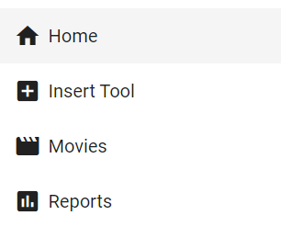
Figure 4-12: Administrator menu
The first section we will discuss about is the “Insert Tool” menu option. The administrator has access here to three types of forms for inserting movie categories, actors and movies.
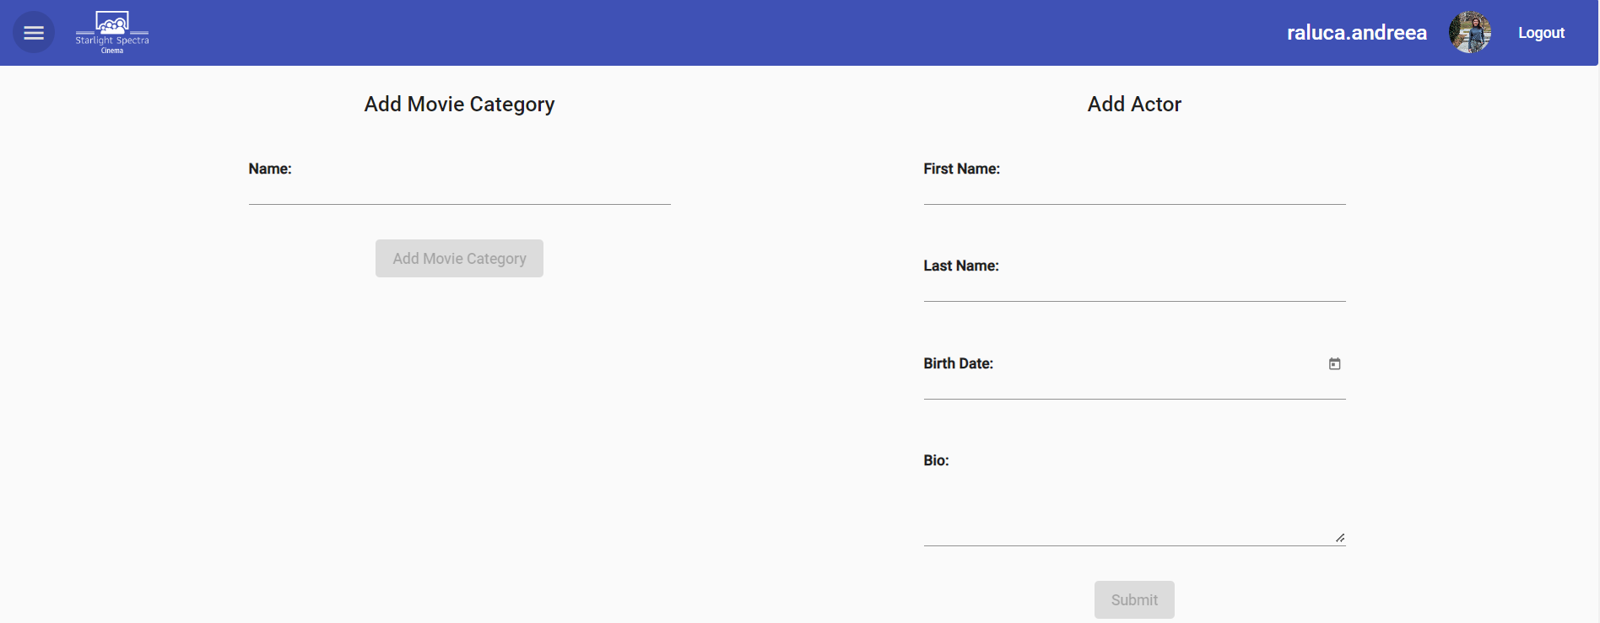
Figure 4-13: Insert tool part I
In order to be able to insert new data, the administrator has to complete the required fields with valid values. It can only be added new data that does not already exist in the database, otherwise an error message will be displayed and the data will not be inserted.
The most complex form on this page is the movie insertion form because it has multiple input fields of different types. Some of the fields are required, some offer multiple options through a dropdown. The administrator can also upload a picture for the movie. Ensuring each movie entry is unique in the database is essential, thus an error message will be displayed if the administrator tries to enter a movie with the same title twice and the insertion will not be completed successfully.
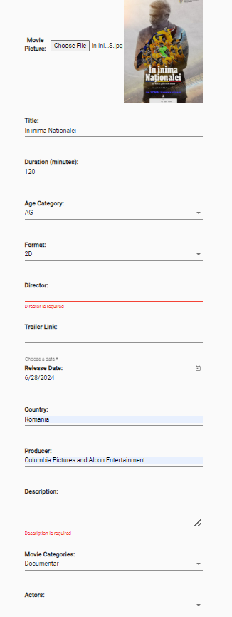
Figure 4-14: Insert tool part II
Another section that the administrator only has access to is the edit movie pop-up. To reach this pop-up, the administrator has to navigate to a movie details page and then, on top right it will be available a button “Edit Movie Details”. Clicking the button triggers a pop-up window that contains the movie details pre-populated. The administrator can change anything while respecting the requirements of each input field.
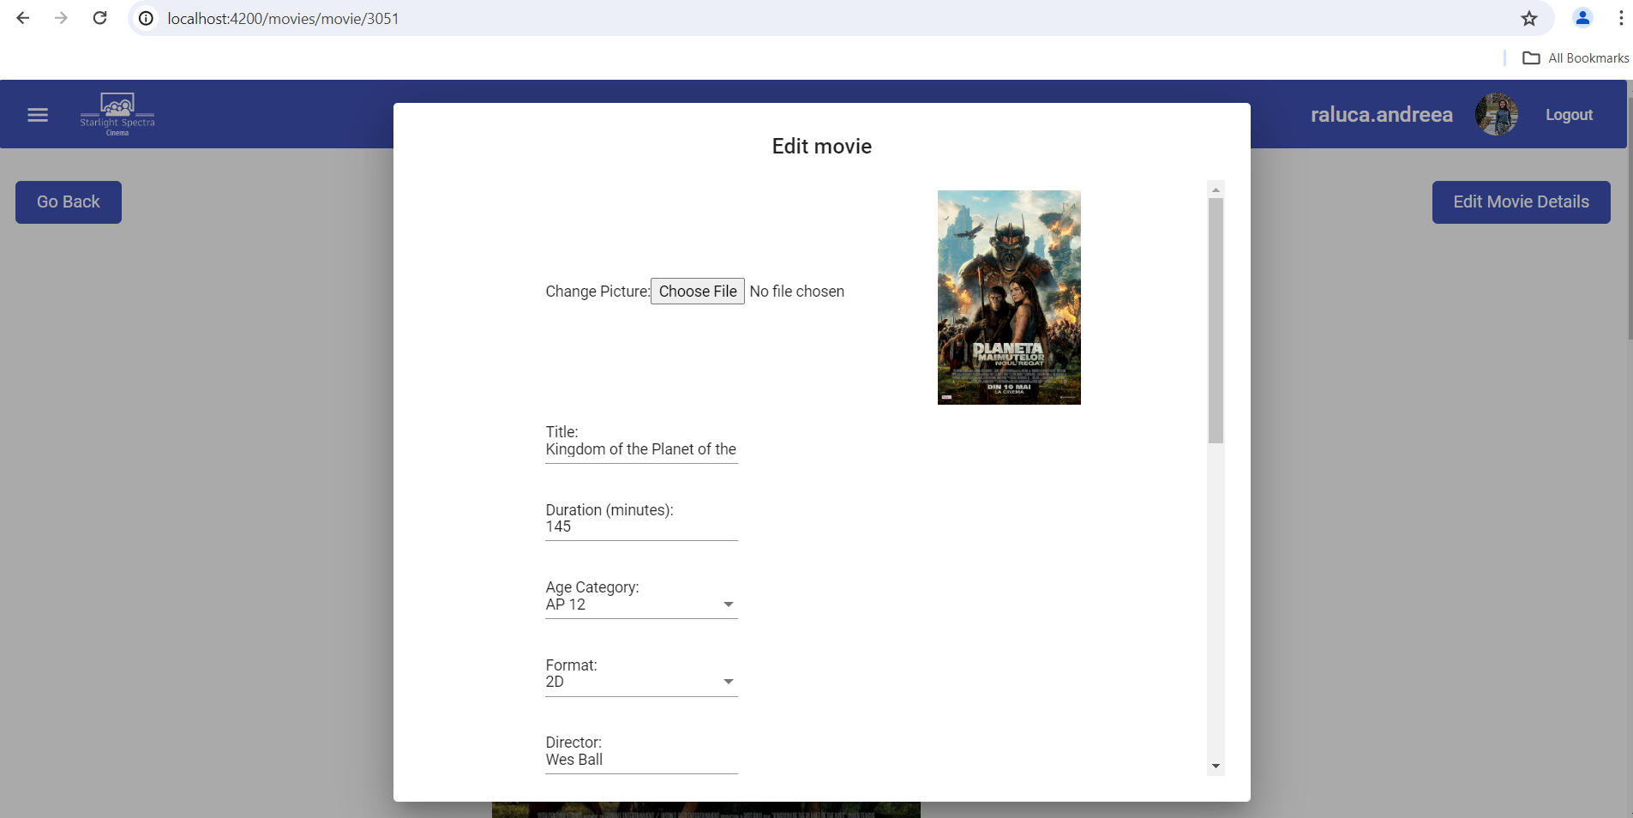
Figure 4-15: Edit movie pop-up
Navigating through the menu, the administrator can reach the Reports page. There is available data analytics showcasing user preferences concerning movie-related data. The Reports page includes four tabs. The first tab showcases the top actors based on users' preferences, while the second tab displays users' favorite movie categories. The third tab showcases the most booked movies, and the last tab lists movies ordered by rating, regardless of their status. The data is displayed in two different types of charts: pie charts and bar charts.
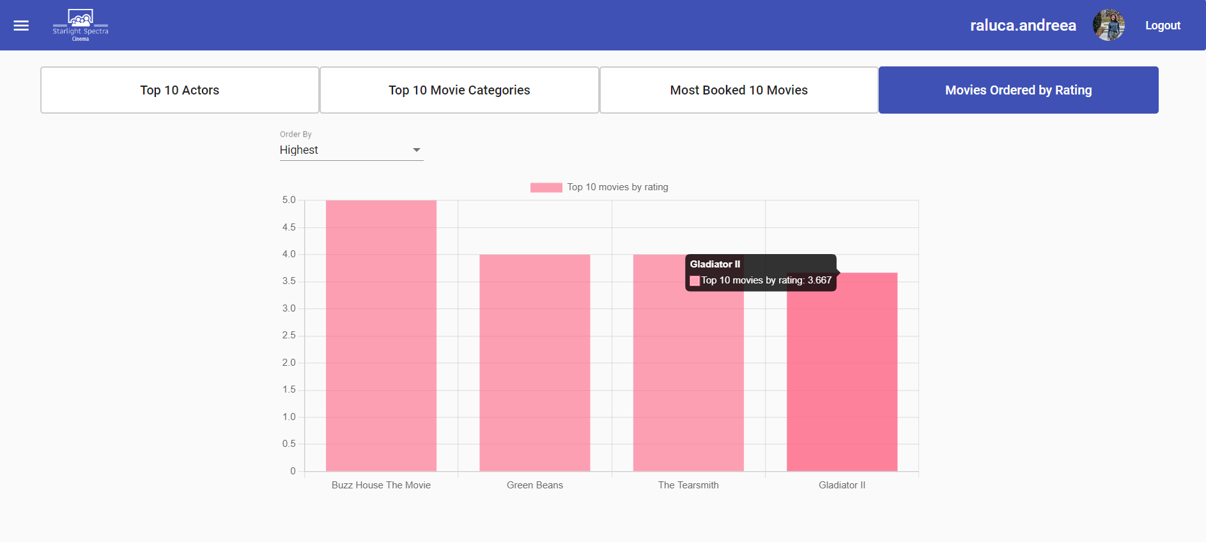
Figure 4-16: Bar chart movie ratings
In “Movies Ordered by Rating” tab, the administrator has the option to select the order in which to display the movies by rating: either the best rated movies or the worst rated movies. The Y-axis represents the ratings, while the X-axis displays the movie titles. When hovering over the pink section, all the details about the corresponding movie will appear.
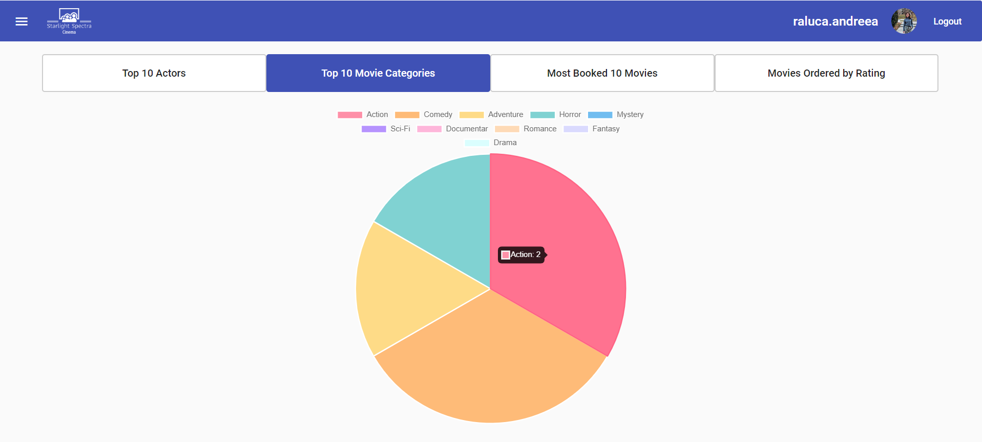
Figure 4-17: Pie chart movie categories
In figure 4-14 it is displayed a pie chart of the user’s most preferred movie categories. Each time a user adds a category to their favorite movie categories section on the profile page, it's counted as a preference. The pie chart reflects the number of users who prefer each category, with each category's slice proportional to the number of users who prefer it.

Conclusions

Achievements
Throughout the development of the “Cinema Bookings and Recommendations Platform,” I gained many new skills, including how to develop a user-based recommendations algorithm, upload and display pictures in the interface, implement an auto-suggest search, utilize charts, and much more.
In addition to acquiring technical skills, I also developed essential soft skills such as perseverance and attention to details as I encountered and overcame various challenges throughout the development process. I improved my adaptability as I went on with developing the project and I realized some libraries versions did not go well with each other and I had to use something new. I think it was a chance for me to develop my problem-solving skill while troubleshooting technical issues, optimizing code, and finding creative solutions. Balancing faculty projects, classes, homework, exams with work and developing the platform was a challenging task for me, however this is led to developing time management skills. Seeking guidance from my coordinator professor further polished my critical thinking, as I evaluated and made decisions based on the options presented.
I have implemented numerous features to meet the platform’s objectives for regular users. Filtering and sorting mechanisms make it easy for users to find movies, while the intuitive booking process provides all the necessary information. One notable feature is the recommendations algorithm, which suggests movies based on other users' ratings, offering a personalized experience within the platform. Beyond the platform's primary goals, I have enhanced community engagement by sending email notifications, by allowing visiting other users’ profiles and by providing adding ratings and reviews feature, which serve as valuable feedback for other users.
For administrators, the platform functions as a precious tool for intuitively and pleasantly inserting and modifying the necessary data. Additionally, it offers visually appealing charts representing relevant statistics about movies, actors, and movie categories that are stored within the platform's database.
Moreover, the platform is accessible across all devices and is fully responsive. Whether users access it from a desktop, laptop, tablet, or smartphone, they can enjoy a smooth experience without compromising functionality or usability. This adaptability ensures that users can engage with the platform anytime, anywhere, making it convenient and user-friendly.
All in all, I believe the goal of this platform has been achieved, as it is useful to both regular users and administrators, it engages the community and it offers a personalized experience to each user that interacts with the platform.

System limitations
Although the platform has reached its goal, it is still facing some restrictions, as there is always place for improvement.
With the platform's user number growing, scalability becomes essential. As traffic and data volume increase, architectural considerations must prioritize scalability to maintain optimal performance. This may involve implementing scalable infrastructure solutions, such as cloud-based hosting services, to handle the high demand. Load balancers can distribute incoming traffic across multiple servers, preventing bottlenecks and ensuring responsiveness during peak usage periods. Database segmentation techniques may also be employed to horizontally partition data across multiple servers, improving data retrieval speeds and overall system scalability.
However, as the platform scales, performance issues may arise, impacting user experience. Slow loading times and lagged interface interactions can frustrate users and lower the platform's effectiveness. To address these challenges, optimization efforts are essential. This may include optimizing database queries to minimize delays, caching frequently accessed data to reduce server load, and implementing efficient client-side rendering techniques in the Angular frontend. Regular performance monitoring and profiling can help identify performance bottlenecks and guide targeted optimizations to enhance overall system performance. By proactively addressing scalability and performance considerations, the platform can ensure a smooth and responsive user experience even as it continues to grow.
When it comes to the security of the application, I think it would have been a good choice to consider Two-Factor Authentication (2FA) as it is an additional layer of security for user authentication. This could mean requiring users to provide a second form of verification, such as a one-time password sent via SMS or email, in addition to their password, to access their accounts.
Not having user feedback mechanisms is a limitation to address. Implementing effective user feedback mechanisms, such as surveys, feedback forms, or rating systems, can provide valuable insights into user satisfaction and areas for improvement. Actively soliciting and acting upon user feedback demonstrates a commitment to continuous improvement and can lead to user admiration.
Another limitation is not being an accessible and inclusive platform for everybody. Ensuring the platform is accessible to users with disabilities is not only a legal requirement in many jurisdictions but also aligns with ethical principles of inclusivity. Conducting accessibility audits and implementing features like keyboard navigation, screen reader compatibility, and high contrast modes can improve accessibility for all users.
By focusing on these areas, the platform can continue to grow and adapt, delivering a smooth, secure, and inclusive experience for its expanding user base.

Future development directions
As technology changes and user preferences evolve, it is important to consider how the platform can adapt and improve. In this section, we will explore future directions and strategies to improve user experience, address new challenges, and remain innovative.
First of all, I would improve the user profile page, adding sections for history of ratings and reviews and history of bookings. These functionalities would be useful due to providing users with easy access to their past ratings, reviews, and booking history. This experience can lead to higher user satisfaction and engagement. Furthermore, displaying past ratings and reviews on the user profile page promotes transparency, allowing users to see their feedback and contributions to the platform. This transparency can build trust between users and the platform.
Next, I would take the community and user interaction to another level. I would like to make possible searching users by username and following other users. This would build a stronger meaning of community, facilitating connections between individuals with shared interests. Creating a “For you” page that displays the activity of the followed users and other news related to user preferences provides a personalized experience, allowing users to discover content relevant to their interests and increasing engagement. I would introduce the possibility to like or dislike a review, and to add your own comments to that review and therefore, to start a small conversation or exchange of opinions. It promotes active participation and fosters dynamic exchanges of ideas among users. By facilitating conversations and interactions, the platform becomes a vibrant hub for community engagement, collaboration, and knowledge-sharing.
To enhance the recommendations algorithm, I could explore several paths for improvement, learning from the leading platforms in the industry. Firstly, I might consider incorporating more advanced techniques beyond cosine similarity, such as collaborative filtering or matrix factorization, to provide more accurate and diverse recommendations. These methods can better capture user preferences and item similarities, leading to more personalized suggestions.
Additionally, I could improve the recommendation process by using contextual information, such as user demographics, viewing history, or temporal trends. By analyzing these factors, the algorithm can offer recommendations that are not only relevant to a user's tastes but also specialized to their current context and preferences.
Furthermore, I could improve the algorithm's scalability by optimizing its computational efficiency and handling larger datasets more effectively. This could involve techniques like parallel processing and data partitioning.
Moreover, I could incorporate feedback mechanisms to iteratively refine the recommendations over time based on user interactions and feedback. By continuously learning from user behavior, the algorithm can adapt and evolve to better meet user needs and preferences.
Lastly, I could explore the integration of external data sources, such as social media activity or user-generated content. By using diverse sources of information, the algorithm can provide more meaningful recommendations, enhancing the overall user experience.
By implementing these improvements, the recommendations algorithm would provide more accurate, diverse, and personalized suggestions, ultimately improving user satisfaction and engagement on the platform.
I also aim to integrate user registration and login options through social media accounts like Facebook and Instagram. It is difficult for a user to remember passwords from multiple accounts, and creating an account each time you start using a new platform is time-consuming, thus I believe many users prefer to use an already existing account on social media to access new platforms.
A restriction on the selection of the seats would be a good idea for the cinema companies. The restriction means being able to select only seats that are adjacent to each other, preferably on the same row. For instance, if a user selects one seat in the middle of the room, it could disrupt the seating arrangements for larger groups looking to sit together
For the administrators I would like to add new insert forms for cinemas, rooms, seats. At the moment seats should be added manually for each room in the database. I find the following solution suitable: adding just the rows and columns when creating a new room and then the seats to be added automatically in the backend. My desire is to make every action that the administrator needs to perform available in the interface. I think it would be a good practice to store the history of changes that administrators do and to be accessible for all administrators to see who did what.
I think that the “Reports” section could be improved a lot, adding more suggestive charts including new information. For example, I would add charts for every movie to see what happens to the number of bookings in time, how does it evolve or decrease. Furthermore, I think also displaying data regarding the most crowded days of the week, hours or months at the cinema would help the cinema companies to make more informed decisions regarding scheduling, marketing strategies, and inventory management. Another idea is, incorporating interactive elements into the charts, such as filters for specific time periods or comparison features between movies, could further make the user experience better and facilitate deeper analysis.
Looking ahead, future development should focus on improving user profiles, enhancing community interaction, and optimizing recommendation algorithms for greater personalization. Simplifying administrative functions and improving reporting tools can further enhance operational efficiency and decision-making. By addressing these limitations and exploring these development directions, the platform can adapt to new challenges, stay innovative, and continue to deliver exceptional user experiences.

References
[1]: Steve Krug. (2000). Don't Make Me Think: A Common Sense Approach to Web Usability. New Riders Publishing.
[2]: https://help.netflix.com/en/node/100639?q=algorithms – “How Netflix’s Recommendations System Works”
[3]: https://www.ask.com/news/exploring-prime-video-s-algorithm-shapes-home-page-recommendations - “Exploring Prime Video’s Algorithm: How it Shapes your Home Page Recommendations”, by Staff Writer, 11 September 2023
[4]: https://help.imdb.com/article/imdb/general-information/boards-closure-faq/G5HU888HZYE8LF79?ref_=helpart_nav_39# - “Boards Closure FAQ”
[5]: https://help.imdb.com/article/imdb/track-movies-tv/ratings faq/G67Y87TFYYP6TWAV?showReportContentLink=true# - “Ratings FAQ”, 18 August 2023
[6]: https://www.datacamp.com/blog/sql-vs-nosql-databases - “SQL vs NoSQL Databases: Key Differences and Practical Insights”, Kevin Babitz, Nov 2023
[7]: https://databasetown.com/types-of-nosql-database/ - „Types of NoSQL Database (Advantages, Disadvantages & Popular NoSQL Databases)”
[8]: https://en.wikipedia.org/wiki/Microsoft_SQL_Server - “Microsoft SQL Server”
[9]: https://www.techtarget.com/searchdatamanagement/definition/SQL-Server - “Definition Microsoft SQL Server”, By Rahul Awati, Adam Hughes and Craig Stedman, Industry Editor, March 2024

[10]: https://www.freecodecamp.org/news/acid-databases-explained/ - “ACID Databases – Atomicity, Consistency, Isolation & Durability Explained”, Daniel Adetunji, January 17, 2024
[11]: https://slashdev.io/-building-fast-backend-apis-in-asp-net-core-in-2024 – “Building Fast Backend APIs In ASP.NET Core In 2024”, Patrich
[12]: https://medium.com/@nathanbyers13/understanding-apis-a-comprehensive-guide-to-integration-in-web-development-7241bb3ad793 - “Understanding APIs: A Comprehensive Guide to Integration in Web Development”, Nathan Byers, Dec 12, 2023
[13]: https://www.altexsoft.com/blog/the-good-and-the-bad-of-angular-development/ - “The Good and the Bad of Angular Development”, 6 Sep 2022
[14]: https://about.gitlab.com/topics/version-control/what-is-git-version-control/ - „What is Git version control?”
[15]: https://enkonix.com/blog/functional-requirements-vs-non-functional/ - “What Are Functional And Non-Functional Requirements And How To Document These”, by Pavel Gorbachenko, Co-Founder, CEO
[16]: https://www.baeldung.com/cs/layered-architecture - “Layered architecture”, written by baeldung

A. Source code
https://github.com/Raluca0Bratan/Licenta

B. Website of the project
https://github.com/Raluca0Bratan/Licenta

C. CD/DVD

Index
A  Achievements 46  Administrator functionalities 41  C  Client user functionalities 34  Conclusions 46  Content xi  D  Database structure 22  Defining requirements and system design 13  Document structure 3  F  Functionalities 26  Future development directions 48  I  Identifying the challenge 5  Implementation details 29  Introduction 1  K  Key technologies and frameworks 8 |  | L  List of figures xii  M  Motivation 1  R  References 51  S  Surveying existing systems 6  System architecture 15  System limitations 47  T  Theoretical and technical fundamentals 5  The topic of the application 1  The system of Cinema Bookings and Recommendations 13  U  User manual 34

https://www.inspirecinema.ro/
https://eventbook.ro/
https://www.netflix.com/ro-en/
https://www.primevideo.com/
https://www.imdb.com/

