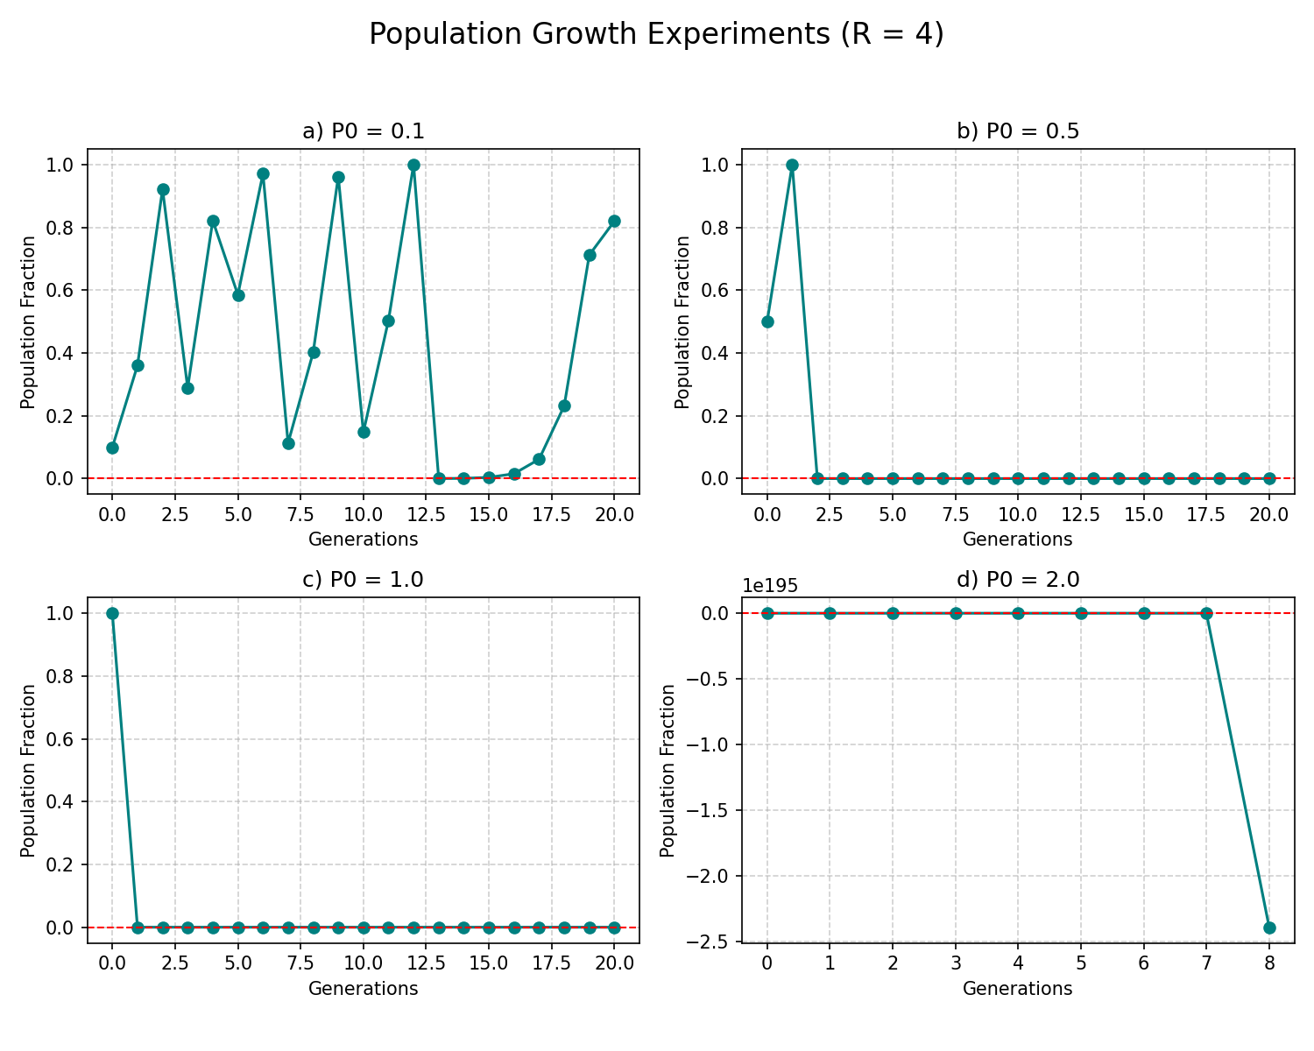a) Initial population = 0.1
The population values fluctuate irregularly and never stabilize.
This indicates chaotic behavior, where small variations lead to very different results.
b) Initial population = 0.5
After the first iteration the population becomes:
$$x_{1}=4⋅0.5(1-0.5)=1$$
Then
$$x_{2}=4⋅1(1-1)=0$$
After this point the population remains zero forever.
c) Initial population = 1.0
$$x_{1}=4⋅1(1-1)=0$$
The population immediately collapses to zero and stays there.
d) Initial population = 2
$$x_{1}=4⋅2(1-2)=-8$$
The system becomes unstable and diverges rapidly, producing large negative values.
This shows that the logistic model is only meaningful when population is between 0 and 1.
For r = 4, the logistic map exhibits chaotic dynamics.
Small changes in the initial population lead to dramatically different outcomes.
Only values between 0 and 1 produce meaningful population dynamics.
Outside this interval the model becomes unstable or collapses to zero.

