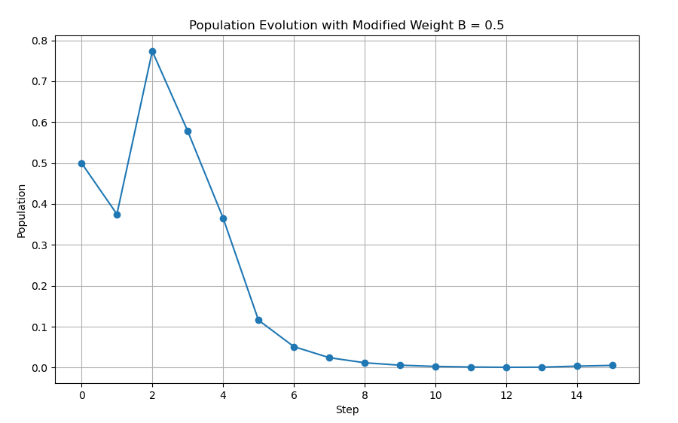
After modifying the weight of state B to r = 0.5, the population evolution was simulated for 15 steps starting from an initial value of 0.5. The graph shows that the population initially fluctuates slightly but then begins to decrease rapidly after several steps. This behavior occurs because when the system enters state B, the growth factor becomes r = 0.5, which is smaller than 1. In the logistic population model, values of r < 1cause the population to shrink toward zero.
From the plotted results we can see that the population approaches very small values after step 10 and is almost zero by step 15.
In conclusion, the population does not survive after step 15, because it decreases toward zero due to the low growth factor associated with state B.

