Ex1.Am adaugat puncte si am pus indicii, iar la final am adaugat punctul cel mai din dreapta jos pentru a nu ramane unit punctul de stanga jos cu cel de dreapta sus.

// Coordonatele varfurilor;

static const GLfloat Vertices[] =

{

-15.0f, -15.0f, 0.0f, 1.0f,

15.0f, -15.0f, 0.0f, 1.0f,

15.0f, 15.0f, 0.0f, 1.0f,

-15.0f, 15.0f, 0.0f, 1.0f,

45.0f, 15.0f, 0.0f, 1.0f,

45.0f, -15.0f, 0.0f, 1.0f,

75.0f, 15.0f, 0.0f, 1.0f,

75.0f, -15.0f, 0.0f, 1.0f,

105.0f, 15.0f, 0.0f, 1.0f,

105.0f, -15.0f, 0.0f, 1.0f,

135.0f, 15.0f, 0.0f, 1.0f,

135.0f, -15.0f, 0.0f, 1.0f,

};

static const GLfloat Colors[] =

{

1.0f, 0.0f, 0.0f, 1.0f,

0.0f, 1.0f, 0.0f, 1.0f,

0.0f, 0.0f, 1.0f, 1.0f,

1.0f, 0.0f, 1.0f, 1.0f,

1.0f, 0.0f, 1.0f, 1.0f,

1.0f, 0.2f, 0.9f, 1.0f,

1.0f, 0.6f, 1.0f, 1.0f,

1.0f, 0.0f, 1.3f, 1.0f,

1.0f, 0.0f, 1.0f, 1.0f,

1.0f, 0.4f, 0.1f, 1.0f,

1.0f, 0.0f, 1.0f, 1.0f,

1.0f, 0.2f, 0.5f, 1.0f,

};

// Indicii care determina ordinea de parcurgere a varfurilor;

static const GLuint Indices[] =

{

0, 1, 2, 3, 0, 2, 4, 5, 1, 4, 6, 7 , 5, 6, 8, 9, 7, 8, 10, 11, 9, 10, 11

};

glDrawElements(GL_LINE_LOOP,23, GL_UNSIGNED_INT, (void*)(0));

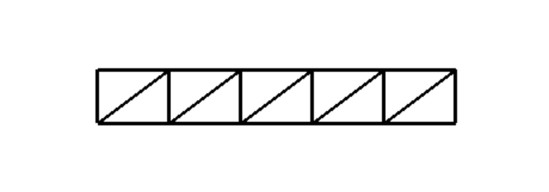

Ex3. Am folosit formulele cu sin si cos pentru punctele de pe cerc si am pus indicii intr-un mod similar cu primul exercitiu dupa un desen pe care l-am facut pe foaie.

GLfloat Vertices[ n * 2 * 4];

for (int i = 0; i < n; ++i) {

float theta = 2 * M_PI * i / n;

Vertices[i * 4] = outerRadius * cos(theta);

Vertices[i * 4 + 1] = outerRadius * sin(theta);

Vertices[i * 4 + 2] = 0.0f;

Vertices[i * 4 + 3] = 1.0f;

}

// Coordonatele varfurilor;

for (int i = n; i < n*2; ++i) {

float theta = 2 * M_PI * i / n;

Vertices[i * 4] = innerRadius * cos(theta);

Vertices[i * 4 + 1] = innerRadius * sin(theta);

Vertices[i * 4 + 2] = 0.0f;

Vertices[i * 4 + 3] = 1.0f;

}

// Culorile ca atribute ale varfurilor;

static const GLfloat Colors[] =

{

1.0f, 0.0f, 0.0f, 1.0f,

0.0f, 1.0f, 0.0f, 1.0f,

1.0f, 0.0f, 0.0f, 1.0f,

0.0f, 1.0f, 0.0f, 1.0f,

1.0f, 0.0f, 0.0f, 1.0f,

0.0f, 1.0f, 0.0f, 1.0f,

1.0f, 0.0f, 0.0f, 1.0f,

0.0f, 1.0f, 0.0f, 1.0f,

1.0f, 0.0f, 0.0f, 1.0f,

0.0f, 1.0f, 0.0f, 1.0f,

1.0f, 0.0f, 0.0f, 1.0f,

0.0f, 1.0f, 0.0f, 1.0f,

1.0f, 0.0f, 0.0f, 1.0f,

0.0f, 1.0f, 0.0f, 1.0f,

1.0f, 0.0f, 0.0f, 1.0f,

0.0f, 1.0f, 0.0f, 1.0f,

};

// Indicii care determina ordinea de parcurgere a varfurilor;

static const GLuint Indices[] =

{

14,15,6,7,15,8,7,0,8,9,0,1,9,10,1,2,10,11,2,3,11,12,3,4,12,13,4,5,13,14,5,6

};

glDrawElements(GL_LINE_LOOP, 32, GL_UNSIGNED_INT, (void*)(0));

