**Livrabil intermediar**

**Problem Statement**

SportMatch is an application for sports enthusiasts that helps them connect with other players and organize matches on sports fields in Bucharest. We have noticed that the frontend design can be improved for the user experience, along with notifications for the chat feature. Also, in order for the application to be more interactive, features such as adding a profile picture and event picture should be implemented. Additionally, the users require more information when choosing a sport venue for the event, therefore we will include more details and a review feature for each of them.

**Product features and functionalities**

Users can filter events by date and number of players, and send requests to join the desired events. Each event is organized by a user who becomes an administrator, contacts the sports field for rental and accepts participants to form a team. The application has a chat system to improve the experience of organizing events and has access to the map to locate the fields. SportMatch aims to facilitate the organization of sports events and promote a community of sports enthusiasts with common interests in Bucharest.

Future features include improving the frontend design, creating a location details page and a review system for them, notifications, changes to the event details page and uploading profile and event pictures.

Integration points:

* For the application’s database we used Firebase Cloud Storage
* For user-uploaded content like profile pictures and event pictures we will use Firebase Cloud Storage
* For the map with all sport locations we used Google Cloud API

Product Roadmap:

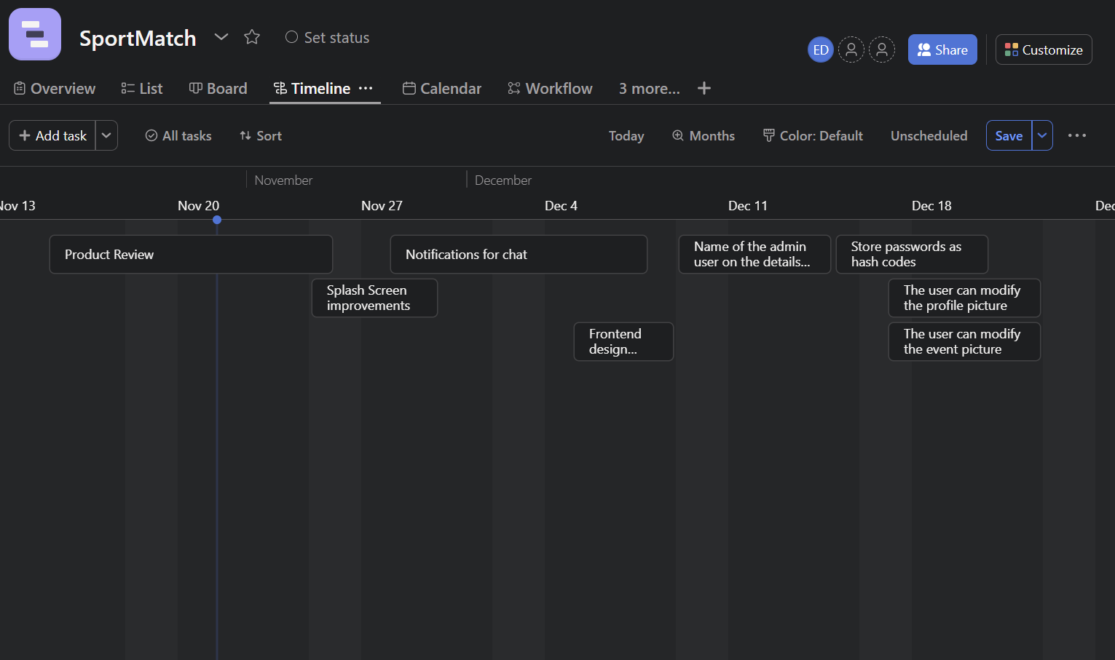

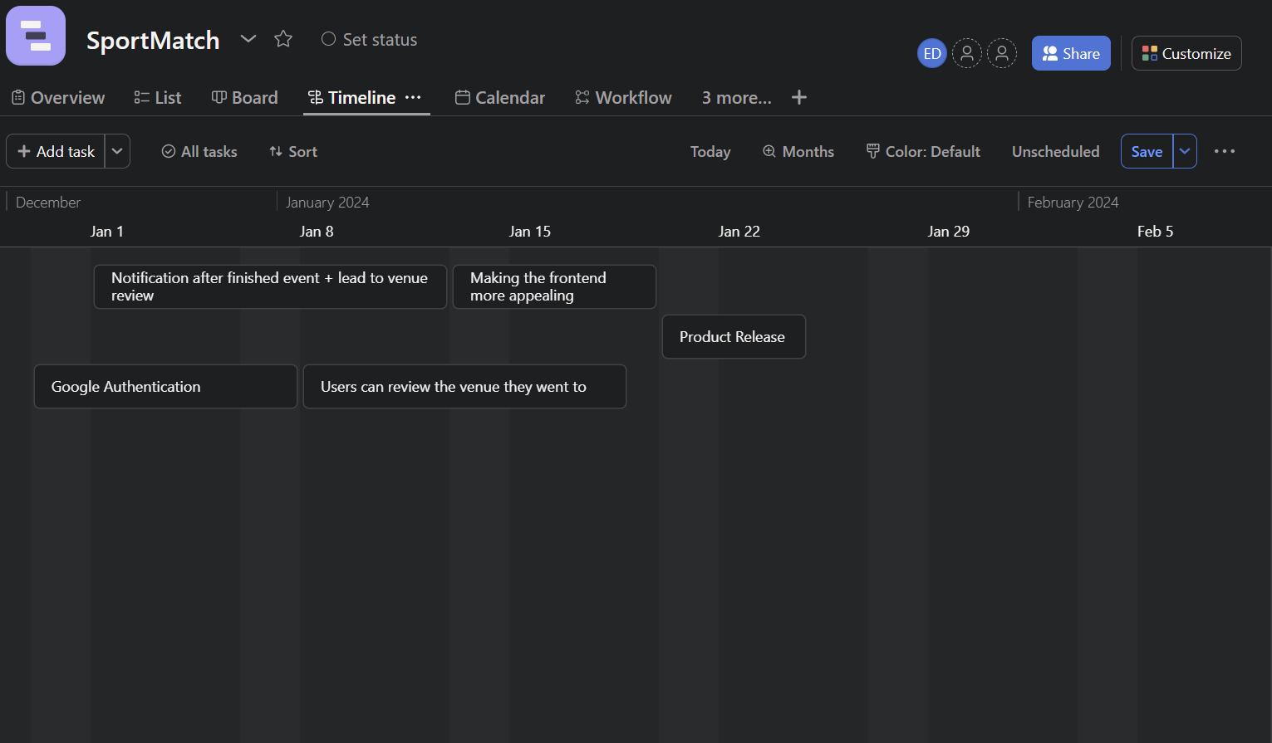

**Non-functional requirements**

As the creator of the sports event organization application for the Android platform, developed with Firebase as the database, I considered a set of essential non-functional requirements to ensure the success and quality of the project. Here's how we addressed them:

Performance:

From the outset, we prioritized performance. We optimized queries to the Firebase database to ensure fast loading of events and real-time updates, so users could experience a quick response time.

Security:

When it comes to the security of our sports event organization application, we decided to rely on the security provided by Firebase. Firebase provides robust security features and authentication mechanisms to protect data and prevent unauthorized access to the application.

„The Firebase Realtime Database provides a full set of tools for managing the security of your app. These tools make it easy to authenticate your users, enforce user permissions, and validate inputs.

Firebase-powered apps run more client-side code than those with many other technology stacks. Therefore, the way we approach security may be a bit different than you're used to.

The Firebase Realtime Database handles many other security details for you. For example, we use SSL with strong 2048 bit keys for our certificates and we follow best practices for authentication tokens.”

Usability:

The user interface of the application was developed with a focus on ease of use. Users can easily navigate events, create new events, and connect with other participants.

Scalability:

In anticipation of rapid user and event growth, we configured Firebase to meet scalability requirements. We utilized real-time databases to efficiently manage data flow. It's worth noting that we operated within the limits of Firebase's Spark plan, which allows a maximum of 100 simultaneous connections at a given time, along with generous data usage allowances, providing 10GB of data downloaded per month and 1GB of storage. These allowances ensured our ability to effectively scale the application while staying within these limits.

Testability:

We ensured rigorous testing by thoroughly examining every feature of the app ourselves, as well as involving our friends, allowing for the prompt identification and resolution of any issues. Our testing approach encompassed both automated and manual methods to verify the functionality and security of the application.

**Customer Journey**

User Personas

Admin User of an event:This user is able to edit the event that he created,he is able to decide who is gonna participate in the event.

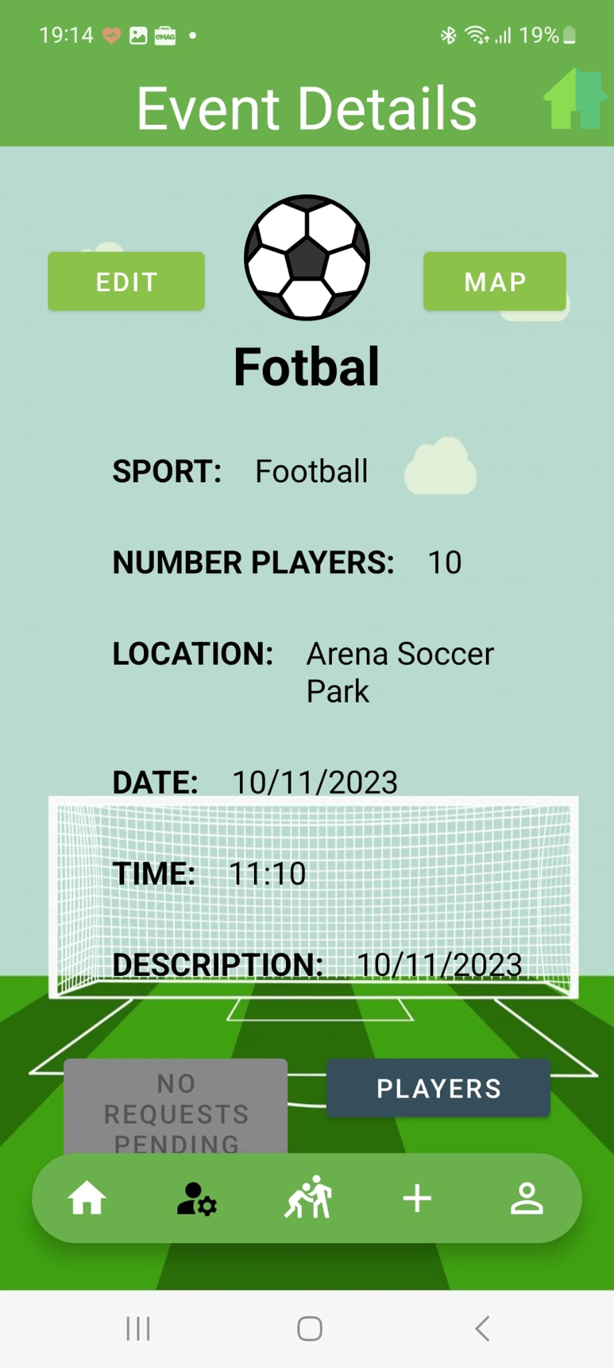 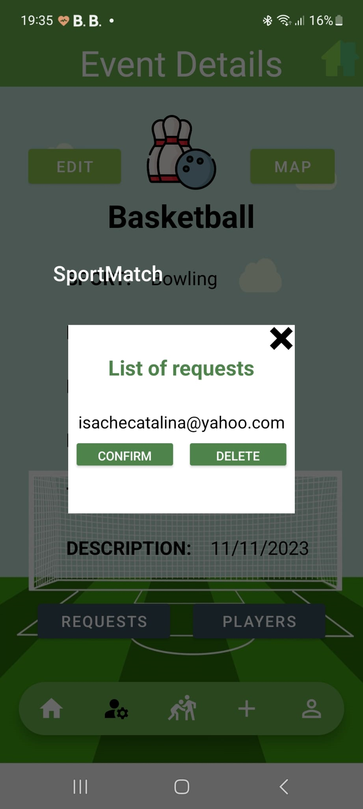

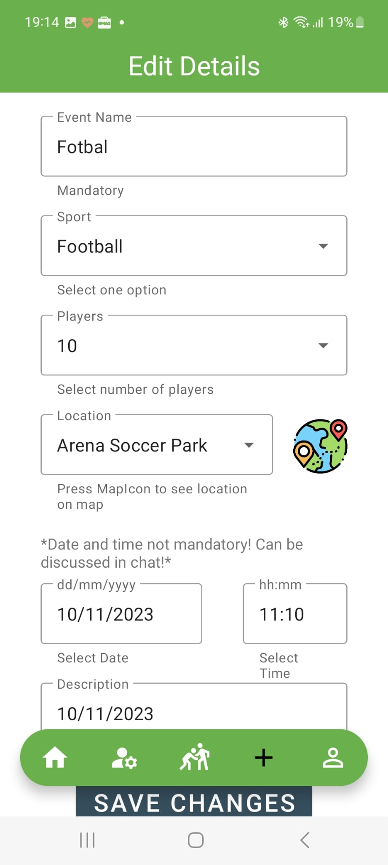

A normal user is able to chat with other users through an event, is able to see the other events.

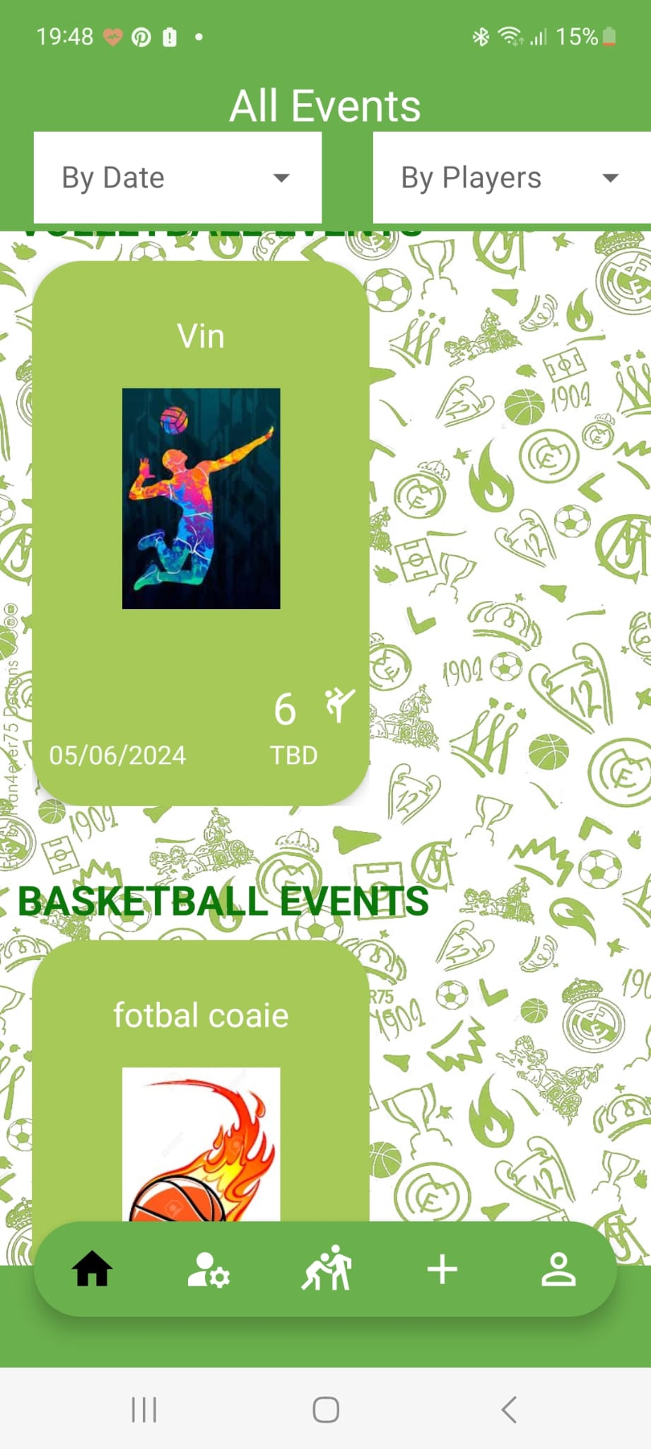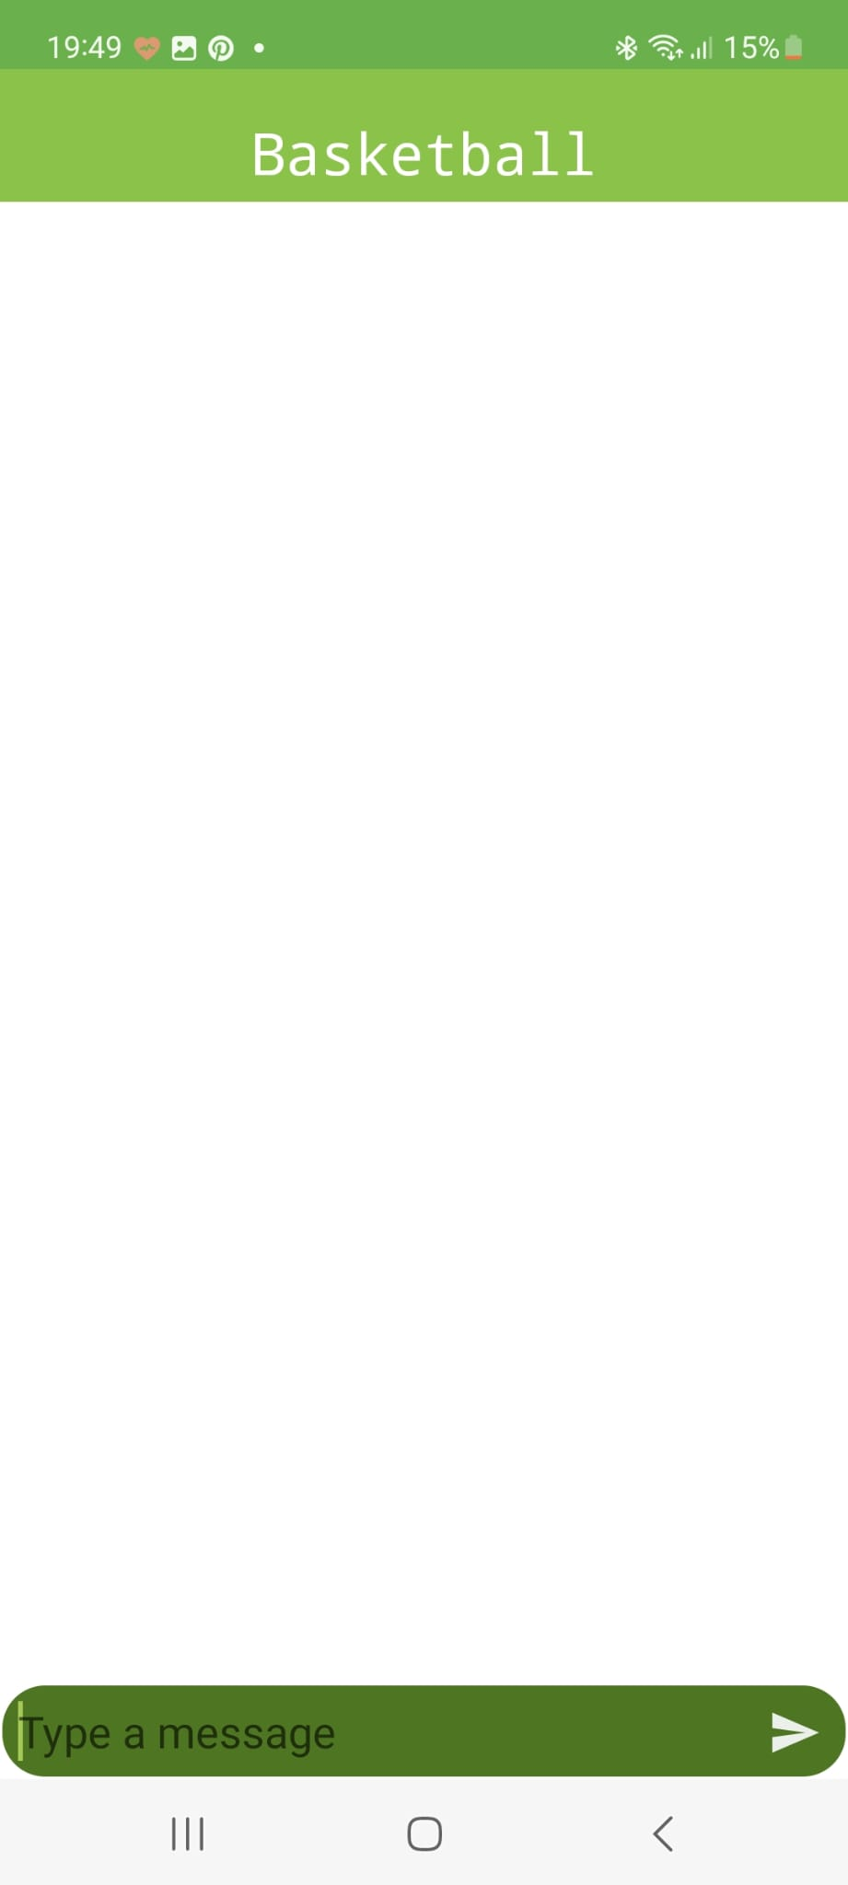

**Activity Diagram or State Diagram**

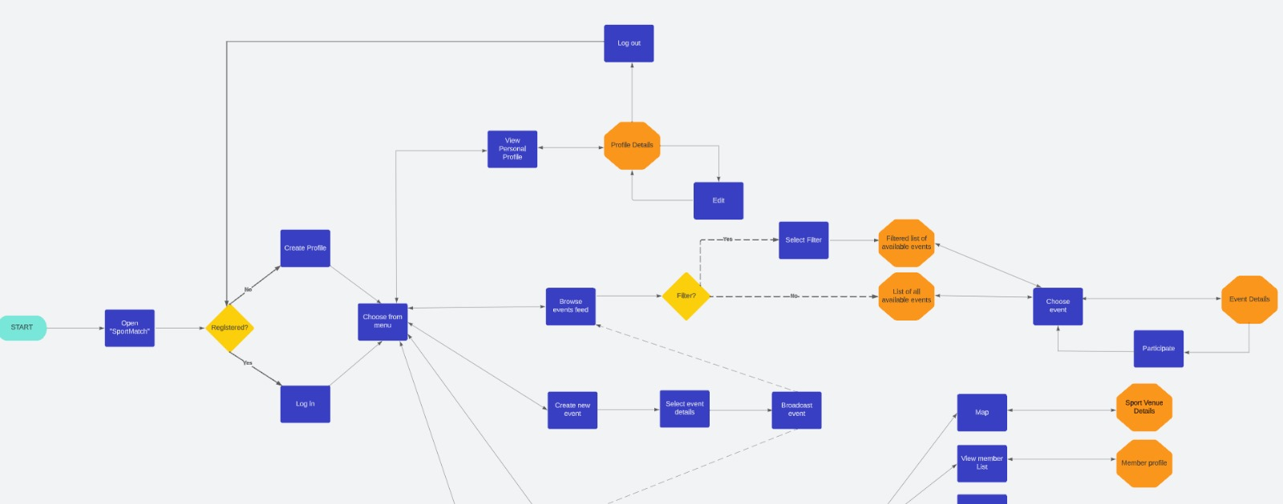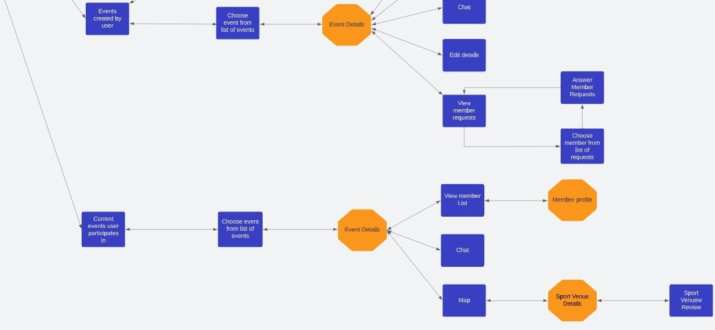

**A set of User Stories**

1. As a user, i want to communicate efficiently with the members of the team using the chat so i can be in touch with their new ideas about the game.
2. As a user, i want to be able to view all events i participatein or i am admin of**,** on the specific pages, so that im able to manage my schedule better.
3. As a user, i could see all the events i participate in on the specific page,and the pages i was admin making it easy to manage my activities.
4. As a user i could choose from various sports being easy to get fit.
5. As a user i can review the fields i played on before, being easy for other users to create an opinion for themselves about the field
6. “As a user i can see the locations of the fields on the map being easy for me to find the nearest field to me.”
7. “As a user if i am getting a message or a request about joining a group i will get notifications so it’s easy for me to manage the app.”

|  |
| --- |

| **Prioritized Product Backlog** |
| --- |

**User Story: Efficient Communication**

As a user, I want to communicate efficiently with team members through chat to stay in touch with their new ideas about the game.

Tasks:

* Design and implement notification system for chat messages.
  + 7 story points

**User Story: View and Manage Events**

As a user, I want to view all events I participate in or am an admin of on specific pages for better schedule management.

Tasks:

* Design the page displaying events user is participating in.
  + 2 story points
* Design the page displaying events user is admin of.
  + 2 story points
* Improve functionality to manage events (e.g., join, leave, edit).
  + 1 story point

**User Story: Choose from Various Sports**

As a user, I want to be able to choose from various sports for an easy way to get fit.

Tasks:

* Make a more user-friendly interface for selecting preferred sports.
  + 2 story points

**User Story: Intriguing interface**

As a user, I want to have a nice user experience, custom to the application, when I open the app.

Tasks:

* Implement a splash screen
  + 3 story points