Workforce Attrition & Retention Analysis
A Business-Intelligence Project Report
Dataset: IBM HR Analytics Employee Attrition & Performance (1,470 employees)
Bharat Cares × IBM Skills Build — AI-Powered BI Project Submission
Prepared by: Ram Kumar

1. Executive Overview
Employee attrition — whether voluntary or involuntary — is one of the most expensive and least predictable risks for any organization. This project analyzes 1,470 employee records across 35 attributes from the IBM HR Analytics dataset to convert raw HR data into actionable business decisions. Using a Business Intelligence framework: Facts → Trends → Drivers → Risks & Opportunities → Recommended Actions, the analysis identifies who is at risk of leaving (16.1% overall attrition), why they leave, and what retention strategies management should implement.

Key Performance Indicators
1470  Total Employees | 16.1%  Attrition Rate | $6,503  Avg Monthly Income | 2.73 / 4  Avg Job Satisfaction

Overall, 16.1% of employees have left the company. Roughly 10.4% of the workforce falls into a high-risk profile — working overtime while reporting low job satisfaction — making them the priority group for retention action.

2. Workforce & Attrition Analysis (Trends & Drivers)
Attrition is not evenly spread across the company. The Sales department has the highest attrition rate at 20.6%, compared to just 13.8% in Research & Development — the most stable department.

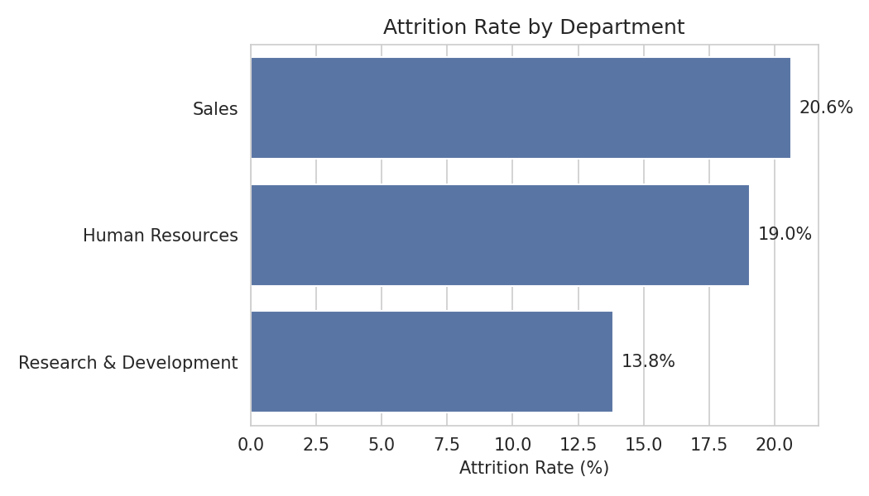
Figure 1 — Attrition rate by department

Within departments, risk concentrates further by role: Sales Representative has the highest attrition of any role at 39.8% — nearly 1 in 2 leave.
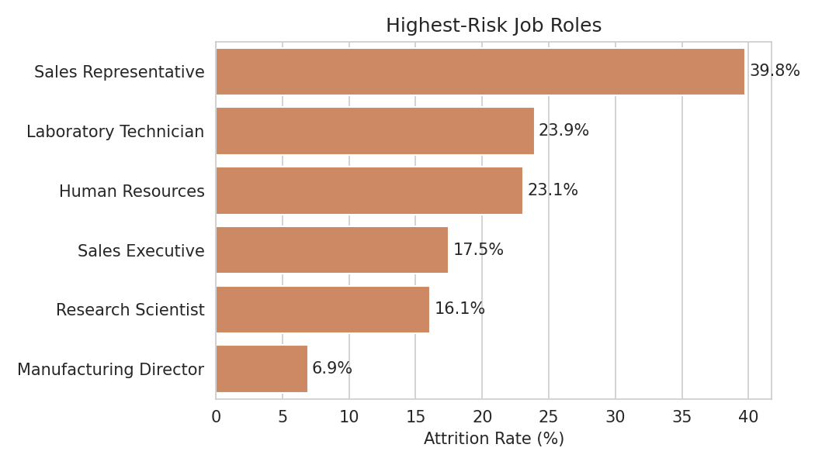
Figure 2 — Highest-risk job roles

Compensation as a Driver
Pay is a clear driver: employees who left earned a median of $3,202/month, versus $5,204/month for those who stayed — a gap of roughly 38%.
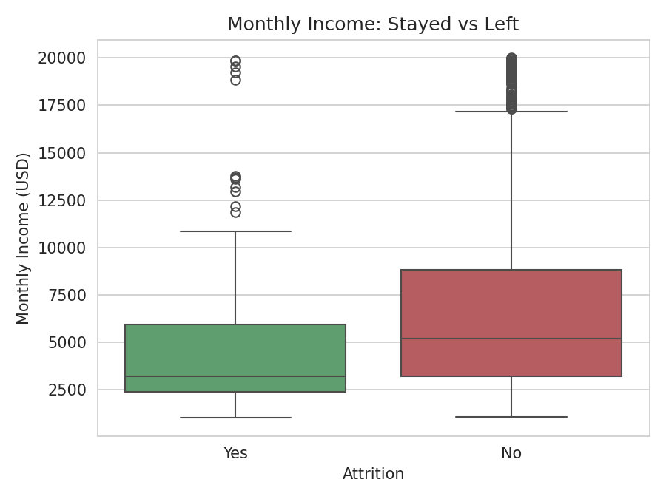
Figure 3 — Monthly income distribution: stayed vs. left

Satisfaction and Overtime
Job satisfaction shows a near-linear relationship with attrition: employees at the lowest satisfaction level leave at 22.8%, versus 11.3% at the highest level. Overtime is an even sharper signal — employees working overtime leave at 30.5%, almost three times the 10.4% rate of those who don't.
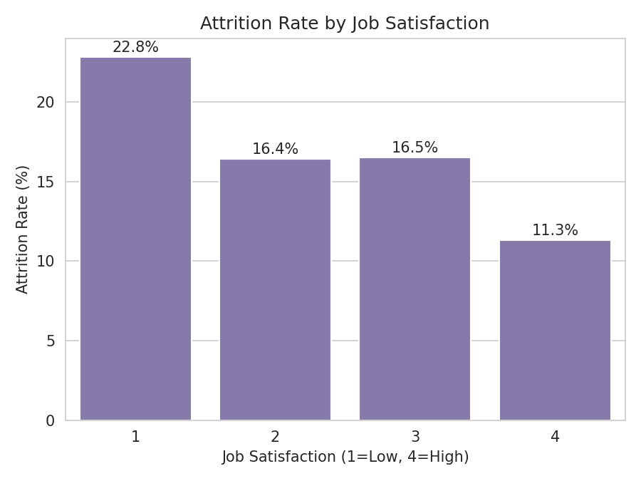
Figure 4 — Attrition rate by job satisfaction level

Model-Confirmed Drivers
A Random Forest model was built to predict employee attrition using HR attributes, which quantitatively validates the above findings. The key features driving the model's predictions are displayed below.
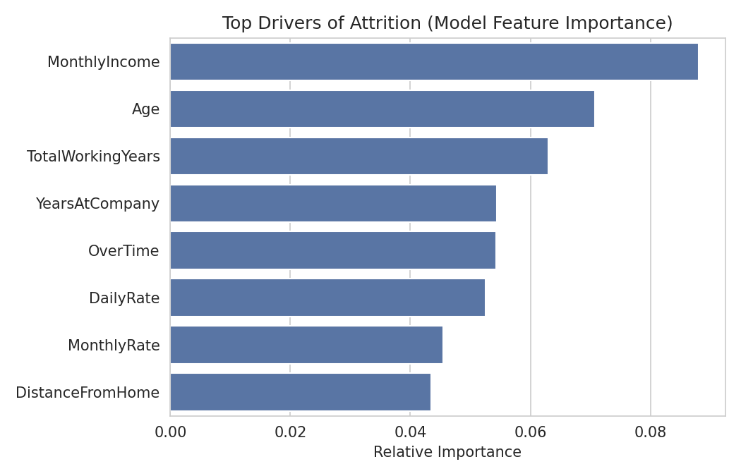
Figure 5 — Top drivers of attrition (model feature importance)

3. Risk, Opportunity & Recommended Actions

Risk
- Sales is the highest-risk department, with the Sales Representative role showing the most critical attrition rate at 39.8% (20.6% dept-wise).
- The most vulnerable segment is employees working overtime with low job satisfaction, representing ∼10.4% (153 employees) of the total workforce with over 30% attrition risk.
- A significant compensation gap drives attrition — employees who left earned an average of $3,202 vs. $5,204 for those who stayed (38% gap), indicating pay dissatisfaction in lower bands as a key driver.

Opportunity
- Retention improves dramatically with small gains in satisfaction — attrition drops sharply as job satisfaction moves from level 1-2 to level 3+, meaning even low-cost engagement initiatives can deliver outsized retention ROI.
- R&D sets the benchmark for stability with just 8% attrition, proving that low attrition is achievable. Its best practices in workload balance, career growth, and management can be studied and replicated in high-risk departments like Sales.
- The predictive model is deployment-ready with 82% accuracy and 0.778 ROC-AUC, enabling HR to proactively flag at-risk employees and intervene before resignation, rather than reacting after.

Recommended Actions

• Launch a targeted retention audit for Sales — prioritize compensation review and workload assessment for Sales Representatives who are high on overtime and low on job satisfaction.
• Implement overtime caps and workload rebalancing, starting with the highest-risk roles. Reduce mandatory overtime and introduce compensatory time-off for employees exceeding threshold hours.
• Conduct a compensation-band review for all roles below the company median ($5,204). Close the 38% pay gap for at-risk bands to address compensation-driven attrition.
• Operationalize the predictive model as a quarterly HR early-warning system — flag employees with >50% predicted attrition risk for proactive 1:1 check-ins, career coaching, and retention offers before they resign.

Model Performance
Model | Random Forest Classifier (scikit-learn)
Accuracy | 82%
ROC-AUC | 0.778
Train / Test Split | 1176 / 294 employees (80/20)

4. Conclusion
This project demonstrates an end-to-end Business Intelligence pipeline — from raw HR data cleaning and exploration to predictive modeling — to deliver clear, actionable insights. Instead of overwhelming stakeholders with dozens of charts, the analysis intentionally focuses on the five KPIs that truly drive attrition: overall attrition rate (16.1%), department/role risk, compensation gap, job satisfaction, and overtime. Each finding is directly linked to a specific management action. The accompanying Jupyter Notebook (Employee_attrition_analysis_ramIntelligence.ipynb) fully reproduces every KPI, visualization, and model result (82% accuracy, 0.778 ROC-AUC) presented in this report, and includes a reusable predict_attrition_risk() function to score any individual employee's attrition risk in real-time.

