**VISVESVARAYA TECHNOLOGICAL UNIVERSITY**

**“JnanaSangama”, Belgaum -590014, Karnataka.**



**LAB REPORT**

**on**

**Analysis and Design of Algorithms**

***Submitted by***

**Aditya Ram S H (1BM22CS019)**

***in partial fulfillment for the award of the degree of***

**BACHELOR OF ENGINEERING**

***in***

**COMPUTER SCIENCE AND ENGINEERING**



**B.M.S. COLLEGE OF ENGINEERING**

**(Autonomous Institution under VTU)**

**BENGALURU-560019**

**April-2024 to August-2024**

**B. M. S. College of Engineering,**

**Bull Temple Road, Bangalore 560019**

(Affiliated to Visvesvaraya Technological University, Belgaum)

**Department of Computer Science and Engineering**



**CERTIFICATE**

This is to certify that the Lab work entitled “**Analysis and Design of Algorithms**” carried out by **Aditya Ram S H (1BM22CS019),** who is a bonafide student of **B.M.S. College of Engineering.** It is in partial fulfillment for the award of **Bachelor of Engineering in Computer Science and Engineering** of the Visvesvaraya Technological University, Belgaum during the academic semester April-2024 to August-2024. The Lab report has been approved as it satisfies the academic requirements in respect of an **Analysis and Design of Algorithms (23CS4PCADA)** work prescribed for the said degree.

Vikranth B.M Dr. Jyothi S Nayak

Assistant Professor Professor and Head

Department of CSE Department of CSE

BMSCE, Bengaluru BMSCE, Bengaluru

**Index Sheet**

| **Lab Program No.** | **Program Details** | **Page No.** |
| --- | --- | --- |
| 1 | Leetcode exercises on Stacks, Queues, Circular Queues, Priority Queues. | 5-11 |
| 2 | Write a program to obtain the Topological ordering of vertices in a given digraph. | 12-14 |
| 3 | Implement Johnson Trotter algorithm to generate permutations. | 15-18 |
| 4 | Sort a given set of N integer elements using Merge Sort technique and compute its time taken. Run the program for different values of N and record the time taken to sort. | 19-22 |
| 5 | Sort a given set of N integer elements using Quick Sort technique and compute its time taken. | 23-25 |
| 6 | Sort a given set of N integer elements using Heap Sort technique and compute its time taken. | 26-29 |
| 7 | Implement 0/1 Knapsack problem using dynamic programming. | 30-34 |
| 8 | Implement All Pair Shortest paths problem using Floyd’s algorithm. | 35-37 |
| 9 | Find Minimum Cost Spanning Tree of a given undirected graph using Prim’s algorithm.  Find Minimum Cost Spanning Tree of a given undirected graph using Kruskal’s algorithm. | 38-41 |
| 10 | Implement Fractional Knapsack using Greedy technique. | 42-46 |
| 11 | From a given vertex in a weighted connected graph, find shortest paths to other vertices using Dijkstra’s algorithm. | 47-53 |

**Course Outcome**

| CO1 | Analyze time complexity of Recursive and Non-recursive algorithms using asymptotic notations. |
| --- | --- |
| CO2 | Apply various design techniques for the given problem. |
| CO3 | Apply the knowledge of complexity classes P, NP, and NP-Complete and prove certain  problems are NP-Complete |
| CO4 | Design efficient algorithms and conduct practical experiments to solve problems. |

**1)Leetcode exercises on Stacks, Queues, Circular Queues, Priority Queues.**

**Implementation of a Circular Queue in C**

#include <stdio.h>

#include <stdbool.h>

#include <stdlib.h>

typedef struct {

int* queue;

int front;

int rear;

int size;

int count;

} MyCircularQueue;

// Function declarations

MyCircularQueue* myCircularQueueCreate(int k);

bool myCircularQueueEnQueue(MyCircularQueue* obj, int value);

bool myCircularQueueDeQueue(MyCircularQueue* obj);

int myCircularQueueFront(MyCircularQueue* obj);

int myCircularQueueRear(MyCircularQueue* obj);

bool myCircularQueueIsEmpty(MyCircularQueue* obj);

bool myCircularQueueIsFull(MyCircularQueue* obj);

void myCircularQueueFree(MyCircularQueue* obj);

// Function definitions

MyCircularQueue* myCircularQueueCreate(int k) {

MyCircularQueue* obj = (MyCircularQueue*)malloc(sizeof(MyCircularQueue));

obj->queue = (int*)malloc(k * sizeof(int));

obj->front = -1;

obj->rear = -1;

obj->size = k;

obj->count = 0;

return obj;

}

bool myCircularQueueEnQueue(MyCircularQueue* obj, int value) {

if (myCircularQueueIsFull(obj)) return false;

if (myCircularQueueIsEmpty(obj)) obj->front = 0;

obj->rear = (obj->rear + 1) % obj->size;

obj->queue[obj->rear] = value;

obj->count++;

return true;

}

bool myCircularQueueDeQueue(MyCircularQueue* obj) {

if (myCircularQueueIsEmpty(obj)) return false;

if (obj->front == obj->rear) obj->front = obj->rear = -1;

else obj->front = (obj->front + 1) % obj->size;

obj->count--;

return true;

}

int myCircularQueueFront(MyCircularQueue* obj) {

if (myCircularQueueIsEmpty(obj)) return -1;

return obj->queue[obj->front];

}

int myCircularQueueRear(MyCircularQueue* obj) {

if (myCircularQueueIsEmpty(obj)) return -1;

return obj->queue[obj->rear];

}

bool myCircularQueueIsEmpty(MyCircularQueue* obj) {

return obj->count == 0;

}

bool myCircularQueueIsFull(MyCircularQueue* obj) {

return obj->count == obj->size;

}

void myCircularQueueFree(MyCircularQueue* obj) {

free(obj->queue);

free(obj);

}

// Example of usage

int main() {

int k = 5;

MyCircularQueue* obj = myCircularQueueCreate(k);

printf("Enqueue 1: %s\n", myCircularQueueEnQueue(obj, 1) ? "True" : "False");

printf("Enqueue 2: %s\n", myCircularQueueEnQueue(obj, 2) ? "True" : "False");

printf("Enqueue 3: %s\n", myCircularQueueEnQueue(obj, 3) ? "True" : "False");

printf("Enqueue 4: %s\n", myCircularQueueEnQueue(obj, 4) ? "True" : "False");

printf("Enqueue 5: %s\n", myCircularQueueEnQueue(obj, 5) ? "True" : "False");

printf("Enqueue 6 (should be false): %s\n", myCircularQueueEnQueue(obj, 6) ? "True" : "False");

printf("Front: %d\n", myCircularQueueFront(obj));

printf("Rear: %d\n", myCircularQueueRear(obj));

printf("Dequeue: %s\n", myCircularQueueDeQueue(obj) ? "True" : "False");

printf("Front: %d\n", myCircularQueueFront(obj));

printf("Rear: %d\n", myCircularQueueRear(obj));

myCircularQueueFree(obj);

return 0;

}

**OUTPUT:**

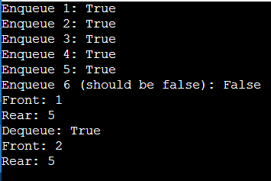

1. **Leetcode exercises on Stacks, Queues, Circular Queues, Priority Queues.**

**Given a circular integer array nums of length n, return the maximum possible sum of a non-empty subarray of nums**

#include <stdio.h>

#include <limits.h>

// Function to find the maximum of two integers

int max(int a, int b) {

return (a > b) ? a : b;

}

// Function to find the minimum of two integers

int min(int a, int b) {

return (a < b) ? a : b;

}

// Function to find the maximum subarray sum using Kadane's algorithm

int kadane(int nums[], int size, int isMin) {

int result = isMin ? INT_MAX : INT_MIN;

int current_sum = 0;

for (int i = 0; i < size; i++) {

if (isMin) {

current_sum = min(nums[i], current_sum + nums[i]);

result = min(result, current_sum);

} else {

current_sum = max(nums[i], current_sum + nums[i]);

result = max(result, current_sum);

}

}

return result;

}

// Function to find the maximum circular subarray sum

int maxSubarraySumCircular(int* nums, int numsSize) {

int max_sum_non_circular = kadane(nums, numsSize, 0);

int min_sum_non_circular = kadane(nums, numsSize, 1); // For finding the minimum sum

int total_sum = 0;

// Calculate total sum of the array

for (int i = 0; i < numsSize; i++) {

total_sum += nums[i];

}

// Find the maximum circular subarray sum

int max_sum_circular = total_sum - min_sum_non_circular;

if (min_sum_non_circular != total_sum) {

max_sum_non_circular = max(max_sum_non_circular, max_sum_circular);

}

return max_sum_non_circular;

}

int main() {

int nums1[] = {1, -2, 3, -2};

int nums2[] = {5, -3, 5};

int nums3[] = {-3, -2, -3};

int size1 = sizeof(nums1) / sizeof(nums1[0]);

int size2 = sizeof(nums2) / sizeof(nums2[0]);

int size3 = sizeof(nums3) / sizeof(nums3[0]);

printf("%d\n", maxSubarraySumCircular(nums1, size1)); // Output: 3

printf("%d\n", maxSubarraySumCircular(nums2, size2)); // Output: 10

printf("%d\n", maxSubarraySumCircular(nums3, size3)); // Output: -2

return 0;

}

**OUTPUT:**

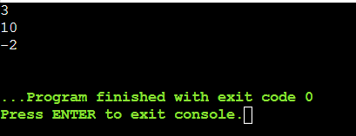

**2)Write a program to obtain the Topological ordering of vertices in a given digraph.**

#include <stdio.h>

#include <stdbool.h>

#define MAX_V 106

void topoutil(int v, int adj[][MAX_V], bool vis[], int *st, int *top) {

vis[v] = true;

for (int i = 0; i < MAX_V; i++) {

if (adj[v][i] && !vis[i]) {

topoutil(i, adj, vis, st, top);

}

}

st[(*top)++] = v;

}

void topo(int adj[][MAX_V], int V) {

int st[MAX_V];

bool vis[MAX_V] = { false };

int top = 0;

for (int i = 0; i < V; i++) {

if (!vis[i]) {

topoutil(i, adj, vis, st, &top);

}

}

printf("Topological sorting of the graph:\n");

for (int i = top - 1; i >= 0; i--) {

printf("%d ", st[i]);

}

printf("\n");

}

int main() {

int V, E;

printf("Enter the number of vertices: ");

scanf("%d", &V);

int adj[MAX_V][MAX_V] = {0}; // Adjacency matrix initialized to 0

printf("Enter the number of edges: ");

scanf("%d", &E);

printf("Enter the edges (format: from to):\n");

for (int i = 0; i < E; i++) {

int from, to; scanf("%d %d", &from, &to);

adj[from][to] = 1;

}

topo(adj, V);

return 0;

}

**OUTPUT:**

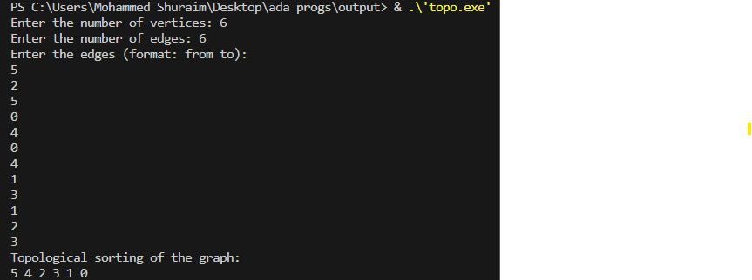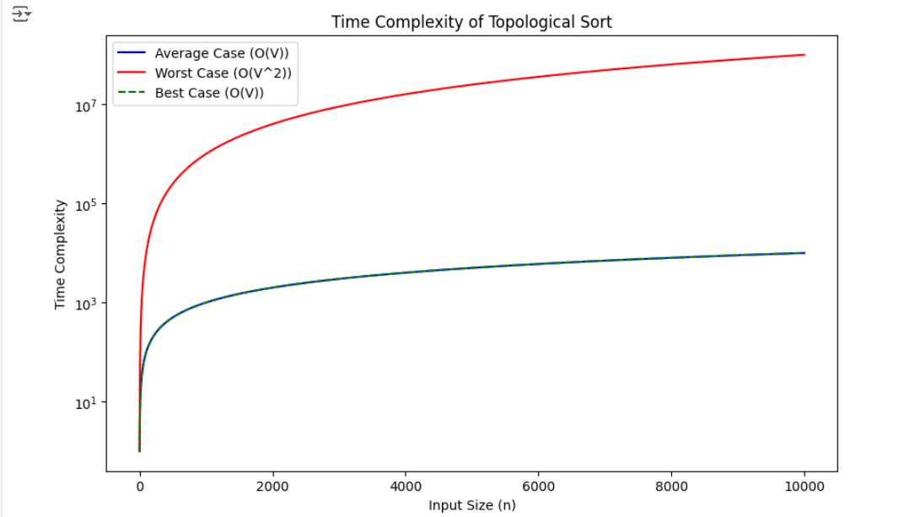

**3)Implement Johnson Trotter algorithm to generate permutations.**

#include <stdio.h>

#include <stdlib.h>

#define LEFT_TO_RIGHT 1

#define RIGHT_TO_LEFT 0

void swap(int* a, int* b) {

int temp = *a;

*a = *b;

*b = temp;

}

void printPermutation(int* perm, int n) {

for (int i = 0; i < n; i++) {

printf("%d ", perm[i]);

}

printf("\n");

}

int findMobile(int* perm, int* dir, int n) {

int mobile_prev = 0, mobile = 0;

for (int i = 0; i < n; i++) {

if (dir[perm[i] - 1] == RIGHT_TO_LEFT && i != 0) {

if (perm[i] > perm[i - 1] && perm[i] > mobile_prev) {

mobile = perm[i];

mobile_prev = mobile;

}

}

if (dir[perm[i] - 1] == LEFT_TO_RIGHT && i != n - 1) {

if (perm[i] > perm[i + 1] && perm[i] > mobile_prev) {

mobile = perm[i];

mobile_prev = mobile;

}

}

}

return mobile;

}

int findPosition(int* perm, int n, int mobile) {

for (int i = 0; i < n; i++) {

if (perm[i] == mobile) {

return i + 1;

}

}

return -1;

}

void changeDirection(int* perm, int* dir, int n, int mobile) {

for (int i = 0; i < n; i++) {

if (perm[i] > mobile) {

if (dir[perm[i] - 1] == LEFT_TO_RIGHT) {

dir[perm[i] - 1] = RIGHT_TO_LEFT;

} else if (dir[perm[i] - 1] == RIGHT_TO_LEFT) {

dir[perm[i] - 1] = LEFT_TO_RIGHT;

}

}

}

}

void johnsonTrotter(int n) {

int* perm = (int*)malloc(n * sizeof(int));

int* dir = (int*)malloc(n * sizeof(int));

for (int i = 0; i < n; i++) {

perm[i] = i + 1;

dir[i] = RIGHT_TO_LEFT;

}

printPermutation(perm, n);

while (1) {

int mobile = findMobile(perm, dir, n);

if (mobile == 0) {

break;

}

int pos = findPosition(perm, n, mobile);

if (dir[perm[pos - 1] - 1] == RIGHT_TO_LEFT) {

swap(&perm[pos - 1], &perm[pos - 2]);

} else if (dir[perm[pos - 1] - 1] == LEFT_TO_RIGHT) {

swap(&perm[pos], &perm[pos - 1]);

}

// Print the current permutation

printPermutation(perm, n);

// Reverse the direction of all elements larger than the largest mobile element

changeDirection(perm, dir, n, mobile);

}

// Free allocated memory

free(perm);

free(dir);

}

int main() {

int n;

printf("Enter the number of elements: ");

scanf("%d", &n);

johnsonTrotter(n);

return 0;

}

**OUTPUT:**

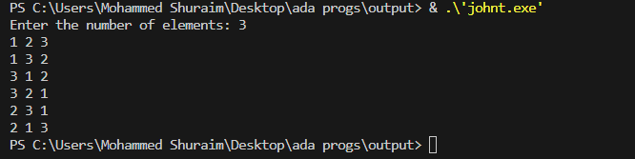

**4) Sort a given set of N integer elements using the Merge Sort technique and compute its time taken. Run the program for different values of N and record the time taken to sort.**

#include <stdio.h>

#include <stdlib.h>

#include <time.h>

void merge(int arr[], int l, int m, int r) {

int i, j, k;

int n1 = m - l + 1;

int n2 = r - m;

int L[n1], R[n2];

for (i = 0; i < n1; i++)

L[i] = arr[l + i];

for (j = 0; j < n2; j++)

R[j] = arr[m + 1 + j];

i = 0;

j = 0;

k = l;

while (i < n1 && j < n2) {

if (L[i] <= R[j]) {

arr[k] = L[i];

i++;

} else {

arr[k] = R[j];

j++;

}

k++;

}

while (i < n1) {

arr[k] = L[i];

i++;

k++;

}

while (j < n2) {

arr[k] = R[j];

j++;

k++;

}

}

void mergeSort(int arr[], int l, int r) {

if (l < r) {

int m = l + (r - l) / 2;

mergeSort(arr, l, m);

mergeSort(arr, m + 1, r);

merge(arr, l, m, r);

}

}

void printArray(int A[], int size) {

for (int i = 0; i < size; i++)

printf("%d ", A[i]);

printf("\n");

}

int main() {

int n;

printf("Enter the number of elements: ");

scanf("%d", &n);

int *arr = (int *)malloc(n * sizeof(int));

printf("Enter %d elements:\n", n);

for (int i = 0; i < n; i++)

scanf("%d", &arr[i]);

printf("Given array is:\n");

printArray(arr, n);

clock_t start, end;

double cpu_time_used;

start = clock();

mergeSort(arr, 0, n - 1);

end = clock();

cpu_time_used = ((double)(end - start)) / CLOCKS_PER_SEC;

printf("\nSorted array is:\n");

printArray(arr, n);

printf("\nTime taken for sorting: %d seconds\n", cpu_time_used);

free(arr);

return 0;

}

**OUTPUT:**

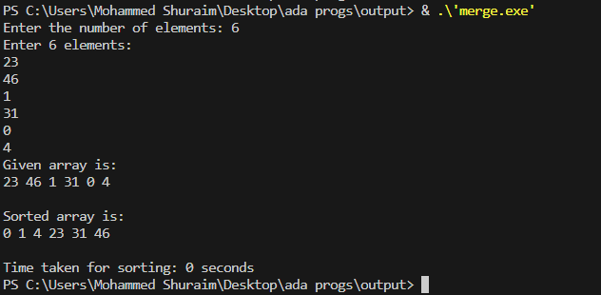

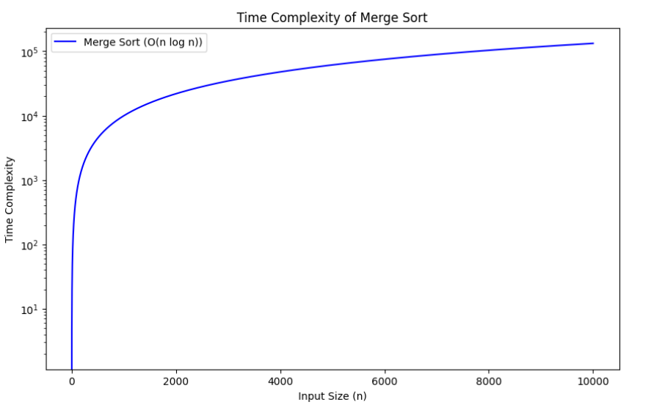

**5) Sort a given set of N integer elements using Quick Sort technique and compute its time taken.**

#include <stdio.h>

void print_array(int array[], int size) {

    for (int i = 0; i < size; i++) {

        printf("%d ", array[i]);

    }

    printf("\n");

}

int partition(int array[], int low, int high) {

    int pivot = array[low];

    int start = low + 1;

    int end = high;

    while (1) {

        while (start <= end && array[start] <= pivot) {

            start++;

        }

        while (array[end] >= pivot && end >= start) {

            end--;

        }

        if (end < start) {

            break;

        } else {

            int temp = array[start];

            array[start] = array[end];

            array[end] = temp;

        }

    }

    int temp = array[low];

    array[low] = array[end];

    array[end] = temp;

    return end;

}

void quick_sort(int array[], int low, int high) {

    if (low < high) {

        int p = partition(array, low, high);

        quick_sort(array, low, p - 1);

        quick_sort(array, p + 1, high);

    }

}

int main() {

    int n;

    printf("Enter the number of elements: ");

    scanf("%d", &n);

    int arr[n];

    printf("Enter %d elements: ", n);

    for (int i = 0; i < n; i++) {

        scanf("%d", &arr[i]);

    }

    printf("Original array:\n");

    print_array(arr, n);

    quick_sort(arr, 0, n - 1);

    printf("Sorted array:\n");

    print_array(arr, n);

    return 0;

}

**OUTPUT:**

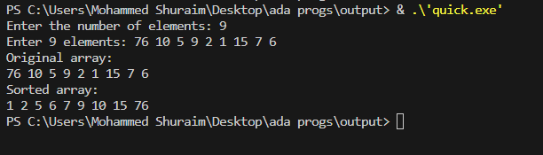

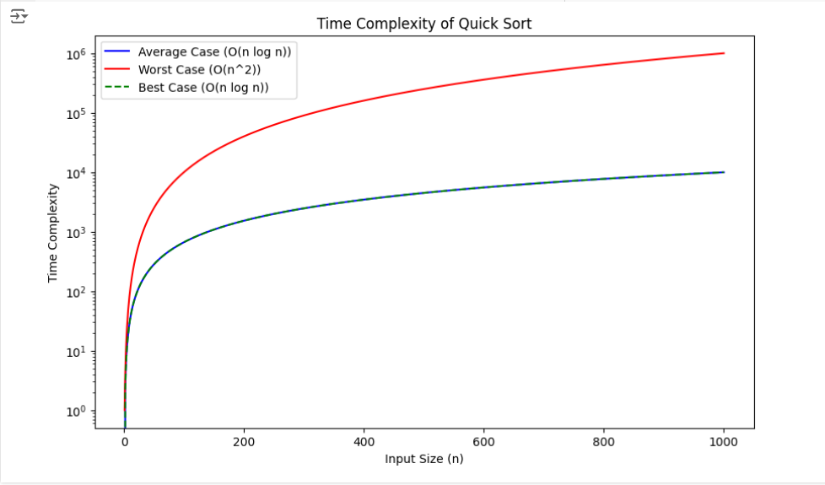

**6)** **Sort a given set of N integer elements using Heap Sort technique and compute its time taken.**

#include <stdio.h>

#include <stdlib.h>

#include <time.h>

void Insert(int A[], int n) {

    int i = n, temp;

    temp = A[i];

    while (i > 1 && temp > A[i / 2]) {

        A[i] = A[i / 2];

        i = i / 2;

    }

    A[i] = temp;

}

int Delete(int A[], int n) {

    int i, j, x, temp, val;

    val = A[1];

    x = A[n];

    A[1] = A[n];

    A[n] = val;

    i = 1;

    j = i * 2;

    while (j <= n - 1) {

        if (j < n - 1 && A[j + 1] > A[j])

            j = j + 1;

        if (A[i] < A[j]) {

            temp = A[i];

            A[i] = A[j];

            A[j] = temp;

            i = j;

            j = 2 * j;

        } else {

            break;

        }

    }

    return val;

}

void heap_sort(int A[], int n) {

    for (int i = 2; i <= n; i++) {

        Insert(A, i);

    }

    for (int i = n; i > 1; i--) {

        Delete(A, i);

    }

}

int main() {

    int n;

    printf("Enter the number of elements: ");

    scanf("%d", &n);

    int *A = (int *)malloc((n + 1) * sizeof(int));

    if (A == NULL) {

        printf("Memory allocation failed!\n");

        return 1;

    }

    printf("Enter %d elements: ", n);

    for (int i = 1; i <= n; i++) {

        scanf("%d", &A[i]);

    }

    printf("Original array:\n");

    for (int i = 1; i <= n; i++) {

        printf("%d ", A[i]);

    }

    printf("\n");

    clock_t start, end;

    double cpu_time_used;

    start = clock();

    heap_sort(A, n);

    end = clock();

    cpu_time_used = ((double) (end - start)) / CLOCKS_PER_SEC;

    printf("Sorted array:\n");

    for (int i = 1; i <= n; i++) {

        printf("%d ", A[i]);

    }

    printf("\n");

    printf("Time taken to sort the array: %f seconds\n", cpu_time_used);

    free(A);

    return 0;

}

**OUTPUT:**

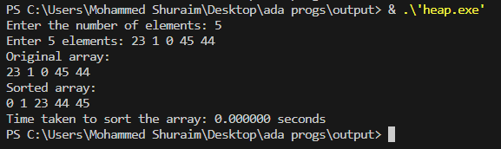

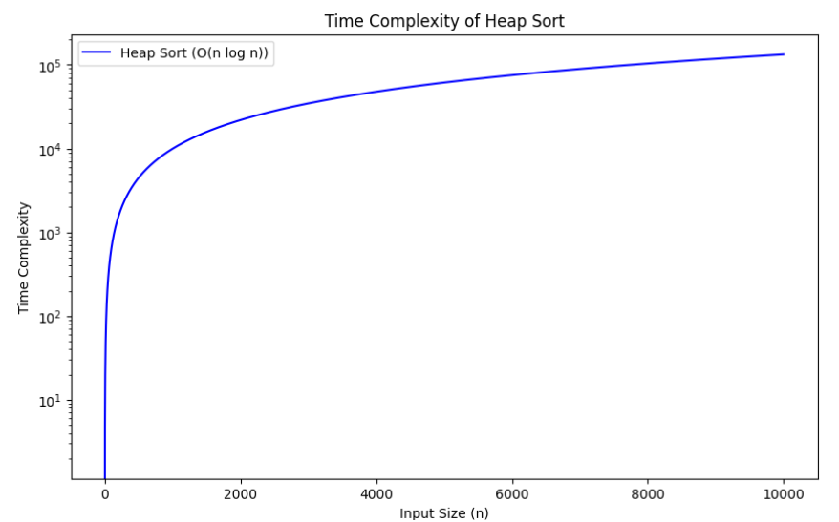

**7) Implement 0/1 Knapsack problem using dynamic programming.**

#include <stdio.h>

#include <stdbool.h>

// A utility function that returns maximum of two integers

int max(int a, int b) { return (a > b) ? a : b; }

int knapSack(int W, int wt[], int val[], int n, bool selected[])

{

    int dp[n + 1][W + 1];

    // Build table dp[][] in bottom up manner

    for (int i = 0; i <= n; i++) {

        for (int w = 0; w <= W; w++) {

            if (i == 0 || w == 0)

                dp[i][w] = 0;

            else if (wt[i - 1] <= w)

                dp[i][w] = max(val[i - 1] + dp[i - 1][w - wt[i - 1]], dp[i - 1][w]);

            else

                dp[i][w] = dp[i - 1][w];

        }

    }

    // dp[n][W] contains the maximum profit

    int maxProfit = dp[n][W];

    // Finding the selected items using backtracking

    int remainingWeight = W;

    for (int i = n; i > 0 && maxProfit > 0; i--) {

        if (maxProfit != dp[i - 1][remainingWeight]) {

            selected[i - 1] = true;

            maxProfit -= val[i - 1];

            remainingWeight -= wt[i - 1];

        }

    }

    // Print the dp table

    printf("\nDP Table:\n");

    printf("    ");

    for (int w = 0; w <= W; w++) {

        printf("%-5d", w);

    }

    printf("\n");

    for (int i = 0; i <= n; i++) {

        printf("%-3d", i);

        for (int w = 0; w <= W; w++) {

            printf("%-5d", dp[i][w]);

        }

        printf("\n");

    }

    return dp[n][W];

}

void printKnapsackTable(int W, int wt[], int val[], int n, bool selected[])

{

    printf("\nKnapsack Table:\n");

    printf("Item\tWeight\tProfit\n");

    for (int i = 0; i < n; i++) {

        if (selected[i])

            printf("%d\t%d\t%d\n", i + 1, wt[i], val[i]);

        else

            printf("%d\t%d\t%d\t(Not Selected)\n", i + 1, wt[i], val[i]);

    }

}

int main()

{

    int n;

    printf("Enter the number of items: ");

    scanf("%d", &n);

    int profit[n], weight[n];

    bool selected[n];

    printf("Enter the profits and weights of the items:\n");

    for (int i = 0; i < n; i++) {

        printf("Item %d: ", i + 1);

        scanf("%d %d", &profit[i], &weight[i]);

        selected[i] = false;

    }

    int capacity;

    printf("Enter the capacity of the knapsack: ");

    scanf("%d", &capacity);

    int maxProfit = knapSack(capacity, weight, profit, n, selected);

    printf("\nMaximum Profit: %d\n", maxProfit);

    printKnapsackTable(capacity, weight, profit, n, selected);

    return 0;

}

**OUTPUT:**

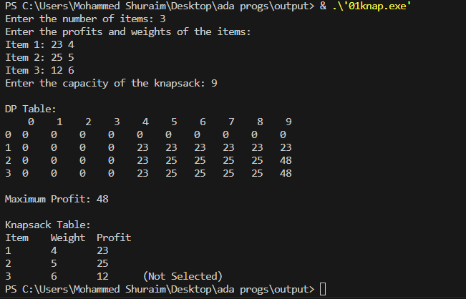

**8)** **Implement All Pair Shortest paths problem using Floyd’s algorithm.**

#include <stdio.h>

#define INF 99999

#define V 4  // Number of vertices

void floydWarshall(int graph[][V]) {

    int dist[V][V];

    int i, j, k;

    for (i = 0; i < V; i++) {

        for (j = 0; j < V; j++) {

            dist[i][j] = graph[i][j];

        }

    }

    // Applying Floyd-Warshall algorithm to find shortest paths

    for (k = 0; k < V; k++) {

        for (i = 0; i < V; i++) {

            // Pick all vertices as destination for the above picked source

            for (j = 0; j < V; j++) {

                if (dist[i][k] != INF && dist[k][j] != INF && dist[i][k] + dist[k][j] < dist[i][j]) {

                    dist[i][j] = dist[i][k] + dist[k][j];

                }

            }

        }

    }

    printf("Shortest distances between every pair of vertices:\n");

    for (i = 0; i < V; i++) {

        for (j = 0; j < V; j++) {

            if (dist[i][j] == INF) {

                printf("%7s", "INF");

            } else {

                printf("%7d", dist[i][j]);

            }

        }

        printf("\n");

    }

}

int main() {

    int graph[V][V] = {

        {0,   5,   INF, 10},

        {INF, 0,   3,   INF},

        {INF, INF, 0,   1},

        {INF, INF, INF, 0}

    };

    floydWarshall(graph);

    return 0;

}

**OUTPUT:**

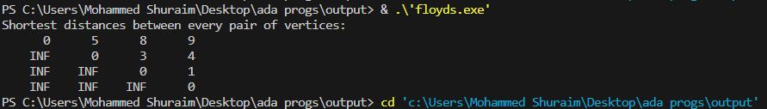

**9) Find Minimum Cost Spanning Tree of a given undirected graph using Prim’s algorithm.**

#include <limits.h>

#include <stdbool.h>

#include <stdio.h>

#define V 5 // Number of vertices in the graph

int minKey(int key[], bool mstSet[]);

void primMST(int graph[V][V]);

void printMST(int parent[], int graph[V][V]);

void printGraph(int graph[V][V]);

int minKey(int key[], bool mstSet[])

{

    int min = INT_MAX, min_index;

    for (int v = 0; v < V; v++)

        if (mstSet[v] == false && key[v] < min)

            min = key[v], min_index = v;

    return min_index;

}

void printMST(int parent[], int graph[V][V])

{

    printf("Edge \tWeight\n");

    for (int i = 1; i < V; i++)

        printf("%d - %d \t%d \n", parent[i], i, graph[i][parent[i]]);

}

void primMST(int graph[V][V])

{

    int parent[V];

    int key[V];

    bool mstSet[V];

    for (int i = 0; i < V; i++)

        key[i] = INT_MAX, mstSet[i] = false;

    key[0] = 0;

    parent[0] = -1;

    for (int count = 0; count < V - 1; count++) {

        int u = minKey(key, mstSet);

        mstSet[u] = true;

        for (int v = 0; v < V; v++)

            if (graph[u][v] && mstSet[v] == false && graph[u][v] < key[v])

                parent[v] = u, key[v] = graph[u][v];

    }

    printMST(parent, graph);

}

void printGraph(int graph[V][V])

{

    printf("Graph Adjacency Matrix:\n");

    for (int i = 0; i < V; i++) {

        for (int j = 0; j < V; j++)

            printf("%d\t", graph[i][j]);

        printf("\n");

    }

}

int main()

{

    int graph[V][V];

    int choice;

    printf("Choose input method:\n");

    printf("1. Predefined graph\n");

    printf("2. User input graph\n");

    printf("Enter choice: ");

    scanf("%d", &choice);

    switch (choice) {

    case 1:

        graph[0][1] = 2;

        graph[0][3] = 6;

        graph[1][0] = 2;

        graph[1][2] = 3;

        graph[1][3] = 8;

        graph[1][4] = 5;

        graph[2][1] = 3;

        graph[2][4] = 7;

        graph[3][0] = 6;

        graph[3][1] = 8;

        graph[3][4] = 9;

        graph[4][1] = 5;

        graph[4][2] = 7;

        graph[4][3] = 9;

        break;

    case 2:

        printf("Enter the adjacency matrix for the graph (%d x %d):\n", V, V);

        for (int i = 0; i < V; i++)

            for (int j = 0; j < V; j++)

                scanf("%d", &graph[i][j]);

        break;

    default:

        printf("Invalid choice.\n");

        return 1;

    }

    printGraph(graph);

    primMST(graph);

    return 0;

**OUTPUT:**

}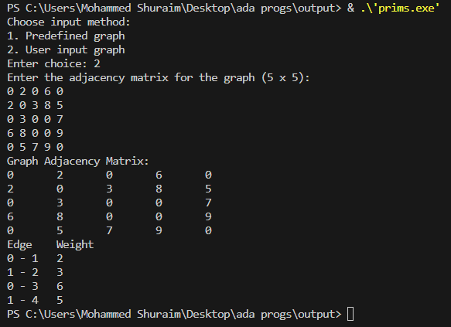

**9)** **Find Minimum Cost Spanning Tree of a given undirected graph using Kruskal’s algorithm.**

#include <stdio.h>

#include <stdlib.h>

int comparator(const void* p1, const void* p2)

{

    const int(*x)[3] = p1;

    const int(*y)[3] = p2;

    return (*x)[2] - (*y)[2];

}

void makeSet(int parent[], int rank[], int n)

{

    for (int i = 0; i < n; i++) {

        parent[i] = i;

        rank[i] = 0;

    }

}

int findParent(int parent[], int component)

{

    if (parent[component] == component)

        return component;

    return parent[component] = findParent(parent, parent[component]);

}

void unionSet(int u, int v, int parent[], int rank[], int n)

{

    u = findParent(parent, u);

    v = findParent(parent, v);

    if (rank[u] < rank[v]) {

        parent[u] = v;

    } else if (rank[u] > rank[v]) {

        parent[v] = u;

    } else {

        parent[v] = u;

        rank[u]++;

    }

}

void kruskalAlgo(int n, int edges[][3], int edgeCount)

{

    qsort(edges, edgeCount, sizeof(edges[0]), comparator);

    int parent[n];

    int rank[n];

    makeSet(parent, rank, n);

    int minCost = 0;

    printf("Following are the edges in the constructed MST\n");

    for (int i = 0; i < edgeCount; i++) {

        int v1 = findParent(parent, edges[i][0]);

        int v2 = findParent(parent, edges[i][1]);

        int wt = edges[i][2];

        if (v1 != v2) {

            unionSet(v1, v2, parent, rank, n);

            minCost += wt;

            printf("%d -- %d == %d\n", edges[i][0], edges[i][1], wt);

        }

    }

    printf("Minimum Cost Spanning Tree: %d\n", minCost);

}

int main()

{

    int V = 4; // Number of vertices

    int E = 5; // Number of edges

    printf("Choose input method:\n");

    printf("1. Predefined edges\n");

    printf("2. User input edges\n");

    printf("Enter choice: ");

    int choice;

    scanf("%d", &choice);

    int edges[E][3]; // Declare edges array here

    if (choice == 2) {

        printf("Enter the number of vertices: ");

        scanf("%d", &V);

        printf("Enter the number of edges: ");

        scanf("%d", &E);

        printf("Enter the edges (src dest weight):\n");

        for (int i = 0; i < E; i++) {

            scanf("%d %d %d", &edges[i][0], &edges[i][1], &edges[i][2]);

        }

        kruskalAlgo(V, edges, E); // Pass edges to the algorithm

    } else {

        int predefined_edges[][3] = {

            {0, 1, 10},

            {0, 2, 6},

            {0, 3, 5},

            {1, 3, 15},

            {2, 3, 4}

        };

        for (int i = 0; i < E; i++) {

            edges[i][0] = predefined_edges[i][0];

            edges[i][1] = predefined_edges[i][1];

            edges[i][2] = predefined_edges[i][2];

        }

        kruskalAlgo(V, edges, E); // Pass edges to the algorithm

    }

    return 0;

}

**OUTPUT:**

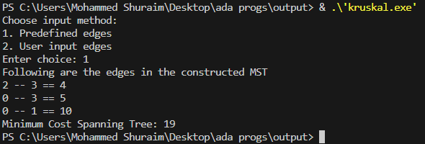

**10)** **Implement Fractional Knapsack using Greedy technique.**

#include <stdio.h>

#include <stdlib.h>

struct Item {

int profit, weight;

};

int cmp(const void* a, const void* b) {

struct Item* item1 = (struct Item*)a;

struct Item* item2 = (struct Item*)b;

double r1 = (double)item1->profit / item1->weight;

double r2 = (double)item2->profit / item2->weight;

if (r1 < r2) return 1;

else if (r1 > r2) return -1;

else return 0;

}

double fractionalKnapsack(int W, struct Item arr[], int N) {

qsort(arr, N, sizeof(struct Item), cmp);

double finalvalue = 0.0;

for (int i = 0; i < N; i++) {

if (arr[i].weight <= W) {

W -= arr[i].weight;

finalvalue += arr[i].profit;

}

else {

finalvalue += arr[i].profit * ((double)W / arr[i].weight);

break;

}

}

return finalvalue;

}

int main() {

int N, W;

printf("Enter the maximum weight of the knapsack: ");

scanf("%d", &W);

printf("Enter the number of items: ");

scanf("%d", &N);

struct Item* arr = (struct Item*)malloc(N * sizeof(struct Item));

printf("Enter the profit and weight of each item:\n");

for (int i = 0; i < N; i++) {

printf("Item %d:\n", i + 1);

printf("Profit: ");

scanf("%d", &arr[i].profit);

printf("Weight: ");

scanf("%d", &arr[i].weight);

}

double maxProfit = fractionalKnapsack(W, arr, N);

printf("Maximum profit: %.2f\n", maxProfit);

free(arr);

return 0;

}

**OUTPUT:**



**11)** **From a given vertex in a weighted connected graph, find shortest paths to other vertices using Dijkstra’s algorithm.**

#include <limits.h>

#include <stdbool.h>

#include <stdio.h>

#define V 9

int minDistance(int dist[], bool sptSet[])

{

int min = INT_MAX, min_index;

for (int v = 0; v < V; v++)

if (sptSet[v] == false && dist[v] <= min)

min = dist[v], min_index = v;

return min_index;

}

void printSolution(int dist[])

{

printf("Vertex \t\t Distance from Source\n");

for (int i = 0; i < V; i++)

printf("%d \t\t\t\t %d\n", i, dist[i]);

}

void dijkstra(int graph[V][V], int src)

{

int dist[V];

bool sptSet[V];

for (int i = 0; i < V; i++)

dist[i] = INT_MAX, sptSet[i] = false;

dist[src] = 0;

for (int count = 0; count < V - 1; count++) {

int u = minDistance(dist, sptSet);

sptSet[u] = true;

for (int v = 0; v < V; v++)

if (!sptSet[v] && graph[u][v] && dist[u] != INT_MAX && dist[u] + graph[u][v] < dist[v])

dist[v] = dist[u] + graph[u][v];

}

printSolution(dist);

}

int main()

{

int graph[V][V];

int choice;

printf("Choose input method:\n");

printf("1. Predefined graph\n");

printf("2. User-defined graph\n");

printf("Enter choice: ");

scanf("%d", &choice);

switch (choice) {

case 1:

{

int predefined_graph[V][V] = {

{ 0, 4, 0, 0, 0, 0, 0, 8, 0 },

{ 4, 0, 8, 0, 0, 0, 0, 11, 0 },

{ 0, 8, 0, 7, 0, 4, 0, 0, 2 },

{ 0, 0, 7, 0, 9, 14, 0, 0, 0 },

{ 0, 0, 0, 9, 0, 10, 0, 0, 0 },

{ 0, 0, 4, 14, 10, 0, 2, 0, 0 },

{ 0, 0, 0, 0, 0, 2, 0, 1, 6 },

{ 8, 11, 0, 0, 0, 0, 1, 0, 7 },

{ 0, 0, 2, 0, 0, 0, 6, 7, 0 }

};

for (int i = 0; i < V; i++)

for (int j = 0; j < V; j++)

graph[i][j] = predefined_graph[i][j];

}

break;

case 2:

printf("Enter the adjacency matrix of the graph:\n");

for (int i = 0; i < V; i++)

for (int j = 0; j < V; j++)

scanf("%d", &graph[i][j]);

break;

default:

printf("Invalid choice\n");

return 1;

}

dijkstra(graph, 0);

return 0;}

**OUTPUT:**

