JD Solar Platform: Database Schema Documentation
Supabase project: solar-app (PostgreSQL 17). Schema: public. 10 tables.

1. Entity Relationship Diagram
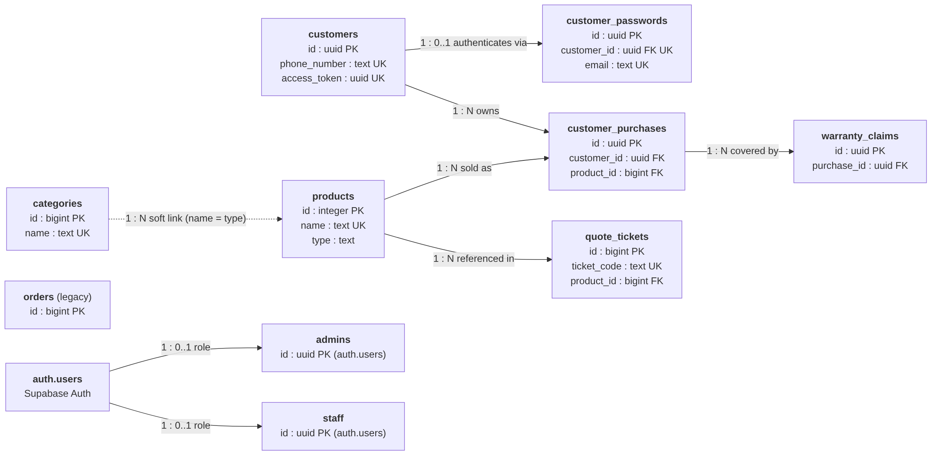
Solid arrows are enforced foreign keys. The dashed arrow is a soft link by name with no database constraint. orders has no relationships.

2. Relationships
Parent | Child | Cardinality | Key
customers | customer_passwords | 1 : 0..1 | customer_passwords.customer_id -> customers.id
customers | customer_purchases | 1 : N | customer_purchases.customer_id -> customers.id
products | customer_purchases | 1 : N | customer_purchases.product_id -> products.id
customer_purchases | warranty_claims | 1 : N | warranty_claims.purchase_id -> customer_purchases.id
products | quote_tickets | 1 : N | quote_tickets.product_id -> products.id (nullable)
categories | products | 1 : N (soft) | products.type matches categories.name; no FK constraint
auth.users | admins | 1 : 0..1 | admins.id -> auth.users.id
auth.users | staff | 1 : 0..1 | staff.id -> auth.users.id

3. Tables

3.1 admins
Name | Data Type | Description
id | uuid, PK, FK | Primary identifier linked to Supabase auth user record
full_name | text | Full name of the system administrator
email | text | Administrator email address used for authentication
phone | text | Contact telephone or mobile number
position | text | Administrative role title within the organization
created_at | timestamptz | Record creation date and timestamp

3.2 staff
Name | Data Type | Description
id | uuid, PK, FK | Primary identifier linked to Supabase auth user record
full_name | text | Full name of the staff member
email | text | Staff email address used for authentication
phone | text | Contact telephone or mobile number
position | text | Assigned job title or operational role
created_at | timestamptz | Record creation date and timestamp

3.3 categories
Name | Data Type | Description
id | bigint, PK | Primary unique identifier for the category
name | text, UNIQUE | Unique product category name
created_at | timestamptz | Category creation date and timestamp

3.4 products
Name | Data Type | Description
id | integer, PK | Primary identifier for the solar equipment item
name | text, UNIQUE | Unique commercial or model name of the product
type | text | Category name; soft link to categories.name
watt | integer | Rated wattage output of the lighting equipment
size | text | Physical dimensions or package size specification
image_url | text | Storage URL pointing to the product photo
sales | integer | Aggregated counter of recorded unit sales
battery | text | Battery chemistry and capacity specifications
in_stock | boolean | Inventory flag indicating catalog availability
waterproof_grade | text | Ingress protection rating such as IP65 or IP67
method_control | text | Control method such as remote, sensor, or timer
material | text | Housing material such as die-cast or aviation aluminum
solar_panel | text | Photovoltaic panel wattage and construction
charging_time | text | Sunlight hours required for a full charge
charging_type | text | Charging mechanism such as solar or hybrid AC
smd_lamp_beads | text | LED diode package specification and bead count
lighting_time | text | Operating duration on a full battery
price_range | text | Estimated retail or wholesale price indicator
recommended_usage | text | Suggested deployment scenario or application
ideal_location | text | Recommended mounting environment
default_warranty_months | integer | Standard warranty coverage in months
stock_quantity | integer | Current warehouse inventory count
beaming_angle | text | Optical beam dispersion angle in degrees
color_temperature | text | Correlated color temperature such as 6500K
voltage | text | Operating electrical voltage requirement
lamp_body_color | text | Exterior fixture finish or housing color
warranty | text | Human-readable warranty description
life_span | text | Rated operating life in hours or years
lumens | text | Luminous flux output in lumens
place_of_use | text | Installation environment such as outdoor or road
power_source | text | Primary energy supply mechanism

3.5 customers
Name | Data Type | Description
id | uuid, PK | Primary unique identifier for the customer
phone_number | text, UNIQUE | Mobile number used for customer lookup
full_name | text | Registered full name of the customer
access_token | uuid, UNIQUE | Secure token for customer portal and receipt access
province | text | Customer's province
city | text | Customer's city or municipality
barangay | text | Customer's barangay
street_address | text | Customer's house number and street address
facebook | text | Customer's Facebook profile or contact link
created_at | timestamptz | Customer registration date and timestamp

3.6 customer_passwords
Name | Data Type | Description
id | uuid, PK | Primary unique identifier for the credential
customer_id | uuid, FK, UNIQUE | References customers.id; one credential per customer
email | text, UNIQUE | Login email address for the customer account
password_hash | text | Password hash generated with pgcrypto
created_at | timestamptz | Credential creation timestamp
updated_at | timestamptz | Last password change timestamp

3.7 customer_purchases
Name | Data Type | Description
id | uuid, PK | Primary unique identifier for the purchase
customer_id | uuid, FK | References customers.id; buyer of the product
product_id | bigint, FK | References products.id; item purchased
serial_number | text | Manufacturer unit serial number
purchase_date | date | Official date of sale
warranty_months | integer | Warranty duration allocated in months
warranty_expires_at | date | Calculated warranty expiration date
branch_location | text | Store branch that processed the sale
is_voided | boolean | Whether warranty coverage has been voided
void_reason | text | Staff explanation for voiding the warranty
voided_at | timestamptz | Date and time the warranty was voided
created_at | timestamptz | Purchase record creation timestamp

3.8 warranty_claims
Name | Data Type | Description
id | uuid, PK | Primary unique identifier for the warranty claim
purchase_id | uuid, FK | References customer_purchases.id; claimed purchase
issue_category | text | Failure category reported by the customer
description | text | Detailed problem description from the claimant
media_urls | text[] | Uploaded photo and video URLs
status | text | Claim status such as pending, approved, or rejected
staff_notes | text | Internal remarks recorded by staff
created_at | timestamptz | Claim submission timestamp
updated_at | timestamptz | Most recent status update timestamp

3.9 quote_tickets
Name | Data Type | Description
id | bigint, PK | Primary sequential identifier for the quote ticket
ticket_code | text, UNIQUE | Human-readable ticket tracking code
product_id | bigint, FK | Optional reference to products.id
product_name | text | Product name snapshot at time of inquiry
product_watt | integer | Product wattage snapshot at time of inquiry
product_price_range | text | Price range snapshot at time of inquiry
product_image_url | text | Product image URL snapshot
quantity | integer | Number of units requested
customer_name | text | Full name of the inquiring party
mobile_contact | text | Inquirer's mobile contact number
email | text | Inquirer's email address
province | text | Installation site province
city | text | Installation site city or municipality
barangay | text | Installation site barangay
street_address | text | Installation site street address
postal_code | text | Installation site postal code
facebook | text | Inquirer's Facebook profile link
instagram | text | Inquirer's Instagram handle
purpose_of_visitation | text | Purpose or scope of the requested consultation
will_visit | boolean | Whether the customer plans a showroom visit
store_branch | text | Showroom branch selected for the visit
visit_date | date | Scheduled visit date
visit_time_slot | text | Scheduled visit time window
preferred_channel | text | Preferred contact channel such as phone or email
delivery_address | text | Delivery destination or instructions
project_notes | text | Customer's technical requirements or project details
status | text | Ticket status such as Pending, Contacted, or Closed
staff_notes | text | Internal remarks entered by sales staff
created_at | timestamptz | Inquiry submission timestamp
updated_at | timestamptz | Last ticket update timestamp

3.10 orders
Name | Data Type | Description
id | bigint, PK | Primary identifier for the legacy order
customer_name | text | Customer name entered on the order
address | text | Customer delivery address
product_name | text | Ordered product name as free text
quantity | integer | Number of units ordered
price | numeric | Total price charged for the order
status | text | Order status such as Pending
created_at | timestamptz | Order creation timestamp

4. Redundancy Review
Verdict: the schema is sufficient for the current system. No deletions are recommended right now, as each redundancy is still referenced by live code.
Area | Assessment
orders vs customer_purchases | orders is a legacy, unnormalized table (free-text customer and product). Still used by OrdersScreen in the Admin and Staff panels. Keep until that screen is retired.
quote_tickets snapshot fields | Duplicated product and contact fields are intentional: inquiries come from anonymous visitors, and snapshots preserve historical accuracy. Keep.
admins vs staff | Identical schemas. Could merge into one profiles table with a role column, but AuthContext, LoginPage, UsersScreen, and RLS policies depend on both. Keep for now.
categories.name vs products.type | Soft string link without a foreign key. Renaming a category does not cascade. Optional future improvement: add products.category_id FK.

5. Mermaid Source
graph LR
customers["`**customers**
id : uuid PK
phone_number : text UK
access_token : uuid UK`"]
customer_passwords["`**customer_passwords**
id : uuid PK
customer_id : uuid FK UK
email : text UK`"]
customer_purchases["`**customer_purchases**
id : uuid PK
customer_id : uuid FK
product_id : bigint FK`"]
warranty_claims["`**warranty_claims**
id : uuid PK
purchase_id : uuid FK`"]
products["`**products**
id : integer PK
name : text UK
type : text`"]
categories["`**categories**
id : bigint PK
name : text UK`"]
quote_tickets["`**quote_tickets**
id : bigint PK
ticket_code : text UK
product_id : bigint FK`"]
orders["`**orders** (legacy)
id : bigint PK`"]
admins["`**admins**
id : uuid PK (auth.users)`"]
staff["`**staff**
id : uuid PK (auth.users)`"]
auth_users["`**auth.users**
Supabase Auth`"]
customers -- "1 : 0..1 authenticates via" --> customer_passwords
customers -- "1 : N owns" --> customer_purchases
products -- "1 : N sold as" --> customer_purchases
customer_purchases -- "1 : N covered by" --> warranty_claims
products -- "1 : N referenced in" --> quote_tickets
categories -. "1 : N soft link (name = type)" .-> products
auth_users -- "1 : 0..1 role" --> admins
auth_users -- "1 : 0..1 role" --> staff

