Preventative Maintenance - FP Semi-Annually

2019-11-18

# Purpose and Application

## Purpose

To define a work instruction for the semi-annual preventative maintenance tasks on the FP machine.

## Application

This work instruction applies to all O-I manufacturing facilities.

# Safety

Observe O-I standard safety requirements and procedures defined by the Global Environmental Health & Safety (EH&S) organization, as well as all applicable local, regional, and national requirements. Safety equipment and instructions specific to the completion of this work instruction are detailed in the Instructions Section.

# Instructions

1. Before starting the work instruction activity, perform the following steps:
2. Do not begin these tasks without confirmation that personnel directly involved have completed the required training associated with the work instruction activity and have reviewed this document.
3. Gather necessary tools and equipment as identified below in the Equipment Section.
4. Wear and use additional Personal Protective Equipment (PPE) and safety equipment required for this specific work instruction.
5. Obey all applicable safety requirements and procedures.
6. Notify appropriate personnel of the activity and estimated time needed to complete the tasks.
7. Clearly identify, mark off, and secure the designated area defined by the work instruction activity.
8. Follow all Lockout/Tagout procedures when work instruction activity requires isolating energy in the designated area. Verify energy is isolated before starting work.
9. Only after energy is verified to be isolated, can the protective guarding be removed and safety interlock gates be opened.
10. To complete the FP semi-annual preventative maintenance, perform the following steps:
11. Inspect all electrical connections, cables and pneumatic hoses for damage, unusual wear or loose connections. Replace as needed.
12. Check the SWA and BHA light sources.
13. Verify that all SWA and BHA lights are working.
14. Verify that the diffusers are clean and in good condition with no scratches or discolorations.
15. Trap a sample container and verify that the SWA and BHA lighting is uniform through the container image.

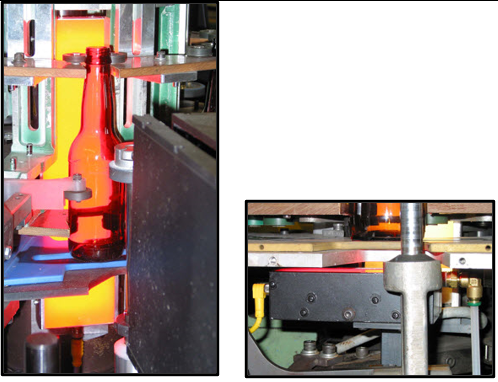

1. Check the lighting output and mounting of all the check detector light sources.
2. Verify that the mountings are tight and the lenses are clean.
3. Verify that the lights are sufficiently bright.
4. Upon completion of tasks, perform the following steps:
5. Replace protective guarding and close safety interlock gates.
6. Confirm the designated work area is clear and communicate to personnel the intent to restart energy.
7. After the designated work area is confirmed clear and personnel are aware of the pending restart, follow all Lockout/Tagout procedures to restart energy supplied to the designated area. Verify energy is active.
8. Remove signs and markings from the designated work area.
9. Perform basic housekeeping duties. Clean up the work space, tools and equipment. Dispose of trash. Put tools and equipment in assigned area.
10. Notify appropriate personnel that the work instruction activity has been completed.
11. Record and report findings and results.
12. Follow appropriate instructions for notification of findings and results relating to specifications, targets and/or reaction limits.

# Required Training

Before performing this work instruction, applicable personnel must be trained by an authorized trainer on the required training contents listed in this document.

# References

## Document Classification

* Asset Protection and Stability
* Quality

## Fundamentals

* N/A

# Approval

Sanctioning Representatives of the Global Team

|  |  |
| --- | --- |
| **Region** | **Representative** |
| Asia Pacific | Finbarr O’Shea |
| Europe | Jerzy Puk |
| Latin America | Juan Franco |
| Mexico | Yigael Hernandez |
| North America | David Gladwin |
| Global Operations | Bob Morin |

# Revision History

|  |  |
| --- | --- |
| 2019-11-18 | Approved by Bob Morin, Global Inspection Discipline Leader  Original Issue |