Exploratory Essay
Why can we do Rasch model using HLM?

By Kazuaki Uekawa
kaz_uekawa at yahoo.com

Episode 1
Rasch model as a logistic regression model 1
Why can we do Rasch model using HLM? 5
APPENDIX 1. Experimenting with Logistic Regression/Rasch model using SAS PROC LOGISTIC 7
Appendix Doing Rasch model using SAS PROC NLMIXED 9
APPENDIX 3. RUNNING WINSPTEPS (The same data) 10

Episode
I met Rasch model in 1995 when my mentor Charles Bidwell received an advice from Larry Hedges about some problems that our project team was facing. We had two data sets where some of the survey items were common. Because the two data sets provide some common items, we were told that we can merge the two data sets to create a scale. Well, it was a hard situation to describe, but anyways I had to read the Rasch book and took a course with Ben Wright and John Linacre. I can see how I didn’t understand Rasch model back then. I felt I understood it when I saw Aki Kamata presenting his material at AERA. For those who understand logistic regression but don’t know Rasch model, I just wanted to share my “aha” moment with you by showing how Rasch model is the same as logistic regression model and also how some people use HLM to do Rasch model.

I say HLM below, but what I really mean is multilevel logistic regression. HLM’s L is linear, so to call it HLM is wrong, but it is just easy to say HLM.

Rasch model as a logistic regression model
Rasch model helps you construct a scale based on a set of survey items. Rasch has been an alternative to a common practice that people do, which is the use of simple means over several items (e.g., in SAS, NewVariable=mean(of X1 X2 X3 X4 X5);). The problem of this approach is famous. Survey items are usually ordinal variables and they are not linear measures. Being linear means that a value of 2 is twice as large as 1. A survey item for example is answered by 0, 1, 2, or 3 (each corresponding some kind of phrases such as “strongly agree”). But this is an ordinal variable and thus no one knows whether a person who answered 2 is twice as large as the person who answered 1 in some kind of quantity that these people exhibit. Rasch model uses logit to express the chance of a person getting higher rating rather than a lower rating on survey items (e.g., the chance of getting “Yes” instead of “No” or “Strongly agree” instead of “Agree”). Because it uses logit, Rasch scores are linear by construction. Yet, if it really is a linear measure depends on whether the data (survey data) behave according to the Rasch equation. You must have seen this equation somewhere before.

One of my “aha” moments came when I learned from Professor Kamata at Florida state university that one can use HLM to do Rasch model. Also I had another “aha” moment when John Linacre, the author of Winsteps/Facets mentioned that such a model (HLM/Rasch) treats person measures as random effects, while his software Winsteps treat person measures as fixed effects. So I figured that Rasch model is a logistic regression. Maybe hearing me say this, Rasch teachers will tell me, “I’ve been telling you that all along.” But I just didn’t get it and am curious if there are people out there who would understand it immediately if they are told that Rasch model is a logistic regression.

It is a lot easier to start from how Rasch model is a logistic regression and how one can also use HLM to do Rasch model.

***

Rasch model actually is the same as logistic regression, if the scoring is dichotomous (Yes or No). If the scoring is based on a likert scale (e.g., Strongly Disagree, Disagree, Agree, Strongly Agree), then Rasch model is the same as ordered logit model (not multinomial logistic model because we at least know that the quantity increases as we go from Strongly disagree to disagree, and so on.)

Because it is easier, let’s focus on a case where respondents responded Yes (often coded as 1) or No (often coded as 0)—as opposed to a likert scale response like Strongly Disagree to Strongly Agree. I said “often coded” because the numbers themselves are just arbitrarily assigned, so software knows that 1 is considered a category that is higher in value than the other category.

First we have to know how the data structure looks like. For many of us who is familiar with how data sets look like in Excel, SAS, or SPSS, each observation represents a moment, so to speak. (I am going to use this notion “moment” later, so please remember it. Roughly it means unit of observation or each row or record in a spread sheet based data set). In a typical survey item, a respondent is meeting a survey question with a varying difficulty level of endorsement (where Yes is endorsement, while No is rejection). That is the unit of analysis in Rasch model. Thus, the following Rasch equation expresses what happens when a person meets a survey item.

Log(P/1-P) = person ability – item difficulty

This means that the chance (expressed in logit) of getting Yes as opposed to No is regulated only by two factors, person’s ability and item’s difficulty of endorsement. If you are used to ANOVA and are used to representing “effects” in the way I did, you find above expression intuitively easy. For people who only learned regression in Stat 101, confirm that the following logistic regression equation means the same thing. Instead of saying “person ability” the equation below uses a series of dummy variables to indicate which observation came from whom, as well as which observation (or “moment” as defined earlier) came from which survey items.

Log(P/1-P)= b1*john + b2*Edward + b3*Mary …. + g1*surveyitem1 + g2*surveyitem2 + g3*surveyitem3 …

The data set would look like this. Essentially, we are modeling the occurrence of Yes or No (dependent variable) using person information and survey information. The coefficients b1, b2, b3, … correspond to person measures (the larger the effect, the more quantity the persons have in whatever quantity you are measuring (the measure of liking science? The measure of deviance? etc.). The coefficients of g1, g2, g3, … correspond to the item easiness (the more, the easier the survey items are for people in general to endorse). Because it is a common practice to talk about item difficulty (rather than item easiness) you can flip the signs of these effects by multiplying g’s with -1.

What happened at the moment when a person meets a survey item?
 | Dependent Variable | Who? |  |  | Which survey item?
 | Yes or NO | John | Mary | Dave | Item 1 | Item 2 | Item 3
John | 1 | 1 | 0 | 0 | 1 | 0 | 0
John | 0 | 1 | 0 | 0 | 0 | 1 | 0
John | 0 | 1 | 0 | 0 | 0 | 0 | 1
Mary | 1 | 0 | 1 | 0 | 1 | 0 | 0
Mary | 1 | 0 | 1 | 0 | 0 | 1 | 0
Mary | 0 | 0 | 1 | 0 | 0 | 0 | 1
Dave | 1 | 0 | 0 | 1 | 1 | 0 | 0
Dave | 1 | 0 | 0 | 1 | 0 | 1 | 0
Dave | 1 | 0 | 0 | 1 | 0 | 0 | 1

Using the logit model in this way, we derive the measures that are linear. The measures are linear by construction – just because logit goes from minus infinity to positive infinity and because it shows a sense of nice gradation (recall sometimes likert scales return coarse distribution shape). However, whether really the measures are linear depend on how well the Rasch model equation’s assumptions are met by the data.

What are such assumptions? Don’t look anywhere else, assumptions are already explicit in this equation.

Log(P/1-P) = person ability – item difficulty

For example, the Rasch equation decided already that item difficulty carry equal weight (or same meaning) for everyone in the data set. What happens, if people differently to survey items? Rasch analysts are often criticized for getting rid of cases when that happens. For example, if black students and white students respond to a question differently, Rasch analysts typically want to get rid of such survey items (while other item response theorists would want to modify the equation to accommodate the behavior of the data, which is a source of big debates.) Rasch analysts, just like anybody else, wants to do a pilot studies of their survey instruments, so they make sure items behave in the say for everyone, i.e., item difficulty does not vary by subgroups.
There are many other things that this equation is explicit about. Though it sounds like a common sense, because the equation does not have an interaction person ability and item difficulty are considered independent from one another. This means that everyone in the data should receive the same level of challenge (of endorsing it by Yes as opposed to No). Whoops, I guess I am repeating a similar theme again as above. If item difficulty varies by subgroups, people say it is a problem of “differential item functioning” or DIF.
Just the fact that there are only two elements in this equation itself is an assumption. In reality, we can think of lots of other factors that influence Log(P/1-P) at the moment when a person meets a survey item. Maybe the respondent was too tired or lazy, so he just answered the question without thinking about it. That is a factor too, but the Rasch equation does not take that into consideration.

Why can we do Rasch model using HLM?
When you do Rasch model by HLM, you want to think of person ability as random effects. In the following HLM model, level-1 is an items and level-2 is a person, so that items are nested within persons.

The equation would look like this:
Level1: log(p/1-p)=b0 + b1*item1 + b2*item2 + b3*item 3 …
Level2: b0=g00 + u00
Level2: b1=g10
Level2: b2=g20
Level2: b3=g30
where u00 is a random component for the intercept b0.

In this HLM formulation, u00 is a person measure.

This can be written also in a combined form:
Log(p/1-p)= g00 + g10*item1 + g20*item2 + g30*item3 .. + u00
where u00 is a random effect for teachers

Again in this formulation, u00 is a person measure.

Note that in the first level-specific equation, u00 is called random component for the intercept (I think), while in the combined model, it is called random effects. They are the same things.
How is this different from a logistic regression that I showed earlier? Let me write it again:

Logistic regression:
Log(P/1-P)= b1*john + b2*Edward + b3*Mary …. + g1*surveyitem1 + g2*surveyitem2 + g3*surveyitem3 …

HLM
Log(p/1-p)= g00 + g10*item1 + g20*item2 + g30*item3 .. + u00
where u00 is random

OR

Level1: log(p/1-p)=b0 + b1*item1 + b2*item2 + b3*item 3 …
Level2: b0=g00 + u00
Level2: b1=g10
Level2: b2=g20
Level2: b3=g30
where u00 is a random component for the intercept b0.

The difference is that in the former, person measures (or person effects or coefficients for person dummy variables) are treated as fixed effects, while in HLM they are treated as random effects. Fixed effects are rather traditional way of treating person measures, as John Linacre’s Winstep program treats person measures in this way. Random effects approach assumes that person measures is a random variable. Now why people want to express person measures as random effects?????

I am not exactly sure and I am not sure what the advantage is for using random effects in Rasch model setting. If we are talking about HLM, random effects have advantage of using Baysian shrinkage—weighting of measures based on the reliability of the measures themselves. In this way, extreme observations that happen to be low on reliability are prevented from influencing the grand mean of person measures.

In Rasch model setting, I am not exactly sure why you want to do that, though maybe you want to do that, so you can avoid treating persons whose reliability is very low.

But why do HLM people want to do such weighting? This is a kind of philosophy. When you think some measures are not reliable, you want to pull the values towards the grand average, so it is safe in a sense that such an extreme case won’t influence the overall average. If you don’t believe in this, there is no reason to do HLM (and thus apply shrinkage to the person measures).

Let me know if I am anyway mistaken.

APPENDIX 1. Experimenting with Logistic Regression/Rasch model using SAS PROC LOGISTIC
In this data we have John, Mary, David, and Arnold. Each person has a power of, respectively, 1,2,3, and 4. These powers are true powers of these persons. Now they tried to lift the weights whose real weights are 1, 2, 3, 4, and 5. The experiment is how these true latent variables, person power and weights, will compare with predicted values from logistic regression model.

data kaz;
input Name $ response weight1 weight2 weight3 weight4 weight5 john1 mary2 david3 arnold4;
cards;
John_power1 1 1 0 0 0 0 1 0 0 0
john_power1 0 0 1 0 0 0 1 0 0 0
john_power1 0 0 0 1 0 0 1 0 0 0
john_power1 0 0 0 0 1 0 1 0 0 0
john_power1 0 0 0 0 0 1 1 0 0 0
mary_power2 1 1 0 0 0 0 0 1 0 0
mary_power2 1 0 1 0 0 0 0 1 0 0
mary_power2 0 0 0 1 0 0 0 1 0 0
mary_power2 0 0 0 0 1 0 0 1 0 0
mary_power2 0 0 0 0 0 1 0 1 0 0
david_power3 1 1 0 0 0 0 0 0 1 0
david_power3 1 0 1 0 0 0 0 0 1 0
david_power3 1 0 0 1 0 0 0 0 1 0
david_power3 0 0 0 0 1 0 0 0 1 0
david_power3 0 0 0 0 0 1 0 0 1 0
arnold_power3 1 1 0 0 0 0 0 0 0 1
arnold_power3 1 0 1 0 0 0 0 0 0 1
arnold_power3 1 0 0 1 0 0 0 0 0 1
arnold_power3 1 0 0 0 1 0 0 0 0 1
arnold_power3 0 0 0 0 0 1 0 0 0 1
;
run;

proc print;
run;

proc logistic data=kaz descending;
model response= weight2 weight3 weight4 weight5 mary2 david3 arnold4;
run;

I plotted each person’s real ability against the predicted logit value obtained from Logistic regression model.
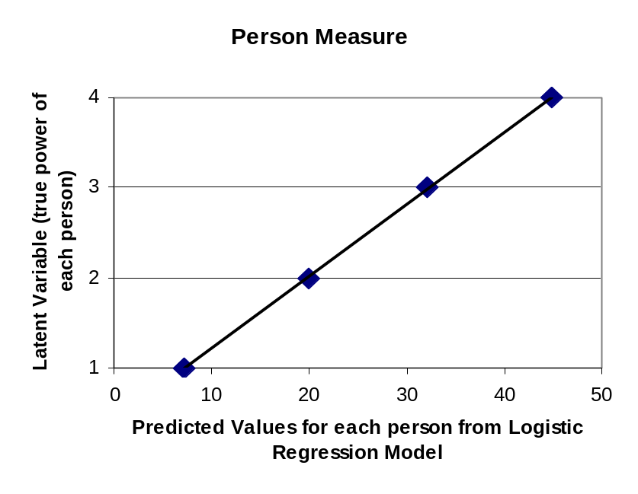
I plotted each weight’s real weight against the predicted logit value obtained from logistic regression model. The predicted logit value represents item easiness (rather than item difficulty) by construction (so to convert this into a conventional concept of item difficulty, multiple the predicted values by -1).
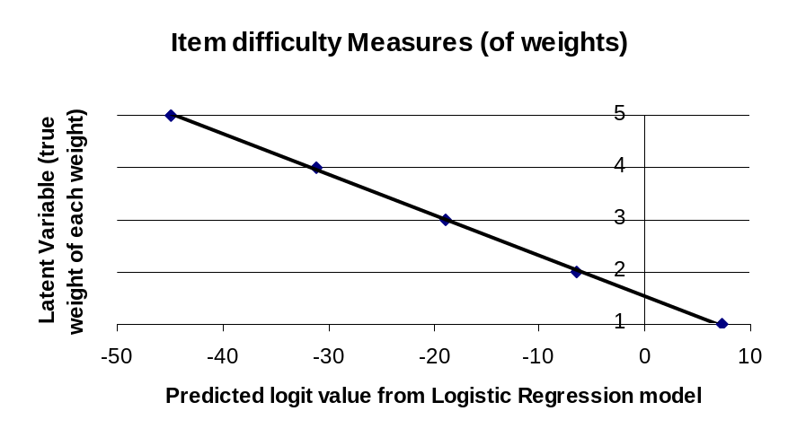
I guess this means that if the data behave perfectly, Rasch model returns a linear measure that really is linear in meaning. But my question is that why is this the case when logit transformation is used. I expected these lines to be more curvy just because we used logit. Maybe it is? Let me know if you are mathematician and can see why I am a bit confused here.

Appendix Doing Rasch model using SAS PROC NLMIXED
data kaz;
input Name $ response weight1 weight2 weight3 weight4 weight5 john1 mary2 david3 arnold4;
cards;
John_power1 1 1 0 0 0 0 1 0 0 0
john_power1 0 0 1 0 0 0 1 0 0 0
john_power1 0 0 0 1 0 0 1 0 0 0
john_power1 0 0 0 0 1 0 1 0 0 0
john_power1 0 0 0 0 0 1 1 0 0 0
mary_power2 1 1 0 0 0 0 0 1 0 0
mary_power2 1 0 1 0 0 0 0 1 0 0
mary_power2 0 0 0 1 0 0 0 1 0 0
mary_power2 0 0 0 0 1 0 0 1 0 0
mary_power2 0 0 0 0 0 1 0 1 0 0
david_power3 1 1 0 0 0 0 0 0 1 0
david_power3 1 0 1 0 0 0 0 0 1 0
david_power3 1 0 0 1 0 0 0 0 1 0
david_power3 0 0 0 0 1 0 0 0 1 0
david_power3 0 0 0 0 0 1 0 0 1 0
arnold_power4 1 1 0 0 0 0 0 0 0 1
arnold_power4 1 0 1 0 0 0 0 0 0 1
arnold_power4 1 0 0 1 0 0 0 0 0 1
arnold_power4 1 0 0 0 1 0 0 0 0 1
arnold_power4 0 0 0 0 0 1 0 0 0 1
;
run;

proc nlmixed data=kaz;
eta=
b1*weight1 +
b2*weight2 +
b3*weight3 +
b4*weight4 +
b5*weight5
+ u;
expeta=exp(eta);
p=expeta/(1+expeta);
model response ~ binary(p);
random u ~ normal(0,s2u) subject=name out=PERSON_MEASURE_FILE;
ods output ParameterEstimates=ITEM_DIFFICULTY_FILE;
run;
proc print data=person_measure_file;run;
proc print data=item_difficulty_file;run;

APPENDIX 3. RUNNING WINSPTEPS (The same data)

I constructed the following control file. I am not sure if 100% if I did the right thing. Seems like my Winsptes is not running well on my XP environment.

; a semi-colon means a comment: remove semi-colons as needed.

&INST

TITLE = "Experimenting with Rasch Model"

;Input Data Format
NAME1 = 1 ; column of start of person information
NAMLEN = 30 ; maximum length of person information
ITEM1 = 15 ; column of first item-level response
NI = 5 ; number of items = test length
XWIDE = 1 ; number of columns per response
PERSON = Person ; Persons are called ...
ITEM = Weight ; Items are called ...

CLFILE = * ; label the categories in Table 3
0 Failed at lifting the weight ; 0 in the data means "Strongly Disagree"
1 Lifted the weight succesfully ; 1 in the data means "Strongly Agree"
*

&END

;Put item labels here for NI= lines
weight1
weight2
weight3
weight4
weight5

END LABELS

;Put data here
John_power1 10000
mary_power2 11000
david_power3 11100
arnold_power4 11110

