Rasch model
The reason why it is impossible to understand and how it still is possible to understand
11/16/2006
Kaz Uekawa

The reason why it is hard to have an aha moment with Rasch model is because many of us don’t understand the meaning of this graphic.

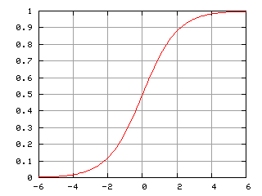
Acknowledgement: Borrowed from http://en.wikipedia.org/wiki/Logistic_function

You see this graph immediately after you are shown this equation:

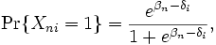
http://en.wikipedia.org/wiki/Rasch_model

We kind of understand the equation and the graphic separately. But it isn’t clear to many of us how the two are related. This is because the graphic is about two variables, say Y (probability) and X (logit). But the equation seems to carry more than two terms. I see at least three in the equation, P, beta, and gamma.

The case of OLS regression
First, let’s think about why many of us have no problem seeing the connection between an OLS regression and the graphic. Let’s take a look at them. A typical OLS regression equation looks like this:

Y= intercept + beta*X + error
Say, Y is like a test score and X is the amount of time you studied prior to taking a test. And look at a graphic that captures the relationship between Y and X. In Excel, I’d type up this sort of table:
Time spent | Test Score
7 | 75
8 | 90
6 | 60
4 | 40
2 | 30
3 | 20

And using a graphic wizard, I’d create this type of chart. I even printed an regression equation on the graph. It is very clear to us how the equation is related to the regression line. The intercept -1.8571 means the location at which the line crosses Y, as we learned in algebra class. 11.971 is the slope of the line. One unit increase in time spent translates into 11.87 increases in test scores, that is. We feel, “Oh, I see."
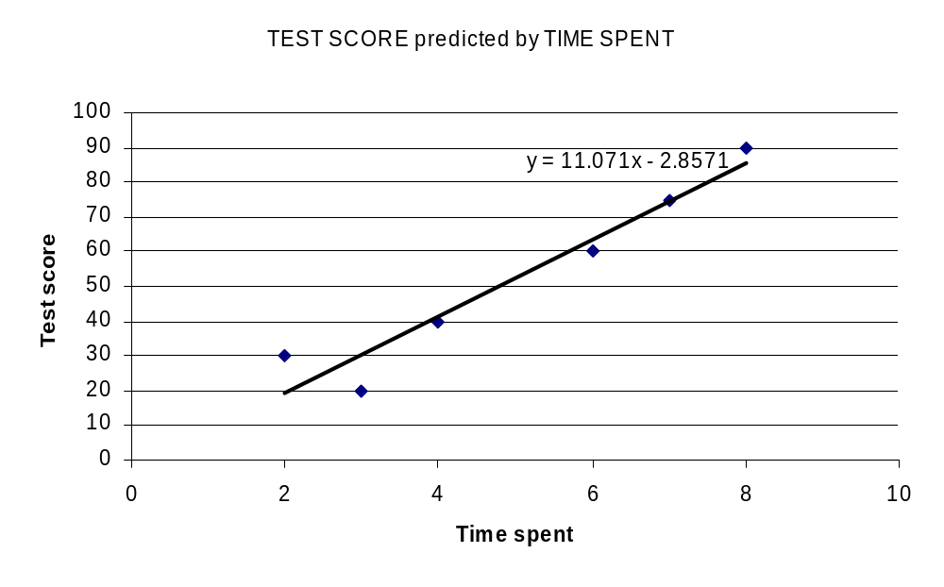

Now Rasch
Let’s take a look at them again. The equation is:

We can simplify this by rewriting it in this way:

LOG(P/1-P)=person measure – item difficulty

The complicated one had P as an outcome. Now we have LOG(P/1-P) as an outcome, so the right side is simple. Either way, they are telling the same story. We predict “chance” of an individual trying to solve a test problem. In one version, we expressed chance by using P. With this, the e thing enters twice, which makes the whole equation complicated. In the other version we use LOG(P/1-P), and the left side looks simple. Chance, expressed in terms of logit, is predicted by the difference between person measure and item difficulty.

Let’s look at the graph again.

So what is Y=axis and what is X-axis? Y is P (probability ranging from 0 to 1). What is X? Actually X is the answer for (person ability – item difficulty). The confusion might have come because you might have thought that Y is either person ability or item difficulty. Actually it is the answer for the subtraction, person ability – item difficulty.

Here is another source of confusion. For OLS regression, it was clear that we are talking about individuals. The units of analysis are individuals. The dots that appear in the OLS graphics are people. (Again, people are the units of analysis that the equation is trying to explain.)

For Rasch model equation, the units of analysis is MOMENTS. It is the MOMENTS when a person (with a certain ability level) meets an item (with a certain difficulty level). So the equation (log(P/1-P)=person ability – item difficulty) is trying to explain this moment, rather than individuals.

So recall Rasch model produces two types of measures. If you use WINSTEPS as a software you get two text files, person measure file and item difficulty file.

This is how an item difficulty file looks like. The highlighted column is item difficulty measure.
; TAP KNOX CUBE TEST Nov 16 15:49 2006
;ENTRY MEASURE STTS COUNT SCORE ERROR IN.MSQ IN.ZSTD OUT.MS OUT.ZSTD DISPL PTME WEIGHT OBSMA EXPMA DISCR G M NAME
4 -4.40 1 34.0 32.0 .81 .90 -.03 .35 -.16 -.03 .55 1.00 94.1 94.0 1.09 1 R 1-3-4
5 -3.83 1 34.0 31.0 .70 1.04 .24 .52 .06 -.02 .55 1.00 88.2 91.7 1.01 1 R 2-1-4
6 -3.38 1 34.0 30.0 .64 1.17 .55 .96 .38 -.02 .53 1.00 91.2 90.0 .87 1 R 3-4-1
7 -3.83 1 34.0 31.0 .70 1.33 .86 2.21 1.11 -.02 .40 1.00 94.1 91.7 .54 1 R 1-4-3-2
8 -2.35 1 34.0 27.0 .54 .59 -1.35 .43 -.41 -.01 .72 1.00 94.1 86.5 1.36 1 R 1-4-2-3
9 -3.38 1 34.0 30.0 .64 .62 -1.04 .21 -.56 -.02 .68 1.00 91.2 90.0 1.34 1 R 1-3-2-4
10 -1.57 1 34.0 24.0 .48 1.06 .32 .83 .03 .00 .61 1.00 79.4 83.0 .97 1 R 2-4-3-1
11 .79 1 34.0 12.0 .45 1.07 .40 .79 -.12 .01 .55 1.00 76.5 79.1 .96 1 R 1-3-1-2-4
12 2.24 1 34.0 6.0 .55 1.16 .58 1.06 .43 .02 .42 1.00 85.3 86.7 .83 1 R 1-3-2-4-3
13 1.95 1 34.0 7.0 .52 .70 -1.04 .38 -.44 .02 .60 1.00 88.2 84.6 1.35 1 R 1-4-3-2-4
14 3.37 1 34.0 3.0 .70 1.56 1.23 1.49 .76 .03 .22 1.00 85.3 92.0 .62 1 R 1-4-2-3-4-1
15 4.80 1 34.0 1.0 1.07 .74 -.09 .11 -.63 .04 .32 1.00 97.1 97.0 1.18 1 R 1-3-2-4-1-3
16 4.80 1 34.0 1.0 1.07 .74 -.09 .11 -.63 .04 .32 1.00 97.1 97.0 1.18 1 R 1-4-2-3-1-4
17 4.80 1 34.0 1.0 1.07 .74 -.09 .11 -.63 .04 .32 1.00 97.1 97.0 1.18 1 R 1-4-3-1-2-4

This is how a person measure file looks like. The highlighted column is for person measures.

; KID KNOX CUBE TEST Nov 16 15:49 2006
;ENTRY MEASURE STTS COUNT SCORE ERROR IN.MSQ IN.ZSTD OUT.MS OUT.ZSTD DISPL PTME WEIGHT OBSMA EXPMA NAME
1 -2.94 1 14.0 4.0 .82 .61 -1.19 .29 -.24 -.03 .80 1.00 92.9 84.6 Richard M
2 -.26 1 14.0 7.0 1.11 .18 -1.33 .08 -.73 .00 .92 1.00 100.0 93.2 Tracie F
3 -.26 1 14.0 7.0 1.11 1.94 1.18 1.19 .60 .00 .82 1.00 85.7 93.2 Walter M
4 -3.61 1 14.0 3.0 .82 .78 -.74 .36 -.15 -.03 .74 1.00 85.7 82.5 Blaise M
5 -.26 1 14.0 7.0 1.11 .18 -1.33 .08 -.73 .00 .92 1.00 100.0 93.2 Ron M
6 -.26 1 14.0 7.0 1.11 .18 -1.33 .08 -.73 .00 .92 1.00 100.0 93.2 William M
7 3.73 1 14.0 11.0 .94 .95 .07 .39 -.10 .04 .69 1.00 85.7 88.8 Susan F
8 -.26 1 14.0 7.0 1.11 .18 -1.33 .08 -.73 .00 .92 1.00 100.0 93.2 Linda F
9 -.26 1 14.0 7.0 1.11 .18 -1.33 .08 -.73 .00 .92 1.00 100.0 93.2 Kim F
10 .92 1 14.0 8.0 1.06 .39 -1.04 .13 -.57 .01 .89 1.00 100.0 91.1 Carol F
11 -2.23 1 14.0 5.0 .88 1.02 .21 .81 .33 -.02 .80 1.00 92.9 87.1 Pete M
12 -2.23 1 14.0 5.0 .88 1.10 .37 .51 .04 -.02 .81 1.00 78.6 87.1 Brenda F
13 -.26 1 14.0 7.0 1.11 4.12 2.49 5.28 2.05 .00 .65 1.00 71.4 93.2 Mike M
14 .92 1 14.0 8.0 1.06 .39 -1.04 .13 -.57 .01 .89 1.00 100.0 91.1 Zula F
15 2.85 1 14.0 10.0 .95 .36 -1.48 .15 -.52 .03 .81 1.00 100.0 89.1 Frank M
16 -.26 1 14.0 7.0 1.11 1.49 .79 .51 .04 .00 .85 1.00 85.7 93.2 Dorothy F
17 -1.37 1 14.0 6.0 1.00 1.16 .45 .97 .45 -.02 .83 1.00 92.9 90.4 Rod M
18 .92 1 14.0 8.0 1.06 .99 .19 .32 -.20 .01 .86 1.00 85.7 91.1 Britton F
19 -1.37 1 14.0 6.0 1.00 .43 -.92 .16 -.49 -.02 .89 1.00 92.9 90.4 Janet F
20 .92 1 14.0 8.0 1.06 .99 .19 .32 -.20 .01 .86 1.00 85.7 91.1 David M
21 1.94 1 14.0 9.0 .98 .52 -.98 .18 -.45 .02 .85 1.00 92.9 88.7 Thomas M
22 1.94 1 14.0 9.0 .98 .65 -.60 .22 -.36 .02 .84 1.00 92.9 88.7 Betty F
23 1.94 1 14.0 9.0 .98 1.60 1.16 .67 .20 .02 .78 1.00 78.6 88.7 Bert M
24 3.73 1 14.0 11.0 .94 1.94 1.67 .88 .38 .04 .61 1.00 71.4 88.8 Rick M
25 -4.32 1 14.0 2.0 .88 1.09 .36 .46 -.01 -.03 .67 1.00 78.6 85.7 Don M
26 -.26 1 14.0 7.0 1.11 .18 -1.33 .08 -.73 .00 .92 1.00 100.0 93.2 Barbara F
27 -2.94 1 14.0 4.0 .82 .61 -1.19 .29 -.24 -.03 .80 1.00 92.9 84.6 Adam M
28 -.26 1 14.0 7.0 1.11 1.49 .79 .51 .04 .00 .85 1.00 85.7 93.2 Audrey F
29 -.26 1 14.0 7.0 1.11 4.08 2.47 6.07 2.23 .00 .65 1.00 71.4 93.2 Anne F
30 -1.37 1 14.0 6.0 1.00 .43 -.92 .16 -.49 -.02 .89 1.00 92.9 90.4 Lisa F
31 -.26 1 14.0 7.0 1.11 .18 -1.33 .08 -.73 .00 .92 1.00 100.0 93.2 James M
32 .92 1 14.0 8.0 1.06 .39 -1.04 .13 -.57 .01 .89 1.00 100.0 91.1 Joe M
33 -3.61 1 14.0 3.0 .82 1.22 .83 .86 .37 -.03 .69 1.00 85.7 82.5 Martha F
34 1.94 1 14.0 9.0 .98 1.74 1.35 .71 .24 .02 .77 1.00 78.6 88.7 Elsie F

To appreciate the equation as well as the graph, you pick a person from the person measure file and you pick an item from an item difficulty file. Imagine, John’s ability measure (expressed in logit) is 2.3. Imagine, an item A’s item difficulty is 1.2. What is John’s getting this item correctly???? Let’s use the equation.

LOG(P/1-P)= 2.3 – 1.2.
If you do this subtraction, the answer is 1.1. Remember this is a logit. SO let’s look at the graph. Remember, X axis is for LOGIT and Y is for Probability.

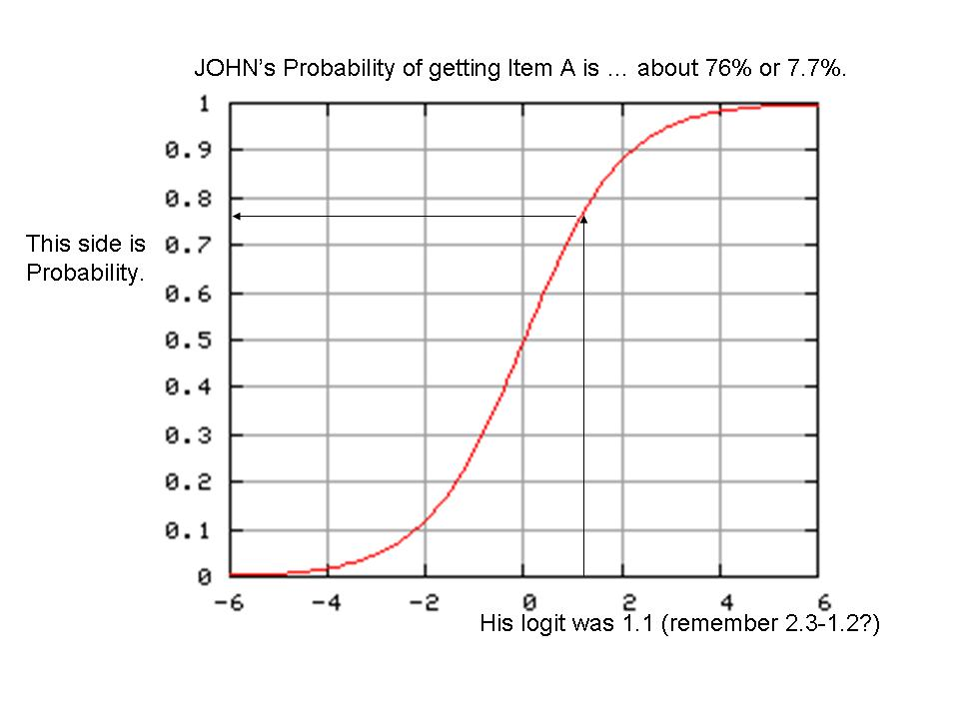

So that is how Rasch equation is related to the graphic of logistic curve. You can confirm your understanding by picking one person from the person file and one item from an item file. For example, a guy Richard’s logit score is -2.94. How would he perform on the items???? Let’s look at the item file again. Richard wont do well with this test, I think. The items highlighted in green, I think Richard will get correct responses. But not with the items in yellow. Do you see why I say so???

; TAP KNOX CUBE TEST Nov 16 15:49 2006
;ENTRY MEASURE STTS COUNT SCORE ERROR IN.MSQ IN.ZSTD OUT.MS OUT.ZSTD DISPL PTME WEIGHT OBSMA EXPMA DISCR G M NAME
4 -4.40 1 34.0 32.0 .81 .90 -.03 .35 -.16 -.03 .55 1.00 94.1 94.0 1.09 1 R 1-3-4
5 -3.83 1 34.0 31.0 .70 1.04 .24 .52 .06 -.02 .55 1.00 88.2 91.7 1.01 1 R 2-1-4
6 -3.38 1 34.0 30.0 .64 1.17 .55 .96 .38 -.02 .53 1.00 91.2 90.0 .87 1 R 3-4-1
7 -3.83 1 34.0 31.0 .70 1.33 .86 2.21 1.11 -.02 .40 1.00 94.1 91.7 .54 1 R 1-4-3-2
8 -2.35 1 34.0 27.0 .54 .59 -1.35 .43 -.41 -.01 .72 1.00 94.1 86.5 1.36 1 R 1-4-2-3
9 -3.38 1 34.0 30.0 .64 .62 -1.04 .21 -.56 -.02 .68 1.00 91.2 90.0 1.34 1 R 1-3-2-4
10 -1.57 1 34.0 24.0 .48 1.06 .32 .83 .03 .00 .61 1.00 79.4 83.0 .97 1 R 2-4-3-1
11 .79 1 34.0 12.0 .45 1.07 .40 .79 -.12 .01 .55 1.00 76.5 79.1 .96 1 R 1-3-1-2-4
12 2.24 1 34.0 6.0 .55 1.16 .58 1.06 .43 .02 .42 1.00 85.3 86.7 .83 1 R 1-3-2-4-3
13 1.95 1 34.0 7.0 .52 .70 -1.04 .38 -.44 .02 .60 1.00 88.2 84.6 1.35 1 R 1-4-3-2-4
14 3.37 1 34.0 3.0 .70 1.56 1.23 1.49 .76 .03 .22 1.00 85.3 92.0 .62 1 R 1-4-2-3-4-1
15 4.80 1 34.0 1.0 1.07 .74 -.09 .11 -.63 .04 .32 1.00 97.1 97.0 1.18 1 R 1-3-2-4-1-3
16 4.80 1 34.0 1.0 1.07 .74 -.09 .11 -.63 .04 .32 1.00 97.1 97.0 1.18 1 R 1-4-2-3-1-4
17 4.80 1 34.0 1.0 1.07 .74 -.09 .11 -.63 .04 .32 1.00 97.1 97.0 1.18 1 R 1-4-3-1-2-4

