USER INTERFACE DESIGN

EXP.NO:7

REG.NO:230701258 DATE:30.04.2025

**AIM :** The aim is to trial different app layouts and color schemes and evaluate user feedback on aesthetics and usability using GIMP.

* **Base Layout:**

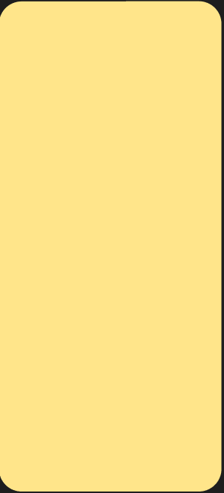

* **Added UI Elements:**

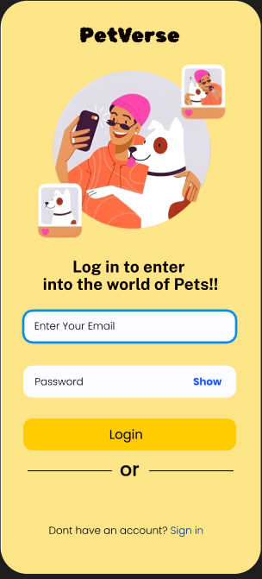

* **Organised Layers:**

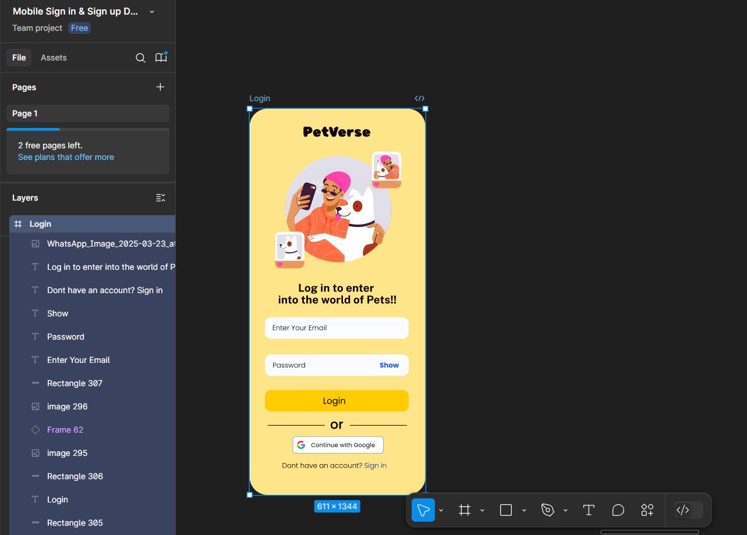

* **Experiment with Color Schemes:**

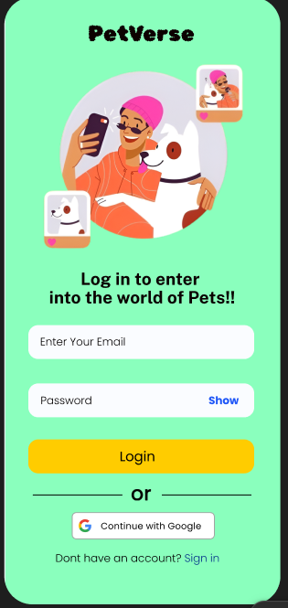

* **Collected User Feedback**

**Google Form Feedback Analysis: Yellow vs Green Variant**

**1. Which layout do you prefer?**

* 🟡 **Yellow Variant**: 60%
* 🟢 **Green Variant**: 40%

🔎 **Interpretation**: Most users preferred the Yellow layout, indicating it may be more visually appealing or better structured.

**2. Which color scheme feels most professional?**

* 🟡 **Yellow Variant**: 65%
* 🟢 **Green Variant**: 35%

🔎 **Interpretation**: The Yellow color scheme is seen as more professional, potentially due to its brightness or better contrast.

**3. How easy was it to find buttons and inputs?**

* 🟡 **Yellow Variant**: 90%
* 🟢 **Green Variant**: 10%

🔎 **Interpretation**: Navigation and usability are clearly better in the Yellow variant, with a very high ease-of-use score.

**4. Which layout would you recommend to others?**

* 🟡 **Yellow Variant**: 55%
* 🟢 **Green Variant**: 45%

🔎 **Interpretation**: While Yellow still leads, this is the closest category, suggesting Green also has its merits worth exploring.

**📈 Visual Representation**

As shown in the graph above, Yellow dominates across all feedback categories, especially in **usability** and **professional appearance**. Green, while liked by some, consistently ranks lower.

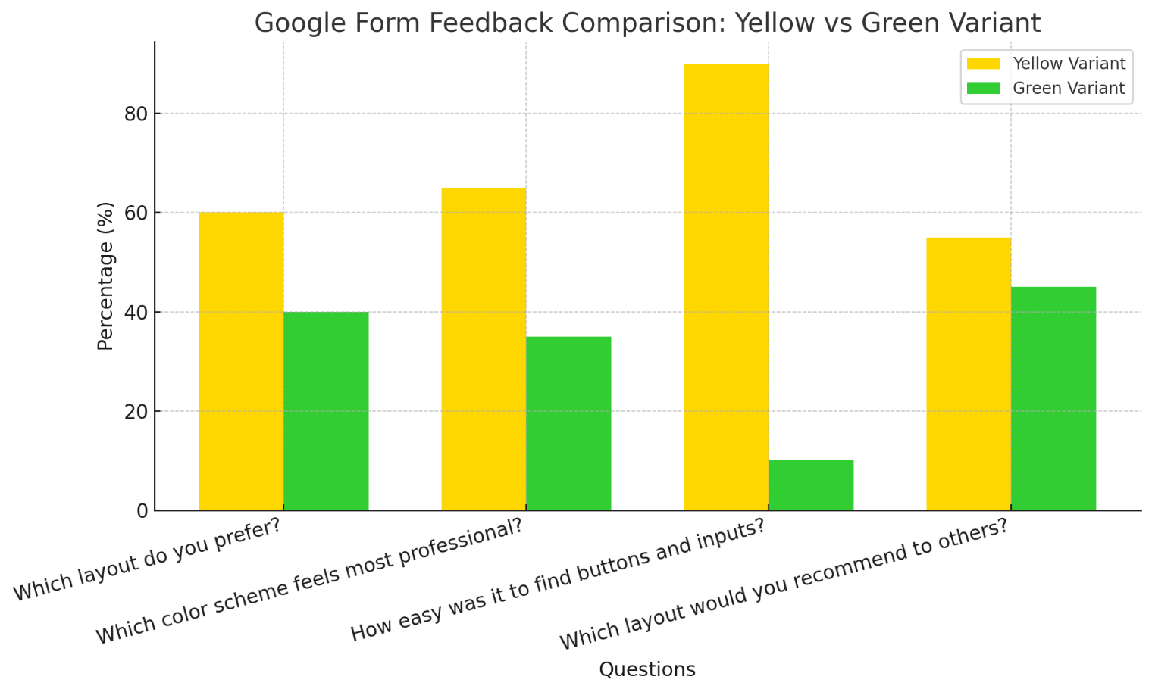

**One suggestion:**

It would be even better and more convenient if there were additional login options like Google and Apple ID login buttons it would make signing in faster and easier for users.

* **Iterate and Refine:**

