**LAB 1**

**Exercise #1: Raw Data**

Student name: Ram Yadav **DIS: 1D**

**Part A Table 1. TCP and UDP Throughput vs. Signal Strength**

|  |  |  |  |  |  |  |  |
| --- | --- | --- | --- | --- | --- | --- | --- |
| Location | Approx. Distance From Access Point(feet) | Signal Strength (From PC)  (dBm) | Noise Power (From PC)  (dBm) | SNR (dB) | UDP Data Rate (Kbps) | TCP Data Rate (Kbps) | Observations (record anything that seems interesting or peculiar e.g. datagram loss) |
| 1. Wall across 3704 Entry | (15ft+15ft)  **30ft** | -53 | -83 | 50 | 155 | 15000 | ___ |
| 1. Next to 3428 Suite Main Entry | (45ft+15ft)  **60ft** | -58 | -82 | 24 | 86.7 | 8680 | **__** |
| 1. Next to 3424 Entry | (75ft+15ft)  **90ft** | -77 | -87 | 10 | 19.9 | 1670 | **__** |

**Part B Table 2. Noise and Throughput in presence of Microwave Oven**

|  |  |  |  |  |  |  |
| --- | --- | --- | --- | --- | --- | --- |
| Microwave Oven Level | Signal Strength (From PC)  (dBm) | Noise Power (From PC)  (dBm) | UDP Data Rate  (Kbps) | TCP Data Rate  (Kbps) | Spectrum Analyzer Display Observation  (Set Start freq. to 2.36 GHz, and Stop freq. to 2.5 GHz) | Other Observation e.g. datagram loss |
| Off | -31 | -80 | 70.9 | 11200 |  |  |
| High | -31 | -83 | 95.3 | 16400 |  |  |
| Medium High | -31 | -80 | 90.9 | 20800 |  |  |
| Medium | -31 | -80 | 73.6 | 12600 |  |  |
| Defrost | -27 | -80 | 57.3 | 11600 |  |  |
| Warm | -28 | -81 | 56.5 | 12800 |  |  |

Approx. Distance from AP(feet): ­ 6

**Microwave power level: 0=off; 1=Warm; 2=Deforest; 3=Medium; 4=Medium high; 5=High.**

**Diagrams**

Graphs from Table 1. Distance vs. signal Strength

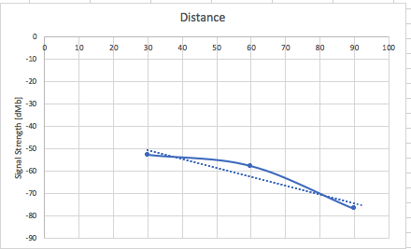

Graphs from Table 1. Distance vs. signal to noise ratio

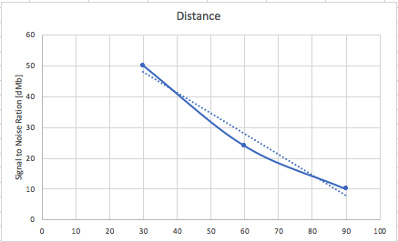

Graphs from Table 1. UDP Throughput vs signal to noise ration

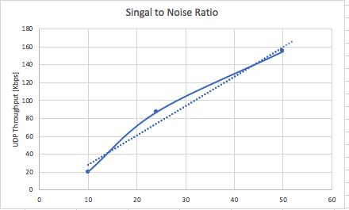

Graph from RDS Table 1. TCP Throughput vs signal to noise ratio

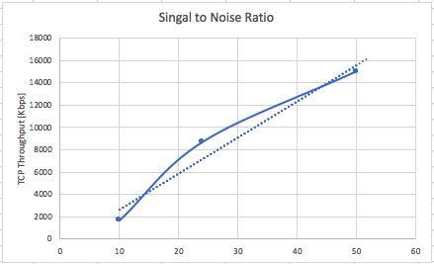

Graph from RDS Table 2. Throughput vs Microwave Power Level

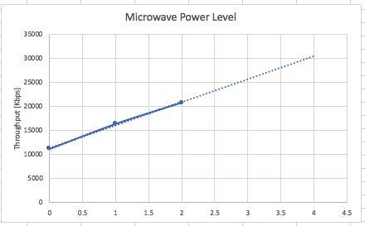

**Microwave power level: 0=off; 1=Warm; 2=Deforest; 3=Medium; 4=Medium high; 5=High.**