*BREAKOUT!*

**Python project**

**Team:** *try: Project raise #NoExceptions*

**Members:-**

* IMT2017012 – *Sai Venkatesh*
* IMT2017521 – *Ram S.*
* IMT2017013 – *Deep Inder Mohan*

**BREAKOUT:** *A Brief History*

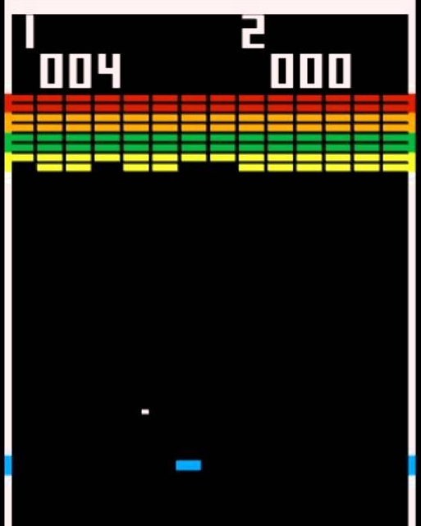

Breakout was a game developed by Atari, Inc. and was released on May 13, 1976. Inspired by Atari Pong *(1972),* the game was built by Steve Wozniak and Steve Jobs. It later became an inspiration for many elements of their Apple 2 personal computer.

*The original Atari Breakout*

**BREAKOUT:** *Our Rendition*

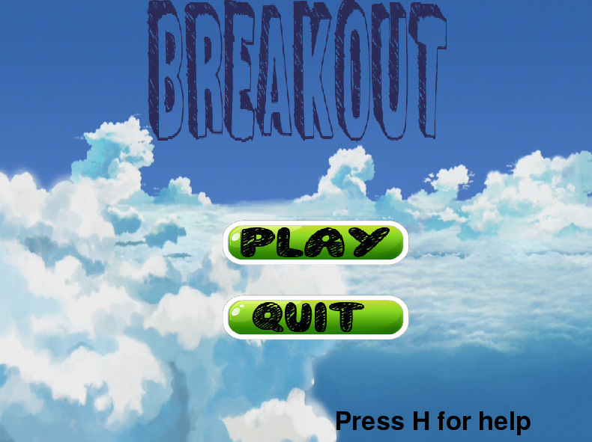We have created a version of breakout using the ***pygame*** set of modules in python. With updated graphics and sounds, the following are the main elements in our game:-

* 2 levels
* 2 game modes (normal and warp)
* 3 difficulty settings (easy, medium and hard)
* Pause menu

We will explain some of our code, and also how we managed to create some of the game elements:-

**STEP 1: Loading up the resources**.

We created a file called ‘loading.py’ in which we put all the commands that load the various game resources, like images (background, ball, bricks) music and sfx.

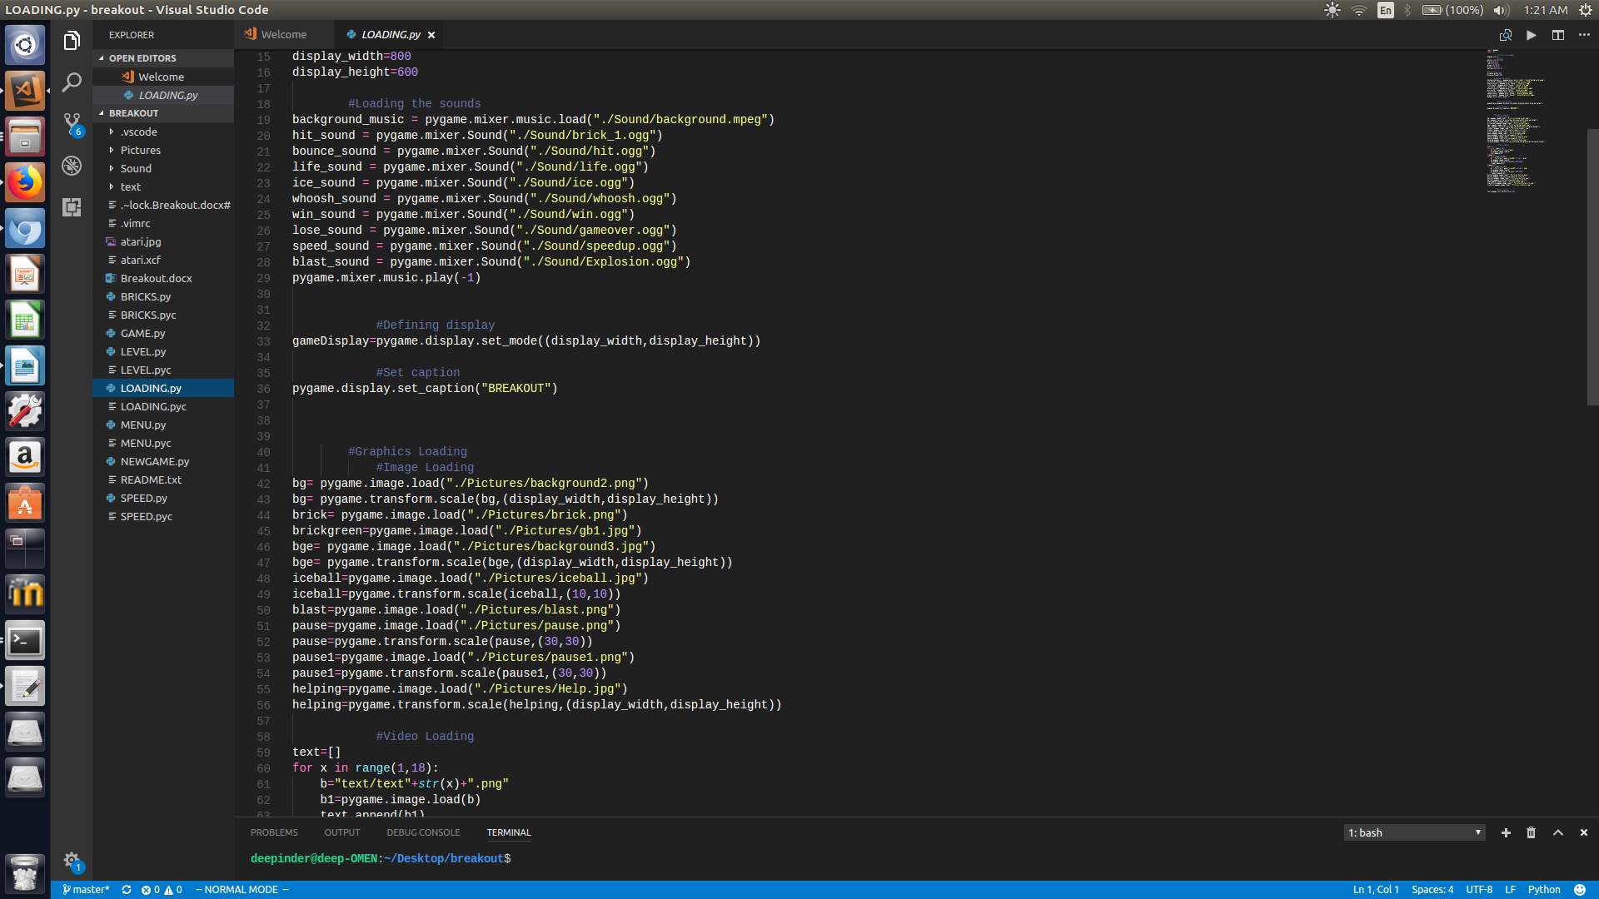

**STEP 2: Making the GUI menu.**

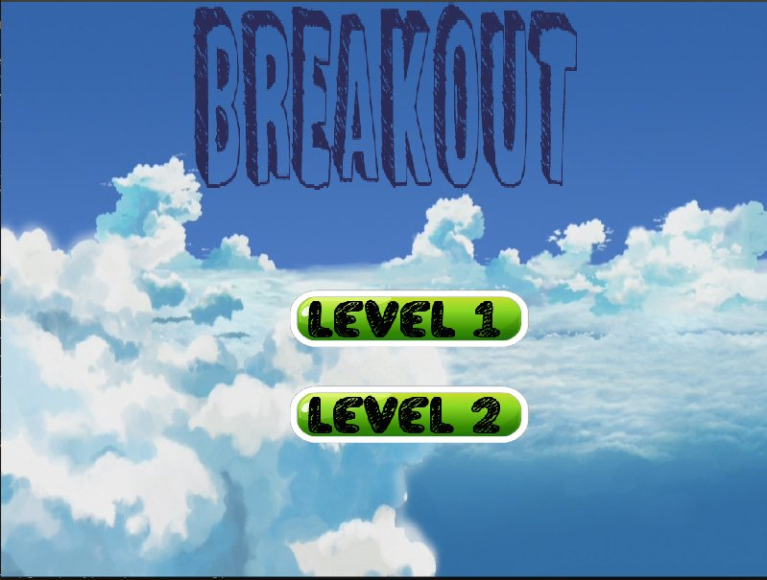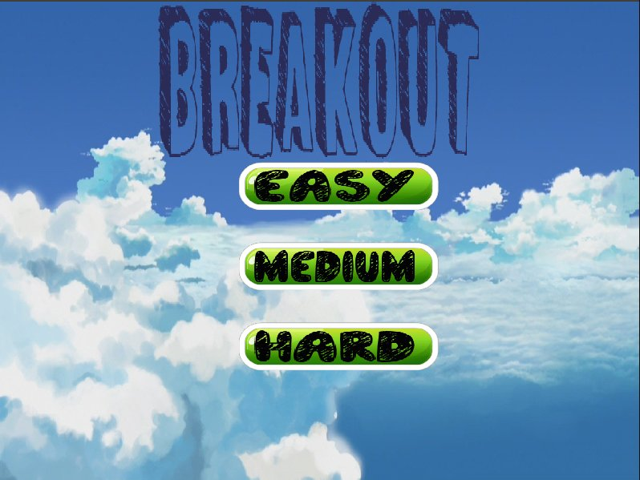

In the file menu.py, we implemented each menu page as a seperate function that gets called in the game loop. The menu can be navigated using a mouse. We also implemented a pause function that temporarily pauses the game and can be activated anytime during gameplay by pressing the spacebar. There are a lot of nifty things in our menu, like the fact that the buttons glow when the mouse hovers over them, and also the demo video for each game mode on the modeselect screen.

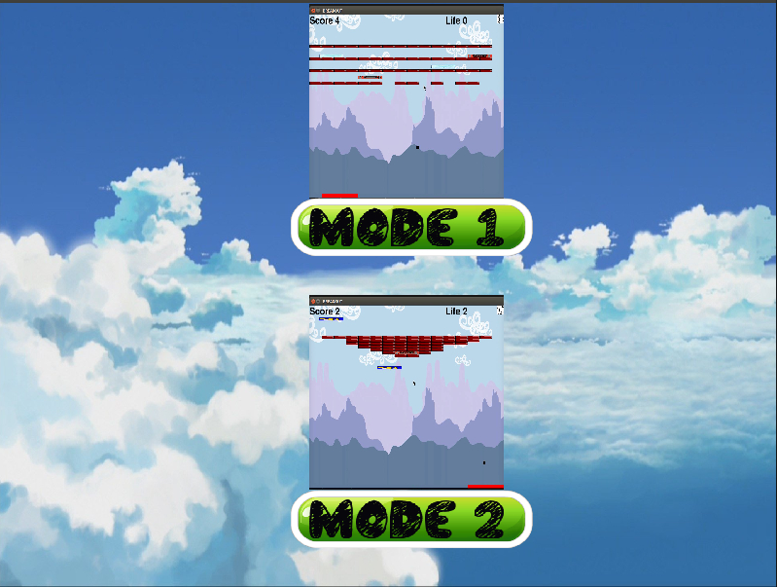

Another distinctive feature of our game is the fact that we offer two game modes. In mode 1, the walls are warped, whereas in mode 2, they reflect. This way, we are able to create an entirely new experience for the user, without actually making any major changes to our primary framework.

**STEP 3: Making the bricks.**

We made five functions, namely *block, timeblock, fastblock, ExplodingBlock1 and ExplodingBlock2,* whicg generate the normal bricks and special bricks as follows:-

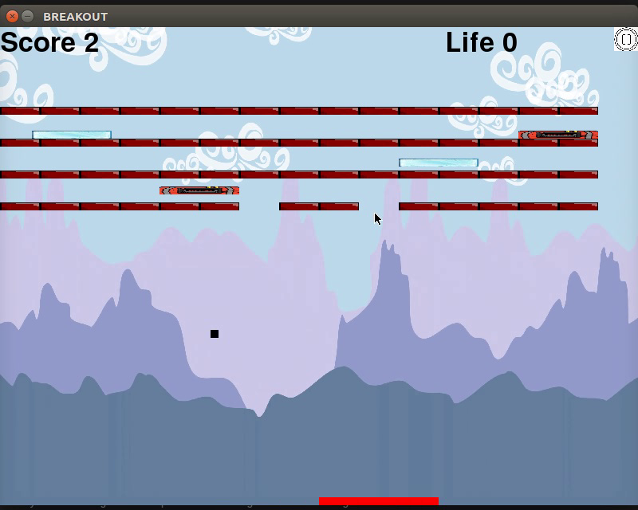

* ***block:*** Generates the normal red blocks, that just do simple reflections, and are destroyed on impact of the ball.
* ***timeblock:*** Generates the white coloured ice blocks, that slow down the ball’s speed dramatically.

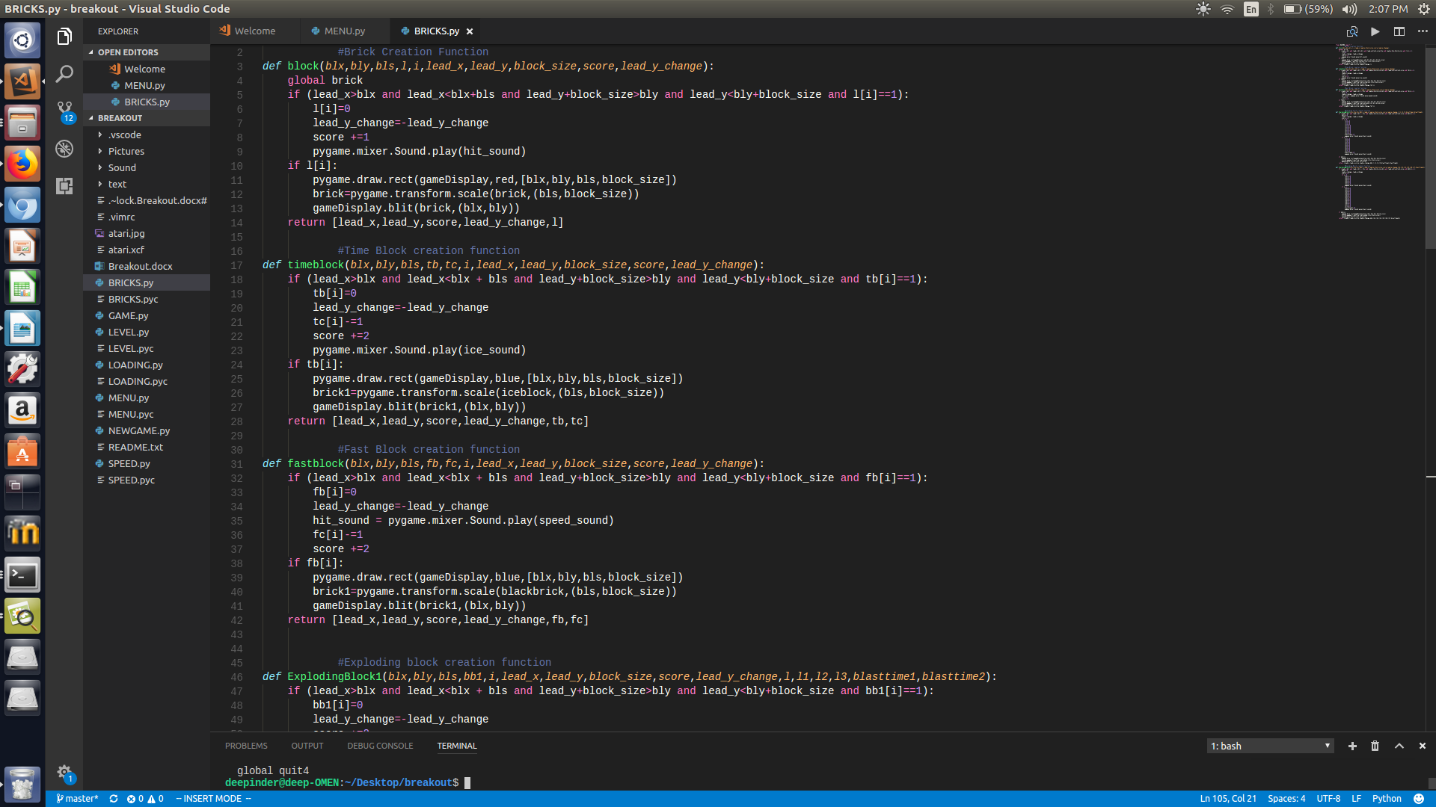

* ***fastblock:*** generates lightning bolt shaped blocks (found in level 2) that speed up the ball considerably.
* ***ExplodingBlock1 & ExplodingBlock2:*** The exploding blocks from level 1 and level 2 that destroy the blocks around them.

We also implemented another file ‘speed.py’ that is able to control the speed of our ball during the time when the fastblock and timeblock powerups are running.

**STEP 4: Designing the levels.**

Level design was implemented in the file ‘level.py’. We created two levels in our game.

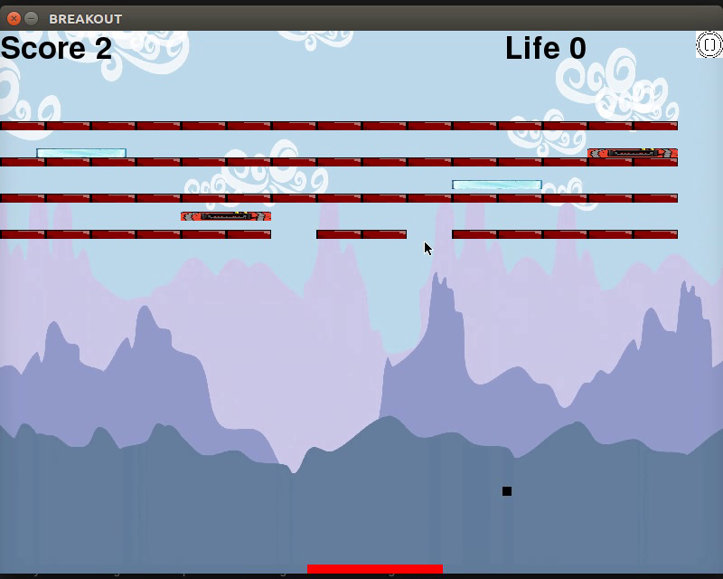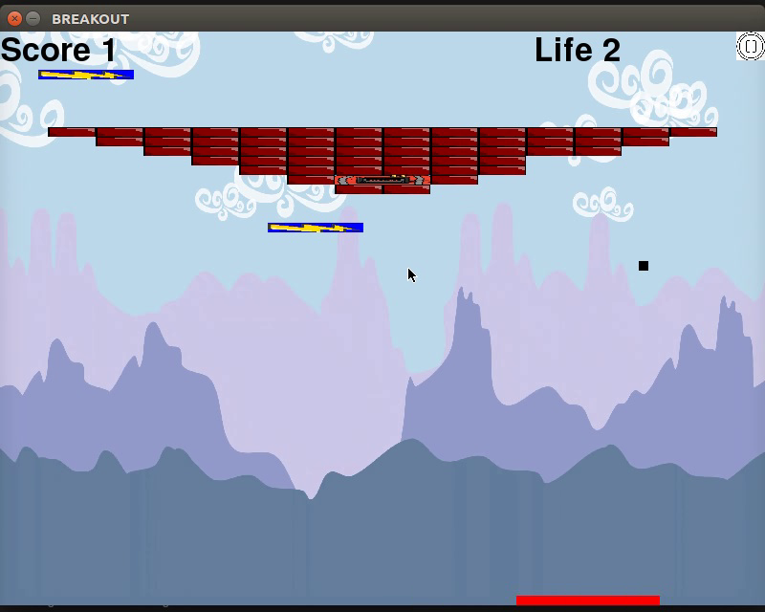

Level 1

Level 2

Levels is the file that binds together all the smaller files like bricks, speed, etc. and draws the screen. There are seperate functions that are used to draw each of the two levels, which call upon the different brick functions which we defined in the bricks file.

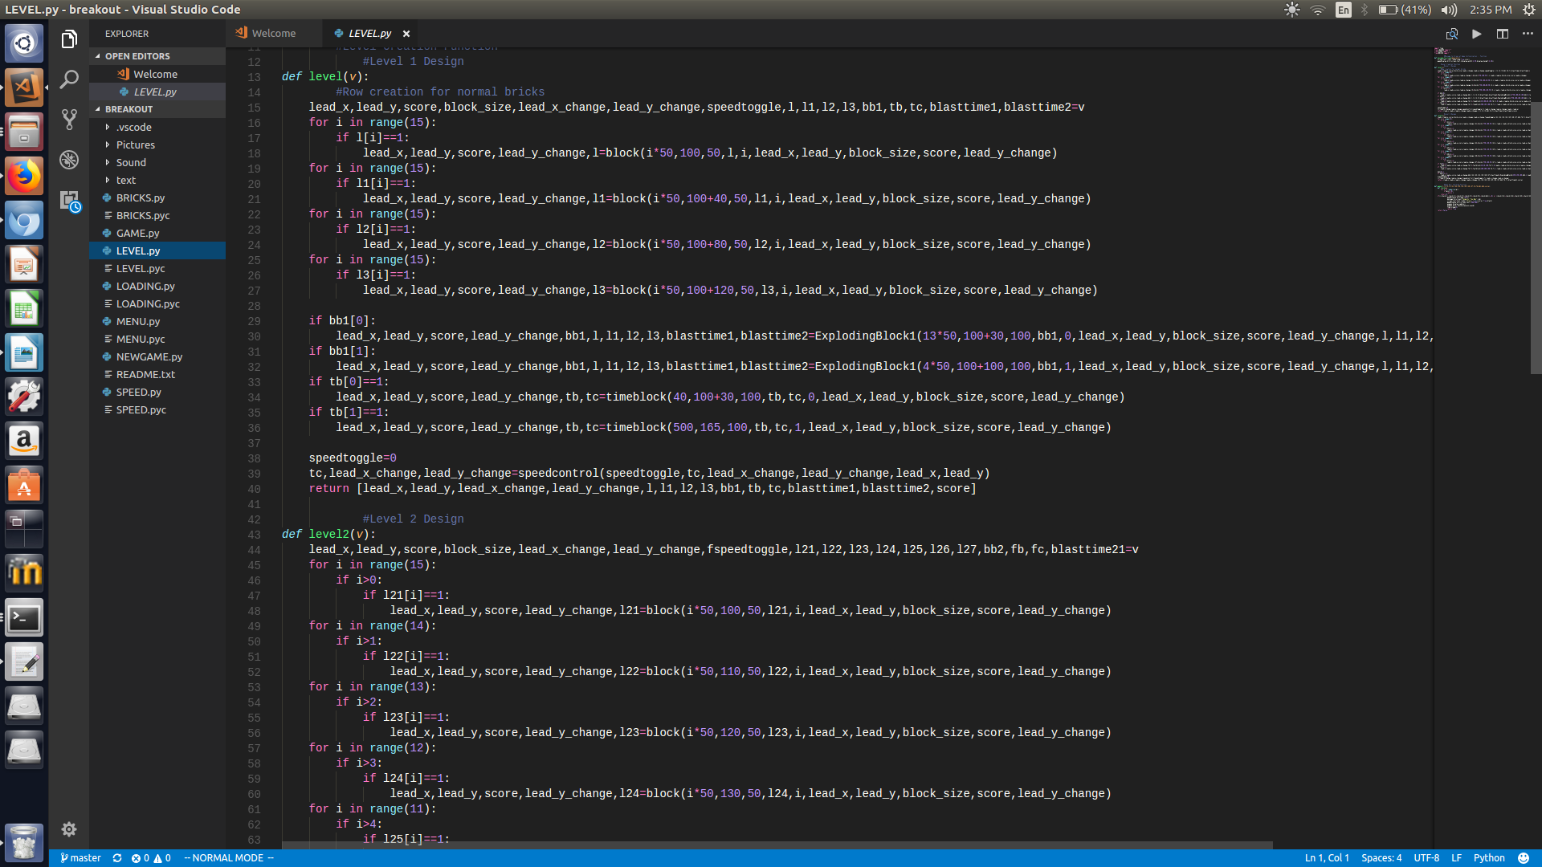

**FINAL STEP: Bringing it all together.**

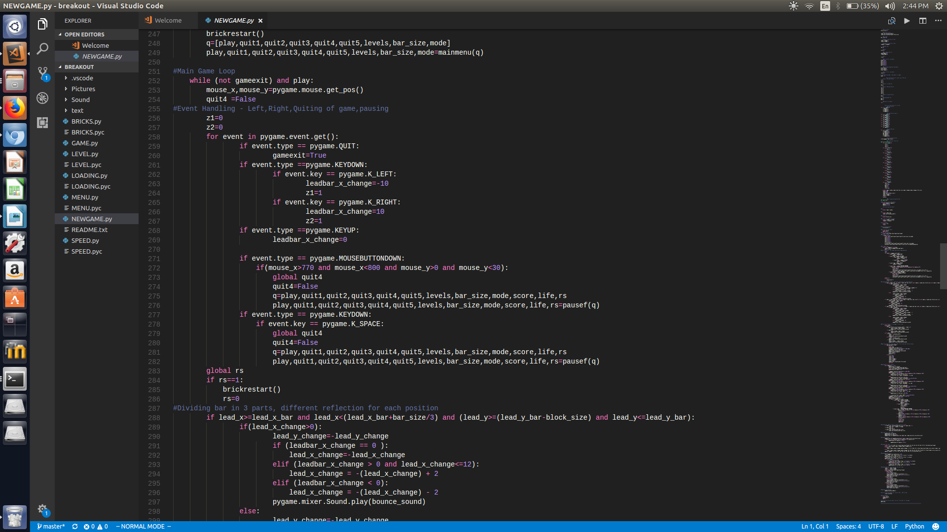The final file (named BREAKOUT.py) contains the main game loop, takes user inputs, deals with updation and handles the physics and logic of the game, with the help of all the smaller files behind it.

The game runs at 60 frames per second.