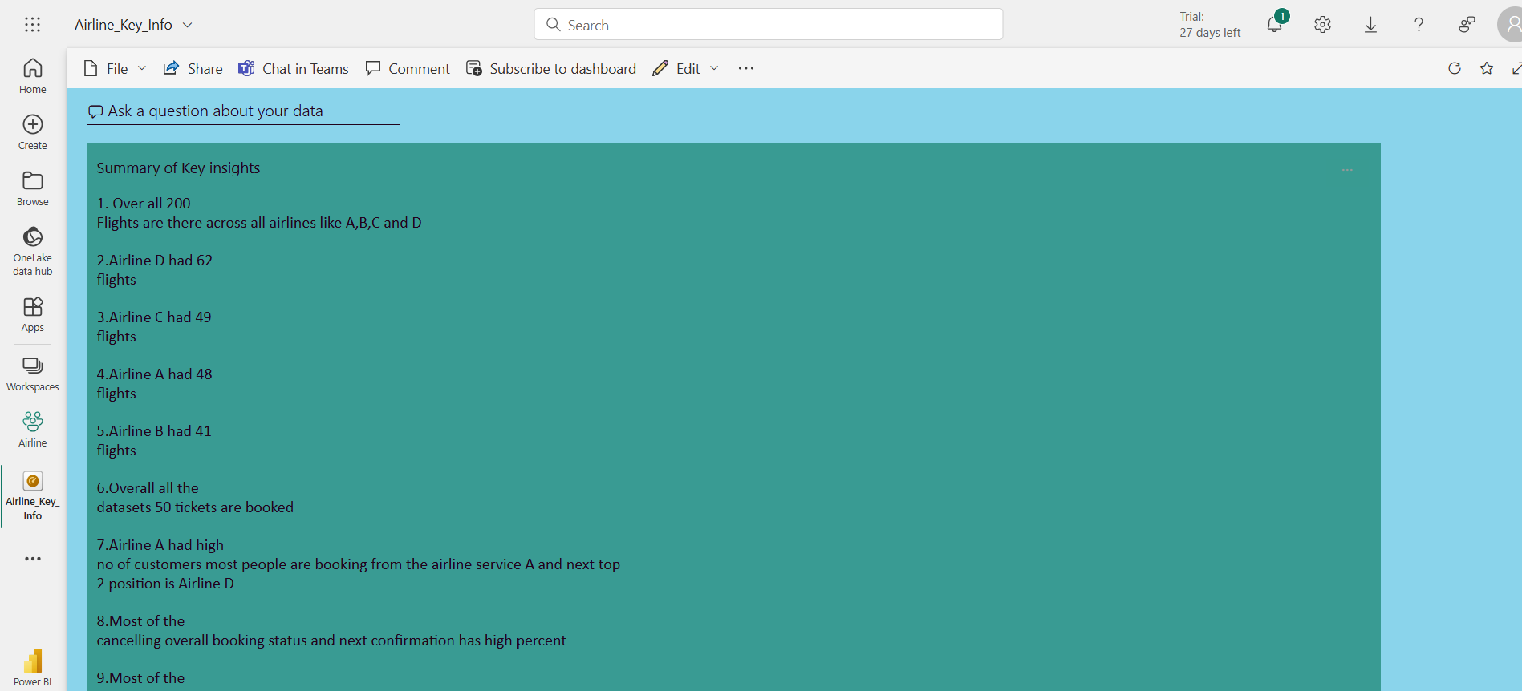

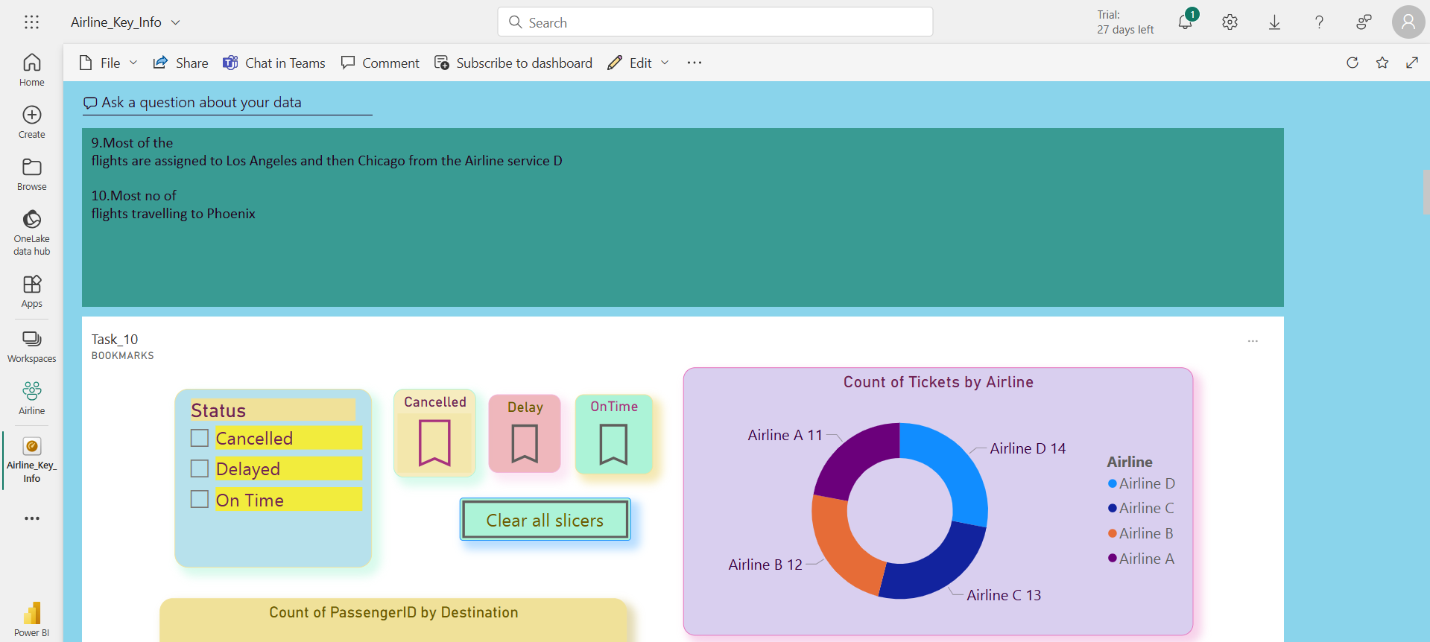

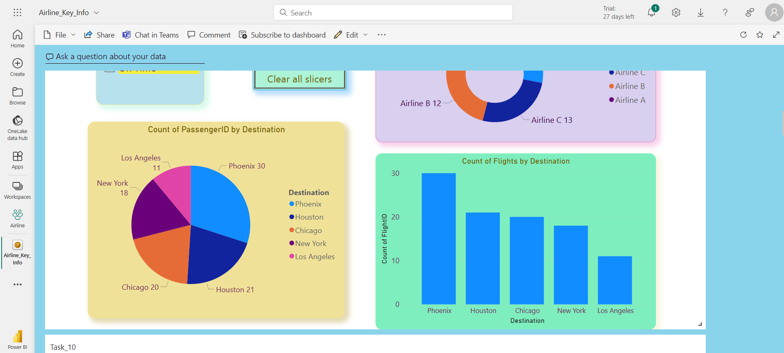

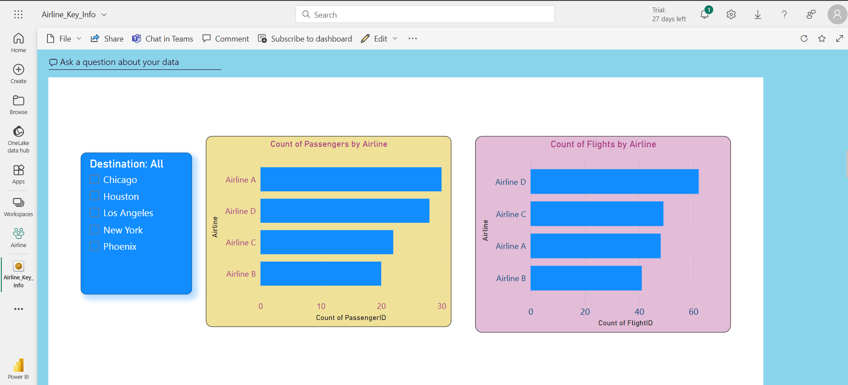

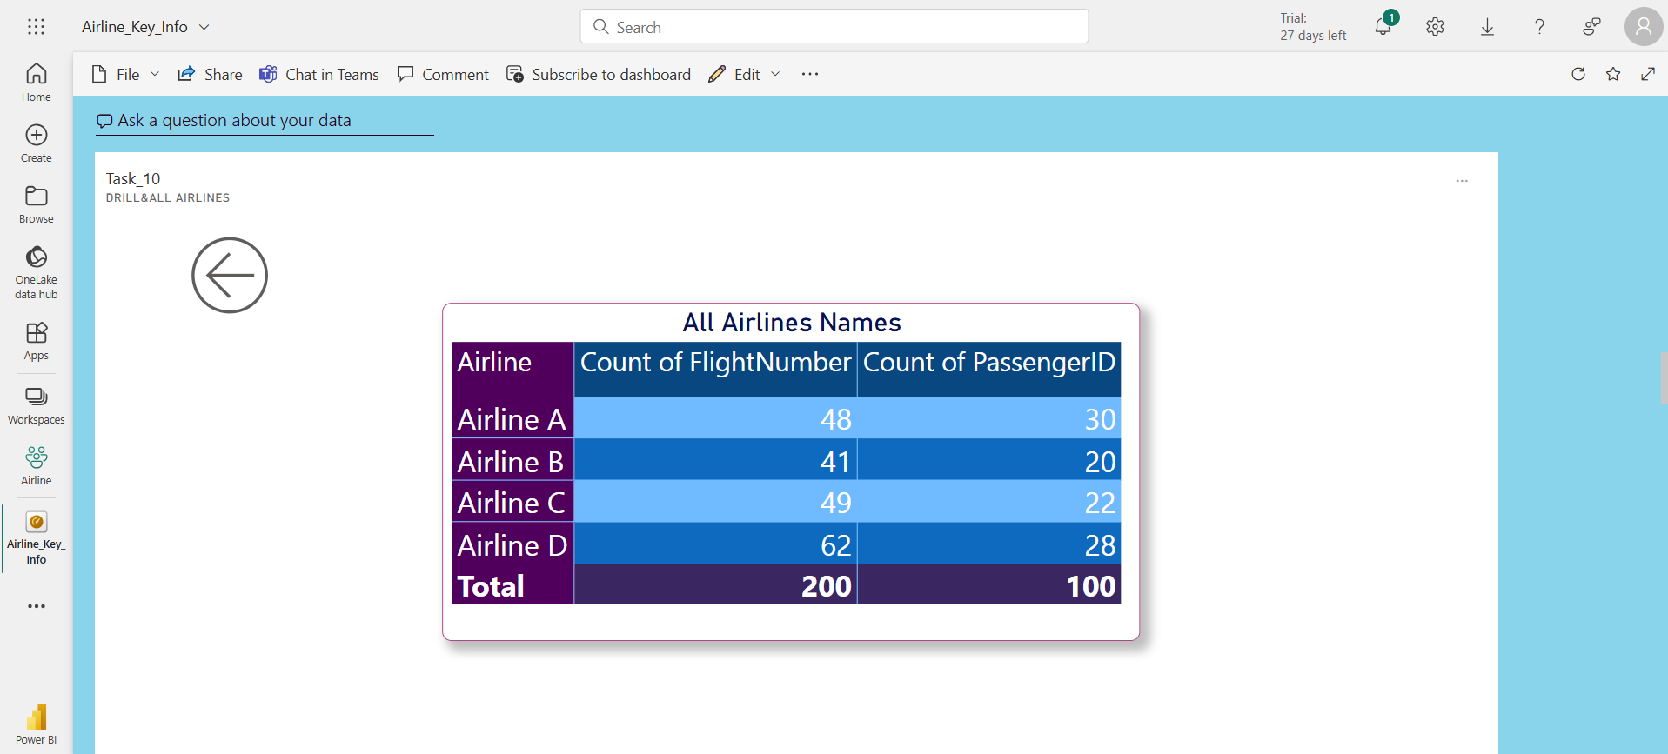

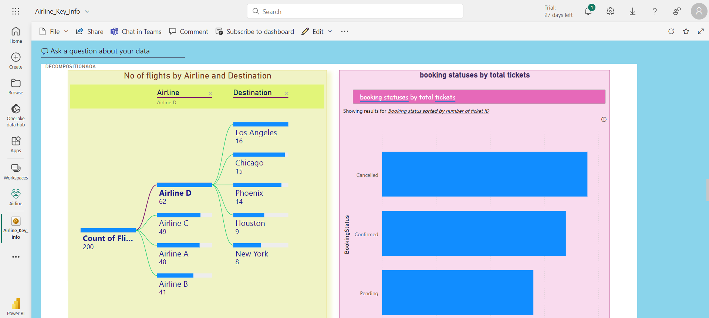

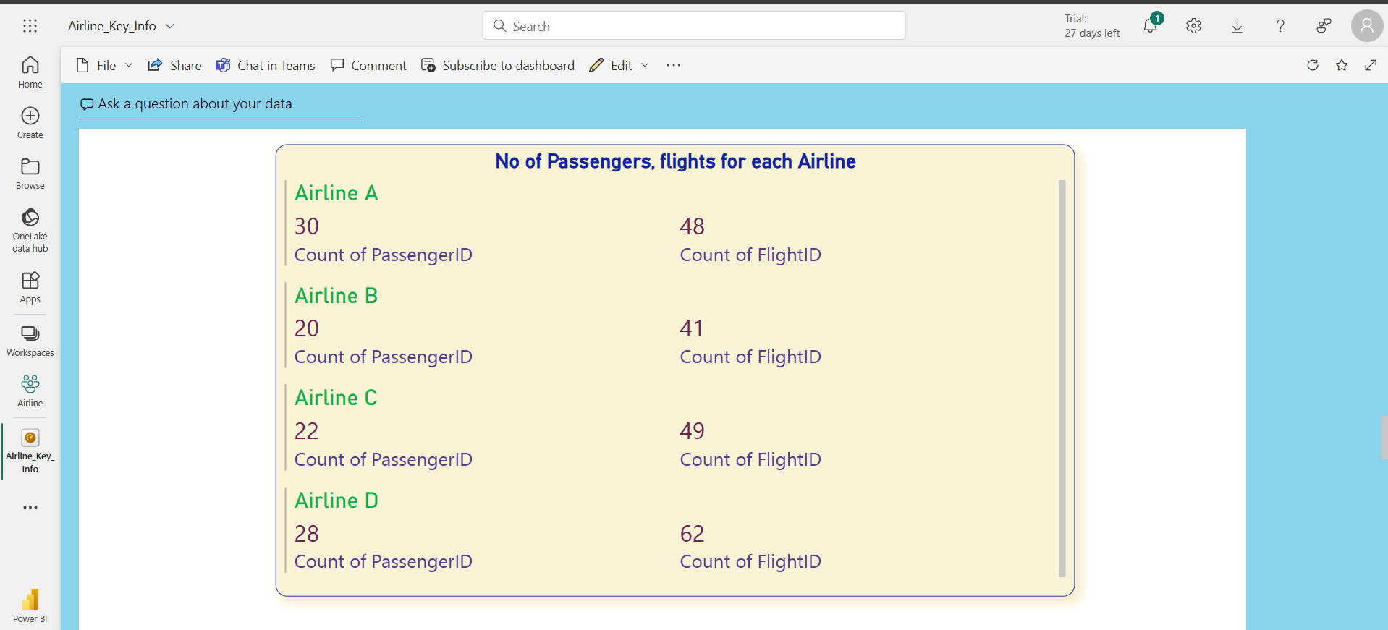

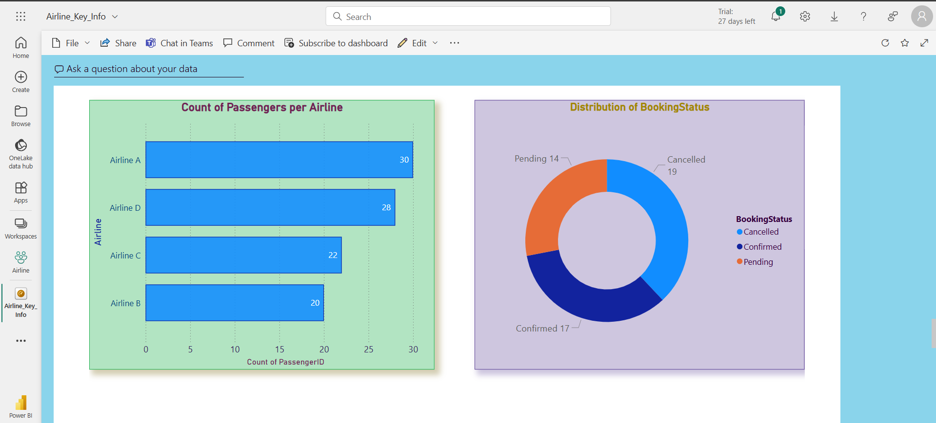

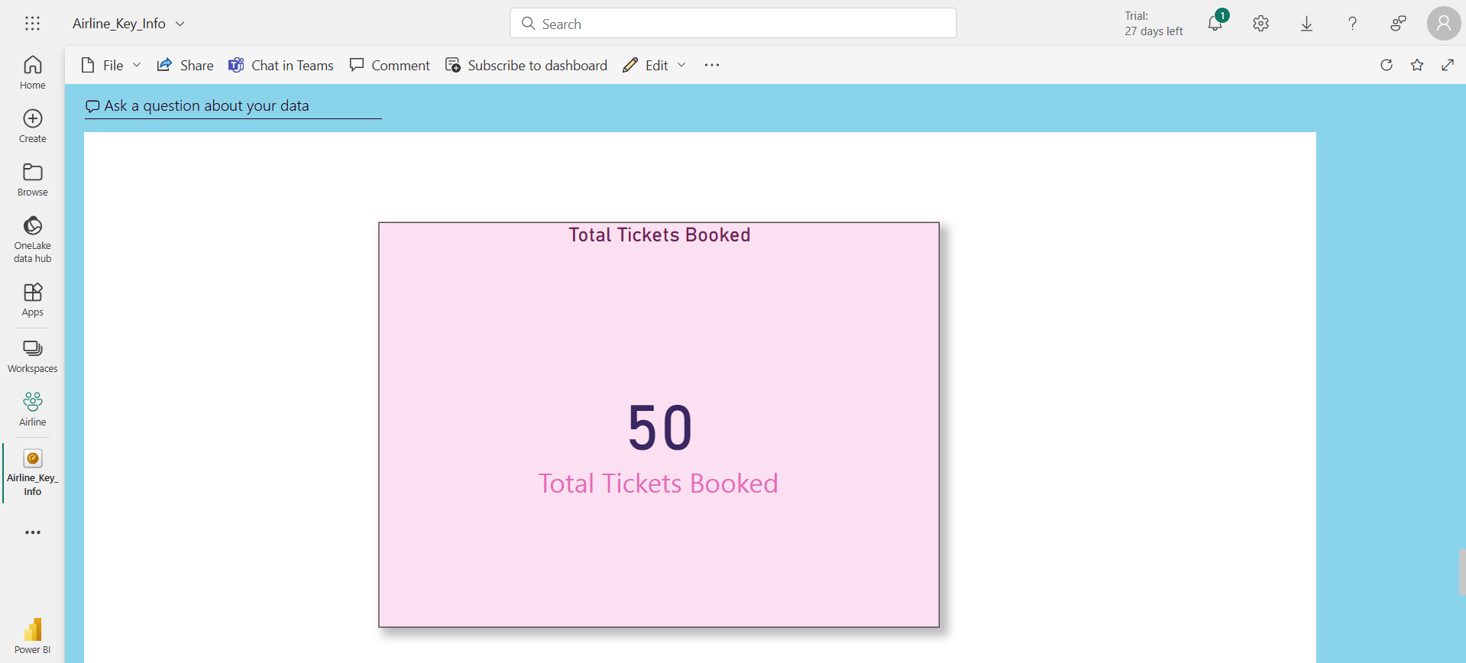

All power bi users may can access the dashboard please go through the below link and Check

**Airline Dashboard Link:-**

https://app.powerbi.com/groups/34f1a1de-7572-4583-b673-c1810f36a824/dashboards/eef8221d-85a4-41ed-b692-4c2007e27848?ctid=101bd0e2-454f-4813-8431-823cc68a255b&pbi_source=linkShare

Note : - Copy and paste in browser

**RLS**

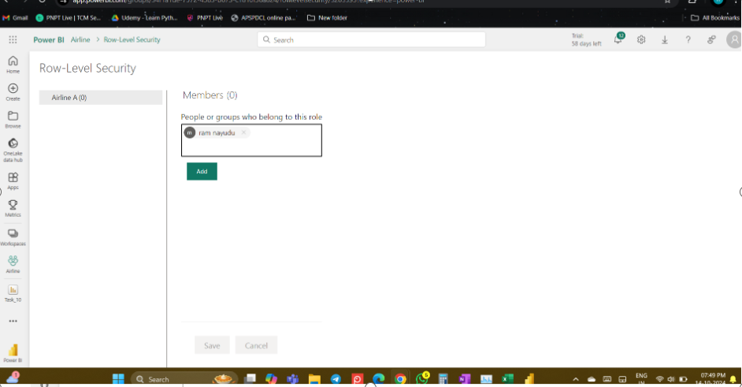

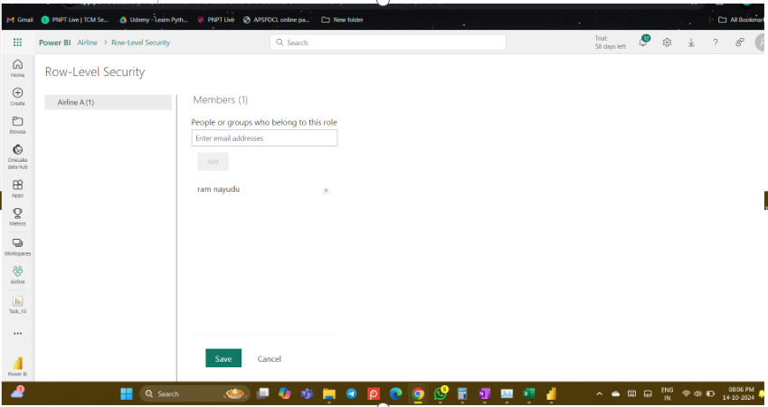

**Des :**

**you can see initially assign member is 0 after shared it went it 1.**

**Refresh**

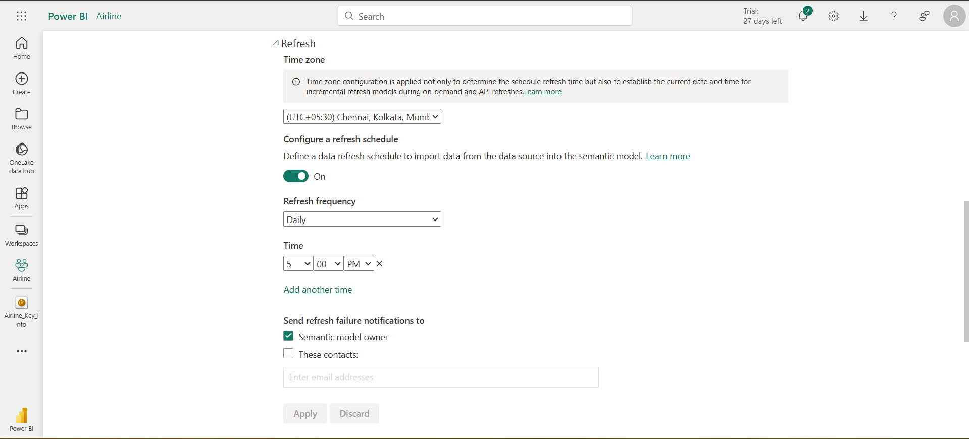

**Des :**

**Refresh got scheduled daily at 5PM.**

**- Thank You!**