
AN IoT SYSTEM FOR DURIAN ORCHARD
ENVIRONMENTAL MONITORING AND SURVEILLANCE
WITH PROVINCIAL YIELD ESTIMATION
TEEMTUS CHAIBAN
PAWEEKORN RAKPHET
BACHELOR OF ENGINEERING
IN COMPUTER ENGINEERING
SCHOOL OF INFORMATION TECHNOLOGY
MAE FAH LUANG UNIVERSITY
2026
© COPYRIGHT BY MAE FAH LUANG UNIVERSITY
AN IoT SYSTEM FOR DURIAN ORCHARD ENVIRONMENTAL MONITORING AND SURVEILLANCE WITH PROVINCIAL YIELD ESTIMATION
TEEMTUS CHAIBAN
PAWEEKORN RAKPHET
A SENIOR PROJECT REPORT SUBMITTED TO
MAE FAH LUANG UNIVERSITY IN PARTIAL FULFILLMENT OF
THE REQUIREMENTS FOR THE DEGREE OF
BACHELOR OF ENGINEERING
IN COMPUTER ENGINEERING

MAE FAH LUANG UNIVERSITY
2026
© COPYRIGHT BY MAE FAH LUANG UNIVERSITY
Draft prepared on 3 November 2026

PROJECT APPROVAL
AN IoT SYSTEM FOR DURIAN ORCHARD ENVIRONMENTAL MONITORING AND SURVEILLANCE WITH PROVINCIAL YIELD ESTIMATION
EXAMINING COMMITTEE
The names below follow the previous proposal. The current committee, academic year and approval date must be confirmed before submission. Signature spaces are intentionally blank; this draft does not state that approval has been granted.

................................................................................
Asst. Prof. Chayapol Kamyod, Ph.D.
ADVISOR (from the previous proposal)

................................................................................
Asst. Prof. Surapol Vorapatratorn, Ph.D.
COMMITTEE (from the previous proposal)

................................................................................
Asst. Prof. Gp. Capt. Thongchai Yooyatiwong, Ph.D.
COMMITTEE (from the previous proposal)
Approval date ................................................
ACKNOWLEDGEMENTS
We would like to thank our project advisor for guidance during the development of the system and the orchard owner for explaining practical monitoring needs and allowing the project to study environmental data from the installed orchard. The project also uses public-sector documents, provincial statistics and openly documented software services identified in the references.
The interpretations, implementation decisions and limitations reported here remain the responsibility of the project team. Mentioning an organisation or service does not imply that it has certified the system. The report excludes the orchard owner’s personal details, individual GAP registration identifiers, precise orchard coordinates and access credentials.
Additional acknowledgements should be confirmed by the authors before the final submission.
Teemtus Chaiban
Paweekorn Rakphet
ABSTRACT
Title: An IoT System for Durian Orchard Environmental Monitoring and Surveillance with Provincial Yield Estimation
Authors: Teemtus Chaiban, Paweekorn Rakphet
Degree: Bachelor of Engineering in Computer Engineering
This project develops an IoT platform for durian orchard environmental monitoring and surveillance, together with an exploratory study of provincial yield estimation. The installed orchard and the historical five-province dataset are separate units of study. An ESP32 gateway acquires soil readings through RS485 and weather-station data through Tuya on a 15-minute upload schedule. The existing Supabase database and backend support private records, while a React and Tailwind interface presents measurements, history, orchard activities, forecasts and spatial reference data.
The annual OAE dataset contains 145 province-year records for five provinces over 1997–2025. The main Ridge plus VPD study uses 80 records over 2010–2025. Rolling-year evaluation over 2017–2025 produces 45 predictions with an MAE of 190.87 kg/rai and an RMSE of 243.42 kg/rai. The previous-year baseline has an MAE of 215.51 kg/rai, an exploratory MAE reduction of 11.44 percent. The model family was selected using previously explored evaluation errors; this is not an independent confirmatory test.
Observed weather extends to the end of the production windows. The current output is therefore retrospective provincial yield estimation, not a validated pre-harvest or individual-orchard forecast. The project does not yet have independently calibrated sensor-accuracy results, confirmed disease labels or sufficient multi-season orchard-yield labels. Software checks, a gateway-upload interruption and data limitations are reported separately from predictive performance.
Keywords: Durian, IoT, Environmental Monitoring, GIS, Machine Learning.
TABLE OF CONTENTS
CHAPTER 1 INTRODUCTION 1
1.1 Background and Problem Definition 1
1.2 Objectives 2
1.3 Scope of the Study 2
1.4 Expected Benefits 3
1.5 Development Sequence and Resources 3
CHAPTER 2 LITERATURE REVIEW 5
2.1 Durian Production and Stage-dependent Management 5
2.2 Environmental Variables and Measurement Limits 5
2.3 Vapour Pressure Deficit and Reference Evapotranspiration 6
2.4 IoT Systems and the Meaning of Accuracy 7
2.5 Time-series Quality Control 7
2.6 Spatial References and GAP Registration 8
2.7 Ridge Regression 8
2.8 Related Research and Identified Gap 9
CHAPTER 3 METHODOLOGY AND SYSTEM DESIGN 11
3.1 Hardware and Physical Connections 11
3.2 Acquisition and Upload Schedule 16
3.3 Database and Access Control 16
3.4 Datasets and Linkage 18
3.5 Quality Control and Missing Data 18
3.6 Target and Feature Engineering 19
3.7 Ridge Calculation and Stored Parameters 20
3.8 Temporal Validation and Model Selection 21
3.9 Evaluation Measures and Operational Meaning 21
3.10 Interface, Testing and Privacy 22
3.11 Complete System Components and Proposed Extensions 23
CHAPTER 4 EXPERIMENTS AND RESULTS 27
4.1 Evidence and Evaluation Conditions 27
4.2 File Structure and Data Checks 27
4.3 Upload Interruption and Fault Interpretation 28
4.4 Ridge plus VPD and the Previous-year Baseline 28
4.5 Supporting National Experiments 30
4.6 Implemented Web Functions 30
4.7 Functional Verification and Access Control 36
4.8 Results That Remain Unavailable 36
CHAPTER 5 CONCLUSION AND DISCUSSION 37
5.1 Achievement of the Objectives 37
5.2 Interpretation of the Model Results 37
5.3 Limitations 38
5.4 Development Priorities 38
5.5 Proposed Delivery Sequence 39
REFERENCES 40
APPENDIX A PROVINCIAL REPLAY PREDICTIONS 42
APPENDIX B EVIDENCE AND REPRODUCIBILITY 44
APPENDIX C USER GUIDE AND DATA DICTIONARY 46
APPENDIX D ITEMS TO CONFIRM BEFORE SUBMISSION 48
APPENDIX E SAVED RIDGE PARAMETERS 49
APPENDIX F IoT FIRMWARE AND INGESTION CODE 50

LIST OF TABLES
Table 1.1 Development sequence supported by project records 3
Table 2.1 Environmental variables and defensible uses 5
Table 2.2 Sources informing the project 9
Table 3.1 Hardware and connection settings supported by code 11
Table 3.2 Principal data structures 17
Table 3.3 Counts from the retained files 18
Table 3.4 Features stored in the Ridge plus VPD model 19
Table 4.1 Key and empty-cell counts in the retained CSV files 27
Table 4.2 Overall retrospective results on identical 45 keys 28
Table 4.3 Annual results and saved alpha values 29
Table 4.4 Examples from the previously explored model comparison 29
Table 4.5 Retained national DOA-weather experiment results 30
Table 4.6 Evidence of software checks and their limits 36
Table A.1 Predictions and errors for each province-year 42
Table B.1 Source locations reviewed 44
Table B.2 Input-file fingerprints at report preparation 45
Table C.1 Important fields and units 47
Table E.1 Stored standardisation and coefficient values 49

LIST OF FIGURES
Figure 3.1 Data architecture from orchard hardware to the existing interface 12
Figure 3.2 Field installation in the study orchard 13
Figure 3.3 Interior of the installed equipment enclosure 14
Figure 3.4 Soil probe and cable at the measurement location 15
Figure 3.5 Logical ownership and revision relationships for private records 17
Figure 4.1 Actual provincial yield interface in the Thai locale 31
Figure 4.2 Existing model-comparison artifact displayed in the interface 31
Figure 4.3 Actual orchard-journal interface in the English locale 32
Figure 4.4 GAP registry map and soil GIS layer 33
Figure 4.5 Orchard sensor data and quality status 34
Figure 4.6 Current weather from the Open-Meteo API 35

CHAPTER 1
INTRODUCTION

1.1 Background and Problem Definition
Managing a durian orchard requires observations of trees, soil, rainfall and irrigation to be considered together. A single reading in a weather-station application does not show what happened before it, and notes stored separately from measurements make it difficult to relate orchard activities to subsequent environmental changes. This project brings these records into one interface and identifies their time, source and quality so that the user can decide what should be checked next.
Practical problems observed during development included negative soil-temperature readings, values reaching 80 °C, extended zero-valued soil channels and a period when no new database rows arrived although the station manufacturer’s application continued to change. These observations identify questionable data or a failure somewhere in the measurement and transmission chain. They do not establish that the soil actually reached the displayed temperature, or that a particular probe or cable failed without electrical inspection.
The previous Plant Life Tracker with Durian Tree proposal emphasised health tracking and disease detection. The evidence currently available does not include disease diagnoses linked to each measurement period. The scope of this report is consequently environmental monitoring and surveillance. Recommendations identify conditions that warrant inspection; they do not assert that a disease has been detected in an orchard.
A second part of the project investigates provincial durian yield per rai using historical agricultural statistics and weather variables. Provincial records provide a usable aggregate target for exploratory modelling, but they cannot be assigned to individual GAP plots as if those plots had measured harvest yields. The installed IoT orchard and the five-province statistical analysis are therefore kept separate throughout the methods and results.

1.2 Objectives
1.2.1 To implement acquisition, storage and presentation of soil and weather readings from the installed orchard, including timestamps, sources and data-quality states.
1.2.2 To provide current and historical views and private records of orchard activities, production stages and actual seasonal harvests.
1.2.3 To integrate external weather forecasts and spatial references for surveillance without treating them as confirmed disease observations.
1.2.4 To evaluate a Ridge plus VPD method for provincial yield per rai using chronological evaluation and a previous-year baseline on identical province-year keys.
1.2.5 To examine hardware limitations, information availability at prediction time and the limits of applying provincial estimates to individual orchards.

1.3 Scope of the Study
The field component concerns one instrumented orchard in Surat Thani Province. The owner described the trees as approximately nine-year-old Monthong durian that had previously borne fruit. These statements are owner-reported context, not a verified tree inventory or planting-date register. The report does not publish the exact orchard location, and a selected GAP marker is not automatically treated as the sensor installation site.
The provincial component covers Chanthaburi, Si Sa Ket, Uttaradit, Surat Thani and Chumphon. Annual production records span 1997–2025. The main Ridge plus VPD panel covers 2010–2025, with previous-year yield and stage-related weather variables. Separate national binary and AutoML experiments are described as supporting work because their targets and evaluation sets differ from those of the main regression study.
The main experimental evidence was assembled through 3 November 2026. Owner-supplied installation photographs and the documentation revision were added on 4 November 2026. File dates do not prove the original field-installation date. Screenshots, database checks and software tests came from separate development rounds and are not represented as one uninterrupted field experiment.

1.4 Expected Benefits
The platform allows a user to identify how recent the available data are, review conditions before and after rainfall or recorded activities, and store what was actually done in the orchard. The modelling component makes the size and variation of provincial estimation errors visible. These benefits concern access to information and reproducible assessment. A reduction in disease, an increase in yield or a financial return would require a separate outcome study and is not inferred from a functioning dashboard.

1.5 Development Sequence and Resources
Table 1.1 Development sequence supported by project records
Period | Work undertaken | Evidence and status
Previous proposal | Plant Life Tracker concept | 2026 proposal; approval metadata requires confirmation
Sep–Oct 2026 | Provincial data, weather and model experiments | Research files and saved training artifacts
20–27 Oct 2026 | GAP context and private harvest records | 20 October snapshot and 27 October verification notes
2–3 Nov 2026 | Journal, language and upload interruption review | Update records and diagnostics, not sensor calibration

The implemented system uses an ESP32 gateway, an RS485 soil probe, a Tuya-compatible weather station, Wi-Fi and a power supply. Development also requires a computer, the existing database and hosting environment, and external weather services. Complete purchase receipts, spare-unit counts, power specifications and actual expenditure were not established from the retained evidence. No estimated prices are substituted for an actual project budget.
The project combines hardware acquisition, environmental surveillance, orchard records, spatial references and provincial yield analysis. Chapter 3 distinguishes implemented components from proposed extensions. Chapter 4 reports only retained evidence; planned components are not presented as completed experiments.

CHAPTER 2
LITERATURE REVIEW

2.1 Durian Production and Stage-dependent Management
Durian management changes between recovery, flower preparation, flowering, fruit set, fruit development and harvest. The Department of Agricultural Extension manual provides management and inspection guidance in a production-stage context [1]. In this project, the stage recorded by the user provides that context. A month alone does not establish the stage of every orchard, cultivar or production season.
Surveillance advice focuses on checking drainage, the trunk base, leaves, fruit and equipment when the available observations warrant follow-up. Humid or rainy conditions are not equivalent to a confirmed root-rot or fruit-rot diagnosis. A provincial disease report is also a different level of evidence from an orchard inspection. The interface must make these distinctions visible rather than imply that a forecast has diagnosed a particular tree.

2.2 Environmental Variables and Measurement Limits
Table 2.1 Environmental variables and defensible uses
Variable | Practical use | Main limitation
Soil moisture | Compare changes before and after irrigation or rain | Requires calibration for soil, depth and installation
Air temperature and RH | Describe air conditions and derive air VPD | Exposure and instruments differ from model grids
Rainfall | Review wet periods and plan inspections | Rolling one-hour totals must not be summed repeatedly
EC and pH | Review device readings and unusual behaviour | Do not replace laboratory soil analysis
Probe N P K | Retain as device-reported values pending verification | Insufficient evidence for a fertiliser prescription
Reference ET₀ | Describe atmospheric reference water demand | Not the direct irrigation volume for a durian tree

A soil-moisture reading concerns the volume and location influenced by the probe. It does not establish the water status of every tree in an orchard. A practical interpretation requires installation depth, contact with soil, irrigation coverage and an appropriate reference measurement. Consequently, a general percentage threshold is not introduced as if it had been validated for this orchard.

2.3 Vapour Pressure Deficit and Reference Evapotranspiration
Vapour pressure deficit is the difference between saturation vapour pressure and actual vapour pressure. FAO Irrigation and Drainage Paper 56 explains the underlying vapour-pressure relationships and reference evapotranspiration [2]. A VPD calculated from air temperature and relative humidity describes air conditions; it is not leaf-to-air VPD unless leaf temperature is also known.
For a simultaneous orchard air reading, the implemented calculation is es(T) = 0.6108 × exp[17.27T / (T + 237.3)] and VPD = es(T) × (1 − RH/100), where T is in °C and VPD is in kPa. The calculation inherits errors in its input temperature and humidity. It does not measure actual tree transpiration or establish a disease-risk probability.
The provincial experiment uses an approximation based on daily minimum and maximum temperature and daily mean RH from NASA POWER. This is distinct from averaging hourly sensor VPD. The source, temporal resolution and summary statistic must therefore be retained in the feature name and interpretation. A window mean or 90th percentile is a model input, not a validated orchard-health threshold.
Reference ET₀ describes evapotranspiration from a defined reference surface. A forecast ET₀ value is not interchangeable with measured pan evaporation or a direct recommendation to open irrigation for a specified duration. The current interface keeps this information within the irrigation section and explains that rainfall, actual irrigation, soil state and system performance must also be considered.

2.4 IoT Systems and the Meaning of Accuracy
An IoT monitoring chain comprises measurement, communication, ingestion, storage, processing and presentation. One stage may remain online while another fails. For example, a weather station may continue updating its manufacturer’s application while the gateway stops uploading to the project database. A functioning web page is therefore not sufficient evidence of a fresh orchard measurement.
Protocol decoding, unit conversion and measurement accuracy are separate questions. Correctly parsing a register and converting its scale does not prove agreement with a calibrated reference instrument. This report uses software verification for API and display behaviour, and reserves sensor-accuracy claims for measurements that would require an independent calibration study.

2.5 Time-series Quality Control
Missing values, genuine zeros, out-of-range readings and repeated stale observations have different meanings. Replacing all of them with zero changes both charts and analytical summaries. Quality checks should retain the cause of exclusion and distinguish measurement time from ingestion time. A database row arriving recently may still contain an old sensor value.
Aggregation also depends on the variable. Mean temperature and interval rainfall cannot be handled identically. A rolling rainfall total overlaps neighbouring intervals; summing every recorded value would double-count water. Historical charts must preserve gaps rather than connect missing periods without explanation or draw a false zero-valued baseline.
Chronological model evaluation reduces direct use of future rows in training, but does not reconstruct the publication history of an official dataset. A retrospectively revised OAE record may not have been available in the same form at a past prediction date. The distinction between final values now available and information then available remains an important limitation.

2.6 Spatial References and GAP Registration
GAP registration supports the display of registry context and point selection. It does not, by itself, provide actual harvested kilograms for every orchard and season. Registered planted area is not necessarily bearing area, and the ability to display a coordinate is not proof of a field-verified orchard boundary or of the current user’s ownership of that plot.
A soil-map unit describes spatial reference information at the source map’s resolution. It is not an in-situ laboratory result or the current soil-probe reading. The owner identified Thung Wa soil-series context, but confirming that the whole orchard belongs to one unit would require a boundary overlay and the relevant Land Development Department documentation. No unverified soil pH or nutrient values are filled from that statement.

2.7 Ridge Regression
Ridge regression is a linear estimator with an L2 penalty on coefficient magnitude. The penalty reduces coefficient sensitivity when predictors are correlated [3]. It is a reasonable transparent starting point for a small tabular panel, but its suitability remains an empirical question. It does not establish a linear biological mechanism or compensate for important unmeasured management factors.
Predictors with different units must be standardised using training-set statistics. The alpha parameter controls shrinkage and should be selected with earlier validation years. Reusing evaluation errors to choose a model family, even when its alpha is tuned chronologically within folds, changes the status of the final assessment from independent confirmation to exploratory comparison.

2.8 Related Research and Identified Gap
Table 2.2 Sources informing the project
Source | Contribution | What it does not establish
DOAE durian manual [1] | Production-stage context and inspections | A tested prescription for the installed orchard
FAO 56 [2] | Vapour-pressure and ET₀ principles | Site-specific forecast or sensor accuracy
Open-Meteo documentation [4] | Hourly and daily forecast variables | Measurements from the orchard station
NASA POWER documentation [5] | Historical daily weather inputs | A bearing-area-weighted mean of every orchard
DOA durian research [13] | Factors and ordinal yield categories | Transferable orchard labels or independent accuracy
Previous proposal [8] | Original scope and author information | Confirmed disease-detection results

2.8.1 Research on Factors Affecting Durian Production
The Department of Agriculture report compiled in 2021 includes a durian experiment using 270 datasets from Chanthaburi, Rayong and Trat over 2016–2018, with logistic modelling of yield categories [13]. The larger project summary refers to 1,470 datasets across multiple fruit crops; those records should not all be described as durian observations.
Table 4 of that report defines low yield as no more than 1,300 kg/rai, moderate yield as 1,301–1,700 kg/rai and high yield as more than 1,700 kg/rai. These are categories used in that study, not universal production standards. Although the report states 71 percent correctness, the worked calculation on page 26 subtracts a percentage discrepancy from 100. This is not directly comparable to classification accuracy on an independently held-out sample. The equation should not be transplanted without its coding and category cut points.

2.8.2 Soil-analysis-based Fertilisation in Upper Southern Thailand
A 2019 Department of Agriculture study compared three fertilisation treatments with seven replications over two production seasons in a Monthong orchard in Surat Thani. Its abstract reports no statistically significant difference in yield and quality between treatments and an average 18 percent reduction in fertiliser expenditure under the soil-analysis-based approach [14]. These results support using measured soil and plant analyses under the study conditions. They do not certify this project’s probe NPK values or demonstrate cost savings in the installed orchard.
The present project therefore addresses integration, data interpretation and transparent evaluation. It does not claim a new disease-diagnosis algorithm. Research summaries without accessible orchard identifiers, harvest years, actual kilograms and verified bearing area cannot be turned into individual-orchard training records. This gap motivates private seasonal harvest recording for a future, separately evaluated study.

CHAPTER 3
METHODOLOGY AND SYSTEM DESIGN

3.1 Hardware and Physical Connections
The hardware description begins with the actual acquisition path. The gateway reads soil data through RS485 and weather-station data through Tuya before transmitting records to two destinations. Pin assignments below are verified in the retained firmware; they are not a substitute for an electrical inspection of the field wiring [9].
Table 3.1 Hardware and connection settings supported by code
Component | Function or setting | Evidence and limitation
ESP32 gateway | UART2 TX GPIO 17, RX GPIO 18; Wi-Fi and HTTPS | Firmware settings; exact board and installed wiring need confirmation
RS485 soil probe | SOIL_BAUD = 4800; multiple soil channels | Model plate, units and calibration certificate not confirmed
Tuya weather station | Local protocol 3.4 with cloud fallback | Station application can work independently of the gateway
Power and network | Power for gateway/probe and Internet uplink | No complete voltage measurements, backup-power record or field schematic
Probe placement | Owner-reported canopy-edge point, approximately 12 inches vertically | A single installation point, not a whole-orchard average

The owner supplied three photographs of the field installation on 4 November 2026. Figures 3.2 to 3.4 document the soil-probe location, the orchard installation and the open equipment enclosure. The photographs do not establish the original installation date, probe depth, calibration accuracy or successful data transmission. Device models and wiring specifications still require confirmation from readable labels and field records.
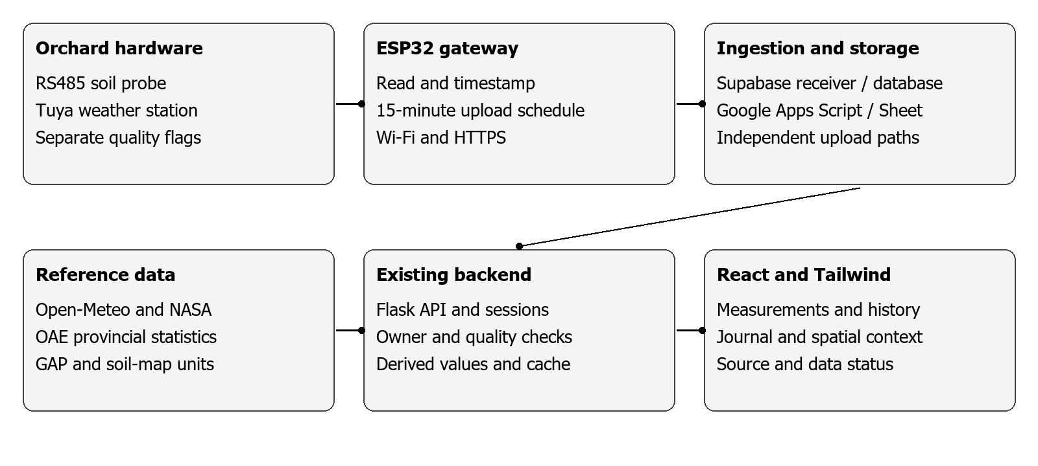
Figure 3.1 Data architecture from orchard hardware to the existing interface

Field Installation Photographs
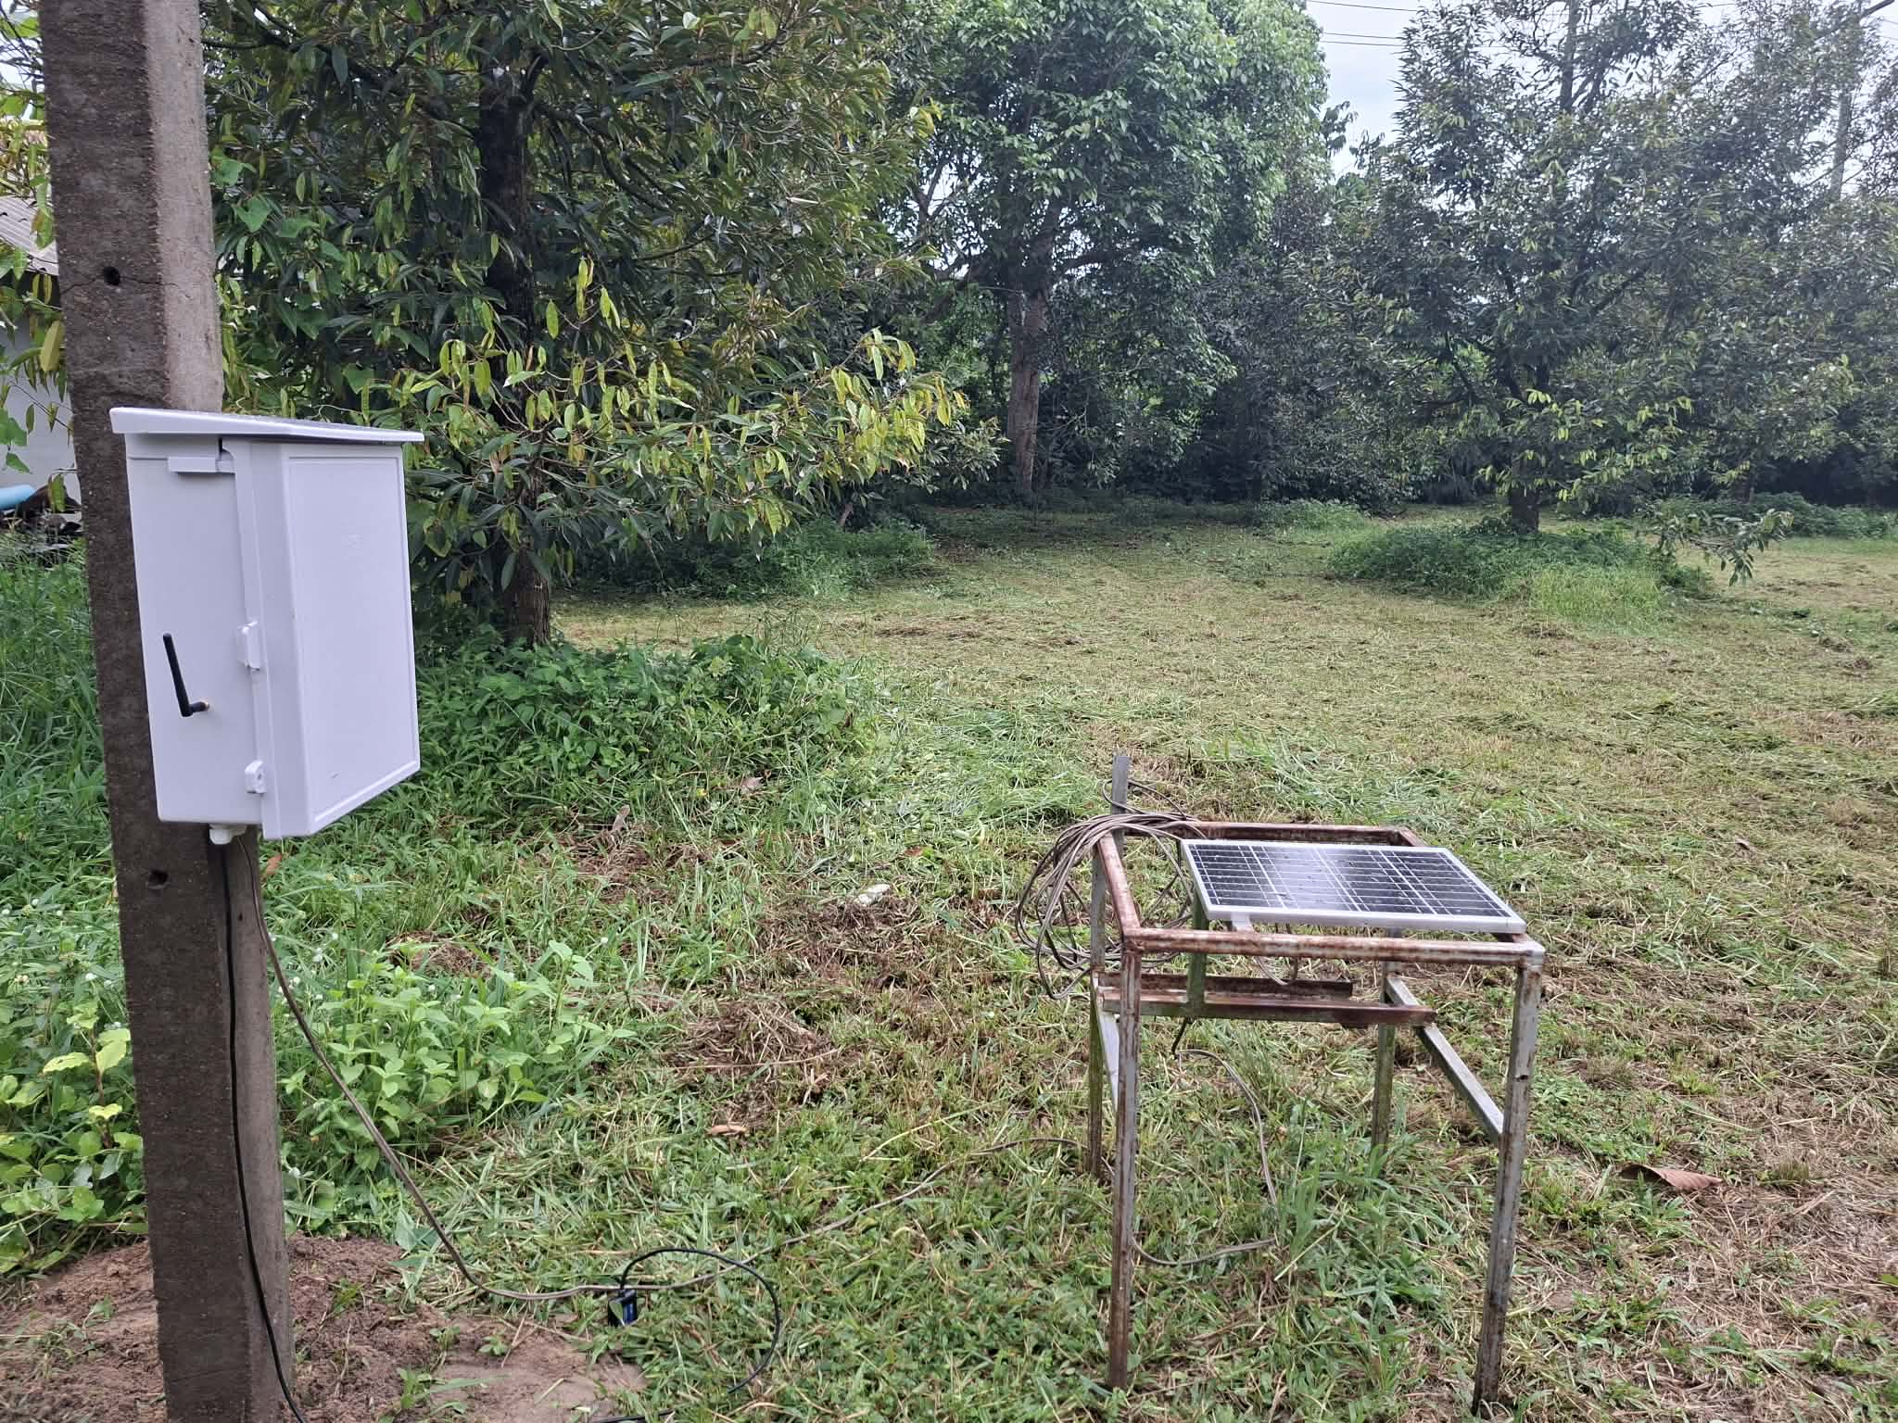
Figure 3.2 Field installation in the study orchard
The photograph shows the equipment enclosure attached to a post and a solar panel on a separate support. Source: photograph supplied by the orchard owner on 4 November 2026; capture date not verified.

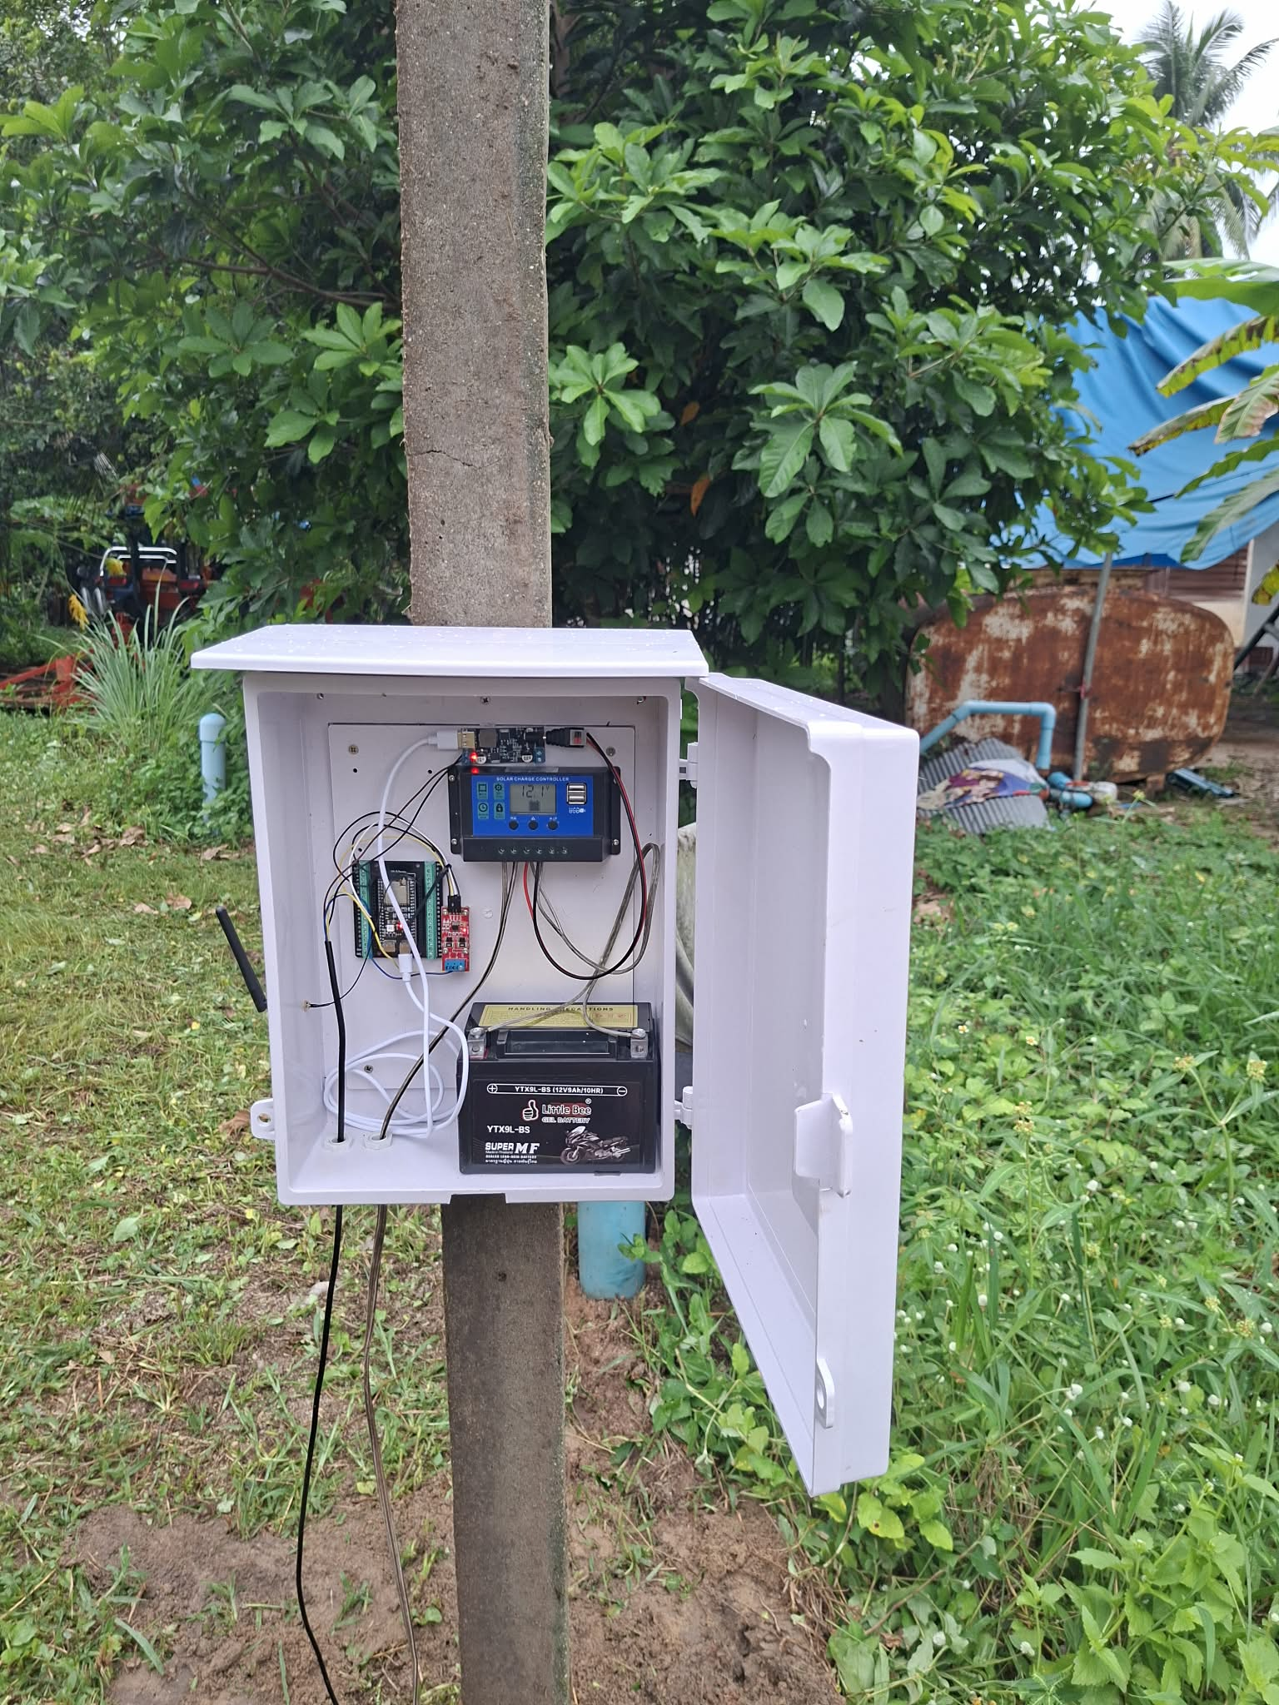
Figure 3.3 Interior of the installed equipment enclosure
The enclosure contains a battery, a solar charge controller, circuit boards and connecting cables. Visible indicator lights do not establish that readings reached the database. Source: orchard owner; supplied 4 November 2026.

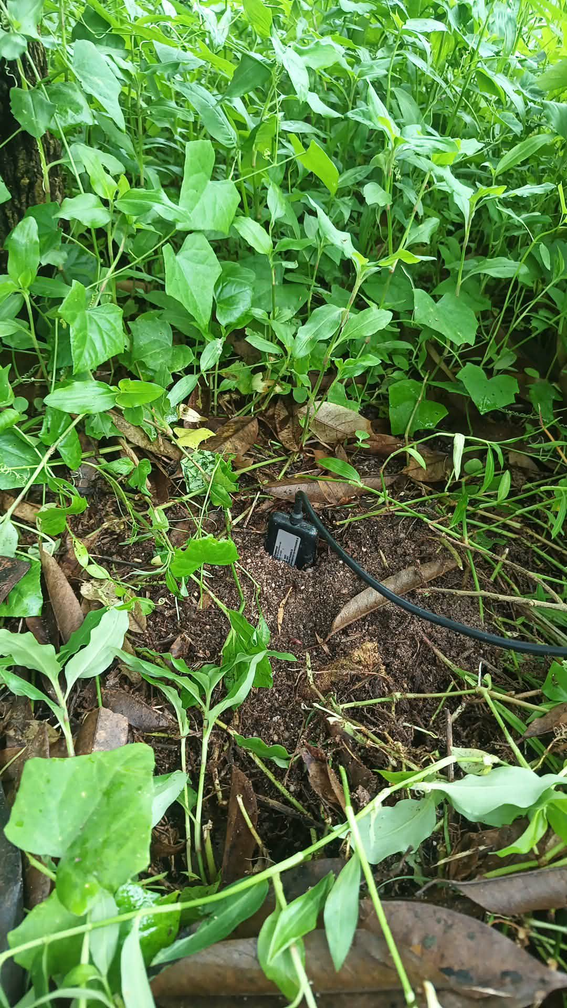
Figure 3.4 Soil probe and cable at the measurement location
The photograph records the probe housing and cable at the soil surface among ground vegetation. Insertion depth, soil contact and calibration cannot be confirmed from this view. Source: orchard owner; supplied 4 November 2026.

3.2 Acquisition and Upload Schedule
The firmware schedules uploads at 15-minute boundaries, namely minutes 00, 15, 30 and 45, and associates records with timestamps and event identifiers. Supabase and Google Apps Script receive separate uploads. Success at one destination does not prove success at the other, and the retained Apps Script receiver is not itself a replacement Tuya polling service.
The receivers validate requests before storage and use event identifiers to reduce duplicates. Google Sheet storage uses readings_15min for measurement records. The retained firmware does not establish a durable queue that guarantees replay of every missed record after an outage. Recovery of connectivity must therefore not be described as proof that all missing observations have been recovered.

3.3 Database and Access Control
The implementation reuses the existing Supabase database and Flask backend. Private record writes require an authenticated session and CSRF protection. The backend derives owner_id from the authenticated account rather than accepting an arbitrary browser-supplied owner. Harvest and activity tables have RLS enabled and are not directly readable by anon or authenticated roles. Since the backend uses a server-side service role, it must enforce ownership on every query [10].
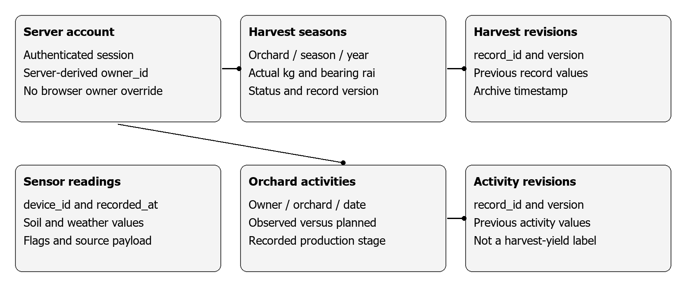
Figure 3.5 Logical ownership and revision relationships for private records
Table 3.2 Principal data structures
Structure | Key fields and units | Purpose
Sensor readings | device_id, recorded_at, soil/weather values | Measurements and source quality payload
orchard_harvest_seasons | Owner, orchard, season, year; kg and rai | Actual seasonal harvest records
orchard_harvest_revisions | record_id and version | Values before an edit
orchard_activities | Owner, orchard, date, type and status | Calendar activities and observed stages
orchard_activity_revisions | record_id and version | Activity revision history
production_annual.csv | province_code and year_ce | Provincial statistical reference

A complete harvest record requires positive actual bearing area, non-negative harvested kilograms, cultivar, harvest dates and a source reference. An incomplete draft preserves null values and does not create a yield value. Edits are checked against a version number to prevent overwriting a different revision. The existence of this schema does not imply that sufficient verified multi-season orchard labels have already been collected.
Activity records distinguish completed or observed work from plans. A stage recorded as observed can contribute to the current-stage display when its date is not in the future; a planned activity does not change the current stage. A harvest activity is not automatically a complete seasonal harvest, because it may represent only one picking round and may lack verified bearing area.

3.4 Datasets and Linkage
Table 3.3 Counts from the retained files
Dataset | Rows | Unit and coverage | Use
OAE annual statistics | 145 | 5 provinces, 1997–2025 | Target and lag
Daily weather | 83,520 | Province code and date | Stage-related weather summaries
Monthly production | 748 | Province, year and month | Historical seasonal context
Ridge plus VPD panel | 80 | 5 provinces, 2010–2025 | Main development panel
Ridge replay predictions | 45 | 5 provinces, 2017–2025 | Nine evaluation years
GAP snapshot | Not a yield label | 20 October 2026 edition | Registry and map context only

Annual statistics are joined on province code and year. Weather is linked by province code and date, then summarised over the saved production windows. The reference point used for a provincial grid request is not a spatial average weighted by the bearing area of all orchards. A large total row count also does not prove complete daily coverage for every province and year.
External orchard weather forecasts use the owner-confirmed sensor-orchard location. Selecting an unrelated GAP point or comparison area must not silently replace that private forecast location. GAP and soil-map information remains spatial context. A 2026 registry snapshot is not introduced as a historical predictor known during a 2020–2025 replay.

3.5 Quality Control and Missing Data
The provincial loader checks duplicate province-year keys, positive bearing area, non-negative production and consistency of the yield formula. Low-yield provinces are not removed merely to improve scores. Model features must satisfy the finite-input checks. Missing required inputs are reported as unavailable instead of silently filled with invented values.
Sensor presentation separates recent, stale, missing and device-check states. Staleness checks consider repeated combinations of weather channels rather than assuming that a naturally slow-changing humidity channel alone proves failure. If an older database schema lacks some quality columns, the reader uses evidence retained in source_payload where available; it does not assume valid=true or age zero.
Historical charts preserve gaps. Rainfall accumulations are interpreted according to their interval or rolling definition. Different units are labelled explicitly and are preferably shown in aligned views rather than combined on an unexplained common axis. These rules concern truthful presentation, not biological thresholds for orchard health.

3.6 Target and Feature Engineering
The provincial target is y(p,Y) = production_tonnes(p,Y) × 1,000 / bearing_rai(p,Y), where p identifies a province and Y identifies the production year. The output is kg/rai. Planted area is not used as the denominator, and GAP registered area is not substituted for bearing area. Multiplying an estimated yield by a supplied bearing area would be a conditional conversion, not an actual orchard harvest measurement.
Table 3.4 Features stored in the Ridge plus VPD model
Group | Feature | Unit or interpretation
Province | province_22, 33, 53, 84, 86 | Five indicator columns
Time | year_ce | Calendar year
Yield history | previous_yield_kg_rai | Previous-year yield
Pre-bloom rain | pre_bloom_90d_rain_mm | Pre-bloom window rainfall
Early-fruit rain | fruit_0_29d_rain_mm | Days 0–29
Fruit rain | fruit_30_59d_rain_mm | Days 30–59
Solar radiation | fruit_60_89d_solar_mj_m2_day | Mean radiation, days 60–89
Air temp. | fruit_90_to_harvest_temperature_c | Mean from day 90 to harvest
VPD | vpd_pre_bloom_mean_kpa | Pre-bloom mean
VPD | vpd_early_fruit_p90_kpa | Early-fruit 90th percentile

The design matrix contains 14 columns: five province indicators, one year column and eight yield/weather predictors. This stored model does not use probe NPK, registered GAP production or orchard disease labels. Bearing area contributes to the construction of the target, but lagged bearing area is not a direct predictor in this particular model. Its results alone therefore cannot establish that adding a bearing-area feature improves prediction.

3.7 Ridge Calculation and Stored Parameters
Each predictor is standardised as z(j) = [x(j) − mean_train(j)] / scale_train(j). Both statistics are estimated from the training rows only. A constant column receives a scale of 1 to avoid division by zero. The retained implementation uses the training-target mean as its intercept and solves the regularised linear system for the coefficients.
In matrix notation, beta = inverse(ZᵀZ + alpha I) Zᵀ(y − mean_train_y). The implementation uses numpy.linalg.solve rather than explicitly constructing the inverse. Prediction is y_hat = max(0, intercept + zᵀbeta). This non-negative lower bound is part of the retained code; a positive upper bound is not imposed using a yield category from an external paper [9].
The final saved bundle trained through 2025 has alpha = 1.0, a simulated window age of 140 days and an intercept of 1089.2091 kg/rai. Its mean, scale and coefficient arrays are stored together in JSON. Coefficients act on standardised predictors; they must not be multiplied directly by raw millimetres or degrees. They describe fitted associations, not causal responses to an extra unit of rainfall or a fertiliser intervention. Appendix E lists the saved numerical parameters.

3.8 Temporal Validation and Model Selection
Evaluation years are 2017–2025. For each year Y, the model trains on 2010 through Y−1, with every province from year Y excluded from training. Inner validation uses the three years immediately preceding Y, and each inner split trains only on earlier years. Window age is selected from 120, 130, 140 and 150 days, and alpha from 1, 10 and 100 using mean inner MAE. The chosen configuration is then refitted on all eligible past rows.
The seasonal-month definition is also obtained from earlier data for each evaluation cutoff. Applying the final seasonal table retrospectively to every fold would not reproduce the intended protocol. However, the saved evaluation audit explicitly states that the stage_ridge_vpd family was selected after reviewing outer errors among 26 previously compared families. Chronological alpha tuning within folds does not make that later family selection independent of the evaluation results.
The principal baseline is y_hat(p,Y) = y(p,Y−1), evaluated on the same 45 province-year keys. The analysis is provincial and does not claim an orchard group holdout, because orchard-level targets are absent. In addition, the publication vintage of the previous-year official yield has not been reconstructed for every historical prediction date.

3.9 Evaluation Measures and Operational Meaning
MAE is the mean absolute difference between predicted and actual yield. RMSE is the square root of the mean squared error. Both are reported in kg/rai. Bias is the mean signed difference, predicted minus actual. MAPE is the mean of |predicted − actual| / actual × 100 for positive actual yields. The MAPE values in this report are recalculated from saved predictions, not obtained from a new model training run.
A direction label would require comparing the predicted yield with the previous-year yield and comparing the actual yield with the same previous-year value. This is a different evaluation task from continuous yield estimation. Similarly, the low, moderate and high categories in the DOA paper require their own scope and coding. They are not silently adopted as universal thresholds or used to redefine this model’s training target.
The orchard-soil artifact models/orchard_soil_6h.json stores a persistence configuration with no learned input columns. It is a latest-value reference, not evidence that a learned moisture model has improved over persistence. Its target is unrelated to provincial yield per rai. Results from these two tasks must not be merged into one accuracy score.

3.10 Interface, Testing and Privacy
The existing interface retains five principal pages: My Orchard, Map and GAP, Weather, Yield and Seasons. My Orchard separates current conditions, seven-day forecasts, data-based advice, history, knowledge/soil context and the orchard journal. Measurements and forecasts carry different source labels, timestamps and states. Secondary explanations can be expanded rather than placing every detail in one long mobile view.
Open-Meteo information includes hourly and daily forecast variables and attribution. ET₀ appears within the irrigation view. Cache handling reduces repeated requests while retaining the distinction between refreshed, cached and stale data. NABC is a link to a provincial report where no permitted public programmatic endpoint has been established; it is not presented as an automatically integrated orchard disease feed.
Tests are separated into calculation, API/ownership, database behaviour and interface behaviour. Test fixtures belong in memory or an isolated database, not in production orchard records. A database probe using rollback does not count as a real farm event. Unit tests establish the behaviours they exercise, not sensor calibration or disease prevention.
This report excludes credentials, individual GAP identifiers and precise orchard coordinates. Restricted GIS remains private under Public HOLD. Cleaner route names do not replace API and storage authorisation; provincial summaries do not disclose private orchard records.

3.11 Complete System Components and Proposed Extensions
The system is organised around decisions that an orchard owner needs to make: what was measured, whether the reading can be trusted, what conditions are expected, what was done in the orchard and how yield estimates should be interpreted. The components below describe the complete intended scope. Existing functions are identified separately from work that still requires implementation, additional data or independent evaluation.

3.11.1 Field Hardware and Measurement
The documented field installation contains the enclosure, solar panel, battery, ESP32 gateway and soil-probe connection shown in Figures 3.2 to 3.4. Soil acquisition and Tuya weather access are represented in the retained firmware. Proposed additions are a verified wiring diagram, a labelled device inventory, recorded probe depth and distance from irrigation, reference-instrument comparisons, and a maintenance log. Photographs alone do not establish calibration or successful transmission.

3.11.2 Collection and Transmission Reliability
The firmware uses quarter-hour collection slots and separate upload destinations. A proposed reliability extension would retain unsent events locally, retry using the original event identifier and distinguish measurement time from reception time. Power, connectivity and last-successful-upload records would help locate failures along the device, gateway and receiver path. Recovery must be tested using controlled outages; uninterrupted delivery is not claimed from the existing source.

3.11.3 Private Storage and Traceable Records
The existing database and authentication path support private orchard information, harvest entries and activity records. The complete design retains ownership checks, units, sources, timestamps and revisions. Proposed documentation improvements include an explicit retention policy, tested recovery procedure and a common record dictionary across the gateway, Apps Script and database. A record must remain identifiable after an edit without exposing another owner's information.

3.11.4 Orchard Monitoring and Historical Review
The existing interface separates current sensor measurements, historical graphs and recorded production stages. Missing, stale and device-invalid conditions must remain distinguishable from a genuine zero. The intended monitoring workflow compares the same variable and period before and after rainfall or a recorded activity. A sensor reading describes its measurement location and does not establish the condition of every tree.

3.11.5 Weather Forecasts and Water Planning
Open-Meteo forecasts are displayed separately from physical sensors. The intended planning view combines hourly and seven-day information with rainfall, humidity, temperature and VPD summaries. ET0 remains within the irrigation context. A future water-budget module would require measured irrigation delivery, a defensible crop coefficient, rooting depth and site-specific soil-water information before recommending a quantity. Those requirements are additional data, not values to infer from tree age alone.

3.11.6 Soil Maps and Nutrient Interpretation
The platform combines soil-unit context with independently labelled sensor channels. The owner identifies Thung Wa as the relevant soil-series context; this is not a substitute for a verified point-in-polygon match or a laboratory sample. The proposed nutrient workflow records sample location, depth, date and laboratory results, then connects those records to stage-specific guidance. Probe NPK outputs must not trigger an automatic fertiliser formula.

3.11.7 GAP Mapping and Area Comparison
The implemented map supports GAP registry locations, filters, soil layers and comparison areas A and B. Registry area is not automatically bearing area, and registry status is not a confirmed orchard-health observation. Proposed improvements concern a documented coordinate-verification workflow and owner confirmation of the instrumented orchard. Provincial output remains a provincial reference when a user clicks a GAP location.

3.11.8 Activities and Production Calendar
The journal records dated plans, completed activities and observed production stages. The intended calendar links irrigation, fertiliser application, inspection, flowering, fruit set and harvest records to the orchard history. Proposed reminder delivery would require an explicit owner preference and an agreed delivery channel. A planned activity must not overwrite an observed stage or be treated as proof that work was completed.

3.11.9 Surveillance and Practical Guidance
Existing advice distinguishes data quality from agronomic interpretation. The complete intended workflow displays the recommended inspection, supporting readings and times, unknown conditions and the cited guidance. Weather favourable to a problem, a provincial pest report and disease confirmed within the orchard are three separate evidence classes. Expert-confirmed observations would be required before developing a disease classifier. No unvalidated disease probability or automatic pesticide schedule is proposed as a completed capability.

3.11.10 Provincial Yield Analysis
The retained regression uses previous-year yield and stage-related weather summaries; its calculation and retrospective errors are reported in Chapters 3 and 4. The interface may explain low, medium and high yield bands only with their cited definition and population. The proposed next step is a fixed-issue-date evaluation using only inputs available at that date, with a previous-year baseline and annual error tables. Retrospective estimates are not relabelled as forecasts for a future year.

3.11.11 Actual Orchard Harvests and Future Forecasting
Private seasonal harvest records provide the intended foundation for a later orchard model. Required fields are a stable orchard identifier, harvest year, actual kilograms and verified bearing area, with provenance and known-at dates. A previous-season yield reference can be displayed as a baseline. A learned orchard forecast remains proposed until enough genuine orchard seasons exist and evaluation separates time and orchard identity. Neither OAE figures nor GAP declarations may be copied into artificial orchard labels.

3.11.12 Evaluation and Deployment Boundaries
Evaluation is separated into physical measurement accuracy, delivery completeness, database ownership, functional interface behaviour, usefulness of advice and predictive error. Proposed field acceptance work includes reference measurements, outage recovery, owner-access tests and an observed orchard-use study. Hosting the interface does not by itself establish any of these outcomes. Private orchard details remain protected and the Public HOLD boundary remains in force.

CHAPTER 4
EXPERIMENTS AND RESULTS

4.1 Evidence and Evaluation Conditions
This chapter consolidates retained predictions, metrics, software-verification notes and actual interface captures. The report-writing task does not train a model, alter source data or write orchard records. Newly calculated values are descriptive summaries of existing files, including MAPE, duplicate-key counts and empty-cell counts.
The field evidence concerns one orchard. Software checks use the development environment and connected services, while responsive checks use browser viewport emulation rather than every physical mobile device. The code baseline recorded for this review is b060f8c. The presence of a commit does not independently prove that every change is live on the public deployment.

4.2 File Structure and Data Checks
Table 4.1 Key and empty-cell counts in the retained CSV files
Dataset | Rows | Duplicate keys | Empty cells
Annual production | 145 | 0 | 10
Daily weather | 83,520 | 0 | 5590
Monthly production | 748 | 0 | 0

Empty-cell counts refer to blank strings in the original CSV fields; they are not post-QC missing rates. Special source missing-value codes require the relevant loader checks as well. The absence of duplicate keys therefore does not certify every numerical observation or the final status of the official statistics.
The yield formula was checked across all 145 annual rows. The maximum absolute difference from the stored calculated-yield column was 0.0000000000 kg/rai. This establishes arithmetic consistency. It does not independently verify Final Actual status with OAE for every year, or prove how much a particular drought or flood should have reduced a province’s output.

4.3 Upload Interruption and Fault Interpretation
The retained diagnostic review on 3 November 2026 found the latest Supabase measurement at 12:45 on 2 November, Thailand time. Google Apps Script last accepted a successful measurement in the same period. Tuya Cloud still responded successfully and showed later property changes. These observations support an interruption in the gateway-to-storage path rather than a purely frozen web display.
Malformed, non-writing diagnostic requests received the expected receiver errors, but these were not successful firmware measurement uploads. They cannot identify whether gateway power, cabling, Wi-Fi, program execution or rejection of the actual payload caused the interruption. Serial logs and electrical inspection remain necessary. A report that someone tripped over a cable is a useful lead, not a confirmed hardware diagnosis.
The interface indicates old or unavailable data rather than normal conditions without evidence. Invalid soil channels are not used to prescribe a specific fertiliser or irrigation quantity. However, no complete controlled experiment disconnecting power or Internet and measuring recovery time is available. A transmission-success rate or uptime percentage is therefore not reported.

4.4 Ridge plus VPD and the Previous-year Baseline
Table 4.2 Overall retrospective results on identical 45 keys
Method | MAE kg/rai | RMSE kg/rai | Bias kg/rai
Previous-year yield | 215.51 | 269.55 | -44.41
Stage Ridge plus VPD | 190.87 | 243.42 | -27.26

The saved benchmark has an MAE reduction of 11.44 percent against the previous-year baseline. Recalculating MAPE over its 45 predictions gives 16.70 percent. This does not mean that the model is 83.30 percent accurate: the task is continuous estimation, and no such binary correctness rule was defined.
Table 4.3 Annual results and saved alpha values
Year | n | Model MAE | Baseline MAE | MAPE % | Alpha
2017 | 5 | 300.76 | 401.51 | 29.62 | 10.0
2018 | 5 | 198.38 | 152.13 | 15.36 | 100.0
2019 | 5 | 336.44 | 377.56 | 24.91 | 100.0
2020 | 5 | 247.14 | 136.22 | 24.37 | 1.0
2021 | 5 | 116.32 | 99.06 | 10.69 | 1.0
2022 | 5 | 210.86 | 242.00 | 17.53 | 1.0
2023 | 5 | 72.25 | 137.18 | 6.26 | 1.0
2024 | 5 | 131.65 | 220.84 | 12.49 | 1.0
2025 | 5 | 104.01 | 173.10 | 9.05 | 1.0

The model does not improve on the baseline in every year. Its MAE is higher in 2018, 2020 and 2021, while 2023 has the lowest model MAE in the evaluated period. Annual variation shows why the overall mean must be accompanied by year and province results. Selecting only favourable years would misrepresent the behaviour of the system.
Table 4.4 Examples from the previously explored model comparison
Model family | n | MAE kg/rai | RMSE kg/rai
stage_ridge_vpd | 45 | 190.87 | 243.42
stage_ridge_ndvi_vpd | 45 | 191.66 | 235.10
stage_ridge | 45 | 194.89 | 250.33
whole_year_ridge | 45 | 201.60 | 257.13
inner_selected | 45 | 205.50 | 261.53
stage_catboost_combined | 45 | 205.60 | 269.42

This comparison explains the provenance of the displayed model. It is not evidence of a method selected before inspecting evaluation data. The evaluation JSON explicitly records selection using previously explored outer errors. Stage Ridge has an MAE of 194.89 kg/rai, compared with 190.87 kg/rai for Stage Ridge plus VPD. That difference is descriptive and does not prove a causal VPD effect or prospective superiority.

4.5 Supporting National Experiments
Table 4.5 Retained national DOA-weather experiment results
Case | n | Accuracy % | Macro F1
PreviousKnown | 227 | 51.10 | 0.511
Majority | 227 | 54.19 | 0.351
HistoryArea | 227 | 51.98 | 0.515
ExistingWeather | 227 | 53.30 | 0.533
PaperWeather | 227 | 47.58 | 0.476
SelectedByInner | 227 | 52.86 | 0.528

These national experiments classify increase or decrease under their own protocol. Their accuracy and Macro F1 cannot be directly compared with the Ridge regression MAE. One previously reviewed failure mode was a CatBoost plus ENSO model predicting an increase for every province in 2023. Shared annual ENSO signals were repeated across provinces, illustrating that successful computation does not establish useful province-level discrimination. These experiments are not represented as orchard-yield forecasts.

4.6 Implemented Web Functions
The platform retains the existing five-page navigation. My Orchard separates measurements, forecasts, advice, history, knowledge and the journal. Values have units, timestamps, source labels and quality states. Activity records distinguish plans from completed actions, and the production timeline follows observed records instead of future plans.
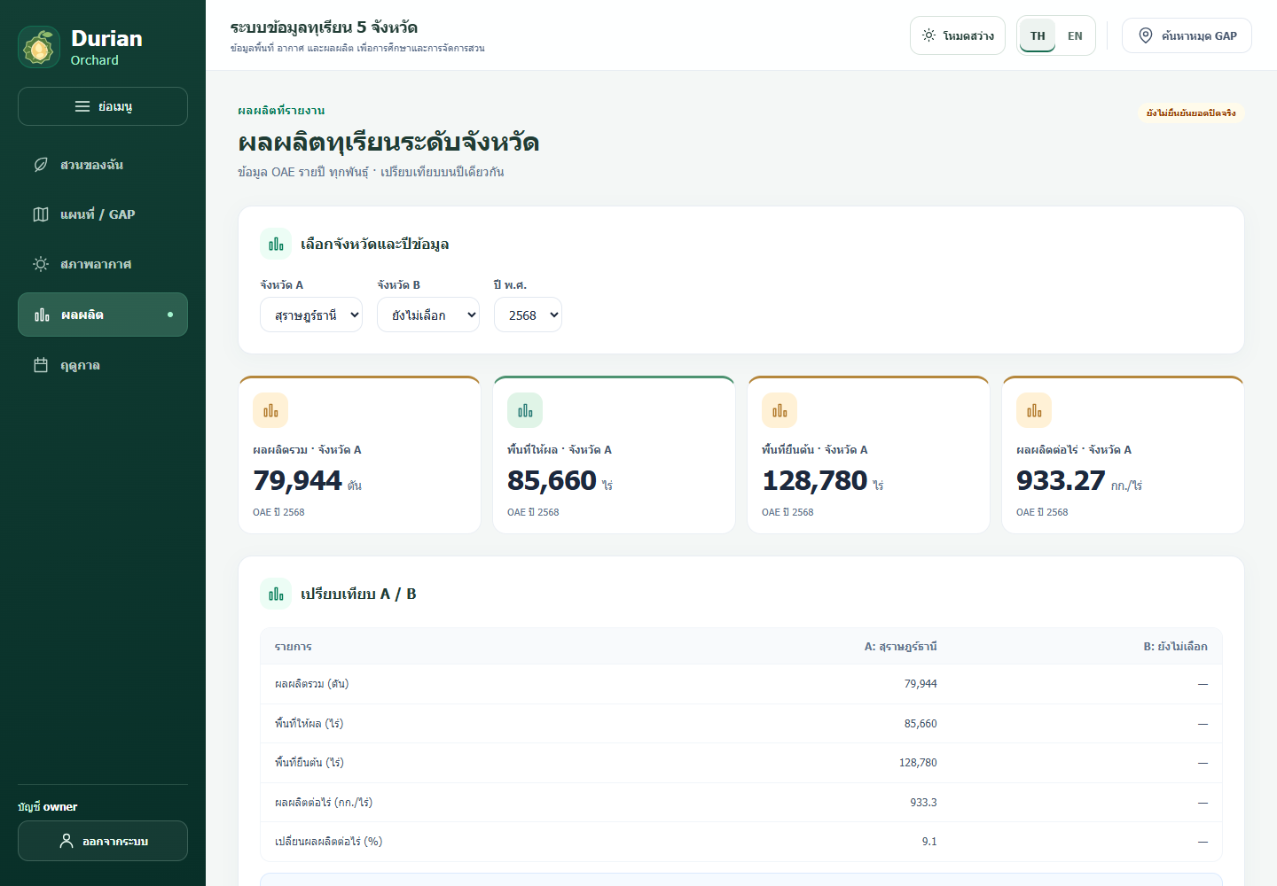
Figure 4.1 Actual provincial yield interface in the Thai locale
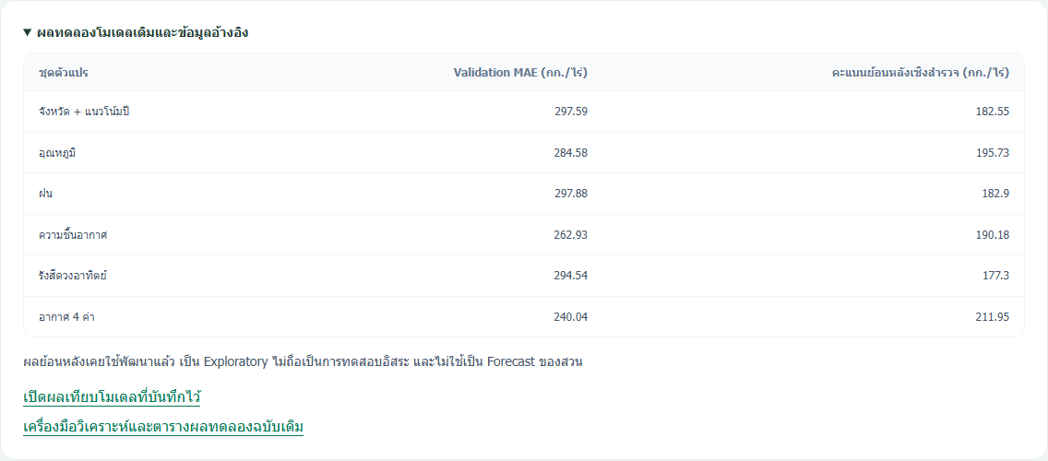
Figure 4.2 Existing model-comparison artifact displayed in the interface
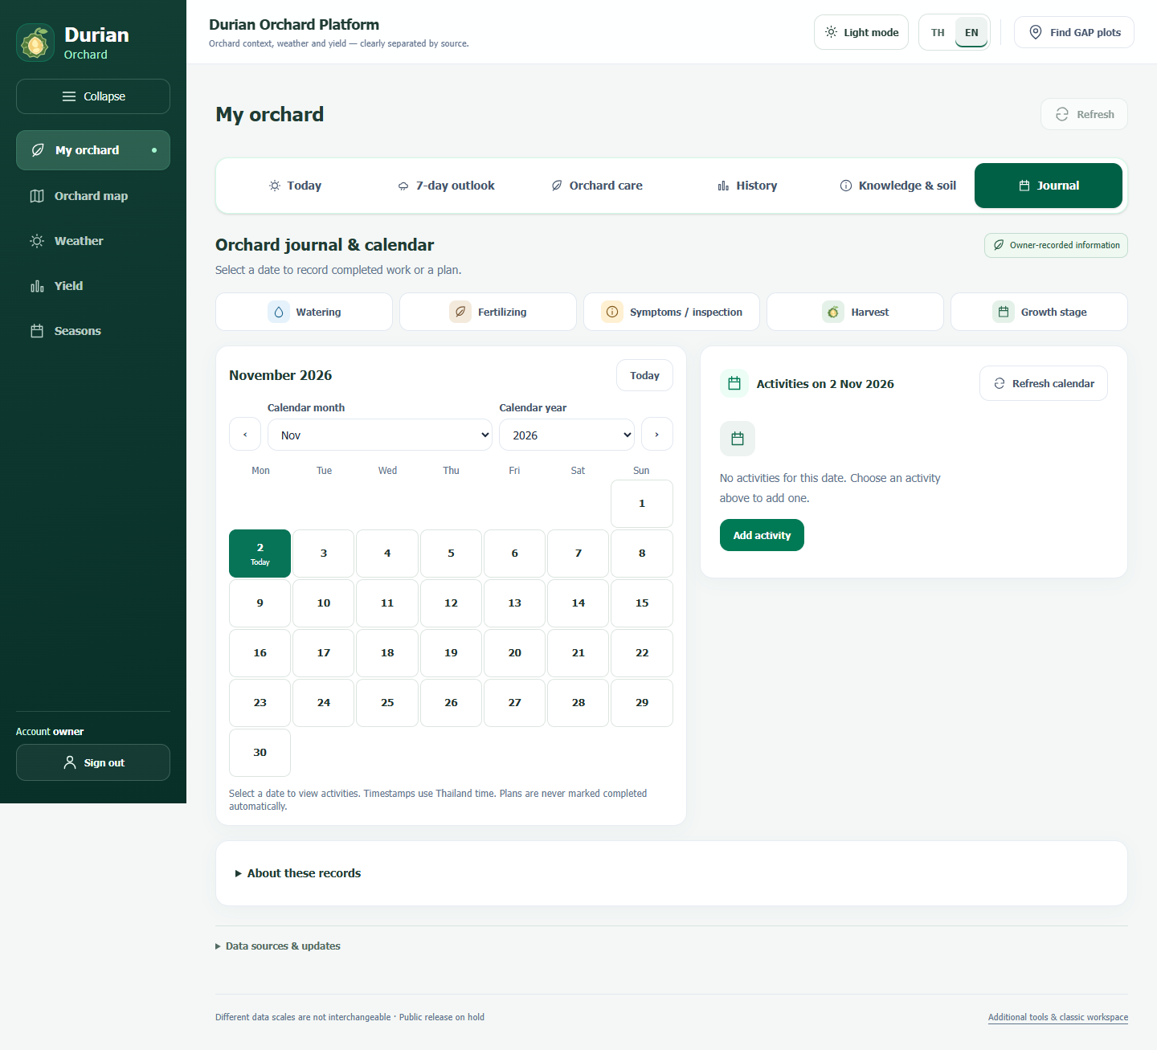
Figure 4.3 Actual orchard-journal interface in the English locale
The captures document real interface states from their respective verification rounds. They do not prove uninterrupted availability of live data services. Screens containing detailed private map coordinates or individual registry information are excluded. Selecting comparison areas A and B provides spatial context; it does not transform provincial yield into orchard yield or relocate the sensor-orchard forecast to every clicked point.
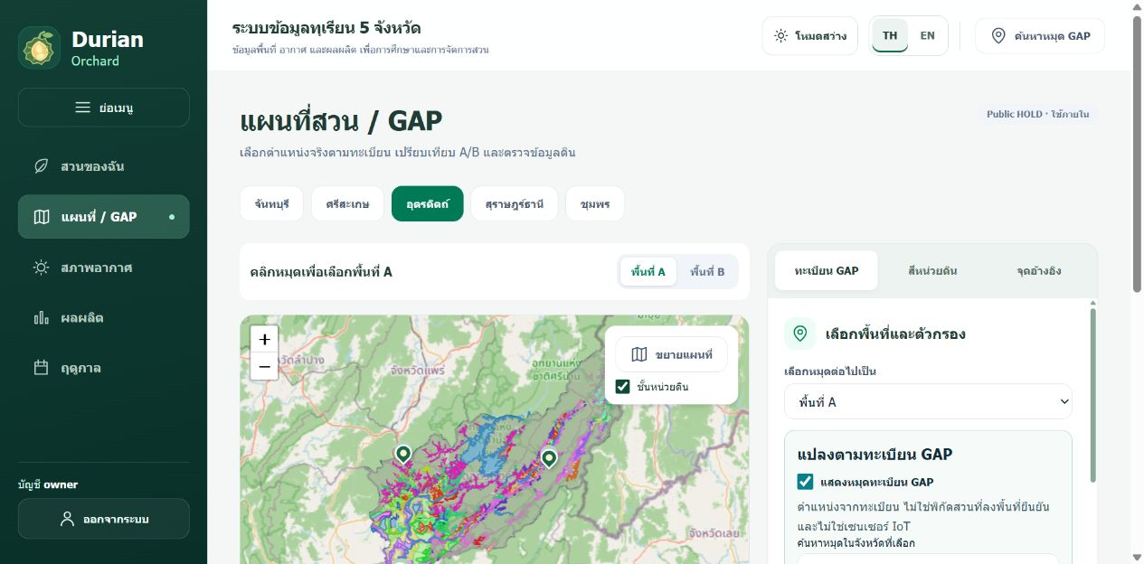
Figure 4.4 GAP registry map and soil GIS layer
The actual interface shows a provincial-scale view with clustered GAP registry points, soil-map colours, selection controls and filtering. Registry coordinates are not field-verified; soil polygons are contextual map units and not laboratory measurements of an individual orchard. Source: project website, captured 4 November 2026.
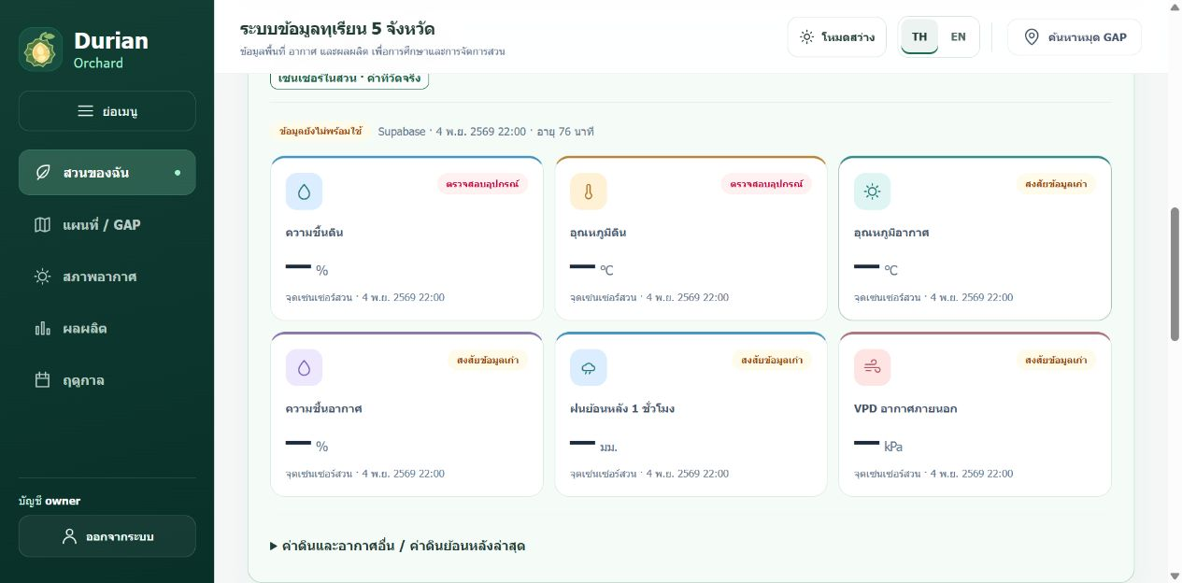
Figure 4.5 Orchard sensor data and quality status
At capture, the latest record was dated 4 November 2026 at 22:00 Bangkok time and was shown as old or requiring device inspection. Unavailable values are displayed as dashes. This screenshot records the actual state at capture; it does not establish continuous real-time delivery. Source: project website and Supabase.
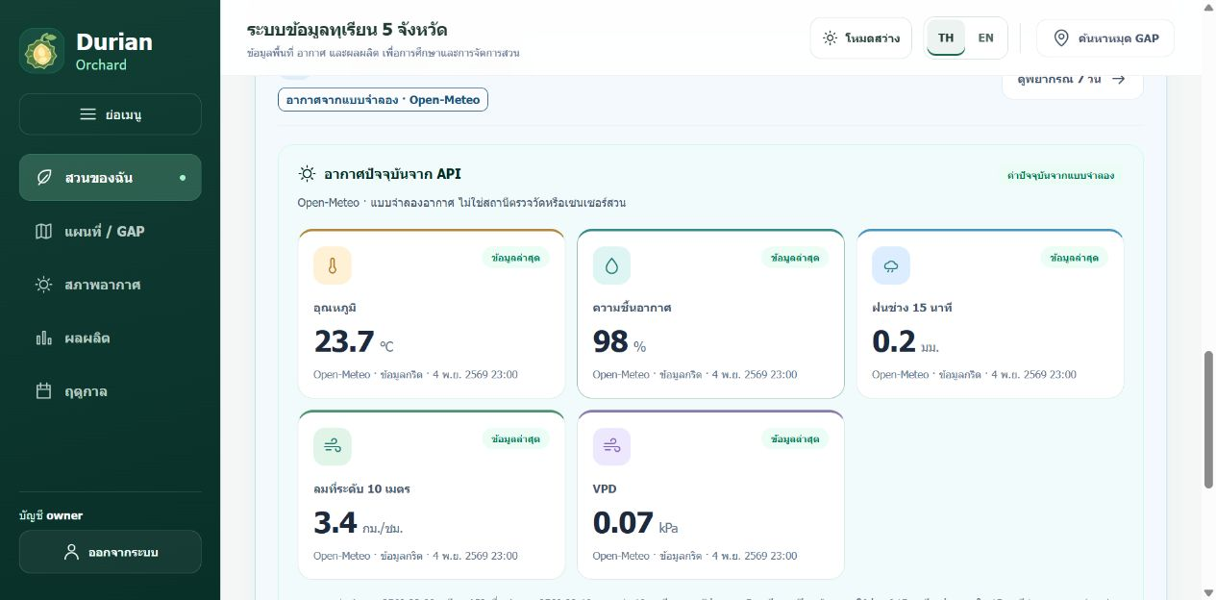
Figure 4.6 Current weather from the Open-Meteo API
The interface identifies these as model-grid estimates, separate from orchard measurements. The screenshot shows the 4 November 2026 23:00 Bangkok-time model values: temperature 23.7 degrees Celsius, relative humidity 98%, 15-minute rain 0.2 mm, wind 3.4 km/h and VPD 0.07 kPa. These are time-specific model values, not measurements by the orchard station. Source: Open-Meteo via the project website.

4.7 Functional Verification and Access Control
Table 4.6 Evidence of software checks and their limits
Item | Recorded result | Limit of interpretation
Access and editing | API/SQL checks cover owner, version and CSRF | Not a complete penetration test
Orchard records | Create, edit, reload and planned-stage behaviour checked | Memory adapter or isolated probes, not fabricated production events
Responsive layout | 360/390/768/1440 px records report no overflow in scope | Not all physical devices
Latest focused checks | 42 React/language and 3 Vercel checks recorded as passing | Not a complete test-suite rerun during writing
Data-quality states | Missing, stale and device-check views supported | No independent sensor calibration
Target users | Owner feedback informed development | No formal sample-based usability or outcome study

4.8 Results That Remain Unavailable
A single locked field-study interval with complete IoT counts before and after QC has not been established. A whole-season missing rate or uptime cannot be inferred from a Sheet row number alone. No paired laboratory results for pH, EC or NPK, reference soil-moisture calibration, or date-linked confirmed orchard-disease observations are available. Their accuracy is not replaced by the number of software tests that passed.
The OAE refresh implementation checks on page access and uses a cache. Source access has returned HTTP 403 or 418, and successful automatic addition of a new production year has not been established. It is not a daily cron job that runs without a visitor. Passing schema checks on a future download would also not certify Final Actual status.

CHAPTER 5
CONCLUSION AND DISCUSSION

5.1 Achievement of the Objectives
The project implements a platform for following environmental data from one installed orchard, together with private records, historical views and spatial context. Surveillance is expressed as checks the user should consider and the observations supporting them, not as a diagnosis from weather alone. The software implementation is supported by focused verification records, while the gateway interruption remains an operational issue requiring field inspection.
The provincial study produces an exploratory MAE of 190.87 kg/rai for Ridge plus VPD, compared with 215.51 kg/rai for the previous-year baseline on identical keys. Model-family selection used previously explored results, and the inputs include weather observed through the production windows. These findings cannot be converted into a claim that the platform accurately forecasts next year’s harvest for an individual orchard.

5.2 Interpretation of the Model Results
Stage-related weather may provide more meaningful exposure summaries than a single whole-year aggregate. The retained comparison shows a lower MAE for Stage Ridge plus VPD than for Whole-year Ridge. However, there are only five provinces and nine evaluation years, and several modelling choices were explored. The difference should be treated as a hypothesis for future prospective evaluation, not proof that VPD determines yield.
Differences between a station and Open-Meteo do not immediately establish that either is wrong. Location, model resolution, exposure, timing and instrument quality differ. A useful comparison must align the time and variable definitions and check both sources. Old orchard readings must not be compared with a fresh forecast and interpreted as simultaneous measurement error.

5.3 Limitations
Hardware limitations include a small number of measurement locations, incomplete independent calibration and incomplete confirmation of field wiring. Missed records may not be recoverable after a gateway outage. Multi-channel soil-probe readings cannot be assumed to equal laboratory analyses, and insufficient evidence remains for an orchard-specific fertiliser, chemical or irrigation-quantity prescription.
Data limitations include provincial aggregation, retrospective revisions to OAE values and incomplete historical publication vintages. GAP is a snapshot, not a multi-season harvest history; planted area differs from bearing area. Registration declarations and export quantities do not establish total harvested orchard yield. The required verified multi-orchard, multi-season labels are not yet available.
Evaluation limitations include repeated use of historical years for development and the absence of a new untouched holdout. There is no completed reference-instrument calibration study, controlled disease-reduction trial or formally designed user outcome study. The report therefore does not claim that the system has reduced disease, increased yield or delivered measured financial returns.

5.4 Development Priorities
The immediate technical priority is to inspect gateway power and cabling, capture fault logs and implement a traceable retry mechanism if needed. A defined field-study interval and expected-record count would enable a defensible missing-data analysis. Reference measurements and recorded installation conditions should precede site-specific sensor thresholds.
A prospective yield study should lock its issue date, model-selection method and feature-availability rules before a new evaluation year is observed. Data vintages known at that date should be retained. An orchard study would require stable orchard codes, actual bearing area, actual harvested kilograms and known-at dates across multiple seasons, with separate evaluation for familiar orchards in a new year and previously unseen orchards.
Future disease modelling would require inspection criteria and expert-confirmed labels. Advice text or predicted rainfall cannot serve as disease ground truth. Likewise, an LLM that has not been implemented and evaluated belongs in future work rather than in the description of completed system components.

5.5 Proposed Delivery Sequence
The first delivery phase consolidates the field installation record, device calibration, timestamp definitions and a controlled transmission test. Its acceptance evidence is a traceable set of reference readings, expected collection slots, received records and explained exclusions.
The second phase connects owner-confirmed orchard information, activity history, soil-laboratory records and source-labelled weather to inspection guidance. Evaluation records whether the owner can identify the evidence behind an action and distinguish a warning from a diagnosis. No crop benefit is assumed without observing outcomes.
The third phase tests yield forecasting prospectively. Provincial forecasting requires a locked issue date and archived data vintages; orchard forecasting additionally requires authentic multi-season harvest labels and an adequate set of orchards. Functions that lack these prerequisites remain clearly labelled as proposed. This sequence covers the intended system without treating all components as already completed.

REFERENCES
[1] Department of Agricultural Extension, “Durian planting and management techniques,” 7-page manual, in Thai. Available: https://edoae.doae.go.th/aopdh02/wp-content/uploads/sites/9/2026/01/Durian.pdf . Accessed: 3 Nov. 2026.
[2] R. G. Allen, L. S. Pereira, D. Raes, and M. Smith, Crop Evapotranspiration: Guidelines for Computing Crop Water Requirements, FAO Irrigation and Drainage Paper 56, 1998, ch. 3. Available: https://www.fao.org/4/x0490e/x0490e07.htm . Accessed: 3 Nov. 2026.
[3] scikit-learn developers, “Linear Models: Ridge regression and classification.” Used for the statistical principle; the retained implementation solves the system directly. Available: https://scikit-learn.org/stable/modules/linear_model.html . Accessed: 3 Nov. 2026.
[4] Open-Meteo, “Weather Forecast API Documentation.” Available: https://open-meteo.com/en/docs . Accessed: 3 Nov. 2026.
[5] NASA POWER, “Daily API Documentation.” Available: https://power.larc.nasa.gov/docs/services/api/temporal/daily/ . Accessed: 3 Nov. 2026.
[6] Office of Agricultural Economics, durian dataset and workbook retained by the project. Available: https://catalog.oae.go.th/dataset/durian_product . Local edition metadata: data_date 2026-07-14. Final Actual status is not independently verified for every row; latest source access was blocked.
[7] Department of Agriculture GAP registry snapshot, 20 Oct. 2026, GAP_5_PROVINCES_20261020.xlsx, internal source file. Individual records and precise coordinates are not reproduced.
[8] T. Chaiban and P. Rakphet, Plant Life Tracker with Durian Tree, project proposal, Mae Fah Luang University, 2026. Author and approval metadata are inconsistent across some original pages and require confirmation.
[9] Project team, C:/project source code and saved artifacts, reviewed 3 Nov. 2026, Git baseline b060f8c. See Appendix B for source locations.
[10] Project team, ORCHARD_HARVEST_TH.md and ORCHARD_JOURNAL_2026-11-02.md, internal database, access-control and verification records.
[11] Project team, ridge_vpd_audit.json, ridge_vpd_evaluation.json and ridge_vpd_predictions.csv, retained exploratory provincial benchmark artifacts.
[12] Project team, retained interface and data-access verification records, local development evidence. These records describe functional checks rather than field calibration or a complete user-outcome study.
[13] N. Phromnil et al., The Study of Factors of Economic Fruits Production for Yield Prediction Model, Department of Agriculture, 2021, in Thai; durian experiment, pp. 12–26. User-supplied file 415_2564.pdf. Catalogue: https://info.doa.go.th/research/?act=view_detail&id=3450 . Accessed: 3 Nov. 2026.
[14] Department of Agriculture, “Improving durian fertiliser-use efficiency based on soil analysis and yield in upper southern production areas,” 2019, in Thai. Catalogue abstract only; raw tree-level records were not inspected. Available: https://info.doa.go.th/research/?act=view_detail&id=3677 . Accessed: 3 Nov. 2026.

APPENDIX A PROVINCIAL REPLAY PREDICTIONS
The following table reproduces the retained 45 prediction records, rounded only for presentation. Absolute percentage error is recalculated as |predicted − actual| / actual × 100. No model was retrained. Every row is a retrospective provincial estimate using observed stage-window weather, not an individual-orchard forecast.
Table A.1 Predictions and errors for each province-year
Province | Year | Actual kg/rai | Predicted kg/rai | Abs. error %
Chanthaburi | 2017 | 1,622.5 | 1,233.3 | 23.99
Si Sa Ket | 2017 | 1,130.3 | 921.9 | 18.44
Uttaradit | 2017 | 923.2 | 604.9 | 34.48
Surat Thani | 2017 | 795.3 | 1,137.0 | 42.96
Chumphon | 2017 | 872.7 | 1,119.0 | 28.22
Chanthaburi | 2018 | 1,509.6 | 1,243.6 | 17.62
Si Sa Ket | 2018 | 1,457.7 | 982.4 | 32.61
Uttaradit | 2018 | 960.3 | 894.9 | 6.81
Surat Thani | 2018 | 899.9 | 1,032.6 | 14.75
Chumphon | 2018 | 1,051.4 | 999.0 | 4.98
Chanthaburi | 2019 | 1,751.2 | 1,250.1 | 28.62
Si Sa Ket | 2019 | 1,105.9 | 1,026.1 | 7.22
Uttaradit | 2019 | 648.1 | 878.4 | 35.54
Surat Thani | 2019 | 1,173.8 | 1,044.3 | 11.03
Chumphon | 2019 | 1,759.6 | 1,018.2 | 42.13
Chanthaburi | 2020 | 1,928.5 | 1,692.1 | 12.26
Si Sa Ket | 2020 | 1,158.0 | 1,077.6 | 6.95
Uttaradit | 2020 | 559.6 | 795.7 | 42.20
Surat Thani | 2020 | 961.7 | 1,392.8 | 44.83
Chumphon | 2020 | 1,608.7 | 1,357.1 | 15.64
Chanthaburi | 2021 | 1,842.8 | 1,827.8 | 0.81
Si Sa Ket | 2021 | 1,337.9 | 1,385.6 | 3.56
Uttaradit | 2021 | 691.1 | 822.9 | 19.07
Surat Thani | 2021 | 1,010.1 | 1,182.1 | 17.03
Chumphon | 2021 | 1,658.3 | 1,443.3 | 12.97
Chanthaburi | 2022 | 2,194.4 | 1,793.2 | 18.28
Si Sa Ket | 2022 | 1,347.8 | 1,521.6 | 12.89
Uttaradit | 2022 | 799.0 | 909.1 | 13.79
Surat Thani | 2022 | 719.1 | 935.1 | 30.04
Chumphon | 2022 | 1,208.6 | 1,361.8 | 12.67
Chanthaburi | 2023 | 1,967.7 | 1,930.7 | 1.88
Si Sa Ket | 2023 | 1,269.2 | 1,330.3 | 4.82
Uttaradit | 2023 | 850.0 | 900.6 | 5.96
Surat Thani | 2023 | 1,033.2 | 1,119.0 | 8.31
Chumphon | 2023 | 1,224.1 | 1,350.7 | 10.34
Chanthaburi | 2024 | 1,519.6 | 1,746.2 | 14.91
Si Sa Ket | 2024 | 1,067.9 | 1,081.5 | 1.27
Uttaradit | 2024 | 806.1 | 827.0 | 2.59
Surat Thani | 2024 | 855.6 | 1,080.7 | 26.30
Chumphon | 2024 | 990.8 | 1,162.9 | 17.37
Chanthaburi | 2025 | 1,713.7 | 1,713.0 | 0.04
Si Sa Ket | 2025 | 1,370.9 | 1,101.7 | 19.64
Uttaradit | 2025 | 929.5 | 816.1 | 12.20
Surat Thani | 2025 | 933.3 | 1,009.0 | 8.12
Chumphon | 2025 | 1,158.1 | 1,097.2 | 5.26

APPENDIX B EVIDENCE AND REPRODUCIBILITY
Paths in this appendix are relative to C:/project. They identify implementation evidence without disclosing credentials or private rows. Source data and production models were not changed during report preparation. A source path indicates where a behaviour is implemented; it does not by itself prove that the same version is deployed.
Table B.1 Source locations reviewed
Path under C:/project | Line | Purpose
iot/receiver_gateway/receiver_gateway.ino | 52 | UART and gateway settings
api/google-apps-script/Code.gs | 10 | Google Sheet receiver
tools/durian_model/common.py | 66 | Target checks and lag join
tools/train_monthly_production.py | 20 | Standardisation and Ridge solver
tools/durian_model/step3_train_model.py | 5 | Temporal tuning and refit
tools/compare_harvest_stage_yield.py | 39 | Daily grid-derived VPD
tools/orchard_harvest.py | 27 | Private harvest validation
api/supabase/migrations/004_private_orchard_harvest.sql | 3 | Harvest schema
api/supabase/migrations/005_private_orchard_activities.sql | 3 | Activity schema
tools/orchard_oae_update.py | 28 | OAE update handling
ml/orchard_live_model.py | 25 | Orchard air VPD

The main artifacts are in research_data/five_province_history/training/: ridge_vpd_audit.json, ridge_vpd_splits.json, ridge_vpd_models.json, ridge_vpd_final_model.json, ridge_vpd_prediction_contract.json, ridge_vpd_evaluation.json and ridge_vpd_comparison_models.csv. Supporting national results are in research_data/internal_research/national_automl_demo/results/run_20261026_doa_weather_v1/.
Table B.2 Input-file fingerprints at report preparation
File | SHA256
production_annual.csv | c5eed63bddcb777afcbf4bb04e9f25cccdbf08d758636136a96730c884655b73
harvest_monthly.csv | a1a04a1bcd4e37d1640a76a3fb733221563fcb5b00a43f6ce2046760bff7f739
weather_daily.csv | 28dfcab00a24086735a7a8b596a19c52334a5025a7c3abb0297ff2a663d21054

These fingerprints help detect changed input editions. Reproducing a saved score requires the associated model and protocol as well as the same files. The report does not claim that current official revisions will reproduce old results without checking the snapshot.

APPENDIX C USER GUIDE AND DATA DICTIONARY

Sign-in and ownership
Use an account configured by the platform administrator, not a Supabase administrator password in the web form. Check the active account and source timestamps. Users sharing one account also share its ownership context.

Reading current conditions
Distinguish orchard-sensor labels from model-forecast labels. Check quality and measurement time before using a value. A dash is not a zero. Old or invalid values require a device or data check rather than a claim that conditions are normal.

Recording activities
Choose date, activity and planned or completed status. Enter quantities only when known. Editing requires the latest version. A single harvest activity must not be interpreted as the complete seasonal total.

Recording an actual harvest
Use a stable orchard code and enter year, cultivar, verified bearing area, actual harvested kilograms, harvest dates and source reference. Complete the season only after the required information is available. Yield is calculated as actual kg divided by actual bearing rai.

Reading the map
Use markers and A/B selections for reference and comparison. Registration and soil-map units are contextual information. Displaying a coordinate is not proof of field verification or ownership.

Reading model output
Check the supported province, year and weather window. An estimate based on observed weather after the window has ended is not an advance forecast. Multiplying it by a GAP planted area does not produce an actual orchard harvest.
Table C.1 Important fields and units
Field | Unit or type | Meaning
recorded_at | Timestamp with time zone | Measurement/record time, distinct from ingestion
device_id | Text | Device reference; actual private identifier omitted
soil_moisture_percent | Device-converted percent | Requires calibration before site-specific interpretation
outdoor_temperature_c | °C | Outdoor station air temperature
outdoor_humidity_percent | %RH | Outdoor relative humidity
production_tonnes | Tonnes | Provincial aggregate production
bearing_rai | Rai | Bearing area, not all planted area
harvested_kg | kg | Actual harvest reported by the user
status and version | Text and integer | Completion state and revision number
source_payload | JSON | Original fields and quality evidence where present

APPENDIX D ITEMS TO CONFIRM BEFORE SUBMISSION
The chapters use the evidence currently available. The following items remain unconfirmed and must not be invented to complete an institutional form. The year 2026 on the cover is the document-preparation year; the academic submission year must be confirmed separately.
• Author membership, student IDs, spelling, current school designation and the project title approved by the advisor. Three authors appear on the proposal cover, but some internal pages list only two.
• Current advisor and committee titles, signatures, academic year and approval date. The inherited 2022 approval wording in the proposal is not reused as a real approval date.
• Exact hardware models, quantities, unit labels, supply specifications, actual circuit, installation photographs and purchase evidence for the budget.
• Verified installation date and a locked IoT evaluation interval with expected and retained record counts and explained exclusions.
• Reference sensor calibration, laboratory soil results and confirmed disease observations, if conducted; otherwise retain the stated unavailable status.
• Historical OAE publication vintages and Final Actual status, and prospective feature availability at a fixed issue date.
• Actual multi-season orchard harvest records with evidence for kilograms and bearing area before any orchard-model claim.
• The institution’s current submission rules, reference style and approval wording. This draft follows the supplied full-book examples rather than the two-column paper template.

Author biographies
Educational histories and contact information approved for publication remain to be supplied. Biographies from the sample reports are not copied, and unapproved personal contact details are not included.

APPENDIX E SAVED RIDGE PARAMETERS
The following values come from ridge_vpd_final_model.json trained through 2025. They document the saved calculation rather than a new fit. Each beta multiplies a predictor standardised with the mean and scale from the same model bundle. Earlier replay years have separate bundles in ridge_vpd_models.json.
Table E.1 Stored standardisation and coefficient values
Predictor | Mean | Scale | Beta
province_22 | 0.2000 | 0.4000 | 126.1320
province_33 | 0.2000 | 0.4000 | 104.3512
province_53 | 0.2000 | 0.4000 | -157.8873
province_84 | 0.2000 | 0.4000 | -55.6798
province_86 | 0.2000 | 0.4000 | -16.9161
year_ce | 2017.5000 | 4.6098 | 79.9471
previous_yield_kg_rai | 1070.0453 | 385.6392 | 168.2789
pre_bloom_90d_rain_mm | 265.6761 | 220.3531 | -29.5627
fruit_0_29d_rain_mm | 61.9472 | 67.9974 | -196.3371
fruit_30_59d_rain_mm | 104.4248 | 85.8825 | 169.6683
fruit_60_89d_solar_mj_m2_day | 19.3116 | 0.9837 | 68.7362
fruit_90_to_harvest_temperature_c | 27.2575 | 1.2538 | -145.1060
vpd_pre_bloom_mean_kpa | 0.7660 | 0.2792 | -55.8833
vpd_early_fruit_p90_kpa | 1.7961 | 0.7672 | -52.4777

Intercept = 1089.209084 kg/rai; alpha = 1.0; predictors = 14. Negative outputs are clipped to zero by the saved prediction function. The 140-day simulated window is not a verified fruit age for every orchard.

APPENDIX F IoT FIRMWARE AND INGESTION CODE
This appendix documents selected code retained in the project on 4 November 2026. The listings explain the acquisition, timing and upload path shown in Chapter 3; they are excerpts with external dependencies, not standalone sketches. No device was reflashed for this report, and the installed firmware revision has not been independently confirmed.
Secrets and private settings remain in excluded configuration headers or Google Apps Script Properties. Network passwords, device keys, account identifiers, access tokens and precise orchard coordinates are not reproduced. Symbolic names in the listings refer to those external settings. All source line numbers refer to the inspected project files.
Source fingerprints for reproducibility
Gateway SHA256 904b6fababe641c572a992f09eb523110de305d390493709dd90f5a84477de30
Apps Script SHA256 2dc3320b10294e6e36fba61a05aac78c5765c897ea05b5df027fa144404c2c37
Interpretation limits: a successful CRC validates the communication frame, not agronomic accuracy. The retained firmware marks a decoded frame as valid without proving calibration. NPK outputs must not be treated as laboratory soil analysis. The retained HTTP helper uses client.setInsecure(), which skips server-certificate verification; this is an observed security limitation, not a recommended deployment configuration. A Google redirect is treated as transport acceptance and is not independent proof of a stored spreadsheet row.

F.1 Soil communication and signed temperature decoding
Source iot/receiver_gateway/receiver_gateway.ino
UART2 uses TX GPIO 17, RX GPIO 18 and 4800 baud in the retained configuration. Seven Modbus registers are read. Temperature uses a signed 16-bit conversion, and a missing valid frame sets soil.valid to false. CRC success alone cannot exclude a damaged or miscalibrated probe.
804 uint16_t modbusCrc16(const uint8_t* data, size_t length) {
805 uint16_t crc = 0xFFFF;
806 for (size_t i = 0; i < length; ++i) {
807 crc ^= data[i];
808 for (uint8_t bit = 0; bit < 8; ++bit) {
809 crc = (crc & 1) ? (crc >> 1) ^ 0xA001 : crc >> 1;
810 }
811 }
812 return crc;
813 }

815 bool readSoilSensor() {
816 // Exact request from the original working soil sender. Do not reduce this
817 // to the four-register example from the generic sensor manual: this probe
818 // also supplies N, P and K in registers 0004H-0006H.
819 static const uint8_t request[] = {
820 0x01, 0x03, 0x00, 0x00, 0x00, 0x07, 0x04, 0x08
821 };
822
823 while (soilSerial.available()) soilSerial.read();
824 soilSerial.write(request, sizeof(request));
825 soilSerial.flush();
826 Serial.println("Soil Modbus TX: 01 03 00 00 00 07 04 08");
827
828 // Collect the complete response and scan it for a valid frame. A larger
829 // buffer also tolerates a converter that echoes bytes before the reply.
830 uint8_t response[64];
831 size_t received = 0;
832 unsigned long startedAt = millis();
833 while (millis() - startedAt < 1500 && received < sizeof(response)) {
834 while (soilSerial.available() && received < sizeof(response)) {
835 response[received++] = soilSerial.read();
836 }
837 delay(1);
838 }
839
840 Serial.printf("Soil Modbus RX (%u bytes): ", (unsigned)received);
841 for (size_t i = 0; i < received; ++i) Serial.printf("%02X ", response[i]);
842 Serial.println();

F.1 Soil communication and signed temperature decoding continued
Source iot/receiver_gateway/receiver_gateway.ino
843
844 for (size_t offset = 0; offset + 19 <= received; ++offset) {
845 uint8_t* frame = response + offset;
846 if (frame[0] != SOIL_ADDRESS || frame[1] != 0x03 || frame[2] != 0x0E)
continue;
847
848 uint16_t calculatedCrc = modbusCrc16(frame, 17);
849 uint16_t receivedCrc = frame[17] | (uint16_t(frame[18]) << 8);
850 if (calculatedCrc != receivedCrc) continue;
851
852 auto reg = [&](uint8_t index) -> uint16_t {
853 uint8_t pos = 3 + index * 2;
854 return (uint16_t(frame[pos]) << 8) | frame[pos + 1];
855 };
856
857 soil.moisture = reg(0) / 10.0f;
858 soil.temp = int16_t(reg(1)) / 10.0f;
859 soil.ec = reg(2);
860 soil.ph = reg(3) / 10.0f;
861 soil.n = reg(4);
862 soil.p = reg(5);
863 soil.k = reg(6);
864 soil.valid = true;
865 soil.updatedMs = millis();
866
867 Serial.printf("Soil OK: moisture=%.1f%% temp=%.1fC EC=%d pH=%.1f N=%d P=%d
K=%d\n",
868 soil.moisture, soil.temp, soil.ec, soil.ph,
869 soil.n, soil.p, soil.k);
870 return true;
871 }
872
873 soil.valid = false;
874 Serial.println("Soil RS485 failed: no valid 19-byte Modbus frame");
875 return false;
876 }

F.2 Tuya source fallback and sensor metadata
Source iot/receiver_gateway/receiver_gateway.ino
The gateway attempts the local Tuya path before the cloud fallback and clears the weather structure if both fail. The JSON excerpt carries measurement validity and age; these flags must be interpreted separately from whether the upload succeeded.
456 bool fetchTuyaWeather() {
457 if (ENABLE_TUYA_LOCAL && fetchTuyaWeatherLocal()) return true;
458 Serial.println("Using Tuya Cloud fallback");
459 if (fetchTuyaWeatherCloud()) return true;
460 weather = WeatherData();
461 return false;
462 }
// Excerpt from buildCombinedJson; function continues in source.
900 s["valid"] = soil.valid;
901 s["moisture_percent"] = soil.moisture;
902 s["temperature_c"] = soil.temp;
903 s["ec"] = soil.ec;
904 s["ph"] = soil.ph;
905 s["n"] = soil.n;
906 s["p"] = soil.p;
907 s["k"] = soil.k;
908 s["age_sec"] = ageSec(soil.valid, soil.updatedMs);
909
910 JsonObject w = doc.createNestedObject("weather");
911 w["valid"] = weather.valid;
912 w["age_sec"] = ageSec(weather.valid, weather.updatedMs);
913 w["source"] = weather.source;
914 w["wind_unit"] = "km/h";
915 w["light_unit"] = "lux";
916
917 if (weather.hasAirTemp) w["air_temperature_c"] = weather.airTemp;

F.3 Authenticated upload helper and destinations
Source iot/receiver_gateway/receiver_gateway.ino
The same generated payload is sent to enabled destinations. Supabase uses an x-device-key header, while the retained Apps Script path uses a key query parameter. The actual values are not printed. Transport status alone does not establish end-to-end storage. The current helper disables certificate verification and logs response bodies; both require security review before any claim of hardened telemetry.
994 bool postJson(const char* label, const String& url, const String& json, bool
addDeviceHeader) {
995 if (!ensureWiFi()) {
996 Serial.print(label);
997 Serial.println(" skipped: WiFi not connected");
998 return false;
999 }
1000
1001 WiFiClientSecure client;
1002 client.setInsecure();
1003 client.setTimeout(45000);
1004
1005 HTTPClient http;
1006 http.begin(client, url);
1007 const bool isGoogleSheets = strcmp(label, "Google Sheets") == 0;
1008 // Google Apps Script redirects the POST and may take longer than the
1009 // library's short default timeout, especially with weak farm Wi-Fi.
1010 http.setConnectTimeout(15000);
1011 http.setTimeout(45000);
1012 // Apps Script runs doPost() and then redirects to the response page. Do not
1013 // POST the JSON again to googleusercontent; the original /exec POST already
1014 // reached the sheet script when the 3xx response is returned.
1015 http.setFollowRedirects(isGoogleSheets
1016 ? HTTPC_DISABLE_FOLLOW_REDIRECTS
1017 : HTTPC_FORCE_FOLLOW_REDIRECTS);
1018 http.addHeader("Content-Type", "application/json");
1019 if (addDeviceHeader) {
1020 http.addHeader("x-device-key", DEVICE_INGEST_KEY);
1021 }
1022
1023 int code = http.POST(json);
1024 String res = http.getString();
1025 http.end();
1026
1027 Serial.print(label);
1028 Serial.print(" HTTP: ");
1029 Serial.println(code);
1030 if (res.length() > 0) {
1031 Serial.println(res);

F.3 Authenticated upload helper and destinations continued
Source iot/receiver_gateway/receiver_gateway.ino
1032 }
1033
1034 if (isGoogleSheets && code >= 300 && code < 400) {
1035 Serial.println("Google Sheets POST accepted (redirect not followed)");
1036 return true;
1037 }
1038 return code >= 200 && code < 300;
1039 }

1041 bool forwardCombinedData(const String& json) {
1042 bool ok = true;
1043 if (ENABLE_SUPABASE && String(SUPABASE_INGEST_URL).length() > 0) {
1044 ok = postJson("Supabase", SUPABASE_INGEST_URL, json, true) && ok;
1045 }
1046
1047 if (ENABLE_GOOGLE_SHEETS && String(GOOGLE_SHEETS_URL).length() > 0) {
1048 String sheetsUrl = String(GOOGLE_SHEETS_URL) + "?key=" +
DEVICE_INGEST_KEY;
1049 ok = postJson("Google Sheets", sheetsUrl, json, false) && ok;
1050 }
1051 return ok;
1052 }

F.4 Clock aligned collection schedule
Source iot/receiver_gateway/receiver_gateway.ino
The 900-second division aligns uploads to quarter-hour slots. A failed soil read still permits a row carrying soil.valid=false. This scheduler sets lastUploadSlot before sending; the excerpt does not provide an automatic retry queue for an unsuccessful upload in the same slot. Forecast and NDVI branches are retained source behavior, not evidence that these products are used as orchard-sensor measurements.
1111 void runClockAlignedSchedule() {
1112 time_t now = time(nullptr);
1113 if (now < 1700000000) return;
1114
1115 struct tm localNow;
1116 localtime_r(&now, &localNow);
1117 int dateKey = (localNow.tm_year + 1900) * 1000 + localNow.tm_yday;
1118
1119 // Refresh forecasts once per local day at/after 06:00. Setup performs the
1120 // first refresh immediately, then following days stay aligned to 06:00.
1121 if (localNow.tm_hour == 6 && lastForecastDateKey != dateKey) {
1122 lastForecastDateKey = dateKey;
1123 fetchTmdForecast();
1124 fetchHourlyForecast();
1125 forecastsPendingUpload = true;
1126 }
1127
1128 // NDVI is intentionally offset by five minutes so the external APIs are not
1129 // all called at the same instant.
1130 if (localNow.tm_hour == 6 && localNow.tm_min >= 5 && lastNdviDateKey !=
dateKey) {
1131 lastNdviDateKey = dateKey;
1132 fetchNdvi();
1133 }
1134
1135 long long slot = (long long)now / 900LL;
1136 if (slot == lastUploadSlot) return;
1137 lastUploadSlot = slot;
1138
1139 // The row timestamp is the exact boundary (:00, :15, :30, :45), even if
1140 // network work completes a few seconds later.
1141 scheduledRecordedAt = (time_t)(slot * 900LL);
1142 if (!requestFreshSoilReading(scheduledRecordedAt)) {
1143 // Keep the clock-aligned cloud row even when this Modbus read fails.
1144 // valid=false distinguishes it from a successful fresh soil sample.
1145 soil.valid = false;
1146 Serial.println("Soil unavailable; uploading scheduled row with
soil.valid=false");
1147 }
1148 fetchTuyaWeather();
1149 sendCombinedData();
1150 scheduledRecordedAt = 0;
1151 }

F.5 Google Apps Script request authorization
Source api/google-apps-script/Code.gs
The receiver checks the supplied key against Script Properties, parses JSON and uses a script lock before appending a reading. SPREADSHEET_ID and DEVICE_INGEST_KEY are property names; their values are intentionally excluded. The existence of this file does not prove the deployed Apps Script version matches it.
10 function doPost(e) {
11 const props = PropertiesService.getScriptProperties();
12 if (!e || e.parameter.key !== props.getProperty('DEVICE_INGEST_KEY')) {
13 return jsonResponse_({ ok: false, error: 'unauthorized' });
14 }
15
16 let data;
17 try {
18 data = JSON.parse(e.postData.contents);
19 } catch (err) {
20 return jsonResponse_({ ok: false, error: 'invalid_json' });
21 }
22
23 const lock = LockService.getScriptLock();
24 lock.waitLock(10000);
25 try {
26 const book = SpreadsheetApp.openById(props.getProperty('SPREADSHEET_ID'));
27 appendReading_(book, data);
28 } finally {
29 lock.releaseLock();
30 }
31
32 return jsonResponse_({ ok: true, event_id: data.event_id || '' });
33 }

F.6 Spreadsheet event deduplication and field mapping
Source api/google-apps-script/Code.gs
The receiver searches the event_id column to avoid appending the same event twice and maps soil and weather properties into readings_15min. Helper functions and the header list remain in the source. This function does not itself reject all physically implausible or stale soil values; quality checks elsewhere must not be inferred from this excerpt.
44 function appendReading_(book, data) {
45 const sheet = getSheet_(book, 'readings_15min', READING_HEADERS);
46 ensureReadingHeaders_(sheet);
47 const eventId = data.event_id || `${data.device_id ||
'unknown'}:${data.recorded_at || new Date().toISOString()}`;
48 if (sheet.getLastRow() > 1 && sheet.getRange(2, 1, sheet.getLastRow() - 1,
1)
49 .createTextFinder(eventId).matchEntireCell(true).findNext()) return;
50
51 const s = data.soil || {};
52 const w = data.weather || {};
53 const recordedAt = data.recorded_at || new Date().toISOString();
54 sheet.appendRow([
55 eventId, recordedAt, bangkokTime_(recordedAt), data.device_id || '',
56 value_(s.moisture_percent), value_(s.temperature_c), value_(s.ec),
value_(s.ph),
57 value_(s.n), value_(s.p), value_(s.k),
58 value_(w.air_temperature_c), value_(w.humidity_percent),
59 value_(w.outdoor_temperature_c), value_(w.outdoor_humidity_percent),
60 value_(w.pressure_hpa), value_(w.wind_avg), value_(w.wind_gust),
61 value_(w.rain_1h_mm), value_(w.rain_24h_mm), value_(w.rain_rate_mm_h),
62 value_(w.uv_index), value_(w.dew_point_c), value_(w.feels_like_c),
63 value_(w.heat_index_c), value_(w.light_lux)
64 ]);
65 }

