Install Maven on Windows

1. Download Maven latest Maven software from [Download latest version of Maven](http://maven.apache.org/download.cgi)

<http://maven.apache.org/download.cgi>

For example: **apache-maven-3.1.1-bin.zip**

1. Extract the apache maven

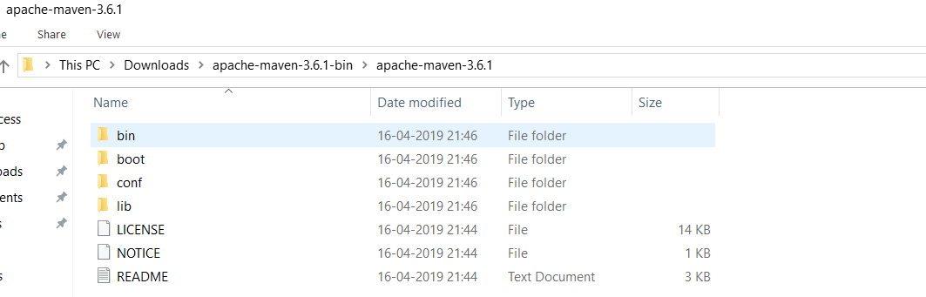

1. Right click on MyComputer -> properties -> Advanced System Settings -> Environment variables -> click new button
2. Now add MAVEN_HOME in variable name and path of maven in variable value. It must be the home directory of maven i.e. outer directory of bin. For example: C:\Users\Satyam\Downloads\apache-maven-3.6.1-bin\apache-maven-3.6.1 .It is displayed below:

