**Assignment 2: Automated S3 Bucket Cleanup Using AWS Lambda and Boto3**

**Objective**: To gain experience with AWS Lambda and Boto3 by creating a Lambda function that will automatically clean up old files in an S3 bucket.

**Task**: Automate the deletion of files older than 30 days in a specific S3 bucket.

**Instructions**:

1. S3 Setup:

- Navigate to the S3 dashboard and create a new bucket.

- Upload multiple files to this bucket, ensuring that some files are older than 30 days (you may need to adjust your system's date temporarily for this or use old files).

**Screenshot**: S3 bucket with files which are older than 30 days

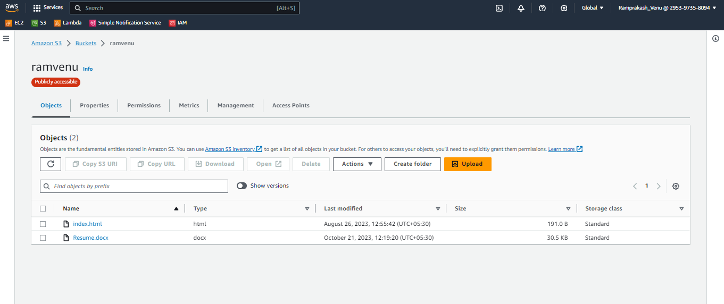

2. Lambda IAM Role:

   - In the IAM dashboard, create a new role for Lambda.

   - Attach the `AmazonS3FullAccess` policy to this role. (Note: For enhanced security in real-world scenarios, use more restrictive permissions.)

**Screenshot**: IAM Role created with all the access required to complete the tasks. ( one role for all assignment questions

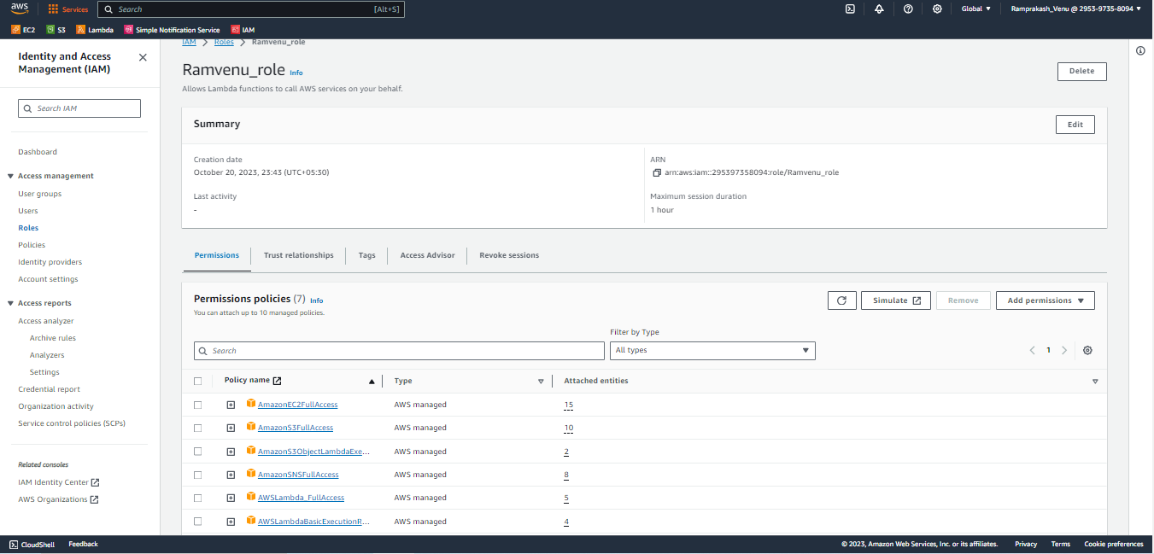

3. Lambda Function:

   - Navigate to the Lambda dashboard and create a anew function.

   - Choose Python 3.x as the runtime.

   - Assign the IAM role created in the previous step.

   - Write the Boto3 Python script to:

1. Initialize a boto3 S3 client.
2. List objects in the specified bucket.
3. Delete objects older than 30 days.
4. Print the names of deleted objects for logging purposes.

**Screenshot**: deploying Lambda codes and running it.

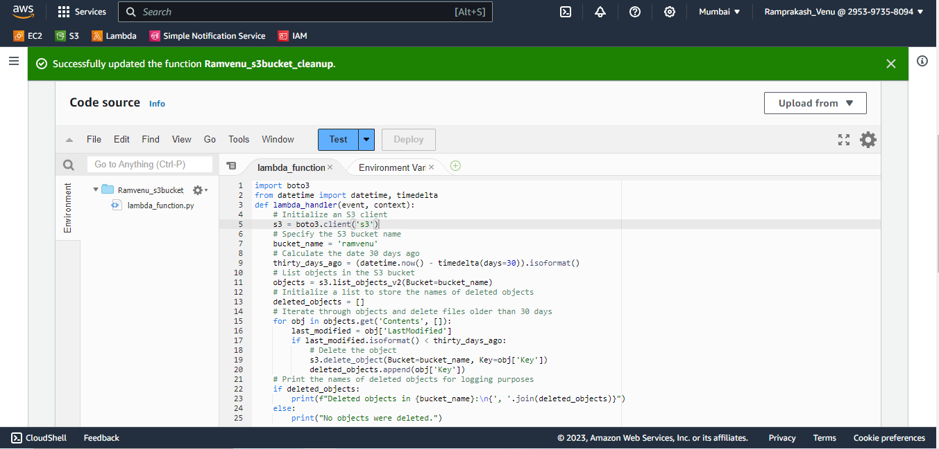

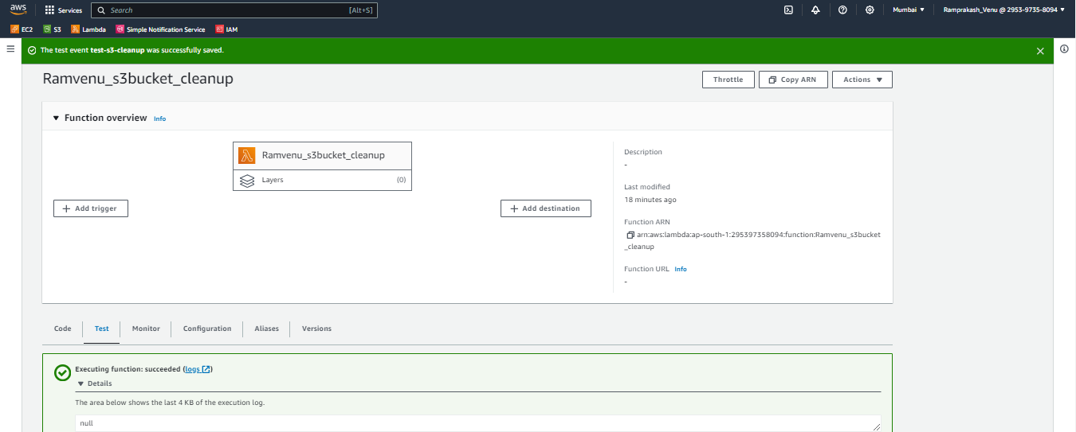

4. Manual Invocation:

   - After saving your function, manually trigger it.

   - Go to the S3 dashboard and confirm that only files newer than 30 days remain.

**Screenshot**: S3 Bucket after clearing the file older than 30 days

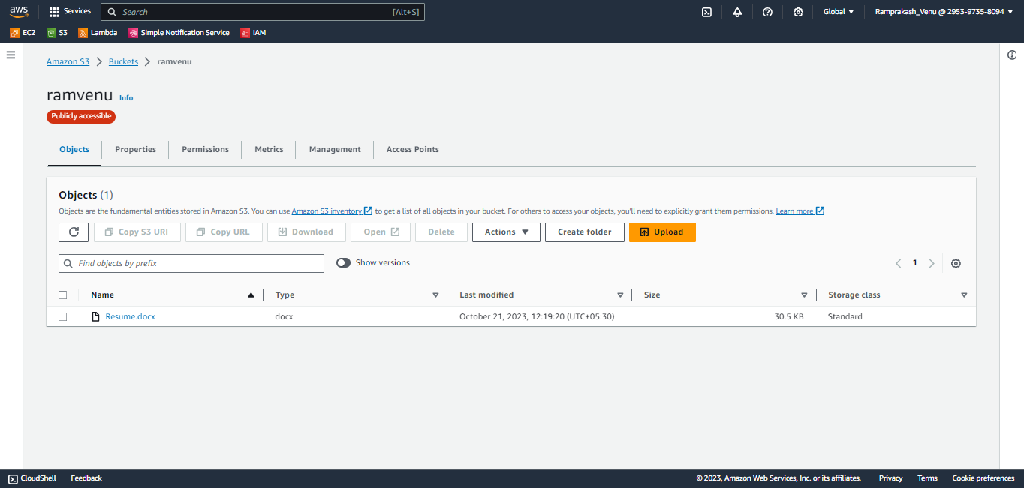

**Screenshot: Logfile indicating the task executed and the file name which was deleted**

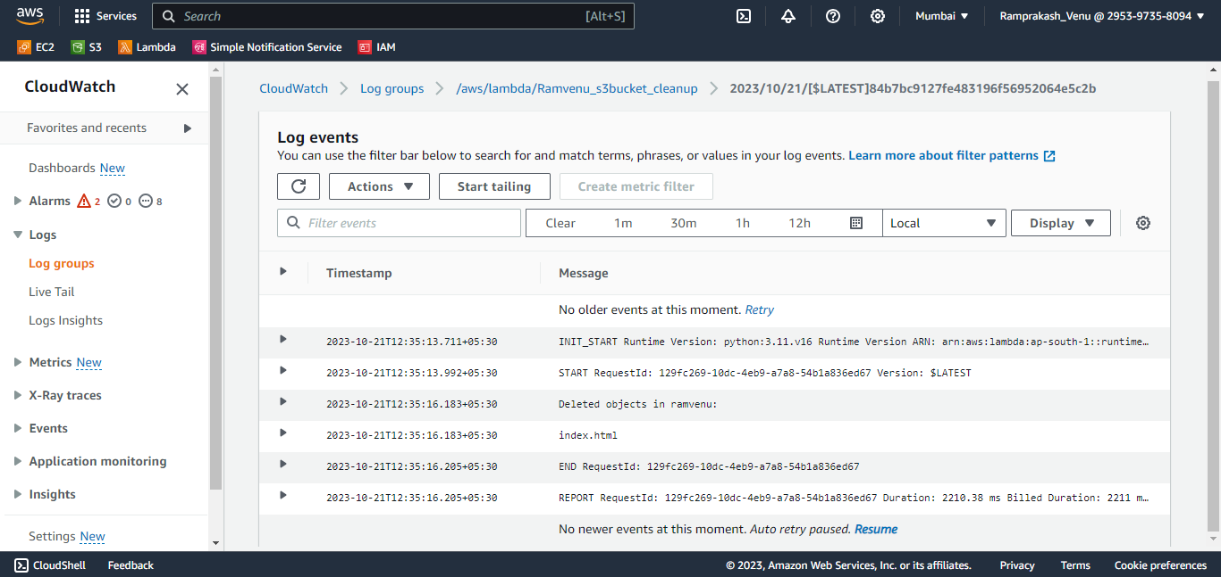

**Assignment 20: Load Balancer Health Checker**

**Objective:**Design a Lambda function that checks the health of registered instances behind an Elastic Load Balancer (ELB) and notifies via SNS if any instances are unhealthy.

**Instructions:**

1. Launch Two Ec2 instances , create Loadbalancer and add these Ec2 instance into aTarget Group

Screenshot: Ec2 instances Launched for the task



**Screenshot**: Load balancer Created

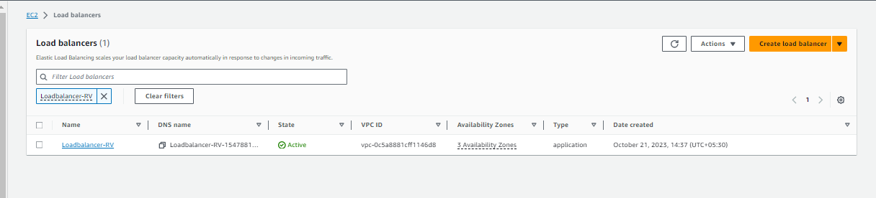

**Screenshot**: Target Group with two instances

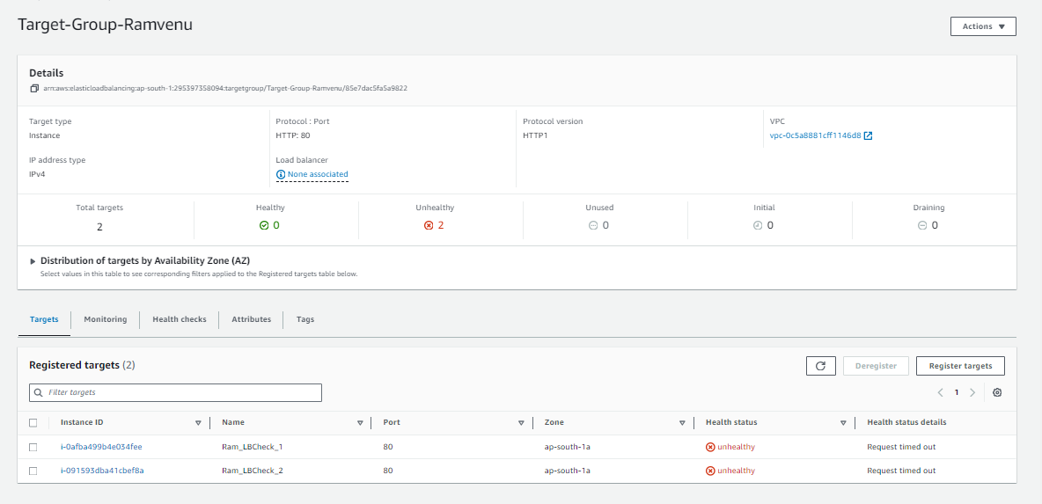

1. Create a Lambda function.

With Boto3, configure the function to:

Check the health of registered instances behind a given ELB. If any instances are found to be unhealthy, publish a detailed message to an SNS topic.

**Screenshot**: Lambda function created

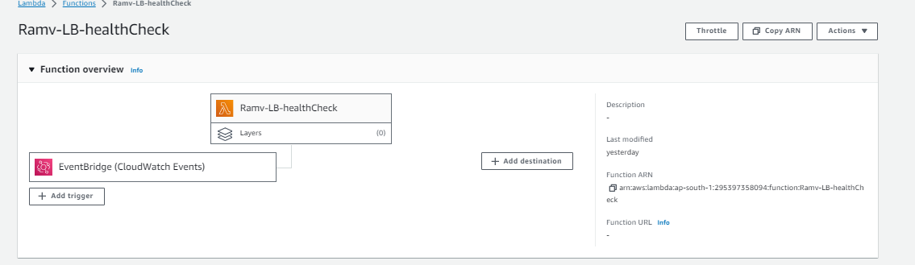

**Screenshot** : Boto3 Code

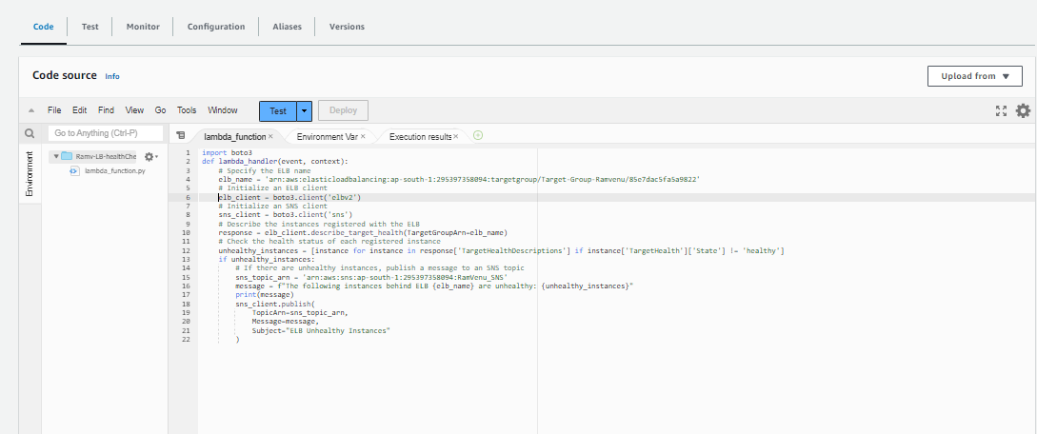

**Screenshot** : Detailed message with instance id notified on email

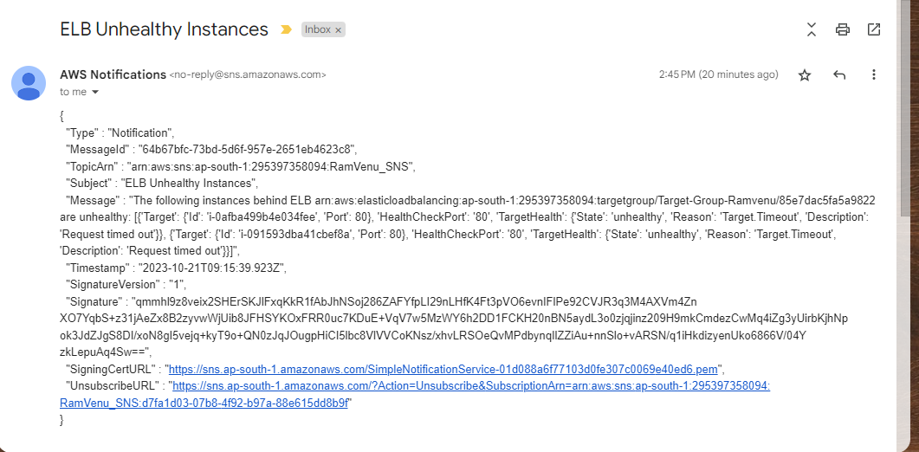

1. Set up a CloudWatch event to trigger this Lambda function every 10 minutes.

**Screenshot**: event trigger - Cron Job set to check health status every 10 mins and notify if instances is unheathy

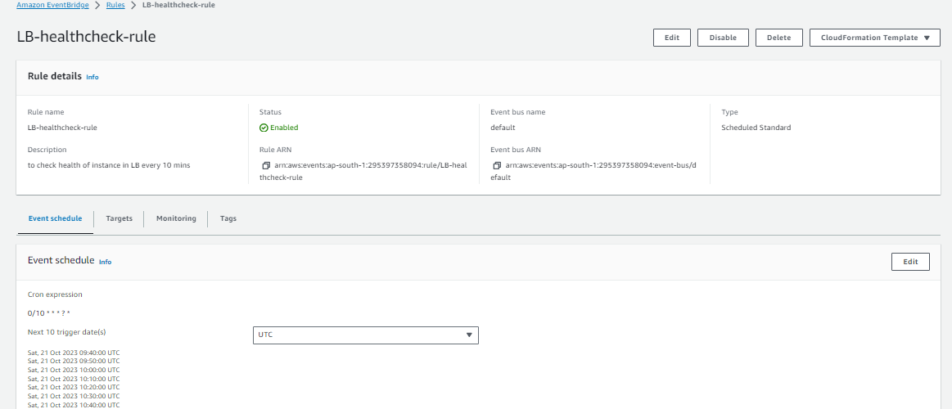

**Screenshot** : SNS message on email for every 10 mins



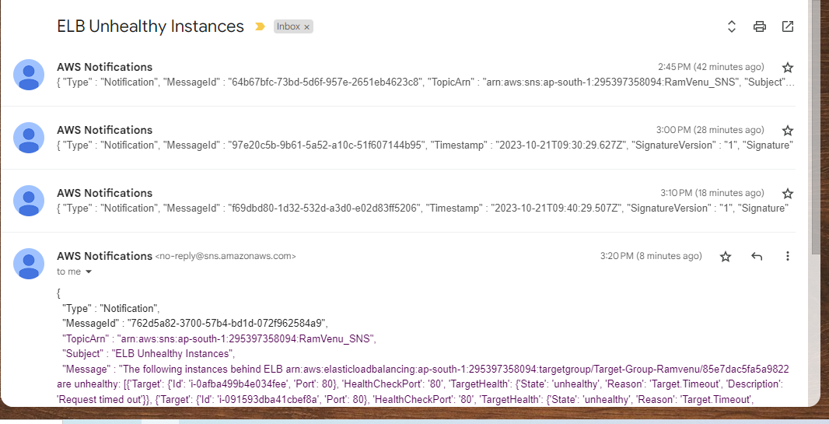

**Assignment 6: Auto-Tagging EC2 Instances on Launch Using AWS Lambda and Boto3**

**Objective**: Learn to automate the tagging of EC2 instances as soon as they are launched, ensuring better resource tracking and management.

**Task:** Automatically tag any newly launched EC2 instance with the current date and a custom tag.

**Instructions:**

1. EC2 Setup:

   - Ensure you have the capability to launch EC2 instances.

**Screenshot**: EC2 instance launched and tags before.



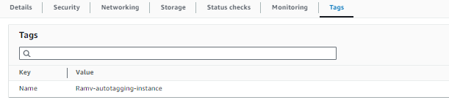

2. Lambda IAM Role:

   - In the IAM dashboard, create a new role for Lambda.

   - Attach the `AmazonEC2FullAccess` policy to this role.

**Screenshot**: IAM Role created with all the access required to complete the tasks. ( one role for all assignment questions)



3. Lambda Function:

   - Navigate to the Lambda dashboard and create a new function.

   - Choose Python 3.x as the runtime.

   - Assign the IAM role created in the previous step.

   - Write the Boto3 Python script to:

1. Initialize a boto3 EC2 client.
2. Retrieve the instance ID from the event.
3. Tag the new instance with the current date and another tag of your choice
4. Print a confirmation message for logging purposes.

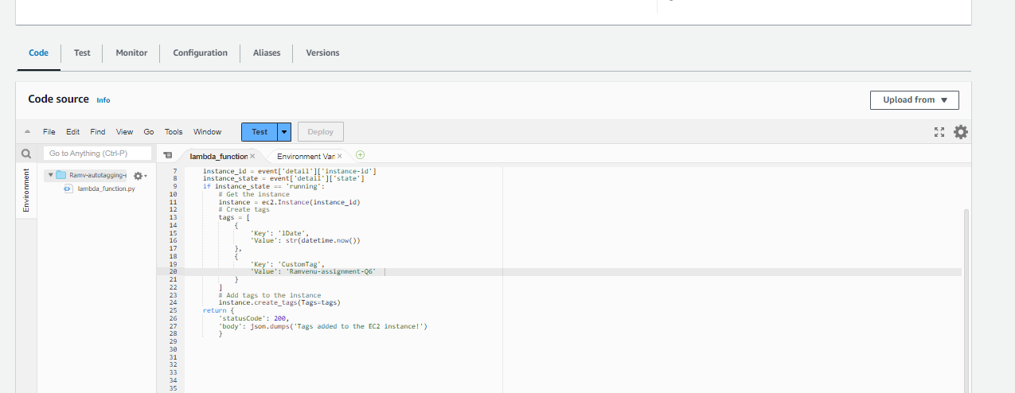

4. CloudWatch Events:

   - Set up a CloudWatch Event Rule to trigger on the EC2 instance launch event.

   - Attach the Lambda function as the target.

**Screenshot**: Triggers configured for lambda function

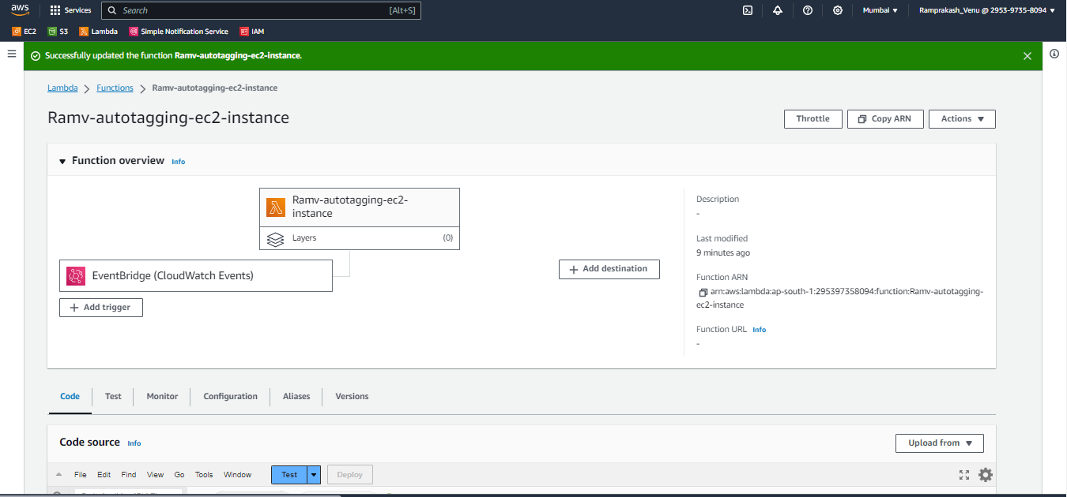

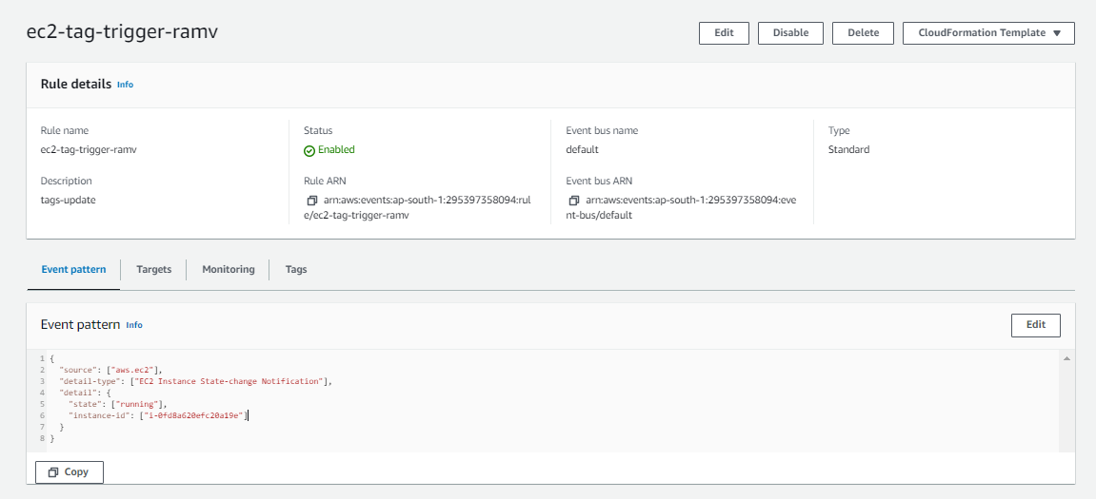

5. Testing:

   - Launch a new EC2 instance.

   - After a short delay, confirm that the instance is automatically tagged as specified.

**Screenshot**: Tags successfully updated



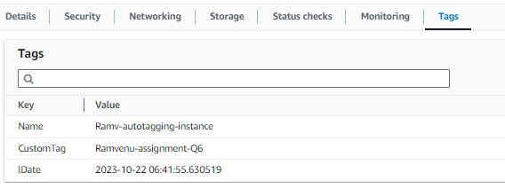

**Assignment 15: Monitor EC2 Instance State Changes Using AWS Lambda, Boto3, and SNS**

**Objective:** Automatically monitor changes in EC2 instance states and send notifications whenever an instance is started or stopped.

**Task:** Set up a Lambda function that listens to EC2 state change events and sends SNS notifications detailing the state changes.

**Instructions:**

1. SNS Setup:

   - Navigate to the SNS dashboard and create a new topic.

   - Subscribe to this topic with your email.

**Screenshot** : SNS dashboard

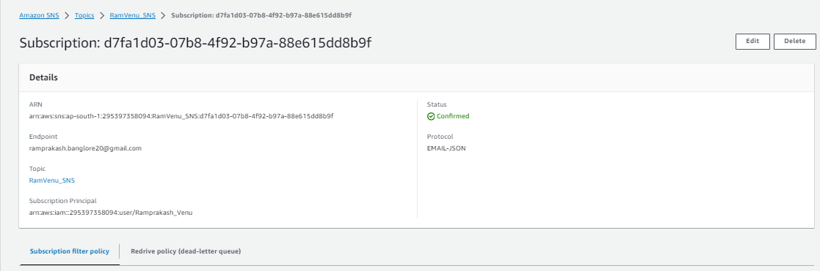

2. Lambda IAM Role:

   - Create a role with permissions to read EC2 instance states and send SNS notifications.

**Screenshot**: IAM Role created with all the access required to complete the tasks. ( one role for all assignment questions)



3. Lambda Function:

   - Create a function and assign the above IAM role.

   - Use Boto3 to:

1. Extract details from the event regarding the EC2 state change.
2. Send an SNS notification with details about which EC2 instance changed state and the new state (e.g., started, stopped).

**Screenshot**: Lambda Function

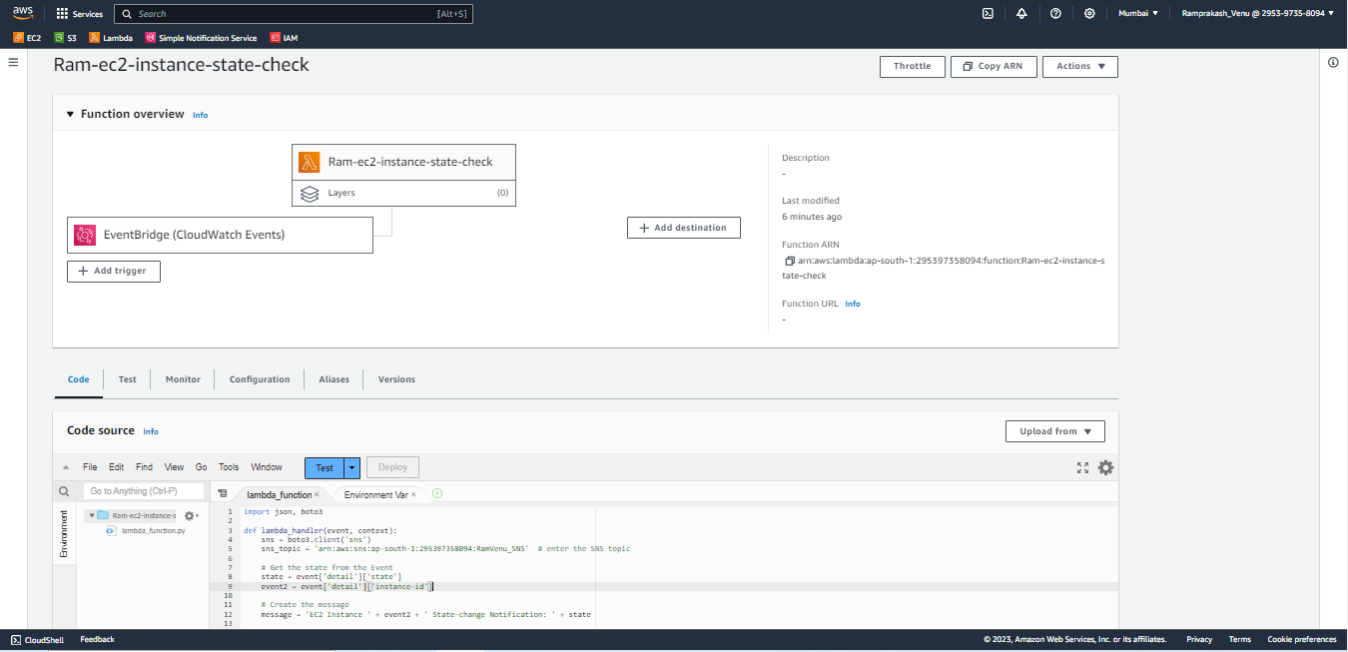

4. EC2 Event Bridge (formerly Cloud Watch Events):

   - Set up an Event Bridge rule to trigger your Lambda function whenever an EC2 instance state changes.

**Screenshot**: EventBridge rule configuration

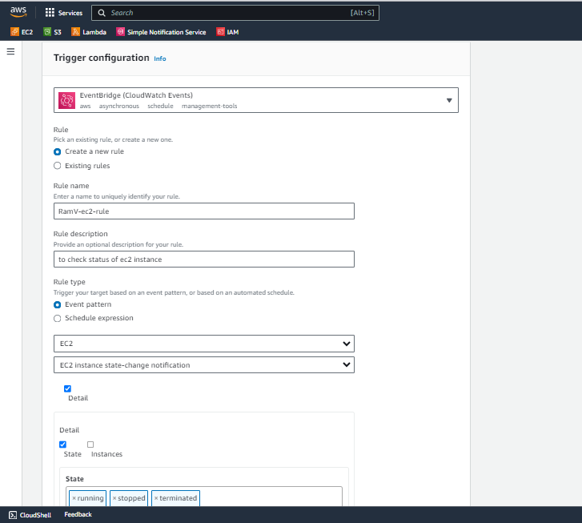

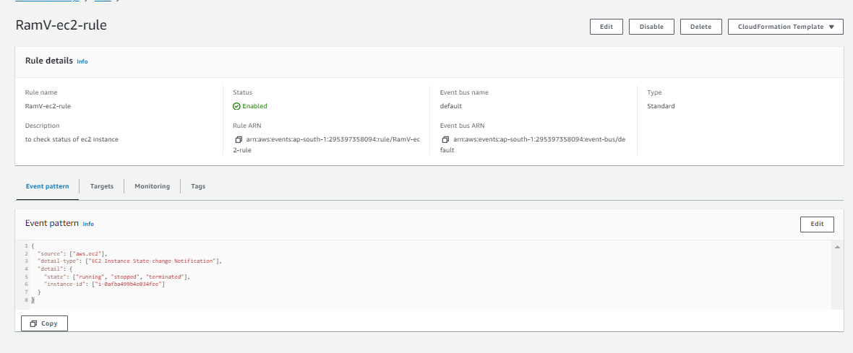

5. Testing:

   - Start or stop one of your EC2 instances.

   - Confirm you receive an SNS notification about the state change.

**Screenshot**: State of Ec2 instance Ram_LBcheck_1 before testing

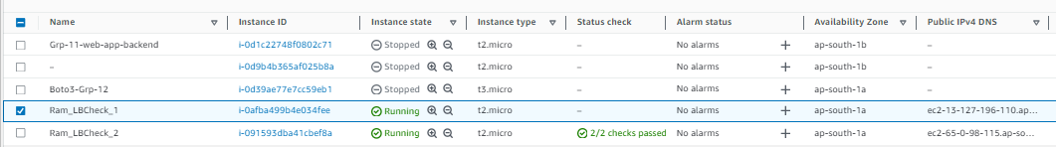

**Screenshot**: State changed from running to stopped.



**Screenshot**: Notified through email about state change an related information

