* **Task 1:** Set Up a Simple HTML Project
  + - Create a simple HTML project and push it to a GitHub repository.
* **Task 2:** Set Up an AWS EC2/Local Linux Instance with Nginx
* **Task 3:** Write a Python Script to Check for New Commits
  + - Create a Python script to check for new commits using the GitHub API.
* **Task 4:** Write a Bash Script to Deploy the Code
  + - Create a bash script to clone the latest code and restart Nginx.
* **Task 5:** Set Up a Cron Job to Run the Python Script
  + - Create a cron job to run the Python script at regular intervals.
* **Task 6:** Test the Setup
  + - Make a new commit to the GitHub repository and check that the changes are automatically deployed.

**Github URL: https://github.com/Ram495-ctrl/CICD_HV.git**

# TASK1

**Created a new repository in GITHUB and clone**

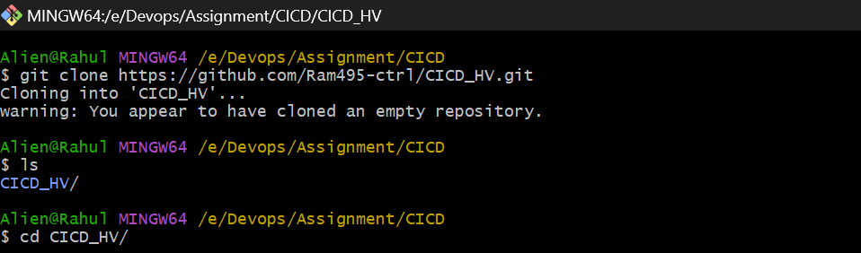

Create index.html file

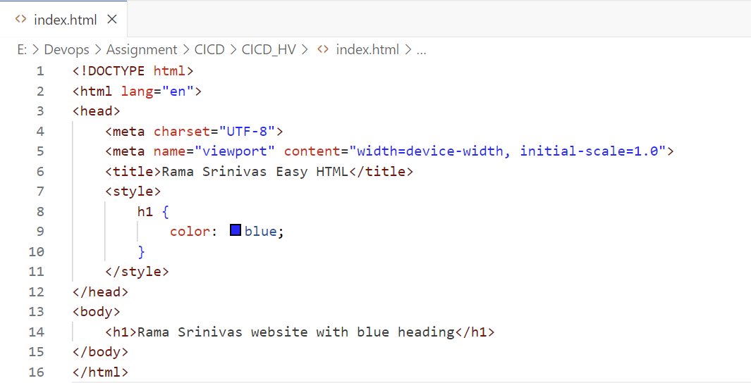

**Commit and push to main**

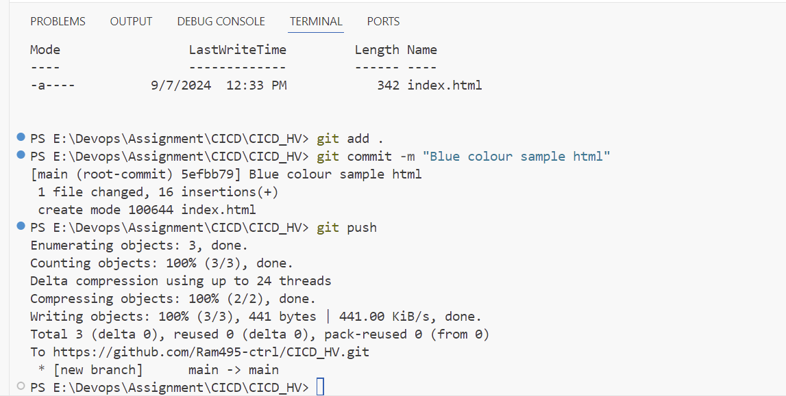

**Can see in Git remote**

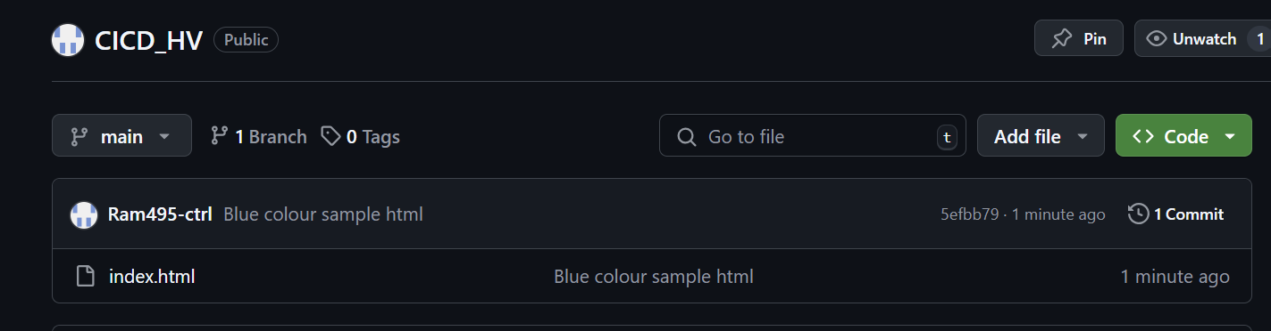

Task 2**:** Set Up an AWS EC2/Local Linux Instance with Nginx deploying the app1

**Create an Ec2 Instance running and hosting our simple html in app1**

**Im running all instructions as part of the start up script for ease and the startup script is shown below**

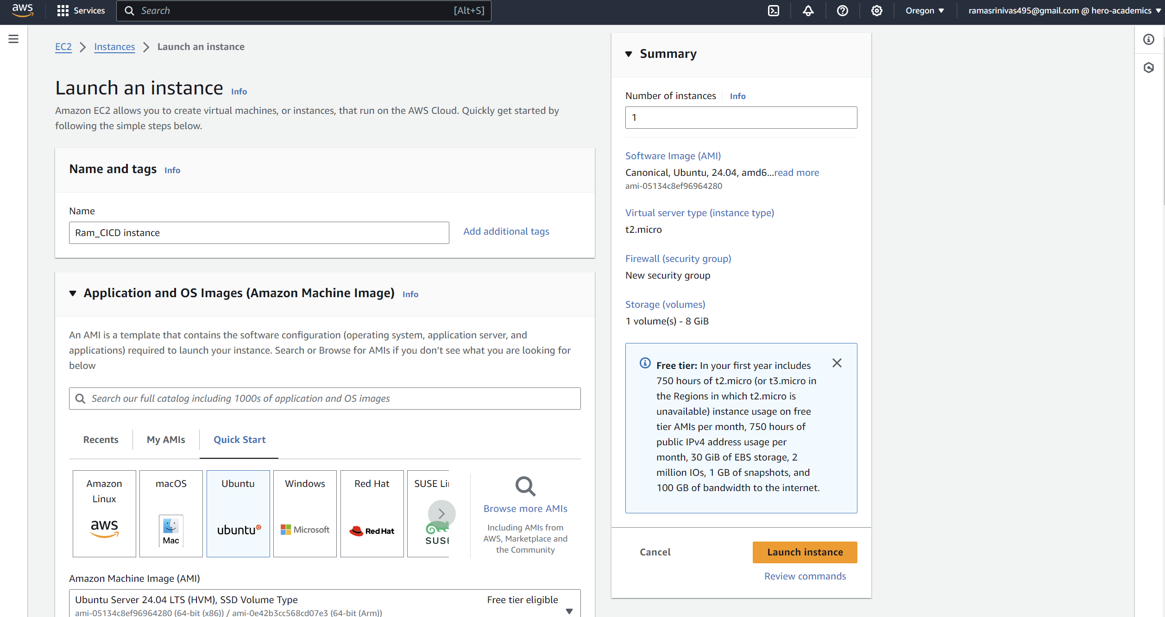

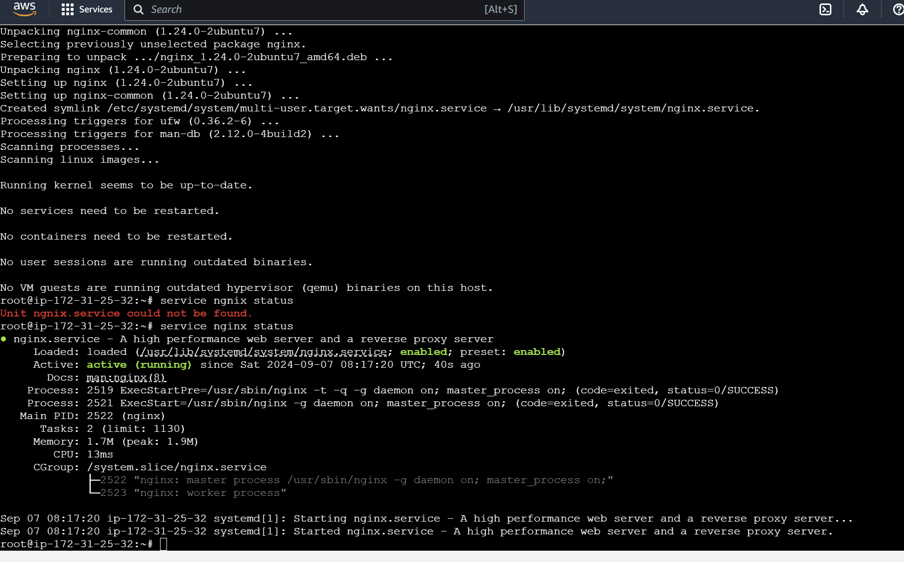

PublicIP: 35.94.60.13

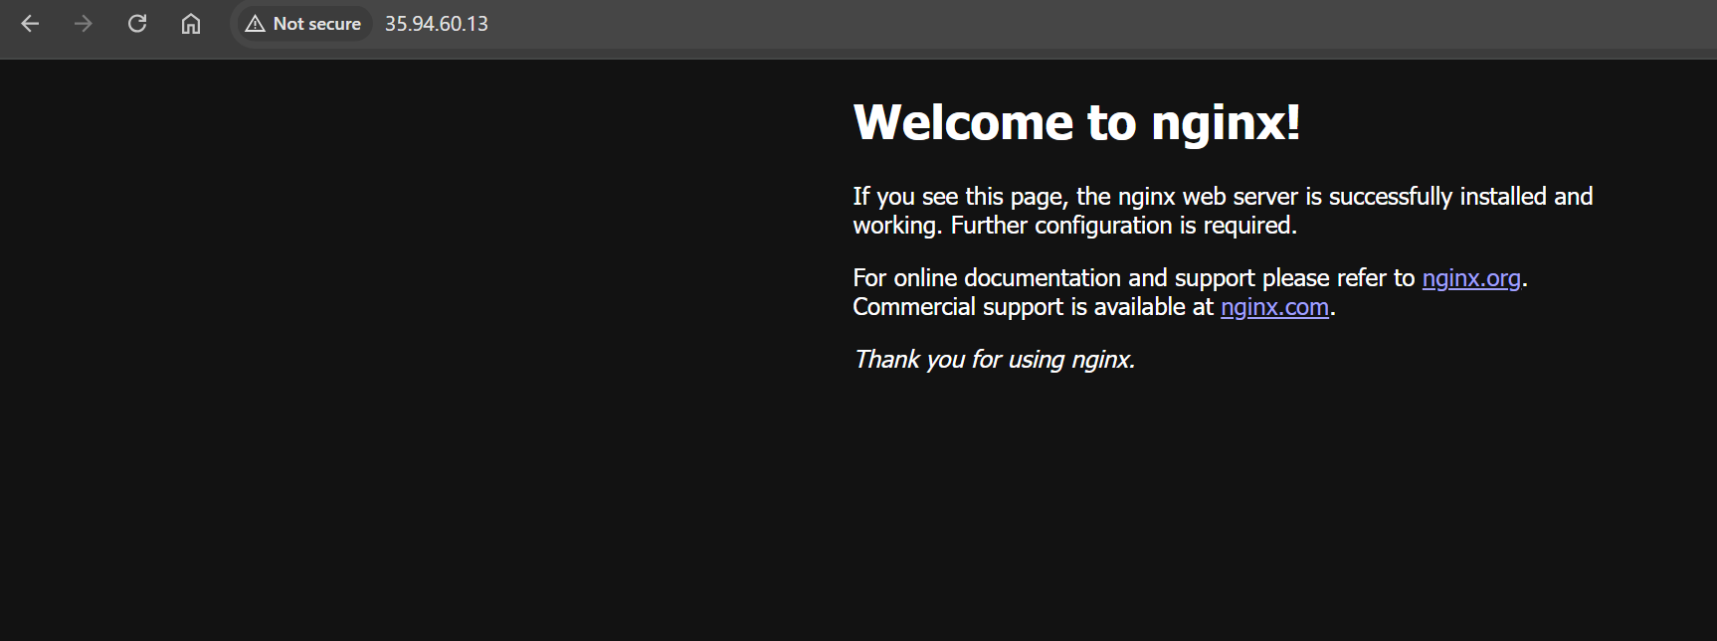

# Create the /var/www/html/app1 directory if it doesn't exist

# Give necessary permissions to the /var/www/html/app1 directory

# sudo chmod -R 755 /var/www/html/app1

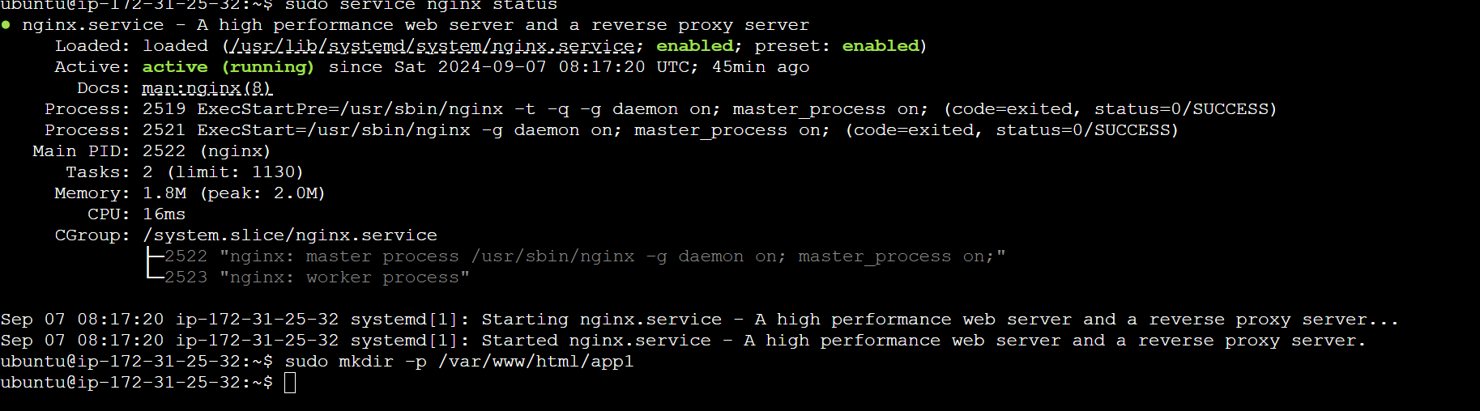

**Do Git clone in EC2:**

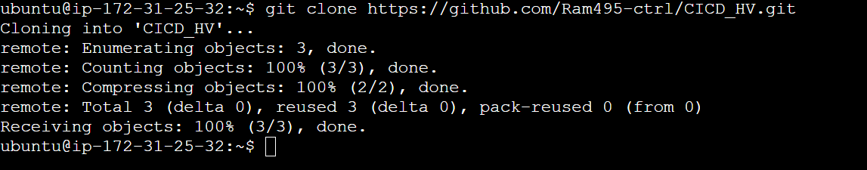

**Create bashscript.sh file**

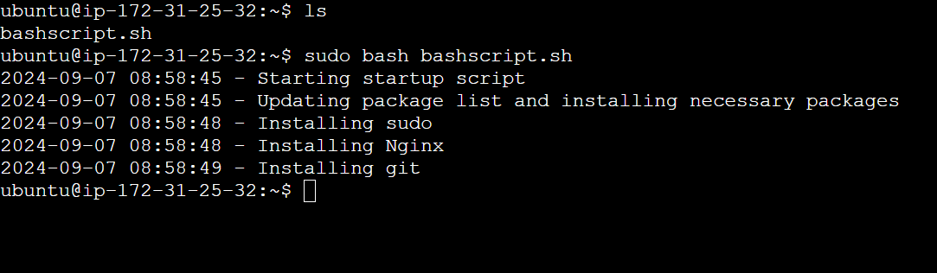

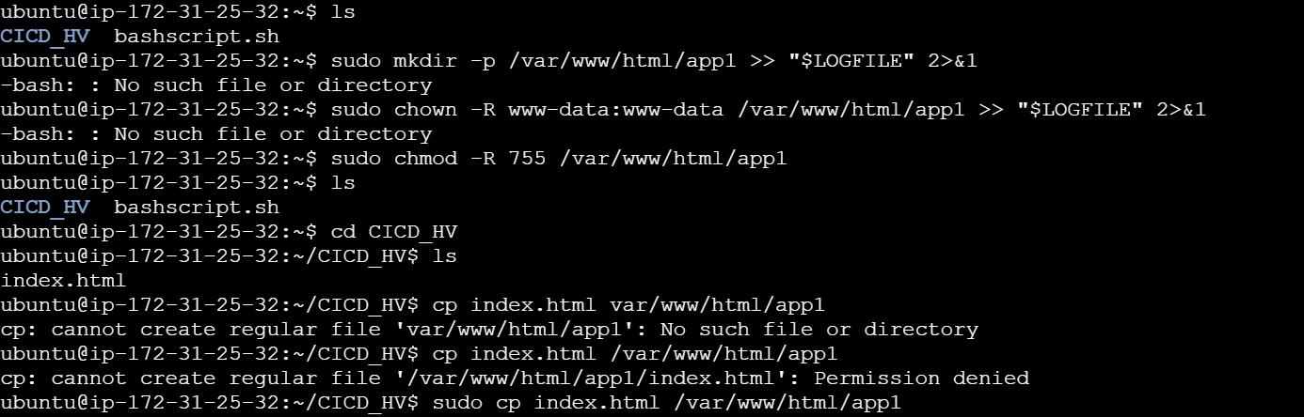 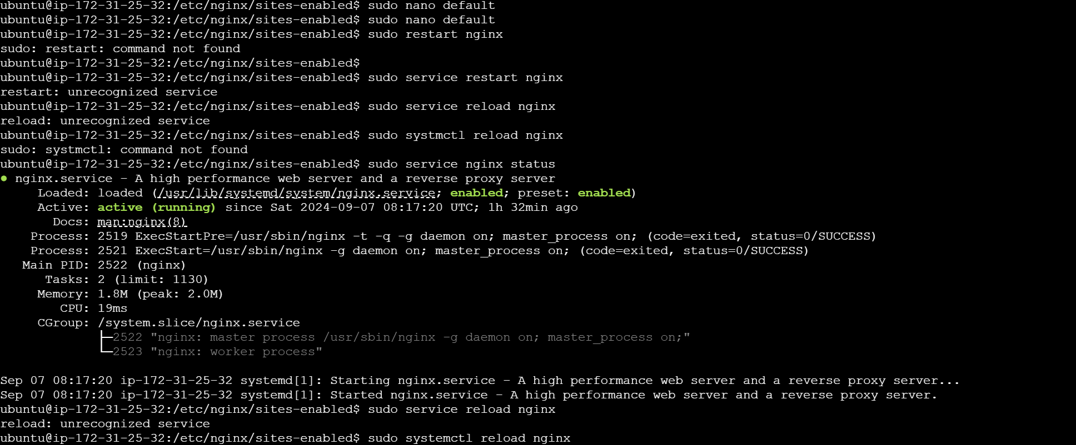

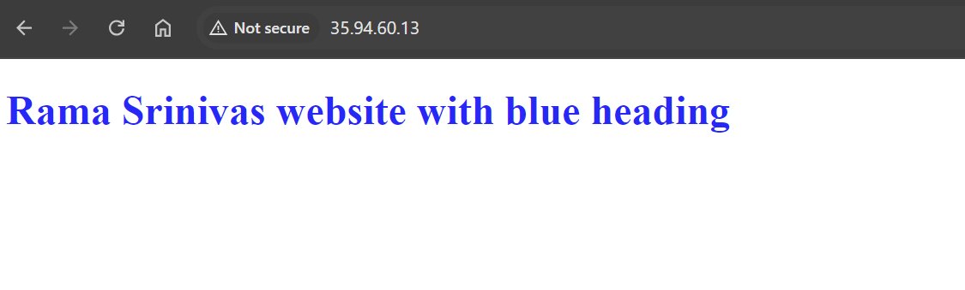

**Create Bash file**

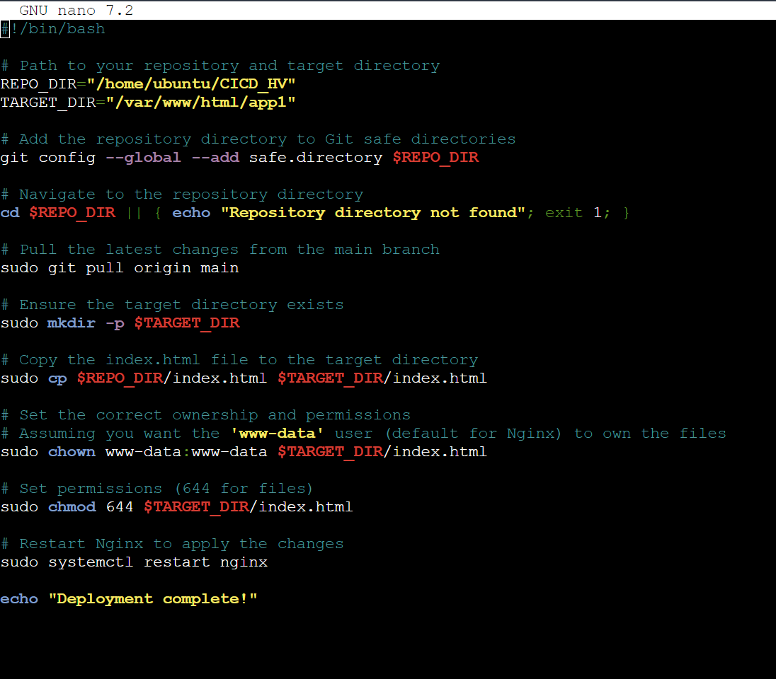

**Changing the html and pushing the Green colour code to GITHUB which should be picked up automatically now by the cronjob**

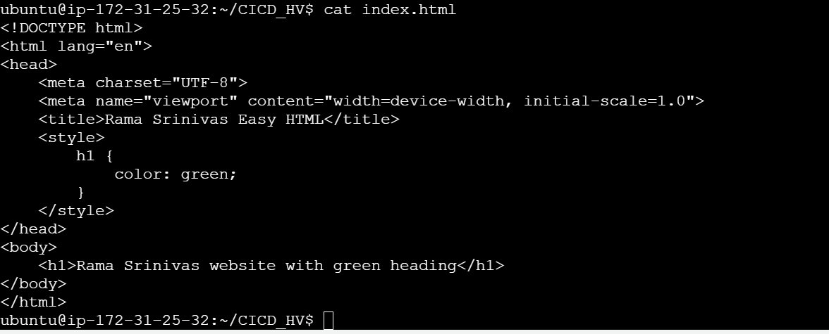

**Cronjob to run every minute to check for commits**

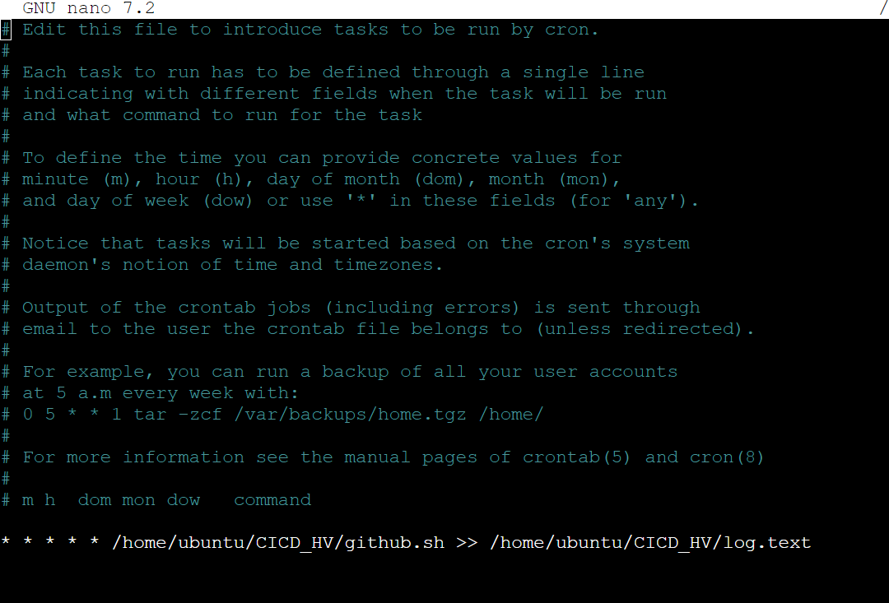

**Test now changing the html and pushing the Green colour code to GITHUB which should be picked up automatically now by the cronjob**

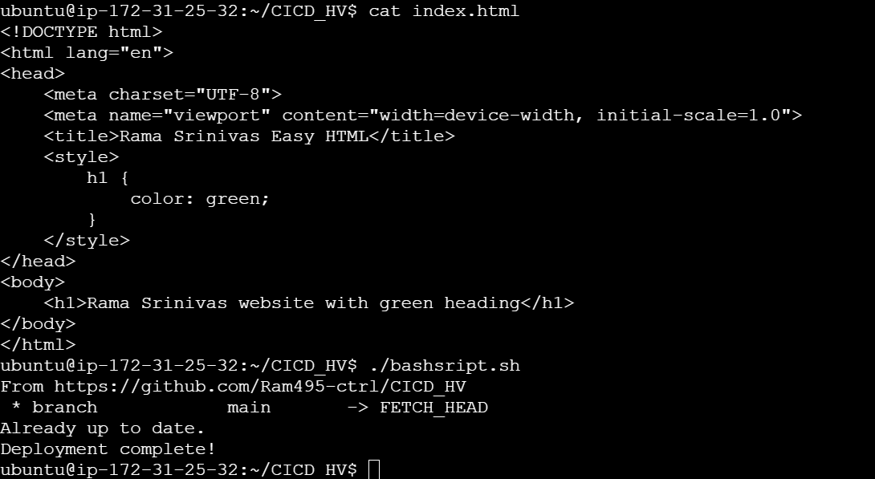

**Finally colour is changed to Green automatically once the shell script is executed**

