Hangaroo

1. Added a start button and the phrase to be guessed.

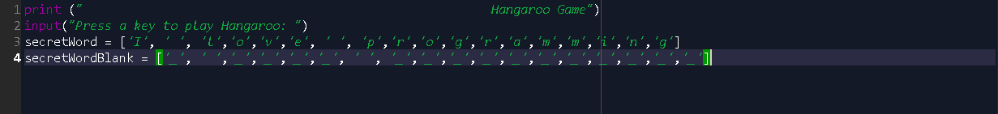

1. Added a loop and control statements where the game tells you whether you guessed a correct letter

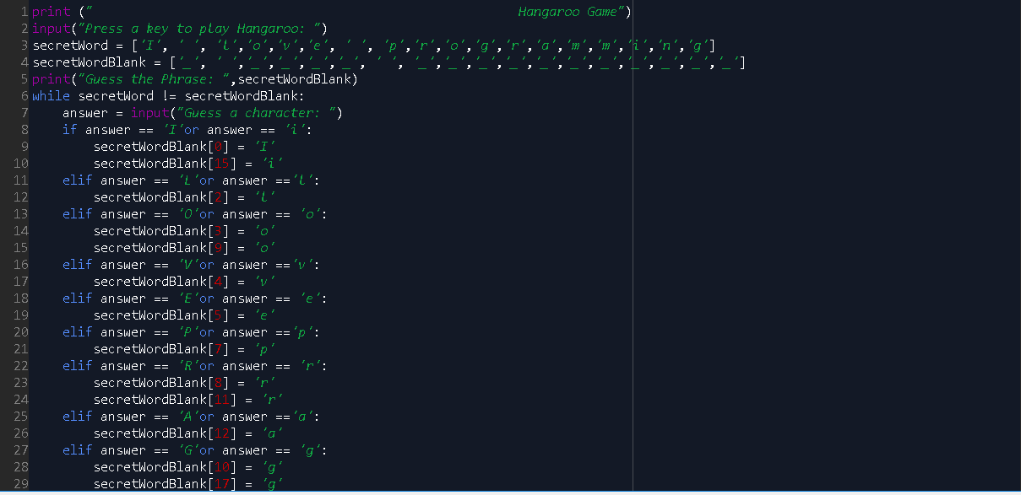

1. Added a control statement to tell the player that he guessed wrong.

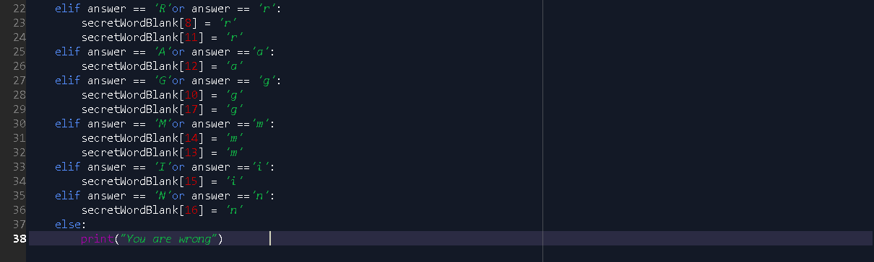

1. The game prints the blanks and the letters guessed every turn.

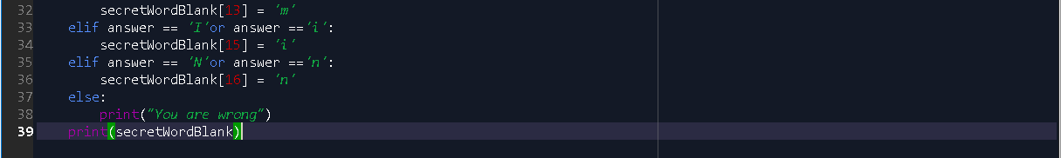

1. If the phrase is completed, the program will tell you so that you beat the game.

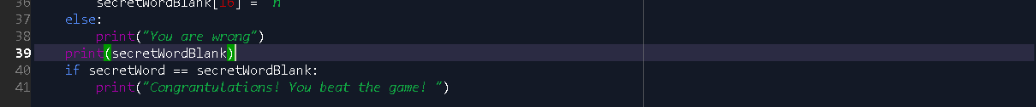

1. The program will now tell the number of turns you took to beat the game.



1. Output

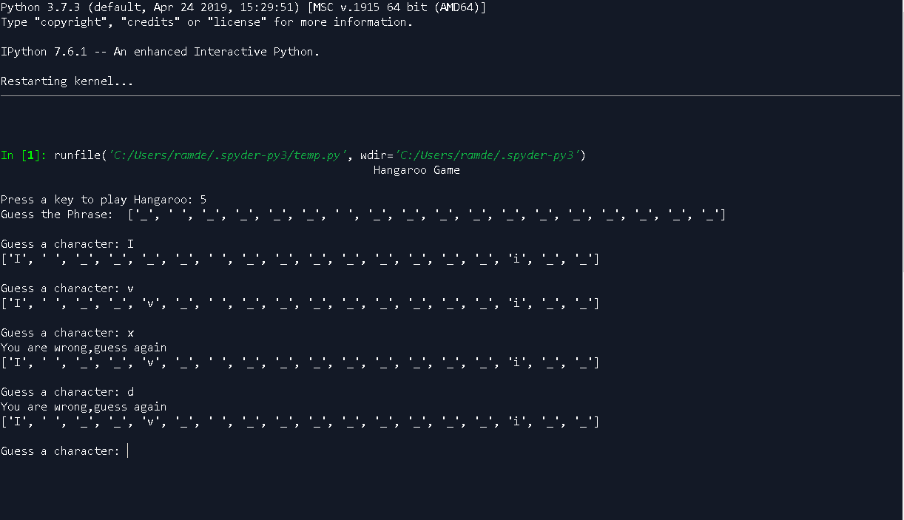

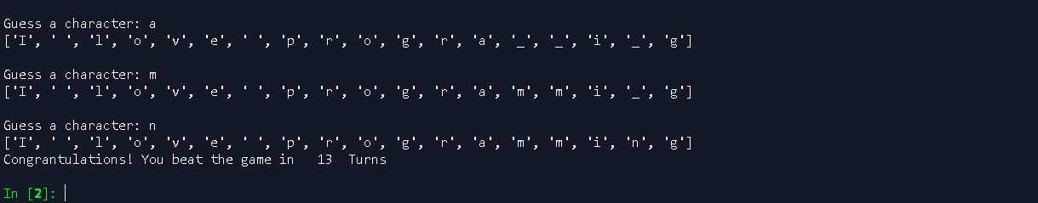

**Is word guessed**

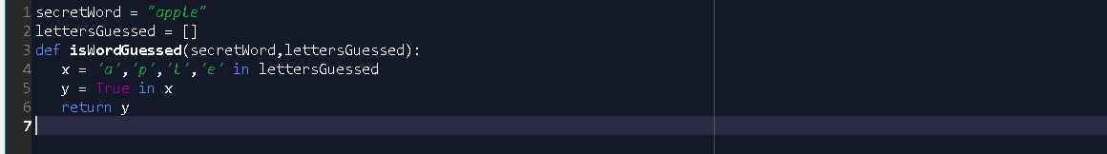

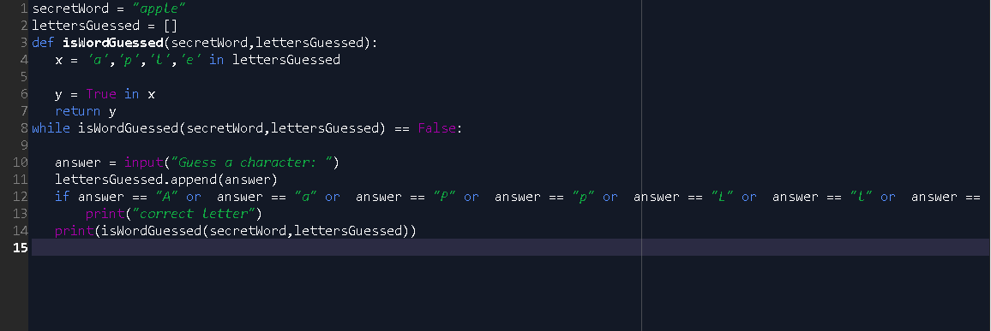

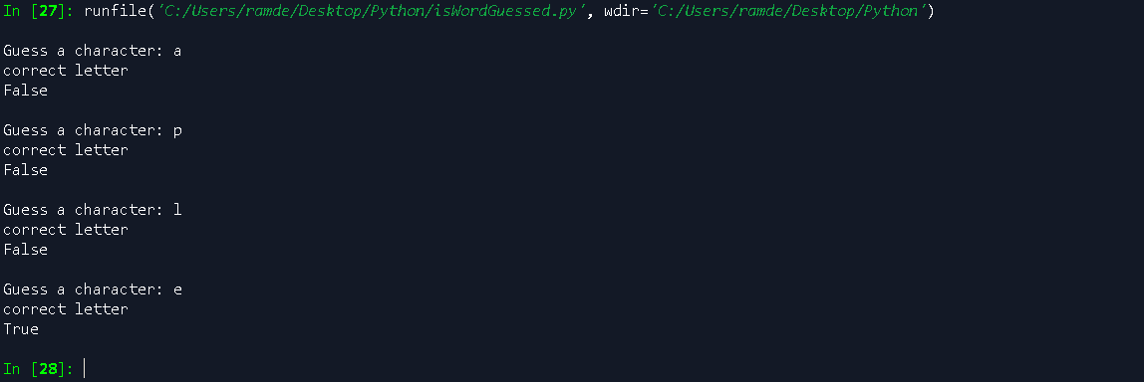

**getGuessedWord**



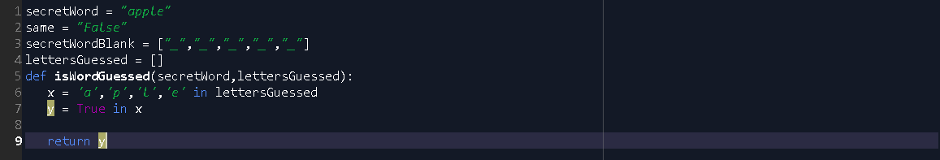

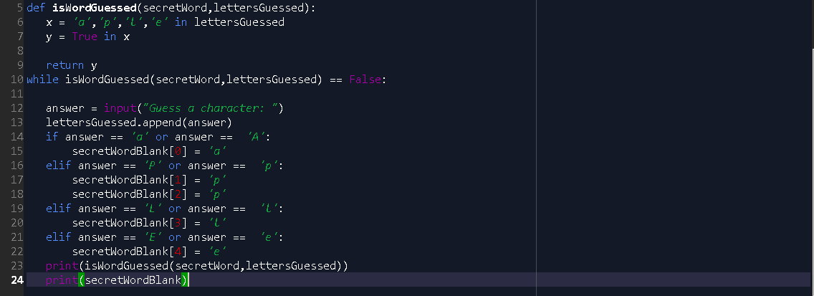

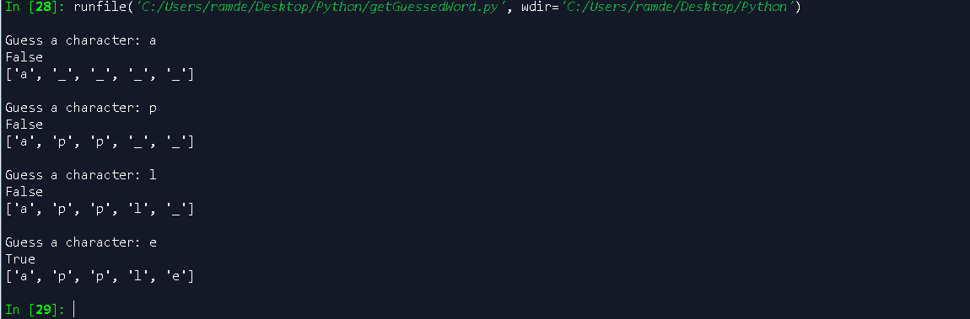

**getAvailableLetters**

