**Problem 1**

**Loaded csv file**

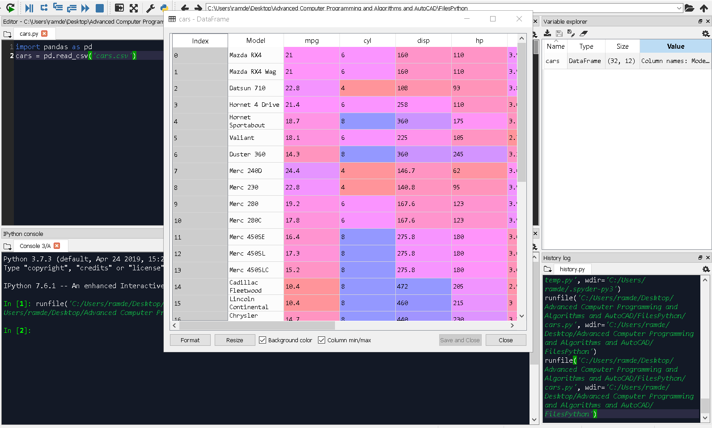

**Added commands to display first and last 5 rows of the data frame.**

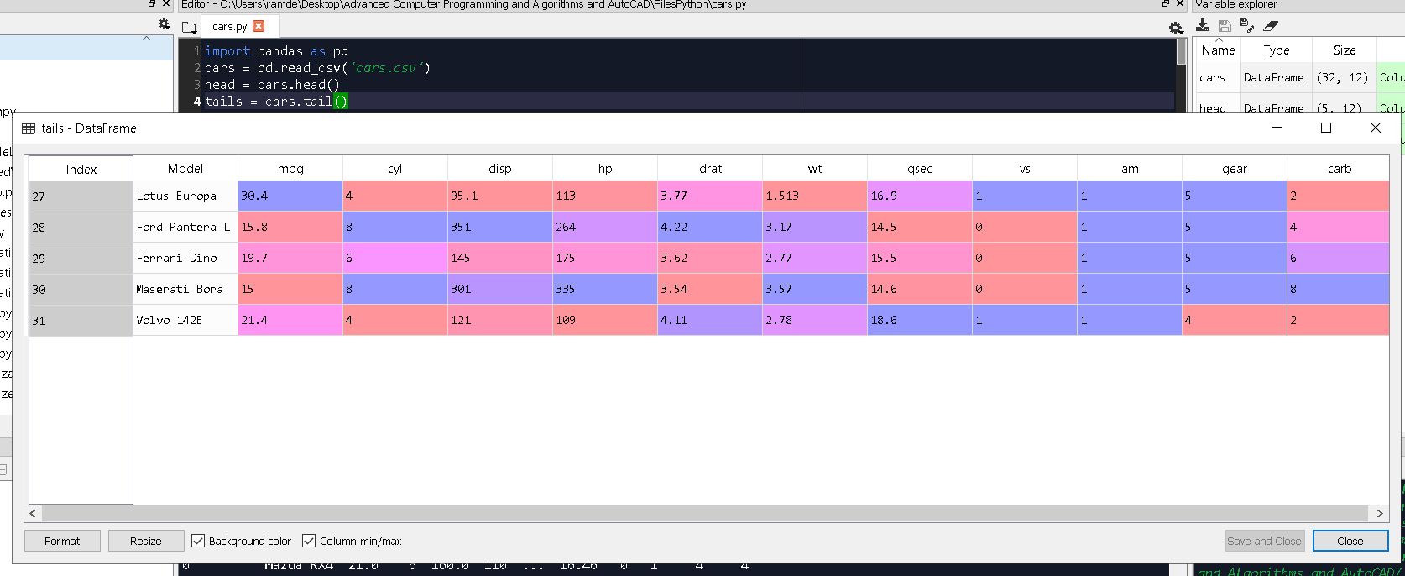

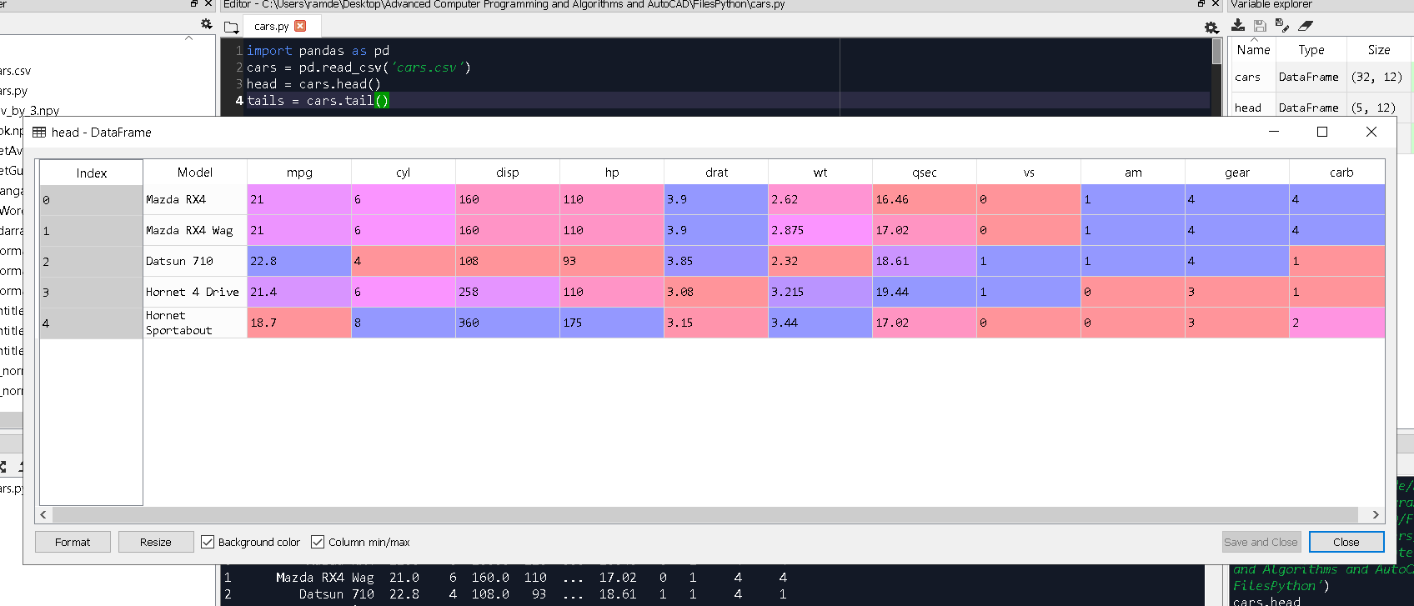

**Problem 2**

1. **Display the first five rows that with odd-numbered columns (columns 1,3,5,7…) of cars.**

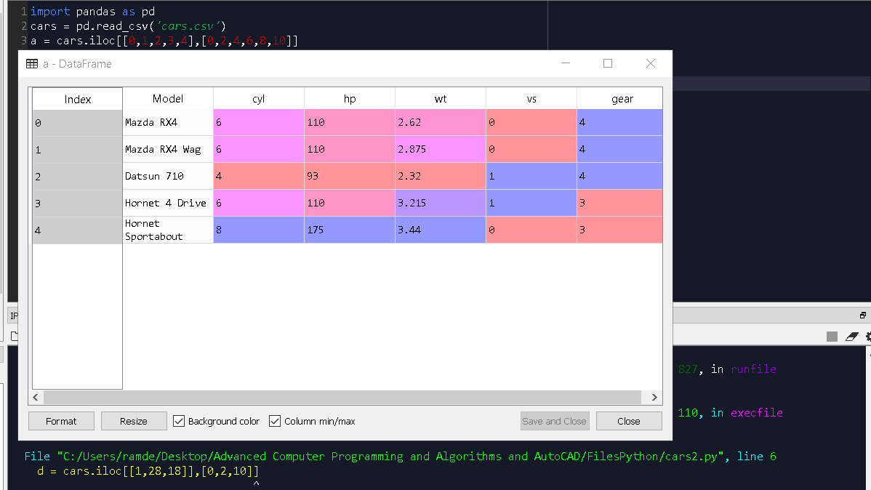

1. **Display the row that contains ‘Model’ of ‘Mazda RX4’**

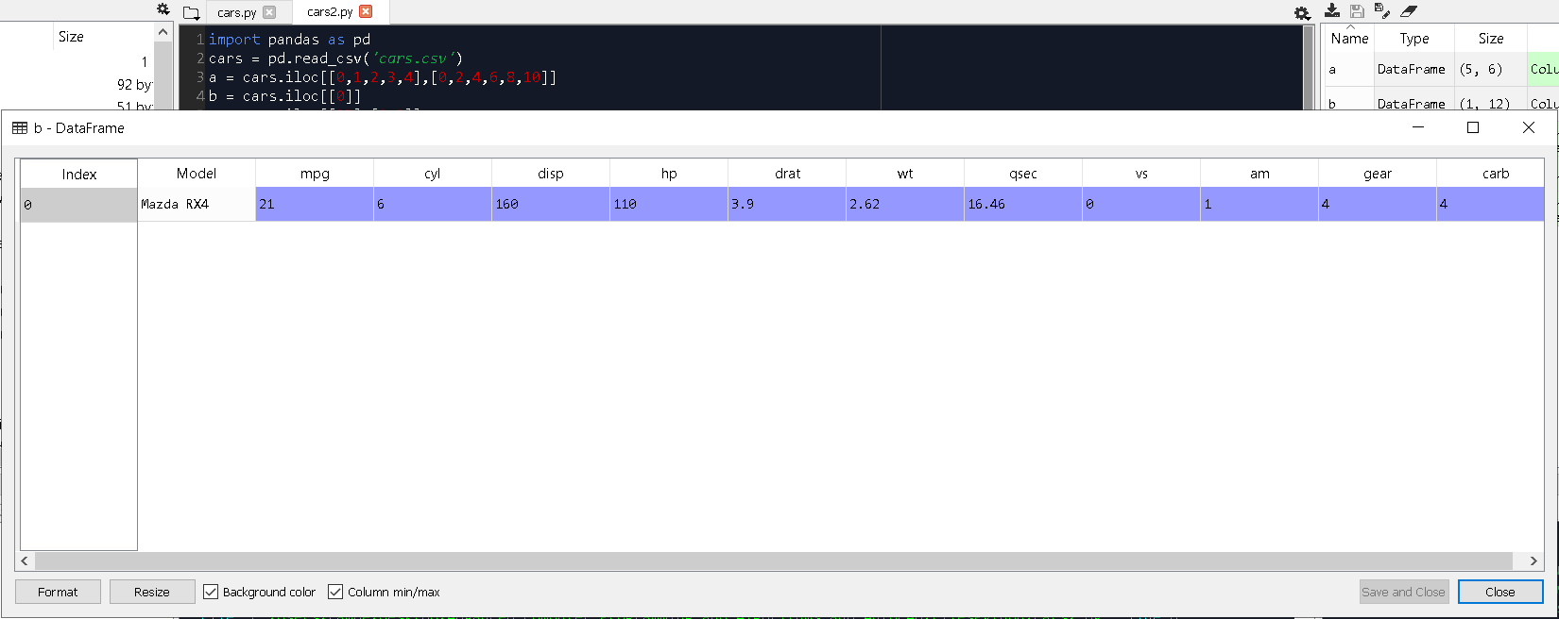

1. **How many cylinders (‘cyl’) does the car model ‘Camaro Z28’ have?**

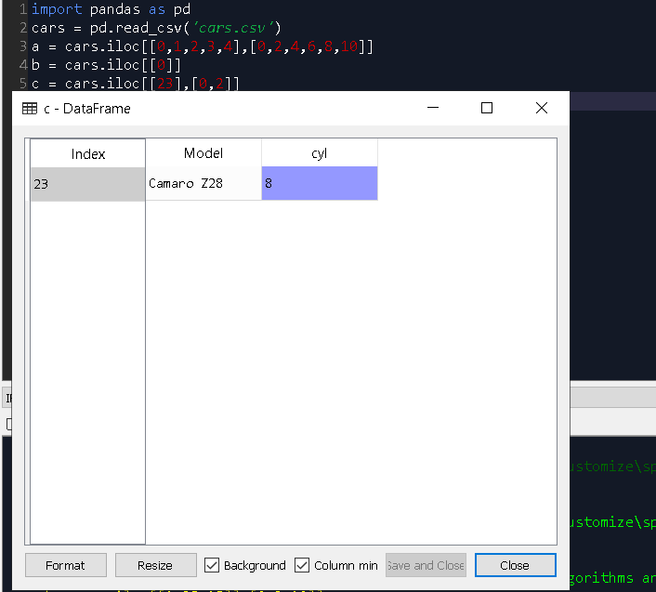

1. **Determine how many cylinders ‘cyl’ and what gear type ‘gear’ do the cars models ‘Mazda RX4**

**Wag’, ’Ford Pantera L’ and ‘Honda Civic’ have?**

