Ramdhanush.V

205001082

CSE-B

1.

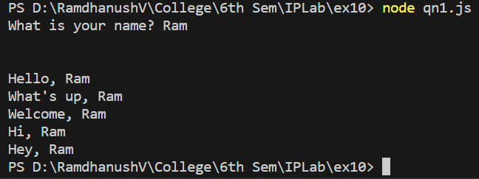

2.

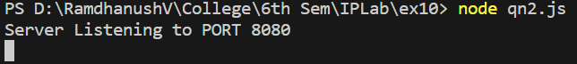



3.

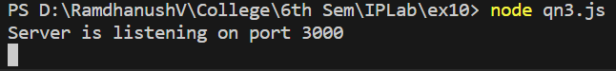

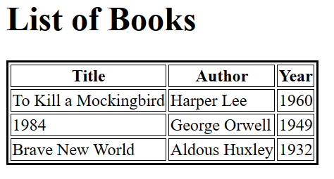

4.