**TheFoodCourt**

**User Manual**

**TheFoodCourt** is a website which allows users to search for restaurants in New York City by unique and original parameters. It is the first website that features restaurant search by favored ingredients or by taste preferences. Apart from these two main search features, the website also supports some more unique features which will be described as well.

1. **Restaurant Search**

The main page of the website displays one of the two restaurant searches. Each restaurant search is different by its main unique search parameter. Other shared search parameters are the following:

* Price range – either unbounded or a price range out of a discrete number of options.
* Review rating – filter restaurants by minimal review rating (between 0.0 and 5.0).
* Online deliveries – either without a filter, or an option to search only for restaurants that have online deliveries.
* Location – the user can also activate search by location. If this option is activated, the restaurants in the result will all be in a small distance from the center of the map when the search is run.

The unique search parameters themselves are in two different pages, either the main page (also ‘find restaurants by ingredient’) and the ‘find restaurants by taste’ page.

The ‘find restaurants by ingredient’ page (image 1.1) includes a full text search. The user can input an ingredient name which is then checked against the ingredients in the database as a prefix of the user’s input. For example, if the user inputs ‘asp’, one of the results will be ‘asparagus’. The results are then displayed as a hint for the user. The restaurant search will only display restaurants if the user inputs a valid ingredient that exists in the database. This is why the hint options are needed and useful.

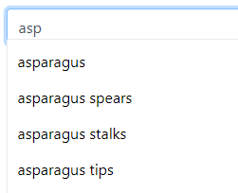

(image 1.1)

In the ‘find restaurants by taste’ page, the flavors picker replaces the full text search. Here, the user can choose the picker state ( $2^{4}=16$ options) to best match the user’s taste. For each flavor (e.g. ‘sweetness’), the user can choose whether he/she likes it or not. Image 1.2 shows the page and the taste pickers.

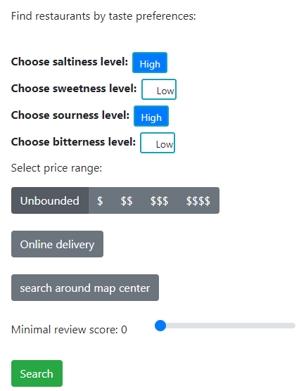

(image 1.2)

To go from ingredient or taste preferences to restaurants, the backend runs unique SQL queries to find the cuisines which are the most associated with them, and then searches for restaurant of these cuisine types. See SOFTWARE_DOCUMENTATION for more details on that.

After clicking the search button, the search results are displayed in a table, which gives the user the option to both order the column by the order of his/hers choosing and decide on the amount of results per page. An option to display the restaurant location on the map is available by pressing on the  icon in the ‘Show on map’ column. An example of the table and the map with results can be seen in image 1.3 below.

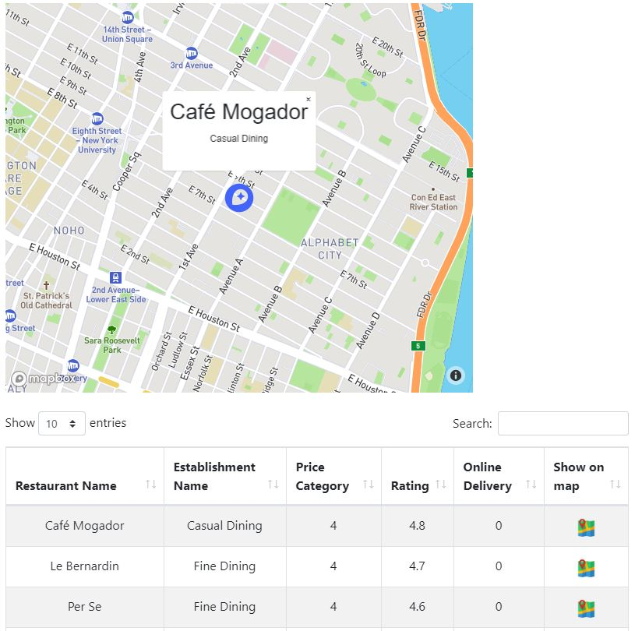

(image 1.3)

1. **Cuisines**

Two of the additional features in the website are related to cuisine types. We at TheFoodCourt decided to utilize our database to give unique information on cuisine types. These two additional features can be seen in the ‘Cuisines’ page (see image 2.1 below). Both searches in that page are based on an input cuisine type which can be selected with the cuisine selector. The search type is decided by a radio button.

The first one is ‘Discover similar cuisines’. This search finds other cuisines which are similar to the input cuisine by their top common ingredients. The second one is ‘Show cuisine’s unique ingredients’, and as the name suggests, this shows the input’s cuisine top unique ingredients.

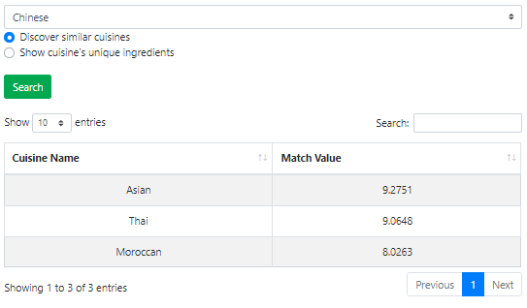

(image 2.1)

1. **Best franchise to open**

Finally, we at TheFoodCourt understand that information is power, and that money is power, and that’s why we offer the last feature of the website – searching for the best franchise one can open at a given location. This service allows users who want to open a branch of a franchise in a specific location to know which franchise will be optimal for it. See the SOFTWARE_DOCUMENTATION for more information on how this search is implemented.

In the ‘Best franchise location’ (**TODO** – better name?)page (see image 3.1) the user can choose a location on the map (by centering the map around the location, similarly to the location filtering in the restaurant search) and after clicking search, the suggested franchises will be displayed below in a table.

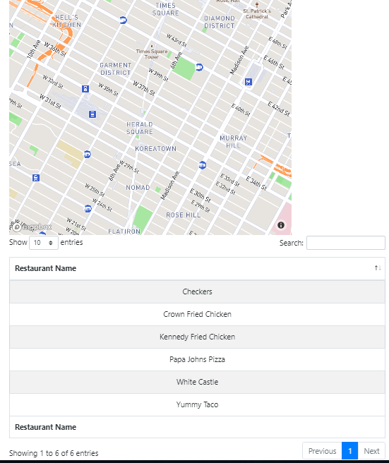

(image 3.1)