EDTK – EAI – CRM

(DAD Upload to Siebel CRM Performance/Load Testing) Documentation.

- This Document Details the findings of initial load testing done on the EAI integration piece built for EDTK-EAI-Siebel integration for DAD Upload to Siebel.

- Environment:Single Node

- Individual issues encountered as part of payloads that contain about 2500 Quote Line Items.

- Sections would include

- Component Model Diagram:
- Issues:
- Cause:
- Resolution:
- Open Queries:

Component Model Diagram

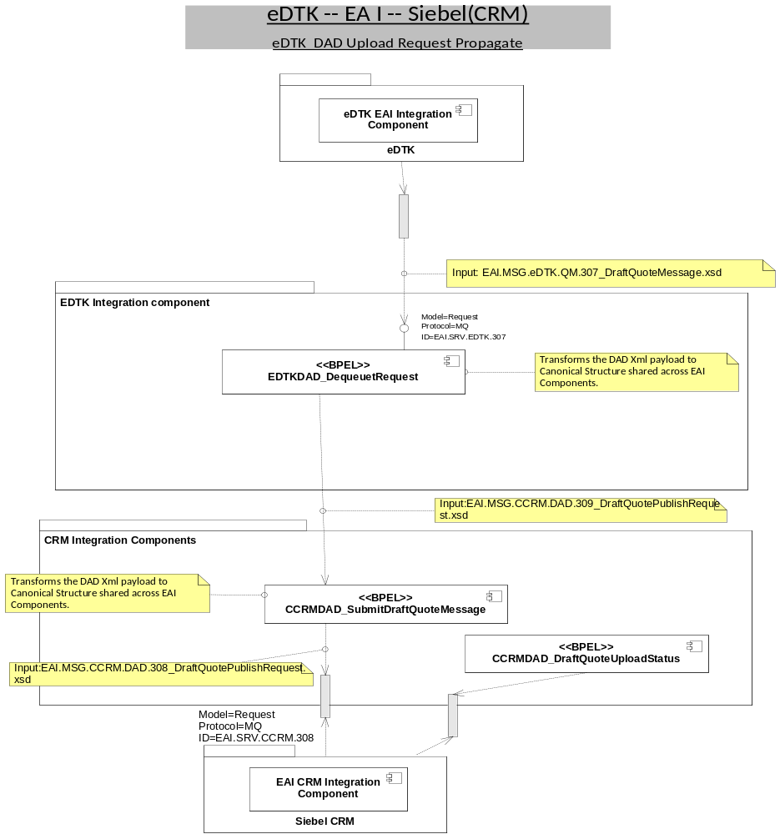

Issue 1:

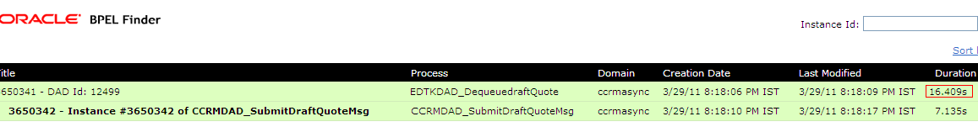
- Inbound component that dequeues and receives the DAD Xml takes 16 second to complete in case of 2500 QLIs

Details/Cause:
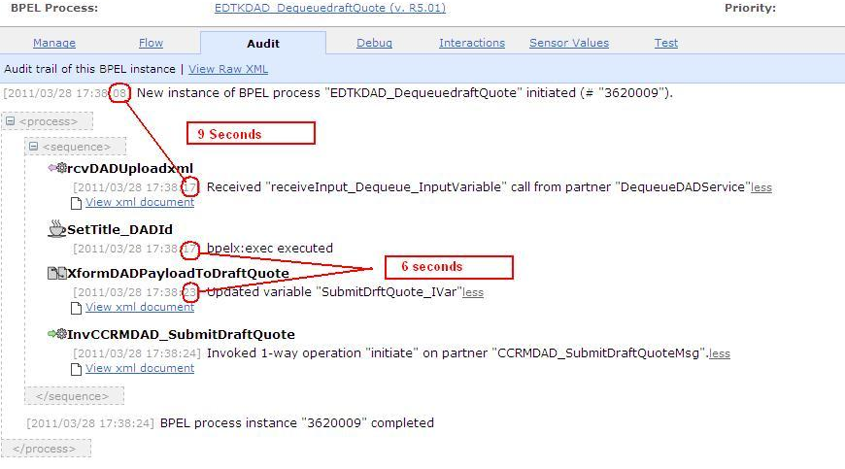

- Intiation <- to ->receive takes 9 seconds(creation of DOM Structure of receiving variable was taking this time)
- Transform from DADSchema to EAI internal Schema takes 6 seconds(XSLT transformation where in we are mapping the BillStartDate/BillStopDate from Source Schema from Header to All the 2500 quotelines in target schema)
Resolution:
- Intiation <- to ->receive takes 9 seconds
Receiving the incoming schema as String and then converting it to DOM Structure using parseEscapedXML(getvariabledata(receive_inputVar))
reduced this time to→ 1 sec.

- Transform from DADSchema to EAI internal Schema takes 6 seconds
We will need to have these BillStartDate/BillStopDate to be moved to Quote Line Item Level in Source Schema. –
reduced this time to→ 2 sec.

As a result of this we are able to achieve the process completion in approx →3.4 Sec(80% reduction)

Issue 2:

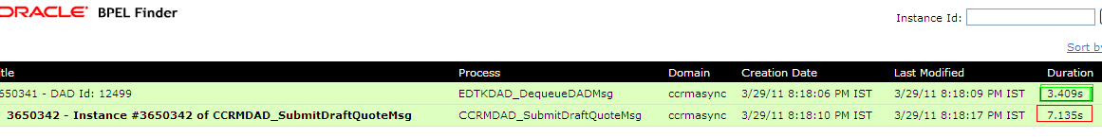
The propagate Component takes approx 7.13 Sec to complete in case of 2500 QLIs.

Details/Cause:

- Receive and Invoke takes 3 seconds each

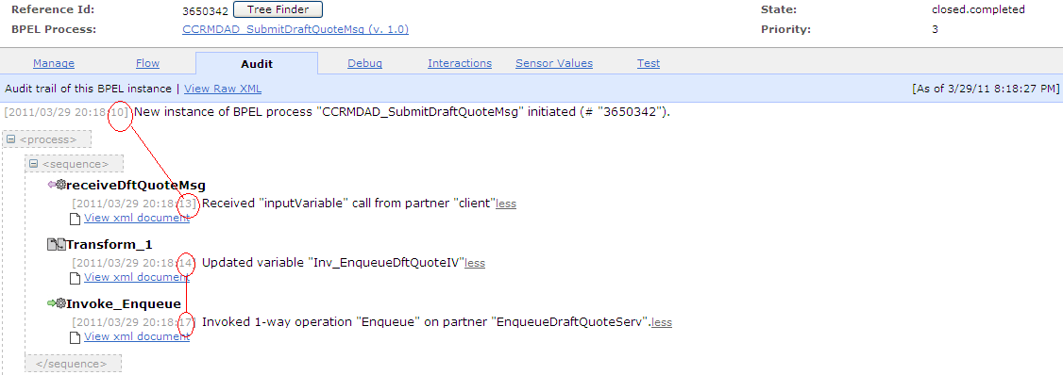
The possible cause would be BPEL being Stateful service ,try to de-hydrate the instance.
If this 7.13 Sec is not acceptable,Converting the Propagating component from BPEL to ESB need to be tested for performance analysis.

