

Billing to Cash Collection Project
Interface Detail Design Document

Development ID I001 – Customer Master Data
IB Interfaces: Siebel CRM to SAP

TABLE OF CONTENTS
1) Approvals 3
2) Review List 3
3) Related Documentation 3
4) Glossary 3
5) Introduction 4
5.1 Document Context 4
5.2 Document Structure 4
5.3 Scope. 4
5.4 Out of Scope 4
5.5 Assumptions 4
6) Interface Definition 4
6.1 Customer master data 4
6.1.1 Interface Purpose ….4
6.1.2 Context 5
6.1.3 Interface Characteristics 5
6.2 Interface Design 5
6.2.1 High Level Interface Design 5
6.2.2 Overview 7
6.2.2 Data Definitions 7
6.3 Interface Design Components 8
6.3.1 CCRMAM_DequeueAccountRequest 8
6.3.2 SAPAM_EventManager 9
6.3.3 SAPAM_Invoker 11
6.3.4 PL-SQL 12
7) Developer Notes 12
7.1 Code management 12
7.2 Deployment Process: 12
8) Issues/Workarounds: 13

DOCUMENT HISTORY
Version | Change Description | Author | Date Released
1.0 | First draft | Mallesh | April 14, 2010
1.1 | Revised IDD after sharing final version of FS. | Lavanya Chagantipati | June 25 2010

Approvals
The individuals listed below will be required to review and approve this document.

Role | Name | Signature | Date

Review List

Name | Position

Related Documentation

Ref | Title | Author | Version
I001 | Customer Master Data | Chris Banks | 1.0

Glossary

Abbreviation | Definition
CCRM | Commerce and Customer Relationship Management
EAI | Enterprise Application Integration
B2CC | Bill To Cash Collection
SAP | SAP System

Introduction

Document Context
This document is one of a set of Interface Definition Documents providing the definition and High Level Design of the interfaces required for the Siebel CRM to SAP B2CC This document details the interfaces which support the propagation of changes (creation, modification and cancellation) to customer accounts from master system Siebel CRM to receipt systems (SAP B2CC ).

Document Structure
This document describes about the requirements of an interface in terms of scope, functionality and characteristics. This document focus on what the interface does from an end-to-end perspective. Also covers the design of interface and the technical integration implementation.

Scope
The scope of this interface document defines the customer data creation into SAP from SIEBEL. SIEBEL being the Customer master data for accounts, triggers messages to SAP through EAI layer. SAP stores the customer data in the new hierarchical model.

This interface defines the scope of account propagation from SIEBEL to SAP (request component) alone.

Only the OMS accounts, first in hierarchy and the new internal accounts are to be propagated to SAP.

Out of Scope
-NA-

Assumptions
SIEBEL will be a single point of entry to propagate Accounts data to SAP.

Interface Definition

Customer master data

Interface Purpose

The purpose of this interface is to allow CRM to publish account events to SAP B2CC system.
EAI will handle the process of propagating account reference data updates from Siebel to B2CC that is subscribed to receive it. Siebel will publish updates to EAI using one standard interface and EAI will transform this data to fit the interface(s) exposed by the consuming systems like SAP B2CC and manage the distribution of the data through EAI interface components.

Context

In SAP B2CC, Siebel CRM will be the master for account reference data within Reuters. There are multiple types of account that form a hierarchy of composition into which most types of account fit. Propagation of accounts from SIEBEL, the master data into SAP, to fit in the new hierarchy, is being set in this interface.

Interface Characteristics

Seibel enqueues request messages into e_CRM_EAI_025_ACCT_PUB_RQST_Q message queue to which the BPEL component, CCRMAM_DequeueAccountRequest subscribes, reads the messages and pushes the data into a EAI specific JMS Topic. From this topic, the messages are read and processed to propagate to SAP, the corresponding downstream system.

Interface Design

High Level Interface Design
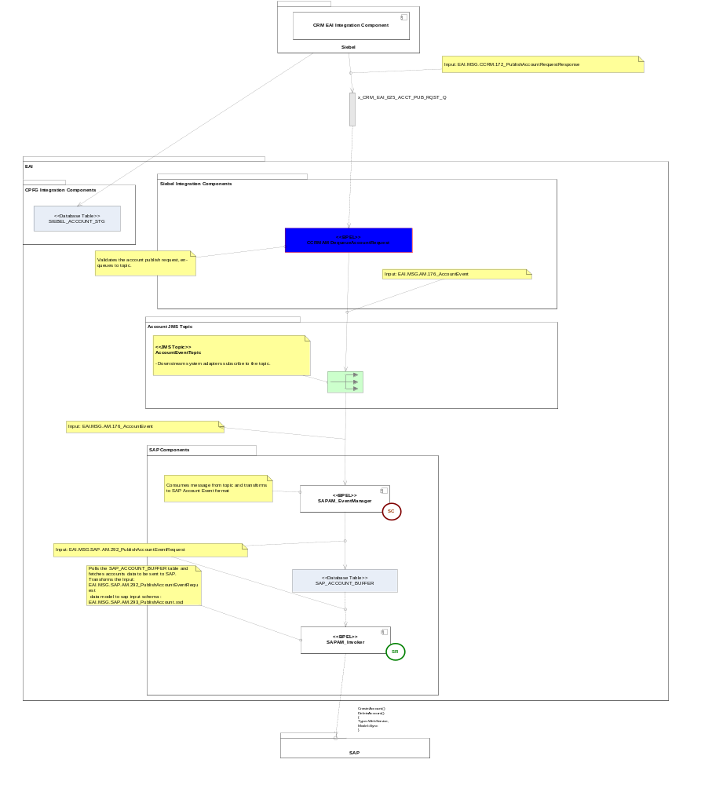

NOTE: BLUE : Existing BPEL Components

Overview

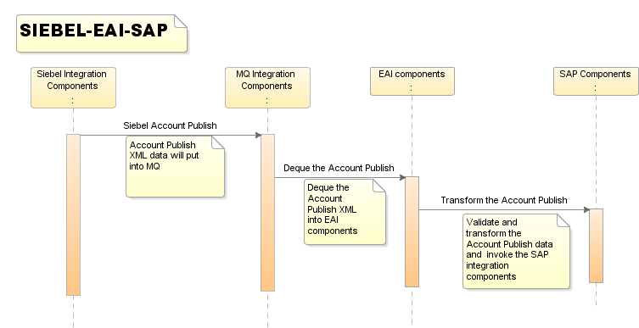

Data Definitions

The message specifications used in the interfaces between EAI and the external systems are defined in the API specification [6].
Latest versions of the XML schemas for the messages used in the interface are stored in the Reuters Developer Network Subversion repository (https://int.thomsonreuters.com) project called sami.cdt.int (https://sami.cdt.int.thomsonreuters.com). The definitions for this interface can be found in subversion at:
https://sami.cdt.int.thomsonreuters.com/svn/eai_eai/branches/6.1/design/EAI1.0/Interfaces

Interface Design Components

S.No | Module Name/Method | Component Type | Existing/New
1 | CCRMAM_DequeueAccountRequest | BPEL Process | Existing BPEL Component
2 | SAPAM_EventManager | BPEL Process | New BPEL Component
3 | SAPAM_Invoker | BPEL Process | New BPEL Component

CCRMAM_DequeueAccountRequest

- Purpose

This process dequeues the account Contact request from the MQ and writes it to a JMS publish-subscribe topic to publish the account in SAP.

- Program Logic

The process dequeues the message from the queue e_CRM_EAI_025_ACCT_PUB_RQST_Q to which Siebel enqueues the message ,‘e’ is the environment P- prod, B – blue, BL – Blue Lite, A – UAT, Y – System test, D – Support, T – test/development and NFT - Non Functional transforms is to a canonical account event (EAI.MSG.AM.176.AccountEvent) and writes this to the AccountEventTopic
The necessary message transformations are performed by TransAccountRequest.xsl, Transforms from PublishAccountRequestResponse(EAI.MSG.CCRM.172) to PublishAccountEvent (EAI.MSG.AM.176.AccountEvent)

- DVM
None

- Data Mapping (Transformation)
TransAccountRequest.xsl.

- Exception Handling:

All the scope in CCRMAM_DequeueAccountRequest catches all types exceptions and throws the fault message.
RemoteFault:
For all the remote fault messages captured at the catch block, the relevant message will be captured and set as Title to the faulted instance..
RuntimeFault:
For all the runtime fault messages captured at the catch block, the relevant message will be captured and set as Title to the faulted instance.
BindFault:
For all the bind fault messages captured at the catch block, the relevant message will be captured and set as Title to the faulted instance.
For the above mentioned and for any other exceptions caught, the exceptions message is customized, concatenated with the unique Account ID in the process and the submitted as the Title of the process. This gives the user an ease to search the status of the Account Data submitted to SAP.
The user can use the same Account ID, navigate to the instance tab and search from the BPEL Console of the respective environment for the Account ID. The title will then show the status for the status.

- Input/output Schemas:

EAI.MSG.CCRM.172_PublishAccountRequestResponse.xsd
EAI.MSG.AM.176_AccountEvent.xsd

- Partner links

DequeueAccountRequest.wsdl
EnqueueAccountRequest.wsdl

SAPAM_EventManager

- Purpose

Receives account events and propagates the Accounts data to the interface buffer table enabling the SAPAM_INVOKER to initiate call. The SAPAM Account Manager uses the EAI Event Sequencer so that multiple instances can be run concurrently whilst maintaining sequential integrity of updates that could potentially conflict with each other.

- Program Logic

The data from the Topic is read, transformed in the interface_buffer table schema and then sent to the table using a database adapter.
Also the sequence checker (SC) is invoked from the SAPAM_EventManager and SC is initiated.
The sequence is released in SAPAM_Invoker only upon completion of the process and the sequence is released for the corresponding request instance.
The inserted data of Interface_Buffer is polled by SAPAM_Invoker.

- DVM
CRMAppReference

- Exception Handling:

All the scope in SAPAM_EventManager catches all types exceptions and throws the fault message.
RemoteFault:
For all the remote fault messages captured at the catch block, the relevant message will be captured and set as Title to the faulted instance..
RuntimeFault:
For all the runtime fault messages captured at the catch block, the relevant message will be captured and set as Title to the faulted instance.
BindFault:
For all the bind fault messages captured at the catch block, the relevant message will be captured and set as Title to the faulted instance.
For the above mentioned and for any other exceptions caught, the exceptions message is customized, concatenated with the unique Account ID in the process and the submitted as the Title of the process. This gives the user an ease to search the status of the Account Data submitted to SAP.
The user can use the same Account ID, navigate to the instance tab and search from the BPEL Console of the respective environment for the Account ID. The title will then show the status for the status.

- Data Mapping (Transformation)
Process passes the same message which has been received from SAPAM account even subscriber but with the original tracing ID replaced with a unique correlation ID generated by this process.

- Input/output Schemas:

EAI.MSG.AM.176_AccountEvent.xsd
EAI.MSG.CCRM.292_PublishAccountRequestResponse.xsd

- Partner links
DequeueAccount.wsdl
WriteSAPAccount.wsdl (DB Adapter)
AsyncSequenceChecker.wsdl

- Database:

Database tables are
Interface_config- To Configure the SAP.
Interface_buffer table, the payload, referenceID and created by will inserts the record using WriteSAPAccount DB Adpater.

SAPAM_Invoker

- Purpose

The BPEL process SAPAM_invoker component poll the data from the DB table and transforms the DB payload data to SAP. It Invokes the SAP System to transfer the data.

- Program Logic

Poll the data from Interface Buffer table, releases the sequence releaser, mapping with SAP formatted data and sent the data to SAP system. The Polling Interval from The DB is 10 secs.

1. The inserted data from SAPAM_EventManager to Interface_Buffer table will be polled by SAPAM_Invoker Component using DB Adapter.

2.Receives the data from SAPAM Polling DB adapter.

3.Create the partner link for Sequence releaser.

4.Create the Partner link for SAP WSDL

5.Transform the received Db data to SAP WSDL data.

6.Invoke the SAP partner link.

7.Update the interface_buffer table with status as ‘C’ completed Or ‘E’ as Error (if any errors)

- DVM

NA

- Exception Handling:

All the scope in SAPAM_Invoker catches all types exceptions and throws the fault message.
RemoteFault:
For all the remote fault messages captured at the catch block, the relevant message will be captured and set as Title to the faulted instance..
RuntimeFault:
For all the runtime fault messages captured at the catch block, the relevant message will be captured and set as Title to the faulted instance.
BindFault:
For all the bind fault messages captured at the catch block, the relevant message will be captured and set as Title to the faulted instance.
For the above mentioned and for any other exceptions caught, the exceptions message is customized, concatenated with the unique Account ID in the process and the submitted as the Title of the process. This gives the user an ease to search the status of the Account Data submitted to SAP.
The user can use the same Account ID, navigate to the instance tab and search from the BPEL Console of the respective environment for the Account ID. The title will then show the status for the status.

- Partner links:
The following partner links have been used for the SAP Account publish.

SAP.wsdl
SequenceReleaser.wsdl

- Input /Out Put schemas:
EAI.MSG.CCRM.292_PublishAccountRequestResponse.xsd
EAI.MSG.SAP.AM.293_PublishAccount.xsd

- Database:
Database tables are
Interface_buffer and interface_config tables will be using by DB adapter SAPAM_POLLING_VIEW

PL-SQL

SAPAM_POLLING_VIEW:
CREATE OR REPLACE FORCE VIEW & topEAIOwnerUserName. "SAPAM_POLLING_V" ("ID", "CREATED", "PAYLOAD", "INTERFACE_ID", "REFERENCE_ID", "STATE", "LAST_UPDATED") AS

Select ib.id, ib.created, ib.payload, ib.interface_id, ib.reference_id, ib.state, ib.last_updated
from eaiowner.interface_buffer ib, eaiowner.interface_config ic
where ic.ID = 'SAPAM'
and ic.state = 'ON'
and ic.IS_AVAILABLE = 'Y'
and ib.INTERFACE_ID = ic.ID
and ib.STATE in ('N','R')
and ib.SEND_ATTEMPTS < ic.MAX_SEND_ATTEMPTS;

- Data Mapping (Transformation)

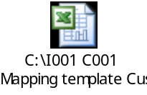

Developer Notes

Code management
For Code management and usage of subversion refer the document.

Deployment Process:
The deployment process for BPEL, ESB or web services components and as well as for any other deployments like DB Scripts, Business rules configurations: refer EAI- Build and Deployment Process.doc in

https://sami-crm6-eai.reutersdev.net/svn/sami-crm6-eai/trunk/dev/EAI-CRM61/R2releases/BuildDocs folder in SVN.

Issues/Workarounds:

S.No | Summary | Status | Assigned to | Solution
1 | Siebel CRM Schemas | Closed | CRM team
2 | SAP Schemas and WSDLs | Open | SAP Team

