

Billing to Cash Collection Project
Interface Detail Design Document

Development ID I001 – Customer Master Data
IB Interfaces: Siebel CRM to SAP

TABLE OF CONTENTS
1) Approvals 3
2) Review List 3
3) Related Documentation 3
4) Glossary 4
5) Introduction 4
5.1 Document Context 4
5.2 Document Structure 4
5.3 Scope 4
5.4 Out of Scope 4
5.5 Assumptions 4
6) Interface Definition 4
6.1 Customer master data 5
6.1.1 Interface Purpose 5
6.1.2 Context 5
6.1.3 Interface Characteristics 5
6.2 Interface Design 5
6.2.1 High Level Interface Design 5
6.2.2 Overview 6
6.2.1 Data Definitions 7
6.3 Interface Design Components 7
6.3.1 CCRMAM_DequeueAccountRequest 8
6.3.2 CCRMAM_AccountDispatcher 9
6.3.3 SAPAM_EventManager 10
6.3.4 SAPAM_Invoker 11
6.3.4 PL-SQL 13
7) Developer Notes 13
7.1 Code management 13
7.2 Deployment Process: 13
8) Issues/Workarounds: 14

DOCUMENT HISTORY

Version | Change Description | Author | Date Released
1.0 | First draft | Mallesh | April 14, 2010
1.1 | Revised IDD after sharing final version of FS. | Lavanya Chagantipati | June 25 2010
1.2 | Updated for R5 | Lavanya Chagantipati | Nov 15 2010
1.3 | Updated Wave2 Changes | Mallesh | Dec 13 2010
1.4 | Finance Charges logic and Pay Terms DVM updated | Mallesh | Jan 11 2011
1.5 | VATCode logic updated. | Mallesh | Jan 18 2011

Approvals

The individuals listed below will be required to review and approve this document.

Role | Name | Signature | Date

Review List

Name | Position

Related Documentation

Ref | Title | Author | Version
I001 | Customer Master Data | Chris Banks | 1.0

Glossary

Abbreviation | Definition
CCRM | Commerce and Customer Relationship Management
EAI | Enterprise Application Integration
B2CC | Bill To Cash Collection
SAP | SAP System

Introduction

Document Context
This document is one of a set of Interface Definition Documents providing the definition and High Level Design of the interfaces required for the Siebel CRM to SAP B2CC This document details the interfaces which support the propagation of changes (creation, modification and cancellation) to customer accounts from master system Siebel CRM to receipt systems (SAP B2CC ).

Document Structure
This document describes about the requirements of an interface in terms of scope, functionality and characteristics. This document focus on what the interface does from an end-to-end perspective. Also covers the design of interface and the technical integration implementation.

Scope
The scope of this interface document defines the customer data creation into SAP from SIEBEL. SIEBEL being the Customer master data for accounts, triggers messages to SAP through EAI layer. SAP stores the customer data in the new hierarchical model.

This interface defines the scope of account propagation from SIEBEL to SAP (request component) alone.

Only the OMS accounts, first in hierarchy and the new internal accounts are to be propagated to SAP.

Out of Scope
-NA-

Assumptions

SIEBEL will be a single point of entry to propagate Accounts data to SAP.

Interface Definition

Customer master data

Interface Purpose

The purpose of this interface is to allow CRM to publish account events to SAP B2CC system.
EAI will handle the process of propagating account reference data updates from Siebel to B2CC that is subscribed to receive it. Siebel will publish updates to EAI using one standard interface and EAI will transform this data to fit the interface(s) exposed by the consuming systems like SAP B2CC and manage the distribution of the data through EAI interface components.

Context

In SAP B2CC, Siebel CRM will be the master for account reference data within Reuters. There are multiple types of account that form a hierarchy of composition into which most types of account fit. Propagation of accounts from SIEBEL, the master data into SAP, to fit in the new hierarchy, is being set in this interface.
As Part of Wave2, implementing following CRs in EAI.
CR548(CRM Special Invoice Handling) : Added new row(Local Print NY ---- 80) in DVM(SAPAMHardCopyDispatch).
CR531(Finance Charges) : New Field Addition in Siebel has to Propagate to SAP through EAI.
Based on the value of financial charges of SIEBEL, two fields of SAP are populated a) Dunning procedure(MAHNA) b)Dunning Grouping(MGRUP)
- If finance charge is 1.5 then dunning procedure would be Z1 and Dunning grouping would be Z1.

- If finance charge is 0 then dunning procedure would be Z0 and Dunning grouping would be Z1.

- If finance charge is blank for a given account in Siebel then it has to be defaulted to 0 and the dunning procedure and the Dunning grouping should aquire the value w.r.t to 0%.

CR510(Payment terms) : Created new DVM (SAPAMPaymentTerms) in EAI and RCRMPayTerms element in Siebel has to propagate to SAP through EAI.
- When a billing account is published to Core Suite for a SAP – integrated country, EAI will always send a value of ‘0’ to SPM. For SAP, EAI will send the Payment terms as it is input in Siebel.

- When a billing account is published to Core Suite for non-SAP integrated country, EAI will send the Payment Terms as it is in input in Siebel ( AS-IS, no change)

- EAI/SAP should continue to default Payment terms to 30 days if the field is blank in Siebel for a given account

CR412(VAT Reg No) : RCRMVATCode element in Siebel has to propagate to SAP through EAI.

Interface Characteristics

Seibel enqueues request messages into e_CRM_EAI_025_ACCT_PUB_RQST_Q message queue to which the BPEL component, CCRMAM_DequeueAccountRequest subscribes, reads the messages and transforms to CCRMAM_AccountDispatcher. From this BPEL component, the messages are processed to propagate to SAP, the corresponding downstream system.

Interface Design

6.2.1 High Level Interface Design

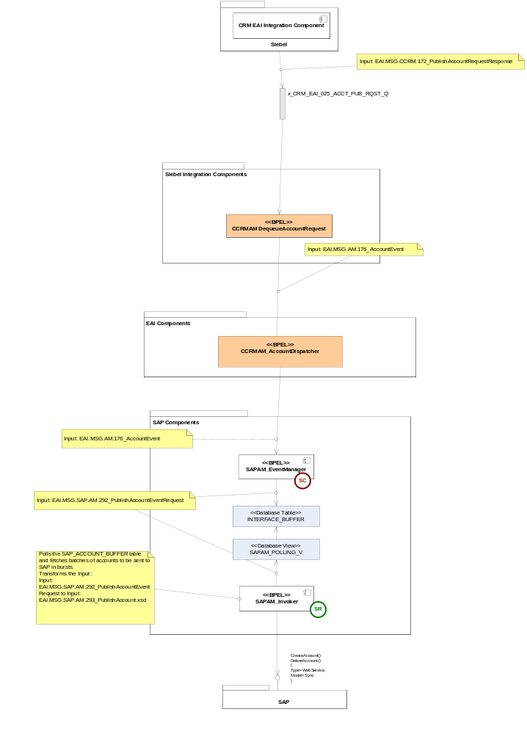

NOTE:TAN: Existing BPEL Components

Overview

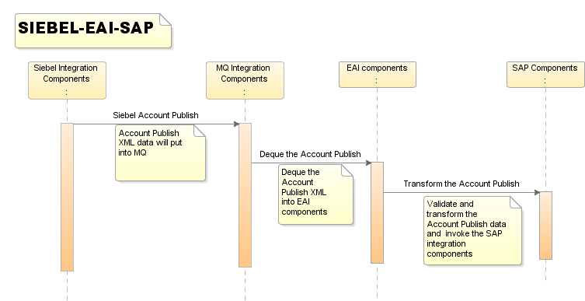

Data Definitions

The message specifications used in the interfaces between EAI and the external systems are defined in the API specification [6].
Latest versions of the XML schemas for the messages used in the interface are stored in the Reuters Developer Network Subversion repository (https://int.thomsonreuters.com) project called sami.cdt.int (https://sami.cdt.int.thomsonreuters.com). The definitions for this interface can be found in subversion at:
https://sami.cdt.int.thomsonreuters.com/svn/eai_eai/branches/6.1/design/EAI1.0/Interfaces

Interface Design Components

S.No | Module Name/Method | Component Type | Existing/New
1 | CCRMAM_DequeueAccountRequest | BPEL Process | Existing BPEL Component
2 | CCRMAM_AccountDispatcher | BPEL Process | Existing BPEL Component
3 | SAPAM_EventManager | BPEL Process | New BPEL Component
4 | SAPAM_Invoker | BPEL Process | New BPEL Component

CCRMAM_DequeueAccountRequest

- Purpose

This process dequeues the account Contact request from the MQ and propogates it to SAP through CCRMAM_AccountDispatcher.

- Program Logic

The process Propogates the message to SAP through CCRMAM_AccountDispatcher
The necessary message transformations are performed by TransAccountRequest.xsl,it Transforms from PublishAccountRequestResponse(EAI.MSG.CCRM.172) to PublishAccountEvent (EAI.MSG.AM.176.AccountEvent)

- DVM
None

- Data Mapping (Transformation)

TransAccountRequest.xsl
- Exception Handling:

All the scope in CCRMAM_DequeueAccountRequest catches all types exceptions and throws the fault message.
RemoteFault:
For all the remote fault messages captured at the catch block, the relevant message will be captured and set as Title to the faulted instance..
RuntimeFault:
For all the runtime fault messages captured at the catch block, the relevant message will be captured and set as Title to the faulted instance.
BindFault:
For all the bind fault messages captured at the catch block, the relevant message will be captured and set as Title to the faulted instance.
For the above mentioned and for any other exceptions caught, the exceptions message is customized, concatenated with the unique Account ID in the process and the submitted as the Title of the process. This gives the user an ease to search the status of the Account Data submitted to SAP.
The user can use the same Account ID, navigate to the instance tab and search from the BPEL Console of the respective environment for the Account ID. The title will then show the status for the status.

- Input/output Schemas:

EAI.MSG.CCRM.172_PublishAccountRequestResponse.xsd
EAI.MSG.AM.176_AccountEvent.xsd

- Partner links

DequeueAccountRequest.wsdl
CCRMAM_AccountDispatcher.wsdl

CCRMAM_AccountDispatcher

- Purpose

This process propogates the account Contact request which has dequed from the MQ and propogates it to SAP through CCRMAM_AccountDispatcher.

- Program Logic

The process Propogates the message to SAP through CCRMAM_AccountDispatcher
The necessary message transformations are performed by TransAccountContact_To_SAPAM.xsl,It transforms the message from EAI.MSG.AM.176.AccountEvent to PublishAccountEvent EAI.MSG.AM.176.AccountEvent.

If payTerms is received as 30,45,60,90 and 180, EAI will send a value as ‘0’ else the value will be sent as-is to SPM.

payTerms  ↓ | PayTerms
payTerms  ↓ | CS/SPM | SAP | TRUST | CPFG | TOM
30,45,60,90,180 | 0 | AS-IS | NA | NA | NA
!( 30,45,60,90,180) | AS-IS | NA | NA | NA | NA

- DVM
SAPAMPaymentTerms

- Data Mapping (Transformation)

TransformAccountContact_To_CSPublishAccountContactRequest.xsl

- Exception Handling:

All the scope in CCRMAM_AccountDispatcher catches all types exceptions and throws the fault message.
RemoteFault:
For all the remote fault messages captured at the catch block, the relevant message will be captured and set as Title to the faulted instance..
RuntimeFault:
For all the runtime fault messages captured at the catch block, the relevant message will be captured and set as Title to the faulted instance.
BindFault:
For all the bind fault messages captured at the catch block, the relevant message will be captured and set as Title to the faulted instance.
For the above mentioned and for any other exceptions caught, the exceptions message is customized, concatenated with the unique Account ID in the process and the submitted as the Title of the process. This gives the user an ease to search the status of the Account Data submitted to SAP.
The user can use the same Account ID, navigate to the instance tab and search from the BPEL Console of the respective environment for the Account ID. The title will then show the status for the status.

- Input/output Schemas:

EAI.MSG.AM.176_AccountEvent.xsd
EAI.MSG.AM.176_AccountEvent.xsd

- Partner links

SAPAM_EventManager.wsdl

SAPAM_EventManager

- Purpose

Receives account events and propagates the Accounts data to the interface buffer table enabling the SAPAM_INVOKER to initiate call. The SAPAM Account Manager uses the EAI Event Sequencer so that multiple instances can be run concurrently whilst maintaining sequential integrity of updates that could potentially conflict with each other.

- Program Logic

The data dequed from the MQ is read, transformed to the interface_buffer table schema if PublishAccountToSAP!=N,This can be done by using database adapter.Also the sequence checker (SC) is invoked from the SAPAM_EventManager and SC is initiated.The sequence is released in SAPAM_Invoker only upon completion of the process and the sequence is released for the corresponding request instance.The inserted data of Interface_Buffer is polled by SAPAM_Invoker.

If Account Hierarchy types not in (Billing,Athena,Wildcat,Multipub,MOPS,Peoplesoft) then map RCRMVATCode of SIEBEL to SAP filed.
- DVM

SAPAMAccountClass -- New rows added.
SAPAMAccountFamily
SAPAMAccountStatus
SAPAMBillingFrequency
SAPAMBillinglanguage
SAPAMBusinessChannel
SAPAMContractType
SAPAMCountryCodes
SAPAMCurrency
SAPAMFunction
SAPAMHardCopyDispatch -- New row added.
SAPAMIndustryCode
SAPAMInvoiceDeliveryVariant
SAPAMPriceList
SAPAMRegions -- DVM values increased from 469 to 1539.
SAPAM_Tolerance_Group
SAPAMPaymentTerms -- New DVM

SIEBEL SAP
---------- ------
30 TR30
45 TR45
60 TR60
90 TR90
180 T180

Note:if the field is blank from Siebel side the default value should to SAP should be TR30

As part of Wave2, added new ‘Account Hierarchy types’ in
SAPAMAccountClass DVM.

SIEBEL SAP
---------- ------
Athena ZPAY
Wildcat ZPAY
PeopleSoft ZPAY

As part of Wave2, added new row in
SAPAMHardCopyDispatch DVM.

SIEBEL SAP
---------- ------
Local Print NY 80

- Exception Handling:

All the scope in SAPAM_EventManager catches all types exceptions and throws the fault message.
RemoteFault:
For all the remote fault messages captured at the catch block, the relevant message will be captured and set as Title to the faulted instance..
RuntimeFault:
For all the runtime fault messages captured at the catch block, the relevant message will be captured and set as Title to the faulted instance.
BindFault:
For all the bind fault messages captured at the catch block, the relevant message will be captured and set as Title to the faulted instance.
For the above mentioned and for any other exceptions caught, the exceptions message is customized, concatenated with the unique Account ID in the process and the submitted as the Title of the process. This gives the user an ease to search the status of the Account Data submitted to SAP.
The user can use the same Account ID, navigate to the instance tab and search from the BPEL Console of the respective environment for the Account ID. The title will then show the status for the status.

- Data Mapping (Transformation)

Trans176To293Schema.xsl
TransCRMtoEAI.xsl

- Input/output Schemas:

EAI.MSG.AM.176_AccountEvent.xsd
EAI.MSG.AM.293_AccountEvent.xsd
EAI.MSG.CCRM.293_PublishAccountRequestResponse.xsd

- Partner links
AsyncSequenceChecker.wsdl
WriteBuffer.wsdl (DB Adapter)

- Database:

Database tables are
Interface_config- To Configure the SAP.
Interface_buffer table, the payload, referenceID and created by will inserts the record using WriteSAPAccount DB Adpater.

SAPAM_Invoker

- Purpose

The BPEL process SAPAM_invoker component poll the data from the DB table (Interface_Buffer) and transforms the DB payload data to SAP. It Invokes the SAP System to transfer the data.

- Program Logic

Poll the data from Interface Buffer table, releases the sequence releaser, mapping with SAP formatted data and sent the data to SAP system. The Polling Interval from The DB is 10 secs.

1. The inserted data from SAPAM_EventManager to Interface_Buffer table will be polled by SAPAM_Invoker Component using DB Adapter.

2.Receives the data from SAPAM Polling DB adapter.

3.Create the partner link for Sequence releaser.

4.Create the Partner link for SAP WSDL

5.Transform the received Db data to SAP WSDL data.

6.Invoke the SAP partner link.

7.Update the interface_buffer table with status as ‘C’ completed Or ‘E’ as Error (if any errors)

- DVM

NA

- Exception Handling:

All the scope in SAPAM_Invoker catches all types exceptions and throws the fault message.
RemoteFault:
For all the remote fault messages captured at the catch block, the relevant message will be captured and set as Title to the faulted instance..
RuntimeFault:
For all the runtime fault messages captured at the catch block, the relevant message will be captured and set as Title to the faulted instance.
BindFault:
For all the bind fault messages captured at the catch block, the relevant message will be captured and set as Title to the faulted instance.
For the above mentioned and for any other exceptions caught, the exceptions message is customized, concatenated with the unique Account ID in the process and the submitted as the Title of the process. This gives the user an ease to search the status of the Account Data submitted to SAP.
The user can use the same Account ID, navigate to the instance tab and search from the BPEL Console of the respective environment for the Account ID. The title will then show the status for the status.

- Partner links:
The following partner links have been used for the SAP Account publish.

SAPAM_POLLING_VIEW.wsdl
CustomerAccountPublish.wsdl
SequenceReleaser.wsdl
Update_Interface_Buffer.wsdl

- Input /Out Put schemas:

InterfaceBufferCollection.xsd
EAI.SRV.AM.SAP.71_AccountPublishRef.wsdl

- Database:
Database tables are
Interface_buffer and interface_config tables will be using by DB adapter
SAPAM_POLLING_V

PL-SQL

SAPAM_POLLING_VIEW:
CREATE OR REPLACE FORCE VIEW & topEAIOwnerUserName. "SAPAM_POLLING_V" ("ID", "CREATED", "PAYLOAD", "INTERFACE_ID", "REFERENCE_ID", "STATE", "LAST_UPDATED") AS

Select ib.id, ib.created, ib.payload, ib.interface_id, ib.reference_id, ib.state, ib.last_updated
from eaiowner.interface_buffer ib, eaiowner.interface_config ic
where ic.ID = 'SAPAM'
and ic.state = 'ON'
and ic.IS_AVAILABLE = 'Y'
and ib.INTERFACE_ID = ic.ID
and ib.STATE in ('N','R')
and ib.SEND_ATTEMPTS < ic.MAX_SEND_ATTEMPTS;

- Data Mapping (Transformation)

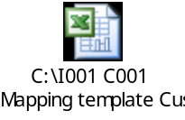

Developer Notes

Code management
For Code management and usage of subversion refer the document.

Deployment Process:
The deployment process for BPEL, ESB or web services components and as well as for any other deployments like DB Scripts, Business rules configurations: refer EAI- Build and Deployment Process.doc in

https://sami-crm6-eai.reutersdev.net/svn/sami-crm6-eai/trunk/dev/EAI-CRM61/R2releases/BuildDocs folder in SVN.

Issues/Workarounds:

S.No | Summary | Status | Assigned to | Solution
1 | Siebel CRM Schemas | Closed | CRM team
2 | SAP Schemas and WSDLs | Closed | SAP Team

