

Billing to Cash Collection Project

Interface Detail Design Document

Development ID I004 – Order to Bill
IB Interfaces: Siebel CRM to SAP Sales Orders

1) Approvals 3
2) Review List 3
3) Related Documentation 3
4) Glossary 3
5) Introduction 4
5.1 Document Context 4
5.2 Document Structure 4
5.3 Scope 4
5.4 Out of Scope 4
5.5 Assumptions 4
6) Order To Bill 5
6.1 Interface Definition 5
6.1.1 Interface Purpose 5
6.1.2 Context 5
6.1.3 Functional View 6
6.1.4 Interface Characteristics 6
6.2 Interface Design 7
6.2.1 High Level Interface Design 7
6.2.2 Overview 8
6.2.3 Data Definitions 8
6.3 Interface Design Components 9
8.3.1 CCRMOM_DequeueNValidateOrderRequest 9
8.3.2 CCRMOM Order Request Validator Stub 11
8.3.3 OM Order Dispatcher 12
8.3.4 SAPOM_EventManager 17
8.3.5 SAPOM_Invoker 18
8.3.6 PL-SQL 19
8.3.7 Data Mapping (Transformation) 19
7) Developer Notes 19
➢ Code management 19
➢ Deployment Process: 19
8) Issues/Workarounds: 19
Document History
Version | Change Description | Author | Date Released
1.0 | First draft | Damodar | March 2, 2010
1.1 | First Review comments | Damodar | March 26, 2010

Approvals
The individuals listed below will be required to review and approve this document.
Role | Name | Signature | Date

Review List
Name | Position

Related Documentation
Ref | Title | Author | Version
I004 | Order to Bill | Justine Perry | 1.0

Glossary
Abbreviation | Definition
CCRM | Commerce and Customer Relationship Management
EAI | Enterprise Application Integration
B2CC | Bill To Cash Collection
SAP | SAP System

Introduction

Document Context
This document is one of a set of Interface Definition Documents providing the definition and High Level Design of the interfaces required for the Siebel CRM to SAP B2CC inbound interface that will enable the creation, modification, or cancellation of Sales Orders within SAP B2CC, which will ultimately be driven by the Siebel CRM system.

Document Structure
This document describes about the requirements of an interface in terms of scope, functionality and characteristics. This document focus on what the interface does from an end-to-end perspective. Also covers the design of interface and the technical integration implementation.

Scope
This document covers the interface that will support the Enterprise Application Integration (EAI) solution by providing functionality to allow:
Create SAP Sales Order: The orders that are created in Siebel CRM will be propagated to SAP B2CC systems through EAI layer after applying the required business rules/conditions.
An initial validation will be performed in EAI layer prior to allowing a successful release to SAP B2CC as part of the current order process
EAI should not transmit Siebel Order Lines to SAP B2CC if the line item meets any of the following criteria:
    - Siebel CRM Order Line is a Free Trial Order
    - Siebel CRM Order Line PLI does not have a Billing Platform of “SAP” and the Siebel will be doing the validation of SAP orders based on Country and billing platform. Validation in CRM example is
Sold To Country ‘CA’ & Billing Platform of PLI is not ‘null’ or not ‘NONE’ then Billing Platform is: SAP
Sold To Country ‘UA’ & Billing Platform of PLI is not ‘null’ or not ‘NONE’ or not ‘IRAS’ then Billing Platform is: SAP

Out of Scope
- NA-

Assumptions
- Siebel CRM will be the single point of entry for order processing. All orders must be raised, changed, or removed within Siebel CRM and subsequently fed to SAP B2CC.
- The SAP Sales Order is created when the Siebel Sales Order lines are released to billing from Siebel CRM.

Order To Bill

Interface Definition

Interface Purpose
The purpose of this interface is to allow Siebel CRM to submit the orders to SAP-B2CC for processing.
Function | SAP-B2CC
Creation of a SAP order | Yes
Start and stop billing date change | Yes
Creation of a free trial order | No
Creation of an order with special price | Yes
Managing order line status | Yes
Aborting an install order line prior to Billing | Yes
AKR Change | Yes
Billing Account Change | Yes
Free Trail Extension | No
Free Trail Conversion | Yes
Manual Permissioning Products | No

Context
The creation of order process is initiated from Siebel CRM. This is part of an overall process which governs the sale or modification of the provision of Thomson Reuters services to customers. EAI will orchestrate the end to end process by invoking the creation of order process on the SAP System through message-based event.

Functional View
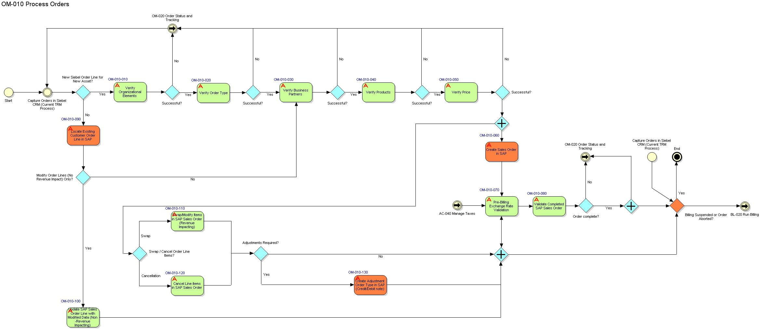

Interface Characteristics
EAI dequeues the Order data from MQ e_CRM_EAI_014_ORD_RQST_Q to which Seibel enqueues request message, BPEL process CCRMOM_DequeueNValidateOrderRequest The BPEL process dequeues the Order data. The Order interface is offered by EAI to Siebel to allow Create the valid Orders in SAP.
The messaging style used for the Submit Order interface is the ‘Command Style’, where a general purpose message format is used with a standard data payload and the required functionality is specified by an ‘action code’.

Interface Design

High Level Interface Design
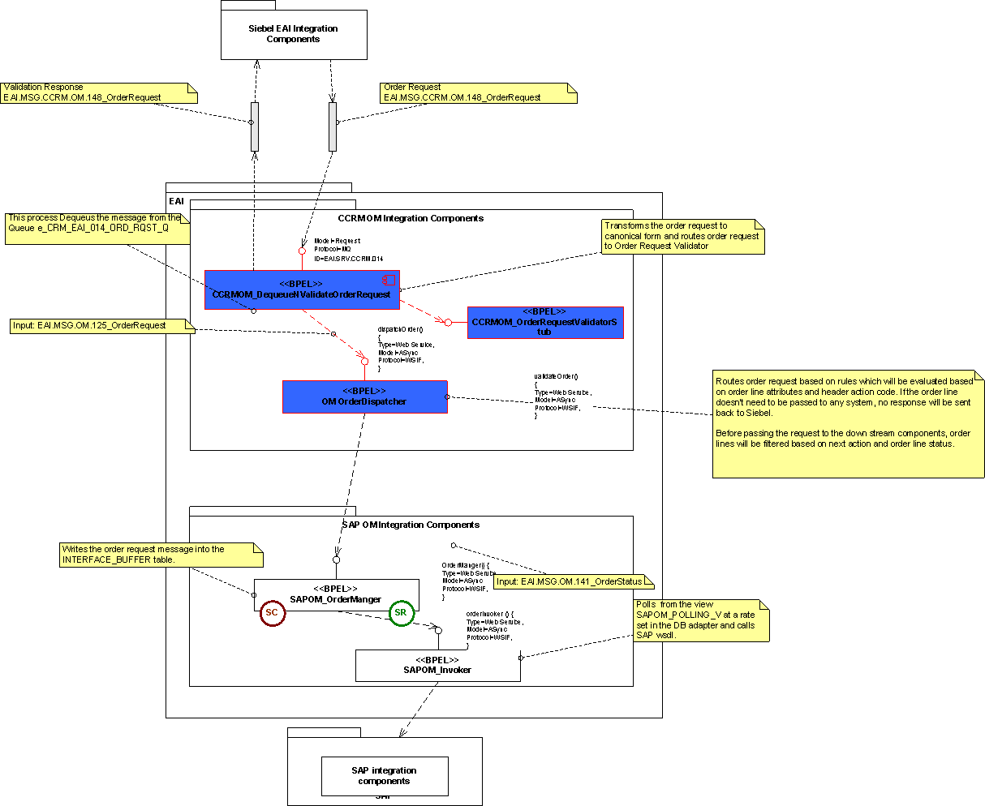

NOTE: BLUE: Existing BPEL Components

Overview
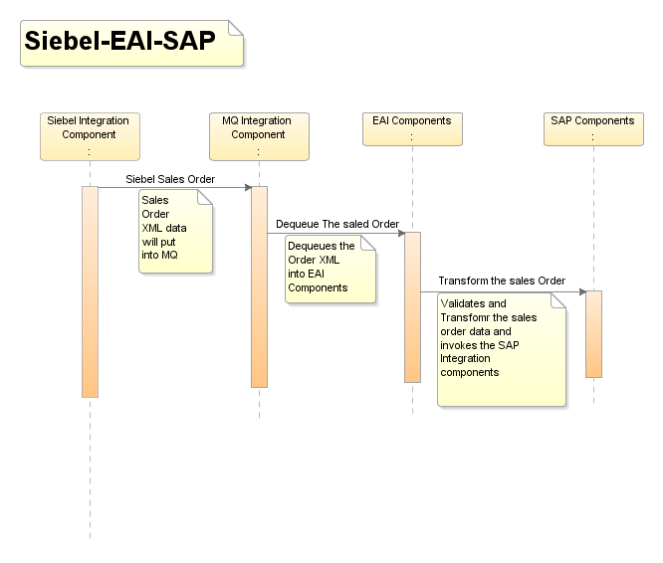

Data Definitions
The message specifications used in the interfaces between EAI and the external systems are defined in the API specification [6].
Latest versions of the XML schemas for the messages used in the interface are stored in the Reuters Developer Network Subversion repository (https://int.thomsonreuters.com) project called sami (https://sami.cdt.int.thomsonreuters.com). The definitions for this interface can be found in subversion at:
https://sami.cdt.int.thomsonreuters.com/svn/eai_eai/branches/6.1/design/EAI1.0/Interfaces

Interface Design Components

S.No | Module Name/Method | Component Type | Existing/New
1 | CCRMOM_DequeueNValidateOrderRequest | BPEL Process | Existing BPEL Component
2 | CCRMOM OrderRequestValidatorStub | BPEL Process | Existing BPEL Component
3 | OM Order Dispatcher | BPEL Process | Existing BPEL Component
4 | SAPOM_EventManager | BPEL Process | New BPEL Component
5 | SAPOM_Invoker | BPEL Process | New BPEL Component

CCRMOM_DequeueNValidateOrderRequest
- Purpose

The BPEL process de-queues the Order request from the MQ and process for validating the data and Order Dispatcher BPEL component to create the order in SAP.

- Program Logic

AS-IS Process:
The process dequeues the message from the queue e_CRM_EAI_014_ORD_RQST_Q to which Siebel enqueues The message ,‘e’ is the environment P- prod, B – blue, BL – Blue Lite, A – UAT, Y – System test, D – Support, T – test/development and NFT - Non Functional transforms.
The EAI service receives the order request in the form of the Order Request schema (EAI.MSG.CCRM.OM.148_OrderRequest) by deqeuing from MQ Adapter. On receipt of the request, it validates the content by calling CCRMOM OrderRequestValidatorStub with the Partner Link Property “ValidateXML” set to “true”. CCRMOM OrderRequestValidatorStub returns a response to indicate that the data is valid or invalid .If data is invalid then a response message is prepared and returned and enqueued to Seibel Queue e_EAI_CRM_014_ORD_VAL_RPLY_Q. ‘e’ is the environment P- prod, B – blue, BL – Blue Lite, A – UAT, S – System test, D – Support, T – test/development and NFT - Non FunctionalTransforms.Before calling CCRMOM OrderRequestValidatorStub, the request message will be transformed to the canonical CCRM order request (EAI.MSG.CCRM.OM.138_OrderRequest).when initial order request orderlinestatus=”In Progress” and PermissioningStatus=”In Progress” will be sent in Seibel Request for further process of Order request. Core suite will send initial “Contract Signed” message to Seibel.
All the order detail is stored in Order_cache table by using DB adapter on receipt of order request. Before calling DB adapter certain condition are checked.
If permissioningStatus != "Permission Date Error" then permissioningStatus is mapped to fulfilmentStatus and orderLineStatus-- orderlineStatus.
When ((message Header action Code = "Manual Permissioned") or ((manualPermissioningRequired = "N") or ((actionCode = "Billing Account Change") or ((actionCode = "AKR Change") or ((actionCode = "Start Date Change") or ((actionCode = "Stop Date Change") or (actionCode = "Special Price Change"))))))) or (businessCase = "User Swap")' then manualPermComplete =’Y’.
When ‘(messageHeader actionCode! = "Manual Permissioned") and ((manualPermissioningRequired = "Y") and (((businessCase = "Abort") and (messageHeader/actionCode = "Abort")) or (permissioningStatus = "In Progress"))) then manualPermComplete=”N”.When ((actionCode = "Billing Account Change") or ((actionCode = "AKR Change") or ((actionCode = "Start Date Change") or ((actionCode = "Stop Date Change") or ((actionCode = "FT Extension") or ((actionCode = "Special Price Change") or (((permissioningSystem = "NONE") and (interfaceForFulfilment = "Y")) or (interfaceForFulfilment = "N")))))))) or (businessCase = "User Swap")' then autoPermComplete=”Y” .
When '((permissioningSystem = "SPM") or (permissioningSystem = "CPfG")) and (((interfaceForFulfilment = "Y") and (messageHeader/actionCode! = "Manual Permissioned")) and (((businessCase = "Abort") and (messageHeader/actionCode = "Abort")) or (permissioningStatus = "In Progress")))' then autoPermComplete=”N”.
Based on above condition data is stored in Order Cache Table and Order request call is forwarded to components OM_OrderDispatcher & TF_orderDispacther. If Orderheader/TargetSystem contain values ‘TOM’ then request is forwarded to the calling component TF_OrderDispacther otherwise call is not forwarded to TF_OrderDispacther.i.e only Technical vetting request are forwarded to ‘TOM’
“CCRMOM_OrderRequestValidatorTF_OrderDispatcherUpdateTypeMap” DVM is used before forwarding call to TF_OrderDispacther if messageHeader/actionCode=”Manual Permissioned” we setting Update Type=”REDUCED” otherwise by default Update Type=”FULL” is passed to “TOM”.
As part of the transformation the date format is to be transformed to ‘YYYY-MM-DD’ and date time format to ‘YYYY-MM-DDTHH24:MI:SS’.
Siebel sends the requests with date in the format ‘MM/DD/YYYY’.
TO-BE:
There will be Input Siebel schema (dequeue) changes and added new elements in the schema transformations with output schema.

- DVM
CCRM_UpdateSiebelServiceMarketingConsentMap
CCRMCM_PublishContactRequestValidatorLegalConsentMap
CCRMOM_OrderRequestValidatorTF_OrderDispatcherUpdateTypeMap
CRMAppReferenc

- Data Mapping (Transformation)
TransRcvOrderRequestToValidateOrderRequest.
TransOrderRequestToOrderCacheDBAdapter.
TransOrderRequestToTFOrderDispatcher.
TransOrderRequestToDispatcher.
TransOrderReqIVToValidationMsg.

- Scope:
ValidateXML
- Exception Handling:

For All the scopes in CCRMOM_DequeueNValidateOrderRequest catch all types exceptions and throwing the fault message.
Selection Failure:
For any Selection Failure fault exception while transformation catches the exception and throwing remote fault exception and appending the fault message to the title.
remoteFault:
For any Remote fault exception while transformation catches the exception and throwing remote fault exception and appending the fault message to the title.
runtimeFault:
For any run time fault exception while transformation catch the exception and throwing run time fault exception and appending the fault message to the title.
bindFault:
For any data binding or data validations exceptions while transformation catch the exception and throwing remote fault exception and appending the fault message to the title.

NOTE: After Fault the BPEL instance is ready for Re-initiate, Manually user/Ops team will be re-initiating after all validations done.

- Input/output Schemas:
EAI.MSG.CCRM.OM.138_OrderRequest.xsd
EAI.MSG.CCRM.OM.148_OrderRequest.xsd

- Partner links
TF_OrderDispatcher.wsdl
CCRMOM_OrderRequestValidatorStub.wsdl
DequeueOrderRequest.wsdl

CCRMOM Order Request Validator Stub

- Purpose
This module exposes an interface that accepts EAI.MSG.CCRM.OM.138_OrderRequest message as the only input parameter. Callers to this interface use Partner Link properties to turn XML validation on or off. By catching validation errors, the calling component can take appropriate action for an invalid message.

- Program Logic

AS-IS:

There is no actual logic within this component it just accepts the input data and returns it in a response. The component itself does no validation but if called with the appropriate Partner Link property will allow the input parameters to be validated by the BPEL Process Manager.
TO-BE:
There will be Input Siebel schema (dequeue) changes and added new elements in the schema transformations with output schema.
- DVM
-NONE-

- Data Mapping (Transformation)
There are no mappings or transformations for this component. Since this component is validating the received input data as per schema.

- Input/output Schemas:

EAI.MSG.CCRM.OM.138_OrderRequest.xsd

- Partner links
NA

OM Order Dispatcher

- Purpose
OM Order Dispatcher acts as a bridge between CCRM Integration components, CS and SAP Integration components. Orchestrates the order based on the order line attributes.
- Program Logic
AS-IS
Data Inserted in Order Cache table will be used to manage the order lines status and the action
Each order line in the order request will be passed to a decision service to decide the actions to be done on the request, the order line and permissioning statuses to be sent to Siebel.
Next Action: Upon receiving user creation status, the status will be sent to Siebel. On successful user creation only the order request will be sent for order creation.
For all other actions the lines will be inspected & filtered based on the rules which had been specified in Order Request Sheet in EAI Order Rule Grid.
Following parallel flows will handle the request:
- Amend Permission Dates
- Free Trail Conversions
- Sub Account Swap
- Amend AKR
- Amend Bill Date (AKR will be set to empty)
- Create Order
- Abort Order
- Reply to Siebel
- Release to billing
- Special Price Change
- Cpfg Fufilment Request
User request will be passed to User Fulfillment process and other request will be passed to Order Splitter for Coresuite.
TO-BE:
After Business Rules validation or transformations will be adding parallel flows based on the NextAction1 value.
Following Parallel flows will handle the request:
SAPCreateOrder
SAPAmendAKRChange
SAPUserSwap
SAPAmendBillingNoteChange
SAPAmendBillingAccountChange
SAPAmendBillDate(Stop Billing, Start Billing)
SAPSpecialPriceChange
SAP Release to billing
SAPAbortOrder

The above flows will be invoked the SAPOM_EventManager partner link to send the Siebel order data to SAP system.
SAPOM_EventManager (Partner Link): BPEL component which takes requested input values from Business rules elements which being called in OM_OrderDispatcher component and based on the nextAction1 value Parallel flows activities will be invoked to flow the data to SAP System.
To enter the only SAP- B2CC order added the following condition in all business rules
OrderLineRequestFactsType.billingPlatform == "SAP"
To Avoid Free trial Products in order used the following condition in all business rule
OrderLineRequestFactsType.freeTrialFlag!='Y'

- Business Rules

The following business rules will be validated for SAP Order

    - SAPCreateOrder: SAPCreate Order
If
OrderLineRequestFactsType.messageHeaderActionCode == "Create" && (OrderLineRequestFactsType.actionCode == "Add"||OrderLineRequestFactsType.actionCode == "Delete") && OrderLineRequestFactsType.interfaceForBilling == "Y" && OrderLineRequestFactsType.orderLineStatus == "In Progress"&&OrderLineRequestFactsType.billingPlatform == "SAP"&&OrderLineRequestFactsType.freeTrialFlag!='Y'
Then
OrderLineRequestFactsType.setNextAction1( "SAPCreate Order" )
OrderLineRequestFactsType.setField1( "SAPCreatOrderRule" )

    - AKR Change: SAPAmendAKRChange
If OrderLineRequestFactsType.actionCode == "Update" && OrderLineRequestFactsType.buinsesscase == "AKR Change" && OrderLineRequestFactsType.interfaceForBilling == "Y" && OrderLineRequestFactsType.orderLineStatus == "In Progress” && OrderLineRequestFactsType.billingPlatform == "SAP" && OrderLineRequestFactsType.freeTrialFlag!='Y'
Then
OrderLineRequestFactsType.setNextAction1( "SAP AKRChange" )
This business rule is being used for SAP Order Line modification for user related changes in Non Revenue Impacting Update.
    - SAP UserSwap: SAPUserSwap
If OrderLineRequestFactsType.actionCode == "Update" && OrderLineRequestFactsType.buinsesscase == "User Swap" && OrderLineRequestFactsType.interfaceForBilling == "Y" && OrderLineRequestFactsType.orderLineStatus == "In Progress”&& OrderLineRequestFactsType.billingPlatform == "SAP" && OrderLineRequestFactsType.freeTrialFlag!='Y'
Then
OrderLineRequestFactsType.setNextAction1( "SAPAmend UserSwap" )
This business rule is being used for SAP Order Line modification for user related changes in Non Revenue Impacting Update.

    - SAPBillingNoteChange: SAPAmend BillingNote
If OrderLineRequestFactsType.actionCode == "Update" && OrderLineRequestFactsType.buinsesscase == "Billing Note Change" && OrderLineRequestFactsType.interfaceForBilling == "Y" && OrderLineRequestFactsType.orderLineStatus == "In Progress” && OrderLineRequestFactsType.billingPlatform == "SAP" && OrderLineRequestFactsType.freeTrialFlag!='Y'
Then
OrderLineRequestFactsType.setNextAction1( "SAP Billing Note Change" ).
This business rule is being used for SAP Order Line modification for billing note related changes in Non Revenue Impacting Update.

    - SAPBillingAccountChange: SAPAmend BillingAccountChange
If OrderLineRequestFactsType.actionCode == "Update" && OrderLineRequestFactsType.buinsesscase == " Billing Account Change" && OrderLineRequestFactsType.interfaceForBilling == "Y" && OrderLineRequestFactsType.orderLineStatus == "In Progress” && OrderLineRequestFactsType.billingPlatform == "SAP" && OrderLineRequestFactsType.freeTrialFlag!='Y'
Then
OrderLineRequestFactsType.setNextAction1( "SAP Billing Account Change" ).
This business rule is being used for SAP Order Line modification for billing note related changes in Revenue Impacting Update.
    - SAPAmendBillDate: SAPAmendBillDate
If OrderLineRequestFactsType.actionCode == "Update" && OrderLineRequestFactsType.buinsesscase == "Start Date Change" ||
OrderLineRequestFactsType.buinsesscase == "Stop Date Change "
&& OrderLineRequestFactsType.interfaceForBilling == "Y" && OrderLineRequestFactsType.orderLineStatus == "In Progress” && OrderLineRequestFactsType.billingPlatform == "SAP" && OrderLineRequestFactsType.freeTrialFlag!='Y'
Then
OrderLineRequestFactsType.setNextAction1( " SAPAmendBillDate" ).
This business rule is being used for SAP Order Line modification for billing note related changes in Revenue Impacting Update.
    - SAPSpecialPriceChange: SAPSpecialPriceChange
If OrderLineRequestFactsType.messageHeaderactionCode == "Create" && OrderLineRequestFactsType. actionCode == " SAPSpecialPriceChange"
&& OrderLineRequestFactsType.interfaceForBilling == "Y" && OrderLineRequestFactsType.orderLineStatus == "In Progress” && OrderLineRequestFactsType.billingPlatform == "SAP" && OrderLineRequestFactsType.freeTrialFlag!='Y'
Then
OrderLineRequestFactsType.setNextAction1( " SAPSpecialPriceChange" ).
This business rule is being used for SAP Order Line modification for billing note related changes in Revenue Impacting Update.
    - SAP Abort Order: SAPAbortOrder
If OrderLineRequestFactsType.actionCode == "Delete" && OrderLineRequestFactsType.buinsesscase == "Cancel Order" && OrderLineRequestFactsType.interfaceForBilling == "Y" && OrderLineRequestFactsType.orderLineStatus == "In Progress”&& OrderLineRequestFactsType.billingPlatform == "SAP" && OrderLineRequestFactsType.freeTrialFlag!='Y'
Then
OrderLineRequestFactsType.setNextAction1( "SAPAbortOrder" )
This business rule is being used for SAP Order Line cancellation
- Data Mapping (Tranformations)

Existing transformations:
TransBPELVarToRuleFacts.
TransExtendedOrderRequestToRuleFacts.
TransFactsToBPELVar.
TransFactsToRuleService.
TransfFilterSubAccountSwap.
TransFilterAmendAKRLines.
TransFilterAmendBillDateOrderLines.
TransFilterAmendPermissionDates.
TransFilterCreateOrderLines.
TransFilterFTConversionLines.
TransFilterOLsForAbort.
TransFilterReplyToSiebelLines.
TransFilterRTBLines.
TransFilterUserLines.
TransOrderRequestToExtendedOrderRequest.
TransRuleFactsToExtendedOrderRequest.
TransRuleServiceToFacts.
TransSortFTConversionLines.
TransUserStatusToPropogateUserStatus.
TransFilterCPfGFulfilmentRequests.
TransFilterSpecialPriceChange.

The following new transformations for each parallel flow for SAP Order
TransfSAPFilterUserSwap.
TransSAPFilterAmendAKRLines.
TransSAPFilterAmendBillDateOrderLines.
TransSAPFilterAmendBillNoteChanges
TransSAPFilterAmendBillAccountChanges.
TransSAPFilterCreateOrderLines.
TransSAPFilterSpecialPriceChange

- Exception Handling:

For All the scopes in OM Order Dispatcher catch all types exceptions and throwing the fault message.

remoteFault:
For any Remote fault exception while transformation in Parallel flows catch the exception and throwing remote fault exception and appending the fault message to the title.
runtimeFault:
For any run time fault exception while transformation in Parallel flows catch the exception and throwing run time fault exception and appending the fault message to the title.
bindFault:
For any data binding or data validations exceptions while transformation in Parallel flows catch the exception and throwing remote fault exception and appending the fault message to the title.
NOTE: After Fault the BPEL instance is ready for Re-initiate, Manually user/Ops team will be re-initiating after all validations done.

- Partner links:
The following partner links have been used for the SAP Order.

SAPOM_EventManager.wsdl
- Input /Out Put schemas:
EAI.MSG.OM.125_OrderRequest.xsd
EAI.MSG.OM.193_ExtendedOrderRequest.xsd

SAPOM_EventManager

- Purpose

The BPEL process SAPOM_EventManager transforms the requested data from Siebel CRM to SAP based data elements to create the Order.

- Program Logic:
SAPOM_OrderManager Asynchronous BPEL component invoked by OM_OrderDispatcher based on the Business rules condition with the nextAction1 field
    - Mapping/Transformation of dequeued Order schema data to SAPOrder request schema data
    - Invoking DB adapter to create the record in INTERFACE_BUFFER DB table with the payload data.

    - The inserted data will be polled by SAPOM_Invoker Component.

- Data Mapping (Transformations)

TransDequeueOrderToManageOrder.xsl
TransInvBufferToDBWrite.xsl

- DVM:
OrderLineActionCodeMap
BillingTypeMap
SAP_Credit_Debit
Delayed_Bill_period

- Partner links:
WriteSAPOrder (DB Adapter)

- Database:
Database tables are
Interface_config- To Configure the SAP.
Interface_buffer table, the payload, referenceID and created by will inserts the record using WriteSAPOrder DB Adpater.

- Exception Handling:

For All the scopes in SAPOM_EventMaanger catch all types exceptions and throwing the fault message.

remoteFault:
For any Remote fault exception while transformation in Parallel flows catch the exception and throwing remote fault exception and appending the fault message to the title.
runtimeFault:
For any run time fault exception while transformation in Parallel flows catch the exception and throwing run time fault exception and appending the fault message to the title.
bindFault:
For any data binding or data validations exceptions while transformation in Parallel flows catch the exception and throwing remote fault exception and appending the fault message to the title.
NOTE: After Fault the BPEL instance is ready for Re-initiate, Manually user/Ops team will be re-initiating after all validations done.

SAPOM_Invoker

- Purpose

The BPEL process SAPOM_invoker component poll the data from the DB table and transforms the DB payload data to SAP. It Invokes the SAP System to transfer the data.

- Program Logic:

Poll the data from Interface Buffer table, releases the sequence releaser, mapping with SAP formatted data and sent the data to SAP system. The Polling Interval from The DB is 10 secs.

    - The inserted data from SAPOM_OrderManager to Interface_Buffer table will be polled by SAPOM_Invoker Component using DB Adapter.
    - Receives the data from SAPOM Polling DB adapter..
    - Create the partner link for Sequence releaser.
    - Create the Partner link for SAP WSDL
    - Transform the received Db data to SAP WSDL data.
    - Invoke the SAP partner link.
    - Update the interface_buffer table with status as ‘C’ completed Or ‘E’ as Error (if any errors)

- DVM
NONE

- Business Rules:
NONE

- Exception Handling:

For All the scopes in SAPOM_OrderManger catch all types exceptions and throwing the fault message.

remoteFault:
For any Remote fault exception while transformation in Parallel flows catch the exception and throwing remote fault exception and appending the fault message to the title.
runtimeFault:
For any run time fault exception while transformation in Parallel flows catch the exception and throwing run time fault exception and appending the fault message to the title.
bindFault:
For any data binding or data validations exceptions while transformation in Parallel flows catch the exception and throwing remote fault exception and appending the fault message to the title.
NOTE: After Fault the BPEL instance is ready for Re-initiate, Manually user/Ops team will be re-initiating after all validations done.

- Data Mapping (Transformations)

TransRequestOrderToSAPOrder.xsl

- Partner links:
SAPOM_POLLING_VIEW (DB Adapter)
Sales_Create_Order.wsdl(SAP Provided WSDL i.e. external wsdl)

- Database:
Database tables are
Interface_buffer table, the payload, referenceID and created by will be ready by using Polling in DB adapter SAPOM_POLLING_VIEW.

PL-SQL
SAPOM_POLLING_VIEW:
CREATE OR REPLACE FORCE VIEW &topEAIOwnerUserName.."SAPOM_POLLING_V" ("ID", "CREATED", "PAYLOAD", "INTERFACE_ID", "REFERENCE_ID", "STATE", "LAST_UPDATED") AS
select ib.id, ib.created, ib.payload, ib.interface_id, ib.reference_id, ib.state, ib.last_updated
from eaiowner.interface_buffer ib, eaiowner.interface_config ic
where ic.ID = 'SAPOM'
and ic.state = 'ON'
and ic.IS_AVAILABLE = 'Y'
and ib.INTERFACE_ID = ic.ID
and ib.STATE in ('N','R')
and ib.SEND_ATTEMPTS < ic.MAX_SEND_ATTEMPTS;

SAP OM Interface Config:
INSERT INTO INTERFACE_CONFIG(ID,STATE,IS_AVAILABLE,SHUTOFF_THRESHOLD_SECONDS,SHUTOFF_THRESHOLD_MESSAGES) VALUES ('SAPOM','ON','Y',NULL,10);

Data Mapping (Transformation)
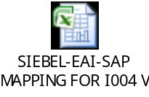

Developer Notes

Code management
For Code management and usage of subversion refer the document.

Deployment Process:
The deployment process for BPEL, ESB or webservices components and as well as for any other deployments like DB Scripts, Business rules configurations: refer EAI- Build and Deployment Process.doc in https://gcap-crm6-eai.reutersdev.net/svn/gcap-crm6-eai/trunk/dev/EAI-CRM61/R2releases/BuildDocs folder in SVN.

Issues/Workarounds:

S.No | Summary | Status | Assigned to | Solution
1 | Siebel CRM Schemas | Open | CRM team
2 | SAP WSDLs | Open | SAP Team
3 | EAI Dev environment details required | Open | EAI
Appendix A

This section gives a quick over view of the typical functionality which had been implemented.

