Billing to Cash Collection Project

Interface Detail Design Document

Development ID I027 – Order to Bill
OB Interface: SAP to Siebel CRM

1) Approvals 4
2) Review List 4
3) Related Documentation 4
4) Glossary 4
5) Introduction 5
5.1 Document Context 5
5.2 Document Structure 5
5.3 Scope 5
5.4 Out of Scope 5
5.5 Assumptions 5
6) SAP Order Status to CRM 6
6.1 Interface Definition 6
6.1.1 Interface Purpose 6
6.1.2 Context 6
6.1.3 Functional View 6
6.2 Interface Characteristics 6
6.3 Interface Design 7
6.3.1 High Level Interface Design 7
6.3.2 Overview 8
6.3.3 Data Definitions 8
6.4 Interface Design Components 8
6.4.1 SAPOM_OrderStatus 9
6.4.2 SAPOM_TransformOrderStatus 10
6.4.3 OM Manage Order Line Status 11
6.4.4 CCRMOM_ProxyPropagateOrderStatus 12
6.4.5 CCRMOM_PropagateOrderStatus 13
6.4.6 CCRMOM Dequeue Order Update status 14
6.4.7 Data Mapping (Transformation) 15
7) Developer Notes 15
➢ Code management 15
➢ Deployment Process: 15
8) Issues/Workarounds: 15

Document History
Version | Change Description | Author | Date Released
1.0 | First draft | Sreeja | March 5, 2010
1.1 | After review comments | Damodar | March 29, 2010

Approvals
The individuals listed below will be required to review and approve this document.
Role | Name | Signature | Date

Review List
Name | Position

Related Documentation
Ref | Title | Author | Version
I004 | Order to Bill | Justine Perry | 1.0

Glossary
Abbreviation | Definition
CCRM | Commerce and Customer Relationship Management
EAI | Enterprise Application Integration
B2CC
SAP

Introduction

Document Context
This document is a set of Interface Definition Documents providing the definition and High Level Design of the interfaces required for the SAP to Siebel CRM outbound interface that will enable the creation, modification, or cancellation of Sales Orders within SAP B2CC, which will ultimately be driven by the Siebel CRM system.

Document Structure
This document describes about the requirements of an interface in terms of scope, functionality and characteristics. This document focus on what the interface does from an end-to-end perspective. Also covers the design of interface and the technical integration implementation.

Scope
This document covers the online integration of billing from SAP order status to Siebel CRM – This document describes the various responses Messages from SAP to SIEBEL.

Out of Scope
-NA-

Assumptions

Siebel CRM will be the single point of entry for order processing. All orders must be raised, changed, or removed within Siebel CRM and subsequently fed to SAP B2CC.
The SAP Sales Order is created when the Siebel Sales Order lines are released to billing from Siebel CRM.
Payment status updates and disputes will not be updated to Siebel CRM via the EAI, since the info will not be updating from Outbound (SAP) interface.

SAP Order Status to CRM

Interface Definition

Interface Purpose
The purpose of this interface is to allow SAP to return updated order line status to CCRM. This will provide status and reference data to Siebel CRM. The Order Tracking and Status process defines the elements required to provide Siebel Orders with status and error information relating to their corresponding SAP Sales Orders. The main aim of the process is to facilitate the review of the order status and to track orders as they progress to the SAP B2CC Sales and Distribution module.

Context
The order status process is initiated from SAP. The order status is processed by the SAP components. When the order is created in SAP, Order status is sent back to EAI and it further propagates to CRM and the order line in CRM is updated. When a Sales order cannot be validated in the SAP system resulting in a failure to process, the OMS will be able to view the error on the Order Line in Siebel CRM where they can see why the order failed and the type of error.EAI will orchestrate the end to end process by invoking the order status update workflow on the CCRM platform through an MQ.

Functional View
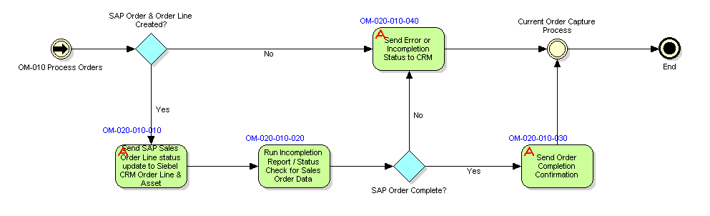

Interface Characteristics
EAI exposes an interface known as SAP Order Status to receive the order status update events from SAP. The interface provides the ability to:
Pass order line status updates to the CCRM platform

- Once the SAP Sales Order is completed and all information on the SAP Sales Order is complete in the sense that it has an established billing plan in SAP B2CC, a status of “Complete” should be sent back to the Siebel CRM Order Line.

- In case of any failure in creating the billing in SAP, the validation error will be sent back to the Siebel Order Line with the details of the failed Siebel Order and include a standard set of error reasons for display within the Validation Messages in the Siebel Order.

The interface is an asynchronous ESB service invoked using SOAP over HTTPS. The messaging style used for the Submit Order interface is the ‘Command Style’, where a general purpose message format is used with a standard data payload.

Interface Design

High Level Interface Design
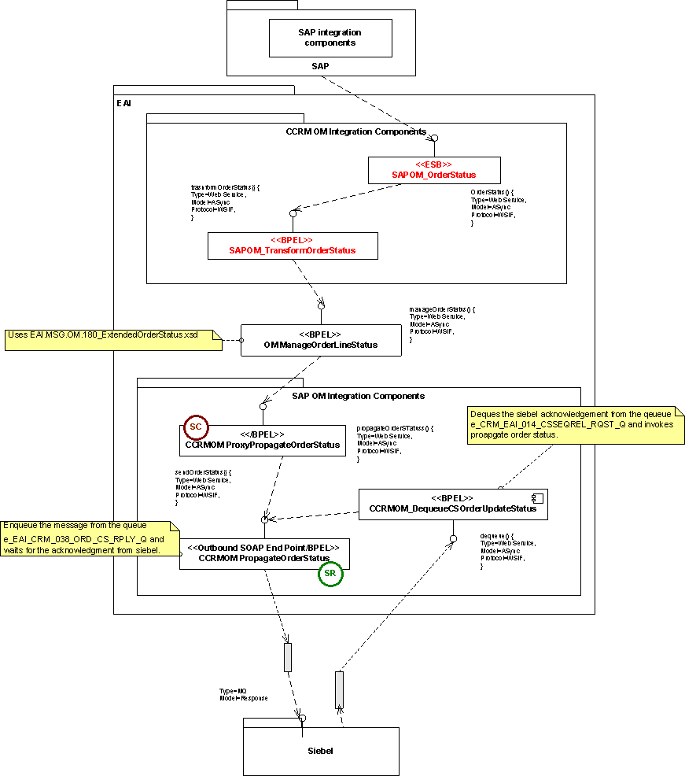

Overview
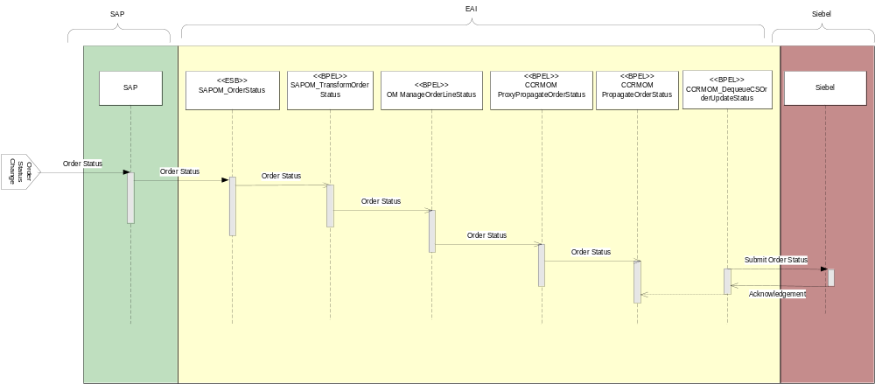

Data Definitions
The message specifications used in the interfaces between EAI and the external systems are defined in the API specification [6].
Latest versions of the XML schemas for the messages used in the interface are stored in the Reuters Developer Network Subversion repository (https://int.thomsonreuters.com) project called sami (https://sami.cdt.int.thomsonreuters.com). The definitions for this interface can be found in subversion at:
https://sami.cdt.int.thomsonreuters.com/svn/eai_eai/branches/6.1/design/EAI1.0/Interfaces

Interface Design Components

S.No | Module Name/Method | Component Type | Existing/New
1 | SAPOM_OrderStatus | ESB Process | New ESB Component
2 | SAPOM_TransformOrderStatus | BPEL Process | New BPEL Component
3 | OM_Manage Orderlinestatus | BPEL Process | Existing BPEL Component
4 | CCRMOM_ProxyPropagateOrderStatus | BPEL Process | Existing BPEL Component
5 | CCRMOM PropagateOrderStatus | BPEL Process | Existing BPEL Component
5 | CCRMOM Dequeue Order Update status | BPEL Process | Existing BPEL Component

SAPOM_OrderStatus
- Purpose

SAPOM Order Status is an async webservice invoked by SAP system, EAI exposes this webservice to receive the order status update events from SAP
- Program Logic

TO-BE:
This process invokes SAPOM_TransformOrderStatus process and transforms the message from SAP format to EAI format. The data mapping section describes the fields that SAP sends to EAI for the order status
- DVM
-NONE-

- Data Mapping (Transformation)
Source(SAP) | Target (EAI) | Description
MessageHeader | Message Header
ORDER_ID | OLI | Order Line id
ASSET_ID |  | Asset Integration Number
CTORDNO |  | Order Number
CTORDITMNO |  | Item number
STAT_CODE |  | Status Code – ‘0/1’
ERROR_CODE |  | Error Code for any errors
MESSAGE |  | Descripton

- Exception Handling:
-NONE-

- Input/output Schemas:

EAI.MSG.SAP.OM.285_OrderStatus.xsd

- Business Rules
NONE

- Partner links
EAI.SRV.EXT.SAP.67_ReceiveOrderStatusToSAP.wsdl

SAPOM_TransformOrderStatus

- Purpose
SAPOM_TransformOrderStatus BPEL process does the data transformations for order status into canonical form.

- Program Logic

TO-BE:
The BPEL process invoked by SAPOM_OrderStatus ESB Process and the order status data from SAP will be transformed to Siebel format and it will invoke the OM_ManageOrderlineStatus to validate the data with Buinsess rules of Order status to CRM.

- DVM
OrderLineStatus: Added new column SAPOrderLineStatus.
EAIOrderlineStatus | SAPOrderLineStatus
Billed | 0
Release to Bill Error | 1

- Data Mapping (Transformation)

TransExtendedOrderStatusToPropagateOrderStatus.xsl
- Input/output Schemas:

EAI.MSG.OM.225_OrderStatus.xsd

- Exception Handling:
For All the scopes in SAPOM_TransformOrderStatus catch all types exceptions and throwing the fault message.
Selection Failure:
For any Selection Failure fault exception while transformation catches the exception and throwing remote fault exception and appending the fault message to the title.
remoteFault:
For any Remote fault exception while transformation catches the exception and throwing remote fault exception and appending the fault message to the title.
runtimeFault:
For any run time fault exception while transformation catch the exception and throwing run time fault exception and appending the fault message to the title.
bindFault:
For any data binding or data validations exceptions while transformation catch the exception and throwing remote fault exception and appending the fault message to the title.

NOTE: After Fault the BPEL instance is ready for Re-initiate, Manually user/Ops team will be re-initiating after all validations done.

- Partner links
CCRMOM_ProxyPropagateOrderStatus.wsdl

OM Manage Order Line Status
- Purpose
The service based on the Status rules in the rules engine processes the Order Status coming from Core Suite and SAP.

- Program Logic
AS-IS
OM_ManageOrderLineStatus process receives the order status from Core Suite and applies rules based on the values on the order line attributes. Below fields drive the Billing status and Permissioning Status to be passed to Siebel and next action to be taken.
Core Suite Order Line Status
Header Action Code
Business Case
Order Line Action Code
Billing Integration Flag
Permissioning Integration Flag
Permissioning System
Manual Permissioning Required
STB
Free Trail Flag
Manual Permissioning Complete
Auto Permissioning Complete
permBillFlag

Based on attribute values, decision service decides (uses rules engine) what Permissioning and Billing status needs to be sent to Siebel and the next action to be taken. If the next action is RTB (Release to Billing), EAI will send a billing release request to Core Suite by forwarding call to CSOM_COMPASSOrderFulfilment. Any failure in release the billing notified to Siebel.

Rules: Currently integration supports the release to billing (RTB) action as next action. New actions will be added in due course. Rules will be defined based on the values in the Order Status sheet of EAI Order Rule Grid.

The OM_ManageOrderLineStatus enriches order line details before passing them to the CCRMOM_ProxyPropagateOrderStatus if next action is "Reply to Siebel". This can be used when the data passed to the component (e.g. data returned from Core Suite) does not include all the data that was originally sent by Siebel but must be provided to Siebel in the status update. The component does this by reading information stored in the Order Cache.

TO-BE:

For SAP Status message to CRM implemented new business rule as SAPOrderLineStatus

OrderLineStatus is Billed (0) or Release to Bill Error and billingPlatform is SAP then nextAction2 will be set to Reply to Siebel.

Based on the business rule validation CCRMOM_ProxyPropgateOrderStatus will be invoked.

- BuinessRules:
SAPOrderLineStatus

CCRMOM_ProxyPropagateOrderStatus

- Purpose
The service transforms and routes the order status to Siebel integration components.

- Program Logic
AS-IS
CCRMOM_ProxyPropagateOrderStatus acts as a proxy to CCRMOM_PropagateOrderStatus, all the components that used to call CCRMOM_PropagateOrderStatus will call CCRMOM_ProxyPropagateOrderStatus.
There are 2 parallel flows which being called
TF_OrderDispatcher
Propagate OrderStatus.

TO-BE:
Input and Out schema changes to be done.
- Exception Handling:
For All the scopes in CCRMOM_ProxyPropagateOrderStatus catch all types exceptions and throwing the fault message.
Selection Failure:
For any Selection Failure fault exception while transformation catches the exception and throwing remote fault exception and appending the fault message to the title.
remoteFault:
For any Remote fault exception while transformation catches the exception and throwing remote fault exception and appending the fault message to the title.
runtimeFault:
For any run time fault exception while transformation catch the exception and throwing run time fault exception and appending the fault message to the title.
bindFault:
For any data binding or data validations exceptions while transformation catch the exception and throwing remote fault exception and appending the fault message to the title.

NOTE: After Fault the BPEL instance is ready for Re-initiate, Manually user/Ops team will be re-initiating after all validations done.
- DVM
NONE

- Input/output Schemas:

EAI.MSG.OM.180_ExtendedOrderStatus.xsd
EAI.MSG.UTL.268_SequenceCheckerRequest.xsd
- Partner links:
TF_OrderDispatcher
CCRMOM_PropagateOrderStatus.wsdl

CCRMOM_PropagateOrderStatus

- Purpose

The service transforms and routes the order status to Siebel integration components by enqueuing Message to Siebel MQ.

- Program Logic
AS-IS
CCRMOM propagate Order Status Service uses e_EAI_CRM_038_ORD_CS_RPLY_Q queue to propagate order status to Siebel where e – is environment. P – Production, B – Blue, BL – Blue Lite, A – UAT, Y – System test, NFT – Non functional environment and T – test/development.
Before enqueuing message to Siebel MQ, message will be transformed from EAI.MSG.OM.225_OrderStatus to EAI.MSG.CCRM.OM.148_OrderRequest.Message. After successful enqueuing message to Siebel. EAI receive “Success” or “Error” from Siebel .If Order request actionCode=’Success” call is forwarded to Sequence Releaser .Otherwise Seibel error is thrown.As part of the transformation static data transformation will be done using DVM (domain value map lookups).
TO-BE:
Input and Out schema changes to be done (if any)
- Exception Handling:
For All the scopes in CCRMOM_PropagateOrderStatus catch all types exceptions and throwing the fault message.
Selection Failure:
For any Selection Failure fault exception while transformation catches the exception and throwing remote fault exception and appending the fault message to the title.
remoteFault:
For any Remote fault exception while transformation catches the exception and throwing remote fault exception and appending the fault message to the title.
runtimeFault:
For any run time fault exception while transformation catch the exception and throwing run time fault exception and appending the fault message to the title.
bindFault:
For any data binding or data validations exceptions while transformation catch the exception and throwing remote fault exception and appending the fault message to the title.

NOTE: After Fault the BPEL instance is ready for Re-initiate, Manually user/Ops team will be re-initiating after all validations done.
- DVM
NONE

- Data Mapping (Transformation)

<<TBD>>
- Input/output Schemas:

EAI.MSG.CCRM.OM.148_OrderRequest.xsd
EAI.MSG.OM.225_OrderStatus.xsd

CCRMOM Dequeue Order Update status

- Purpose

The service Dequeues message “Success” or “Error” from Seibel MQ indicating message as been received from core suite and call is forward to CCRMOM_PropagateOrderStatus.
- Program Logic
AS-IS
The process dequeues the message from the queue e_CRM_EAI_014_CSSEQREL_RQST_Q to which Siebel enqueues the message. e – Is environment. P – Production, B – Blue, BL – Blue Lite, A – UAT, Y – System test, NFT – Non functional environment, T – test/development.
Actioncode =“Success” or “Error” message is enqueued to Siebel MQ.
This is in EAI.MSG.CCRM.OM.148_OrderRequest format. And forwards call to CCRMOM_PropagateOrderStatus on “Success” message and call is forwarded to sequence releaser component..
TO-BE:
Input and Out schema changes to be done (if any)
- Exception Handling:
For All the scopes in CCRMOM_PropagateOrderStatus catch all types exceptions and throwing the fault message.
Selection Failure:
For any Selection Failure fault exception while transformation catches the exception and throwing remote fault exception and appending the fault message to the title.
remoteFault:
For any Remote fault exception while transformation catches the exception and throwing remote fault exception and appending the fault message to the title.
runtimeFault:
For any run time fault exception while transformation catch the exception and throwing run time fault exception and appending the fault message to the title.
bindFault:
For any data binding or data validations exceptions while transformation catch the exception and throwing remote fault exception and appending the fault message to the title.

NOTE: After Fault the BPEL instance is ready for Re-initiate, Manually user/Ops team will be re-initiating after all validations done.
- DVM
NONE

- Data Mapping (Transformation)

<<TBD>>

Data Mapping (Transformation)
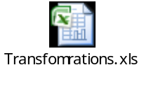

Developer Notes

Code management
For Code management and usage of subversion refer the document.

Deployment Process:
The deployment process for BPEL, ESB or webservices components and as well as for any other deployments like DB Scripts, Business rules configurations: refer EAI- Build and Deployment Process.doc in https://gcap-crm6-eai.reutersdev.net/svn/gcap-crm6-eai/trunk/dev/EAI-CRM61/R2releases/BuildDocs folder in SVN.

Issues/Workarounds:

S.No | Summary | Status | Assigned to | Solution
1 | Siebel CRM Schemas | Open | CRM team
2 | SAP WSDLs | Open | SAP Team
3 | EAI Dev environment details required | Open | EAI
Appendix A

This section gives a quick over view of the typical functionality which had been implemented.

