***Welcome to***

***FARMER PLACE***



**DESCRIPTION:**

An ecommerce website for farmers would be a platform that provides a marketplace for farmers to sell their produce directly to consumers. The website would feature various products such as fresh fruits, vegetables, grains and some other products. In the website users can upload images of the problems they face, and other users can comment with solutions or suggestions to help solve the issue. The website can provide a platform for farmers to get help and learn from each other, creating a community that supports each other.

Users would be able to create profiles on the website and list their products for sale. consumers would be able to browse and transactions would need to be completed outside of the website using alternative payment methods such as cash or bank transfers.

Overall, an ecommerce website for farmers would provide valuable resources, creating a direct connection between producers and consumers while offering solutions for common farming challenges.

**Scope & Software Stack ➖**

React(Redux), Express, NodeJS, MongoDB( MERN) Stack

This Project Mainly comprises of two Panels

User Panel - User can post stories of the crops or the products they want to sell. Other users can like, dislike and post comments on it. It has a market place to make a listing and sell their yield and they have right to manage their content and listings

Admin Panel - Admin has rights over content to delete anything that is misleading the other users. Admin can block user profile that might be inappropriate according to the app rules. Admin has access to all the feedbacks written by all the users.

**Functional requirements:**

1.User Registration and Login: Users should be able to create their own account, log in and log out of the system.

2.User forgot password: User should be able to reset his password by clicking on forget password link.

3.Content Creation and Posting: Users should be able to create and post their own content, including text, images, videos, and other multimedia files.

4.Content Management: The platform should allow users to manage their own content, including editing, deleting, and updating their posts.

5.Marketplace Functionality: The platform should have a marketplace feature that allows users to buy and sell products.

6.Product filtering: User should be able to do the product filtering by using the filter option.

7.Search Functionality: The platform should have a search feature that allows users to search for specific content or products.

8.Account deleting: User and Admin should be able to delete their own account.

9.Admin login: Admin should be able to login and logout of the system and also be able reset his password.

10. Content Management: Admin should be able to block the posts, videos and users accounts (including marketplace) if the content is not related to the website.

11.Admin and User profile management: Admin should be able to edit his own profile and also User should be able to edit his own profile.

12.User should be able to see other users posts and comment on the posts and also and also be able to see the other users on posts in the marketplace.

**Non-functional requirements:**

1.Security: The platform should be secure, with measures in place to protect user data and prevent unauthorized access.

2.Performance: The platform should be fast and responsive, with minimal downtime or latency.

3.Scalability: The platform should be able to scale up as the number of users and amount of content grows.

4.Usability: The platform should be easy to use and navigate, with an intuitive user interface and clear instructions.

5.Compatibility: The platform should be compatible with a variety of devices and browsers.

**Poker Planning :**

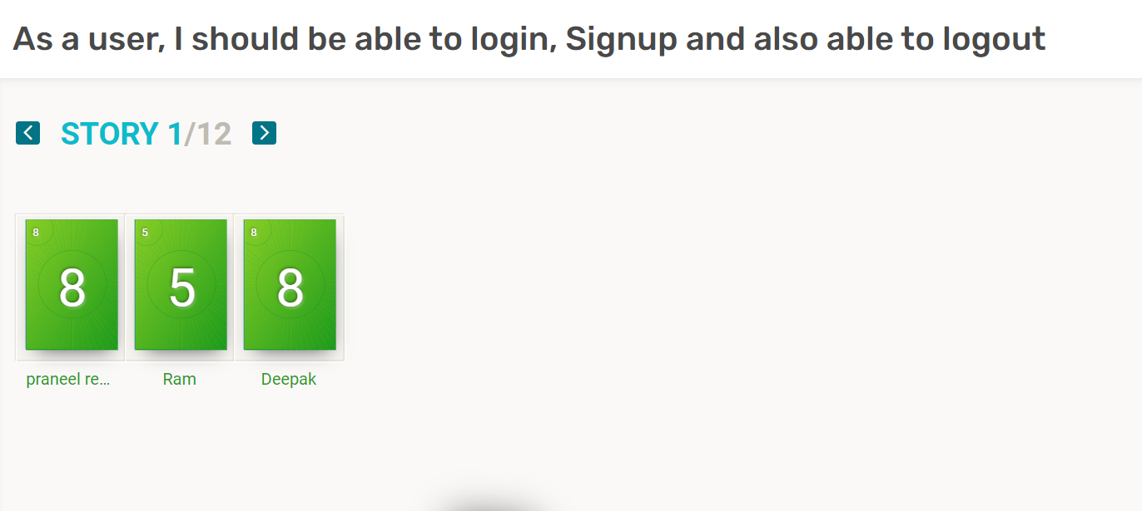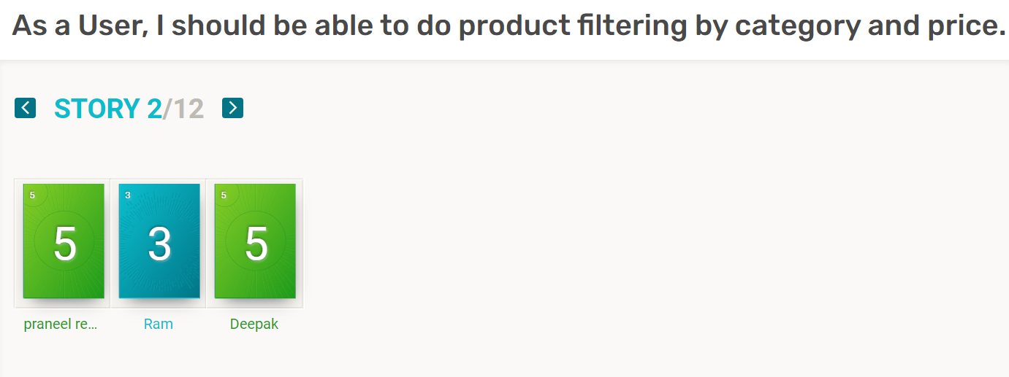

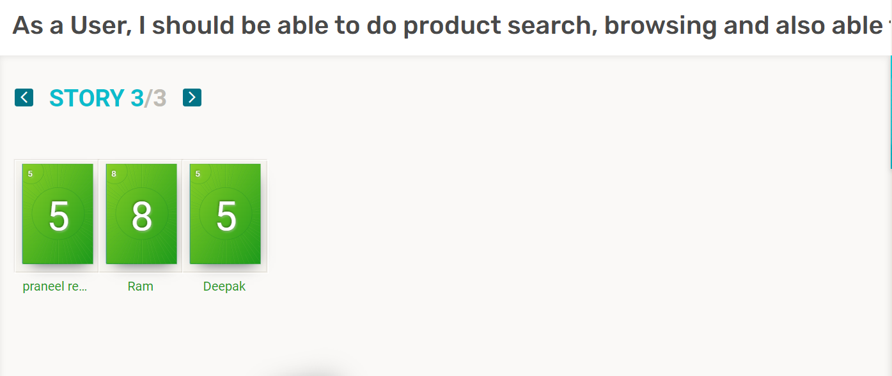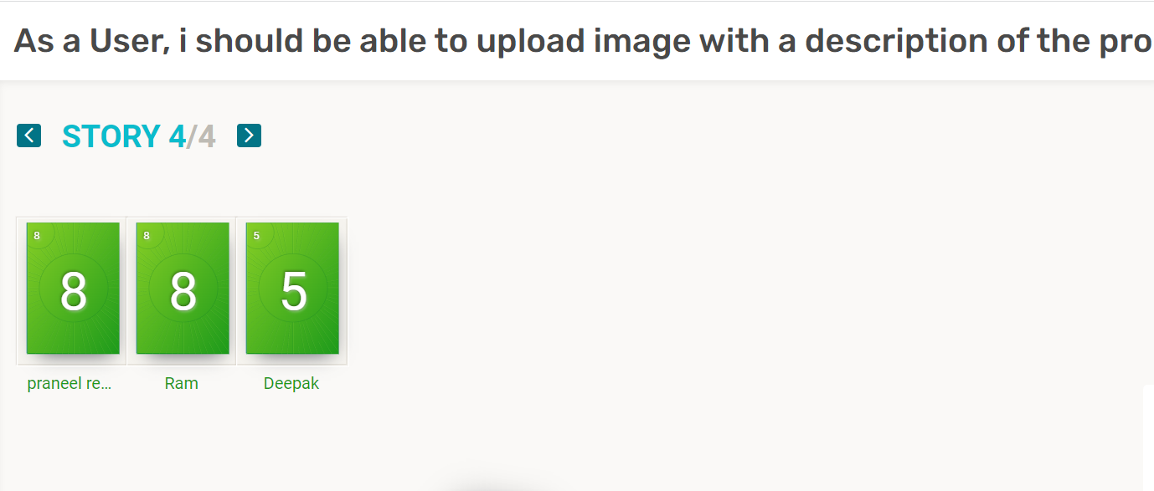

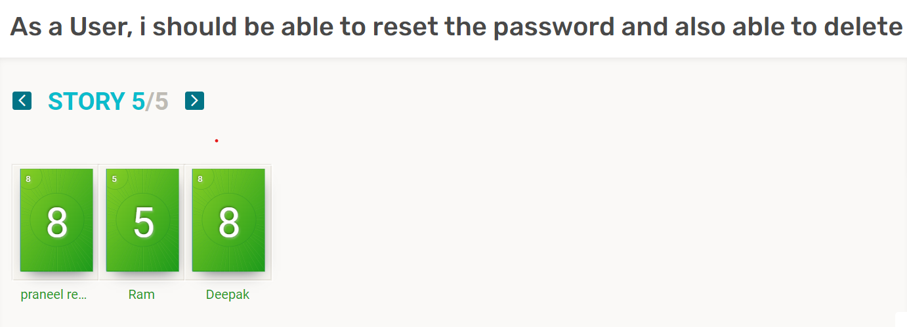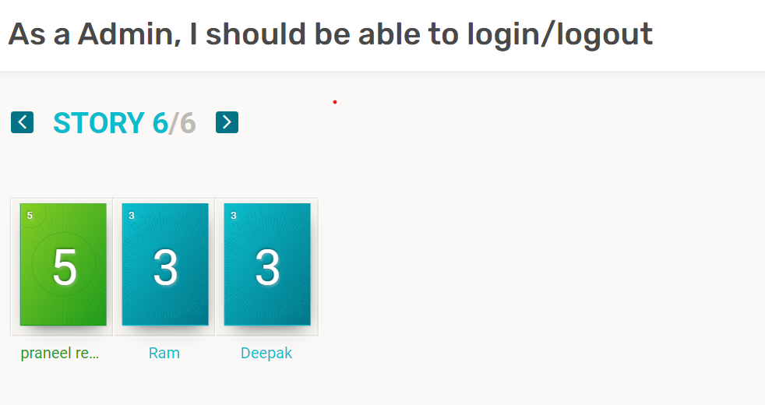

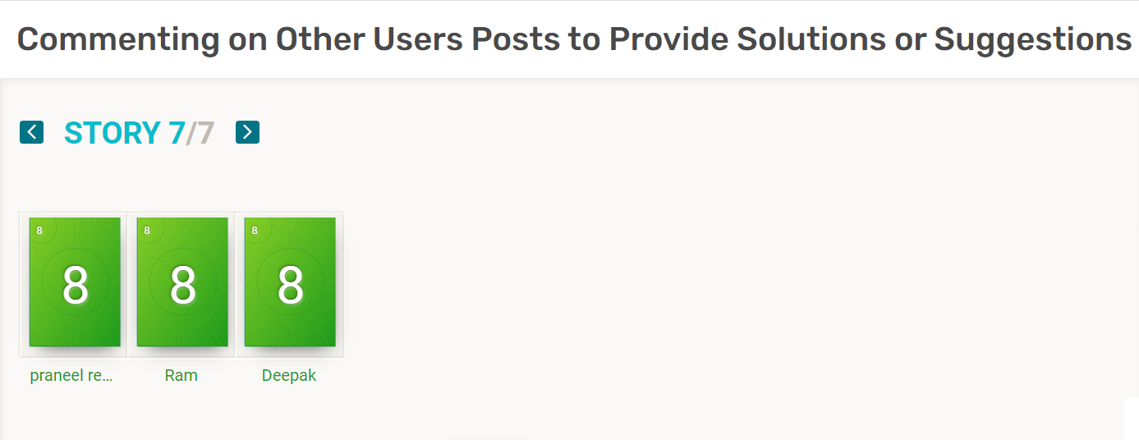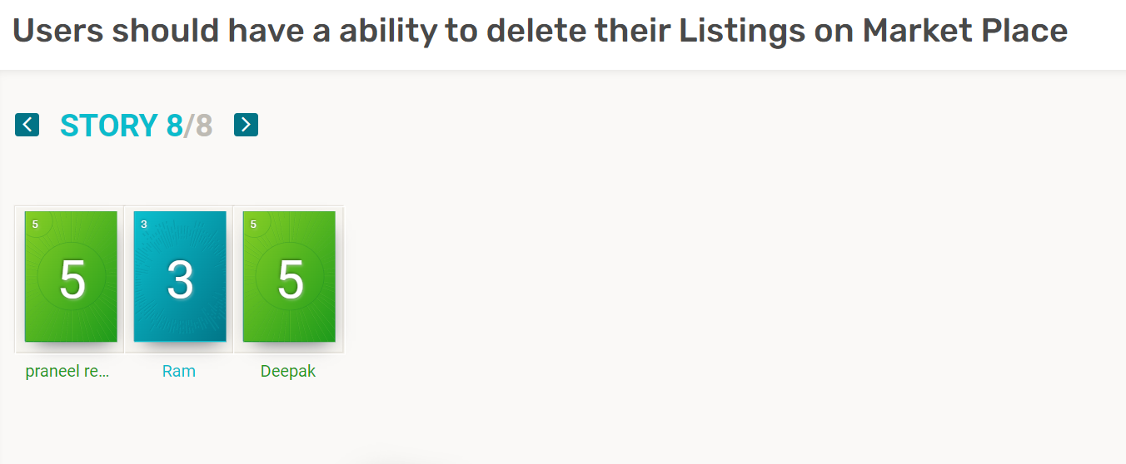

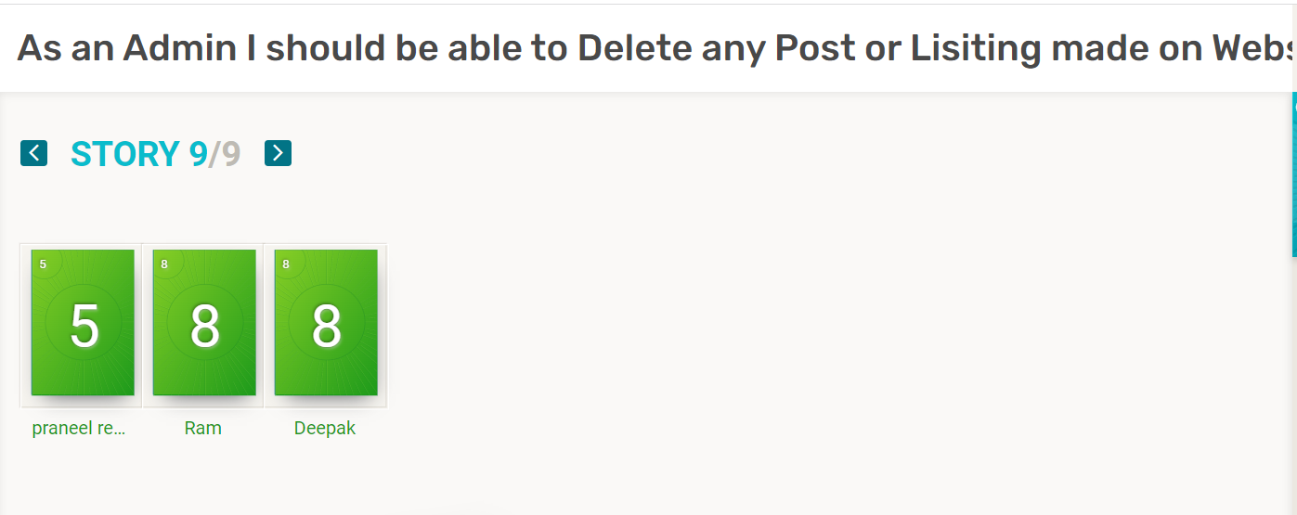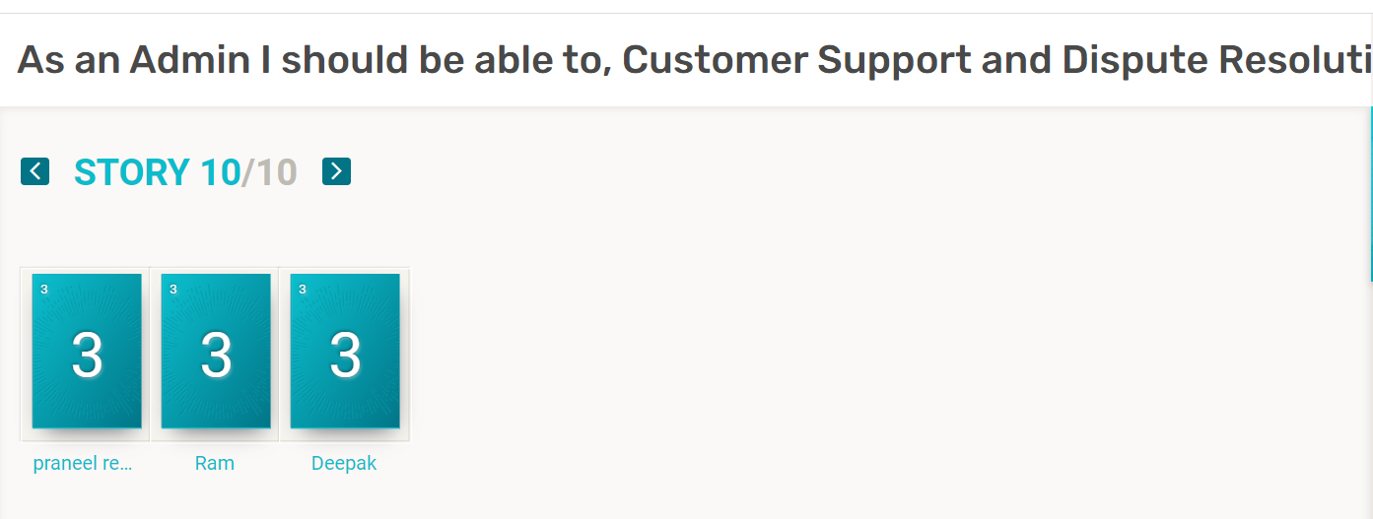

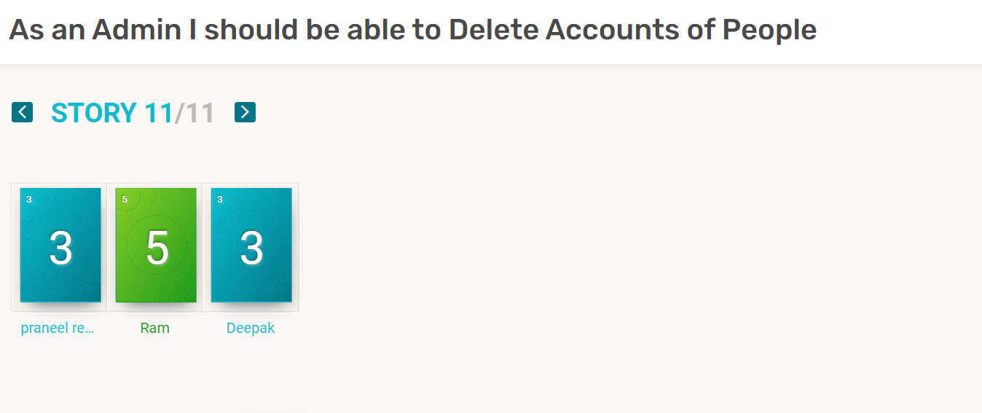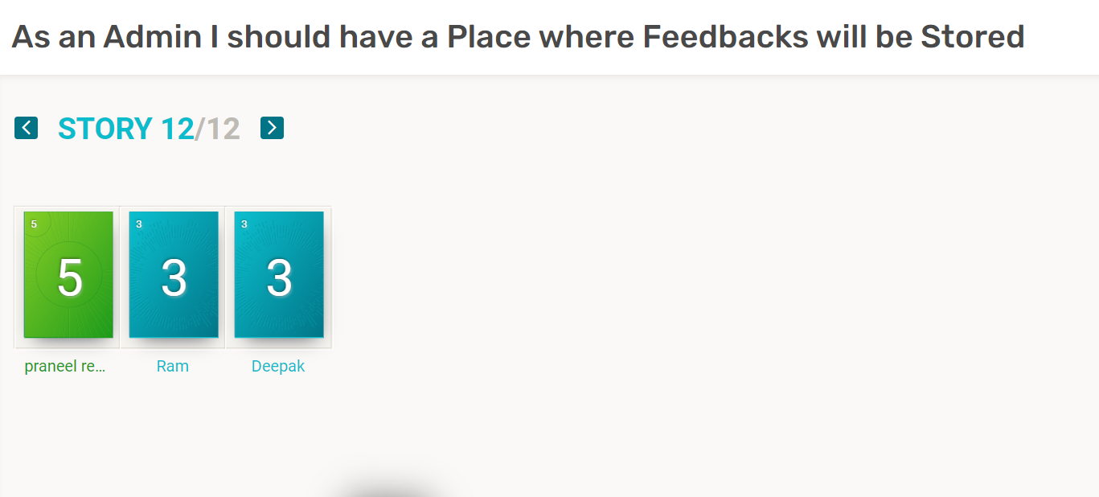

**Backlogs :**

| userID | User description | User story point | priority |
| --- | --- | --- | --- |
| FP1 | As a User, I should be able to Login/Signup into the Website and also able to logout | 8 | High |
| FP2 | As a User, I should be able to like or dislike any post made on website. | 5 | Medium |
| FP3 | As a User, I should be able to do product search and also able to Search the Posts | 8 | High |
| FP4 | As a User, i should be able to upload image with a description as a post in feed and be able to do listing in Market Place | 8 | High |
| FP5 | As a User, i should be able to reset the password and also able to delete the account | 8 | High |
| FP6 | As a Admin, I should be able to Login/Logout and be able to reset Password | 5 | High |
| FP7 | Commenting on Other Users Posts to Provide Solutions or Suggestions | 8 | Medium |
| FP8 | Users should have a ability to delete their Listings on Market Place or Delete their Posts in the Feed | 5 | High |
| FP9 | As an Admin I should be able to Delete any Post or Lisiting made on Website | 8 | High |
| FP10 | As an Admin I should be able to, Customer Support and Dispute Resolution | 3 | Low |
| FP11 | As an Admin I should be able to block/ unblock Accounts of Users | 5 | High |
| FP12 | As an Admin I should have a Place where  Feedbacks will be Stored | 5 | Medium |
| Total(Hrs) |  | 74 Hrs |  |
| Total Iterations(3) | Number of Hours: | 74/3 = 25 Hrs |  |

**Release Plan ➖**

***First Iteration***

| **User ID** | **User Description** | **User Story points** | **Priority** |
| --- | --- | --- | --- |
| **FP1** | As a User I should be able to login/signup and also be able to logout | 8 | High |
| **FP5** | As a User, i should be able to reset the password and also able to delete the account | 8 | High |
| **FP6** | As a Admin, I should be able to Login/Logout and be able to reset Password | 5 | High |
| **FP11** | As an Admin I should be able to Block Accounts of Users | 5 | High |
| **Total Hours** |  | 26 Hours |  |

***Second Iteration***

| **User ID** | **User Description** | **User Story points** | **Priority** |
| --- | --- | --- | --- |
| **FP4** | As a User, i should be able to upload image with a description as a post in feed and be able to do listing in Market Place | 8 | High |
| **FP3** | As a User, I should be able to do product search and also able to Search the Posts | 8 | High |
| **FP9** | As an Admin I should be able to Delete any Post or Listing made on Website | 8 | High |
| **Total Hours** |  | 24 Hours |  |

***Third Iteration***

| **User ID** | **User Description** | **User Story Points** | **Priority** |
| --- | --- | --- | --- |
| **FP8** | Users should have a ability to delete their Listings on Market Place or Delete their Posts in the Feed | 5 | High |
| **FP2** | As a User, I should be able to like or dislike any post made on website. | 5 | Medium |
| **FP7** | Commenting on Other Users Posts to Provide Solutions or Suggestions | 8 | Medium |
| **FP10** | As an Admin I should be able to, Customer Support and Dispute Resolution | 3 | Low |
| **Total Hours** |  | 19 Hours |  |

**Burndown Chart ➖**

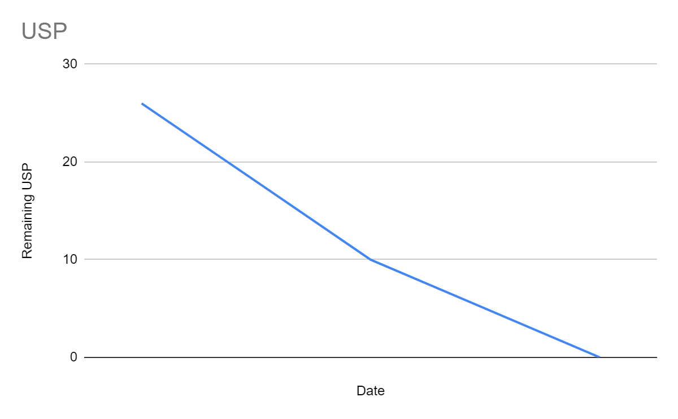

This is burndown chart for First Iteration or 1/3 rd of the Backlogs

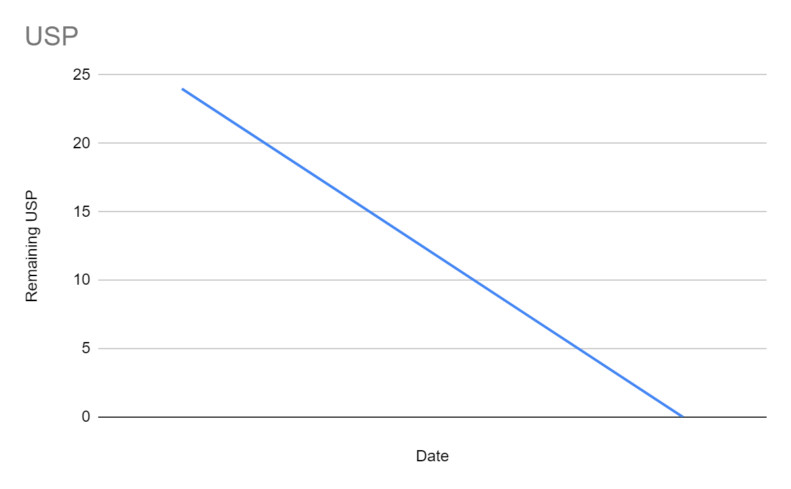

This is burndown chart for 2/3 of backlogs (or) Second Iteration

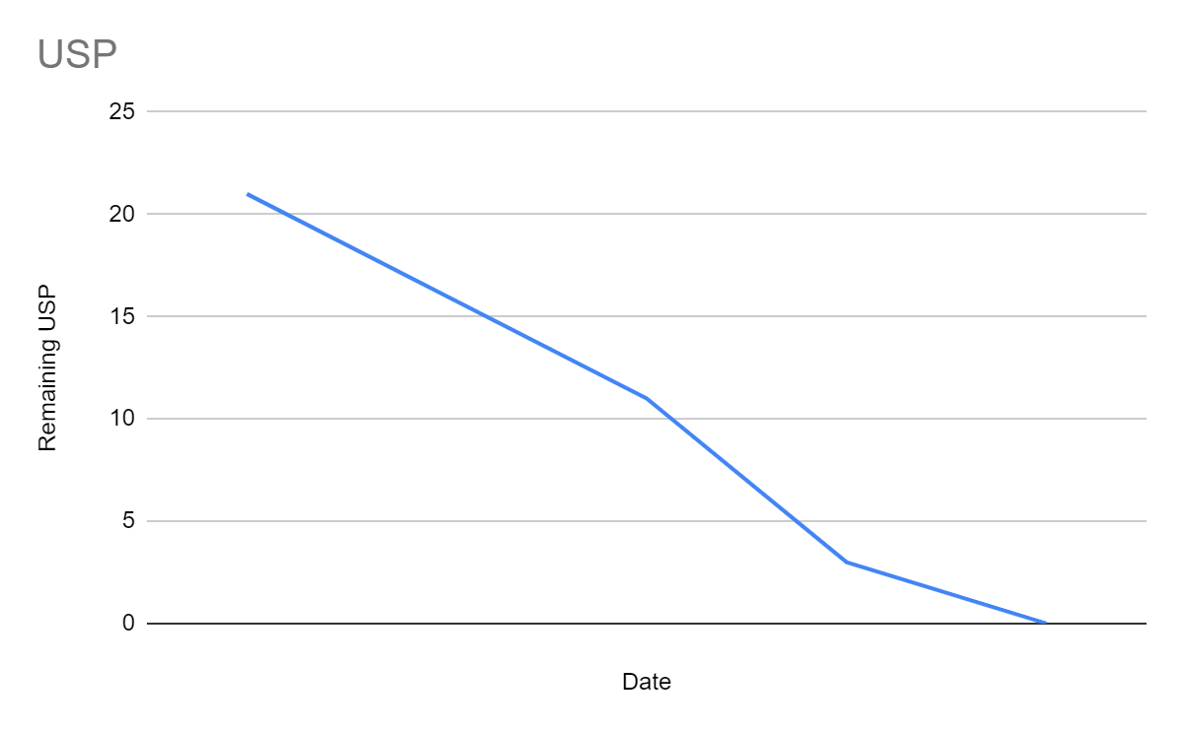

This is burndown chart for third iteration

**Moqups Link:**

https://app.moqups.com/wlFoO4zilWvP4aYXKewZDPFF9ocriUtw/edit/page/a04c7c305

**Flow of Moqups:**

As a User

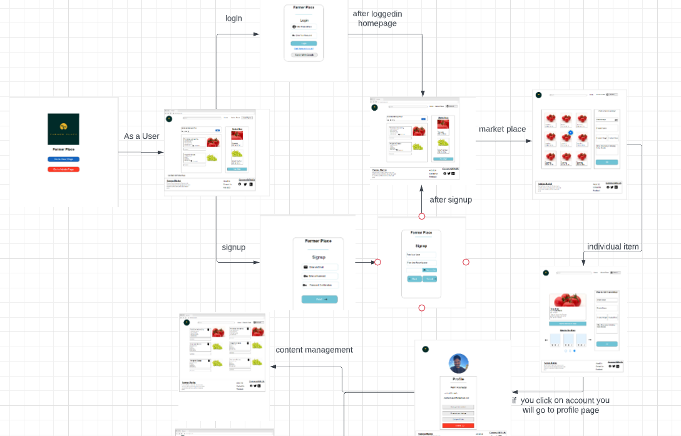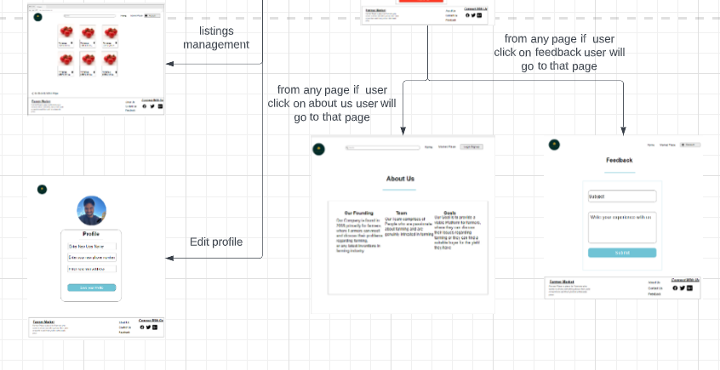

As a Admin

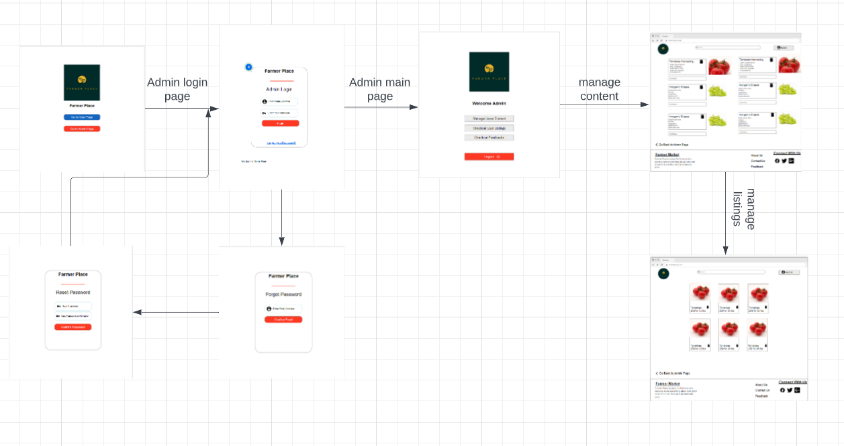

**Use Case :**

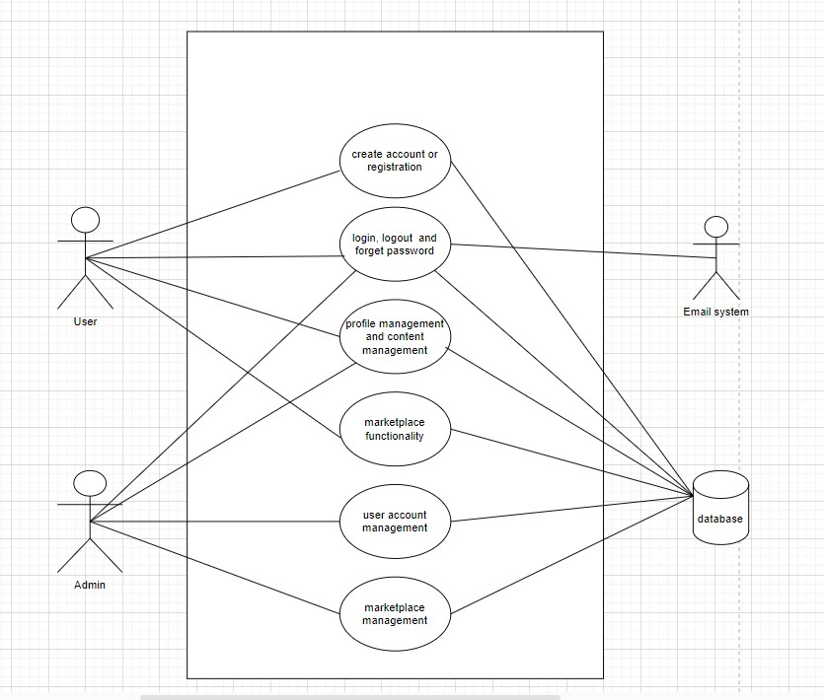

**Fully Dressed Use case:**

| UC ID | 1 |
| --- | --- |
| Use Case Name | Create account or Registration |
| Actor | User |
| pre-condition | User should not already have an account on the website |
| Main success scenario | Users enter their personal information, such as name, email, and password, and the system creates a new account for the user and stores the information in the database. |
| Alternative scenario | If the user enters invalid information or an existing email address, the system should display an error message and prompt the user to correct the information. |

| UC ID | 2 |
| --- | --- |
| Use Case Name | Access to profile |
| Actor | User  Admin |
| Pre-condition | User or Admin should already have an account on the website |
| Main success scenario | 1. User or Admin enters their email and password, and the system verifies the information from the database. If the information is correct, the system logs the user in and grants them access to the website.  2.User or Admin clicks the "Logout" button, and the system logs them out and ends their session.  3.User or Admin clicks on the "Forgot Password" link, enters their email address, and the system sends a password reset link to their email. The user or admin can then follow the link and reset their password. |
| Alternative scenario | 1.If the user or admin enters invalid information, the system should display an error message and prompt the user to enter the correct information.  2.If the user or admin enters an invalid email address, the system should display an error message and prompt the user to enter a valid email address. |

| UC ID | 3 |
| --- | --- |
| Use Case Name | Profile and content management |
| Actor | User  Admin |
| Pre-condition | User or admin should already be logged in to the website |
| Main success scenario | 1. Users or admin can edit their personal information, such as name, email, password, and profile picture, and the system updates the information in the database.  2. Users or admin can create new content by adding text, images, select the category and post the content on the platform for others to see. They can also edit or delete their own content, and the system updates the content in the database accordingly. |
| Alternative scenario | If the user or admin entered invalid information or tries to modify content that is not their own, the system should display an error message and prevent the action. |

| UC ID | 4 |
| --- | --- |
| Use Case Name | Marketplace functionality |
| Actor | User |
| Pre-condition | User should already be logged in to the website |
| Main success scenario | 1. Users can sell products on the platform, create product listings, add descriptions and images, and set prices.  2. Other users can search for products.  3. Users can search for specific content or products by using keywords.The system updates the product information. |
| Alternative scenario | If the user enters invalid information the system should display an error message and prevent the action. |

| UC ID | 5 |
| --- | --- |
| Use Case Name | User account management |
| Actor | Admin |
| Pre-condition | Admin should already be logged in to the website |
| Main success scenario | 1.Admin can block inappropriate posts posted by users.  2. Admin can manage user accounts, including blocking and unblocking their accounts and editing user information.  3.Also admin can block the inappropriate posts and content posted in the marketplace by users.  4. The admin should be able to generate reports on user activity. |
| Alternative scenario | If the admin tries to modify an account that does not exist or enters invalid information, the system should display an error message and prevent the action. |

| UC ID | 6 |
| --- | --- |
| Use Case Name | Marketplace management |
| Actor | Admin |
| Pre-condition | Admin has logged in to the system |
| Main success scenario | 1.Admin can view the current list of products on the marketplace.  2.Admin can remove a product from the marketplace.  3.The system updates the product information in the database accordingly. |
| Alternative scenario | If the admin tries to modify or delete a product that does not exist, the system should display an error message and prevent the action. |

**Activity Diagram:**

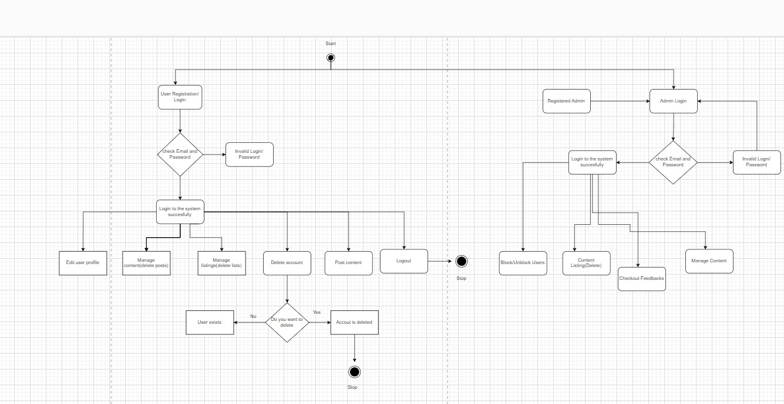

***Sequence Diagram:***

**1.User Panel Sequence diagram -**

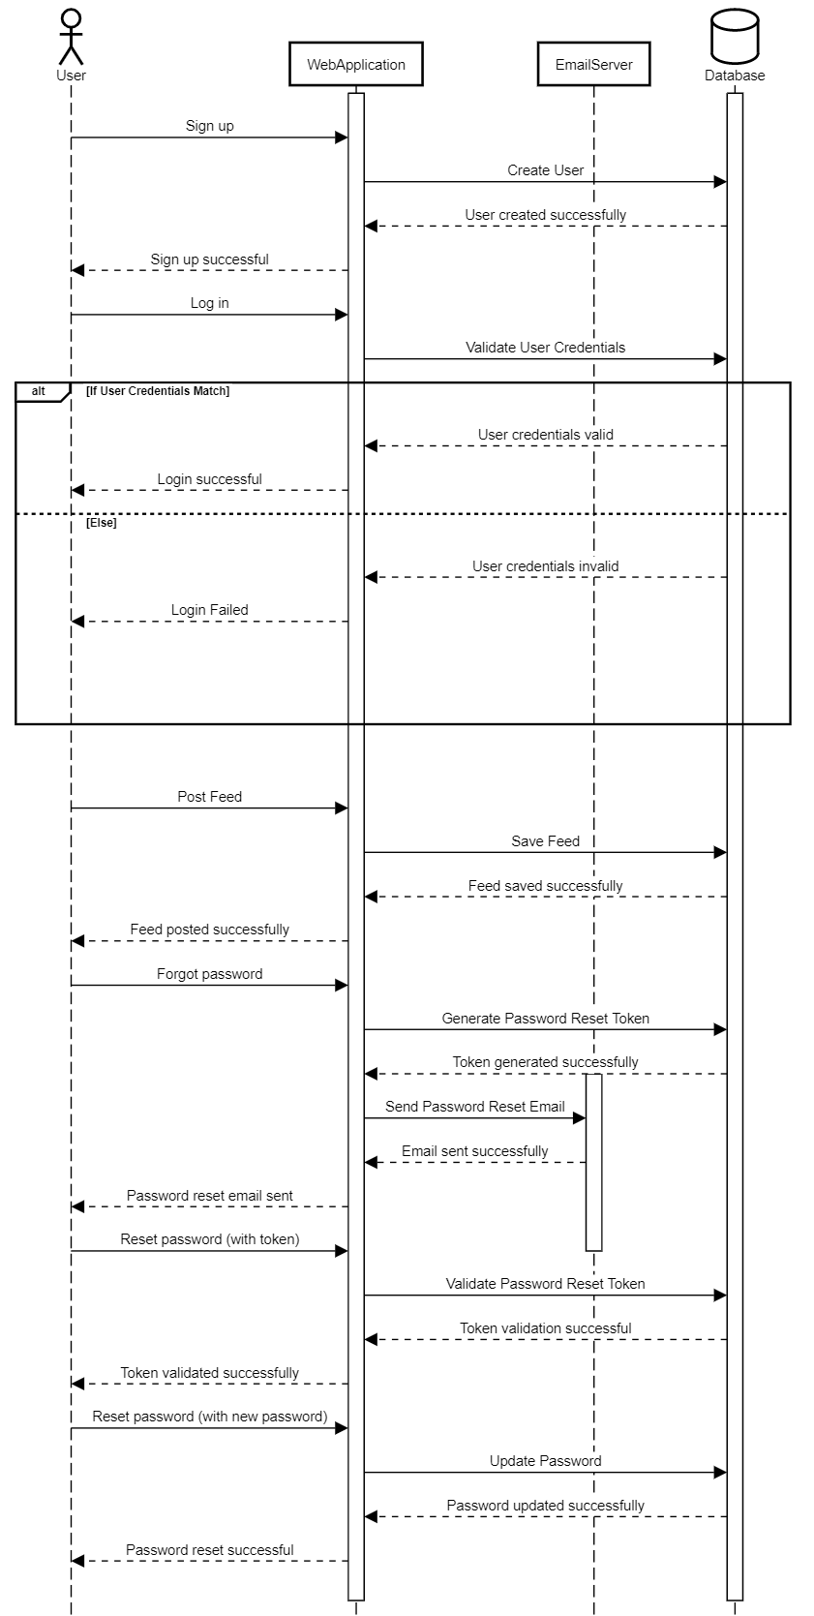

**2.Admin Panel Sequence diagram -**

