#include<stdio.h>
#include<stdlib.h>
struct tree
{
int key;
struct tree *left,*right;
};
typedef struct tree Tree;
Tree *gettree()
{
return (Tree *)malloc(sizeof(Tree));
}
void preorder(Tree *root)
{
printf("%d ",root->key);
if(root->left!=NULL)
preorder(root->left);
if(root->right!=NULL)
preorder(root->right);
}
void inorder(Tree *root)
{
if(root->left!=NULL)
inorder(root->left);
printf("%d ",root->key);
if(root->right!=NULL)
inorder(root->right);
}
void postorder(Tree *root)
{
if(root->left!=NULL)
postorder(root->left);
if(root->right!=NULL)
postorder(root->right);
printf("%d ",root->key);
}
Tree *insert(Tree *root, Tree *ins)
{
Tree *temp=root;
if(root==NULL)
root=ins;
else if(temp->key>=ins->key)
{
temp=insert(temp->left,ins);
root->left=temp;
}
else
{
temp=insert(temp->right,ins);
root->right=temp;
}

return root;
}
void main()
{
Tree *root=NULL,*temp=NULL;
int a;
scanf("%d",&a);
while(a!=-1)
{
temp=gettree();
temp->key=a;
temp->left=temp->right=NULL;
root=insert(root,temp);
scanf("%d",&a);
}
printf("Preorder:\n");
preorder(root);
printf("\nInorder:\n");
inorder(root);
printf("\nPostorder:\n");
postorder(root);
printf("\n");
}

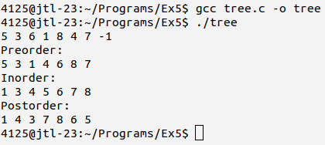

#include<stdio.h>
#include<stdlib.h>
#include<ctype.h>
struct tree
{
char key;
struct tree *left,*right;
};
typedef struct tree Tree;
struct node
{
Tree *data;
struct node *back;
};
typedef struct node Node;
Tree *gettree()
{
return (Tree *)malloc(sizeof(Tree));
}
Node *getnode()
{
return (Node *)malloc(sizeof(Node));
}
Node *push(Node *top, Tree *root)
{
if(top==NULL)
{
top=getnode();
top->data=root;
top->back=NULL;
}
else
{
Node *temp=getnode();
temp->data=root;
temp->back=top;
top=temp;
}
return top;
}
Node *pop(Node *top)
{
Node *p=top;
if(top!=NULL)
top=top->back;
free(p);
return top;
}
Node *in2tr(Node *top, char *infix)
{
Tree *b[100],*p,*z;

int i=0,j=0;
while(infix[i]!='\0')
{
p=gettree();
char q=infix[i];
p->key=q;
p->left=p->right=NULL;
if(isdigit(q))
{
b[j]=p;
j++;
}
else if(q=='(')
{
top=push(top,p);
}
else if(q=='+' || q=='-')
{
if(top==NULL || top->data->key=='(')
top=push(top,p);
else
{
z=top->data;
top=pop(top);
j--;
z->right=b[j];
z->left=b[j-1];
b[j-1]=z;
top=push(top,p);
}
}
else if(q=='*' || q=='/' || q=='%')
{
if(top==NULL || top->data->key=='(' || top->data->key=='+' || top->data->key=='-')
top=push(top,p);
else
{
z=top->data;
top=pop(top);
j--;
z->right=b[j];
z->left=b[j-1];
b[j-1]=z;
top=push(top,p);
}
}
else if(q=='^')
top=push(top,p);
else if(q==')')
{
while(top!=NULL)

{
if(top->data->key=='(')
{
top=pop(top);
break;
}
else
{
z=top->data;
top=pop(top);
j--;
z->right=b[j];
z->left=b[j-1];
b[j-1]=z;
}
}
}
i++;
}
while(top!=NULL)
{
if(top->data->key!='(')
{
z=top->data;
j--;
z->right=b[j];
z->left=b[j-1];
b[j-1]=z;
}
top=pop(top);
}
top=push(top,b[0]);
return top;
}
void postorder(Tree *root)
{
if(root->left!=NULL)
postorder(root->left);
if(root->right!=NULL)
postorder(root->right);
printf("%c",root->key);
}

void main()
{
Node *top=NULL;
char *infix=(char *)malloc(sizeof(100));
scanf("%s",infix);
top=in2tr(top,infix);
postorder(top->data);
printf("\n");
}

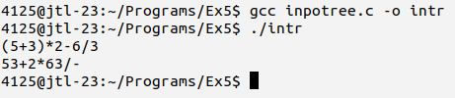

#include<stdio.h>
#include<stdlib.h>
struct tree
{
int key;
struct tree *left,*right;
};
typedef struct tree Tree;
Tree *gettree()
{
return (Tree *)malloc(sizeof(Tree));
}
void preorder(Tree *root)
{
printf("%d ",root->key);
if(root->left!=NULL)
preorder(root->left);
if(root->right!=NULL)
preorder(root->right);
}
void inorder(Tree *root)
{
if(root->left!=NULL)
inorder(root->left);
printf("%d ",root->key);
if(root->right!=NULL)
inorder(root->right);
}
void postorder(Tree *root)
{
if(root->left!=NULL)
postorder(root->left);
if(root->right!=NULL)
postorder(root->right);
printf("%d ",root->key);
}
Tree *max(Tree *root)
{
while(root->right!=NULL)
root=root->right;
return root;
}
Tree *insert(Tree *root, Tree *ins)
{
Tree *temp=root;
if(root==NULL)
root=ins;
else if(temp->key>=ins->key)
{
temp=insert(temp->left,ins);
root->left=temp;

}
else
{
temp=insert(temp->right,ins);
root->right=temp;
}
return root;
}
Tree *input(Tree *root, Tree *temp)
{
int a;
scanf("%d",&a);
while(a!=-1)
{
temp=gettree();
temp->key=a;
temp->left=temp->right=NULL;
root=insert(root,temp);
scanf("%d",&a);
}
return root;
}
Tree *delete(Tree *root, int v)
{
if(root==NULL)
return root;
if(root->key>v)
root->left=delete(root->left,v);
else if(root->key<v)
root->right=delete(root->right,v);
else
{
if(root->left==NULL)
{
Tree *t=root->right;
free(root);
return t;
}
else if(root->right==NULL)
{
Tree *t=root->left;
free(root);
return t;
}
Tree *t=max(root->left);
root->key=t->key;
root->left=delete(root->left,t->key);
}
return root;
}
void print(Tree *root)

{
printf("Preorder:\n");
preorder(root);
printf("\nInorder:\n");
inorder(root);
printf("\nPostorder:\n");
postorder(root);
printf("\n");
}
void main()
{
Tree *root=NULL,*temp=NULL;
root=input(root,temp);
print(root);
root=input(root,temp);
print(root);
int a;
scanf("%d",&a);
while(a!=-1)
{
root=delete(root,a);
scanf("%d",&a);
}
print(root);
}
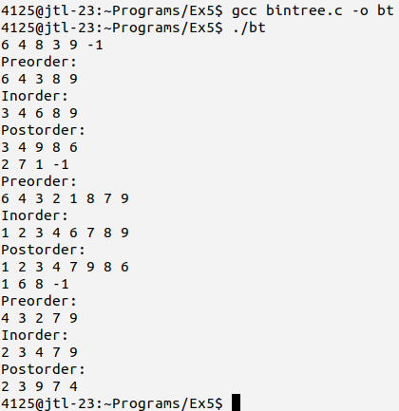

#include<stdio.h>
#include<stdlib.h>
struct tree
{
int key,height;
struct tree *left,*right;
};
typedef struct tree Tree;
int height(Tree *root)
{
if(root==NULL)
return 0;
return root->height;
}
int max(int a, int b)
{
return (a>b)?a:b;
}
Tree *gettree()
{
return (Tree*)malloc(sizeof(Tree));
}
Tree *rotateright(Tree *root)
{
Tree *x=root->left;
Tree *y=x->right;
x->right=root;
root->left=y;
root->height=max(height(root->left),height(root->right))+1;
x->height = max(height(x->left), height(x->right))+1;
return x;
}
Tree *rotateleft(Tree *root)
{
Tree *x=root->right;
Tree *y=x->left;
x->left=root;
root->right=y;
root->height=max(height(root->left),height(root->right))+1;
x->height=max(height(x->left),height(x->right))+1;
return x;
}
int balfac(Tree *root)
{
if(root==NULL)
return 0;
return height(root->left)-height(root->right);
}
Tree* insert(Tree* root, int val)
{
if(root==NULL)

{
root=gettree();
root->key=val;
root->left=root->right=NULL;
root->height = 1;
return root;
}
if (val<root->key)
root->left=insert(root->left,val);
else if(val>root->key)
root->right=insert(root->right,val);
else
return root;
root->height=1+max(height(root->left),height(root->right));
int balance=balfac(root);
if(balance>1 && val<root->left->key)
return rotateright(root);
if(balance<-1 && val>root->right->key)
return rotateleft(root);
if(balance>1 && val>root->left->key)
{
root->left=rotateleft(root->left);
return rotateright(root);
}
if(balance<-1 && val<root->right->key)
{
root->right=rotateright(root->right);
return rotateleft(root);
}
return root;
}
void pre_order(Tree *root)
{
printf("%d ",root->key);
if(root->left!=NULL)
pre_order(root->left);
if(root->right!=NULL)
pre_order(root->right);
}
void in_order(Tree *root)
{
if(root->left!=NULL)
in_order(root->left);
printf("%d ",root->key);
if(root->right!=NULL)
in_order(root->right);
}
void post_order(Tree *root)
{
if(root->left!=NULL)
post_order(root->left);

if(root->right!=NULL)
post_order(root->right);
printf("%d ",root->key);
}

int main()
{
int a;
Tree *root=NULL;
scanf("%d",&a);
while(a!=-1)
{
root=insert(root,a);
scanf("%d",&a);
}
printf("Preorder: ");
pre_order(root);
printf("\n");
printf("Inorder: ");
in_order(root);
printf("\n");
printf("Postorder: ");
post_order(root);
printf("\n");
return 0;
}

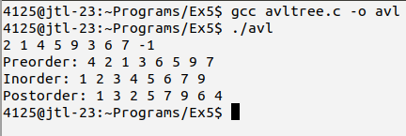

#include<stdio.h>
void insert(int a[], int k, int i, int q)
{

if(a[k]==0)
a[k]=q;
else
{
if(q<a[k])
{
for(int j=i;j>=k;j--)
a[j+1]=a[j];
a[k]=q;
}
else if(q<a[k+1])
{
for(int j=i;j>=k+1;j--)
a[j+1]=a[j];
a[k+1]=q;
}
else
insert(a,2*k+1,i,q);
}
}
void print(int a[], int n)
{
for(int i=0;i<n;i++)
printf("%d ",a[i]);
printf("\n");
}
void delete(int a[], int k, int q)
{
if(a[k]==q)
{
int i;
for(i=k;a[i]!=0;i++)
a[i]=a[i+1];
a[i-1]=0;
}
else if(a[k+1]==q)
{
int i;
for(i=k+1;a[i]!=0;i++)
a[i]=a[i+1];
a[i-1]=0;
}
else
delete(a,2*k+1,q);
}
int main()
{

int a[100],q;
scanf("%d",&q);
int i=0;
while(q!=-1)
{
a[i]=0;
insert(a,0,i,q);
scanf("%d",&q);
i++;
}
print(a,i);
printf("Enter elements to be deleted\n");
scanf("%d",&q);
while(q!=-1)
{
i--;
delete(a,0,q);
scanf("%d",&q);
}
print(a,i);
}

