#include<stdio.h>
int push(int a[], int size, int top)
{
int n;
while(1)
{
if(top==size-1)
{
printf("Stack is full\n");
break;
}
else
{
printf("Enter element ");
scanf("%d",&n);
top++;
a[top]=n;
printf("Do you want to continue? 1.yes 2.no ");
int c;
scanf("%d",&c);
if(c==2)
break;
}
}
return top;
}
int pop(int a[], int top)
{
while(1)
{
if(top==-1)
{
printf("Stack is empty\n");
break;
}
else
{
printf("Top=%d\n",a[top]);
top--;
printf("Do you want to continue? 1.yes 2.no ");
int c;
scanf("%d",&c);
if(c==2)
break;
}
}
return top;
}
void main()
{
int size,top=-1;

printf("Enter the size ");
scanf("%d",&size);
int stack[size];
top=push(stack,size,top);
top=pop(stack,top);
if(top!=-1)
printf("Top=%d\n",stack[top]);
}

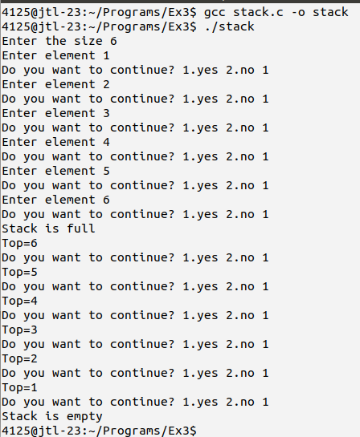

#include<stdio.h>
#include<stdlib.h>
#include<ctype.h>
struct node1
{
char data;
struct node1 *back;
};
typedef struct node1 Node1;
Node1 * get_node()
{
return (Node1 *)malloc(sizeof(Node1));
}
Node1 * push1(Node1 * top1, char a)
{
Node1 *temp1;
if(top1==NULL)
{
top1=get_node();
top1->data=a;
top1->back=NULL;
}
else
{
temp1=get_node();
temp1->data=a;
temp1->back=top1;
top1=temp1;
}
return top1;
}
Node1 * pop1(Node1 *top1)
{
Node1 *temp1=top1;
if(top1->back==NULL)
top1=NULL;
else
top1=top1->back;
free(temp1);
return top1;
}
char * in2po(char *infix, Node1 *top1)
{
char *postfix=(char *)malloc(100);
int i=0,j=0;
while(infix[i]!='\0')
{
char q=infix[i];
if(isdigit(q)!=0)
{
postfix[j]=q;

j++;
}
else if(q=='(')
top1=push1(top1,q);
else if(q=='+' || q=='-')
{
if(top1==NULL || top1->data=='(')
top1=push1(top1,q);
else
{
postfix[j]=top1->data;
j++;
top1=pop1(top1);
top1=push1(top1,q);
}
}
else if(q=='*' || q=='/' || q=='%')
{
if(top1==NULL ||top1->data=='(' || top1->data=='+' || top1->data=='-')
top1=push1(top1,q);
else
{
postfix[j]=top1->data;
j++;
top1=pop1(top1);
top1=push1(top1,q);
}
}
else if(q=='^')
top1=push1(top1,q);
else if(q==')')
{
while(top1!=NULL)
{
if(top1->data=='(')
{
break;
}
else
{
postfix[j]=top1->data;
j++;
top1=pop1(top1);
}
}
}
i++;
}
while(top1!=NULL)
{
if(top1->data!='(')

{

postfix[j]=top1->data;
j++;
}
top1=top1->back;
}
free(top1);
return postfix;
}
void main()
{
Node1 *top1;
top1=NULL;
char *postfix,*infix;
infix=(char *)malloc(100);
scanf("%s",infix);
postfix=in2po(infix,top1);
printf("Postfix: %s\n",postfix);
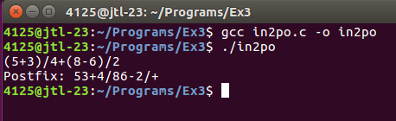
}

#include<stdio.h>
#include<stdlib.h>
#include<ctype.h>
#include<math.h>
struct node{
int key;
struct node *back;
};
typedef struct node Node;
Node * getnode()
{
return (Node *)malloc(sizeof(Node));
}
Node * push(Node * top, int a)
{
Node *temp;
if(top==NULL)
{
top=getnode();
top->key=a;
top->back=NULL;
}
else
{
temp=getnode();
temp->key=a;
temp->back=top;
top=temp;
}
return top;
}
Node * pop(Node *top)
{
Node *temp=top;
top=top->back;
free(temp);
return top;
}
void po2res(char *postfix, Node *top)
{
int k=0,b[2],result;
while(postfix[k]!='\0')
{
if(isdigit(postfix[k]))
{
int a=(int)postfix[k]-(int)'0';
top=push(top,a);
}
else
{
for(int j=0;j<2;j++)

{
b[j]=top->key;
top=pop(top);
}
if(postfix[k]=='+')
result=b[1]+b[0];
else if(postfix[k]=='-')
result=b[1]-b[0];
else if(postfix[k]=='*')
result=b[1]*b[0];
else if(postfix[k]=='/')
result=b[1]/b[0];
else if(postfix[k]=='%')
result=b[1]%b[0];
else if(postfix[k]=='^')
result=pow(b[1],b[0]);
top=push(top,result);
printf("%d%c%d=%d\n",b[1],postfix[k],b[0],result);
}
k++;
}
}
void main()
{
Node *top;
top=NULL;
char *postfix=(char *)malloc(100);
scanf("%s",postfix);
po2res(postfix,top);



