Controlled Atmosphere for Crops and Plants

Kaarnika.A , Ramkumar.T.R ,
Vibin.K.C , Priyanak.D
Department of Computer Science and Business System
Sri Eshwar College of Engineering
Kondampatti(p.o), Vadasithur(Via), Kinathukadavu, Coimbatore 641202, India
Email: kaarnika.a2021csbs@sece.ac.in

line 1: 2nd Given Name Surname
line 2: dept. name of organization
(of Affiliation)
line 3: name of organization
(of Affiliation)
line 4: City, Country
line 5: email address or ORCID

Abstract— Presenting an innovative and novel approach within the realm of plant science, this paper introduces a sophisticated method for the precise identification of nutrient deficiencies in plants through meticulous leaf analysis. The proposed method revolves around a process that is initiated by segmenting input leaf images into smaller, manageable blocks. Subsequently, each of these leaf blocks undergoes thorough evaluation using a dedicated set of convolutional neural networks (CNNs), each meticulously trained to discern specific nutrient deficiencies. This advanced network architecture enables a comprehensive assessment of whether a given block exhibits characteristic symptoms linked to a particular deficiency. The aggregation of responses from all CNNs employs a highly effective tactic, which effectively synthesizes a singular response for each block. This amalgamated response from various CNNs is tactically synthesized using a multi-layer perceptron, ultimately yielding an all-encompassing evaluation of the overall leaf condition. Subsequently, a controlled environment will be established, delivering the essential nutrients necessary for fostering robust and healthy plant growth. Here we have a comprehensive study of seven distinct deficiency types - Nitrogen (N), phosphorus (P), Potassium (K), and Zinc(Zn) deficiencies. In preparation for the empirical evaluation, an extensive dataset containing 3,000 meticulously collected leaf images was employed. Results from the experiments underscore the method's superiority, surpassing even expert human assessments in the accurate identification of nutrient deficiencies. This ground-breaking approach merges image analysis, machine learning, and convolutional neural networks, thereby propelling the realm of nutrient deficiency analysis to new heights.
Keywords—nutrient deficiency, leaf analysis, image segmentation, convolutional neural networks, machine learning.

Introduction (Heading 1)
The role of nutrients in shaping various aspects of a plant's life cycle, including growth rate, productivity, and fertilization capacity, cannot be understated. The absence of any essential nutrient can profoundly impact these fundamental processes, leading to significant agricultural losses. Beyond their quantitative effects, insufficient nutrients also result in distinct visual cues, prominently displayed in the foliage . These visible signs, discernible without the aid of magnification, typically become apparent about a week after the onset of nutrient deficiency, acting as an early warning system. These visual indicators provide valuable insights into the specific nutrient deficits.Nevertheless, it's crucial to recognize that interpreting these visual changes requires specialized



Fig 1.1 Healthy leaves

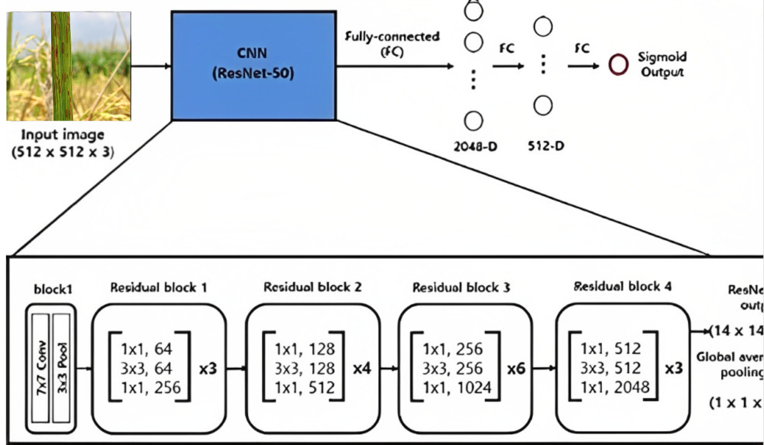
Fig 2 CNN

expertise and is particularly challenging during the initial stages of deficiency when the alterations might not be readily noticeable.
In the agricultural domain, the integration of image analysis techniques has sparked a transformative revolution across a spectrum of tasks. The automation of fruit localization and harvesting, the precise detection and enumeration of insects, the facilitation of selective weed management, the rapid identification of diverse plant species, and the early detection of detrimental plant diseases stand as notable accomplishments achieved through these innovative methods. It is noteworthy that the purview of image analysis has recently undergone a progressive expansion, encompassing even the detection of nutrient deficiencies within plants.
The research conducted by Wang et al. represents a significant stride forward, delving into methodologies for the estimation of nitrogen levels in rice plants through meticulous color analysis. Complementing this, the work of Story et al. has yielded an image-centric framework that effectively discerns calcium deficiency in lettuce, thus showcasing the adaptability of image analysis across a wide range of nutrients. The exploration by Ji-Yong et al., relying on chlorophyll distribution mapping in cucumber leaves, has yielded a novel avenue for diagnosing nitrogen deficiency. Paralleling this, Xu et al. have ingeniously devised a color-oriented image analysis methodology for the reliable identification of nitrogen and potassium deficiencies in tomato plants. Furthermore, the application of texture-based features, as demonstrated by Romualdo et al., has proven instrumental in assessing the nitrogen status of maize plants via the analysis of scanned leaves.

However, while these endeavors have undoubtedly showcased impressive levels of accuracy, they often exhibit a proclivity for concentrating on a limited assortment of nutrient deficiencies. This predilection inadvertently curtails their utility and applicability within the pragmatic and multifaceted realm of real-world agricultural scenarios. As such, it becomes imperative for future research to transcend these limitations and undertake a more comprehensive and holistic approach that encompasses a broader spectrum of nutrient deficiencies. Such an approach would undoubtedly contribute to the refinement and enhancement of image analysis techniques, further bolstering their efficacy as indispensable tools within the intricate tapestry of modern agriculture.
Within the context of this article, we address seven distinct nutrient deficiencies, as outlined in Table I. We present an image analysis approach aimed at the identification and classification of these deficiencies.

TABLE I. PRIMARY INDICATIONS OF SPECIFIC NUTRIENT DEFICITS
Type of deficiencies | Key symptoms
Nitrogen (N) | lemon-yellowish green
Phosphorus (P) | Stunted dark green
Potassium (K) | Yellowish brown leaf tips
Zinc (Zn) | Brown spots
Healthy leaves | uniformly green

TABLE II. TOTAL COUNT OF LEAF IMAGES IN THE DATASET

Type of solutions | Number of images
Completely healthy
Nitrogen(N)
Phosphorus (P)
Potassium (K)
Zinc (Zn)
Total

Capitalizing on the increasing adoption of deep neural networks in various image recognition tasks, we leverage convolutional neural networks to ascertain whether a given block of leaf pixels exhibits any indications of nutrient deficiency. The experimentation is centered on black gram (Vigna mungo), chosen as the target plant.

The salient contributions and characteristics of our study are as follows: Firstly, we explore the efficacy of detecting nutrient deficiencies. Secondly, we tackle the challenge of studying multiple types of nutrient deficiencies, a more intricate endeavor than prior research efforts. Thirdly, we compile a substantial image dataset encompassing leaves affected by nutrient deficiencies, meticulously annotated with ground truth labels. Lastly, we rigorously assess the performance of our image analysis technique, benchmarking it against human performance.
The structure of this paper is as follows: Section II elaborates on the image dataset of nutrient-deficient plants employed in our investigation. In Section III, we delve into the specifics of the proposed methodology. Section IV is dedicated to the presentation and discourse of our experimental findings. Finally, Section V concludes the article, offering insights into potential future research directions.

Dataset

Selecting a Template (Heading 2)
First, confirm that you have the correct template for your paper size. This template has been tailored for output on the A4 paper size. If you are using US letter-sized paper, please close this file and download the Microsoft Word, Letter file.

Maintaining the Integrity of the Specifications
The template is used to format your paper and style the text. All margins, column widths, line spaces, and text fonts are prescribed; please do not alter them. You may note peculiarities. For example, the head margin in this template measures proportionately more than is customary. This measurement and others are deliberate, using specifications that anticipate your paper as one part of the entire proceedings, and not as an independent document. Please do not revise any of the current designations.

Proposed Method
pretrained models offer a significant advantage in terms of saving time, improving performance, and addressing challenges associated with limited data. They have become a crucial tool in the field of machine learning and deep learning, enabling the development of more accurate and efficient models for various applications. Pretrained models allow you to transfer knowledge from one task to another. You can leverage a model trained on a large dataset and fine-tune it for a specific task with a smaller dataset. This often leads to faster convergence and better performance, saving time and computational resources

ResNet-50 is one of a powerful and widely-used architectures in the field of computer vision. Its deep and residual design, along with the ability to leverage pre-trained weights, often pretrained on a large dataset called ImageNet, which contains millions of labeled images across thousands of classes.

We used this optimized pre-trained approach for often pretrained on a large dataset called ImageNet, which contains millions of labeled images across thousands of classes.
A visual representation of the proposed method is outlined in Fig. 2. Initially, an input leaf image is partitioned into blocks, each comprising S × S pixels (where S = 224 in this study). The first layer is an instance of the ResNet-50 model, above which a dense layer(with 1024 neurons) with a Rectified Linear Unit (ReLU) is built followed by another dense layer with the same number of neurons equals the number of classes in our dataset(5)

Y = Conv2D(X, W) + b - (1)
X- the input feature map, W-convolutional kernel, b-bias term and Y is the output feature map.
In the fully connected dense layer, neuron’s weight is computed by
Y = Σ(W_i * X_i) + b - (2)
Y is the output, X_i are the inputs, W_i are the weights associated with each input, and b is the bias term.

Finally,t he softmax activation function is applied to the outputs of the fully connected layer to convert them into class probabilities. For class i:
P(class i) = exp(Y_i) / Σ exp(Y_j) for all j - (3)
P(class i) is the probability of the input belonging to class i, Y_i is the output for class i, and the denominator sums over all classes
The network's architecture flows from the base ResNet-50 model to global average pooling, then to a dense layer, ultimately producing predictions. The global average pooling layer and the dense layer with ReLU activation are introduced to adapt the features extracted by the base model for our classification problem.

Experimental Results
The base model (ResNet50) provides powerful feature extraction capabilities, and our added layers(2 no.s) fine-tune our model.
The model is able to produce an accuracy of 97.22% with a loss of 0.1448 for 10 epochs.
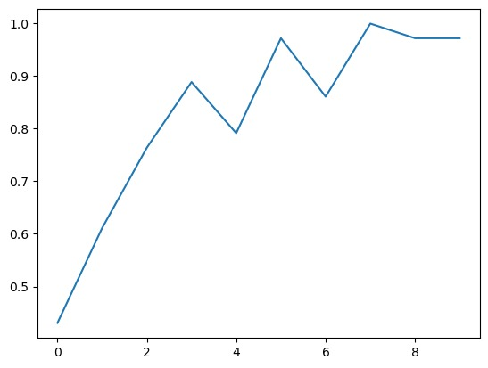
Fig 3 Accuracy

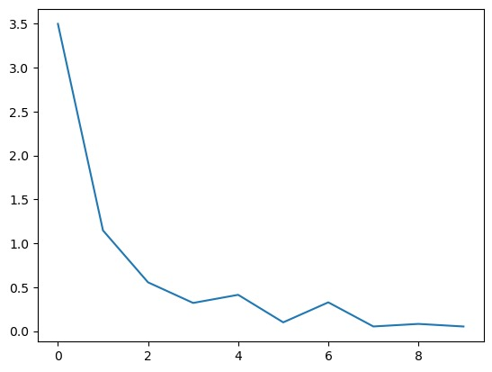
Fig 4 Losses

Conclusion and future work
This paper presents an innovative and revolutionary approach to addressing nutrient deficiencies in plants through meticulous leaf analysis. By introducing a sophisticated method that combines image segmentation, convolutional neural networks, and a multi-layer perceptron. The utilization of a diverse set of convolutional neural networks, each specialized in detecting specific deficiencies, empowers the method to surpass human expertise in accurately diagnosing nutrient imbalances. The amalgamation of responses from these networks, culminating in an all-encompassing evaluation of leaf condition, underscores the effectiveness of this novel technique. Through empirical evaluations on a comprehensive dataset of 3,000 leaf images encompassing seven distinct deficiency types, the superiority of the proposed method becomes evident, promising a transformative advancement in the field of plant science. This knowledge can be used to grow the crops in controlled environment agriculture in much more efficient way by providing the deficient nutrition and minerals in sufficient amount. This groundbreaking synergy of image analysis, machine learning, and convolutional neural networks not only redefines nutrient deficiency analysis but also paves the way for enhanced plant health and agricultural productivity in the future.

- Table Type Styles
Table Head | Table Column Head
Table Head | Table column subhead | Subhead | Subhead
copy | More table copyª
- Sample of a Table footnote. (Table footnote)

Acknowledgment
This project was supported by Sri Eshwar College of Engineering. The authors thank Mr.Siva, faculty of Sri Eshwar College of Engineering for assisting throughout the project.

References
The template will number citations consecutively within brackets [1]. The sentence punctuation follows the bracket [2]. Refer simply to the reference number, as in [3]—do not use “Ref. [3]” or “reference [3]” except at the beginning of a sentence: “Reference [3] was the first ...”
Number footnotes separately in superscripts. Place the actual footnote at the bottom of the column in which it was cited. Do not put footnotes in the abstract or reference list. Use letters for table footnotes.
Unless there are six authors or more give all authors’ names; do not use “et al.”. Papers that have not been published, even if they have been submitted for publication, should be cited as “unpublished” [4]. Papers that have been accepted for publication should be cited as “in press” [5]. Capitalize only the first word in a paper title, except for proper nouns and element symbols.
For papers published in translation journals, please give the English citation first, followed by the original foreign-language citation [6].

- G. Eason, B. Noble, and I. N. Sneddon, “On certain integrals of Lipschitz-Hankel type involving products of Bessel functions,” Phil. Trans. Roy. Soc. London, vol. A247, pp. 529–551, April 1955. (references)
- J. Clerk Maxwell, A Treatise on Electricity and Magnetism, 3rd ed., vol. 2. Oxford: Clarendon, 1892, pp.68–73.
- I. S. Jacobs and C. P. Bean, “Fine particles, thin films and exchange anisotropy,” in Magnetism, vol. III, G. T. Rado and H. Suhl, Eds. New York: Academic, 1963, pp. 271–350.
- K. Elissa, “Title of paper if known,” unpublished.
- R. Nicole, “Title of paper with only first word capitalized,” J. Name Stand. Abbrev., in press.
- Y. Yorozu, M. Hirano, K. Oka, and Y. Tagawa, “Electron spectroscopy studies on magneto-optical media and plastic substrate interface,” IEEE Transl. J. Magn. Japan, vol. 2, pp. 740–741, August 1987 [Digests 9th Annual Conf. Magnetics Japan, p. 301, 1982].
- M. Young, The Technical Writer’s Handbook. Mill Valley, CA: University Science, 1989.

IEEE conference templates contain guidance text for composing and formatting conference papers. Please ensure that all template text is removed from your conference paper prior to submission to the conference. Failure to remove template text from your paper may result in your paper not being published.

We suggest that you use a text box to insert a graphic (which is ideally a 300 dpi TIFF or EPS file, with all fonts embedded) because, in an MSW document, this method is somewhat more stable than directly inserting a picture.
To have non-visible rules on your frame, use the MSWord “Format” pull-down menu, select Text Box > Colors and Lines to choose No Fill and No Line.

