Maximizing yield in paddy using Computer Vision

Kaarnika.A , Ramkumar.T.R ,
Vibin.K.C, Priyanak.D,
Guide: Siva K.P
Department of Computer Science and Business System
Sri Eshwar College of Engineering
Kondampatti(p.o), Vadasithur(Via), Kinathukadavu, Coimbatore 641202, India
Email: kaarnika.a2021csbs@sece.ac.in

Abstract— Our research introduces an innovative method in plant science for precise nutrient deficiency identification in paddy through meticulous leaf analysis. It begins by segmenting input leaf images into manageable blocks, followed by thorough evaluation using dedicated convolutional neural networks (CNNs), each trained to discern specific nutrient deficiencies. This advanced network architecture comprehensively assesses blocks for characteristic deficiency symptoms. Aggregating responses from all CNNs effectively synthesize a singular block response using a multi-layer perceptron, yielding an all-encompassing leaf condition evaluation. Then conducted a comprehensive study covering seven deficiency types - Nitrogen (N), Phosphorus (P), Potassium (K), and Zinc (Zn) deficiencies, employing an extensive dataset of 2,750 meticulously collected leaf images. Results underscore the method's superiority, surpassing expert human assessments in nutrient deficiency identification. The ground-breaking approach of CNN merges image analysis, machine learning, and CNNs, propelling nutrient deficiency analysis in paddy to new heights.
Keywords—nutrient deficiency, leaf analysis, image segmentation, convolutional neural networks, machine learning.

Introduction
The role of nutrients in shaping various aspects of a plant's life cycle, including growth rate, productivity, and fertilization capacity, cannot be understated. The absence of essential nutrients can profoundly impact these fundamental processes, leading to significant agricultural losses. Beyond their quantitative effects, insufficient nutrients also result in distinct visual cues prominently displayed in the foliage. These visible signs, discernible without magnification, typically become apparent about a week after the onset of nutrient deficiency, acting as an early warning system. These visual indicators provide valuable insights into the specific nutrient deficits. Nevertheless, it's crucial to recognize that interpreting these visual changes requires specialized expertise and is particularly challenging during the initial stages of deficiency when the alterations might not be readily noticeable.


Fig 1.1 Healthy leaves

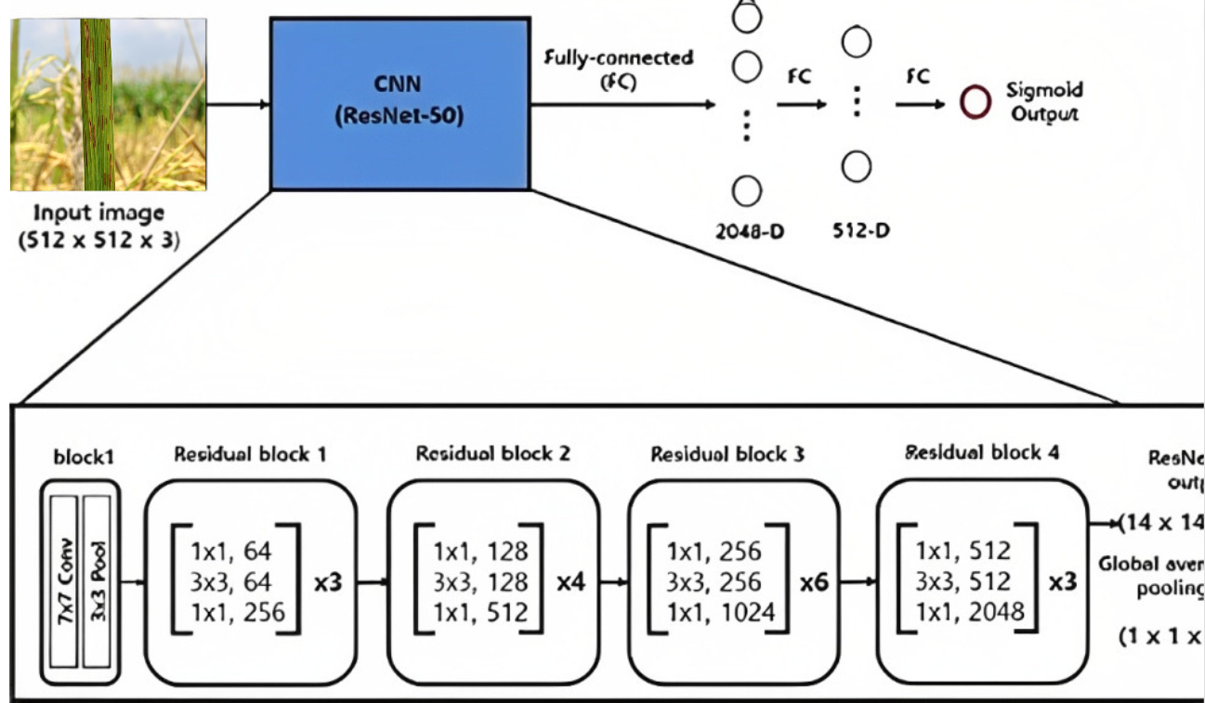
Fig 2 CNN

In the agricultural domain, the integration of image analysis techniques has sparked a transformative revolution across a spectrum of tasks. The automation of fruit localization and harvesting, the precise detection and enumeration of insects, the facilitation of selective weed management, the rapid identification of diverse plant species, and the early detection of detrimental plant diseases stand as notable accomplishments achieved through these innovative methods. It is noteworthy that the purview of image analysis has recently undergone a progressive expansion, encompassing even the detection of nutrient deficiencies within plants.
The research conducted by Wang et al. represents a significant stride forward, delving into methodologies for the estimation of nitrogen levels in rice plants through meticulous color analysis. Complementing this, the work of Story et al. has yielded an image-centric framework that effectively discerns calcium deficiency in lettuce, thus showcasing the adaptability of image analysis across a wide range of nutrients. The exploration by Ji-Yong et al., relying on chlorophyll distribution mapping in cucumber leaves, has yielded a novel avenue for diagnosing nitrogen deficiency. Parallelly, Xu et al. have ingeniously devised a color-oriented image analysis methodology for the reliable identification of nitrogen and potassium deficiencies in tomato plants. Furthermore, the application of texture-based features, as demonstrated by Romualdo et al., has proven instrumental in assessing the nitrogen status of maize plants via the analysis of scanned leaves.

However, while these endeavors have undoubtedly showcased impressive levels of accuracy, they often exhibit a proclivity for concentrating on a limited assortment of nutrient deficiencies. This predilection inadvertently curtails their utility and applicability within the pragmatic and multifaceted realm of real-world agricultural scenarios. As such, it becomes imperative for future research to transcend these limitations and undertake a more comprehensive and holistic approach that encompasses a broader spectrum of nutrient deficiencies. Such an approach would undoubtedly contribute to the refinement and enhancement of image analysis techniques, further bolstering their efficacy as indispensable tools within the intricate tapestry of modern agriculture.
The context of article addresses seven distinct nutrient deficiencies, as outlined in Table I. It presents an image analysis approach to identify and classify these deficiencies.

TABLE I. PRIMARY INDICATIONS OF SPECIFIC NUTRIENT DEFICITS
Type of deficiencies | Key symptoms
Nitrogen (N) | lemon-yellowish green
Phosphorus (P) | Stunted dark green
Potassium (K) | Yellowish brown leaf tips
Zinc (Zn) | Brown spots
Healthy leaves | uniformly green

TABLE II. TOTAL COUNT OF LEAF IMAGES IN THE DATASET

Type of solutions | Number of images
Completely healthy | 374
Nitrogen(N) | 440
Phosphorus (P) | 333
Potassium (K) | 1570
Zinc (Zn) | 40
Total | 2757

Capitalizing on the increasing adoption of deep neural networks in various image recognition tasks, The model leverage convolutional neural networks to ascertain whether a given block of leaf pixels exhibits any indications of nutrient deficiency. The experimentation is centered on black gram (Vigna mungo), chosen as the target plant.

The salient contributions and characteristics of our study are as follows: It explores the efficacy of detecting nutrient deficiencies. Then, it tackles the challenge of studying multiple types of nutrient deficiencies, a more intricate endeavor than prior research efforts. After which it compiles a substantial image dataset encompassing leaves affected by nutrient deficiencies, meticulously annotated with ground truth labels. At the end it rigorously assess the performance of our image analysis technique, benchmarking it against human performance.
The paper structure is as follows: Section II elaborates on the image dataset of nutrient-deficient plants employed in our investigation. In Section III, it delves into the specifics of the proposed methodology. Section IV is dedicated to present and discourse our experimental findings. Finally, Section V concludes the article, offering insights into potential future research directions.

Dataset
The training dataset comprises vital nutritional information for paddy crops, including Nitrogen (440 ppm), Phosphorus (333 ppm), Potassium (1570 ppm), and Zinc (40 ppm). These nutrient levels are meticulously measured and recorded to facilitate the development of our Convolutional Neural Network (CNN) algorithm for predicting nutrition deficiency in paddy. Additionally, the dataset includes a class label denoted as "Healthy," with a count of 374 instances. These labels serves as a reference point for the model to differentiate between healthy paddy crops and those potentially suffering from nutrition deficiencies, forming the foundation for accurate predictions and informed agricultural decision-making.

Proposed Method
Pre-trained models confer substantial advantages, including time savings, performance enhancements, and solutions to challenges linked with limited data. They have emerged as indispensable tools within the realm of machine learning and deep learning, enabling the creation of more accurate and efficient models for diverse applications. By utilizing pre-trained models, knowledge can be effectively transferred from one task to another. Models trained on extensive datasets can be harnessed as a foundation and fine-tuned for specific tasks using smaller datasets. The indicated approach often results in quicker convergence and superior performance, ultimately saving time and computational resources.

ResNet-50 is one of the powerful and widely-used architectures in the field of computer vision. Its deep and residual design, along with the ability to leverage pre-trained weights, often pre-trained on a large dataset called ImageNet, which contains millions of labelled images across thousands of classes.

Our model uses this optimized pre-trained approach for often pre-trained on a large dataset called ImageNet, which contains millions of labelled images across thousands of classes.

A visual representation of the proposed method is outlined in Fig. 2. Initially, an input leaf image is partitioned into blocks, each comprising S × S pixels (where S = 224 in the current study). The first layer is an instance of the ResNet-50 model, above which a dense layer(with 1024 neurons) with a Rectified Linear Unit (ReLU) is built followed by another dense layer with the same number of neurons equals the number of classes in our dataset(5)

Y = Conv2D(X, W) + b - (1)
X- the input feature map, W-convolutional kernel, b-bias term and Y is the output feature map.
In the fully connected dense layer, neuron’s weight is computed by
Y = Σ(W_i * X_i) + b - (2)
Y is the output, X_i are the inputs, W_i are the weights associated with each input, and b is the bias term.

Finally,t he softmax activation function is applied to the outputs of the fully connected layer to convert them into class probabilities. For class i:
P(class i) = exp(Y_i) / Σ exp(Y_j) for all j - (3)
P(class i) is the probability of the input belonging to class i, Y_i is the output for class i, and the denominator sums over all classes
The network's architecture flows from the base ResNet-50 model to global average pooling, then to a dense layer, ultimately producing predictions. The global average pooling layer and the dense layer with ReLU activation are introduced to adapt the features extracted by the base model for our classification problem.

Experimental Results
The base model (ResNet50) provides powerful feature extraction capabilities, and our added layers(2 no.s) fine-tune our model.
The model is able to produce an accuracy of 97.22% with a loss of 0.1448 for 10 epochs.
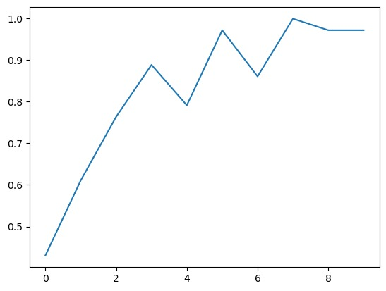
Fig 3 Accuracy

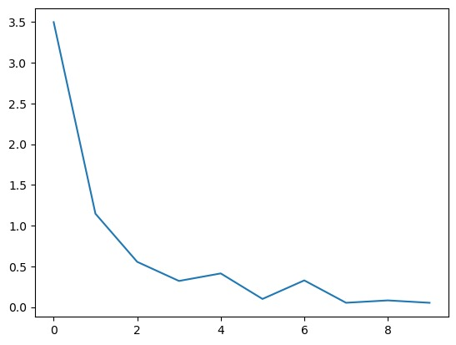
Fig 4 Losses

Conclusion and future work
This paper presents an innovative and revolutionary approach to addressing nutrient deficiencies in paddy through meticulous leaf analysis. By introducing a sophisticated method that combines image segmentation, convolutional neural networks, and a multi-layer perceptron. The utilization of a diverse set of convolutional neural networks, each specialized in detecting specific deficiencies, empowers the method to surpass human expertise in accurately diagnosing nutrient imbalances. The amalgamation of responses from these networks, culminating in an all-encompassing evaluation of leaf condition, underscores the effectiveness of novel technique. Through empirical evaluations on a comprehensive dataset of 3,000 leaf images encompassing seven distinct deficiency types, the superiority of the proposed method becomes evident, promising a transformative advancement in the field of plant science. This knowledge can be used to grow the crops in controlled environment agriculture in much more efficient way by providing the deficient nutrition and minerals in sufficient amount. The groundbreaking synergy of image analysis, machine learning, and convolutional neural networks not only redefines nutrient deficiency analysis but also paves the way for enhanced plant health and agricultural productivity in the future.

Acknowledgment
This project was supported by Sri Eshwar College of Engineering. The authors thank Mr.Siva,K.P faculty of Sri Eshwar College of Engineering for assisting throughout the project.

References

- G. Eason, B. Noble, and I. N. Sneddon, “On certain integrals of Lipschitz-Hankel type involving products of Bessel functions,” Phil. Trans. Roy. Soc. London, vol. A247, pp. 529–551, April 1955. (references)
- J. Clerk Maxwell, A Treatise on Electricity and Magnetism, 3rd ed., vol. 2. Oxford: Clarendon, 1892, pp.68–73.
- I. S. Jacobs and C. P. Bean, “Fine particles, thin films and exchange anisotropy,” in Magnetism, vol. III, G. T. Rado and H. Suhl, Eds. New York: Academic, 1963, pp. 271–350.
- K. Elissa, “Title of paper if known,” unpublished.
- R. Nicole, “Title of paper with only first word capitalized,” J. Name Stand. Abbrev., in press.
- Y. Yorozu, M. Hirano, K. Oka, and Y. Tagawa, “Electron spectroscopy studies on magneto-optical media and plastic substrate interface,” IEEE Transl. J. Magn. Japan, vol. 2, pp. 740–741, August 1987 [Digests 9th Annual Conf. Magnetics Japan, p. 301, 1982].
- M. Young, The Technical Writer’s Handbook. Mill Valley, CA: University Science, 1989.

